**Java Programming**

**Lab-1**

**Submitted by: Submitted to:**

**Aakash Bhatt Saurabh Sir**

**500124633**

**(2023-2024)**

**Q1**. Ramesh’s basic salary is input through the keyboard. His dearness allowance is 40% of basic salary, and house rent allowance is 20% of basic salary. Write a program to calculate his gross salary.

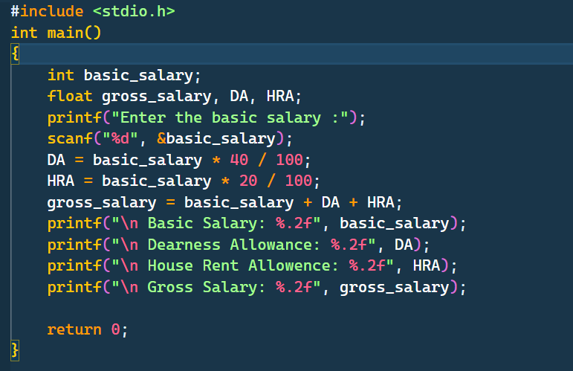

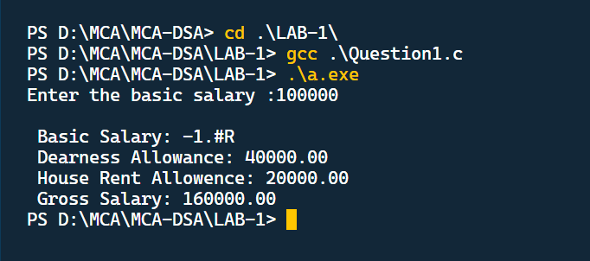

**Q2.** The distance between two cities (in km.) is input through the keyboard. Write a program to convert and print this distance in meters, feet, inches and centimeters.

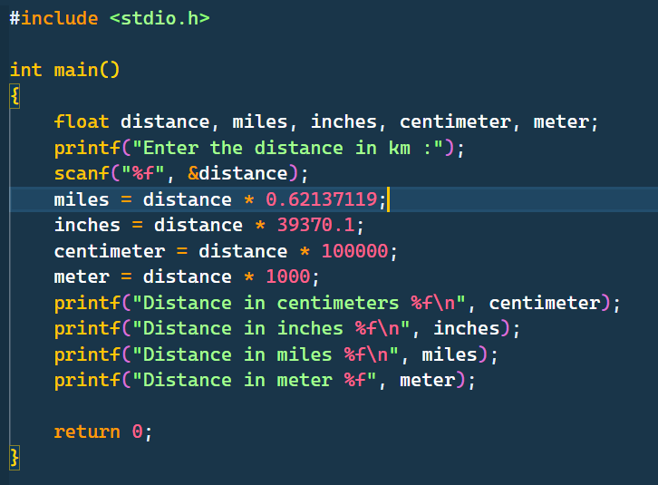

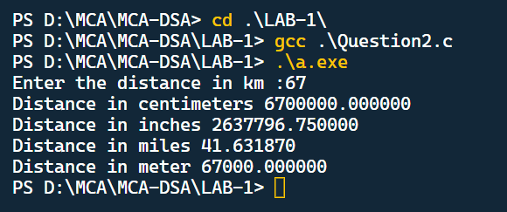

**Q3.** If the marks obtained by a student in five different subjects are input through the keyboard, find out the aggregate marks and percentage marks obtained by the student. Assume that the maximum marks that can be obtained by a student in each subject is 100.

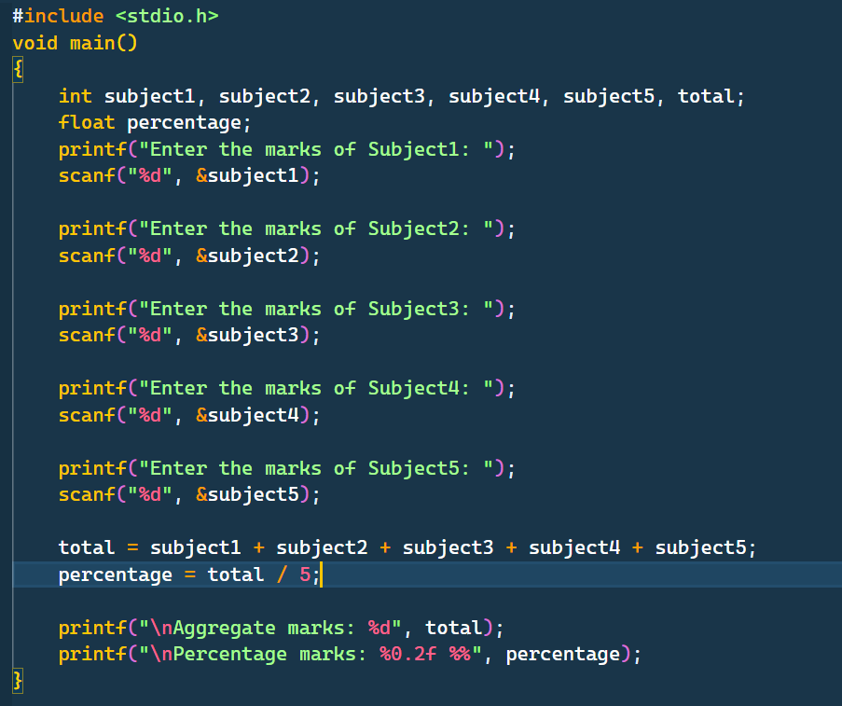

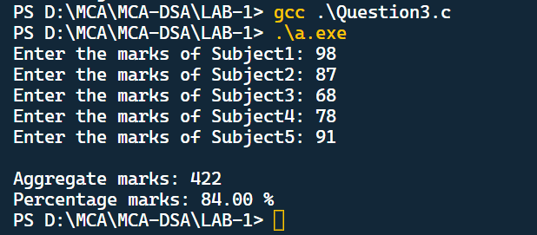

**Q4**. Temperature of a city in Fahrenheit degrees is input through the keyboard. Write a program to convert this temperature into Centigrade degrees.

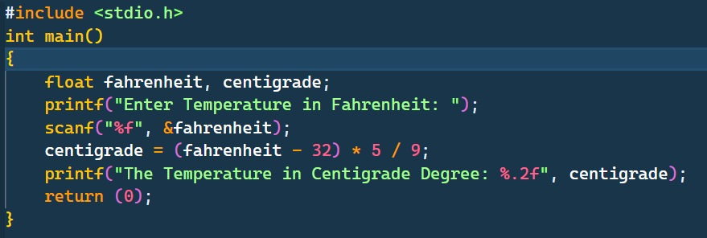

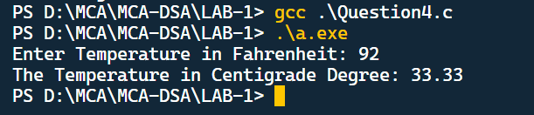

**Q5.**The length & breadth of a rectangle and radius of a circle are input through the keyboard. Write a program to calculate the area & perimeter of the rectangle, and the area & circumference of the circle.

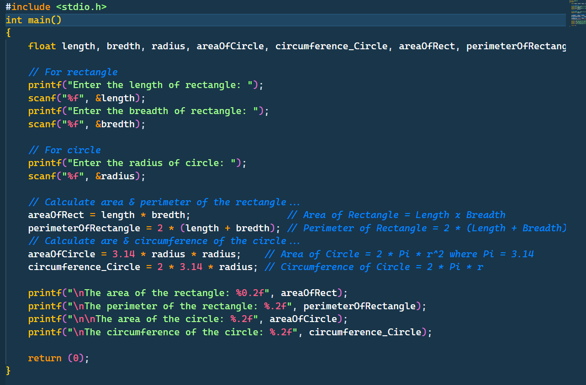

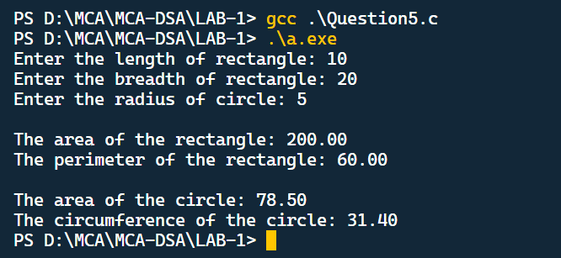

**Q6.**The Paper of size A0 has dimensions 1189 mm * 841mm.Each subsequent size A(n) is defined as A(n-1) cut in half parallel to its shorter sides. Thus paper of size A1would have dimensions 841mm * 594mm. Write a program to calculate and print paper sizes A0,A1,A2….A8.

