**Data Structure**

**Lab-10**

**Submitted by: Submitted to:**

**Aakash Bhatt Pankaj Sir**

**500124633**

**(2023-2024)**

WAP to populate an array of 'n' elements using a random function. Share the time complexity for all the experiments, n should be large enough to see the difference in execution.

1. Implement Insertion sort in the above data set.

#include <stdio.h>

#include <stdlib.h>

#include <time.h>

*// Function to generate random elements in the array*

void populateArrayRandomly(int arr*[]*, int n)

{

    srand(time(NULL)); *// Seed for random number generation*

    for (int i = 0; i < n; i++)

    {

        arr[i] = rand() % 100; *// Generate random numbers between 0 and 99*

    }

}

void insertionSort(int arr*[]*, int n)

{

    int i, j;

    for (i = 1; i < n; i++)

    {

        int temp = arr[i];

        j = i - 1;

        while (j >= 0 && arr[j] > temp)

        {

            arr[j + 1] = arr[j];

            j--;

        }

        arr[j + 1] = temp;

    }

}

int main()

{

    int n = 10; *// Choose a sufficiently large value for n*

    int arr[n];

*// Populate array with random elements*

    populateArrayRandomly(arr, n);

    printf("Original array: ");

    for (int i = 0; i < n; i++)

    {

        printf("%d ", arr[i]);

    }

*// Perform insertion sort*

    insertionSort(arr, n);

    printf("\nSorted array using Insertion Sort algorithm: ");

    for (int i = 0; i < n; i++)

    {

        printf("%d ", arr[i]);

    }

    printf("\n");

    return 0;

}

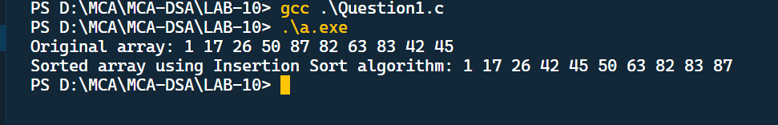

Implement Selection sort in the above data set.

#include <stdio.h>

#include <stdlib.h>

#include <time.h>

void swap(int *a, int *b)

{

    int temp = *a;

    *a = *b;

    *b = temp;

}

void selectionSort(int arr*[]*, int n)

{

    int i, j;

    for (i = 0; i < n - 1; i++)

    {

        int min = i;

        for (j = i + 1; j < n; j++)

        {

            if (arr[j] < arr[min])

            {

                min = j;

            }

        }

*// Swap the elements*

        if (min != i)

        {

            swap(&arr[i], &arr[min]);

        }

    }

}

*// Function to generate random elements in the array*

void populateArrayRandomly(int arr*[]*, int n)

{

    srand(time(NULL)); *// Seed for random number generation*

    for (int i = 0; i < n; i++)

    {

        arr[i] = rand() % 100; *// Generate random numbers between 0 and 99*

    }

}

int main()

{

    int n = 10; *// Choose a sufficiently large value for n*

    int arr[n];

*// Populate array with random elements*

    populateArrayRandomly(arr, n);

    printf("Original array: ");

    for (int i = 0; i < n; i++)

    {

        printf("%d ", arr[i]);

    }

*// Perform selection sort*

    selectionSort(arr, n);

    printf("\nSorted array using Selection Sort algorithm: ");

    for (int i = 0; i < n; i++)

    {

        printf("%d ", arr[i]);

    }

    printf("\n");

    return 0;

}

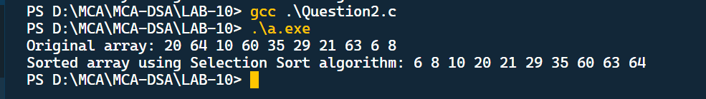

Implement Quicksort in the above data set.

#include <stdio.h>

#include <stdlib.h>

#include <time.h>

void swap(int *a, int *b)

{

    int temp = *a;

    *a = *b;

    *b = temp;

}

int partition(int a*[]*, int low, int high)

{

    int pivot = a[low];

    int i, j;

    i = low;

    j = high;

    while (i < j)

    {

        do

        {

            i++;

        } while (a[i] <= pivot);

        do

        {

            j--;

        } while (a[j] > pivot);

        if (i < j)

        {

            swap(&a[i], &a[j]);

        }

    }

    swap(&a[low], &a[j]);

    return j;

}

void quicksort(int a*[]*, int low, int high)

{

    if (low < high)

    {

        int j = partition(a, low, high);

        quicksort(a, low, j);

        quicksort(a, j + 1, high);

    }

}

*// Function to generate random elements in the array*

void populateArrayRandomly(int a*[]*, int n)

{

    srand(time(NULL)); *// Seed for random number generation*

    for (int i = 0; i < n; i++)

    {

        a[i] = rand() % 100; *// Generate random numbers between 0 and 99*

    }

}

int main()

{

    int n = 10; *// Choose a sufficiently large value for n*

    int arr[n];

*// Populate array with random elements*

    populateArrayRandomly(arr, n);

    printf("Original array: ");

    for (int i = 0; i < n; i++)

    {

        printf("%d ", arr[i]);

    }

*// Perform quick sort*

    quicksort(arr, 0, n - 1);

    printf("\nSorted array using Quick Sort algorithm: ");

    for (int i = 0; i < n; i++)

    {

        printf("%d ", arr[i]);

    }

    printf("\n");

    return 0;

}

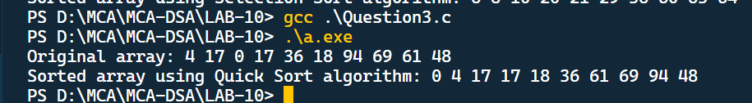

Implement Merge Sort using the above dataset.

#include <stdio.h>

void merge(int a*[]*, int lb, int mid, int ub)

{

    int i, j, k;

    i = lb;

    j = mid + 1;

    k = lb;

    int b[ub + 1];

    while (i <= mid && j <= ub)

    {

        if (a[i] < a[j])

        {

            b[k] = a[i];

            i++;

        }

        else

        {

            b[k] = a[j];

            j++;

        }

        k++;

    }

    if (i > mid)

    {

        while (j <= ub)

        {

            b[k] = a[j];

            j++;

            k++;

        }

    }

    else

    {

        while (i <= mid)

        {

            b[k] = a[i];

            i++;

            k++;

        }

    }

    for (k = lb; k <= ub; k++)

    {

        a[k] = b[k];

    }

}

void mergeSort(int a*[]*, int lb, int ub)

{

    if (lb < ub)

    {

        int mid = (lb + ub) / 2;

        mergeSort(a, lb, mid);

        mergeSort(a, mid + 1, ub);

        merge(a, lb, mid, ub);

    }

}

int main()

{

    int arr*[]* = {15, 5, 24, 8, 1, 3, 16, 10, 20};

    int n = sizeof(arr) / sizeof(arr[0]);

    printf("Original array is: \n");

    for (int i = 0; i < n; i++)

    {

        printf("%d, ", arr[i]);

    }

    mergeSort(arr, 0, n - 1);

    printf("\n\nSorted array using Merge Sort algorithm is: \n");

    for (int i = 0; i < n; i++)

    {

        printf("%d, ", arr[i]);

    }

    return 0;

}

