**Data Structure Lab**

**Lab-2**

**Submitted by: Submitted to:**

**Aakash Bhatt Pankaj Sir**

**500124633**

**(2023-2024)**

**Q1**. WAP to take check if the triangle is valid or not. If the validity is established, do check if the triangle is isosceles, equilateral, right angle, or scalene. Take sides of the triangle as input from a user.

#include <stdio.h>

void main()

{

    int side1, side2, side3;

*// User input for the sides of the triangle*

    printf("Enter the side1 of the triangle: ");

    scanf("%d", &side1);

    printf("Enter the side2 of the triangle: ");

    scanf("%d", &side2);

    printf("Enter the side3 of the triangle: ");

    scanf("%d", &side3);

*// Checking for different types of triangles*

    if (side1 == side2 && side2 == side3)

    {

        printf("Equilateral Triangle"); *// All sides are equal*

    }

    else if (side1 == side2 || side2 == side3 || side3 == side1)

    {

        printf("Isosceles Triangle"); *// Two sides are equal*

    }

    else if (side1 * side1 + side2 * side2 == side3 * side3 || side2 * side2 + side3 * side3 == side1 * side1 || side3 * side3 + side1 * side1 == side2 * side2)

    {

        printf("Right Angle Triangle"); *// Satisfies Pythagorean theorem*

    }

    else if (side1 != side2 && side2 != side3 && side3 != side1)

    {

        printf("Scalene Triangle"); *// All sides are different*

    }

    else

    {

        printf("Invalid Triangle"); *// Invalid input or sides cannot form a triangle*

    }

}

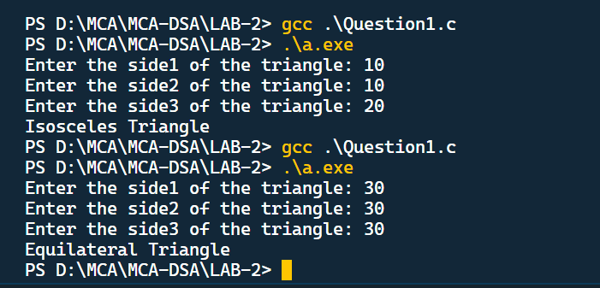

**Q2**. WAP to compute the BMI Index of the person and print the BMI values as per the following ranges. You can use the following formula to compute BMI= weight(kgs)/Height(Mts)*Height(Mts).

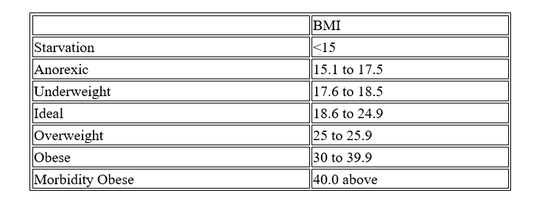

#include <stdio.h>

void main()

{

    float height, weight, bmi;

*// User input for weight and height*

    printf("Enter your weight in (kilograms): ");

    scanf("%f", &weight);

    printf("Enter your height in (meters): ");

    scanf("%f", &height);

*// Calculate BMI*

    bmi = weight / (height * height);

*// Display BMI value*

    printf("Your BMI is: %.2f\n", bmi);

*// Categorize BMI into different groups*

    if (bmi < 15)

        printf("Starvation"); *// BMI less than 15*

    else if (bmi >= 15.1 && bmi <= 17.5)

        printf("Anorexic"); *// BMI between 15.1 and 17.5*

    else if (bmi >= 17.6 && bmi <= 18.5)

        printf("Underweight"); *// BMI between 17.6 and 18.5*

    else if (bmi >= 18.6 && bmi <= 24.9)

        printf("Ideal"); *// BMI between 18.6 and 24.9*

    else if (bmi >= 25 && bmi <= 25.9)

        printf("Overweight"); *// BMI between 25 and 25.9*

    else if (bmi >= 30 && bmi <= 39.9)

        printf("Obese"); *// BMI between 30 and 39.9*

    else

        printf("Morbidity Obese"); *// BMI greater than or equal to 40*

}

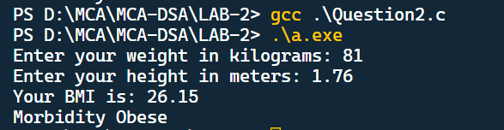

**Q3**. WAP to check if three points (x1,y1), (x2,y2) and (x3,y3) are collinear or not.

#include <stdio.h>

int main()

{

    int x1, x2, x3, y1, y2, y3;

*// User input for the coordinates of three points*

    printf("Enter the value of x1 and y1: ");

    scanf("%d %d", &x1, &y1);

    printf("Enter the value of x2 and y2: ");

    scanf("%d %d", &x2, &y2);

    printf("Enter the value of x3 and y3: ");

    scanf("%d %d", &x3, &y3);

*// Calculate the value to check if the points are collinear*

    int value = x1 * (y2 - y3) + x2 * (y3 - y1) + x3 * (y1 - y2);

*// Check if the value is zero to determine collinearity*

    if (value == 0)

    {

        printf("Entered points are collinear"); *// Points are collinear if the value is zero*

    }

    else

    {

        printf("Entered points are not collinear"); *// Points are not collinear if the value is not zero*

    }

    return 0;

}

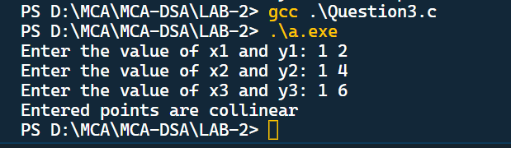

**Q4**. According to the gregorian calendar, it was Monday on the date 01/01/01. If Any year is input through the keyboard write a program to find out what is the day on 1st January of this year.

#include <stdio.h>

void main()

{

    int year, daysInYear, daysOfName;

    printf("Enter the year :");

    scanf("%d", &year);

    daysInYear = year * 365;

    daysOfName = daysInYear % 7;

    if (daysOfName == 1)

        printf("Monday");

    else if (daysOfName == 2)

        printf("Tuesday");

    else if (daysOfName == 3)

        printf("Wednesday");

    else if (daysOfName == 4)

        printf("Thrusday");

    else if (daysOfName == 5)

        printf("Friday");

    else if (daysOfName == 6)

        printf("Saturday");

    else if (daysOfName == 0)

        printf("Sunday");

    else

        printf("Invalid day");

}

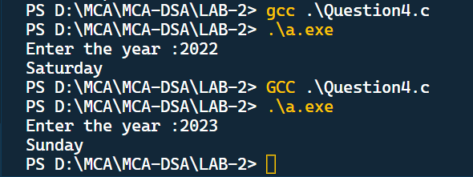

**Q5**. WAP using ternary operator, the user should input the length and breadth of a rectangle, one has to find out which rectangle has the highest perimeter. The minimum number of rectangles should be three.

#include <stdio.h>

int main()

{

*// Declare variables to store dimensions and perimeters*

    int len1, len2, len3, wid1, wid2, wid3;

    int per1, per2, per3;

*// Input dimensions of Rectangle 1*

    printf("Enter the length and breadth of Rectangle 1: ");

    scanf("%d %d", &len1, &wid1);

*// Input dimensions of Rectangle 2*

    printf("Enter the length and breadth of Rectangle 2: ");

    scanf("%d %d", &len2, &wid2);

*// Input dimensions of Rectangle 3*

    printf("Enter the length and breadth of Rectangle 3: ");

    scanf("%d %d", &len3, &wid3);

*// Calculate perimeters for each rectangle*

    per1 = 2 * (len1 + wid1);

    per2 = 2 * (len2 + wid2);

    per3 = 2 * (len3 + wid3);

*// Compare perimeters using ternary operators and print results*

    (per1 > per2 && per1 > per3) ? printf("Rectangle 1 has the greater perimeter\n") : (per2 > per3) ? printf("Rectangle 2 has the greater perimeter\n")

                                                                                                     : printf("Rectangle 3 has the greater perimeter\n");

    return 0; *// Return 0 to indicate successful program execution*

}

