**Data Structure Lab**

**Lab-3**

**Submitted by: Submitted to:**

**Aakash Bhatt Pankaj Sir**

**500124633**

**(2023-2024)**

**Q1**. WAP to enter numbers till the user wants. At the end, it should display the count of positive, negative, and Zeroes entered.

#include <stdio.h>

int main()

{

    int positive_count = 0;

    int negative_count = 0;

    int zero_count = 0;

    float num;

    char user_choice = 'y';

    while (user_choice == 'y' || user_choice == 'Y')

    {

        printf("Enter a number: ");

        scanf("%f", &num);

        if (num > 0)

        {

            positive_count++;

        }

        else if (num < 0)

        {

            negative_count++;

        }

        else

        {

            zero_count++;

        }

        printf("Do you want to enter another number? (y/n): ");

        scanf(" %c", &user_choice);

    }

    printf("Count of positive numbers: %d\n", positive_count);

    printf("Count of negative numbers: %d\n", negative_count);

    printf("Count of zeros: %d\n", zero_count);

    return 0;

}

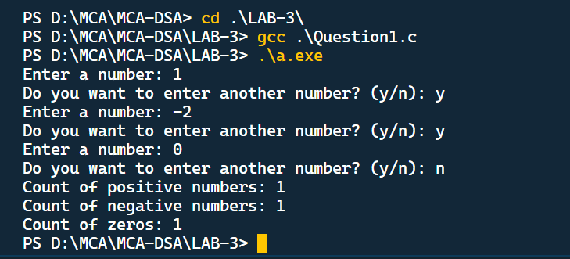

**Q2**. WAP to print the multiplication table of the number entered by the user. It should be in the correct formatting.

#include <stdio.h>

void main()

{

*//* By using For loop*

*// int number;*

*// printf("Enter the number :");*

*// scanf("%d", &number);*

*// for (int i = 1; i <= 10; i++)*

*// {*

*//     printf("%d x %d = %d\n", number, i, number * i);*

*// }*

*//*By using while loop*

*// int number;*

*// printf("Enter the number :");*

*// scanf("%d", &number);*

*// int i = 1;*

*// while (i <= 10)*

*// {*

*//     printf("%d x %d = %d\n", number, i, number * i);*

*//     i++;*

*// }*

*//*By using do while loop*

    int number;

    printf("Enter the number :");

    scanf("%d", &number);

    int i = 1;

    do

    {

        printf("%d x %d = %d\n", number, i, number * i);

        i++;

    } while (i <= 10);

}

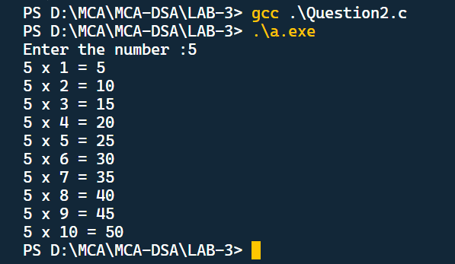

**Q3**. WAP to generate the following set of output.

#include <stdio.h>

void main()

{

*// Pattern 1*

    int count = 1;

    for (int i = 0; i <= 3; i++)

    {

        for (int j = 1; j <= i; j++)

        {

            printf("%d", count);

            count++;

        }

        printf("\n");

    }

*// Pattern 2*

    int num;

    printf("Enter the number of rows :");

    scanf("%d", &num);

    for (int i = 0; i < num; i++)

    {

        int value = 1;

        for (int j = 0; j <= i; j++)

        {

            printf("%d", value);

            value = value * (i - j) / (j + 1);

        }

        printf("\n");

    }

}

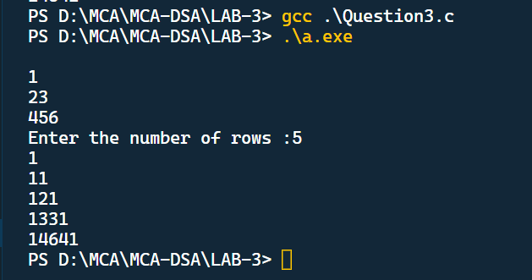

**Q4.** The population of a town is 100000. The population has increased steadily at the rate of 10% per year for the last 10 years. Write a program to determine the population at the end of each year in the last decade.

#include <stdio.h>

void main()

{

    int initial_population = 100000;

    double growth_rate = 0.10;

    int years = 10;

    int population;

    for (int i = 0; i < years; i++)

    {

        population = 100000 + (int)(initial_population * growth_rate);

        printf("%d \t %d\n", i, population);

        initial_population = population;

    }

}

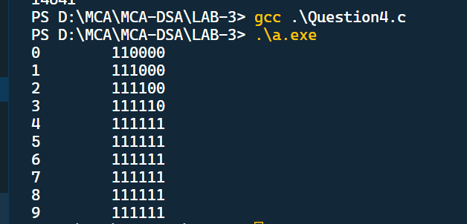

**Q5.** Ramanujan Number is the smallest number that can be expressed as the sum of two cubes in two different ways. WAP to print all such numbers up to a reasonable limit.

#include <stdio.h>

int main()

{

    int i, num, x, y, count;

    printf("Enter the range in which you find the number:");

    scanf("%d", &num);

    for (i = 1; i <= num; i++)

    {

        count = 0;

        for (x = 1; x * x * x < i; x++)

        {

            for (y = x; x * x * x + y * y * y <= i; y++)

            {

                if (x * x * x + y * y * y == i)

                {

                    count++;

                }

            }

        }

        if (count == 2)

        {

            printf("%d\n", i);

        }

    }

}

