**Data Structure Lab**

**Lab-4**

**Submitted by: Submitted to:**

**Aakash Bhatt Pankaj Sir**

**500124633**

**(2023-2024)**

**Q1**. WAP for printing Fibonacci sequence. Take input from the user to print up to a certain limit.

#include <stdio.h>

*// Function to calculate the Fibonacci sequence*

int fibonacci(int num)

{

    if (num == 0 || num == 1) *// Base cases: Fibonacci of 0 and 1 is 1*

    {

        return 1;

    }

    else

    {

*// Recursive step: Fibonacci of num is the sum of the previous two Fibonacci numbers*

        return fibonacci(num - 1) + fibonacci(num - 2);

    }

}

*// Main function*

void main()

{

    int num;

    printf("Enter the number: "); *// Prompt user to input a number*

    scanf("%d", &num); *// Read the input number*

    printf("Fibonacci sequence up to %d:\n", num);

    for (int i = 0; i <= num; i++)

    {

        printf("%d, ", fibonacci(i)); *// Print Fibonacci sequence up to the given number*

    }

}

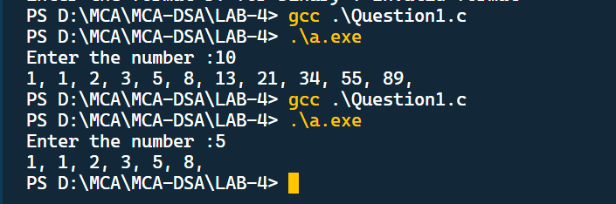

**Q2**. WAP to swap two variables without using a third variable, depict the same using call by value concept.

#include <stdio.h>

*// Function to swap the values of two numbers using pointers*

void swapTwoNumbers(int *num1, int *num2)

{

*// Swapping using arithmetic operations*

    *num1 = *num1 + *num2; *// Add num1 and num2 and store in num1*

    *num2 = *num1 - *num2; *// Subtract num2 from the new num1 and store in num2*

    *num1 = *num1 - *num2; *// Subtract the new num2 from the new num1 and store in num1*

}

int main()

{

    int num1, num2;

    printf("Enter the value of num1: ");

    scanf("%d", &num1); *// Read the value of num1 from the user*

    printf("Enter the value of num2: ");

    scanf("%d", &num2); *// Read the value of num2 from the user*

*// Without using functions*

*// printf("The value before swapping is %d, %d\n", num1, num2);*

*// num1 = num1 + num2;*

*// num2 = num1 - num2;*

*// num1 = num1 - num2;*

*// printf("The value after swapping is %d, %d", num1, num2);*

*// Calling function to swap two numbers using pointers*

    printf("The value before swapping is %d, %d\n", num1, num2);

    swapTwoNumbers(&num1, &num2); *// Call the swap function*

    printf("The value after swapping  is %d, %d", num1, num2);

    return 0; *// Indicate successful execution of the program*

}

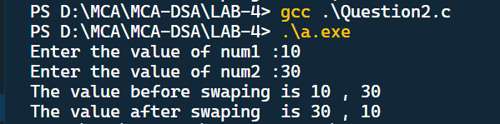

**Q3**. A positive integer is entered through the keyboard. Write a Function to print the prime factors of this number.

For example, 24 have prime factors: 2,2,2, and 3, whereas 35 have prime factors 5 and 7.

#include <stdio.h>

*// Function to find and print prime factors of a number*

void primeFactors(int num)

{

    for (int count = 2; num > 1; count++)

    {

        while (num % count == 0)

        {

            printf("%2d ,", count); *// Print the prime factor*

            num = num / count; *// Reduce the number by dividing it by the prime factor*

        }

    }

}

int main()

{

    int num;

    printf("Enter the number: ");

    scanf("%d", &num); *// Read the input number from the user*

    printf("Prime factors of %d are: ", num);

    primeFactors(num); *// Call the function to find and print prime factors*

    return 0; *// Indicate successful execution of the program*

}

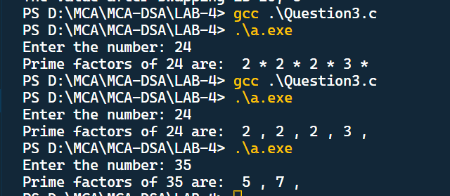

**Q4**. WAP which makes use of Switch and functions to implement the conversion of a given number to a given format.

For eg. If a decimal number is made input, it should ask for which number system you want to convert, and the conversion process should do that. Like Decimal to Binary, the program should take 65 as input and**1000001.**

#include <stdio.h>

*// Function to convert a decimal number to binary representation*

void numberToBinary(int num)

{

    int a[10], i, j;

*// Convert decimal number to binary by repeatedly dividing by 2*

    for (i = 0; num > 0; i++)

    {

        a[i] = num % 2; *// Store the remainder (binary digit)*

        num = num / 2; *// Update num by dividing it by 2*

    }

    printf("\nBinary representation of the given number is: ");

    for (j = i - 1; j >= 0; j--)

    {

        printf("%d", a[j]); *// Print the binary digits in reverse order*

    }

}

*// Function to choose the desired conversion format*

void convert(int number, int format)

{

    switch (format)

    {

    case 1:

        printf("Binary representation of %d is: ", number);

        numberToBinary(number); *// Call function to convert to binary*

        break;

    default:

        printf("Invalid format");

    }

}

int main()

{

    int num, format;

    printf("Enter the number: ");

    scanf("%d", &num); *// Read the input number from the user*

    printf("Enter the format:\nPress 1 for binary: ");

    scanf("%d", &format); *// Read the desired format from the user*

    convert(num, format); *// Call the function to convert and print the result*

    return 0; *// Indicate successful execution of the program*

}

