**Data Structure**

**Lab-8**

**Submitted by: Submitted to:**

**Aakash Bhatt Pankaj Sir**

**500124633**

**(2023-2024)**

Write code to implement Stack Data structures. Implement the Push and Pop operation in the stack.

#include <stdio.h>

#include <stdlib.h>

#define SIZE 4

int top = -1, stack[SIZE];

void push();

void pop();

void display();

void peek();

int main()

{

    int choice;

    while (1)

    {

        printf("\nPerform operations on the stack:");

        printf("\n1.Push the element\n2.Pop the element\n3.Display\n4.Peek\n5.Exit");

        printf("\n\nEnter the choice: ");

        scanf("%d", &choice);

        switch (choice)

        {

        case 1:

            push();

            break;

        case 2:

            pop();

            break;

        case 3:

            display();

            break;

        case 4:

            peek();

            break;

        case 5:

            exit(0);

        default:

            printf("\nInvalid choice!!");

        }

    }

}

void push()

{

    int x;

    if (top == SIZE - 1)

    {

        printf("\nOverflow!!");

    }

    else

    {

        printf("\nEnter the element to be added onto the stack: ");

        scanf("%d", &x);

        top = top + 1;

        stack[top] = x;

    }

}

void pop()

{

    if (top == -1)

    {

        printf("\nUnderflow!!");

    }

    else

    {

        printf("\nPopped element: %d", stack[top]);

        top = top - 1;

    }

}

void display()

{

    if (top == -1)

    {

        printf("\nUnderflow!!");

    }

    else

    {

        printf("\nElements present in the stack: \n");

        for (int i = top; i >= 0; --i)

            printf("%d\n", stack[i]);

    }

}

void peek()

{

    if (top == -1)

    {

        printf("Stack is empty!");

    }

    else

    {

        printf("Topmost element of the stack is: %d", stack[top]);

    }

}

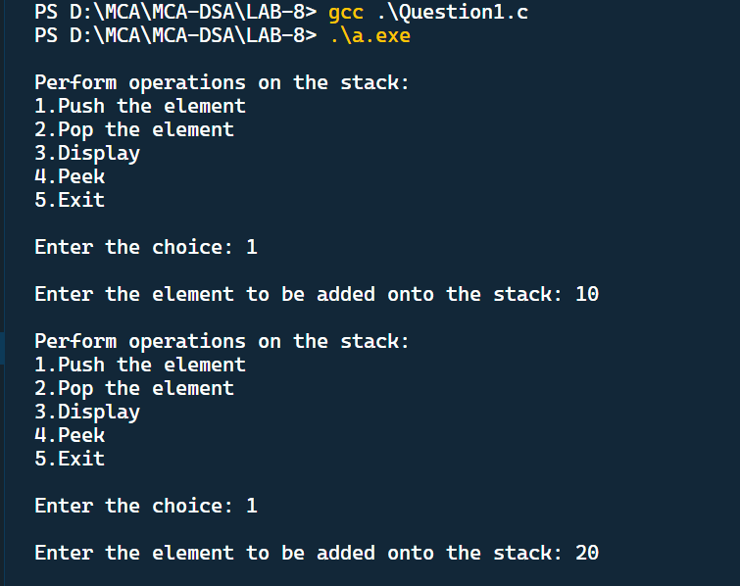

Kindly use the stack data structure to reverse a number/string and if the number is a palindrome, print that number/string.

#include <stdio.h>

#include <stdlib.h>

#include <string.h>

#define MAX_SIZE 100

*// Define the stack data structure*

struct *Stack*

{

    char items[MAX_SIZE];

    int top;

};

*// Initialize the stack*

void initialize(struct *Stack* *stack)

{

    stack->top = -1;

}

*// Check if the stack is empty*

int isEmpty(struct *Stack* *stack)

{

    return stack->top == -1;

}

*// Check if the stack is full*

int isFull(struct *Stack* *stack)

{

    return stack->top == MAX_SIZE - 1;

}

*// Push a character onto the stack*

void push(struct *Stack* *stack, char value)

{

    if (isFull(stack))

    {

        printf("Stack is full. Cannot push %c.\n", value);

        return;

    }

    stack->items[++stack->top] = value;

}

*// Pop a character from the stack*

char pop(struct *Stack* *stack)

{

    if (isEmpty(stack))

    {

        printf("Stack is empty. Cannot pop.\n");

        exit(1);

    }

    return stack->items[stack->top--];

}

int main()

{

    struct *Stack* stack;

    initialize(&stack);

    char input[MAX_SIZE];

    printf("Enter a string: ");

    scanf("%s", input);

    int length = strlen(input);

    int i;

*// Push each character onto the stack*

    for (i = 0; i < length; i++)

    {

        push(&stack, input[i]);

    }

    char reversed[MAX_SIZE];

    int j = 0;

*// Pop characters from the stack to reverse the input*

    while (!isEmpty(&stack))

    {

        reversed[j++] = pop(&stack);

    }

    reversed[j] = '\0'; *// Null-terminate the reversed string*

    printf("Reversed: %s\n", reversed);

*// Check if the input is a palindrome*

    if (strcmp(input, reversed) == 0)

    {

        printf("%s is a palindrome!\n", input);

    }

    else

    {

        printf("%s is not a palindrome.\n", input);

    }

    return 0;

}

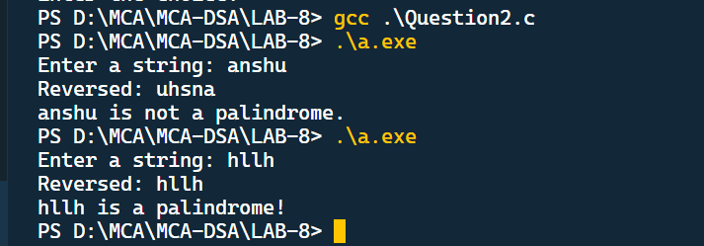

For the given string 2+3*5+8/2+6, convert this into postfix and eventually solve this using Stack.

#include <stdio.h>

#include <stdlib.h>

#include <string.h>

#include <ctype.h> *// Include ctype.h for isdigit function*

#define MAX_SIZE 100

*// Define a stack data structure for characters*

struct *Stack*

{

    char items[MAX_SIZE];

    int top;

};

*// Initialize the stack*

void initialize(struct *Stack* *stack)

{

    stack->top = -1;

}

*// Check if the stack is empty*

int isEmpty(struct *Stack* *stack)

{

    return stack->top == -1;

}

*// Check if the stack is full*

int isFull(struct *Stack* *stack)

{

    return stack->top == MAX_SIZE - 1;

}

*// Push a character onto the stack*

void push(struct *Stack* *stack, char value)

{

    if (isFull(stack))

    {

        printf("Stack is full. Cannot push %c.\n", value);

        return;

    }

    stack->items[++stack->top] = value;

}

*// Pop a character from the stack*

char pop(struct *Stack* *stack)

{

    if (isEmpty(stack))

    {

        printf("Stack is empty. Cannot pop.\n");

        exit(1);

    }

    return stack->items[stack->top--];

}

*// Get the precedence of an operator*

int getPrecedence(char operator)

{

    if (operator== '+' || operator== '-')

        return 1;

    if (operator== '*' || operator== '/')

        return 2;

    return 0; *// Lower precedence for other characters (operands, parentheses)*

}

*// Convert infix expression to postfix*

void infixToPostfix(char *infix, char *postfix)

{

    struct *Stack* operatorStack;

    initialize(&operatorStack);

    int infixLength = strlen(infix);

    int postfixIndex = 0;

    for (int i = 0; i < infixLength; i++)

    {

        char currentChar = infix[i];

        if (isdigit(currentChar))

        {

            postfix[postfixIndex++] = currentChar; *// Operand, add to postfix*

        }

        else if (currentChar == '(')

        {

            push(&operatorStack, currentChar);

        }

        else if (currentChar == ')')

        {

            while (!isEmpty(&operatorStack) && operatorStack.items[operatorStack.top] != '(')

            {

                postfix[postfixIndex++] = pop(&operatorStack);

            }

            pop(&operatorStack); *// Pop and discard '('*

        }

        else

        {

*// Operator*

            while (!isEmpty(&operatorStack) && getPrecedence(currentChar) <= getPrecedence(operatorStack.items[operatorStack.top]))

            {

                postfix[postfixIndex++] = pop(&operatorStack);

            }

            push(&operatorStack, currentChar);

        }

    }

*// Pop any remaining operators from the stack*

    while (!isEmpty(&operatorStack))

    {

        postfix[postfixIndex++] = pop(&operatorStack);

    }

    postfix[postfixIndex] = '\0'; *// Null-terminate the postfix string*

}

*// Evaluate a postfix expression*

int evaluatePostfix(char *postfix)

{

    struct *Stack* operandStack;

    initialize(&operandStack);

    int postfixLength = strlen(postfix);

    for (int i = 0; i < postfixLength; i++)

    {

        char currentChar = postfix[i];

        if (isdigit(currentChar))

        {

            push(&operandStack, currentChar - '0'); *// Convert char to int and push as operand*

        }

        else

        {

            int operand2 = pop(&operandStack);

            int operand1 = pop(&operandStack);

            switch (currentChar)

            {

            case '+':

                push(&operandStack, operand1 + operand2);

                break;

            case '-':

                push(&operandStack, operand1 - operand2);

                break;

            case '*':

                push(&operandStack, operand1 * operand2);

                break;

            case '/':

                push(&operandStack, operand1 / operand2);

                break;

            }

        }

    }

    return pop(&operandStack); *// Result is on top of the operand stack*

}

int main()

{

    char infixExpression*[]* = "2+3*5+8/2+6";

    char postfixExpression[MAX_SIZE];

    infixToPostfix(infixExpression, postfixExpression);

    printf("Infix Expression: %s\n", infixExpression);

    printf("Postfix Expression: %s\n", postfixExpression);

    int result = evaluatePostfix(postfixExpression);

    printf("Result: %d\n", result);

    return 0;

}

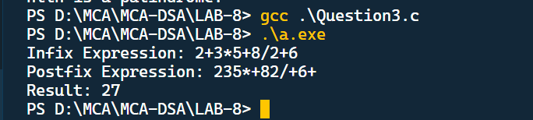

Implement a functionality where a dedicated memory which was allocated using Malloc is about to get filled, reallocate the memory if the available memory is less than 10 %.

#include <stdio.h>

#include <stdlib.h>

int main()

{

    int *ptr;

    int i, n;

    printf("Enter the number of elements\n");

    scanf("%d", &n);

    printf("Entered no is %d", n);

    ptr = (int *)malloc(n * sizeof(int));

    if (ptr == NULL)

    {

        printf("Memeory not allocated\n");

        exit(0);

    }

    else if ()

        else

        {

            printf("Memory is allocated\n");

            for (i = 0; i < n; i++)

            {

                ptr[i] = i;

            }

            printf("Elemets in the array are:\n");

            for (i = 0; i < n; i++)

            {

                printf("%d", ptr[i]);

            }

        }

    return 0;

}