**NOIDA INSTITUTE OF ENGINEERING AND TECHNOLOGY**



**MINI PROJECT (KCS - 354)**

**Department of Computer Science and Engineering**

**Submitted by: Submitted to:**

**ANSHU(1901330100052) MS. RUCHI PATIRA**

**CERTIFICATE**

This is to certify that the Mini Project report entitled **“Airlines Reservation System”** is a record of the work done by the following student:

**STUDENT NAME: ROLL NUMBER:**

**Anubhav Raghav 1901330100053**

**Anshu Jha 1901330100052**

**Amegha Singh 19013301000**

This work is done under our supervision and guidance during the academic year of 2019-20. This report is submitted to the **Noida Institute of Engineering & Technology, Greater Noida** for partial fulfillment for the degree of **B.TECH. (Computer Science and Engineering)** of **Dr. A.P.J. Abdul Kalam Technical University, Lucknow, Uttar Pradesh, India.**

We wish them all the best for all the endeavors.

***Signature of Guide:***

**ACKNOWLEDGEMENT**

I would like to place on record my deep sense of gratitude to **Mrs**. Ruchi Patira **(assistant professor), Ms. Ankita Tripathi (assistant professor) and Mr. Vivek Sharma (assistant professor) in Department of Computer Science and Engineering, Noida Institute of Engineering & Technology**, Greater Noida, Gautam Budha Nagar, Uttar Pradesh, India for his/her generous guidance, help and useful suggestions.

I express my sincere gratitude to **Prof. Chandra Shekhar Yadav, HOD(CSE)**, Noida Institute of Engineering & Technology, Greater Noida for his stimulating guidance, continuous encouragement and supervision throughout the course of present work.

**Date: Student Name:**

**INDEX**

|  |  |  |
| --- | --- | --- |
| **S.NO** | **TOPIC** | **REMARKS/SIGNATURE** |
| **1.** | Introduction |  |
| **2.** | Motivation |  |
| **3.** | Literature Review |  |
| **4.** | Methodology |  |
| **5.** | Plan of work |  |
| **6.** | Modules |  |
| **7.** | Tools and Techniques Required |  |
| **8.** | Project Design Phase |  |
| **9.** | Data Flow Diagram (level 1&0) |  |
| **10.** | Project Snapshots |  |
| **11.** | Code |  |
| **12.** | Future Scope |  |
| **13.** | References |  |

**TITLE OF THE PROJECT**

**AIRLINES RESERVATION SYSTEM**

**INTRODUCTION**

THE AIRLINE RESERVATION SYSTEM is an implementation of a general airline ticketing website like orbitz which contains the details about flight schedules and its fare tariffs, passenger reservations and ticket records. An airline’s inventory contains all flights with their available seats. The inventory of an airline service is generally divided into three category of classes (e.g. first, business or economy class) and each category is having seats up to 16 bookings, along with prices and booking conditions. This project also covers various features like online registration of the users, feedback , modification of customer details … in general this system would be designed to perform like any other airline ticketing website available online.

**MOTIVATION**

 The motivation for doing this project was primarily an interest in undertaking a challenging project in an interesting area of research. The opportunity to learn about a new area of computing not covered in lectures was appealing.

 I have had been studying C programming language since last 1 years therefore decided to learn a new programming language that is **JAVA** .So that I have quite a grasp over it.

 I think it’s a good idea to make a project based on it.

**LITERATURE REVIEW**

**The Project presented here is the airline reservation system.**

* PROJECT OVERVIEW

Airline reservation system contains the details about flight schedules and its fare , passenger reservation and ticket records.

Our system operates flights to 10 destinations in INDIA namely ALLAHABAD, BENGULURU, BHOPAL, DEHRADUN, DELHI, HYDERABAD, JAIPUR, MUMBAI, RAIPUR, PUNE.

* PROJECT DESCRIPTION

Airline Reservation System will hold flight schedules and its fare, passenger reservation and ticket records. It saves time as it allows online procedure and users no longer to wait in a queue to book the flights.

Admin is the main authority who can do addition, deletion, and modification of flight if required.

The project has been planned to be having the view of distributed architecture , with centralized storage of the database . The application for the storage of the data has been planned .Using the constructs of database MYSQL.

The database connectivity is planned using the “SQL Connection” methodology .

The application takes care of different modules and their associated reports, which are produced as per the applicable strategies and standards that are put forwarded by the administrative staff**.**

**METHODOLOGY**

**SOFTWARE DEVELOPMENT LIFE CYCLE (SDLC)**

We have used LINEAR SEQUENTIAL MODEL or WATER FALL MODEL for our system which is a software development model in which development is seen as flowing steadily downwards (like a waterfall) through the phases of requirements analysis , design, implementation testing.

We have used this process model because of the following reasons :-

* As our system proceeds from one phase to another in sequential and systematic manner .i.e. the phase are well segregated and only after the completion of one phase , the development of software moves to the next phase.
* As our system is simple to implement and represents processes which are easy to manage and measure.
* All the requirements stated by the user are known before hand and are well understood.
* As this is short duration project.

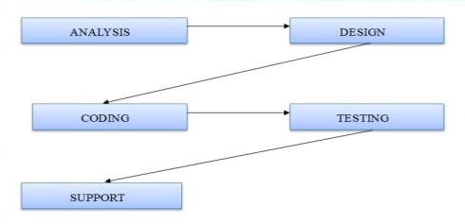

**PLAN OF WORK**

PERT CHART

PERT charts provide project managers with an estimation of the minimum amount of time needed to complete a project. Managers can also analyze the work breakdown and task connections as well as assess the risk associated with the project. The breakdown structure makes it easy to organize a complex project with a variety of moving parts by visualizing the dependencies between each step of the process.



GANTT CHART

**MODULES**

* **REGISTRATION MODULE** : In this module first we ask passenger to give his / her details . after registering with us the passenger can login to his/her own account and can view all flight details such as timings , price , availability of seats , and can book the ticket with unique ticket id. once the passenger registered with us can book any number of tickets.
* **ADMINISTRATIVE MODULE** : Administrative module is provided for the sake of administrators to manage the site and update the content at regular intervals.
* **LOGIN MODULE** : This module performs the login of the required customer. In this module customer-id and password is verified.
* **RESERVATION MODULE** : This module performs the login of the ticket to the registered module.
* **CANCELLATION MODULE** : This module performs the cancellation of the reserved ticket.
* **SCHEDULE CHECKING MODULE** : In this module user can check the available tickets timings and price.
* **PAYMENT MODULE** : In this module user will make the payment for their reserved tickets.

**PROJECT CATEGORY**

**OBJECT** **ORIENTED** **PROGRAMMING** **(OOPS)** oops is a programming paradigm that represents concepts as "objects" that have data fields (attributes that describe the object) and associated procedures known as methods. objects, which are usually instances of classes, are used to interact with one another to design applications and computer programs object-oriented programming is an approach to designing modular reusable software systems. Although discussions of object-oriented technology often get mired in the weeds of details about one language vs. the other the real key to the object-oriented approach is that it is a modelling approach first. Although often hyped as a revolutionary way to develop software by zealous proponents, the object-oriented approach is in reality a logical extension of good design practices that go back to the very beginning of computer programming. Object-orientation is simply the logical extension of older techniques such as structured programming and abstract data types. An object is an abstract data type with the addition of polymorphism and inheritance. Java has been tested, refined, extended, and proven by a dedicated community. And numbering more than 6.5 million developers, it's the largest and most active on the planet. With its versatility, efficiency, and portability, java has become invaluable to developers by enabling them to:

* Write software on one platform and run it on virtually any other platform.
* create programs to run within a web browser and web services
* develop server-side applications for online forums, stores, polls, html forms processing and more
* combine applications or services using the java language to create highly customized applications or services
* Write powerful and efficient applications for mobile phones, remote processors, low-cost consumer products and practically any other device with a digital heartbeat.

**SOFTWARE** **USE**:

* FRONT END : NETBEANS JAVA

• **Java** is a [computer programming language](http://en.wikipedia.org/wiki/Computer_programming_language) that is [concurrent](http://en.wikipedia.org/wiki/Concurrent_computing), based, object, and specifically designed to have as few implementation dependencies as possible. it is intended to let application developers "[write once, run anywhere"](http://en.wikipedia.org/wiki/Write_once,_run_anywhere) (WORA) , meaning that code that runs on one platform does not need to be recompiled to run on another. Java applications are

Typically [compiled](http://en.wikipedia.org/wiki/Compiler) to [byte code](http://en.wikipedia.org/wiki/Java_bytecode) ([class file](http://en.wikipedia.org/wiki/Class_(file_format))) that can run on any [java virtual machine](http://en.wikipedia.org/wiki/Java_virtual_machine) (JVM) regardless of [computer architecture](http://en.wikipedia.org/wiki/Computer_architecture). Java is, as of 2014, one of the most popular programming languages in use, particularly for client-server web applications, with a reported 9 million developers. There were five primary goals in the creation of the java language:

• It is "simple, object-oriented and familiar"

• It is "simple, "robust and secure"

• It is "simple, "architecture -neutral and portable"

• It is "simple execute with "high performance"

• It is "simple, "interpreted, threaded, and dynamic

BACK END: MYSQL

MySQL development project has made its source code available under the terms of the gnu general public license, as well as under a variety of proprietary agreements. MySQL was owned and sponsored by a single for-profit firm, the Swedish company MySQL now owned by Oracle Corporation. For proprietary use, several paid editions are available, and offer additional functionality.

**TOOLS AND TECHNIQUES REQUIREMENTS**

**HARDWARE**

Processor :i3 7TH Generation

RAM **:** 4 GB

Hard disk **:** 500 GB

Keyboard **:** Any PC/AT compatible

Monitor **:** Any SVGA Color Monitor

**SOFTWARE**

Operating System **:** Windows 10

Data Base **:** MYSQL

User Interface Unit: Keyboard

Front End **:** NetBeans Java

**PROJECT**

**DESIGN**

**PHASE**

**Data Flow Diagram (DFD)**

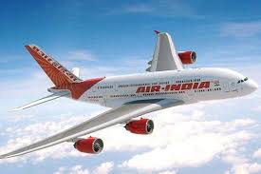

**Data Flow Diagram (DFD)**

A data flow diagram shows the way information flows through a process or system. It includes data inputs and outputs, data stores, and the various sub processes the data moves through. DFDs are built using standardized symbols and notation to describe various entities and their relationships.

Data flow diagrams visually represent systems and processes that would be hard to describe in a chunk of text. Visualizing each element makes it easy to identify inefficiencies and produce the best possible system.

**Data flow diagram levels**

 Level 0 DFDs, also known as context diagrams, are the most basic data flow diagrams. They provide a broad view that is easily digestible but offers little detail. Level 0 data flow diagrams show a single process node and its connections to external entities.

 Level 1 DFDs are still a general overview, but they go into more detail than a context diagram. In a level 1 data flow diagram, the single process node from the context diagram is broken down into sub processes.

 Level 2+ DFDs simply break processes down into more detailed sub processes.

**Process**

**Data flow**

**Entity**

**Database**

C**ONTEXT LEVEL**

BOOKING /CANCELLATION

ENQUIRY

SOFTWARE SETTINGS

REGISTRATION

LOGIN

LOGIN

**ADMIN**

**USER**

USER DETAILS

AUTHENTICATION

ACKNOWLEDGEMENT

AUTHENTICATION

1 LEVEL DFD:

VALID (NO))

**CUSTOMER**

**CUSTOMER**

VALID (YES)

D2

**ADMIN**

D1

D1

D1

**PROJECT SNAPSHOTS**

**HOME PAGE:**

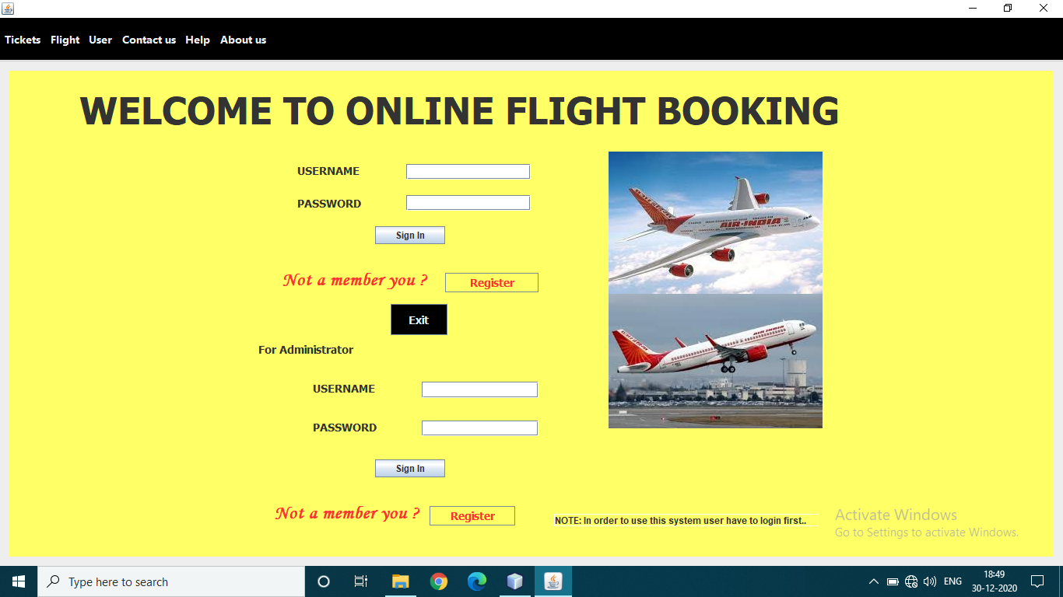

**REGISTRATION PAGE:**

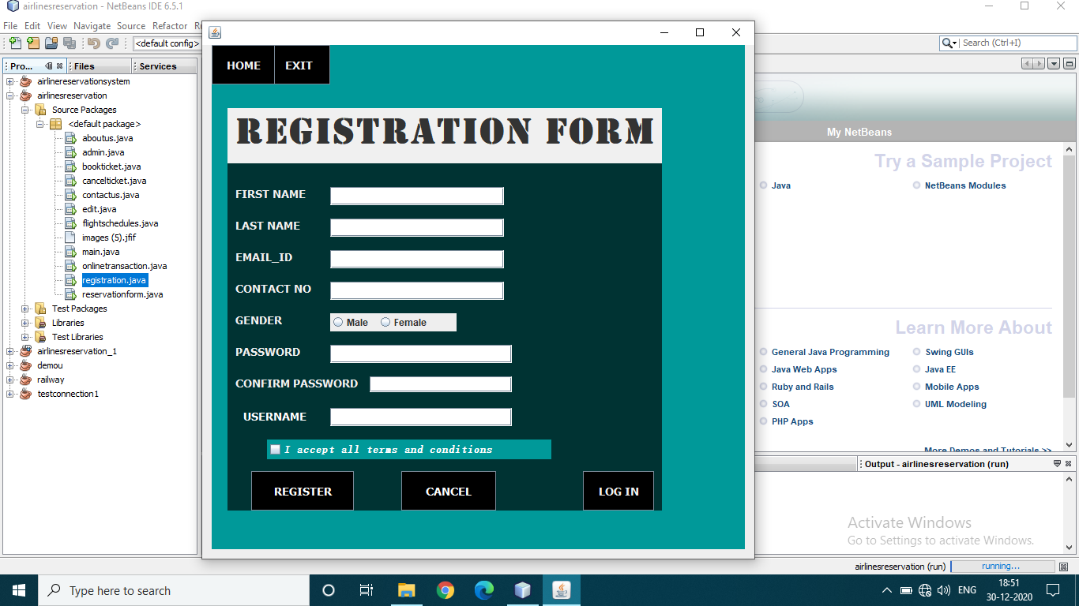

**ONLINE TRANSACTION:**

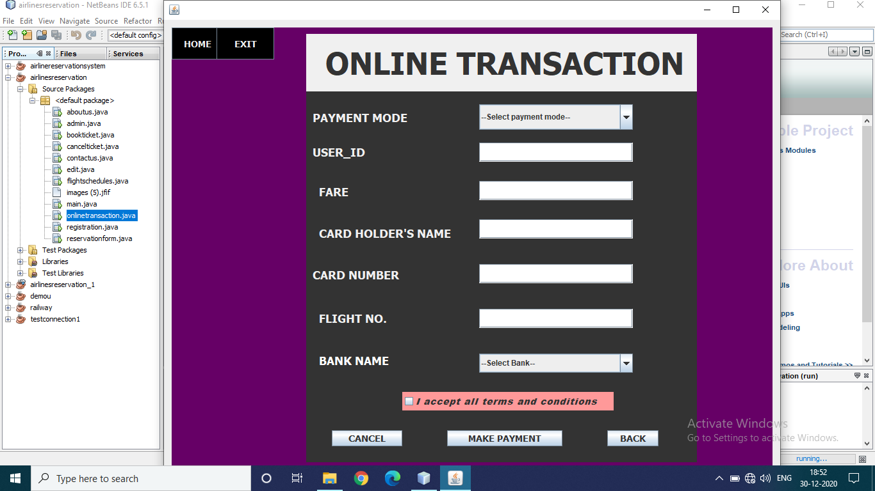

**FLIGHT SCHEDULE PAGE:**

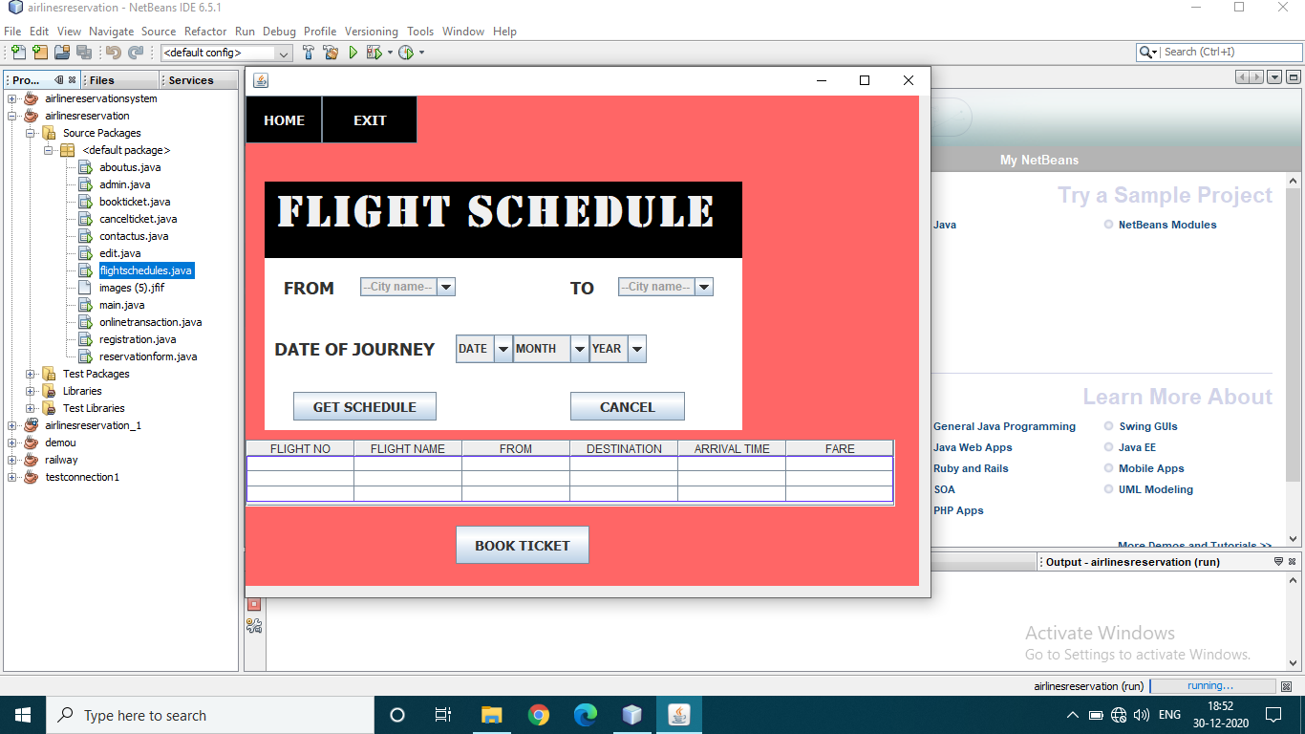

**ONLINE RESERVATION FORM PAGE:**

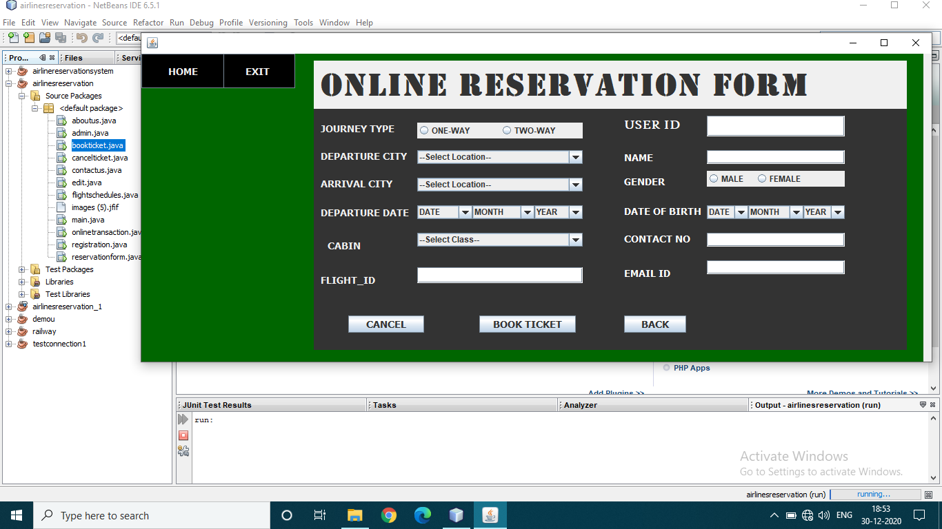

**CANCEL RESERVATION PAGE :**

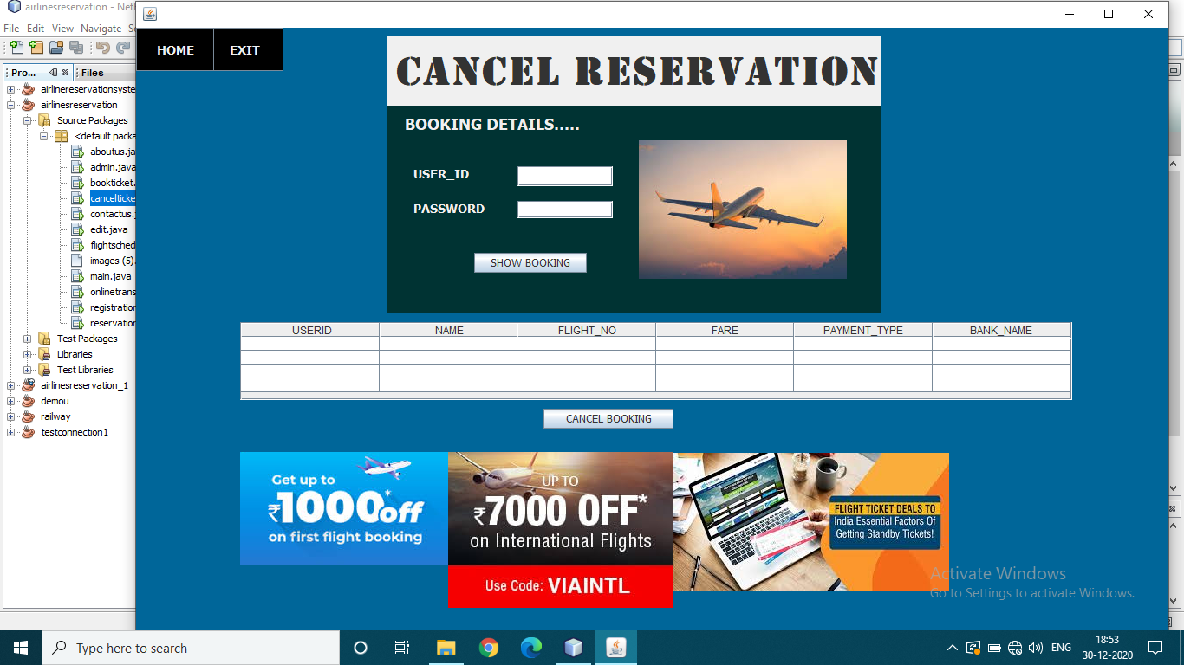

**CONTACT US PAGE:**

**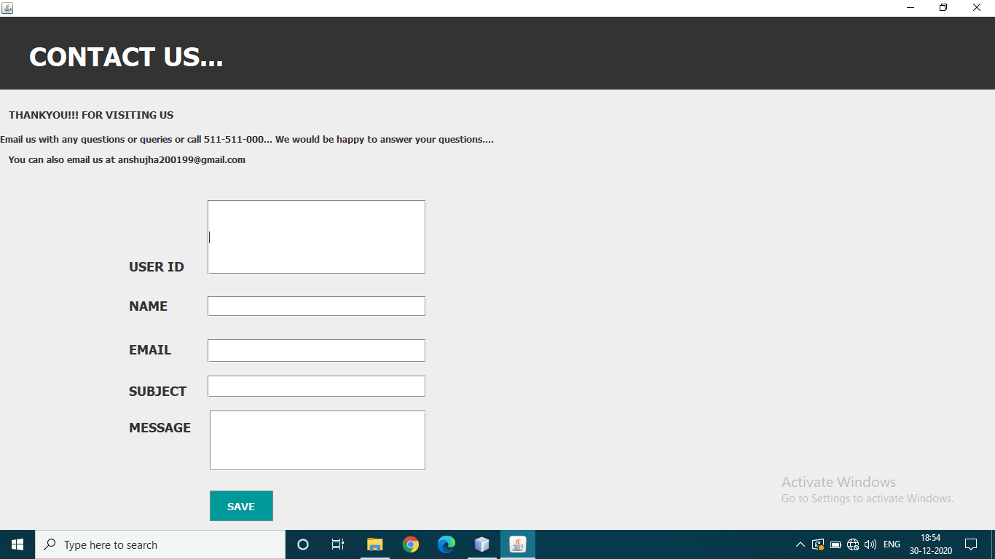**

**ABOUT US PAGE:**

**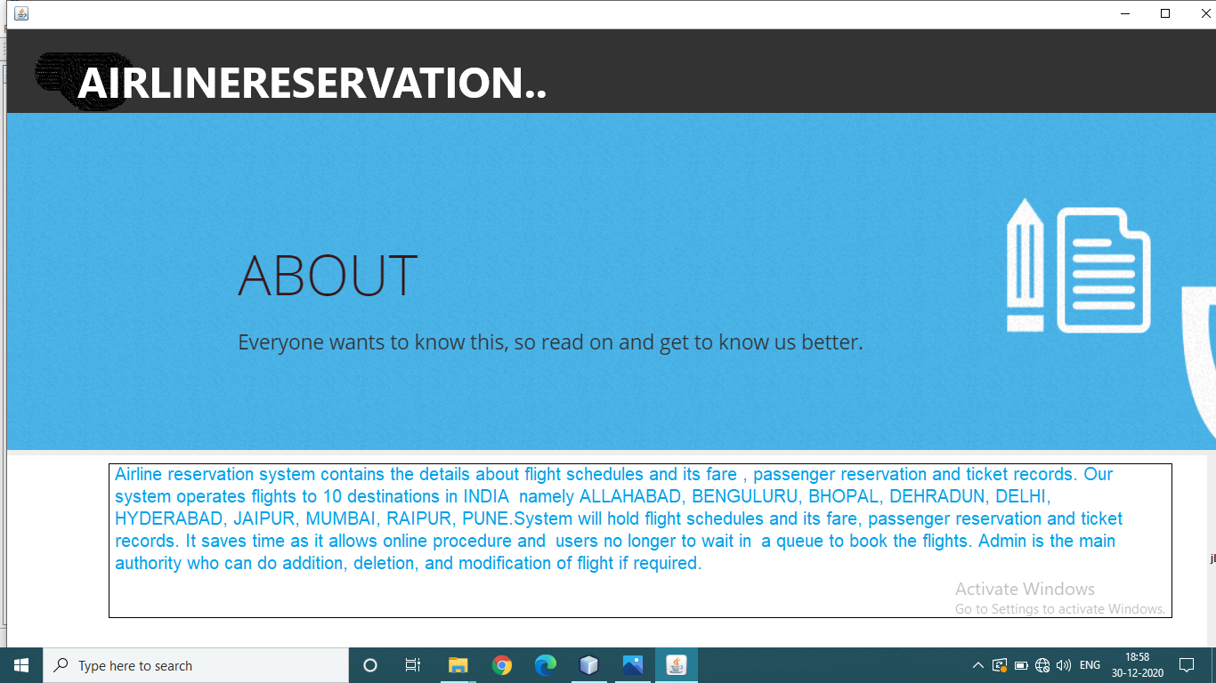**

**EDIT DETAILS PAGE :**

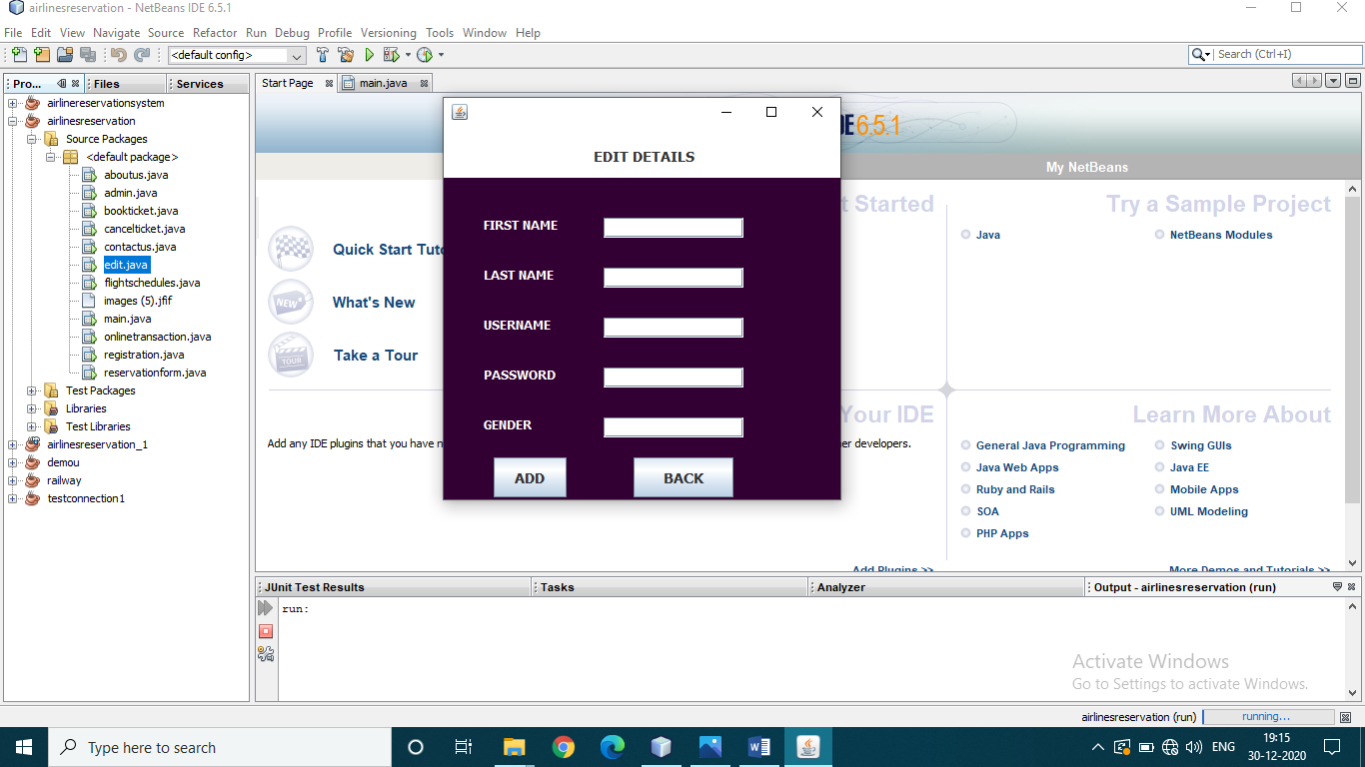

**ADMIN MODULE:** 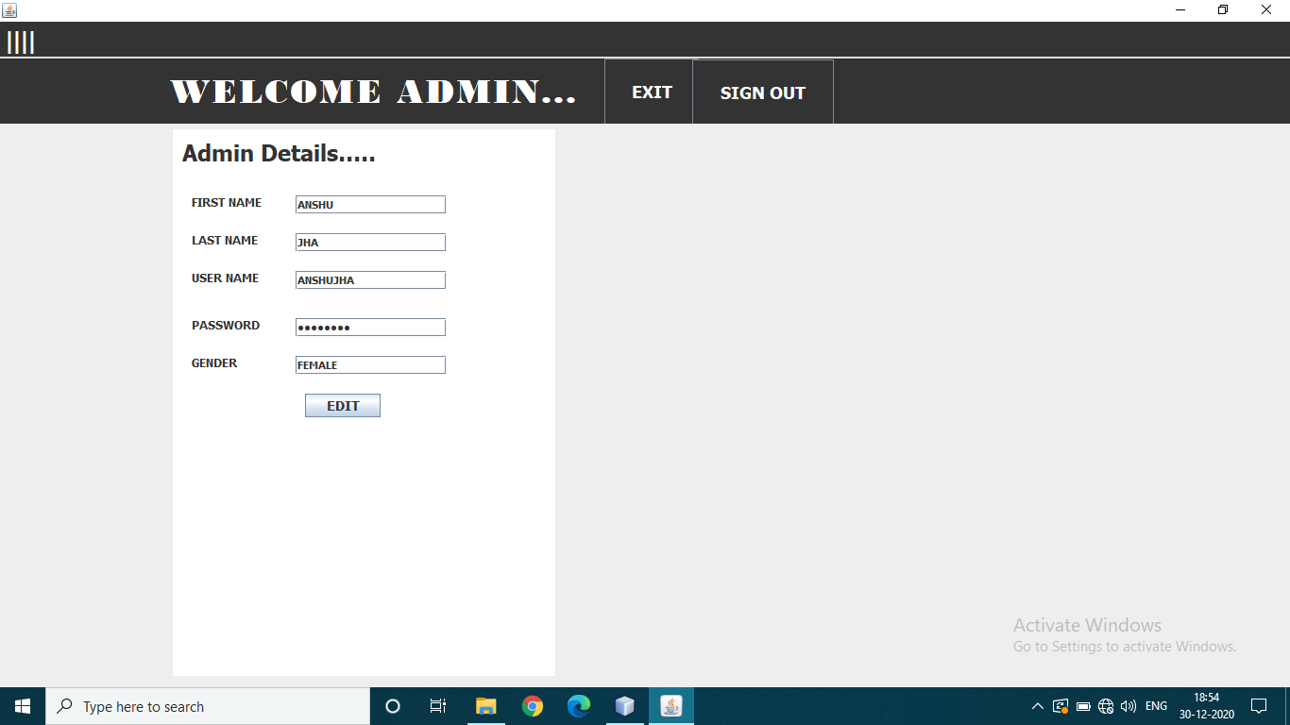

**BACK END CODING:**

**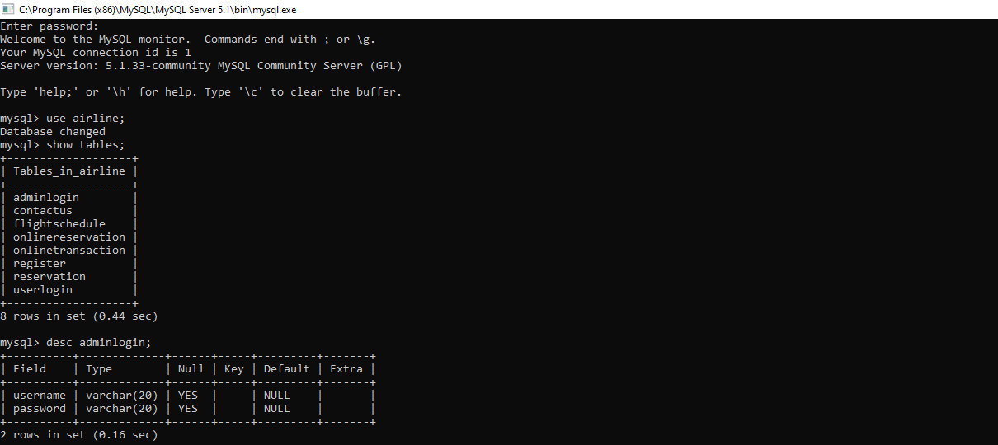**

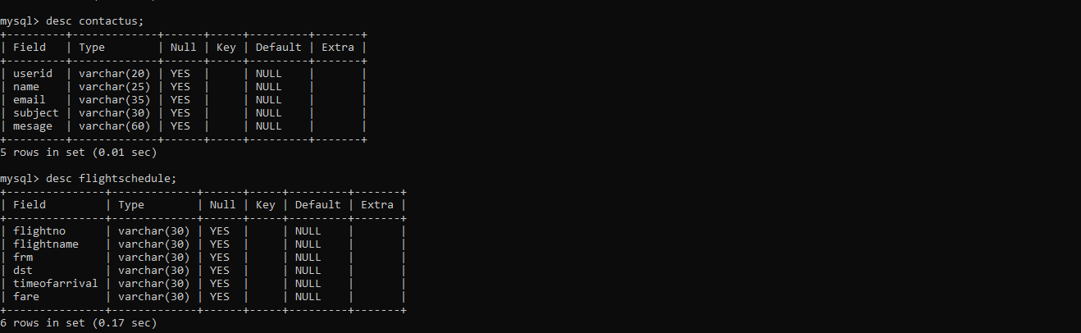

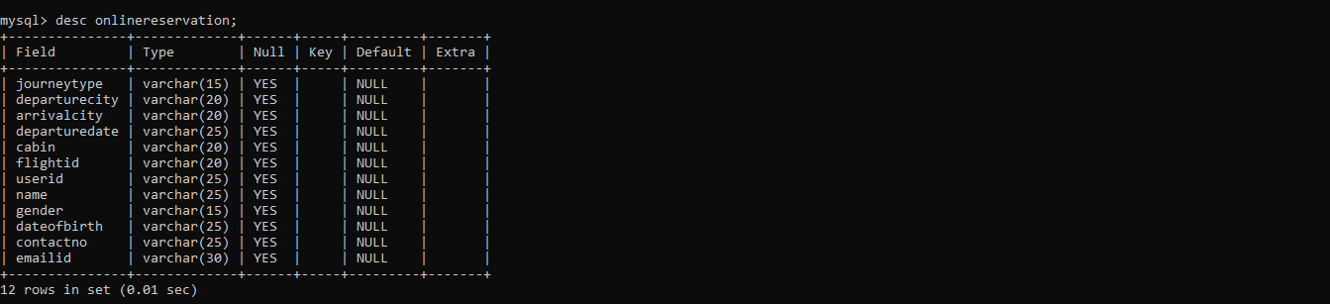

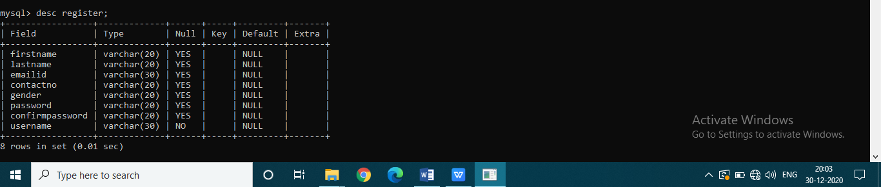

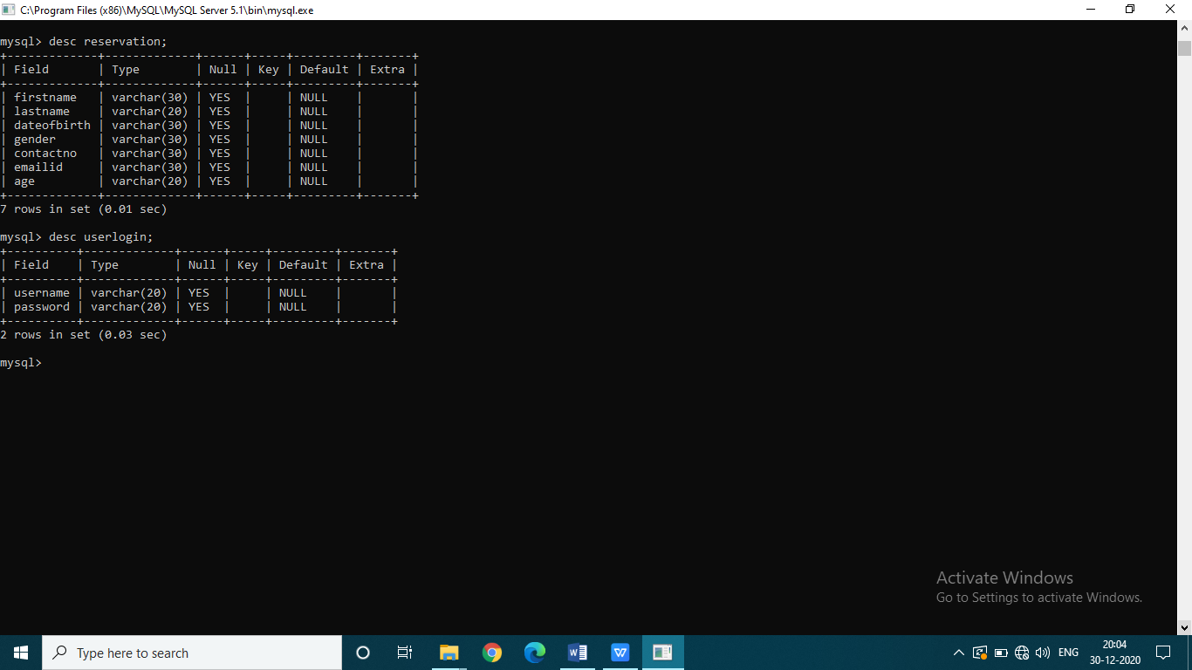

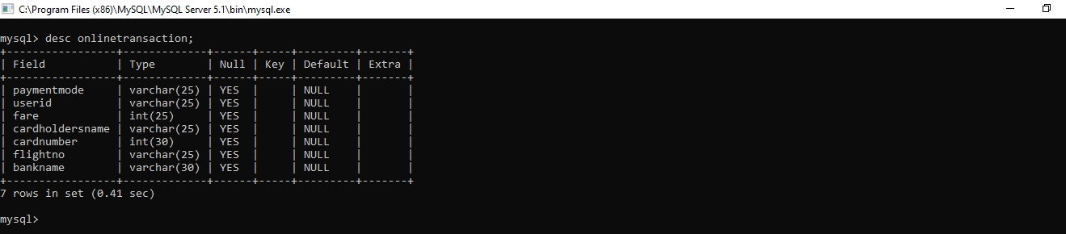

FRONT END CODING:-

**Home page –**

import javax.swing.JOptionPane;

import java.sql.DriverManager;

import com.mysql.jdbc.Connection;

import com.mysql.jdbc.Statement;

import java.sql.ResultSet;

private void jButton1ActionPerformed(java.awt.event.ActionEvent evt) {

// TODO add your handling code here:

String p1="",username=jTextField1.getText(),password=new String(jPasswordField1.getPassword());

try{

Class.forName("java.sql.DriverManager");

Connection con = (Connection)

DriverManager.getConnection

("jdbc:mysql://localhost:3306/airline",

"root", "");

Statement stmt = (Statement) con.createStatement();

String query="select \* from register where username='"+username+"';";

ResultSet rs=stmt.executeQuery(query);

if(rs.next()){

p1=rs.getString("password");

if(p1.equals(password)){JOptionPane.showMessageDialog(null,"login successful");

flightschedules a=new flightschedules();

a.setVisible(true);

this.setVisible(false);

JOptionPane.showMessageDialog(null,"WELCOME\n"+username);

}

else JOptionPane.showMessageDialog(null,"please check the password");

}else {JOptionPane.showMessageDialog(null,"sorry wrong username");

jTextField1.setText("");

jPasswordField1.setText("");}

}catch(Exception e){JOptionPane.showMessageDialog(this,e.getMessage());}

}

private void jButton2ActionPerformed(java.awt.event.ActionEvent evt) {

// TODO add your handling code here:

registration a= new registration ();

a.setVisible(true);

this.setVisible(false); }

private void jMenuItem3ActionPerformed(java.awt.event.ActionEvent evt) {

// TODO add your handling code here:

bookticket a= new bookticket ();

a.setVisible(true);

this.setVisible(false);

}

private void jMenuItem4ActionPerformed(java.awt.event.ActionEvent evt) {

// TODO add your handling code here:

cancelticket a= new cancelticket ();

a.setVisible(true);

this.setVisible(false);

}

private void jMenuItem5ActionPerformed(java.awt.event.ActionEvent evt) {

// TODO add your handling code here:

flightschedules a= new flightschedules ();

a.setVisible(true);

this.setVisible(false);

}

private void jButton4ActionPerformed(java.awt.event.ActionEvent evt) {

// TODO add your handling code here:

int Airway = JOptionPane.showConfirmDialog(this,"Do you really want to EXIT ??");

if (Airway == 0)

{ JOptionPane.showMessageDialog(this,"Have a nice day!!");

System.exit(0);

}

}

private void jButton5ActionPerformed(java.awt.event.ActionEvent evt) {

// TODO add your handling code here:

registration a= new registration ();

a.setVisible(true);

this.setVisible(false); }

private void jButton3ActionPerformed(java.awt.event.ActionEvent evt) {

// TODO add your handling code here:

String p1="",username=jTextField2.getText(),password=new String(jPasswordField2.getPassword());

try{

Class.forName("java.sql.DriverManager");

Connection con = (Connection)

DriverManager.getConnection

("jdbc:mysql://localhost:3306/airline",

"root", "");

Statement stmt = (Statement) con.createStatement();

String query="select \* from adminlogin where username='"+username+"';";

ResultSet rs=stmt.executeQuery(query);

if(rs.next()){

p1=rs.getString("password");

if(p1.equals(password)){JOptionPane.showMessageDialog(null,"login successful");

admin a=new admin();

a.setVisible(true);

this.setVisible(false);

JOptionPane.showMessageDialog(null,"WELCOME\n"+username);

}

else JOptionPane.showMessageDialog(null,"please check the password");

}else {JOptionPane.showMessageDialog(null,"sorry wrong username");

jTextField1.setText("");

jPasswordField1.setText("");}

}catch(Exception e){JOptionPane.showMessageDialog(this,e.getMessage());}

}

private void jMenuItem1ActionPerformed(java.awt.event.ActionEvent evt) {

// TODO add your handling code here:

aboutus a= new aboutus ();

a.setVisible(true);

this.setVisible(false);

} private void jMenuItem2ActionPerformed(java.awt.event.ActionEvent evt) {

// TODO add your handling code here:

contactus a= new contactus ();

a.setVisible(true);

this.setVisible(false);

}

/\*\*

\* @param args the command line arguments

\*/

public static void main(String args[]) {

java.awt.EventQueue.invokeLater(new Runnable() {

public void run() {

new main().setVisible(true);

}

});

}

**REGISTRATION PAGE :**

import com.mysql.jdbc.Connection;

import com.mysql.jdbc.Statement;

import java.sql.DriverManager;

import javax.swing.JOptionPane;

private void jButton3ActionPerformed(java.awt.event.ActionEvent evt) {

// TODO add your handling code here:

main a= new main ();

a.setVisible(true);

this.setVisible(false);

}

private void jButton4ActionPerformed(java.awt.event.ActionEvent evt) {

// TODO add your handling code here:

int Airway = JOptionPane.showConfirmDialog(this,"Do you really want to EXIT ??");

if (Airway == 0)

{

JOptionPane.showMessageDialog(this,"Have a nice day!!");

System.exit(0);

}

}

private void jButton2ActionPerformed(java.awt.event.ActionEvent evt) {

// TODO add your handling code here:

int Airway = JOptionPane.showConfirmDialog(this,"Do you really want to EXIT ??");

if (Airway == 0)

{

main a= new main ();

a.setVisible(true);

this.setVisible(false); } }

private void jButton1ActionPerformed(java.awt.event.ActionEvent evt) {

// TODO add your handling code here:

// jCheckBox1.setSelected(true); if (jCheckBox1.isSelected()==true)

String firstname ,lastname ,emailid,gender=null,password,confirmpassword,username;

int contactno;

firstname = jTextField1.getText();

lastname = jTextField2.getText();

emailid = jTextField3.getText();

contactno = Integer.parseInt(jTextField4.getText());

username = jTextField6.getText();

if(jRadioButton1.isSelected()==true){gender="male";}

else if(jRadioButton2.isSelected()==true){gender="female";}

password=new String(jPasswordField1.getPassword());

confirmpassword =new String(jPasswordField2.getPassword());

try

{

Class.forName("java.sql.DriverManager");

Connection con = (Connection)

DriverManager.getConnection

("jdbc:mysql://localhost:3306/airline",

"root", "");

Statement stmt = (Statement) con.createStatement();

String query="insert into register values('"+firstname+"','"+lastname+"','"+emailid+"','"+contactno+"','"+gender+"','"+password+"','"+confirmpassword+"','" +username+ "');";

JOptionPane.showMessageDialog(null,""+query);

JOptionPane.showMessageDialog(null,"record entered successfully\n ||REGISTRATION SUCCESSFUL||");

stmt.executeUpdate(query);

/\*home t=new home();

t.setVisible(true);

this.setVisible(false);\*/

}

catch(Exception z){JOptionPane.showMessageDialog(null, z.getMessage());}

}

private void jButton5ActionPerformed(java.awt.event.ActionEvent evt) {

// TODO add your handling code here:

main a= new main ();

a.setVisible(true);

this.setVisible(false);

}

private void jCheckBox1ActionPerformed(java.awt.event.ActionEvent evt) {

// TODO add your handling code here:

jCheckBox1.setSelected(true);

if(jCheckBox1.isSelected()){

}else{

JOptionPane.showMessageDialog(this,"Please select the check box");

}

}

/\*\*

\* @param args the command line arguments

\*/

public static void main(String args[]) {

java.awt.EventQueue.invokeLater(new Runnable() {

public void run() {

new registration().setVisible(true);

}

});

}

**ONLINE TRANSACTION:**

import com.mysql.jdbc.Connection;

import com.mysql.jdbc.Statement;

import java.sql.DriverManager;

import javax.swing.JOptionPane;

private void jButton3ActionPerformed(java.awt.event.ActionEvent evt) {

// TODO add your handling code here:

main a= new main ();

a.setVisible(true);

this.setVisible(false);

}

private void jButton1ActionPerformed(java.awt.event.ActionEvent evt) {

// TODO add your handling code here:

int cardnumber,fare;

String cardholdersname,userid,flightno;

Object bankname,paymentmode;

bankname=jComboBox2.getSelectedItem().toString();

paymentmode=jComboBox1.getSelectedItem();

cardholdersname= jTextField3.getText();

flightno = jTextField5.getText();

cardnumber = Integer.parseInt(jTextField4.getText());

fare=Integer.parseInt(jTextField2.getText());

userid=jTextField1.getText();

try

{

Class.forName("java.sql.DriverManager");

Connection con = (Connection)

DriverManager.getConnection

("jdbc:mysql://localhost:3306/airline",

"root", "");

Statement stmt = (Statement) con.createStatement();

String query="insert into onlinetransaction values('"+paymentmode+"','"+userid+"','"+fare+"','"+cardholdersname+"','"+cardnumber+"','" +flightno+"','"+bankname+ "');";

JOptionPane.showMessageDialog(null,""+query);

JOptionPane.showMessageDialog(null,"!!PAYMENT SUCCESSFULL!!\n --THANKYOU--");

stmt.executeUpdate(query);

}

catch(Exception z){JOptionPane.showMessageDialog(null, z.getMessage());}

}

private void jButton2ActionPerformed(java.awt.event.ActionEvent evt) {

// TODO add your handling code here:

int Airway = JOptionPane.showConfirmDialog(this,"Do you really want to EXIT ??");

if (Airway == 0)

{

main a= new main ();

a.setVisible(true);

this.setVisible(false);

}

}

private void jButton5ActionPerformed(java.awt.event.ActionEvent evt) {

// TODO add your handling code here:

reservationform a= new reservationform ();

a.setVisible(true);

this.setVisible(false);

}

/\*\*

\* @param args the command line arguments

\*/

public static void main(String args[]) {

java.awt.EventQueue.invokeLater(new Runnable() {

public void run() {

new onlinetransaction().setVisible(true);

}

});

}

**BOOK TICKET :**

import com.mysql.jdbc.Connection;

import com.mysql.jdbc.Statement;

import java.sql.DriverManager;

import java.sql.ResultSet;

import javax.swing.JOptionPane;

private void jButton3ActionPerformed(java.awt.event.ActionEvent evt) {

// TODO add your handling code here:

main a= new main ();

a.setVisible(true);

this.setVisible(false);

}

private void jButton2ActionPerformed(java.awt.event.ActionEvent evt) {

// TODO add your handling code here:

int Airway = JOptionPane.showConfirmDialog(this,"Do you really want to EXIT ??");

if (Airway == 0)

{

main a= new main ();

a.setVisible(true);

this.setVisible(false);

}

}

private void jButton4ActionPerformed(java.awt.event.ActionEvent evt) {

// TODO add your handling code here:

int Airway = JOptionPane.showConfirmDialog(this,"Do you really want to EXIT ??");

if (Airway == 0)

{

JOptionPane.showMessageDialog(this,"Have a nice day!!");

System.exit(0);

}

}

private void jButton5ActionPerformed(java.awt.event.ActionEvent evt) {

// TODO add your handling code here:

int contactno;

String journeytype=null,flightid,userid,name,emailid,gender=null;

Object dt,mn,yr,departuredate,dateofbirth,dat,mnt,yer,departurecity,arrivalcity,cabin;

name=jTextField7.getText();

userid=jTextField6.getText();

emailid=jTextField12.getText();

flightid=jTextField4.getText();

if(jRadioButton3.isSelected()==true){gender="male";}

else if(jRadioButton4.isSelected()==true){gender="female";}

if(jRadioButton1.isSelected()==true){journeytype="ONE-WAY";}

else if(jRadioButton2.isSelected()==true){journeytype="TWO-WAY";}

contactno = Integer.parseInt(jTextField11.getText());

dt =jComboBox3.getSelectedItem();

mn=jComboBox4.getSelectedItem();

yr=jComboBox5.getSelectedItem();

departuredate=dt+"/"+mn+"/"+yr;

departuredate=departuredate.toString();

dat =jComboBox7.getSelectedItem();

mnt=jComboBox8.getSelectedItem();

yer=jComboBox9.getSelectedItem();

dateofbirth=dat+"/"+mnt+"/"+yer;

dateofbirth=dateofbirth.toString();

departurecity =jComboBox1.getSelectedItem();

//departurecity=departurecity.toString();

arrivalcity =jComboBox2.getSelectedItem();

// arrivalcity=arrivalcity.toString();

cabin =jComboBox6.getSelectedItem();

//cabin=cabin.toString();

try{

Class.forName("java.sql.DriverManager");

Connection con = (Connection)

DriverManager.getConnection

("jdbc:mysql://localhost:3306/airline",

"root", "");

Statement stmt = (Statement) con.createStatement();

String qy="select \* from flightschedule where flightno='"+flightid+"';";

// String qry="select \* from register where username='"+userid+"';";

ResultSet rs=stmt.executeQuery(qy);

// ResultSet rj =stmt.executeQuery(qry);

if(rs.next()){

String query="insert into onlinereservation values('"+journeytype+"','"+departurecity+"','"+arrivalcity+"','"+departuredate+"','"+cabin+"','"+flightid+"','"+userid+"','"+name+"','"+gender+"','"+dateofbirth+"','"+contactno+"','"+emailid+ "');";

stmt.executeUpdate(query);

JOptionPane.showMessageDialog(this,"Your Ticket Has Been Booked.Please make the payment details to confirm booking");

onlinetransaction a=new onlinetransaction();

a.setVisible(true);

this.setVisible(false);

}else {JOptionPane.showMessageDialog(this,"\*\*WRONG FLIGHTID\*\*");}

}catch(Exception z){JOptionPane.showMessageDialog(this,z.getMessage());}

}

private void jButton6ActionPerformed(java.awt.event.ActionEvent evt) {

// TODO add your handling code here:

flightschedules a= new flightschedules ();

a.setVisible(true);

this.setVisible(false);

}

**CANCEL TICKET :**

import com.mysql.jdbc.Connection;

import com.mysql.jdbc.Statement;

import java.sql.DriverManager;

import java.sql.ResultSet;

import javax.swing.JOptionPane;

import javax.swing.table.DefaultTableModel;

private void jButton1ActionPerformed(java.awt.event.ActionEvent evt) {

// TODO add your handling code here:

DefaultTableModel ticket=(DefaultTableModel)jTable1.getModel();

String pass=null,userid;

userid = jTextField1.getText();

try{

Class.forName("java.sql.DriverManager");

Connection con = (Connection)

DriverManager.getConnection

("jdbc:mysql://localhost:3306/airline",

"root", "");

Statement stmt = (Statement) con.createStatement();

String qy="select \* from onlinetransaction where userid='"+userid+"';";

ResultSet rs=stmt.executeQuery(qy);

if(rs.next()){

String USER\_ID = rs.getString("userid");

String NAME=rs.getString("cardholdersname");

String FLIGHT\_NO=rs.getString("flightno");

String FARE=rs.getString("fare");

String PAYMENT\_TYPE=rs.getString("paymentmode");

String BANK\_NAME =rs.getString("bankname");

ticket.addRow(new Object[]{USER\_ID,NAME,FLIGHT\_NO,FARE,PAYMENT\_TYPE,BANK\_NAME})

}

else {JOptionPane.showMessageDialog(this,"!!USER\_ID NOT EXIST!!");}

}catch(Exception z){JOptionPane.showMessageDialog(this,z.getMessage());}

}

private void jButton3ActionPerformed(java.awt.event.ActionEvent evt) {

// TODO add your handling code here:

String uid =jTextField1.getText();

int a=JOptionPane.showConfirmDialog(this,"Do you really want to cancel your ticket");

if(a==0){

try{

Class.forName("java.sql.DriverManager");

Connection con = (Connection)

DriverManager.getConnection

("jdbc:mysql://localhost:3306/airline",

"root", "");

Statement stmt = (Statement) con.createStatement();

String qy="delete from onlinetransaction where userid='"+uid+"';";

stmt.executeUpdate(qy);

stmt.close();

Statement st = (Statement) con.createStatement();

String query="delete from onlinetransaction where userid='"+uid+"';";

st.executeUpdate(query);

JOptionPane.showMessageDialog(this,"Your Booking has been cancelled!!!");

main e= new main();

e.setVisible(true);

this.setVisible(false);

}catch(Exception z){JOptionPane.showMessageDialog(this,z.getMessage());}

}

/\* int Airway = JOptionPane.showConfirmDialog(this,"ARE YOU SURE ??");

if (Airway == 0)

{

JOptionPane.showMessageDialog(this,"Booking cancelled\n THANK YOU!!");

}\*/

}

private void jButton2ActionPerformed(java.awt.event.ActionEvent evt) {

// TODO add your handling code here:

main a= new main ();

a.setVisible(true);

this.setVisible(false);

}

private void jButton4ActionPerformed(java.awt.event.ActionEvent evt) {

// TODO add your handling code here:

int Airway = JOptionPane.showConfirmDialog(this,"Do you really want to EXIT ??");

if (Airway == 0)

{

JOptionPane.showMessageDialog(this,"Have a nice day!!");

System.exit(0);

}

}

public static void main(String args[]) {

java.awt.EventQueue.invokeLater(new Runnable() {

public void run() {

new cancelticket().setVisible(true);

}

});

}

**FLIGHT SCHEDULE :**

import com.mysql.jdbc.Connection;

import com.mysql.jdbc.Statement;

import java.sql.DriverManager;

import java.sql.ResultSet;

import javax.swing.JOptionPane;

import javax.swing.table.DefaultTableModel;

private void jButton1ActionPerformed(java.awt.event.ActionEvent evt) {

// TODO add your handling code here:

DefaultTableModel td=(DefaultTableModel)jTable1.getModel();

String frm,dst;

frm=jComboBox1.getSelectedItem().toString();

dst=jComboBox2.getSelectedItem().toString();

try{

Class.forName("java.sql.DriverManager");

Connection con = (Connection)

DriverManager.getConnection

("jdbc:mysql://localhost:3306/airline",

"root", "");

Statement stmt = (Statement) con.createStatement();

String qy="select \* from flightschedule where frm='"+frm+"'and dst='"+dst+"';";

ResultSet rs=stmt.executeQuery(qy);

if(rs.next()){

String flightno=rs.getString("flightno");

String flightname=rs.getString("flightname");

String arrivaltime=rs.getString("timeofarrival");

String fare=rs.getString("fare");

td.addRow(new Object[]{flightno,flightname,frm,dst,arrivaltime,fare});

}

}catch(Exception z){JOptionPane.showMessageDialog(this,z.getMessage());}

}

private void jButton4ActionPerformed(java.awt.event.ActionEvent evt) {

// TODO add your handling code here:

main a= new main ();

a.setVisible(true);

this.setVisible(false);

}

private void jButton3ActionPerformed(java.awt.event.ActionEvent evt) {

// TODO add your handling code here:

bookticket a= new bookticket ();

a.setVisible(true);

this.setVisible(false);

}

private void jButton5ActionPerformed(java.awt.event.ActionEvent evt) {

// TODO add your handling code here:

int Airway = JOptionPane.showConfirmDialog(this,"Do you really want to EXIT ??");

if (Airway == 0)

{

JOptionPane.showMessageDialog(this,"Have a nice day!!");

System.exit(0);

}

}

private void jComboBox2ActionPerformed(java.awt.event.ActionEvent evt) {

// TODO add your handling code here:

}

private void jButton2ActionPerformed(java.awt.event.ActionEvent evt) {

// TODO add your handling code here:

int Airway = JOptionPane.showConfirmDialog(this,"Do you really want to EXIT ??");

if (Airway == 0)

{

main a= new main ();

a.setVisible(true);

this.setVisible(false); }

}

public static void main(String args[]) {

java.awt.EventQueue.invokeLater(new Runnable() {

public void run() {

new flightschedules().setVisible(true);

}

});

}

**ADMIN :**

import javax.swing.JOptionPane;

private void jButton1ActionPerformed(java.awt.event.ActionEvent evt) {

// TODO add your handling code here:

main a= new main ();

a.setVisible(true);

this.setVisible(false);

}

private void jButton2ActionPerformed(java.awt.event.ActionEvent evt) {

// TODO add your handling code here:

int Airway = JOptionPane.showConfirmDialog(this,"Do you really want to EXIT ??");

if (Airway == 0)

{

JOptionPane.showMessageDialog(this,"Have a nice day!!");

System.exit(0);

}

}

private void jButton3ActionPerformed(java.awt.event.ActionEvent evt) {

// TODO add your handling code here:

edit a =new edit();

a.setVisible(true);

this.setVisible(false);

}

public static void main(String args[]) {

java.awt.EventQueue.invokeLater(new Runnable() {

public void run() {

new admin().setVisible(true);

}

});

}

**EDIT :**

import javax.swing.JOptionPane;

private void jButton1ActionPerformed(java.awt.event.ActionEvent evt) {

// TODO add your handling code here:

int Airway = JOptionPane.showConfirmDialog(this,"DO YOU REALLY WANT TO UPDATE ??");

if (Airway == 0)

{

JOptionPane.showMessageDialog(this,"-RECORD UPDATED-");

}

}

private void jButton2ActionPerformed(java.awt.event.ActionEvent evt) {

// TODO add your handling code here:

admin a= new admin ();

a.setVisible(true);

this.setVisible(false);

}

/\*\*

\* @param args the command line arguments

\*/

public static void main(String args[]) {

java.awt.EventQueue.invokeLater(new Runnable() {

public void run() {

new edit().setVisible(true);

}

});

}

REFERENCES

1.[www.mysqltutorial.org](http://www.mysqltutorial.org)

2.[www.javatpoint.com](http://www.javatpoint.com)

3.[www.mainjava.com](http://www.mainjava.com)

4.[www.wikipedia.org](http://www.wikipedia.org" \l "inbox/_blank" \t "https://mail.google.com/mail/u/0/)

5.[www.netbeans.org](http://www.netbeans.org)

**FUTURE SCOPE**

* We will create web based application for Airlines Reservation System.
* We will add new features like voice mailing in case of forget passwords.