**Method Name**

Chinese NER Using Lattice LSTM

Yue Zhang, Jie Yang: Chinese NER Using Lattice LSTM, Proceedings of the 56th Annual Meeting of the Association for Computational Linguistics (ACL) 2018

https://arxiv.org/pdf/1805.02023v4.pdf

**Original Code**

https://github.com/jiesutd/LatticeLSTM

**Requirements**

Python: 2.7

Pytorch: 0.3.0

**Description**

The task of the paper was investigating a lattice structure LSTM model for doing Chinese NER. It is an extension of the character base model using integration of word based cells and additional gates for control.

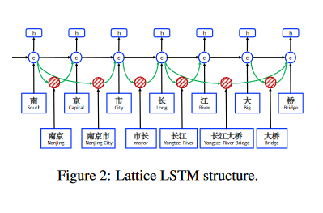

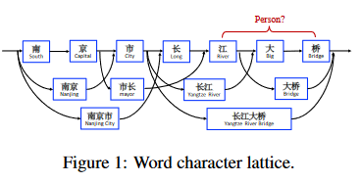

**Input and Output**

CoNLL format (prefer BIOES tag scheme), with each character its label for one line. Sentences are splited with a null line.

美 B-LOC

国 E-LOC

的 O

华 B-PER

莱 I-PER

士 E-PER

我 O

跟 O

他 O

谈 O

笑 O

风 O

生 O

**Evaluation**

MSRA dataset, Weibo are the benchmarks

F1 is the evaluation metric

|  |  |
| --- | --- |
| MSRA | WEIBO |
| 92.76 | 57.91 |

**Demo**