The Product Company

~ Final Data Mart Development Report ~

Team Members
Anshu Raina
Haince Pen
Monica Mantri
Sindhu Srinivasan

Date: 12/11/2014

ISTE 724 Data Warehousing

~ Table of Contents ~

I. Data Mart Design Definition 2
1. Universe of Discourse 2
2. Information Package 2
II. Dimensional Model 11
III. Data Staging: ETL – Data Extract File Definitions 13
IV. Data Staging: ETL – Source-to-Target Mappings 16
V. SQL Code – Tables & Constraints 29
VI. Data Staging Activities - ETL 33
1. Data Cleansing 33
2. Data Transformation 50
3. Table Population 58
VII. End User Applications 67
1. Queries 67
2. Materialized Views & Summaries 72
VIII. Handling Slowly Changing Dimensions (SCD) 74
IX. N-M Implementation Option 88

I. Data Mart Design Definition

The universe of discourse for this data mart is financial analysis and control for all divisions of TPC, namely TPC-E, TPC-W and PEC, including sales by divisions to external clients as well as among themselves over year, quarter, month & day.
Scope
Sales and manufacturing of products by each division of TPC to external clients as well as among themselves over year, quarter, month or day.

1. Universe of Discourse

2. Information Package
Process Name: Financial Analysis and Sales for all divisions of TPC
Grain: The single sale made by any division of TPC
customer | product | supplier | orderdate | salesdate | method
customer_SK | product_SK | supplier_SK | orderdate_SK | salesdate_SK | method_SK
custid | prodid | supplierid | orderdate_calendaryear | salesdate_calendaryear | ordermethod
custname | description | suppliername | orderdate_calendarqtr | salesdate_calendarqtr | paymentmethod
custaddr1 | price1 | supplieraddr1 | orderdate_calendarmonth | salesdate_calendarmonth | shipmethod
custaddr2 | price2 | supplieraddr2 | orderdate_calendarweek | salesdate_calendarweek
custcity | prodtypeid | suppliercity | orderdate_Day | salesdate_Day
custstate | unitcost | supplierstate | orderdate_fiscalyear | salesdate_fiscalyear
custzip | typedescription | supplierzip | orderdate_fiscalqtr | salesdate_fiscalqtr
custtypeid | buid | division | orderdate_fiscalmonth | salesdate_fiscalmonth
custtypename | buidname |  | orderdate_fiscalweek | salesdate_fiscalweek
division | abbrev
 | division

Facts: amt, qty, grossprofit, daystocompleteorder
Flag kept in fact table: discounted

3. Entity Definitions
Entity | Entity Definition (genus differentia)
customer | This entity represents the customers of each division, PEC, TPC-E and TPC-W. The customer dimension has the following attributes:  - Customer_SK: This attribute represents the surrogate key of this dimension.  - Custid: This attribute represents the primary key from the OLTP data, which would be the natural key in our star schema.  - Custname: This attribute represents the names of all the customers of all three divisions – PEC, TPC-E and TPC-W.  - Custaddr1 – This attribute represents the first part of the customer address. This column has been used for the suite and department part of the customer address.  - Custaddr2 – This column represents the second part of the address of the customer address. This column contains everything other than the suite and department part of the address.  - Custcity – This column represents the customer city.  - Custstate – This column represents the customer state.  - Custzip – This column represents the zip code.  - Custtypeid – This column represents the customer type id for the customer –F(US Govt), E(Education), S(State/Local Govt) or C(commercial).  - Custtypename – This column represents the name of the corresponding id, for e.g. US Govt for F.  - Division – This column represents the division of which this customer is a customer of.
method | This is the junk dimension of our star schema. It includes data related to payment method, shipping method and order method, i.e the low cardinality columns. It has 36 rows, one for each combination of payment method, shipping and order method. It has one extra row for missing values of these methods. The column descriptions are as below:  - The column ordermethod signifies the method used to place order by the customer. This can be – email, internet, phone or unknown.  - The paymentmethod signifies the method used by customer to pay. This can be – cod, cash, charge or unknown.  - The shipmethod defines the method used for shipping by the division. This can be – air, train, truck, unknown or n/a.  - The method_SK is the surrogate key for this dimension.
product | This dimension represents each product manufactured/sold by each division – TPC-E,TPC-W and PEC. It has the following columns:  - Product_SK – This column represents the surrogate key of this dimension.  - Prodid – This column represents the primary key of the OLTP system. This shall become the natural key in the star schema.  - Description – This column represents the description of the respective product.  - Price1 – This represents the standard price of the product per unit. i.e. when the discounted flag is ‘0’.  - Price2 – This represents the discounted price of the product, i.e when discounted is ‘1’.  - prodtypeId – This column represents the id for the product type, of the product.  - Unitcost – This column represents the standard cost of the product per unit.  - Typedescription – This column represents the description of the product’s type based on the prodTypeId.  - Buid – This column represents the Id of the business unit to which the product belongs.  - Buidname – This column represents the name of the business unit corresponding to the buid.  - Abbrev – This column represents the abbreviated name of the business unit name.  - Division – This column represents the division which manufactured this product (in the case of PEC)/ sold this product.
supplier | This dimension represents all the suppliers to all the divisions – PEC, TPC-E and TPC-W. This dimension has the following attributes:  - Supplier_SK – This column has the surrogate key for the supplier dimension.  - Supplierid – This column has the primary key from the OLTP database for the supplier dimension. In the star schema, this column becomes the natural key.  - Suppliername – This column contains the names of the respective suppliers.  - Supplieraddr1 – This column contains the first part of the address of the supplier. This column contains the name of the contact person to whom all correspondence should be addressed to (other than those where values are missing).  - Supplieraddr2 – This column contains the second part of the address, including the street/Apt number and name.  - Suppliercity – This column represents the city of the supplier.  - Supplierstate - This column represents the state of the supplier.  - Supplierzip - This column represents the zipcode of the supplier.  - Division – This column represents the division from which the supplier data has been extracted. This has been included for our reference only.
salesdate | This dimension represents the date of sales for each transaction. It has the following attributes:  - Salesdate_SK: This column represents the surrogate key for the salesdate dimension.  - Salesdate_calendaryear – This column represents the calendar year of the sales date. We are considering the calendar year to begin from Jan 1.  - Salesdate_calendarmonth – This column represents the month of the sales date according to calendar year.  - Salesdate_calendarweek – This column represents the week of the sales date according to calendar year.  - Salesdate_Date – This column represents the date of the transaction.  - Salesdate_fiscalyear – This column represents the year of the salesdate according to the fiscal calendar. We are considering the fiscal year to begin from Oct,1.  - Salesdate_fiscalquarter – This column represents the quarter of the salesdate column according to the fiscal calendar.  - Salesdate_fiscalmonth: This column represents the month of the salesdate column according to the fiscal calendar.  - Salesdate_fiscalweek: This column represents the week of the salesdate column according to the fiscal calendar.
orderdate | This dimension represents the date of order for each transaction. It has the following attributes:  - orderdate_SK: This column represents the surrogate key for the orderdate dimension.  - Orderdate_calendaryear – This column represents the calendar year of the order date. We are considering the calendar year to begin from Jan 1.  - Orderdate_calendarmonth – This column represents the month of the order date according to calendar year.  - Orderdate_calendarweek – This column represents the week of the order date according to calendar year.  - Orderdate_Date – This column represents the date of the transaction.  - Orderdate_fiscalyear – This column represents the year of the orderdate column according to the fiscal calendar. We are considering the fiscal year to begin from Oct, 1.  - Orderdate_fiscalquarter – This column represents the quarter of the orderdate column according to the fiscal calendar.  - Orderdate_fiscalmonth - This column represents the month of the orderdate column according to the fiscal calendar.  - Orderdate_fiscalweek- This column represents the week of the orderdate column according to the fiscal calendar.
Product_sales | This is the fact table of the star schema. It has the following attributes:  - Customer_SK – This column is one of the composite primary and foreign keys of the fact table. This column references the primary key(customer_SK) of the customer table. Through this column we can obtain the customer details associated with each fact table row.  - product_SK – This column is one of the composite primary and foreign keys of the fact table. This column references the primary key(product_SK) of the product table. Through this column we can obtain the product details associated with each fact table row.  - supplier_SK – This column is one of the composite primary and foreign keys of the fact table. This column references the primary key(supplier_SK) of the supplier table. Through this column we can obtain the supplier details associated with each fact table row.  - salesdate_SK – This column is one of the composite primary and foreign keys of the fact table. This column references the primary key(salesdate_SK) of the salesdate table. Through this column we can obtain the sales date details associated with each fact table row.  - orderdate_SK – This column is one of the composite primary and foreign keys of the fact table. This column references the primary key(orderdate_SK) of the orderdate table. Through this column we can obtain the order date details associated with each fact table row.  - Grossprofit – This column lists the profit for each transaction in the fact table. This is calculated using the following formula:  Gross profit = Sale Price – Cost price for the transaction  Sale Price = price1 or price2 * qty  Where price 1 – sale price when discounted = 0  Where price 2 – sale price when discounted = 1  Cost Price = [(Manufacturing cost for a month, year for that productId)/(aggregation of qty that productId sold for that month and year)] * qty;  - Daystocompleteorder – This column lists the difference in the salesdate and orderdate. This is an indicator of the time taken to full fill each order.

II. Physical Dimensional Model

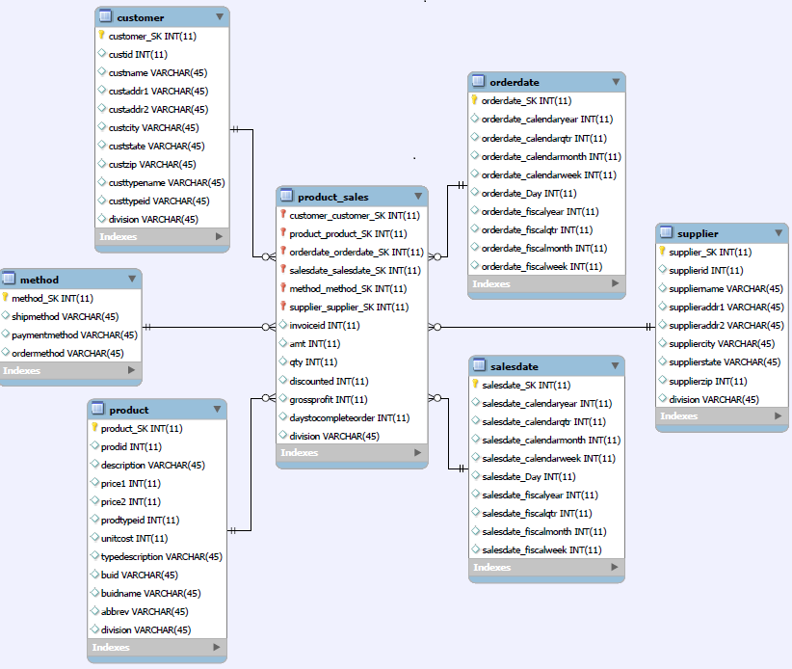

Dimensional Model for SalesOrders

Rationale:
We chose this model because the dimensions – supplier, product, customer, method, salesdate and orderdate all describe a single row in the fact table – product_sales. Also, the lowest level grain has been chosen as a single sale made by TPC and its divisions, to external clients or amongst each other. The invoiceId is an important field in the OLTP system. Since all its related attributes were put into other dimensions, this is a degenerate dimension in our schema. Also payment method, ship method and order method are low cardinality columns and have thus been included in the junk dimension.

Screen shot of individual tables:
The below screen shots represent all the entities, their attributes and primary keys (Having red and yellow symbols before the respective column name), relationships and denormalization in the form of crow’s foot diagram.
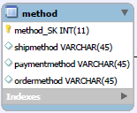
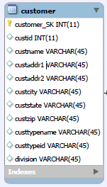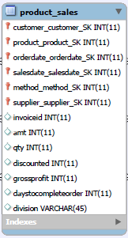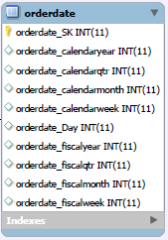

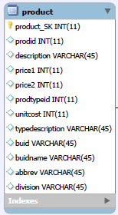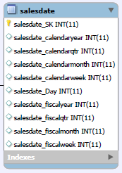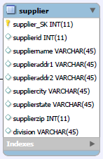

III. Data Staging: ETL – Data Extract File Definitions
Files in data staging and their data formats:

Customer |  |  | Supplier
Field | Data-Format |  | Field | Data-Format
Customer_SK | INT |  | supplier_SK | INT
custid | INT |  | supplierid | INT
custname | VARCHAR |  | suppliername | VARCHAR
custaddr1 | VARCHAR |  | supplieraddr1 | VARCHAR
custaddr2 | VARCHAR |  | supplieraddr2 | VARCHAR
custcity | VARCHAR |  | suppliercity | VARCHAR
custstate | VARCHAR |  | supplierstate | VARCHAR
custzip | VARCHAR |  | supplierzip | VARCHAR
custtypeid | VARCHAR |  | division | VARCHAR
custtypename | VARCHAR
division | VARCHAR

Product
Field | Data-Format
product_SK | INT
prodid | INT
description | VARCHAR
price1 | INT
price2 | INT
prodtypeid | VARCHAR
unitcost | INT
typedescription | VARCHAR
buid | VARCHAR
buidname | VARCHAR
abbrev | VARCHAR
division | VARCHAR

Method
Field | Data-Format
method_SK | INT
ordermethod | VARCHAR
paymentmethod | VARCHAR
shipmethod | VARCHAR

salesdate |  |  | orderdate
Field | Data-Format |  | Field | Data-Format
salesdate_SK | INT |  | orderdate_SK | INT
salesdate_calendaryear | INT |  | orderdate_calendaryear | INT
salesdate_calendarqtr | INT |  | orderdate_calendarqtr | INT
salesdate_calendarmonth | INT |  | orderdate_calendarmonth | INT
salesdate_calenderweek | INT |  | orderdate_calenderweek | INT
salesdate_Date | INT |  | orderdate_Date | INT
salesdate_fiscalyear | INT |  | orderdate_fiscalyear | INT
salesdate_fiscalqtr | INT |  | orderdate_fiscalqtr | INT
salesdate_fiscalmonth | INT |  | orderdate_fiscalmonth | INT
salesdate_fiscalweek | INT |  | orderdate_fiscalweek | INT

product_sales
Field | Data-Format
customer_SK | INT
product_SK | INT
method_SK | INT
supplier_SK | INT
salesdate_SK | INT
orderdate_SK | INT
invoiceid | INT
amt | INT
qty | INT
discounted | INT
grossprofit | INT
daystocompleteorder | INT
division | VARCHAR

IV. Data Staging: ETL – Source-to-Target Mappings [3]

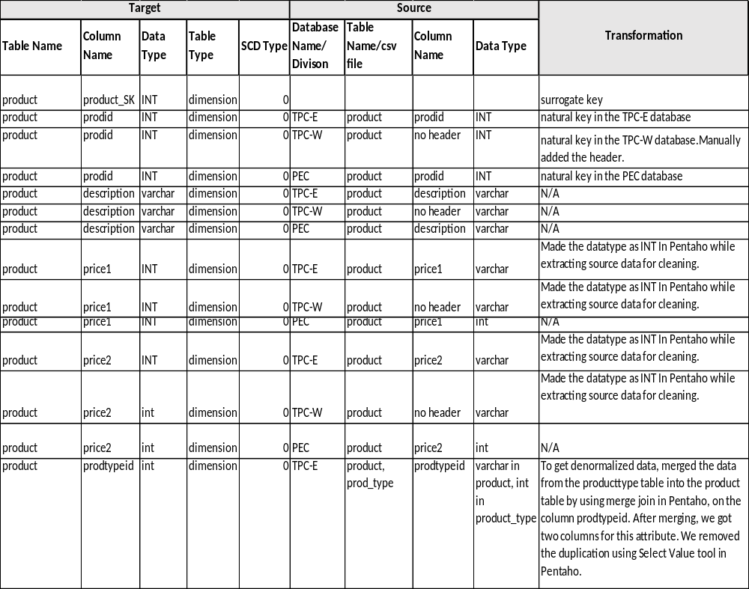

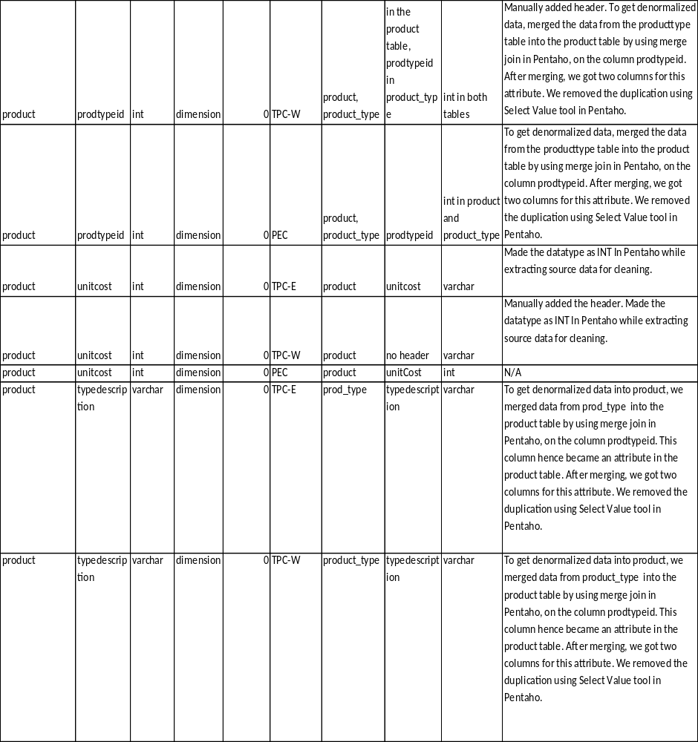

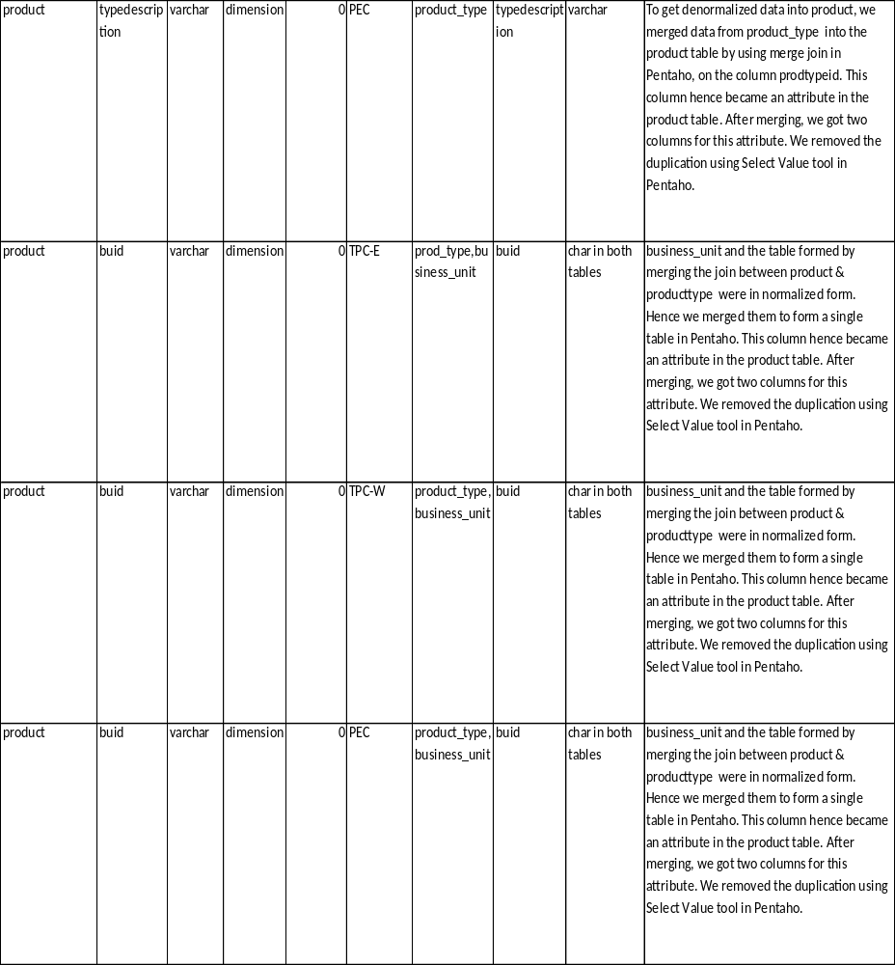

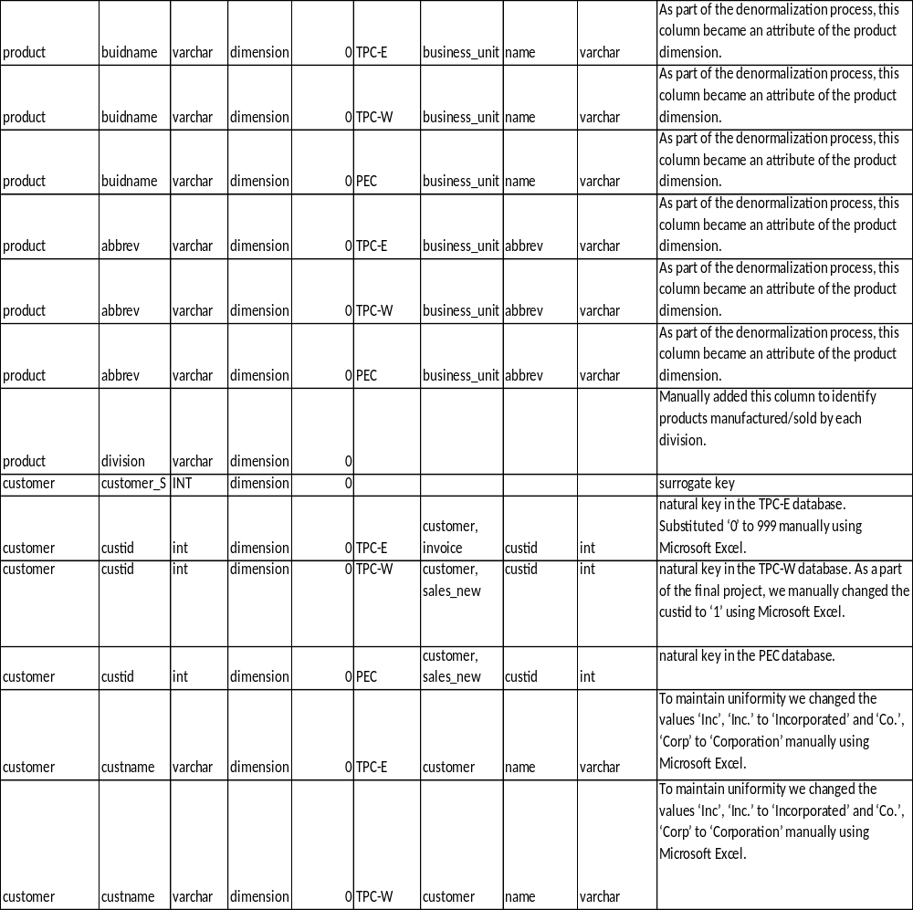

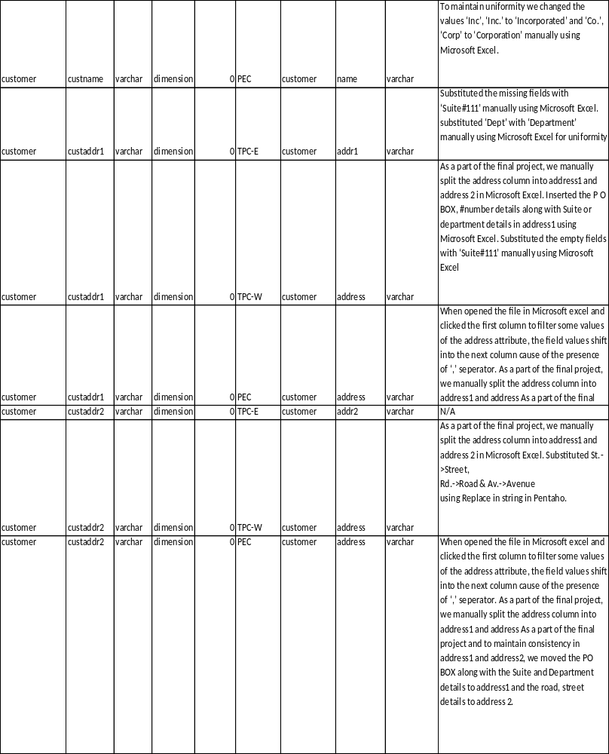

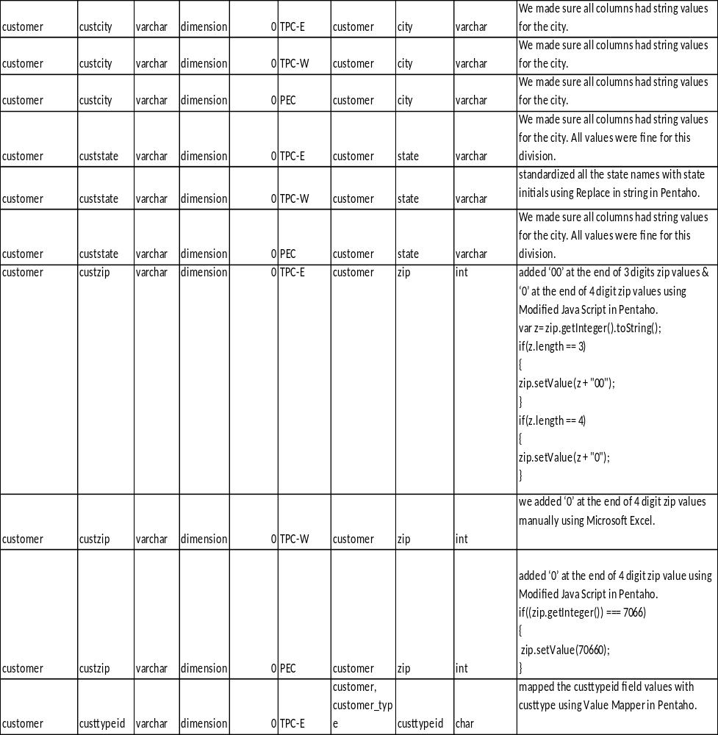

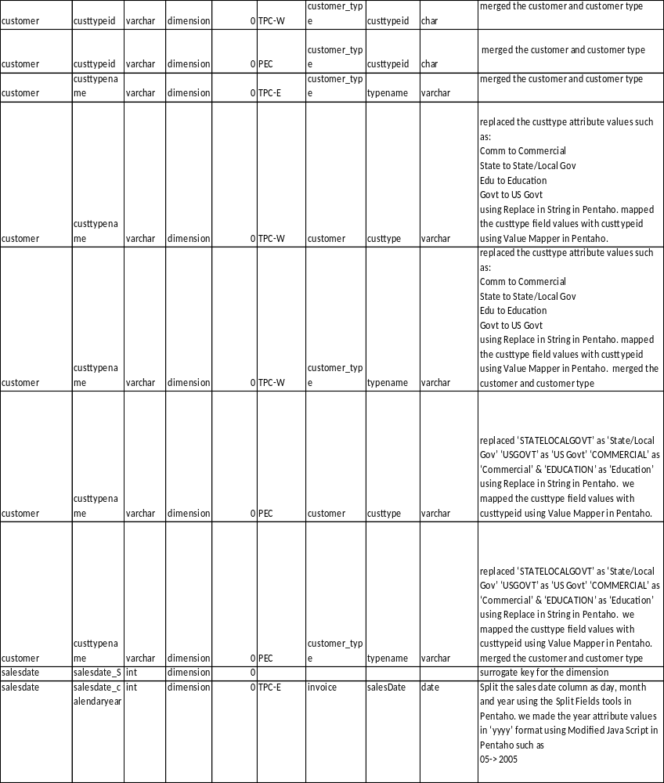

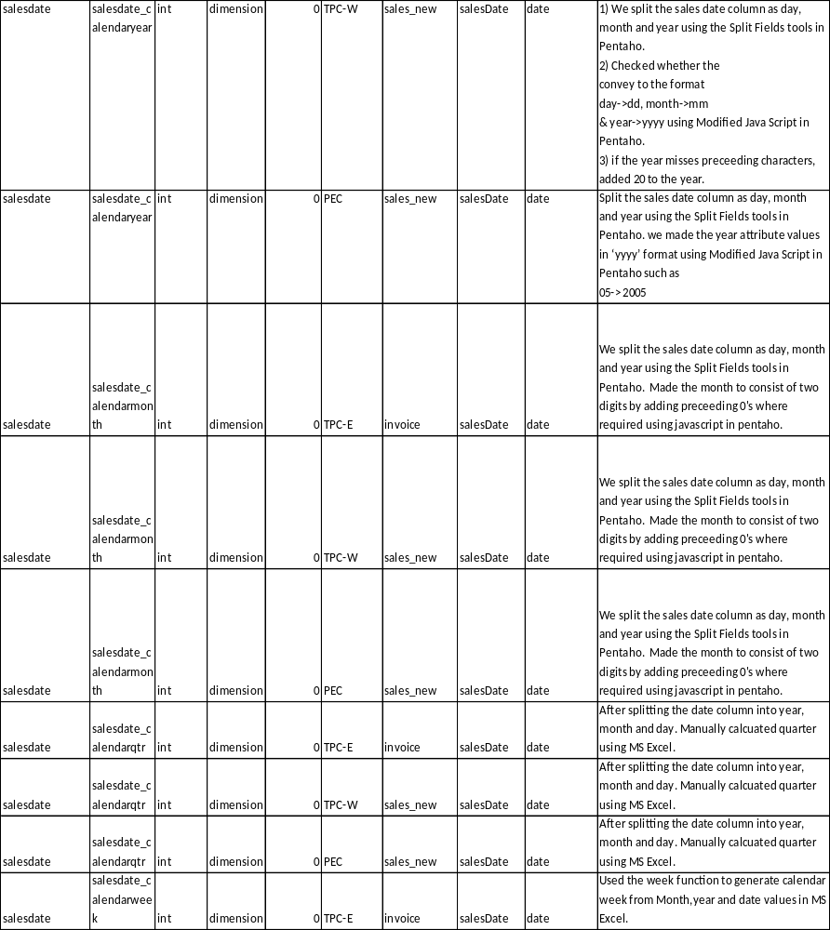

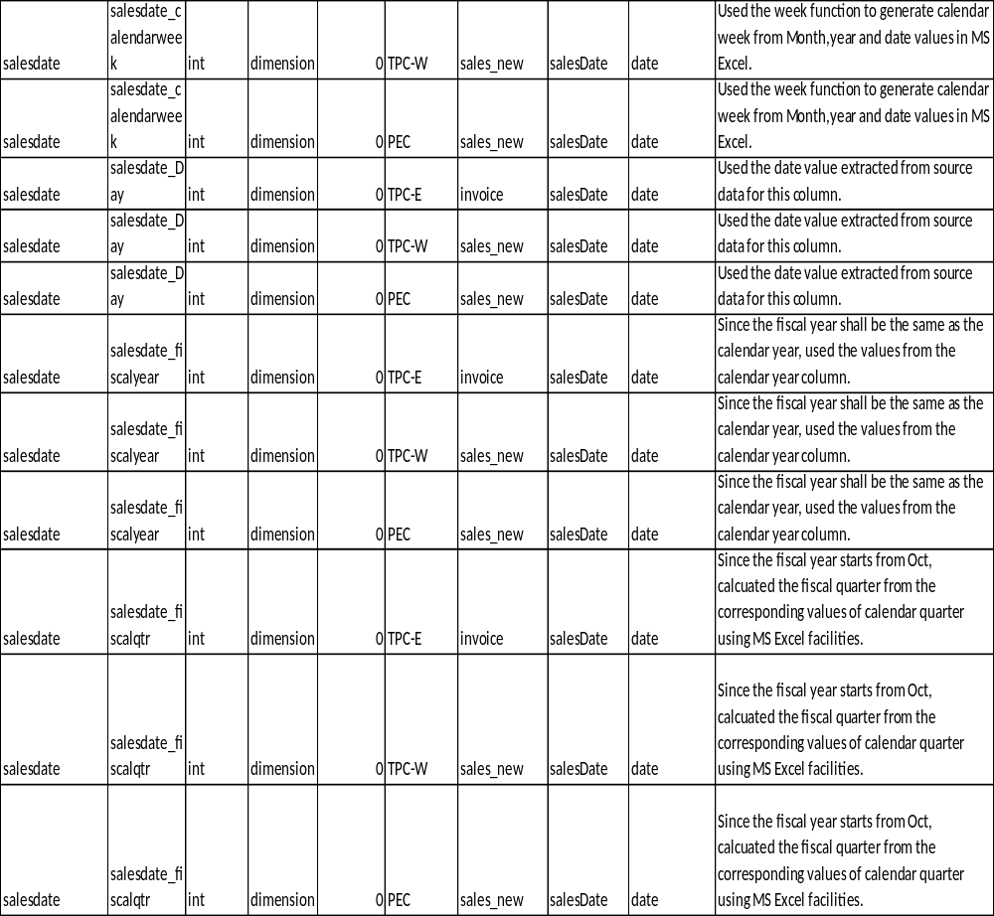

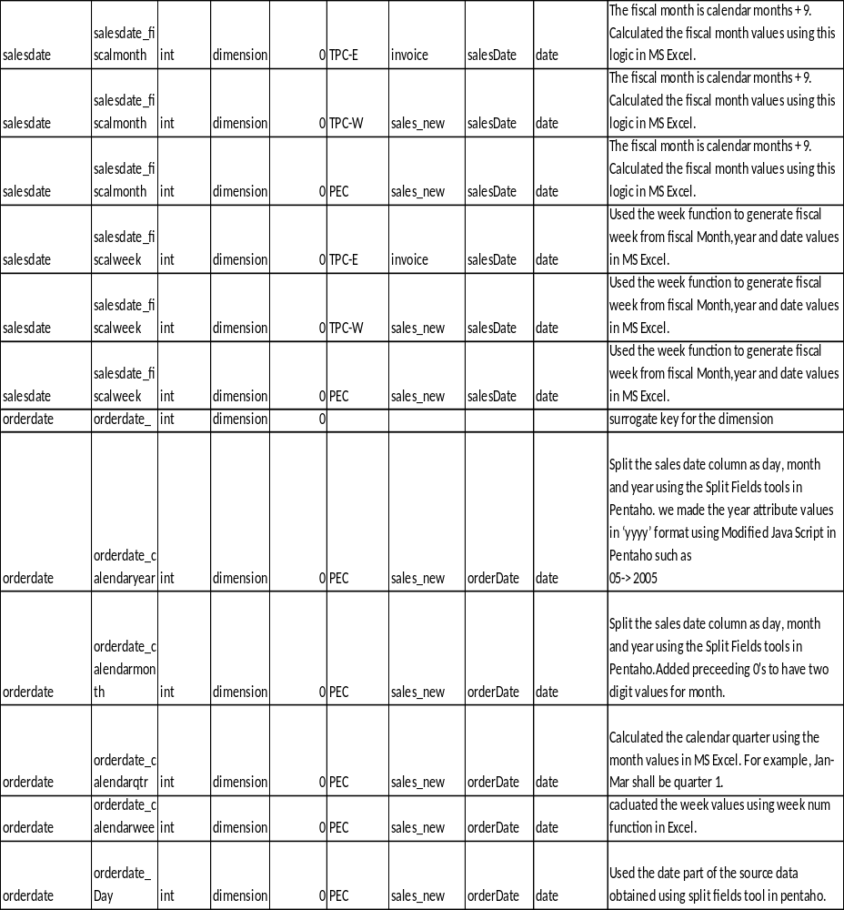

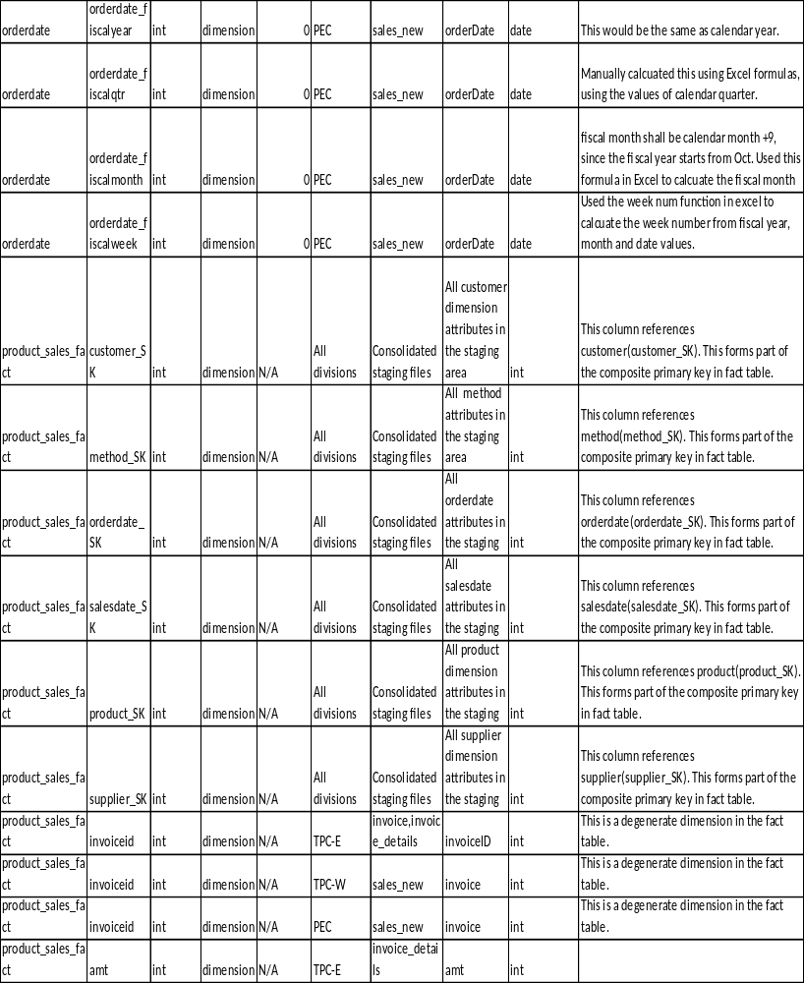

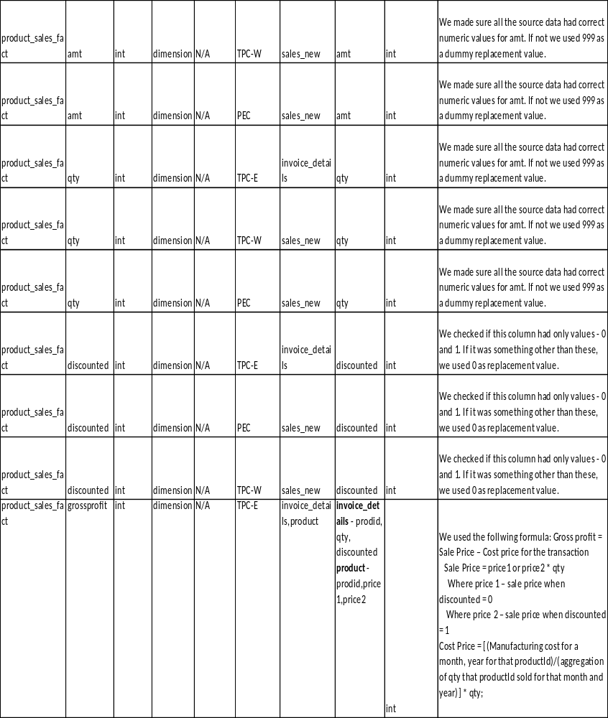

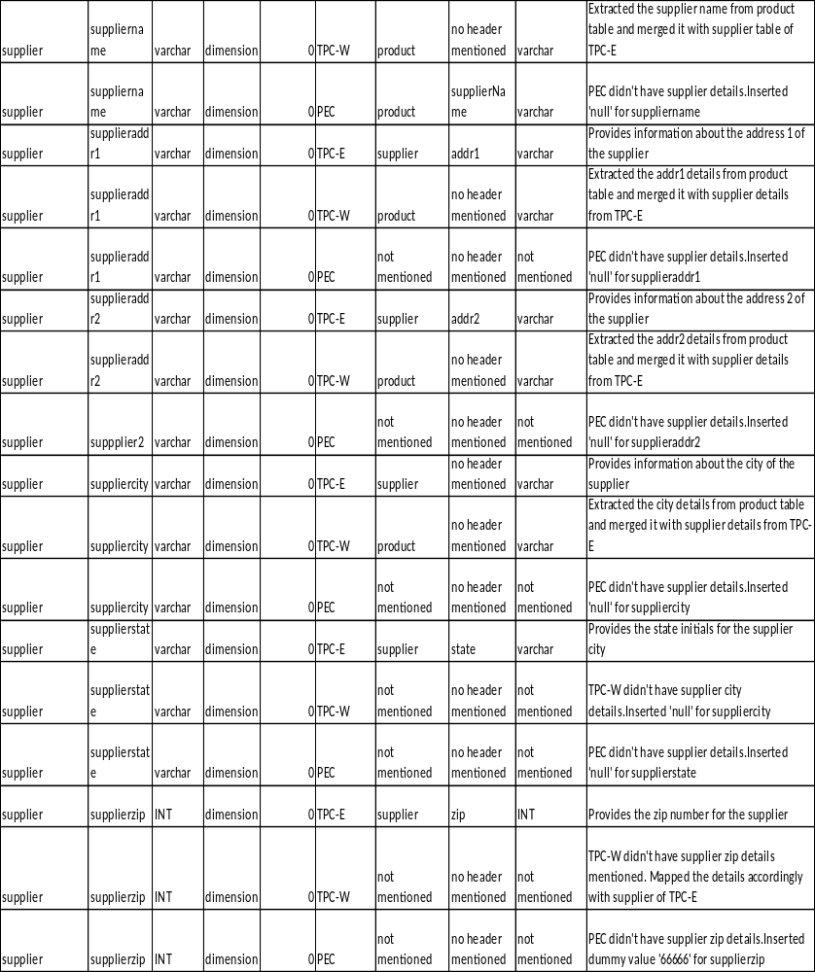

**Please Note that we have attached a screen shot of this table created in excel. You may find a complete excel in the submission folder named “SourceTargetMapping”.

V. SQL Code – Tables & Constraints
Table name: customer

CREATE TABLE `salesorders`.`customer` (
`customer_SK` INT NOT NULL,
`custid` INT NULL,
`custname` VARCHAR(45) NULL,
`custaddr1` VARCHAR(45) NULL,
`custaddr2` VARCHAR(45) NULL,
`custcity` VARCHAR(45) NULL,
`custstate` VARCHAR(45) NULL,
`custzip` VARCHAR(45) NULL,
`custtypeid` VARCHAR(45) NULL,
`custtypename` VARCHAR(45) NULL,
`division` VARCHAR(45) NULL,
PRIMARY KEY (`customer_SK`));

Table name: Supplier

CREATE TABLE `salesorders`.`supplier` (
`supplier_SK` INT NOT NULL,
`supplierid` INT NULL,
`suppliername` VARCHAR(45) NULL,
`supplieraddr1` VARCHAR(45) NULL,
`supplieraddr2` VARCHAR(45) NULL,
`suppliercity` VARCHAR(45) NULL,
`supplierstate` VARCHAR(45) NULL,
`supplierzip` INT NULL,
`division` VARCHAR(45) NULL,
PRIMARY KEY (`supplier_SK`));

Table name: Product

CREATE TABLE `salesorders`.`product` (
`product_SK` INT NOT NULL,
`prodid` INT NULL,
`description` VARCHAR(45) NULL,
`price1` INT NULL,
`price2` INT NULL,
`prodtypeid` INT NULL,
`unitcost` INT NULL,
`typedescription` VARCHAR(45) NULL,
`buid` VARCHAR(45) NULL,
`buidname` VARCHAR(45) NULL,
`abbrev` VARCHAR(45) NULL,
`division` VARCHAR(45) NULL,
PRIMARY KEY (`prod_SK`));

Table name: Method

CREATE TABLE `salesorders`.`method` (
`method_SK` INT NOT NULL,
`ordermethod` VARCHAR(45) NULL,
`paymentmethod` VARCHAR(45) NULL,
`shipmethod` VARCHAR(45) NULL,
PRIMARY KEY (`method_SK`));
`));

Table name: salesdate

CREATE TABLE `salesorders`.`salesdate` (
`salesdate_SK` INT NOT NULL,
'salesdate_calendaryear` INT NULL,
'salesdate_calendarqtr` INT NULL,
`salesdate_calendarmonth` INT NULL,
`salesdate_calenderweek` INT NULL,
'salesdate_Date` INT NULL,
`salesdate_fiscalyear` INT NULL,
`salesdate_fiscalqtr` INT NULL,
`salesdate_fiscalmonth` INT NULL,
`salesdate_fiscalweek` INT NULL,
PRIMARY KEY (`salesdate_SK`));

Table name: Orderdate

CREATE TABLE 'salesorders'.`orderdate` (
`orderdate_SK` int(11) NOT NULL,
`orderdate_calenderyear` int(11) DEFAULT NULL,
`orderdate_calenderqtr` int(11) DEFAULT NULL,
`orderdate_calendermonth` int(11) DEFAULT NULL,
`orderdate_calenderweek` int(11) DEFAULT NULL,
`orderdate_Date` int(11) DEFAULT NULL,
`orderdate_fiscalyear` int(11) DEFAULT NULL,
`orderdate_fiscalqtr` int(11) DEFAULT NULL,
`orderdate_fiscalmonth` int(11) DEFAULT NULL,
`orderdate_fiscalweek` int(11) DEFAULT NULL,
PRIMARY KEY (`orderdate_SK`)
);

Table name: product_sales

CREATE TABLE `product_sales` (
`customer_SK` int(11) DEFAULT NULL,
`method_SK` int(11) DEFAULT NULL,
`orderdate_SK` int(11) DEFAULT NULL,
`salesdate_SK` int(11) DEFAULT NULL,
`product_SK` int(11) DEFAULT NULL,
`supplier_SK` int(11) DEFAULT NULL,
`invoiceid` int(11) DEFAULT NULL,
`amt` int(11) DEFAULT NULL,
`qty` int(11) DEFAULT NULL,
`discounted` int(11) DEFAULT NULL,
`grossprofit` int(11) DEFAULT NULL,
`daystocompleteorder` int(11) DEFAULT NULL,
`division` varchar(45) DEFAULT NULL,
KEY `customer_SK` (`customer_SK`),
KEY `method_SK` (`method_SK`),
KEY `orderdate_SK` (`orderdate_SK`),
KEY `salesdate_SK` (`salesdate_SK`),
KEY `product_SK` (`product_SK`),
KEY `supplier_SK` (`supplier_SK`),

CONSTRAINT `customer_SK` FOREIGN KEY (`customer_SK`) REFERENCES `customer` (`customer_SK`) ON DELETE NO ACTION ON UPDATE NO ACTION,
CONSTRAINT `product_SK` FOREIGN KEY (`product_SK`) REFERENCES `product` (`product_SK`) ON DELETE NO ACTION ON UPDATE NO ACTION,
CONSTRAINT `supplier_SK` FOREIGN KEY (`supplier_SK`) REFERENCES `supplier` (`supplier_SK`) ON DELETE NO ACTION ON UPDATE NO ACTION,
CONSTRAINT `method_SK` FOREIGN KEY (`method_SK`) REFERENCES `method` (`method_SK`) ON DELETE NO ACTION ON UPDATE NO ACTION,
CONSTRAINT `salesdate_SK` FOREIGN KEY (`salesdate_SK`) REFERENCES `salesdate` (`salesdate_SK`) ON DELETE NO ACTION ON UPDATE NO ACTION,
CONSTRAINT `orderdate_SK` FOREIGN KEY (`orderdate_SK`) REFERENCES `orderdate` (`orderdate_SK`) ON DELETE NO ACTION ON UPDATE NO ACTION
)

** Constraints are shown as above.

View name: pec_customer_address

This view provides the details of customer address for PEC divison

CREATE
ALGORITHM = UNDEFINED
DEFINER = `root`@`localhost`
SQL SECURITY DEFINER
VIEW `pec_customer_address` AS
select distinct
`customer`.`custid` AS `custid`,
`customer`.`custaddr1` AS `custaddr1`,
`customer`.`custaddr2` AS `custaddr2`,
`customer`.`custstate` AS `custstate`,
`customer`.`custzip` AS `custzip`
from
(`product_sales`
join `customer` ON (((`product_sales`.`customer_SK` = `customer`.`customer_SK`)
and (`product_sales`.`division` like '%PEC%'))))
VI. Data Staging Activities - ETL

1. Data Cleansing
The following are the modifications we made in the csv files in Pentaho data integration tool and Microsoft Excel:
Flowchart for general cleansing steps for ETL Process: Preliminary steps carried out in excel:

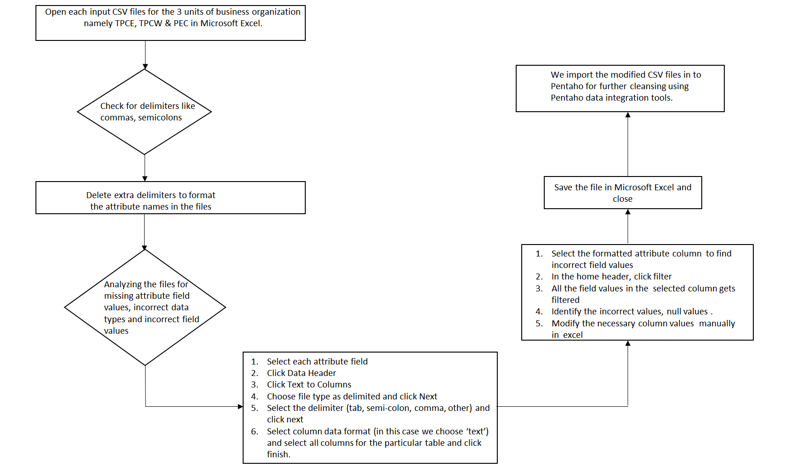

DM Table | Attribute | Problem | Resolution Strategy (attach code)
Product  TPCW (business_unit.csv) | abbrev | The abbrev attribute value for buid=’D’ was empty. | As part of Lab 3, we substituted the empty field value with ‘Miscellaneous’ using Modified Java Script in Pentaho.  var input = abbrev.getString();  input = replace(input,' ','')  if(input==='')  {  abbrev.setValue('Miscellaneous');  }
SalesDate  TPCW  (sales_new.csv) | salesdate | The attribute values had delimiter ‘–‘ | As a part of Lab 3 we substituted the ‘–‘ delimiter with ‘/’ using Replace in String in Pentaho.  day.setValue((month.getString())+"/"+(day.getString())+"/"+(year.getString()));
SalesDate  TPCW  (sales_new.csv) | salesdate | Some attribute values were not in the proper date format. | As part of Lab 3,  - We split the sales date column as day, month and year using the Split Fields tools in Pentaho.  - Checked whether the  convey to the format  day->dd, month->mm  & year->yyyy using Modified Java Script in Pentaho.  if((year.getString().length()) <4)  {  var yr = year.getString();  year.setValue("20"+ yr);  }  if((day.getString().length()) <2)  {  var day1 = day.getString();  day.setValue("0"+ day1);  }  if((month.getString().length()) <2)  {  var mon = month.getString();  month.setValue("0"+ mon);  }  - Concatenated the day column values, month column values and year column values in the format ‘mm/dd/yyyy’ into the day column using Modified Java Script in Pentaho.  - Removed the extra overhead columns ‘month’ & ‘year’ using select values remove option in Pentaho. Renamed the day column to salesdate using select values in Pentaho.
Customer  TPCW  (sales_new.csv) | custid | The attribute value had presence of ‘-1’ for invoiceid=  19061 | As a part of the final project, we manually changed the custid to ‘1’ using Microsoft Excel.
Customer  TPCW  (sales_new.csv) | prodid | The attribute value had presence of ‘prodID’ for invoiceid=  ‘26511’ | As a part of the final project we changed the ‘prodID’ to 999 manually using Microsoft Excel.
Customer  TPCW  (sales_new.csv) | salesdate | The attribute value had presence of word ‘salesDate’ for invoice= ‘26511’ | As a part of the final project we changed ‘salesdate’ to ‘01/01/2005’ manually using Microsoft Excel.
Customer  TPCW  (sales_new.csv) | amt | The attribute value had presence of word ‘amt’ for invoiceid=’26511’ | As a part of the final project we changed ‘amt’ to 999 manually using Microsoft Excel.
Customer  TPCW  (sales_new.csv) | custid | The attribute value had a presence of word ‘custID’ for invoiceid= ‘26511’ | As a part of the final project we changed the ‘cusID’ to 999 manually using Microsoft Excel.
Product_Sales  TPCW  (sales_new.csv) | qty | The qty attribute value had a presence of word ‘qty’ for invoiceid=’26511’ | As a part of the final project we changed ‘qty’ to 999 manually using Microsoft Excel.
Product_Sales  TPCW  (sales_new.csv) | qty | The qty attribute value  was empty for invoice. | For Lab 3, we substituted the empty field value with ‘1’ using Modified Java Script in Pentaho.  if((qty.getInteger()) == "")  {  qty.setValue('999');  }  As a part of the final project, we substituted the values 1 manually using Microsoft Excel.
Product_Sales  TPCW  (sales_new.csv) | discounted | The discounted attribute value  was empty for invoiceid=’45461’. | For Lab 3, we substituted the empty field value with ‘999’ using Modified Java Script in Pentaho.  if((discounted.getInteger()) === "")  {  discounted.setValue('999');  }  As part of the final project, we changed the discounted value to 0 using Microsoft Excel.
Customer  TPCW  (customer.csv) | name | The name attribute had values like Inc. and Corp | As a part of the final project, to obtain uniformity among three divisions, we changed  Inc. -> Incorporated,  Corp-> Corporation  manually using Microsoft Excel
Customer  TPCW  (customer.csv) | address | The address column had consolidated data of the address details of the customers. | As a part of the final project, we manually split the address column into address1 and address 2 in Microsoft Excel.
Customer  TPCW  (customer.csv) | address1 | After splitting the address field in to address1, the attribute column had to have address details. | Inserted the P O BOX, #number details along with Suite or department details in address1 using Microsoft Excel.
Customer  TPCW  (customer.csv) | address2 | After splitting the address field in to address2, the attribute column had to have address details. | As a part of final project we inserted road, avenue, street, circle details about address in address2 using Microsoft Excel.
Customer  TPCW  (customer.csv) | address1 | After splitting the address field, the address1 attribute value had empty fields. | As a part of final project Substituted the empty fields with ‘Suite#111’ manually using Microsoft Excel.
Customer  TPCW  (customer.csv) | address2 | The address attribute values had presence of St., Rd. & Av. | For Lab 3, we substituted St.->Street,  Rd.->Road & Av.->Avenue  using Replace in string in Pentaho.
Customer  TPCW  (customer.csv) | zip | Some of the zip attribute values did not convey the 5 digits convention for zips. | After Lab 3 we were still facing the issue so for the final project we added ‘0’ at the end of 4 digit zip values manually using Microsoft Excel.
Customer  TPCW  (customer.csv) | state | The state attribute values had some state names written completely and some have only state initials. | For Lab 3, we standardized all the state names with state initials using  Replace in string in Pentaho.
Customer  TPCW  (customer.csv) | custtype | The custtype attribute values were specified in abbrev form. | As a part of Lab 3, we replaced the custtype attribute values such as:  Comm to Commercial  State to State/Local Gov  Edu to Education  Govt to US Govt  using Replace in String in Pentaho.
Customer  TPCW  (customer.csv) | custtype | The custtype attribute values were not mapped to custtypeid  which is required for staging. | As part of Lab 3, we mapped the custtype field values with custtypeid using Value Mapper in Pentaho.
Product  TPCW  (product.csv) | No header details mentioned. | The product table didn’t have the header details mentioned. | Inserted the headers in the product manually using Microsoft Excel namely prodid, description, price1, price2, unitcost, suppliername, addr1, addr2, city respectively.
Product  TPCW  (product.csv) | description | The description attribute value had the presence of word ‘Equip’ | As a part of the final project, to maintain consistency in the attribute column, we substituted ‘Equip’ to ‘Equipment’.
Product  TPCW  (product.csv) | prodtypeid | The prottypeid attribute values were not sorted. | As a part of Lab 3 , we sorted the prodtypeid in the ascending order using Sort rows in Pentaho.
Product  TPCW  (product.csv) | suppliername | The suppliername attribute had values like Inc, Inc. | As a part of the final project, we manually changed  ‘Inc’ to ‘Incorporated’ and ‘Inc.’ to ‘Incorporated’ to maintain uniformity among the three divisions.
Product  TPCW  (product.csv) | addr2 | The attribute had values ‘St’ which did not convey the consistency within the entire column. | As a part of the final project, we substituted ‘St’ with Street manually using Microsoft Excel to maintain consistency throughout the column.
Product  TPCW  (product.csv) | suppliername, addr1,addr2, city | The product table had attribute values of supplier details. | Extracted the supplier details from product table using Microsoft Excel & merged it with the supplier table of  TPCE.
Product  TPCW  (product.csv,producttype.csv) | prodtypeid | product and producttype  tables were in normalized form but according to the designed star schema we require them to be in the de-normalized form. | As a part of lab 3 we merged the column prodtypeid in product and productype using Merge Join in Pentaho.
Product  TPCW  (product.csv,business_unit.csv) | buid | business_unit and the table formed by merging the join between product & producttype were in normalized form but we require them to be in the de-normalized form | For Lab3, to make the tables in de-normalized form, we merge the column buid in business_unit and the table formed by merging join of the produt & producttype using Merge Join in Pentaho.
Product  TPCW  (product.csv, business_unit.csv, producttyype.csv) | prodtypeid_1,  buid_1 | After merging the tables product, producttype and business_unit, the producttypeid_1 and buid_1 are duplicated. | As a part of Lab 3, we remove the duplication of prodtypeid_1 and buid_1 using Select values remove option in Pentaho.
Product  TPCE  (business_unit.csv) | abbrev | The abbrev attribute value for buid=’D’ was empty. | As a part of Lab 3, we substituted the empty field value with ‘Miscellaneous’ using Modified Java Script in Pentaho.  var input = abbrev.getString();  input = replace(input,' ','')  if(input==='')  {  abbrev.setValue('Miscellaneous');  }
Customer  TPCE  (customer.csv) | custid | The attribute value had custid has ‘0’ | As a part of the final project we substituted ‘0’ to 999 manually using Microsoft Excel.
Customer  TPCE  (customer.csv) | zip | Some of the zip attribute values did not convey the 5 digits convention for zips. | As a part of Lab 3, we  added ‘00’ at the end of 3 digits zip values & ‘0’ at the end of 4 digit zip values using Modified Java Script in Pentaho.  var z= zip.getInteger().toString();  if(z.length == 3)  {  zip.setValue(z + "00");  }  if(z.length == 4)  {  zip.setValue(z + "0");  }
Customer  TPCE  (customer.csv) | name | The name attribute had values like Inc, Inc., Co., Corp which did not convey uniformity among the three divisions. | As a part of the final project to maintain uniformity we changed the values ‘Inc’, ‘Inc.’ to ‘Incorporated’ and ‘Co.’,  ‘Corp’ to ‘Corporation’ manually using Microsoft Excel.
Customer  TPCE  (customer.csv) | addr1, | The addr1 attribute had missing values | As a part of the final project,we Substituted the missing fields with ‘Suite#111’ manually using Microsoft Excel.
Customer  TPCE  (customer.csv) | addr1 | The addr1 attribute had field values ‘Dept’ | As a part of the final project we substituted ‘Dept’ with ‘Department’ manually using Microsoft Excel for uniformity.
Customer  TPCE  (customer.csv) | custtypeid | The custtypeid attribute values were not mapped to custtype which is required for staging. | As a part of Lab 3, we mapped the custtypeid field values with custtype using Value Mapper in Pentaho.
Product  TPCE  (product.csv) | prodtypeid | The prottypeid attribute values were not sorted. | As a part of Lab 3, we sorted the prodtypeid in the ascending order using Sort Rows in Pentaho.
Product  TPCE  (product.csv) | prodid | The prodid attribute values were not sorted. | As a part of Lab 3, we sorted the prodid in the ascending order using Sort rows in Pentaho.
Product  TPCE  (product.csv) | description | The description attribute column had presence of word ‘Equip’. | As a part of the final project and to maintain consistency within the column, we substituted ‘Equip’ with ‘Equipment’ manually using Microsoft Excel.
Product  TPCE  (product.csv) | prodtypeid | The prodtypeid attribute values were not mapped to typedescription which is required for staging. | Mapped prodtypeid attribute with typedescription attribute using Value Mapper in Pentaho.
Product  TPCE  (producttype.csv) | prodtypeid | The prodtypeid attribute values were not sorted. | For Lab 3, we sorted the prodtypeid attribute values using Sort Rows in ascending order in Pentaho.
Product  TPCE  (product.csv, producttype.csv) | prodtypeid | product and producttype  tables were in normalized form but according to the designed star schema we require them to be in the de-normalized form. | For Lab 3, we merged the column prodtypeid in product and productype using Merge Join in Pentaho.
Product  TPCE  (product.csv, producttype.csv,business_unit.csv) | buid | business_unit and the table formed by merging the join between product & producttype were in normalized form but according to the designed star schema we require them to be in de-normalized form. | To make the tables in de-normalized form,as a part of Lab 3, we merge the column buid in business_unit and the table formed by merging join of the produt & producttype using Merge Join in Pentaho.
Product  TPCE  (product.csv, producttype.csv,business_unit.csv) | prodtypeid_1,  buid_1,  typedescription_1. | After merging the tables product, producttype and business_unit, the producttypeid_1, buid_1 & typedescription_1 are duplicated. | As a part of Lab 3, we remove the duplication of prodtypeid_1,buid_1 & typedescription_1 using Select values remove option in Pentaho.
Supplier  TPCE  (supplier.csv) | name | The name attribute had values like ‘Inc’, ‘Inc.’ which did not convey uniformity among the three divisions | As a part of the final project, we changed ‘Inc’, ‘Inc.’ to ‘Incorporated’ manually using Microsoft Excel to maintain uniformity among the three divisions.
Product  PEC  (business_unit.csv) | abbrev | The abbrev attribute value for buid=’D’ was empty. | For Lab 3, we substituted the empty field value with ‘Miscellaneous’ using Modified Java Script in Pentaho.  var input = abbrev.getString();  input = replace(input,' ','')  if(input==='')  {  abbrev.setValue('Miscellaneous');  }
Customer  PEC  (customer.csv) | address | When opened the file in Microsoft excel and clicked the first column to filter some values of the address attribute, the field values shift into the next column cause of the presence of ‘,’ seperator. | Removed the ‘,’ separator manually in Microsoft Excel to adjust the columns according to their specified attribute headers.
Customer  PEC(customer.csv) | name | The name attribute values like Inc. and Co. | As a part of the final project and to maintain uniformity among the three divisions, changed  ‘Inc.’ to ‘Incorporated’ and ‘Co.’ to Corporation
Customer  PEC  (customer.csv) | address | The address column had consolidated data of the address details of the customers. | As a part of the final project, we manually split the address column into address1 and address 2 in Microsoft Excel.
Customer  PEC  (customer.csv) | address1,  address2 | After splitting the address field into address1, address2 the address details were not mapped correctly into their specific columns. | As a part of the final project and to maintain consistency in address1 and address2, we moved the  PO BOX along with the Suite and Department details to address1 and the road, street details to address 2.  .
Customer  PEC  (customer.csv) | address2 | The address attribute values had presence of St., Rd., Rd, Ave, Dr., Av. | For Lab 3,we  substituted St.->Street,  Rd.->Road, Rd->Road,  Ave->Avenue, Dr.->Drive &  Av.->Avenue  using Replace in string in Pentaho.
Customer  PEC  (customer.csv) | zip | Some of the zip attribute values did not convey the 5 digits convention for zips. | For Lab 3, we  added ‘0’ at the end of 4 digit zip value using Modified Java Script in Pentaho.  if((zip.getInteger()) === 7066)  {  zip.setValue(70660);  }
Customer  PEC  (customer.csv) | custtype | The custtype attribute values  we’re not properly spaced. | For Lab 3, cleaned the values by replacing  ‘STATELOCALGOVT’ as ‘State/Local Gov’  ‘USGOVT’ as ‘US Govt’  ‘COMMERCIAL’ as ‘Commercial’ &  ‘EDUCATION’ as ‘Education’ using Replace in String in Pentaho.
Customer  PEC  (customer.csv) | custtype | The custtype attribute values were not mapped to custtypeid  which is required for staging. | For Lab 3, we mapped the custtype field values with custtypeid using Value Mapper in Pentaho.
Product  PEC  (producttype.csv) | prodtypeid | The prodtypeid attribute values were not sorted. | For Lab 3, we sorted the prodtypeid in the ascending order using Sort rows in Pentaho.
Product  PEC  (product.csv) | unitcost | Some of the unitcost attribute values were empty. | For Lab 3, we replaced the empty values in unitcost attribute with ‘000.0’ using If field value is null in Pentaho.  As a part of the final project, we substituted empty fields with value ‘0’ manually using Microsoft Excel.
Product  PEC  (product.csv) | prodtypeid | The prodtypeid attribute values were not mapped to typedescription which is required for staging. | For Lab 3, we mapped prodtypeid attribute with typedescription attribute using Value Mapper in Pentaho.
Product  PEC  (producttype.csv) | typedescription | The typedescription attribute values were not mapped to buid which is required for staging. | For Lab 3, we mapped typedescription attribute with buid attribute using Value Mapper in Pentaho.
Product  PEC  (producttype.csv) | buid | The buid attribute values mapped with typedescription in product table were not sorted. | For Lab 3, we sorted the buid attribute values in the ascending order using Sort rows in Pentaho.
Product  PEC  (producttype.csv) | buid | The buid attribute values were not mapped to buidname in product table which is required for staging. | For Lab 3, we mapped buid attribute with buidname attribute using Value Mapper in Pentaho.
Product  PEC  (producttype.csv) | buid | The buid attribute values were not mapped to buidabbrev in product table which is required for staging. | For Lab 3, we mapped buid attribute with buidabbrev attribute using Value Mapper in Pentaho.
Product  PEC  (product.csv) | suppliername | The attribute values were empty | As a part of the final project, we substituted the empty values with ‘null’ using Microsoft Excel.
Product_Sales  PEC  (manufacturingcosts.csv) | year | The year attribute values were not specified in the year format of ‘yyyy’. | For Lab 3, we made the year attribute values in ‘yyyy’ format using Modified Java Script in Pentaho such as  05-> 2005  06->2006  07->2007  08->2008  09->2009  10->2010  if (year.getInteger() === 5)  {  year.setValue(2005);  }  if (year.getInteger() === 5)  {  year.setValue(2005);  }  if (year.getInteger() === 6)  {  year.setValue(2006);  }  if (year.getInteger() === 7)  {  year.setValue(2007);  }  if (year.getInteger() === 8)  {  year.setValue(2008);  }  if (year.getInteger() === 9)  {  year.setValue(2009);  }
Product_Sales  PEC  (manufacturingcosts.csv) | prodid | The prodid attribute values were not sorted in the table. | For Lab 3, we sorted the prodid attribute values in the ascending order using Sort Rows in Pentaho.
Product_Sales  PEC  (sales_new.csv) | invoice | The invoice attribute had a field value ‘0000025563”1’ which is incorrect for invoice id attribute. | We manually removed the value ‘0000025563”1’ using Microsoft Excel and replaced it with ‘25563’.
Product_Sales  PEC  (sales_new.csv) | salesDate | The salesDate attribute was not in proper format for invoiceid=111 | Rearranged and Substituted date value to ‘05/16/2008’ manually using Microsoft Excel.
Product_Sales  PEC  (sales_new.csv) | custid | The custid attribute had a field value 33,2001-04-01” which is incorrect for the custid attribute. | For Lab 3, We manually removed the value ’33,2001-04-01’ using Microsoft Excel and replaced it with ‘33’.  As a part of final project, we removed the extra double quotes in 33,2001-04-01” manually using Microsoft Excel which adjusted the data values properly in their respective columns.
Salesdate  PEC  (sales_new.csv) | salesdate | The salesdate attribute had empty values | As a part of final project, we substituted the empty values with ‘01/01/2005’ manually using Microsoft Excel.
Orderdate  PEC  (sales_new.csv) | orderdate | The orderdate attribute had empty values | As a part of final project we substituted the empty values with ‘01/01/2005’ manually using Microsoft Excel.
Method  PEC  (sales_new.csv) | shipcost | The shipcost attribute was in the format ‘#.#’ because of which it was rounding off the shipcost values. | Modified the shipcost attribute in the format ‘#.##’ giving a 2 point precision after the decimal point manually in the csv input file for sales_new Pentaho.
Method  PEC  (sales_new.csv) | shipmethod | The ship method attribute had a value ‘tuck’ which is not spelled correctly. | For Lab 3, we modified ‘tuck’ to ‘truck’ using Replace in string in Pentaho.  For the final project, as we still faced the error of dirty data ‘tuck’ present in clean files, we fixed the error to ‘truck’ manually using Microsoft Excel.
Method  PEC  (sales_new.csv) | ordermethod | ordermethod is a junk dimension in the sales_new table. | For Lab 3, we removed ordermethod using Select values remove option in Pentaho.
Method  PEC  (sales_new.csv) | paymentmethod | paymentmethod is a junk dimension in the sales_new table. | For Lab 3, we removed paymentmethod using Select values remove option in Pentaho.
Method  PEC  (sales_new.csv) | shipmethod | shipmethod is a junk dimension in the sales_new table. | For Lab 3, we removed shipmethod using Select values remove option in Pentaho.
Method  PEC  (sales_new.csv) | ordermethod | ordermethod is a junk dimension in the sales_new table. | For Lab 3, we added the removed junk dimension into Text file-outputjunkDim using Select values in Pentaho.  As a part of final project, we manually extracted the order method details using Microsoft Excel.
Method  PEC  (sales_new.csv) | shipmethod | shipmethod is a junk dimension in the sales_new table. | For Lab 3, we added the removed junk dimension into Text file-outputjunkDim using Select values in Pentaho.  As a part of final project, we manually extracted the ship method details using Microsoft Excel.
Method  PEC  (sales_new.csv) | paymentmethod | paymentmethod is a junk dimension in the sales_new table. | For Lab 3, we added the removed junk dimension into Text file-outputjunkDim using Select values in Pentaho.  As a part of final project, we manually extracted the payment method details using Microsoft Excel.
Salesdate  PEC, TPC-E  (sales_new.csv) | date, calenderyear, calendermonth, calenderquarter, fiscalyear,  fiscalmonth, fiscalquarter, calenderweek, fiscalweek, salesdateid. | The salesdate attribute field in PEC and TPC E was not specified according to the calendar year & fiscal year. | Extracted the salesdate attribute and split into calendar and fiscal year using Microsoft Excel. Used the week function in Microsoft Excel to generate calenderweek & fiscalweek.
Orderdate  PEC, TPC-E  (sales_new.csv) | date, calenderyear, calendermonth, calenderquarter, fiscalyear,  fiscalmonth, fiscalquarter, calenderweek, fiscalweek, orderdateid. | The orderdate attribute field in PEC and TPC E was not specified according to the calendar year & fiscal year. | Extracted the orderdate attribute and split into calendar and fiscal year using Microsoft Excel. Used the week function in Microsoft Excel to generate calenderweek & fiscalweek.

2. Data Transformation
DM Table | Image Creation Process (attach code)
- Customer | Step 1: For TPC W, TPCE and PEC, we merged the customer and customer type clean output files using pentaho after assuring that the fields were consistent with the target Customer dimension. The custtype attribute values were not mapped to custtypeid which is required for staging. Mapped the custtype field values with custtypeid using Value Mapper in Pentaho.  Step 2: For TPCW, TPCE and PEC, we checked that the attribute names were consistent for the customer table. For consistency, we made the attribute names in lowercase among all the three divisions. The customer dimension includes the following attributes namely custid, custname, custaddr1, custaddr2, custcity, custstate, custzip, custtypeid, custtypename, division.  ** To check that the data was consistent, as part of the final project, we verified the same using VLOOKUP facility in MS Excel and joined the tables customer and customer type on the common columns.
- Product | Step 1: For TPC E, TPC W and PEC, we merged product , productType and business_unit clean output files using pentaho and made sure that the fields were consistent to the target Product dimension fields.  - product and producttype tables were in normalized form but according to the designed star schema we require them to be in the de-normalized form. Hence, we merged the data from the producttype table into the product table by using merge join in Pentaho, on the column prodtypeid.  - business_unit and the table formed by merging the join between product & producttype were in normalized form. Hence we merged them to form a single table in Pentaho.  - After merging the tables product, producttype and business_unit, the producttypeid_1, buid_1 & typedescription_1 are duplicated. We removed the duplication using Select Value tool in Pentaho.  Step 2: For TPCW, TPCE and PEC, we checked that the attribute names were consistent for the product table. For consistency, we made the attribute names in lowercase among all the three divisions. The product dimension includes the following attributes prodid, description, price1, price2, prodtypeid, unitcost, typedescription, buid, buidname, abbrev, division.  ** To check that the data was consistent, as part of the final project, we verified the same using VLOOKUP facility in MS Excel and joined the tables product, producttype and business_unit on their common columns.
- Supplier | Step 1: TPCE had the supplier details table. This data was complete, and hence we consolidated it with all other tables within TPCE using the VLOOKUP formula in Microsoft Excel. The VLOOKUP formula was used to append the columns from different tables into one consolidated sheet. We name the file ‘TPCE_consolidated.csv’.  Step 2: TPCW had the supplier details. These were name, address etc. We made sure that these fields belonged to the suppliers records we obtained from TPCE. Since there were no mismatches, we consolidated this data with all other tables within TPCW using the VLOOKUP formula in Microsoft Excel. The VLOOKUP formula was used to append the columns from different tables into one consolidated sheet. We name the file ‘TPCW_consolidated.csv’.  Step 3: PEC had no supplier details mentioned except supplier name which had just two values – TPC East and TPC West within the product table in PEC. We inserted two rows in the supplier table with supplier names – TPC East and TPC West respectively. The zip code for these rows was set to a dummy value – 66666. In order to handle cases where there were no supplier details, a new dummy row was inserted with the following values:  supplierid -> 999, suppliername -> null, supplieraddr1-> null, supplieraddr2 -> null  suppliercity -> null, supplierstate -> null, supplierzip -> 66666  Step 4: For TPCW, TPCE and PEC, we then checked that the attribute names were consistent for the supplier details. For consistency, we made the attribute names in lowercase among all the three divisions and also checked if they were consistet for all the three divisions. The supplier dimension includes the following attributes supplierid, suppliername, supplieraddr1, supplieraddr2, suppliercity, supplierstate, supplierzip & division.  ** To check that the data was consistent, as part of the final project, we verified the same using VLOOKUP facility in MS Excel by consolidating the supplier details from all three divisions.
- Method | Step 1: We took the attributes of the table sales_new.csv namely ordermethod, paymentmenthod and shipping method from PEC. We checked that the attribute names were consistent and in lower case. We selected all possible combinations of order method, payment method and shipping method into Microsoft Excel  Step 2: We then loaded it into staging table ‘stg’ in MySQL workbench and then we assigned a SK which we kept as auto-increment.
- OrderDate | Step 1: We took order date attribute from sales_new.csv from PEC. We split the date into day, month and year in the format MM/DD/YYYY using “/” delimiter. We calculated the fiscal month based on calendar month by adding 9 months to it as the US Financial year starts in October. We calculated Week Number using WEEKNUM function predefined in excel.  Step 2: For consistency, we made the attribute names in lowercase for all the attribute names within the table.  Step 3: We then loaded it into staging table ‘stg’ sequentially created in MySQL workbench.
- SalesDate | Step 1: We took salesdate from sales_new.csv located in PEC and TPCW divisions and from the invoice.csv from TPCE division. We split the date into day, month and year in the format MM/DD/YYYY using “/” delimiter. We calculated the fiscal month based on calendar month by adding 9 months to it as the US Financial year starts in October. We calculated Week Number using WEEKNUM function predefined in excel.  Step 2: For consistency, we made the attribute names in lowercase for all the attribute names within the table.  Step 3: We then loaded it into staging table ‘stg’ sequentially created in MySQL workbench.
- Fact Table | Step 1: After having clean data from each department, we created a consolidated Microsoft Excel file for each division using the VLOOKUP formula. The VLOOKUP formula was used to append the columns from different tables into one consolidated sheet. The VLOOKUP formula is as follows:  VLOOKUP( A2,[entire table to be looked upon ] ,integer value, False)  Here, A2 is the column which is common in two sheets and integervalue is the number of columns that we wanted to have its value entered in the look up sheet.  The consolidated Microsoft Excel file for each division contained data for all the tables within that division. The consolidated Excel files for each division were namely‘TPCW_consolidated.csv’,‘TPCE_consolidated.csv’& ‘PEC_consolidated.csv’. We checked that the attribute values for all the three divisions were consistent.  Step 2: For division TPCW, TPCE we calculated the degenerate dimension ‘gross profit’ by computing the difference between selling price and cost price.  The formula for calculating the selling price is as follows:  Selling price= (price1/price2) * qty  where we consider price1 if discounted =0 and price2 if discounted=1  The formula for calculating the cost price is as follows:  Cost price= unit cost*qty
Where the unit cost and qty attributes were already present for both the divisions TPCW & TPCE.
We computed it in Microsoft excel. We added a new column named ‘gross profit’ in the respective consolidated files which contained the difference of values between selling price and cost price. The formula for calculating gross profit is as follows:
Gross profit= selling price-cost price.
Step 3: For division PEC we calculated the degenerate dimension ‘gross profit’ by computing the difference between selling price and cost price.
The formula for calculating the selling price is as follows:
Selling price= (price1/price2) * qty
where we consider price1 if discounted =0 and price2 if discounted=1
The formula for calculating the cost price is as follows:
Cost price= unit cost*qty
where the unit cost attribute was not present & the qty attribute was present.
We computed the unit cost attribute for PEC by computing the following formula:
unit cost= [aggregate(manufacturing cost)/aggregate(qty)] for a particular year, month and a specific product ID.

We computed it in Microsoft excel. We then added a new column named ‘gross profit’ in the consolidated file which contained the difference of values between selling price and cost price. The formula for calculating gross profit is as follows:
Gross profit= selling price-cost price.
Step 4: For TPCW, TPCE and PEC, we also calculated the degenerate dimension ‘daystocompleteorder’. We added a new column named ‘daystocompleteorder’ in the respective consolidated excel files for each division and we computed it by subtracting the order date from the sales date of the product. We computed it in Microsoft excel. Mathematically, the formula can be stated as follows:
daystocompleteorder = sales date – order date.
Step 5: We then loaded consolidated files for each division into staging table namely ‘stg’ sequentially created in MySQL workbench.

- Consolidation | After having clean data from each department, we created a consolidated Microsoft Excel file for each division using the VLOOKUP formula. TheVLOOKUP formula was used to append the columns from different tables into one consolidated sheet. The VLOOKUP formula is as follows:  VLOOKUP( A2,[entire table to be looked upon ] ,integervalue, False)  Here, A2 is the column which is common in two sheets and integervalue is the number of columns that we wanted to have its value entered in the look up sheet.  The consolidated Microsoft Excel file for each division contained data for all the tables within that division. The consolidated Excel files for each division were namely‘TPCW_consolidated.csv’,‘TPCE_consolidated.csv’& ‘PEC_consolidated.csv’.  Step 4: We then loaded consolidated files for each division into staging table namely ‘stg’ sequentially created in MySQL workbench.

3. Table Population
DM Table | Table Population Process (attach code)
- Staging table named ‘stg’ | We loaded the consolidated files for the respective three divisions TPCW, TPCE and PEC namely ‘TPCE_consolidated.csv’, ‘TPCW_consolidated.csv’ and ‘PECconsolidated.csv’ in to the staging table namely ‘stg’  The following is the code for creating the staging table in MySQL:  CREATE TABLE `stg` (  `MasterKey` varchar(45) NOT NULL,  `invoiceid` int(11) DEFAULT NULL,  `custid` int(11) DEFAULT NULL,  `prodid` int(11) DEFAULT NULL,  `salesdate` varchar(45) DEFAULT NULL,  `amt` int(11) DEFAULT NULL,  `qty` int(11) DEFAULT NULL,  `discounted` int(11) DEFAULT NULL,  `custname` varchar(45) DEFAULT NULL,  `custaddr1` varchar(45) DEFAULT NULL,  `custaddr2` varchar(45) DEFAULT NULL,  `custcity` varchar(45) DEFAULT NULL,  `custstate` varchar(45) DEFAULT NULL,  `custzip` varchar(45) DEFAULT NULL,  `custtypename` varchar(45) DEFAULT NULL,  `custtypeid` varchar(45) DEFAULT NULL,  `description` varchar(45) DEFAULT NULL,  `price1` int(11) DEFAULT NULL,  `price2` int(11) DEFAULT NULL,  `unitcost` int(11) DEFAULT NULL,  `suppname` varchar(45) DEFAULT NULL,  `supaddr1` varchar(45) DEFAULT NULL,  `supaddr2` varchar(45) DEFAULT NULL,  `supcity` varchar(45) DEFAULT NULL,  `supstate` varchar(45) DEFAULT NULL,  `supzip` varchar(45) DEFAULT NULL,  `prodtypeid` varchar(45) DEFAULT NULL,  `typedescription` varchar(45) DEFAULT NULL,  `buid` varchar(45) DEFAULT NULL,
`buidname` varchar(45) DEFAULT NULL,
`abbrev` varchar(45) DEFAULT NULL,
`supplierid` int(11) DEFAULT NULL,
`division` varchar(45) DEFAULT NULL,
`price` int(11) DEFAULT NULL,
`grossprofit` int(11) DEFAULT NULL,
`orderdate` varchar(45) DEFAULT NULL,
`daystocompleteorder` int(11) DEFAULT NULL,
`shipmethod` varchar(45) DEFAULT NULL,
`ordermethod` varchar(45) DEFAULT NULL,
`paymentmethod` varchar(45) DEFAULT NULL,
PRIMARY KEY (`MasterKey`),
KEY `custid` (`custid`),
KEY `prodid` (`prodid`),
KEY `division` (`division`),
KEY `supplierid` (`supplierid`)
)

- customer | We created the dimension table ‘customer’ in MySQL by extracting the customer details from the staging table ‘stg’ and populated it sequentially for all the divisions namely TPCE, TPCW & PEC divisions.  The following is the code for creating the customer table in MySQL:  CREATE TABLE `customer` (  `customer_SK` int(11) NOT NULL,  `custid` int(11) DEFAULT NULL,  `custname` varchar(45) DEFAULT NULL,  `custaddr1` varchar(45) DEFAULT NULL,  `custaddr2` varchar(45) DEFAULT NULL,  `custcity` varchar(45) DEFAULT NULL,  `custstate` varchar(45) DEFAULT NULL,  `custzip` varchar(45) DEFAULT NULL,  `custtypename` varchar(45) DEFAULT NULL,  `custtypeid` varchar(45) DEFAULT NULL,  `division` varchar(45) DEFAULT NULL,  PRIMARY KEY (`customer_SK`)  )  - Displaying the attribute values in ‘facttestingtpcw’:  select * from facttestingtpcw;
- product | We created the dimension table ‘product’ in MySQL by extracting the product details from the staging table ‘stg’ and populated it sequentially for all the divisions namely TPCE, TPCW & PEC divisions.  The following is the code for creating the product table in MySQL:  CREATE TABLE `product` (  `product_SK` int(11) NOT NULL,  `prodid` int(11) DEFAULT NULL,  `description` varchar(45) DEFAULT NULL,  `price1` int(11) DEFAULT NULL,  `price2` int(11) DEFAULT NULL,  `prodtypeid` int(11) DEFAULT NULL,  `unitcost` int(11) DEFAULT NULL,  `typedescription` varchar(45) DEFAULT NULL,  `buid` varchar(45) DEFAULT NULL,  `buidname` varchar(45) DEFAULT NULL,  `abbrev` varchar(45) DEFAULT NULL,  `division` varchar(45) DEFAULT NULL,  PRIMARY KEY (`product_SK`)  )
- supplier | We created the dimension table ‘supplier’ in MySQL by extracting the supplier details from the staging table ‘stg’ and populated it sequentially for all the divisions namely TPCE, TPCW & PEC divisions.  The following is the code for creating the table in MySQL:  CREATE TABLE `supplier` (  `supplier_SK` int(11) NOT NULL,  `supplierid` int(11) DEFAULT NULL,  `suppliername` varchar(45) DEFAULT NULL,  `supplieraddr1` varchar(45) DEFAULT NULL,  `supplieraddr2` varchar(45) DEFAULT NULL,  `suppliercity` varchar(45) DEFAULT NULL,  `supplierstate` varchar(45) DEFAULT NULL,  `supplierzip` int(11) DEFAULT NULL,  `division` varchar(45) DEFAULT NULL,  PRIMARY KEY (`supplier_SK`)  )
- method | We created the dimension table ‘method’ in MySQL by extracting the junk dimension details from the staging table namely ‘stg’ and populated it sequentially.  The following is the code for creating the table in MySQL:  CREATE TABLE `method` (  `method_SK` int(11) NOT NULL,  `shipmethod` varchar(45) DEFAULT NULL,  `paymentmethod` varchar(45) DEFAULT NULL,  `ordermethod` varchar(45) DEFAULT NULL,  PRIMARY KEY (`method_SK`)  )
- orderdate | We created the dimension table ‘orderdate’ in MySQL by extracting the order date details from the staging table namely ‘stg’ and populated it.  The following is the code for creating the table in MySQL:  CREATE TABLE `orderdate` (  `orderdate_SK` int(11) NOT NULL,  `orderdate_calendaryear` int(11) DEFAULT NULL,  `orderdate_calendarqtr` int(11) DEFAULT NULL,  `orderdate_calendarmonth` int(11) DEFAULT NULL,  `orderdate_calendarweek` int(11) DEFAULT NULL,  `orderdate_Day` int(11) DEFAULT NULL,  `orderdate_fiscalyear` int(11) DEFAULT NULL,  `orderdate_fiscalqtr` int(11) DEFAULT NULL,  `orderdate_fiscalmonth` int(11) DEFAULT NULL,  `orderdate_fiscalweek` int(11) DEFAULT NULL,  PRIMARY KEY (`orderdate_SK`)  )
- salesdate | We created the dimension table ‘salesdate’ in MySQL by extracting the salesdate details from the staging table ‘stg’ and populated it.  The following is the code for creating the table in MySQL:  CREATE TABLE `salesdate` (  `salesdate_SK` int(11) NOT NULL,  `salesdate_calendaryear` int(11) DEFAULT NULL,  `salesdate_calendarqtr` int(11) DEFAULT NULL,  `salesdate_calendarmonth` int(11) DEFAULT NULL,  `salesdate_calendarweek` int(11) DEFAULT NULL,  `salesdate_Day` int(11) DEFAULT NULL,  `salesdate_fiscalyear` int(11) DEFAULT NULL,  `salesdate_fiscalqtr` int(11) DEFAULT NULL,  `salesdate_fiscalmonth` int(11) DEFAULT NULL,  `salesdate_fiscalweek` int(11) DEFAULT NULL,  PRIMARY KEY (`salesdate_SK`)  )
- product_sales | We extracted the fact table ‘product_sales’ from the staging table ‘stg’. The fact table ‘product_sales’ contains all the primary keys and foreign keys referenced to their respective dimension tables.  CREATE TABLE `product_sales` (  `customer_SK` int(11) DEFAULT NULL,  `method_SK` int(11) DEFAULT NULL,  `orderdate_SK` int(11) DEFAULT NULL,  `salesdate_SK` int(11) DEFAULT NULL,  `product_SK` int(11) DEFAULT NULL,  `supplier_SK` int(11) DEFAULT NULL,  `invoiceid` int(11) DEFAULT NULL,  `amt` int(11) DEFAULT NULL,  `qty` int(11) DEFAULT NULL,  `discounted` int(11) DEFAULT NULL,  `grossprofit` int(11) DEFAULT NULL,  `daystocompleteorder` int(11) DEFAULT NULL,  `division` varchar(45) DEFAULT NULL,  KEY `customer_SK` (`customer_SK`),  KEY `method_SK` (`method_SK`),  KEY `orderdate_SK` (`orderdate_SK`),  KEY `salesdate_SK` (`salesdate_SK`),  KEY `product_SK` (`product_SK`),  KEY `supplier_SK` (`supplier_SK`),  CONSTRAINT `customer_SK` FOREIGN KEY (`customer_SK`) REFERENCES `customer` (`customer_SK`) ON DELETE NO ACTION ON UPDATE NO ACTION,  CONSTRAINT `product_SK` FOREIGN KEY (`product_SK`) REFERENCES `product` (`product_SK`) ON DELETE NO ACTION ON UPDATE NO ACTION,  CONSTRAINT `supplier_SK` FOREIGN KEY (`supplier_SK`) REFERENCES `supplier` (`supplier_SK`) ON DELETE NO ACTION ON UPDATE NO ACTION,  CONSTRAINT `method_SK` FOREIGN KEY (`method_SK`) REFERENCES `method` (`method_SK`) ON DELETE NO ACTION ON UPDATE NO ACTION,  CONSTRAINT `salesdate_SK` FOREIGN KEY (`salesdate_SK`) REFERENCES `salesdate` (`salesdate_SK`) ON DELETE NO ACTION ON UPDATE NO ACTION,  CONSTRAINT `orderdate_SK` FOREIGN KEY (`orderdate_SK`) REFERENCES `orderdate` (`orderdate_SK`) ON DELETE NO ACTION ON UPDATE NO ACTION  )

VII. End User Applications

1. Queries
Query 1:
User Question:
Details about the number of discounts provided by each division.
SQL Code:
select count(discounted) 'Discounts provided', division from product_sales where discounted = 1 group by division;

Result:
Discounts provided | division
109 | PEC
12 | TPCE
161 | TPCW

Query 2:
User Question:
Details of gross profit across different customer segments (customer types).
SQL Code(SQL 99):
select custtypeid 'Customer Segment', sum(grossprofit) 'Total Profit'
from product_sales join customer
on product_sales.customer_SK=customer.customer_SK
group by 1 order by 2 desc;

Result:
Customer Segment | Total Profit
State/Local Gov | 245013486
Commercial | 163713676
US Govt | 146801441
Education | 99271696
null | 16210

Query 3:
User Question:
Top 5 customers with highest gross profit.
SQL Code(SQL 99):
select custname, sum(grossprofit) as 'Total Gross Profit'
from product_sales join customer
on product_sales.customer_SK=customer.customer_SK
group by 1 order by 2 desc limit 5;

Result:
custname | Total Gross Profit
Gte Corporation | 33005824
Price Rivers | 17156161
Ashton Washington | 17145093
Mullins Incorporated | 17035758
Byron Chemicals | 16910885

Query 4:
User Question:
What is the average number of days to complete an order for each division.
Query:
select division, format(avg(daystocompleteorder),2) as 'Average number of days to compete order'
from product_sales group by division
having division like ("%PEC%")
union all
select division, format(avg(daystocompleteorder),2) as 'Average number of days to compete order'
from product_sales group by division
having division like ("%TPC%");

Result:
division | Average number of days to compete order
PEC | 14.99
TPCE | 1,251.67
TPCW | 805.14

Query 5:
User Question:
To generate the report on the details of gross profit for each Calendar year, quarter and month.
SQL Code:
select salesdate_calendaryear 'Calender Year', salesdate_calendarqtr 'Calender Quarter', salesdate_calendarmonth 'Calender Month', sum(grossprofit) 'grossprofit'
from product_sales, salesdate
where product_sales.salesdate_SK = salesdate.salesdate_SK
group by salesdate_calendaryear, salesdate_calendarqtr, salesdate_calendarmonth
with rollup;

Result(sample output):
Calender Year | Calender Quarter | Calender Month | grossprofit
2005 | 1 | 1 | 160698925
2005 | 1 | 2 | 6852526
2005 | 1 | 3 | 7420834
2005 | 1 | NULL | 174972285
2005 | 2 | 4 | 7004570
2005 | 2 | 5 | 7487771
2005 | 2 | 6 | 7253888
2005 | 2 | NULL | 21746229
2005 | 3 | 7 | 6810352
2005 | 3 | 8 | 7291231
2005 | 3 | 9 | 7363723
2005 | 3 | NULL | 21465306
2005 | 4 | 10 | 7047681
2005 | 4 | 11 | 7177665
2005 | 4 | 12 | 7413644
2005 | 4 | NULL | 21638990
2005 | NULL | NULL | 239822810
2006 | 1 | 1 | 7731807
2006 | 1 | 2 | 7102832
2006 | 1 | 3 | 6763775
2006 | 1 | NULL | 21598414
2006 | 2 | 4 | 6458799
2006 | 2 | 5 | 7699885
2006 | 2 | 6 | 7126561
2006 | 2 | NULL | 21285245
2006 | 3 | 7 | 7020833
2006 | 3 | 8 | 7369310
2006 | 3 | 9 | 7405190
2006 | 3 | NULL | 21795333
2006 | 4 | 10 | 7174195
2006 | 4 | 11 | 6767230
2006 | 4 | 12 | 7272527
2006 | 4 | NULL | 21213952
2006 | NULL | NULL | 85892944
2007 | 1 | 1 | 7339857
2007 | 1 | 2 | 7039097
2007 | 1 | 3 | 7061600
2007 | 1 | NULL | 21440554
2007 | 2 | 4 | 7239714
2007 | 2 | 5 | 6757364
2007 | 2 | 6 | 7359805
2007 | 2 | NULL | 21356883
2007 | 3 | 7 | 6964327
2007 | 3 | 8 | 7988231
2007 | 3 | 9 | 6786855
2007 | 3 | NULL | 21739413
2007 | 4 | 10 | 7521963
2007 | 4 | 11 | 7096614
2007 | 4 | 12 | 7719342
2007 | 4 | NULL | 22337919
2007 | NULL | NULL | 86874769
2008 | 1 | 1 | 7255301
2008 | 1 | 2 | 6820574
2008 | 1 | 3 | 6823477
2008 | 1 | NULL | 20899352
2008 | 2 | 4 | 6921331
2008 | 2 | 5 | 7548256
2008 | 2 | 6 | 7402566
2008 | 2 | NULL | 21872153
2008 | 3 | 7 | 6730570
2008 | 3 | 8 | 7276317
2008 | 3 | 9 | 6754013
2008 | 3 | NULL | 20760900
2008 | 4 | 10 | 7360765
2008 | 4 | 11 | 7064009
2008 | 4 | 12 | 7349324
2008 | 4 | NULL | 21774098
2008 | NULL | NULL | 85306503
2009 | 1 | 1 | 7079956
2009 | 1 | 2 | 6400849
2009 | 1 | 3 | 7692565
2009 | 1 | NULL | 21173370
2009 | 2 | 4 | 6453576
2009 | 2 | 5 | 7758999
2009 | 2 | 6 | 7059353
2009 | 2 | NULL | 21271928
2009 | 3 | 7 | 7075749
2009 | 3 | 8 | 7668376
2009 | 3 | 9 | 6738455
2009 | 3 | NULL | 21482580
2009 | 4 | 10 | 7114751
2009 | 4 | 11 | 7232157
2009 | 4 | 12 | 6830034
2009 | 4 | NULL | 21176942
2009 | NULL | NULL | 85104820
2010 | 1 | 1 | 6916760
2010 | 1 | 2 | 6463083
2010 | 1 | 3 | 7004268
2010 | 1 | NULL | 20384111
2010 | 2 | 4 | 6665133
2010 | 2 | 5 | 7066634
2010 | 2 | 6 | 6833800
2010 | 2 | NULL | 20565567
2010 | 3 | 7 | 7429051
2010 | 3 | 8 | 7412327
2010 | 3 | 9 | 6943300
2010 | 3 | NULL | 21784678
2010 | 4 | 10 | 6862593
2010 | 4 | 11 | 204647
2010 | 4 | 12 | 185766
2010 | 4 | NULL | 7253006
2010 | NULL | NULL | 69987362
2011 | 1 | 1 | 184945
2011 | 1 | 2 | 148597
2011 | 1 | 3 | 185000
2011 | 1 | NULL | 518542
2011 | 2 | 4 | 195771
2011 | 2 | 5 | 183558
2011 | 2 | 6 | 176909
2011 | 2 | NULL | 556238
2011 | 3 | 7 | 181111
2011 | 3 | 8 | 193978
2011 | 3 | 9 | 193733
2011 | 3 | NULL | 568822
2011 | 4 | 10 | 183699
2011 | 4 | NULL | 183699
2011 | NULL | NULL | 1827301
NULL | NULL | NULL | 654816509

2. Views & Summaries
View 1:

User Question:
Details about the customer address for PEC division.

SQL Code:
CREATE
ALGORITHM = UNDEFINED
DEFINER = `root`@`localhost`
SQL SECURITY DEFINER
VIEW `pec_customer_address` AS
select distinct
`customer`.`custid` AS `custid`,
`customer`.`custaddr1` AS `custaddr1`,
`customer`.`custaddr2` AS `custaddr2`,
`customer`.`custstate` AS `custstate`,
`customer`.`custzip` AS `custzip`
from
(`product_sales`
join `customer` ON (((`product_sales`.`customer_SK` = `customer`.`customer_SK`)
and (`product_sales`.`division` like '%PEC%'))))

Result

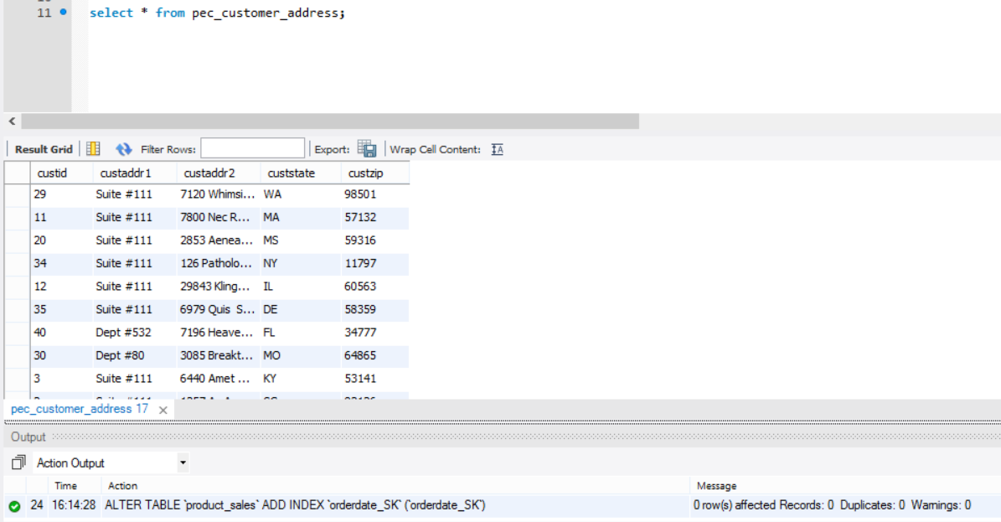

3. Indexes built to support queries
-- ALTER TABLE `product_sales` ADD INDEX `method_SK` (`method_SK`);
-- ALTER TABLE `product_sales` ADD INDEX `orderdate_SK` (`orderdate_SK`);
-- ALTER TABLE `product_sales` ADD INDEX `salesdate_SK` (`salesdate_SK`);
-- ALTER TABLE `product_sales` ADD INDEX `product_SK` (`product_SK`);
-- ALTER TABLE `product_sales` ADD INDEX `supplier_SK` (`supplier_SK`);

VIII. Handling Slowly Changing Dimensions (SCD)
SCD Type 1
Why
This type is also known as “overwrite” type. This is implemented when a data error is reported. When there is no need to maintain the original value and the overwriting can remove the data error, this type is used. We do not require to keep any history in this type.
Implementation
We implement SCD 1 in customer dimension.
Below is the screen shot from all rows displayed in customer dimension table.
select * from customer
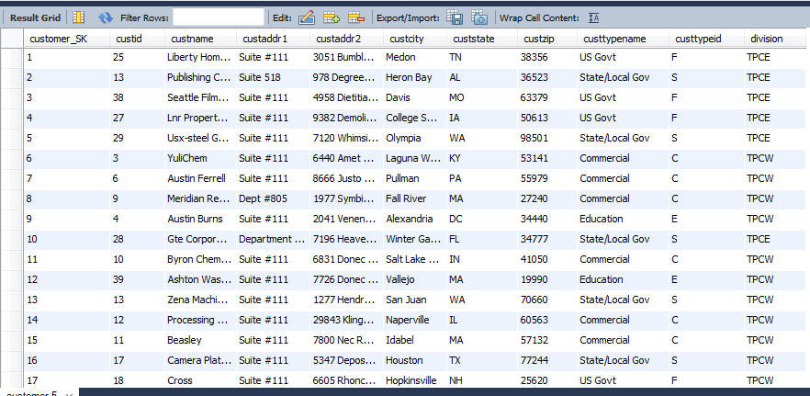
Screenshot for customer table

For example, it is detected that for custid = 3 and division = ‘TPCE’, the custcity has been wrongly placed, as it should have been “Fairport” instead of “Fairfax”.
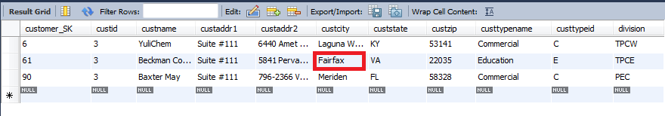To correct this issue, SCD 1 implementation can be used which overwrites the value and we run following query:
update customer set custcity ="Fairport " where customer_SK=61;
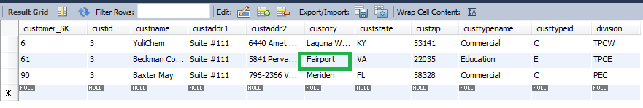
Now we can see that this customer city has been correctly updated to “Fairport “ for custid = 3 and division=’TPCE’.

SCD Type 2
Why
Also known as “Add a new row”, here the type is implemented for non-error cases .When there is need to preserve the historical change and a relevant change in some attribute has occurred. It includes when there is change in operational system and change for attribute is a ‘must’ to be recorded.
Implementation
It includes ‘before’ and ‘after’ field to capture the changes.
We use supplier dimension for this implementation.
We run a simple query, a select all from supplier dimension table and following result is captured. select * from supplier
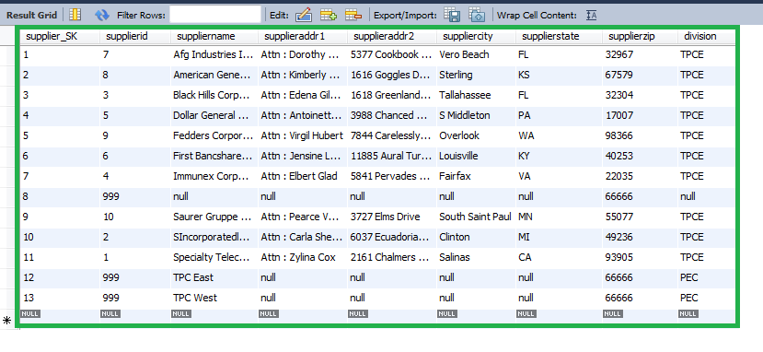
For example ,there is a change in operational system for supplier which says that for supplier id = 8 and division TPCE , the suppliername has been updated now to AG General Ventures Inc. from American General Ventures Incorporated .So ,in order to maintain this change in the data warehouse. We use SCD 2 , which says adding a new row to the table and giving the changed name.
We do it in following steps :
- We alter the table supplier and add column called “current” which give us the current state of the table for the name of supplier.
Similarly we add two other columns as “startdate and enddate” to keep the time track(befor and after) as when did the change happen.
alter table supplier add column current VARCHAR(1) default 'Y';
alter table supplier add column startdate date default '1970-01-01';
alter table supplier add column enddate date default '2099-01-01';
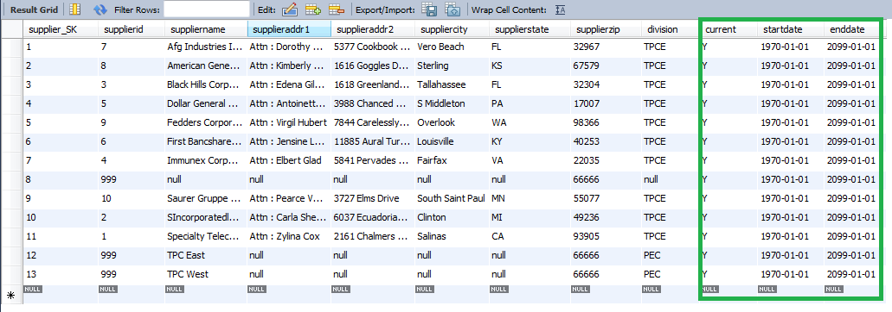
- Since in our case, the change has been recorded for supplierid = 3 & division =’TPCE’ which gives us Supplier _SK =2 , we run following query:
update supplier set current = 'N', enddate = now() where supplier_SK = 2; 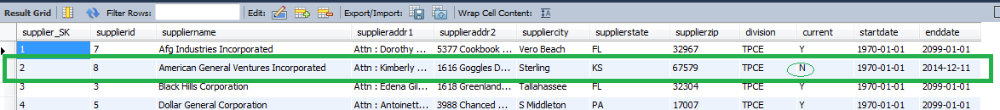
- To make an update for the new suppliername, we enter a new row.
Insert into supplier(supplier_SK,supplierid,suppliername,supplieraddr1,supplieraddr2, suppliercity,supplierstate, supplierzip,division, current, startdate)
values(14,8,'AG Ventures Inc','Attn : Kimberly Yarborough','1616 Goggles Drive','Sterling','KS',67579,'TPCE','Y',now());

- Results for the SCD 2 implementation
To test the same, we ran the following query
select * from supplier where supplier_Sk =2 or supplier_SK= 14;
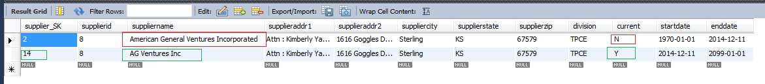
This new row in the supplier dimension keeps the track of history for name changed and automatically partitions history in the fact table.
Similarly, we identify couple of updates happened in operational system for supplierid=7 as follows:
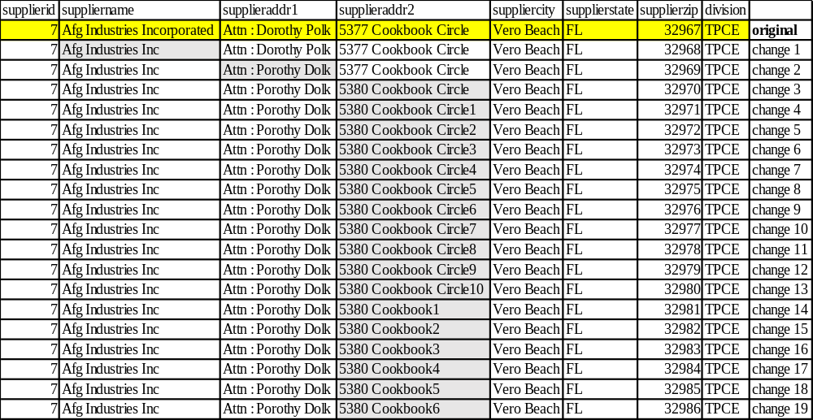
To incorporate these 19 changes we ran following queries:
- insert into supplier(supplier_SK,supplierid,suppliername,supplieraddr1,supplieraddr2, suppliercity,supplierstate, supplierzip,division, current, startdate)
values(15,7,'Afg Industries Inc','Attn : Dorothy Polk','5377 Cookbook Circle','Vero Beach','FL',32967,'TPCE','Y',now());
- insert into supplier(supplier_SK,supplierid,suppliername,supplieraddr1,supplieraddr2, suppliercity,supplierstate, supplierzip,division, current, startdate)
values(16,7,'Afg Industries Inc','Attn : Porothy Dolk','5377 Cookbook Circle','Vero Beach','FL',32967,'TPCE','Y',now());
- insert into supplier(supplier_SK,supplierid,suppliername,supplieraddr1,supplieraddr2, suppliercity,supplierstate, supplierzip,division, current, startdate)
values(17,7,'Afg Industries Inc','Attn : Porothy Dolk','5380 Cookbook Circle','Vero Beach','FL',32967,'TPCE','Y',now());
- insert into supplier(supplier_SK,supplierid,suppliername,supplieraddr1,supplieraddr2, suppliercity,supplierstate, supplierzip,division, current, startdate)
values(18,7,'Afg Industries Inc','Attn : Porothy Dolk','5380 Cookbook Circle1','Vero Beach','FL',32967,'TPCE','Y',now());
- insert into supplier(supplier_SK,supplierid,suppliername,supplieraddr1,supplieraddr2, suppliercity,supplierstate, supplierzip,division, current, startdate)
values(19,7,'Afg Industries Inc','Attn : Porothy Dolk','5380 Cookbook Circle2','Vero Beach','FL',32967,'TPCE','Y',now());
- insert into supplier(supplier_SK,supplierid,suppliername,supplieraddr1,supplieraddr2, suppliercity,supplierstate, supplierzip,division, current, startdate)
values(20,7,'Afg Industries Inc','Attn : Porothy Dolk','5380 Cookbook Circle3','Vero Beach','FL',32967,'TPCE','Y',now());
- insert into supplier(supplier_SK,supplierid,suppliername,supplieraddr1,supplieraddr2, suppliercity,supplierstate, supplierzip,division, current, startdate)
values(21,7,'Afg Industries Inc','Attn : Porothy Dolk','5380 Cookbook Circle4','Vero Beach','FL',32967,'TPCE','Y',now());
- insert into supplier(supplier_SK,supplierid,suppliername,supplieraddr1,supplieraddr2, suppliercity,supplierstate, supplierzip,division, current, startdate)
values(22,7,'Afg Industries Inc','Attn : Porothy Dolk','5380 Cookbook Circle5','Vero Beach','FL',32967,'TPCE','Y',now());
- insert into supplier(supplier_SK,supplierid,suppliername,supplieraddr1,supplieraddr2, suppliercity,supplierstate, supplierzip,division, current, startdate)
values(23,7,'Afg Industries Inc','Attn : Porothy Dolk','5380 Cookbook Circle6','Vero Beach','FL',32967,'TPCE','Y',now());
- insert into supplier(supplier_SK,supplierid,suppliername,supplieraddr1,supplieraddr2, suppliercity,supplierstate, supplierzip,division, current, startdate)
values(24,7,'Afg Industries Inc','Attn : Porothy Dolk','5380 Cookbook Circle7','Vero Beach','FL',32967,'TPCE','Y',now());
- insert into supplier(supplier_SK,supplierid,suppliername,supplieraddr1,supplieraddr2, suppliercity,supplierstate, supplierzip,division, current, startdate)
values(25,7,'Afg Industries Inc','Attn : Porothy Dolk','5380 Cookbook Circle8','Vero Beach','FL',32967,'TPCE','Y',now());
- insert into supplier(supplier_SK,supplierid,suppliername,supplieraddr1,supplieraddr2, suppliercity,supplierstate, supplierzip,division, current, startdate)
values(26,7,'Afg Industries Inc','Attn : Porothy Dolk','5380 Cookbook Circle9','Vero Beach','FL',32967,'TPCE','Y',now());
- insert into supplier(supplier_SK,supplierid,suppliername,supplieraddr1,supplieraddr2, suppliercity,supplierstate, supplierzip,division, current, startdate)
values(27,7,'Afg Industries Inc','Attn : Porothy Dolk','5380 Cookbook Circle10','Vero Beach','FL',32967,'TPCE','Y',now());
- insert into supplier(supplier_SK,supplierid,suppliername,supplieraddr1,supplieraddr2, suppliercity,supplierstate, supplierzip,division, current, startdate)
values(28,7,'Afg Industries Inc','Attn : Porothy Dolk','5380 Cookbook1','Vero Beach','FL',32967,'TPCE','Y',now());
- insert into supplier(supplier_SK,supplierid,suppliername,supplieraddr1,supplieraddr2, suppliercity,supplierstate, supplierzip,division, current, startdate)
values(29,7,'Afg Industries Inc','Attn : Porothy Dolk','5380 Cookbook2','Vero Beach','FL',32967,'TPCE','Y',now());
- insert into supplier(supplier_SK,supplierid,suppliername,supplieraddr1,supplieraddr2, suppliercity,supplierstate, supplierzip,division, current, startdate)
values(30,7,'Afg Industries Inc','Attn : Porothy Dolk','5380 Cookbook3','Vero Beach','FL',32967,'TPCE','Y',now());
- insert into supplier(supplier_SK,supplierid,suppliername,supplieraddr1,supplieraddr2, suppliercity,supplierstate, supplierzip,division, current, startdate)
values(31,7,'Afg Industries Inc','Attn : Porothy Dolk','5380 Cookbook4','Vero Beach','FL',32967,'TPCE','Y',now());
- insert into supplier(supplier_SK,supplierid,suppliername,supplieraddr1,supplieraddr2, suppliercity,supplierstate, supplierzip,division, current, startdate)
values(32,7,'Afg Industries Inc','Attn : Porothy Dolk','5380 Cookbook5','Vero Beach','FL',32967,'TPCE','Y',now());
- insert into supplier(supplier_SK,supplierid,suppliername,supplieraddr1,supplieraddr2, suppliercity,supplierstate, supplierzip,division, current, startdate)
values(33,7,'Afg Industries Inc','Attn : Porothy Dolk','5380 Cookbook6','Vero Beach','FL',32967,'TPCE','Y',now());
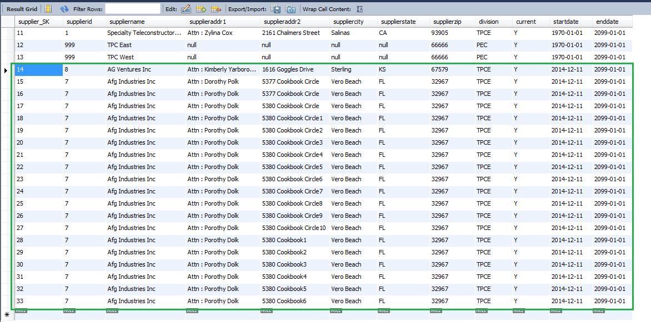

SCD Type 3
Why
Add new attribute, for changes that need to track down before and after .A new attribute is added as “Prior”. We implement type 3 when we require to store the history in a single record only. Type 3 basically keeps tracks of the last changed data.
Implementation
In order to reflect the same change as done in above example for SCD Type 2, we can do same by adding a column which can help in keeping the track for attribute “suppliername”.
The new column added would be named as priorname for supplier.
- Following query is executed to add the column “priorname “in to table.
alter table supplier add column priorname VARCHAR(50) NOT NULL default 'Val';
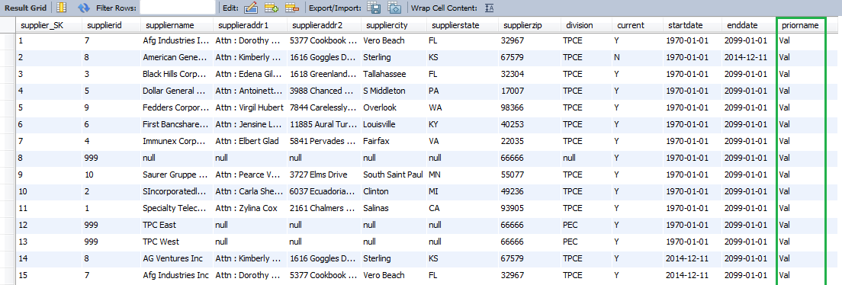

- After adding the column “priorname” into supplier , we set the column values to as “suppliername” column.(Here we uncheck the safe mode operation)
update supplier set priorname =supplier name;
select statement to test the values entered for supplier_SK =14;
select * from supplier ;
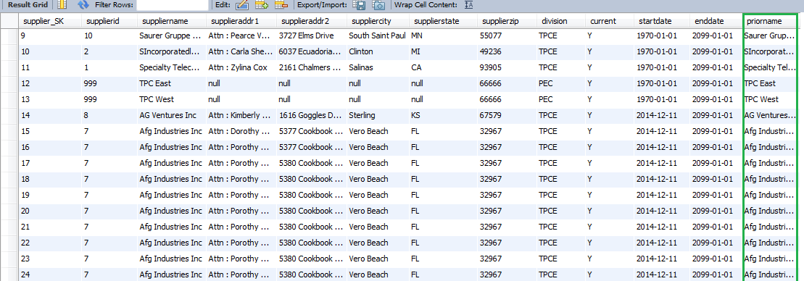
- For setting the change we, run following query:
update supplier set priorname = 'American General Ventures Inc' where supplier_SK = 14;

SCD 6:
Why
It also known as Hybrid dimension. SCD type 6 is a combination of type 1, 2, 3. This type is implemented usually when there is a need to maintain the complete history of the changes made.
Implementation
To implement SCD 6 which is also known as Unpredictable Changes with Single-Version Overlay, which also helps in keeping track of historical changes.
Add Type 1 attribute to Type 2 dimension
• A Type 2 row with a Type 3 column
• Type 3 column is overwritten as a Type 1
• Type 2+3+1
As in ealrlier cases , we have implemented SCD 2 and SCD 3 on supplier dimension , so now to implement we do SCD1 which is shown as below:
update supplier set current = 'N', enddate = now()
where supplier_SK = 14;
insert into supplier(supplier_SK,supplierid,suppliername,supplieraddr1,supplieraddr2, suppliercity,supplierstate, supplierzip,division, current, startdate,priorname)
values(34,8,'SG Ventures Inc','Attn : Kimberly Yarborough','1616 Goggles Drive','Sterling','KS',67579,'TPCE','Y',now(),'SG Ventures Inc');
The results of SCD 6.
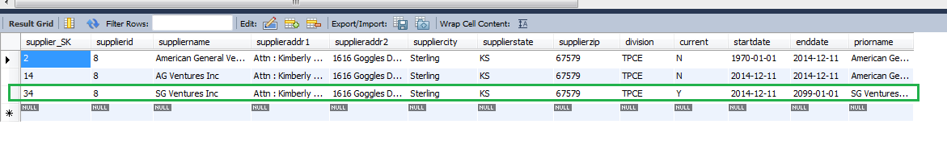

IX Many-to-Many (N-M) Relationship Implementation Option
We used the bridge table to implement M: N relationship between supplier and the shipping company.
The idea of implementing the bridge table is provided on kimbalgroup website[1].There are several other methods of implementing the N: M relationships as discussed in [2]. The paper discusses 5 different approaches for handling thee Many-to-Many relationships. The different approaches are listed below:
- Bridge table approach
- Denormalizing the dimension table by positional flag attributes.
- Denormalizing the dimension table by Non-positional attributes and concatenated field.
- Lowering the grain of the fact table.
- Lowering the grain of the fact table – Using 2 fact tables.
The reason behind using the bridge table approach is that there is no upper limit in many-side i.e the supplier dimension can have any number of rows and calculation of weighting factor is not relevant. Besides the storage redundancy is minimal.
Other approaches have their disadvantages like more storage, data redundancy; therefore we have decided not to implement them.
In our case, a supplier can have one or more shipping companies, and a shipping company may have more than one supplier as clients.
We implement a bridge table called supplier-shippingcompany-bridge which is similar to an associate table, and links the supplier dimension to shipping company dimension using their surrogate keys. We also have an attribute in the bridge table called weightingfactor that is fact used to determine the relationship between supplier and shipping company.
Weightingfactor will determine the strength of relationship between the supplier and shippingcompany. This attribute will be added manually based on the feedback and customer satisfaction surveys. We are assuming the data for this is outsourced to a private consultancy that provides us the numbers for our weightingfactor to associate every supplier with their shipping company and viceversa. Suppliers and shipping companies with no relation will have a weighting factor of 0.
Consider the below tables with dummy data:
Supplier:
supplier_SK | supplierid | suppliername | supplierddr1 | supplierddr2 | suppliercity | supplierstate | supplierzip | division
1 | 123 | John | 129/5 | Dow Road | Rochester | New York | 14623 | PEC
2 | 213 | Jane | 98/C | 2nd Street | Memphis | Tennessee | 32587 | TPCE
3 | 321 | Jimmy | 1290/2 | Link Road | Dallas | Texas | 94821 | TPCE
4 | 654 | jack | 28/B | Wall st. | Columbus | Ohio | 84795 | TPCW

Shipping Company:
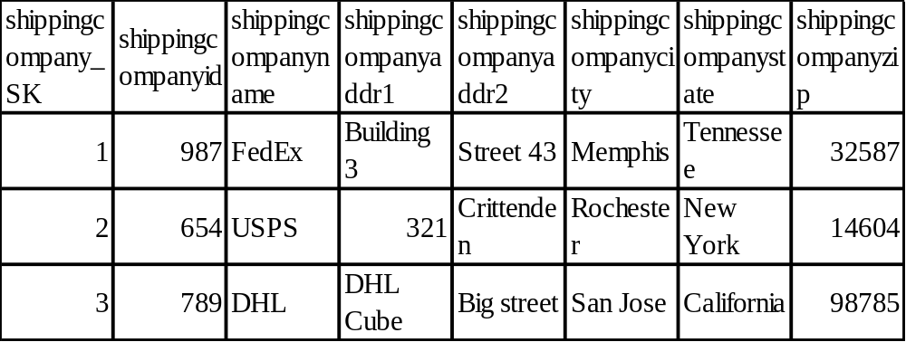
Supplier-to-shipping bridge
Supplier_SK | _SK | Weighting factor
1 | 2 | 0.75
2 | 3 | 0.81
3 | 3 | 0.97
4 | 1 | 0.59
4 | 2 | 0.73

From the above tables, we infer that higher the weighting factor, higher is the positive relation between supplier and the shipping company.
Below diagram displays the relationship between supplier and shipping company.
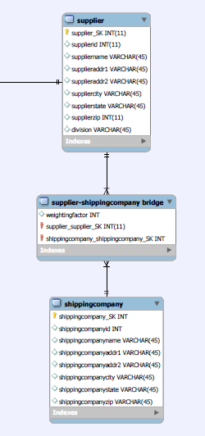
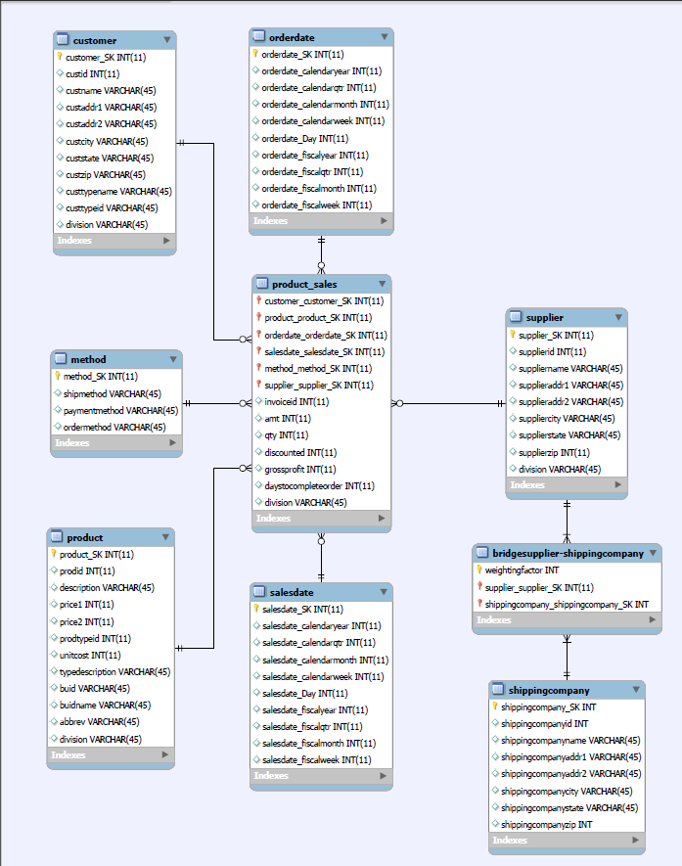
M: N Implemented Star Schema

REFERENCES:
[1] Design Tip #166 Potential Bridge (Table) Detours | Kimball Group. (n.d.). Retrieved from http://www.kimballgroup.com/2014/05/design-tip-166-potential-bridge-table-detours.
[2] Retrieved from http://intranet.cis.drexel.edu:8080/faculty/song/publications/p_Song_M_N_DMDW_final.pdf
[3] Retrieved from http://users.itk.ppke.hu/~szoer/DW/Kimball%20&%20Caserta%20-The%20Data%20Warehouse%20ETL%20Toolkit%20%5BWiley%202004%5D.pdf

**Note :
Entrie document is in “Times New Roman “ font size 12, Tables may or may not be in the same size to the formatting issues.

