An Internship Report
Of
YuvaIntern Web Development Internship

Submitted
To
School of Computer Science and Engineering
IILM University, Greater Noida, U.P.

In partial fulfilment of the requirement of degree of
B.Tech (Computer Science and Engineering)



By

Roll Number of Student: 2410031212
Name of Student: ANSHU RANJAN
Class: 3CSE23
Branch: B.Tech (Computer Science and Engineering)

CANDIDATE'S DECLARATION
I, ANSHU RANJAN, do hereby declare that the internship report titled “YuvaIntern Web Development Internship” has been completed by me to fulfil the requirement for the award of the degree of Bachelor of Technology in Computer Science and Engineering. All the references have been quoted and I have not taken as such any material from any other source. I affirm that this report is my own and has not been submitted to any other institute for any degree/diploma requirement, and further I shall be solely responsible for any kind of copyright violation in this regard.
Signature:-
Student Name: ANSHU RANJAN
Roll No.: 2410031212

ACKNOWLEDGEMENT
I am using this opportunity to express my gratitude to everyone who supported me throughout the Internship Program. I am thankful for their aspiring guidance, invaluably constructive criticism and friendly advice during this work. I am sincerely grateful to them for sharing their truthful and illuminating views on a number of issues related to this work.
I would like to thank the YuvaIntern team for providing me the opportunity and the structured platform to learn and gain hands-on exposure in the domain of Web Development, working on E-Governance & Digital Services projects. I am also thankful to my institute, IILM University, Greater Noida, and the faculty of the School of Computer Science and Engineering for their continuous support and encouragement.
I express my gratitude to my parents for their blessings.
Signature:-
Student Name: ANSHU RANJAN
Roll No.: 2410031212

TABLE OF CONTENTS
1. Candidate's Declaration ......................................................................... i
2. Acknowledgement .................................................................................. ii
3. Internship Completion Certificate & Offer Letter .............................. -
4. Project Description ................................................................................ 1
4.1 Introduction ..................................................................................... 1
4.2 Organization Profile ......................................................................... 2
4.3 Problem Statement ........................................................................... 3
4.4 Project Objectives ............................................................................ 3
4.5 Scope of the Project ......................................................................... 4
4.6 Technologies and Tools Used ........................................................... 4
4.7 System Architecture ......................................................................... 5
4.8 Methodology ..................................................................................... 6
4.9 Expected Outcomes .......................................................................... 7
4.10 Certificates of Completion and Communication Proof ................. 8
5. Bibliography/References ......................................................................... 9

3. INTERNSHIP COMPLETION CERTIFICATE
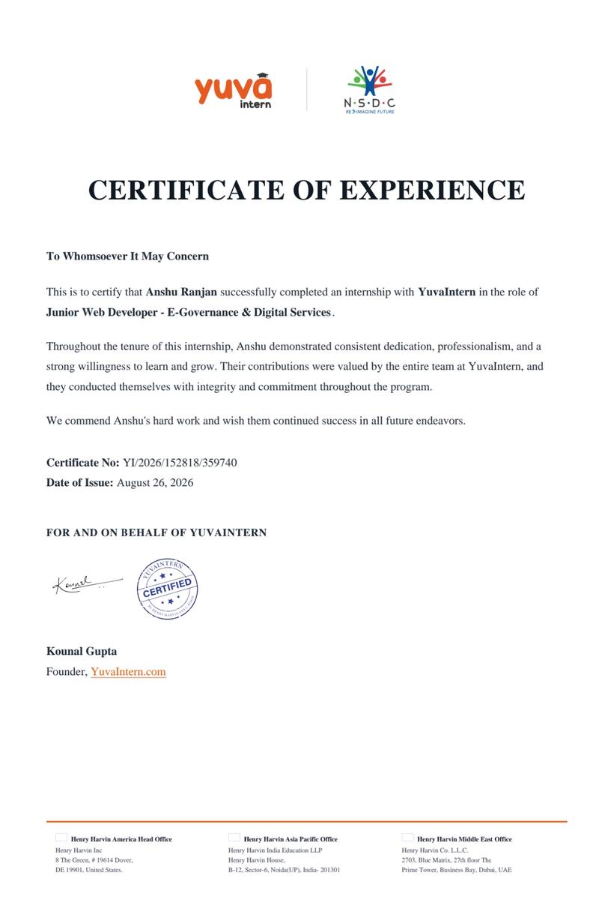

Internship Offer Letter
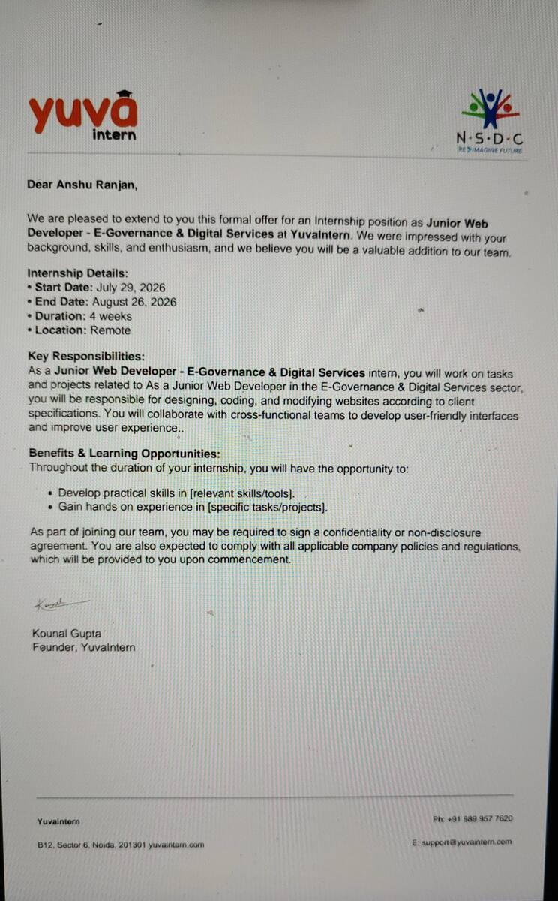

4. PROJECT DESCRIPTION

4.1 Introduction
This report presents a detailed account of the 4-week Internship undertaken with YuvaIntern, in the domain of “E-Governance & Digital Services”, in the role of Junior Web Developer. The internship was carried out from July 29, 2026 to August 26, 2026 as part of the requirement of the Bachelor of Technology (Computer Science and Engineering) programme at IILM University, Greater Noida.
The primary aim of this internship was to build a strong practical foundation in front-end web development using HTML, CSS, JavaScript and React, and to apply it to designing, coding, and modifying websites for E-Governance and digital-service related use cases, with a focus on building user-friendly, responsive interfaces.
The internship followed a structured, remote work model combining hands-on development tasks with collaboration across cross-functional teams. On successful completion of all the requirements, an Internship Certificate of Experience was awarded by YuvaIntern, in association with NSDC (National Skill Development Corporation).

4.2 Organization Profile
YuvaIntern is an internship platform, supported by NSDC (National Skill Development Corporation) under the theme “Re-Imagine Future”, that provides students with practical, project-based internship opportunities across domains including web development, digital services, and e-governance. YuvaIntern partners students with real-world style project tasks to help them build industry-relevant skills before entering the workforce, under the guidance of Kounal Gupta, Founder, YuvaIntern.

4.3 Problem Statement
Although a large number of engineering students learn the theoretical foundations of web technologies during their academic coursework, very few get structured, hands-on exposure to designing and building complete websites using an industry-relevant front-end stack. Concepts such as responsive layouts, DOM-based interactivity, and component-based UI development are often understood only at a theoretical level, with little practice in building, styling, and deploying real interfaces. The problem addressed by this internship was to practically learn and apply an HTML-CSS-JavaScript-React based front-end development workflow to designing, coding, and modifying websites for E-Governance & Digital Services use cases.

4.4 Project Objectives
- To understand and apply the fundamentals of HTML5 for structuring web pages.
- To design responsive, user-friendly interfaces using CSS (Flexbox and Grid layouts).
- To add client-side interactivity and form validation using JavaScript.
- To learn component-based UI development using React.
- To design, code, and modify websites according to client specifications.
- To collaborate with cross-functional teams to improve user experience of digital-service interfaces.
- To successfully complete all assigned tasks within the 4-week internship duration.

4.5 Scope of the Project
The scope of this internship spans the complete front-end web development workflow for E-Governance & Digital Services related pages — starting from understanding requirements and structuring pages with HTML, moving to responsive styling with CSS, adding interactivity with JavaScript, and extending into component-based development using React. The internship was limited to a remote, project-based learning environment provided by YuvaIntern, and did not involve deployment on any live government production system.

4.6 Technologies and Tools Used
- Markup & Styling: HTML5, CSS3 (Flexbox, Grid)
- Programming: JavaScript (DOM manipulation, form validation, event handling)
- Front-end Framework/Library: React (component-based UI development)
- Design Approach: Responsive, mobile-friendly web design
- Collaboration: Remote teamwork with cross-functional project members

4.7 System Architecture
The general architecture followed during the internship for the E-Governance & Digital Services web development track can be summarized in the following layers:
- Structure Layer: HTML5 is used to define the semantic structure and content of each web page.
- Presentation Layer: CSS is used to style pages responsively, ensuring usability across desktop and mobile screen sizes.
- Behaviour Layer: JavaScript adds interactivity, form validation, and dynamic updates to the page content.
- Component Layer: React is used to break the UI into reusable, maintainable components with managed state.
- Integration Layer: Components are assembled into complete pages that reflect client specifications for digital-service portals.

4.8 Methodology
The internship followed a structured, week-wise methodology combining hands-on development tasks, as summarized in the table below.
Week | Module | Description
1 | Onboarding & Requirement Understanding | Orientation to the E-Governance & Digital Services domain, understanding client requirements, wireframing page layouts, and building static page structure using HTML5.
2 | UI Development with CSS | Designing responsive, user-friendly interfaces using CSS (Flexbox/Grid), styling forms, navigation menus, and government-portal style layouts across screen sizes.
3 | Interactivity with JavaScript | Adding client-side interactivity using JavaScript — form validation, dynamic content updates, DOM manipulation, and improving usability of digital-service pages.
4 | Component Development with React | Converting static pages into reusable React components, managing component state, integrating UI with sample data, and final testing before handover.
Note: There was no stipend associated with this internship.

4.9 Expected Outcomes
- Ability to structure and build web pages using HTML5.
- Practical understanding of responsive design using CSS Flexbox and Grid.
- Hands-on exposure to adding interactivity and form validation using JavaScript.
- Capability to build and manage reusable UI components using React.
- Skill to design, code, and modify websites according to client specifications for E-Governance & Digital Services.
- A completed 4-week internship with an Internship Certificate of Experience issued by YuvaIntern, in association with NSDC.

4.10 Certificates of Completion and Communication Proof
The Internship Offer Letter and the Internship Certificate of Experience issued by YuvaIntern, confirming successful completion of the 4-week internship as Junior Web Developer - E-Governance & Digital Services, are attached in Chapter 3 of this report. The official offer communication e-mail from YuvaIntern is attached below as further communication proof.
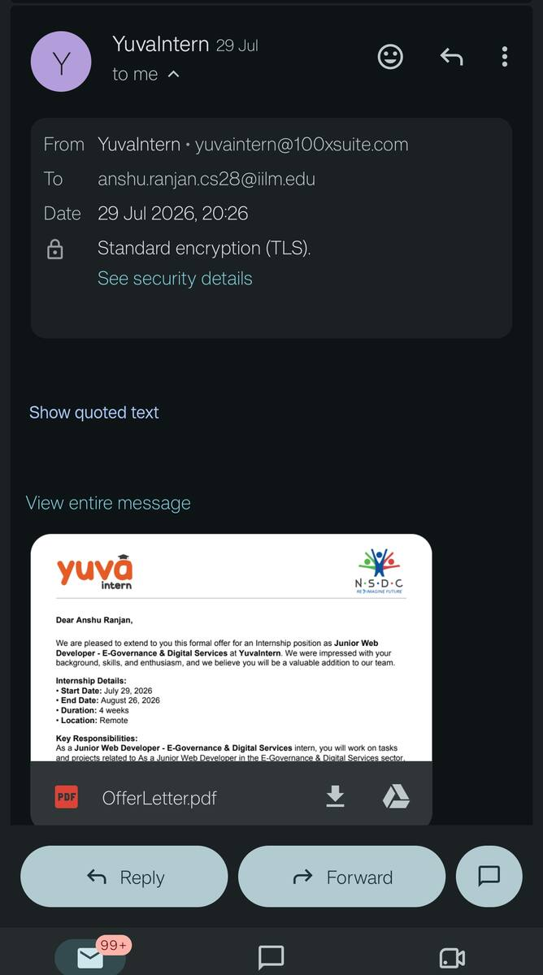

5. BIBLIOGRAPHY/REFERENCES
1. YuvaIntern, “Internship Offer Letter,” Junior Web Developer - E-Governance & Digital Services, 2026.
2. YuvaIntern, “Certificate of Experience,” Certificate No.: YI/2026/152818/359740, Date of Issue: August 26, 2026.
3. MDN Web Docs – HTML, https://developer.mozilla.org/en-US/docs/Web/HTML
4. MDN Web Docs – CSS, https://developer.mozilla.org/en-US/docs/Web/CSS
5. MDN Web Docs – JavaScript, https://developer.mozilla.org/en-US/docs/Web/JavaScript
6. React Documentation, https://react.dev/

