Face Recognition Attendance System

An AI-powered attendance system that uses facial recognition to automatically mark attendance using Python and machine learning libraries.

# 📌 Project Overview

This project automates the attendance-taking process using face recognition technology. The system identifies faces in real-time using a webcam, matches them with pre-stored images, and logs attendance with the current date and time in a CSV file.

# 🧰 Tech Stack

Language: Python

* Libraries Used:
* OpenCV – for capturing images and video stream
* face_recognition – for face encoding and comparison
* NumPy – numerical operations
* Pandas – attendance logging in CSV
* datetime – to log current date and time

# 🚀 Features

* Real-time face detection and recognition
* Attendance logging with name, date, and time
* Duplicate prevention (one attendance per day)
* CSV report generation
* Simple code structure and easy deployment

# 📂 Project Structure

Face_Recognition_Attendance_System/  
├── dataset/ # Registered face images  
├── attendance/ # Saved attendance records (CSV)  
├── encode_faces.py # Encodes faces from dataset  
├── main.py # Runs the webcam and attendance logic  
├── requirements.txt # Required Python libraries  
├── README.md # Documentation  
└── assets/  
 └── output.JPG

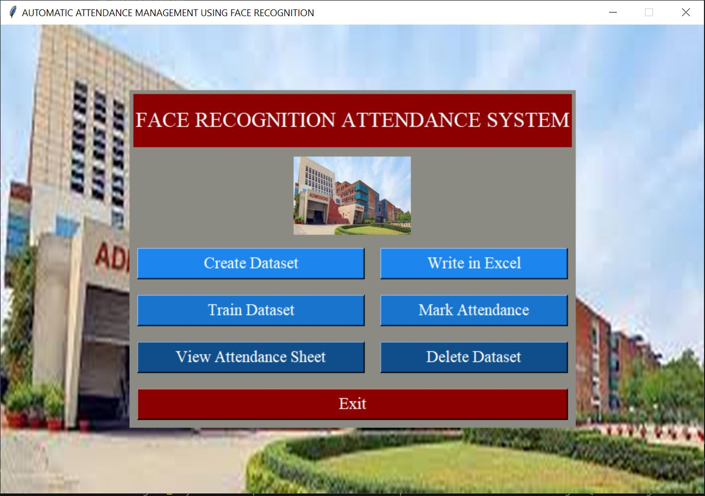

# 🛠️ Installation

1. Clone the repository:

git clone https://github.com/YourUsername/Face_Recognition_Attendance_System.git  
cd Face_Recognition_Attendance_System

2. Install required libraries:

pip install -r requirements.txt

3. Register Faces:  
- Add face images (with names) in the dataset/ folder.

4. Encode Faces:

python encode_faces.py

5. Run Attendance System:

python main.py

# 📸 Sample Output

Below is the GUI of the system showing all the functional buttons:



# 📈 Future Enhancements

* Add GUI using Tkinter or PyQt
* Multiple face detection for group settings
* Cloud database integration
* Real-time SMS/email notification system
* Android app using Flask API

# 🙋‍♂️ Author

Anshu Tripathi  
MCA Graduate | Python Developer | Machine Learning Enthusiast

# 📄 License

This project is open-source and licensed under the MIT License.