EXP 2: COMPUTATION OF TABLE AND GRAPHS

NAME: ANSHU YADAV
REG. NO: 24BAI1638

empid=c(1,2,3,4,5,6,7,8,9,10)
empid #for printing
age=c(30,25,40,34,55,50,35,23,54,44)
age
gender=c(1,0,1,0,1,1,1,1,0,1)
gender
status=c(1,1,2,2,1,2,1,2,2,1)
status

empinfo=data.frame(empid,age,gender,status)
empinfo

nrow(empinfo)
ncol(empinfo)

empinfo$gender=factor(empinfo$gender,levels=c(0,1),labels=c("Male","Female"))
empinfo
empinfo$status=factor(empinfo$status,levels=c(1,2),labels=c("Staff","Faculty"))
empinfo
summary(empinfo)
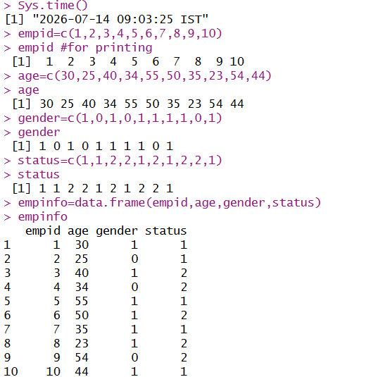

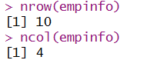
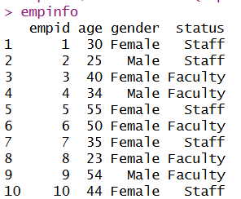

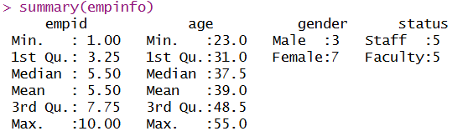

empinfo$age #display only the age column

empinfo[,"age",drop=FALSE] #display as column vector

empinfo[,1]
empinfo[,2]
empinfo[1,]
empinfo[2,]

empinfo[3,3]
empinfo[1:5,2:3]

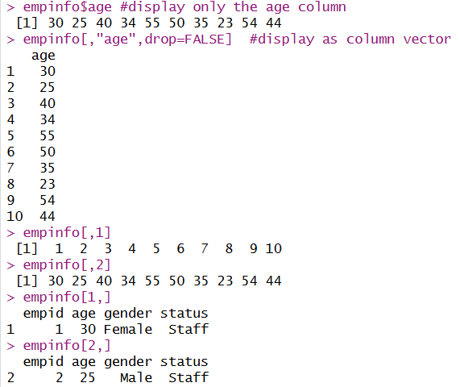
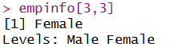
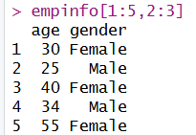

plot(age,type="o",main="Age of subjects",
xlab="Employee order",
ylab="Age in years",
col="blue")

#pie plot
Table1=table(empinfo$gender);
Table1
pie(Table1)

#Bar plot
Table3=table(empinfo$gender,empinfo$status)
Table3
barplot(Table3,beside=T,xlim=c(1,15),ylim=c(0,5),col=c("blue","red"))
legend("topright",legend=rownames(Table3),fill=c("blue","red"))

