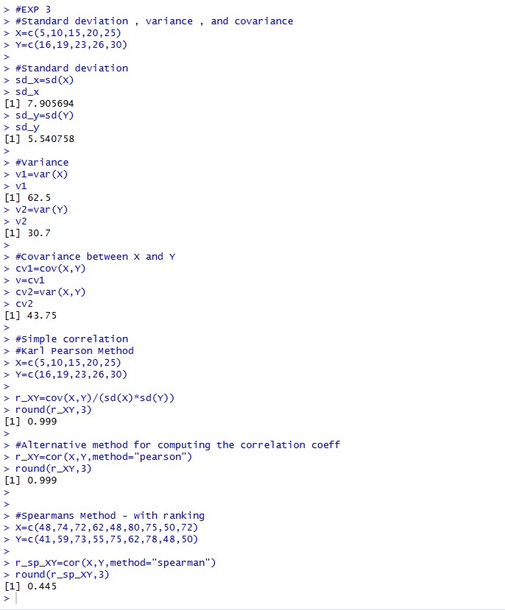

#exp 3 Regression

x=c(1,2,3,4,5)
y=c(40,50,55,65,70)
reg=lm(y~x)
reg
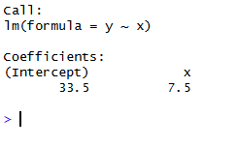
data=mtcars
SLR=lm(data$mpg~data$wt)
SLR
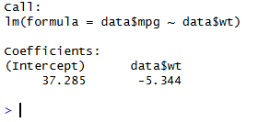
summary(SLR)
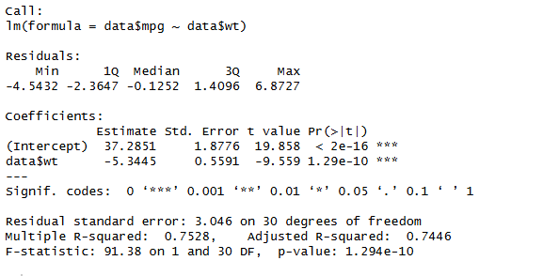

plot(mtcars$hp,mtcars$mpg,main="MPG VS horsepower",xlab="Horsepower",ylab="Miles per gallon",pch=15,col="blue")
abline(lm(mpg~hp,data=mtcars),col="red",lwd=2)
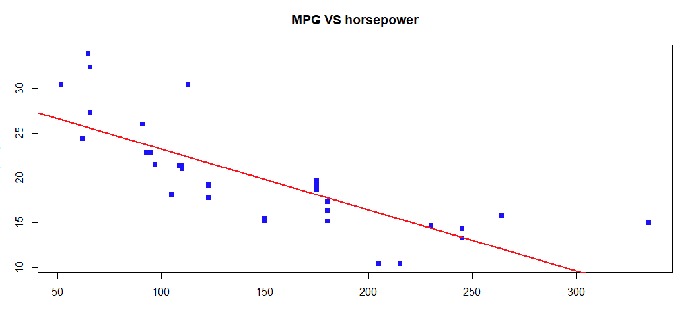

new_data=data.frame(wt=c(1,2,3,50))
new_data
pred=predict(lm(mpg~wt,data=mtcars),newdata=new_data,interval='prediction')
pred
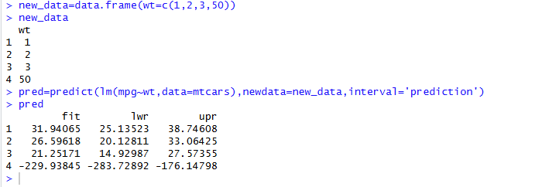

EXP 4

x1=c(30,40,20,50,60,40,20,60)
x2=c(11,10,7,15,19,12,8,14)
y=c(110,80,70,120,150,90,70,120)
reg=lm(y~x1+x2)
summary(reg)

library(scatterplot3d)

graph=scatterplot3d(x1,x2,y,main="Multilpe liinear regression model",pch=4,color="green",xlab="x1",ylab='x2',zlab="Y")
graph$plane3d(reg,col="red",lty=2)

data(mtcars)

head(mtcars)

model=lm(mpg~wt+hp+disp,data=mtcars)

summary(model)

newcar=data.frame(wt=2.8,hp=110,disp=170)
predict(model,newdata=newcar)
predict(model,newdata=newcar, interval="prediction")

x1=c(195,255,195,255,255,255,255,195,255,255,255,255,255,340)
x2=c(4.0,4.0,4.6,4.6,4.2,4.1,4.6,4.3,4.3,4.0,4.7,4.3,4.72,4.3)
y=c(1004,1636,852,1506,1272,1270,1269,903,1555,1260,1146,1276,1225,1321)
reg=lm(y~x1+x2)
summary(reg)

library(scatterplot3d)

graph=scatterplot3d(x1,x2,y,main="Multilpe liinear regression model",pch=4,color="green",xlab="drive in time",ylab='dose',zlab="gain")
graph$plane3d(reg,col="red",lty=2)

x1=c(900,1100,1300,1500,1700,1900,2100,2300,2500,2700,1200,1600,2000,2400,2800)
x2=c(2,2,3,3,3,4,4,4,5,5,2,3,4,5,5)
y=c(10,145,170,195,255,285,315,345,380,155,210,270,335,390,390)

reg=lm(y~x1+x2)

summary(reg)

graph=scatterplot3d(x1,x2,y,main="Multilpe liinear regression model",pch=4,color="green",xlab="Area",ylab='bedrooms',zlab="price")
graph$plane3d(reg,col="red",lty=2)
