**HARDWARE REQUIREMENTS FOR THIS PROJECT**

**1. ESP32 Development Board**

The ESP32 is a development board developed by Espressif systems. It can be programmed using Arduino IDE and ESP-IDF. It has a built in Bluetooth module and CAN protocol and SRAM. It has 36 GPIO Pins with a CPU clock of 160MHz. It has 12-bit ADC onboard and supports CAN, UART, I2C and I2S. It can be used in prototyping IoT products, Low power Battery operated application, small range networking projects, and with the projects which require many Input Output Pins and Wi-Fi and Bluetooth connectivity.

ESP32 WROOM-32 MCU Module Specifications:

Microprocessor: Tensilica Xtensa LX6

Operating Voltage: 3.3V

Analog Input Pins: 12-bit, 18 Channel

DAC Pins: 8-bit, 2 Channel

Digital I/O Pins: 39 (of which 34 is normal GPIO pin)

SRAM: 520KB

WiFi: 802.11 b/g/n

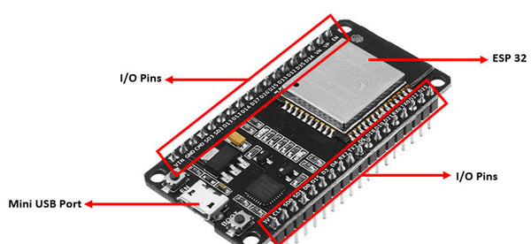

**2. SIM800L GPRS GSM Module**

The **SIM800L** is a micro SIM low cost **GSM/GPRS Development Module**. The Module supports TTL communication and hence can easily communicate with Microcontrollers without the need of additional data converters. The module also supports antenna with IPX connector.

**SIM800L**module can be used to make a call, receive a call, send and receive text messages, connecting to internet through GPRS, TCP/IP, etc. Moreover the module supports quad-band GSM/GPRS network, so it can operate globally.

The **SIM800L GPRS GSM Module** is compact in nature and hence can be directly used on final Designs. The on-board LED indicates the connection status of the Board, when there is no signal the LED flashes quickly and when a signal is established it flashes slowly.

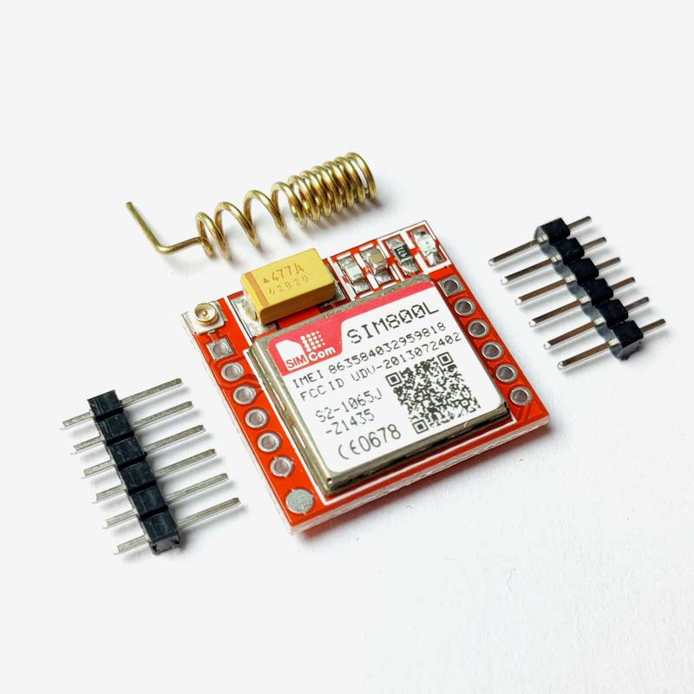

**3. NEO-6M GPS Module**

The **NEO-6M** is a stand-alone **GPS** (Global Positioning System) module featuring a high-performance 50 channel U-Blox 6 positioning engine. The **NEO6M GPS module** checks for location on Earth and provides the Latitude and Longitude of the position it is in. This is a low-cost module with a detachable antenna, which also comes with a logic level converter and a voltage regulator, which makes it compatible with both 5V and 3.3V powered boards like Arduino Uno, ESP32, etc. It can be used in the Navigation Systems of Smartphones and Tablets, Drones, in location-based services, etc.

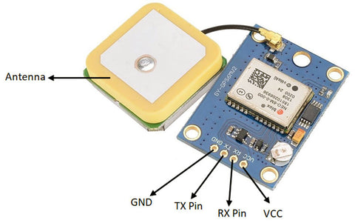

**4. ADXL335 - Triple Axis Linear Accelerometer** ADXL335 is a Breakout board based on 3 axis ADXL335 IC from Analog Devices. The Accelerometer Module requires no external devices and works on 5V power supply. It can be directly interfaced to ADC of a microcontroller without any external components.

This module can be used to sense motion or tilt (in case of non moving) in 3 axis.

 The ADXL335 is a triple axis MEMS accelerometer with extremely low noise and power consumption - only 320uA.

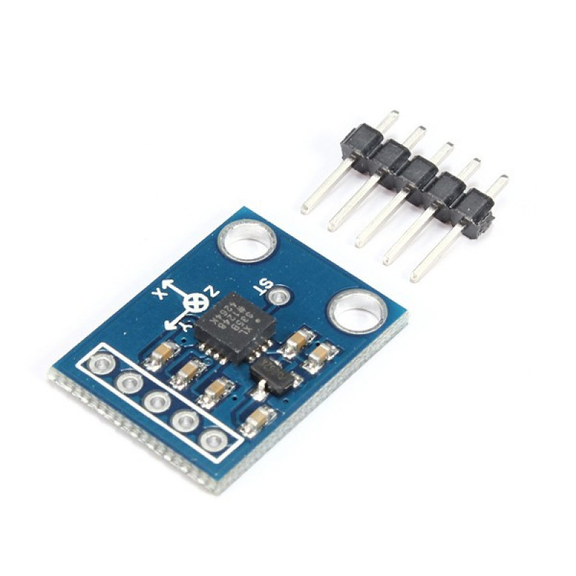

**5. Piezoelectric sensor 35mm** This piezoelectric sensor 35mm measures changes in pressure, acceleration, force, temperature or strain and converts them into electrical voltage.  This is generally used to detect vibration or a knock. This can also be used for a very small audio transducer such as a buzzer. As it gives out analog output you can connect the output to comparator circuit to give out digital output of you can connect an ADC to directly connect to the microcontroller you are using.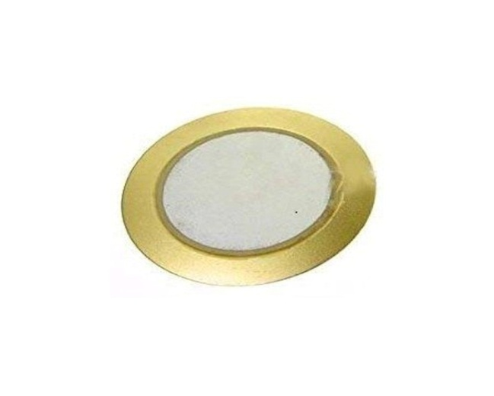

**6. IR Flame/Fire Sensor Module**

This **flame sensor** or **fire sensor module**works on the concept that when a flame or fire is burning it emits IR signals. This IR signal is then received by the IR receiver on the **fire sensor module** to detect the flame or fire.

The sensor has an operating voltage from 3V to 5.5V and has both digital and analog output. The sensitivity of the digital output can be controlled by the on-board potentiometer. Detection angle of sensor is 60 degree and range is theoretically 100cm but practically you can get upto 20-30cm.

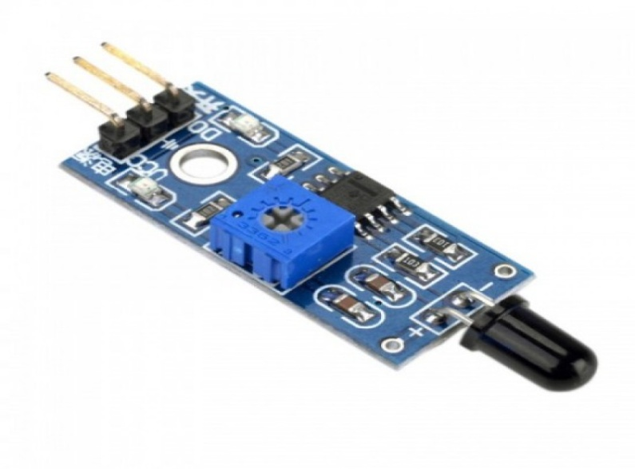

### 7. 18650 Li-ion 2000mAh Rechargeable Battery

**18650 battery** is a Li-ion rechargeable battery with 2000 mAh Battery Capacity. It is very useful for applications which require continuous high current or high current in short bursts. An 18650 cell can be charged and discharged up to 1000 cycles without much loss in battery capacity. They are safe to use, environment friendly and has a long battery life. It comes with high energy density and provides excellent continuous power sources to your device.

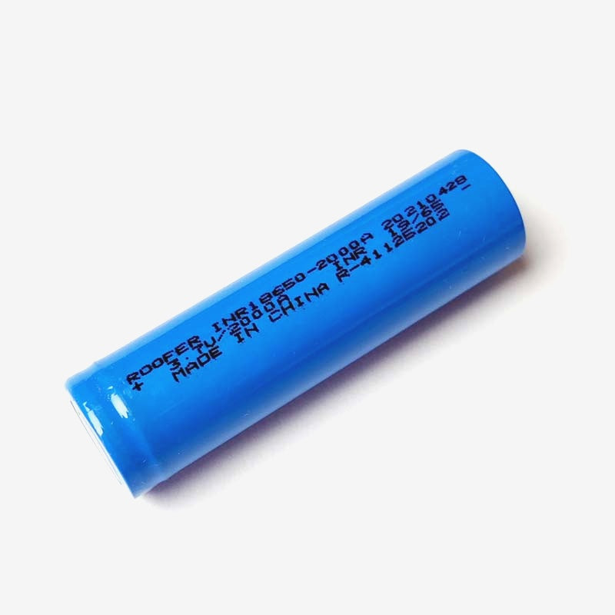

**SOFTWARE REQUIREMENTS FOR THIS PROJECT**

**PlatformIO IDE for VSCode**

PlatformIO is a cross-platform, cross-architecture, multiple framework, professional tool for embedded systems engineers and for software developers who write applications for embedded products. It can be used to develop software platforms for Arduino, ESP32, PIC32, and AVR. PlatformIO can be used with VS Code to provide a powerful set of tools to assist you in development.

**Visual Studio Code** is a lightweight but powerful source code editor which runs on your desktop and is available for Windows, macOS and Linux. PlatformIO can be used as extension in VSCode.

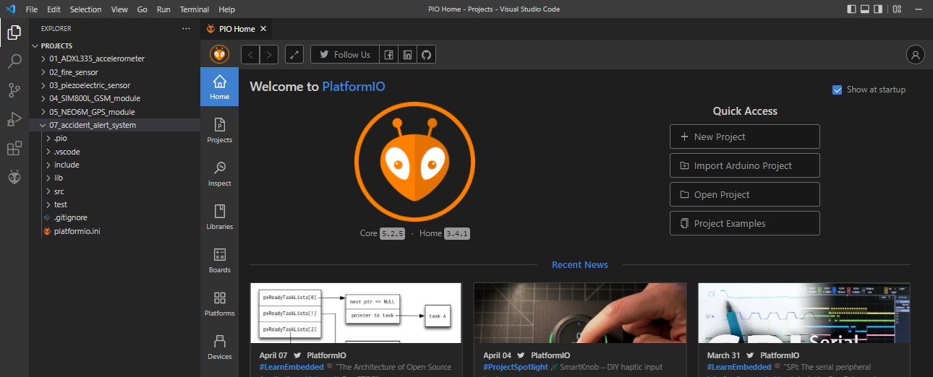

**Libraries used in this Project**

**1. TinyGPS:** TinyGPS is designed to provide most of the NMEA GPS functionality like position, date, time, altitude, speed and course – without the large size that seems to accompany similar bodies of code.  To use it, specify #include <TinyGPS.h>.

**2. SoftwareSerial:** SoftwareSerial is a library that enables serial communication with a digital pin other than the serial port. It is possible to have multiple software serial ports with speeds up to 115200bps. To use it, specify #include <SoftwareSerial.h>.