**Impact of News and Social Media on**

**Financial Markets**

Project Report

**Final year B.Tech Project-2018**

By

**Anshul Goyal** **(147106)**

**Kiran Konduru (147126)**

**Ibrahim Shaik (147148)**

Guided by

**Dr. K. V. Kadambari**

Dept. of Computer Science and Engineering

NIT Warangal

**Contents**

* Abstract …………………………………………………. 1
* Efficient Market Hypothesis ……………………………. 2
* Types of Data …………………………………………… 3
* Data Collection
  1. Datasets …….……………………………………. 4
  2. Data Collection Model …………………………... 5
* Financial Parameter – DJIA …………………………….. 6
* Formal Model – High Level Flow Diagram ……………. 7
* Text Preprocessing …………………………………….... 8
* Text to Features …………………………………………. 9
* Sentiment Analysis …………………………………….. 10
* Basic Implementation ………………………………….. 11
* Future Plan of Action ………………………………....... 12
* References ……………………………………………… 13

**Abstract**

Financial market analysis on the basis of financial news and social media sites like Twitter etc. has drawn a lot of attention recently. The objective of this study is to develop a market sentiment model for financial markets using machine learning and see its impact on various financial market indicators like market indices, trading volumes, market volatility, socio-economic impact and financial risk of companies.

Due to the volatility of the financial market, price fluctuations based on news reports and social media sentiment are common. Traders draw upon a wide variety of publicly-available information to inform their market decisions.

Sentiment analysis can use natural language processing, machine learning, text analysis and computational linguistics to identify the attitude of a writer with respect to a topic. It’s an important cornerstone of behavioral finance, where theorists believe that markets are irrational and that asset prices are driven by human emotion (e.g., fear, greed, hope and overconfidence, among others).

The efficient market hypothesis (EMH) asserts that financial market valuations incorporate all existing, new, and even hidden information, since investors act as rational agents who seek to maximize profits. Behavioral finance has challenged this notion by emphasizing the important role of behavioral and emotional factors, including social mood, in financial decision-making. As a consequence, measuring investor and social mood has become a key research issue in financial prediction and can be done efficiently using machine learning.

The proposed work is currently focused on finding association between financial indicators

and sentiment based on social media, financial news and general world news.

**Efficient Market Hypothesis – An Introduction**

The **efficient market hypothesis** (EMH) asserts that financial markets are "informational efficient", or that prices on traded assets (e.g., stocks, bonds, or property) already reflect all known information, and instantly change to reflect new information. Information or news in the EMH is defined as anything that may affect prices that is unknowable in the present and thus appears randomly in the future. Stock market prediction brings with it the challenge of proving whether the financial market is predictable or not, since there has been no consensus on the validity of Efficient Market Hypothesis (EMH).

Stock market prediction has been an important issue in the field of finance, engineering and mathematics due to its potential financial gain. As a vast amount of capital is traded through the stock market, the stock-market is seen as a peak investment outlet. Researchers have strived for proving the predictability of the financial market. Henceforth, Stock Market prediction has always had a certain appeal for researchers. While numerous scientific attempts have been made, no method has been discovered to accurately predict stock price movement. Even with a lack of consistent prediction methods, there have been some mild successes.

**Types of Data**

We are planning to use three types of data for our analysis.

1. **General World News** – Using the general world news to predict the impact on financial parameters. For example – How would a terrorist in some ‘X’ country affect the DJIA index etc.? We will be analyzing this news in two forms -
2. General World News Headlines
3. General World News Articles
4. **Financial News** – Using news specifically from the financial domain to predict the impact on financial parameters. This should intuitively present better results than the general world news. We will be analyzing this news in two forms -
5. Financial News Headlines
6. Financial News Articles
7. **Social Media Data** – Using data from popular microblogging sites like Twitter which are being extensively used in real time sentiment tracking and public mood modeling.

**Data Collection – Datasets**

1. **Reddit News Dataset:** This dataset consists of top 25 daily general world news headlines collected for the period 2008-2016. The news source is Reddit News. No news articles are available.
2. **New York Times Dataset:** Created our own data collection model in order to use the NYT API to gather news headlines and articles for the period 2008-2016. A financial dictionary was constructed to filter the financial news and a web crawler was written to get the news articles. Approximately, 3800 world news articles per month and 1000 financial news articles are being collected.
3. **Twitter Dataset:** No open source dataset required for our application was found. Dataset is being created on a weekly basis using the Twitter API.
4. **DJIA Dataset:** Dow Jones Industrial Average (DJIA) index data was collected from Yahoo Finance for the period 2008-2016.

**Data Collection – Data Collection Model**

The following diagram shows the data collection model constructed.

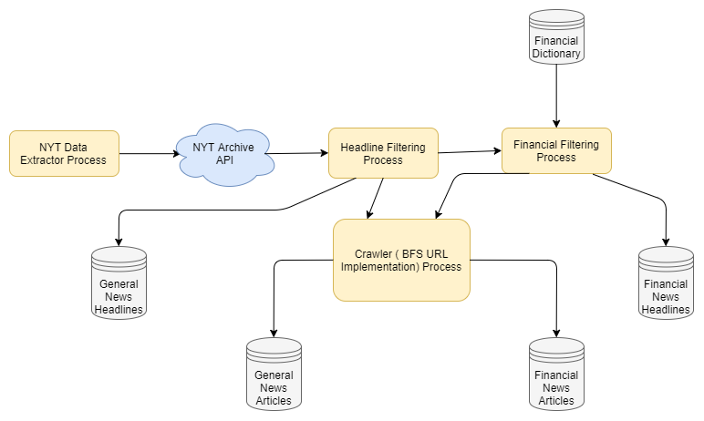

**Financial Parameter – DJIA**

Currently we are working with DJIA as our financial parameter which would also be extended for other financial parameters in the near future.

**DJIA – Dow Jones Industrial Average**

The Dow Jones Industrial Average (DJIA) is a stock market index, and one of several indices created by Wall Street Journal editor and Dow Jones & Company co-founder Charles Dow. The industrial average was first calculated on May 26, 1896.

It is an index that shows how 30 large publicly owned companies based in the United States have traded during a standard trading session in the stock market.

The value of the Dow is not the actual average of the prices of its component stocks, but rather the sum of the component prices divided by a divisor, which changes whenever one of the component stocks has a [stock split](https://en.wikipedia.org/wiki/Stock_split) or [stock dividend](https://en.wikipedia.org/wiki/Stock_dividend), so as to generate a consistent value for the index.

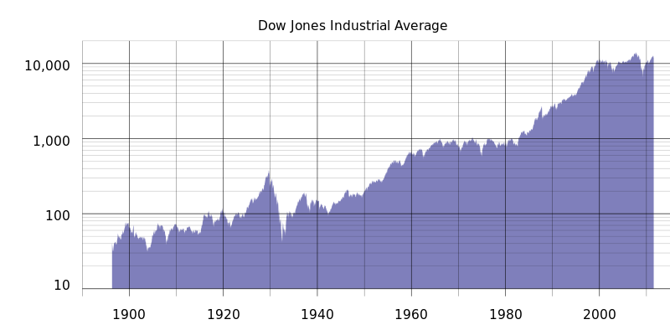

Historical logarithmic graph of the DJIA from 1896 to July 2011

**High Level Flow Diagram**

The following diagram depicts the high level formal model.

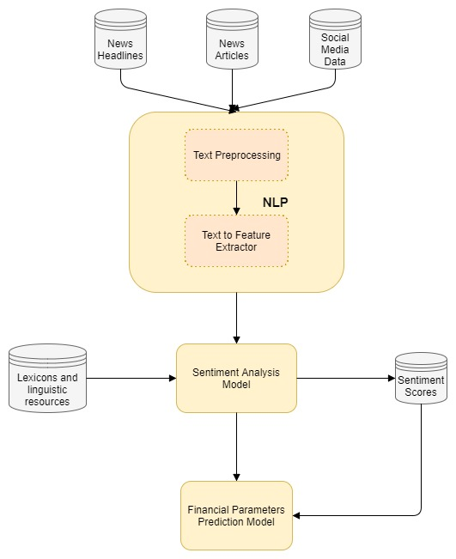

**Text Preprocessing**

The following text preprocessing techniques are being tested for our application.

1. **Noise Removal** - Any piece of text which is not relevant to the context of the data and the end-output can be specified as the noise. A general approach for noise removal is to prepare a dictionary of noisy entities, and iterate the text object by tokens (or by words), eliminating those tokens which are present in the noise dictionary. Ex: Stop words filtering etc.
2. **Lexicon Normalization** - Another type of textual noise is about the multiple representations exhibited by single word. Normalization is a pivotal step which converts the high dimensional features (N different features) to the low dimensional space (1 feature).
   1. **Stemming** - It is a rudimentary rule-based process of stripping the suffixes (“ing”, “ly”, “es”, “s” etc.) from a word.
   2. **Lemmatization** - It is an organized & step by step procedure of obtaining the root form of the word, it makes use of vocabulary (dictionary importance of words) and morphological analysis (word structure and grammar relations).
3. **Object Standardization** – Text data often contains words or phrases which are not present in any standard lexical dictionaries. Example – Removing colloquial slangs from tweets etc.

**Text to Features**

The following feature engineering techniques for text data are being tested for our application.

1. **Named Entity Recognition (NER)** - The process of detecting the named entities such as person names, location names, company names etc. from the text is called as NER. A typical NER model consists of three blocks:
   1. **Noun phrase identification**
   2. **Phrase classification**
   3. **Entity disambiguation**
2. **Topic Modeling** - Topic modeling is a process of automatically identifying the topics present in a text corpus, it derives the hidden patterns among the words in the corpus in an unsupervised manner. Topics are defined as “a repeating pattern of co-occurring terms in a corpus”.
3. **N-grams as features** – A combination of N words together are called N-Grams. N grams (N > 1) are generally more informative as compared to words (Unigrams) as features.
4. **Term Frequency – Inverse Document Frequency (TF – IDF)** - TF-IDF is a weighted model commonly used for information retrieval problems. Formula for TF-IDF calculation is :

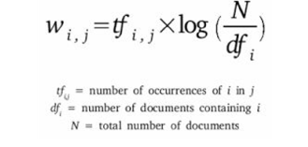

**Sentiment Analysis –TBD by Kiran**

**Basic Implementation**

Current implementation is done on the Reddit general world news headlines dataset without using the sentiment analysis model using different classifiers to predict the direction of DJIA index.

* 1. Without Text-Preprocessing

|  |  |
| --- | --- |
| **Classifier Used** | **Accuracy** |
| Logistic Classifier | 51.58 % |
| SVM | 42.32 % |
| Random Forest | * 1. % |

* 1. With Text-Preprocessing

|  |  |
| --- | --- |
| **Classifier Used** | **Accuracy** |
| Logistic Classifier | 56.35 % |
| SVM | 55.82 % |
| Random Forest | 56.61 % |

**Future Plan of Action**

* Designing and Implementing a Sentiment Analysis Model specifically for use in financial domain.
* Collecting Social Media Data using Twitter API
* Incorporating other types of data for analysis : Financial News and Social Media Data
* Using other financial market parameters apart from DJIA for prediction like commodities, company stocks etc.
* Tackling the effect of news sentiment on (T+1) day.

**References**

# Desheng Dash Wu, David L. Olson - Financial Risk Forecast Using Machine Learning and Sentiment Analysis

# Sunandan Chakraborty, Ashwin Venkataraman, Srikanth Jagabathula and Lakshminarayanan Subramanian - Predicting Socio-Economic Indicators using News Events

# Chuan-Ju Wang , Ming-Feng Tsai , Tse Liu , Chin-Ting Chang - Financial Sentiment Analysis for Risk Prediction

# Jinjian Zhai, Nicholas Cohen, Anand Atreya - Sentiment analysis of news articles for financial signal prediction

# Huina Mao, Scott Counts, Johan Bollen - Predicting Financial Markets: Comparing Survey, News, Twitter and Search Engine Data