**APPENDIX 1**

**CUSTOMER RELATIONSHIP MANAGEMENT**

PROJECT REPORT

***by***

|  |  |
| --- | --- |
| Tirtharaj Dutta Roy | 12323508 |
| Sasmit Dey Sarkar | 12322136 |
| Anshul Bhuria | 12324584 |

(Section: K23CA)

(Roll No. 25, 26, 27)



**Department of Computer Science and Engineering**

**School of Computer Science Engineering**

**Lovely Professional University**

**Jalandhar, Punjab**

November - 2023

**APPENDIX 2**

**Student Declaration**

This is to declare that this report has been written by me/us. No part of the report is copied from other sources. All information included from other sources has been duly acknowledged. I/We acknowledge that if any part of the report is found to be copied, I/we shall take full responsibility for it.

Signature

Sasmit Dey Sarkar

Roll number: 25

Signature

Tirtharaj Dutta Roy

Roll number: 26

Signature

Anshul Bhuria

Roll number:27

Place: Jalandhar, Punjab

Date: 20/11/2023

**APPENDIX 3**

**TABLE OF CONTENTS**

**S.NO TITLE PAGE NO.**

|  |
| --- |
| 1-4 |
| 5 |
| 6-7 |
| 8-9 |
| 10-15 |
| 16-17 |

1. Introduction…………………………………….

2. Objectives of project……………………………

3. Features of Project…….………………………..

4. Website Snapshots……………………………...

5. Code Snapshots………………………………...

6. Future Scope of Project………………………...

**APPENDIX 4**

BONAFIDE CERTIFICATE

Certified that this project report “NEWS WEBSITE” is the bonafide work of

“HARISH BARANWAL, NITISH KUMAR CHOUDHARY, CHAMAN SINGH”

Who carried out the project work under my supervision.

**Mr.Abrar Ahmed Raza**

Assistant Professor

ID: 30574

Department of

Computer Science and

Engineering

# 

# Chapter-1

# Introduction:

**HTML** stands for Hypertext Markup Language. It was created by Tim Berners-Lee in 1991. The first version of HTML is HTML 2.0 which was published in 1999, and the latest version is HTML 5. We can save HTML files with an extension .html. It is the most basic language, and simple to learn and modify.

It contains the elements that can change/develop a web page’s look and the displayed contents. Or we can say that HTML creates or defines the structure of web pages. We can create websites using HTML which can be viewed on internet-connected devices like laptops, android mobile phones, etc. It is a combination of both hypertext and markup language.

Text that is not restricted to a sequential format and that includes links to other text is called Hypertext. The links can connect online pages inside a single or different website.

Markup Language is a language that is interpreted by the browser and it defines the elements within a document using “tags”. It is human-readable, which means that markup files use common words rather than the complicated syntax of programming languages.

HTML is the first language you should learn if you want to go for web development. HTML is a markup language that loads fast and is also light weighted. Whenever you use your browser to contact a server, you will receive a response in the form of HTML and CSS. Many tags are supported by HTML, making your web page more appealing and recognizable. HTML5 has recently incorporated new tags and elements to aid in the development of professional-looking web pages.

Applications of HTML:

HTML is used for various purposes. Let us take a look at them

* Web Pages Development
* Embedding Images and Videos
* Game development
* Data entry support
* Store Things On The Client-Side

**CSS** stands for Cascading Style Sheets, is a simple design language intended to simplify the process of making web pages presentable. Using CSS, you can control the color of the text, the style of fonts, the spacing between paragraphs, how columns are sized and laid out, what background images or colors are used, as well as a variety of other effects.

CSS handles the look and feel part of a web page. CSS is easy to learn and understand but it provides a powerful control over the presentation of an HTML document. Most commonly, CSS is combined with the markup languages HTML or XHTML.

.

Advantages of CSS:

* Multiple Device Compatibility
* Superior styles to HTML.
* CSS saves time
* Pages load faster
* Easy maintenance
* Global web standards

CSS is created and maintained through a group of people within the W3C called the CSS Working Group. The CSS Working Group creates documents called specifications. When a specification has been discussed and officially ratified by the W3C members, it becomes a recommendation. These ratified specifications are called recommendations because the W3C has no control over the actual implementation of the language. Independent companies and organizations create that software.

The World Wide Web Consortium or W3C is a group that makes recommendations about how the Internet works and how it should evolve.

Cascading Style Sheets level 1 (CSS1) came out of W3C as a recommendation in December 1996. This version describes the CSS language as well as a simple visual formatting model for all the HTML tags.

CSS2 became a W3C recommendation in May 1998 and builds on CSS1. This version adds support for media-specific style sheets e.g. printers and aural devices, downloadable fonts, element positioning and tables.

The motivation for making CSS was to provide a system to style the information which is being presented (At that time, this was solely lacking), and to isolate the process of styling from that of content creation. Without using CSS, it is very typical thing for web designers to lay out pages with techniques like HTML tables that obstruct accessibility for the vision-impaired users.

**JavaScript** is a lightweight, cross-platform, and interpreted compiled programming language which is also known as the scripting language for webpages. It is well-known for the development of web pages; many non-browser environments also use it. JavaScript is both imperative and declarative type of language. JavaScript contains a standard library elements of objects, like [Array,](https://www.geeksforgeeks.org/arrays-in-javascript/) [Date,](https://www.geeksforgeeks.org/javascript-date-objects/) and [Math,](https://www.geeksforgeeks.org/javascript-math-object/) and a core set of language like [operators,](https://www.geeksforgeeks.org/javascript-operators/) control structures, and [statements.](https://www.geeksforgeeks.org/javascript-statements/) JavaScript is also being used widely in game development and [Mobile a](https://www.guru99.com/mobile-testing.html)pplication development.

JavaScript was developed by Brendan Eich in 1995, which appeared in Netscape, a popular browser of that time. The language was initially called LiveScript and was later renamed JavaScript.

Being a scripting language, JavaScript cannot run on its own. In fact, the browser is responsible for running JavaScript code. When a user requests an HTML page with JavaScript in it, the script is sent to the browser and it is up to the browser to execute it. The main advantage of JavaScript is that all modern web browsers support JavaScript. So, you do not have to worry about whether your site visitor uses Internet Explorer, Google Chrome, Firefox or any other browser.

To start with, you need a text editor to write your code and a browser to display the web pages you develop. You can use a text editor of your choice including Notepad++, Visual Studio Code, Sublime Text, Atom or any other text editor you are comfortable with.

There are many programmers who think that JavaScript and [Java a](https://www.guru99.com/java-tutorial.html)re the same. In fact,  **Java is a very complex programming language whereas JavaScript is only a scripting language.** The syntax of JavaScript is mostly influenced by the programming language C.

Advantages of JavaScript:

* Reduce the time
* Provides various interfaces
* Capable of front-end as well as back-end development
* Reduces code length
* Works perfect with other programming languages
* Data validation is possible on the browser itself rather than sending it off to the server

**Bootstrap** is an open-source and free CSS framework that helps in directing a responsive device-friendly mobile-first front-end webpage development tool. This tutorial series will teach you about Bootstrap and its various features.

Bootstrap mainly includes CSS (Cascading Style Sheets) and an optional JavaScript-supported design template (plug-ins) that deals with typography, buttons, forms, and other user interface components. This Bootstrap framework helps rapid web development and supports developers in creating responsive web pages.

Twitter Blueprint was the first name for Bootstrap and was developed on Twitter by Mr. Mark Otto and Jacob Thornton. It was released as an open-source product on GitHub in August 2011. The framework is primarily built to encourage design uniformity and reliability of web pages across applications. Before its existence, developers used various external libraries to perform responsive web development, leading to incompatibilities in web development and heavy maintenance burdens.

Advantages of Bootstrap:

* Responsive design and looks
* Easy customization
* Faster and Easier Web Development
* Simple and easy to start
* Clean interface or Developers

Bootstrap Features:

* HTML and CSS based design templates for forms, buttons, navigation, and other components.
* Modularity. Change or remove components or component colors.
* Re-usable code with CSS classes.
* Out of the box JavaScript components with additional features like tooltips, modal windows, etc.

The use of mobile devices to surf the web continues to grow at an astronomical pace, and these devices are often constrained by display size and require a different approach to how content is laid out on the screen.

A multitude of different screen sizes exist across phones, "phablets," tablets, desktops, game consoles, TVs, and even wearables. Screen sizes are always changing, so it's important that your site can adapt to any screen size, today or in the future. In addition, devices have different features with which we interact with them. For example some of your visitors will be using a touchscreen. Modern responsive design considers all of these things to optimize the experience for everyone.

Pages optimized for a variety of devices must include a meta viewport tag in the head of the document. A meta viewport tag gives the browser instructions on how to control the page's dimensions and scaling.

To attempt to provide the best experience, mobile browsers render the page at a desktop screen width (usually about 980px, though this varies across devices), and then try to make the content look better by increasing font sizes and scaling the content to fit the screen. This means that font sizes may appear inconsistent to users, who may have to double-tap or pinch-to-zoom in order to see and interact with the content.

Using the meta viewport value width=device-width instructs the page to match the screen's width in device-independent pixels. A device (or density) independent pixel being a representation of a single pixel, which may on a high density screen consist of many physical pixels. This allows the page to reflow content to match different screen sizes, whether rendered on a small mobile phone or a large desktop monitor.

**Chapter-2**

# Objectives Of Project:

Sure, here is a 200-word write-up on the features of a CRM webpage:

**Empower Your Business with Comprehensive CRM Solutions**

In today's competitive business landscape, effective customer relationship management (CRM) is crucial for achieving sustainable growth and success. A robust CRM webpage serves as a gateway to showcasing the transformative capabilities of CRM solutions, empowering businesses to attract and engage customers, streamline operations, and drive revenue growth.

**Key Features of an Impressive CRM Webpage:**

1. **Compelling Hero Section:** Captivate visitors with a visually appealing hero section that highlights the core benefits of CRM implementation. Use impactful visuals and concise messaging to convey the value proposition.
2. **Comprehensive Feature Overview:** Clearly articulate the various features of the CRM solution, emphasizing how they address specific business needs and pain points. Use bullet points, icons, and infographics to enhance readability and comprehension.
3. **Tangible Benefits Showcase:** Demonstrate the tangible benefits of CRM adoption, showcasing how it can improve customer satisfaction, increase sales revenue, and reduce operational costs. Use case studies, testimonials, and data visualizations to reinforce the impact.
4. **Call-to-Action Prominence:** Include clear and compelling call-to-action buttons throughout the webpage, prompting visitors to take the next step, whether it's requesting a demo, downloading a brochure, or starting a free trial.
5. **Mobile-Responsive Design:** Ensure the CRM webpage is optimized for seamless viewing and navigation across various devices, including smartphones and tablets. This caters to the increasing trend of mobile internet usage.
6. **Engaging Content:** Incorporate engaging content formats, such as videos, infographics, and interactive elements, to keep visitors engaged and increase the time spent on the webpage.
7. **Social Proof Integration:** Leverage social proof elements, such as customer testimonials, industry awards, and positive media mentions, to build credibility and trust among potential customers.
8. **Clear Contact Information:** Provide easily accessible contact information, including phone numbers, email addresses, and live chat options, to encourage inquiries and facilitate communication.

By incorporating these essential features, businesses can create a CRM webpage that effectively communicates the value of their solutions, attracts potential customers, and drives business growth.

# Chapter-3

# Features Of Project:

An effective CRM webpage project encompasses a range of features that work together to showcase the capabilities and benefits of CRM solutions to potential customers. These features should be designed to engage visitors, inform them about the product, and encourage them to take action.

1. Compelling Hero Section:

* Captivating visuals that highlight the core benefits of CRM implementation
* Concise messaging that conveys the value proposition
* Clear call-to-action button to guide visitors to the next step

2. Comprehensive Feature Overview:

* Clear and informative descriptions of key CRM features
* Use of bullet points, icons, and infographics for enhanced readability
* Categorization of features based on business needs and pain points

3. Tangible Benefits Showcase:

* Demonstration of how CRM can improve customer satisfaction, increase sales revenue, and reduce operational costs
* Use of case studies, testimonials, and data visualizations to reinforce the impact
* Emphasis on the ROI of CRM implementation

4. Call-to-Action Prominence:

* Strategic placement of call-to-action buttons throughout the webpage
* Clear and compelling messaging that prompts visitors to take action
* Different call-to-action options, such as requesting a demo, downloading a brochure, or starting a free trial

5. Mobile-Responsive Design:

* Optimization for seamless viewing and navigation across various devices, including smartphones and tablets
* Consistent layout and user experience across different screen sizes
* Adaptability to different screen orientations

6. Engaging Content:

* Incorporation of videos, infographics, and interactive elements to keep visitors engaged
* Use of storytelling to highlight the impact of CRM on real-world businesses
* Variety of content formats to cater to different learning styles

7. Social Proof Integration:

* Leverage of customer testimonials, industry awards, and positive media mentions
* Strategic placement of social proof elements to build credibility and trust
* Demonstration of the positive impact of CRM on customer relationships

8. Clear Contact Information:

* Easily accessible contact information, including phone numbers, email addresses, and live chat options
* Prominent placement of contact information on the webpage
* Availability of multiple contact channels to cater to different preferences

9. User-Friendly Navigation:

* Intuitive navigation structure that allows visitors to easily find the information they need
* Clear and consistent labeling of menu items and links
* Use of breadcrumbs and search functionality to enhance navigation

10. Regular Updates and Maintenance:

* Timely updates to reflect new features, promotions, and case studies
* Maintenance of the webpage to ensure consistent performance and security
* Ongoing optimization based on user feedback and analytics data

# Chapter-4

# Project Screenshots:

**Figure 1. Shows top view of home page**

**Figure 2. Describes mid section view of the page**

**Figure 3. Describes bottom view of the page**

# Chapter-5

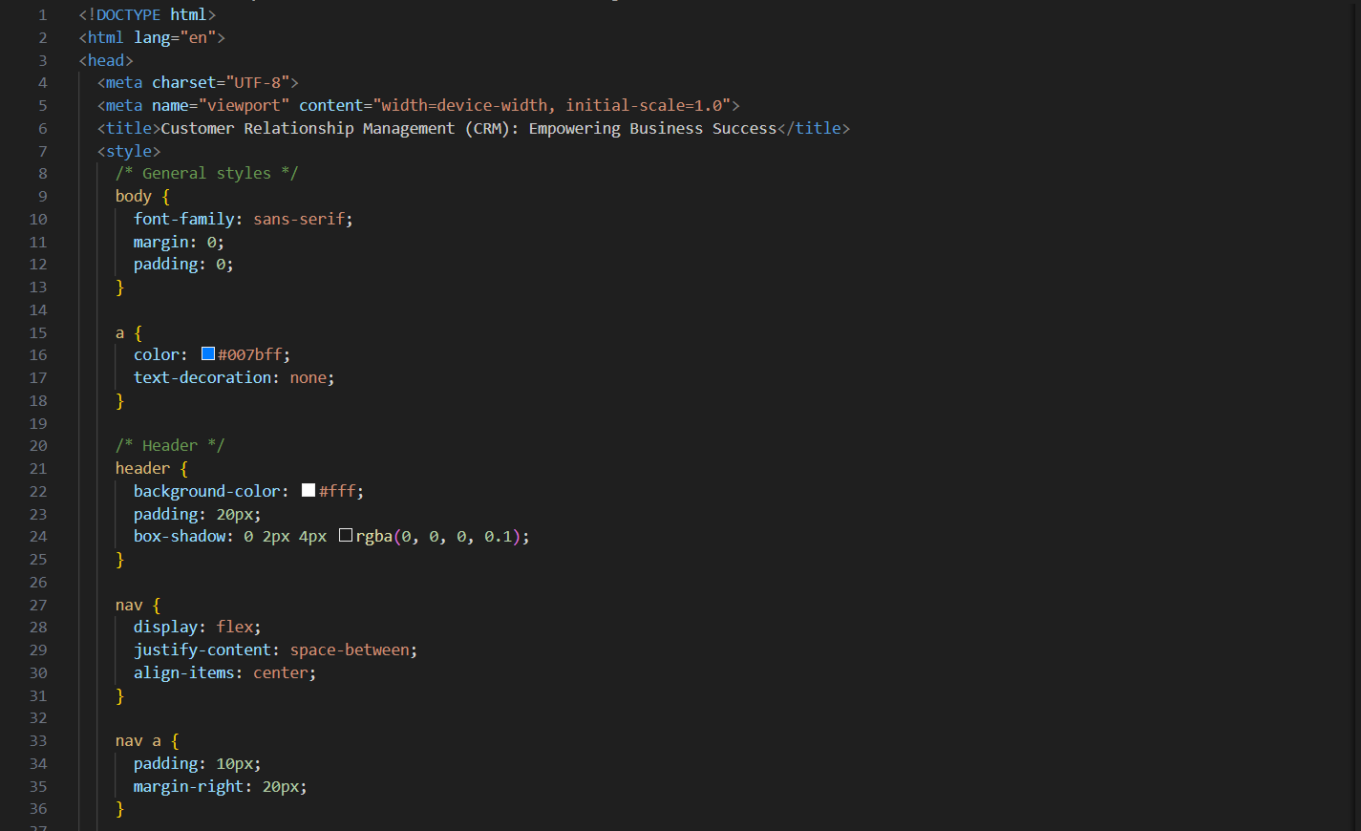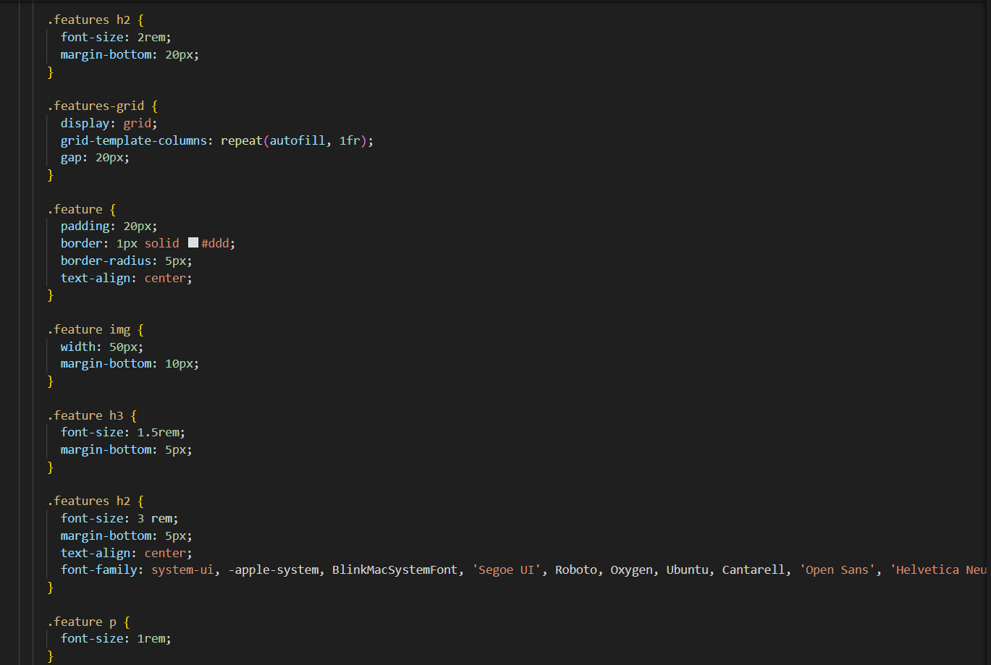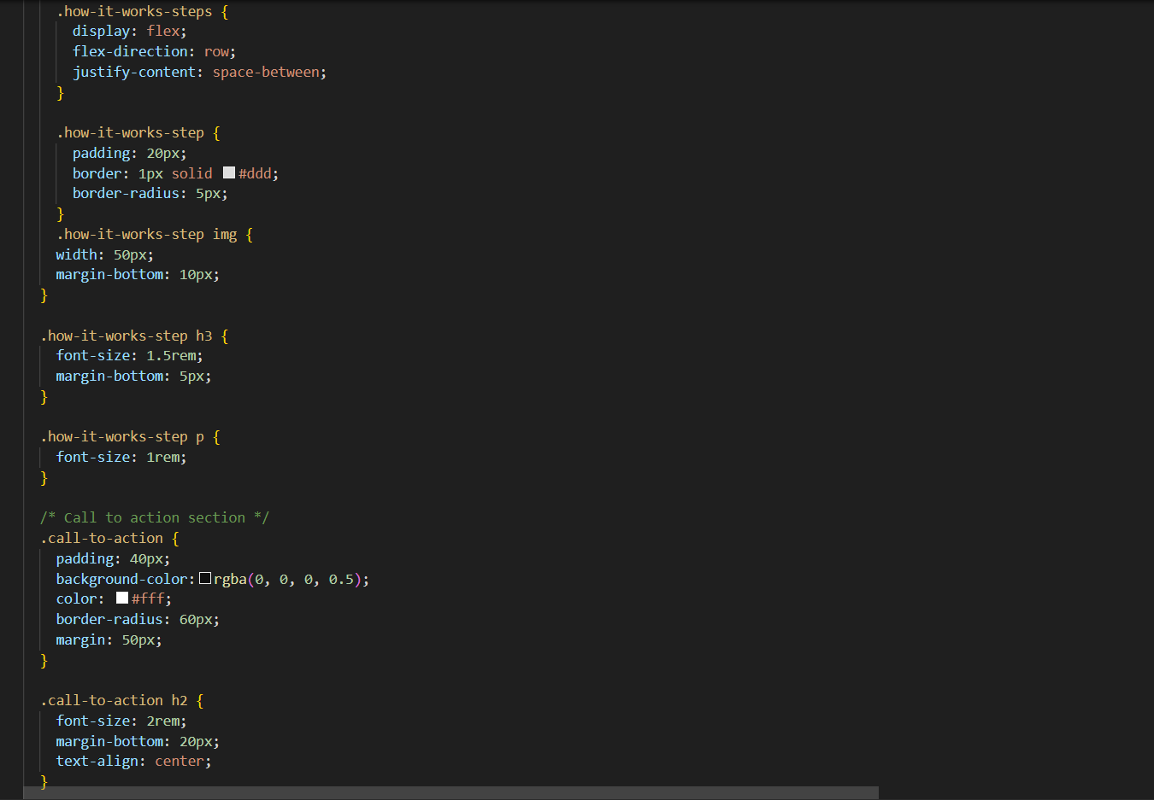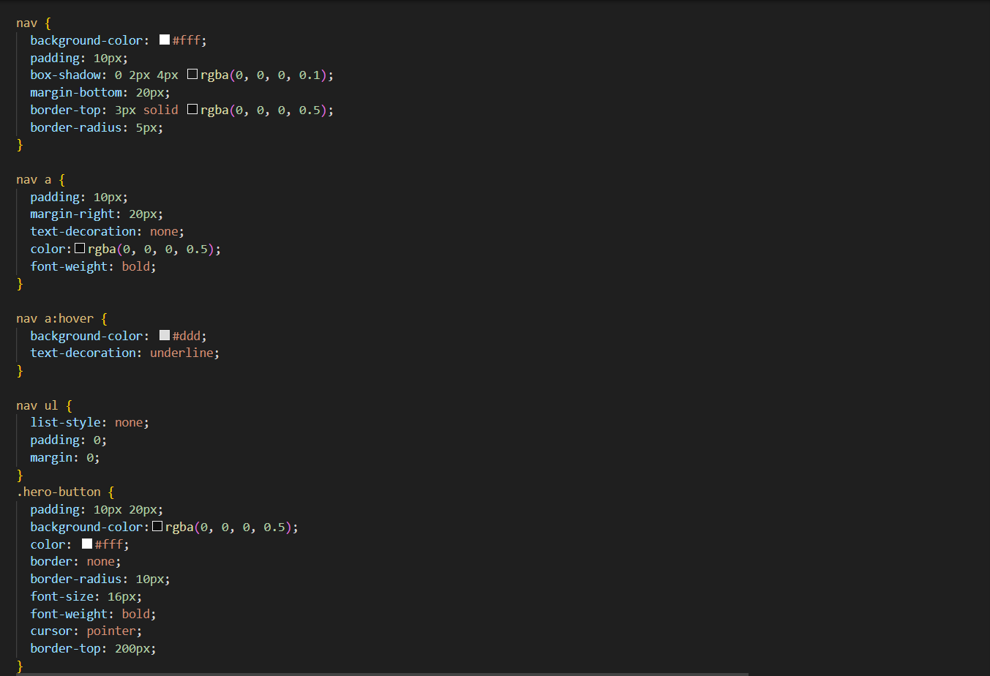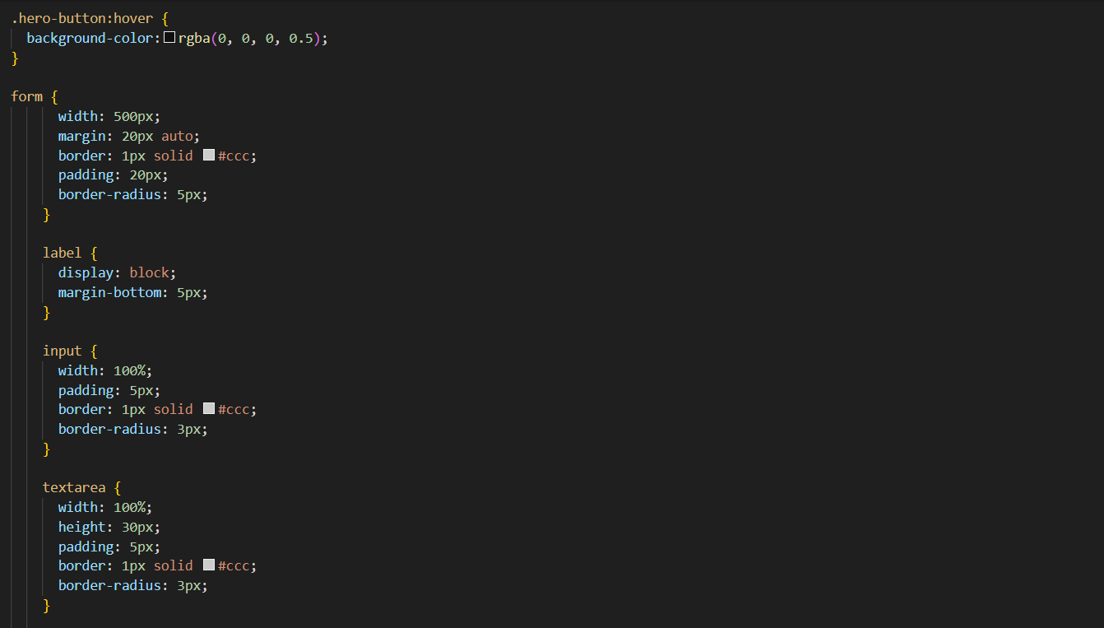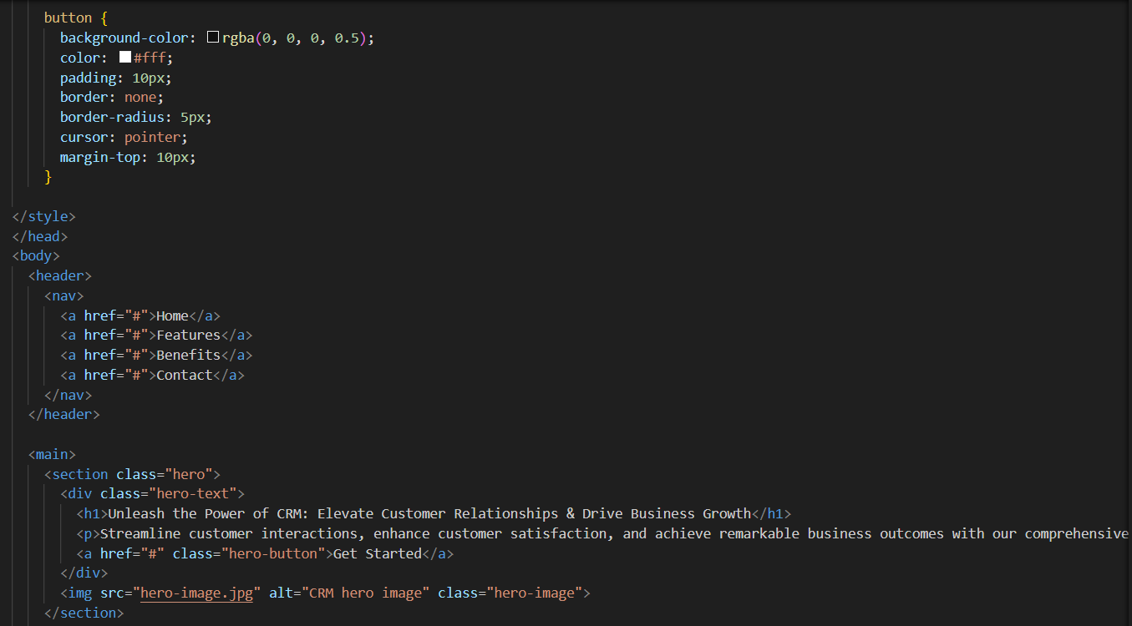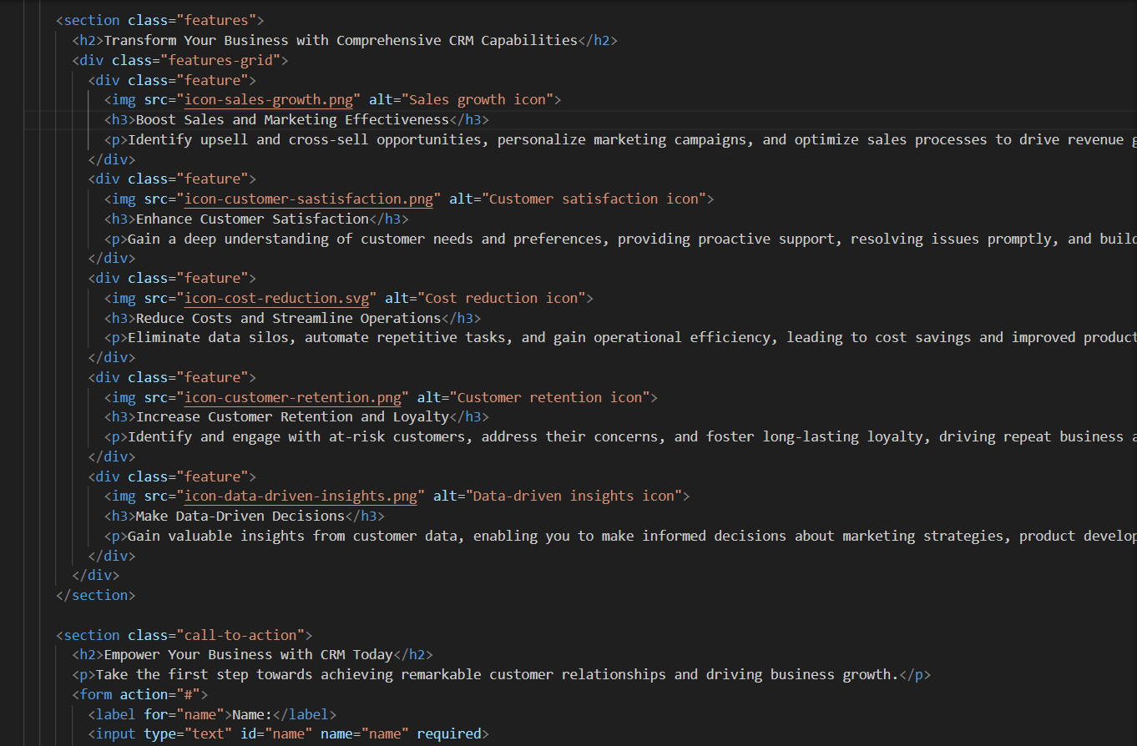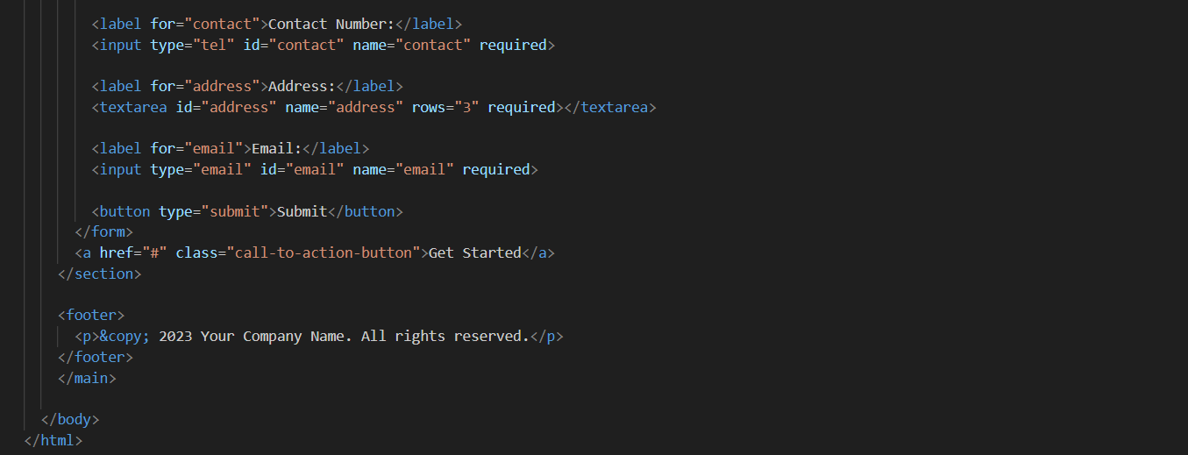

# Chapter-6

# Future Scope Of Project:

The future scope of a CRM webpage project is extensive, as CRM technology continues to evolve and businesses seek innovative ways to engage customers and drive growth. Here are some key areas where CRM webpages can expand in the future:

1. Personalization and Dynamic Content:

* Utilize user data and preferences to personalize the content displayed on the webpage, tailoring it to the specific needs and interests of each visitor.
* Implement dynamic content algorithms to showcase the most relevant features, benefits, and case studies based on the user's industry, company size, and pain points.

2. Interactive Elements and Immersive Experiences:

* Incorporate interactive elements such as chatbots, virtual tours, and augmented reality experiences to provide an engaging and immersive experience for visitors.
* Allow users to interact with product demos, simulate real-world scenarios, and visualize the impact of CRM implementation on their business.

3. Data-Driven Insights and Analytics:

* Integrate data analytics tools to track user behavior, identify popular content, and measure the effectiveness of different call-to-action buttons.
* Use these insights to continuously optimize the webpage, improve user experience, and enhance conversion rates.

4. Artificial Intelligence and Machine Learning Integration:

* Leverage AI and machine learning algorithms to provide personalized recommendations, predict customer needs, and automate tasks such as content personalization and call-to-action optimization.
* Utilize AI-powered chatbots to offer real-time customer support, answer frequently asked questions, and guide visitors through the webpage.

5. Cross-Channel Integration and Multi-Device Optimization:

* Ensure seamless integration with other marketing and sales channels, such as social media platforms, email marketing campaigns, and CRM systems.
* Optimize the webpage for an exceptional user experience across all devices, including smartphones, tablets, and wearable devices.

6. Voice Search Optimization and Conversational Interfaces:

* Adapt the webpage to support voice search capabilities, allowing users to navigate and interact with the content using voice commands.
* Implement conversational interfaces that enable natural language interactions with the CRM solution, providing a more personalized and intuitive experience.

7. Integration with Emerging Technologies:

* Explore integration with emerging technologies such as augmented reality, virtual reality, and the metaverse to create immersive and interactive CRM experiences.
* Utilize these technologies to showcase the capabilities of CRM in a more engaging and impactful manner.

By incorporating these future-oriented features, CRM webpages can become even more effective in attracting potential customers, demonstrating the value of CRM solutions, and driving business growth. As technology advances and user expectations evolve, CRM webpages will continue to adapt and innovate, playing a crucial role in shaping the future of customer relationship management.

Refereces.