


B.TECH CSE (PROJECT REPORT )





UTTAM SINGHAL
B.TECH C.S.E (4th Year)

ACKNOWLEDGEMENT

I express my sincere gratitude to the Surendra group of institutions for giving me the opportunity to undergo 1.5 month Industrial Training after my 8th Semester of B.Tech(C.S.E).

I would also like to thank everyone who has knowingly and unknowingly helped me throughout my work.

Last but not least, a word of thanks for the authors of all those books and papers which I have consulted during my training as well as for preparing the report.

Recognizing the help of these individuals is truly a great joy and a feeling of gratitude.
Special thanks to HOD and Madam Principal for giving me this internship opportunity.

ABSTRACT

E-commerce refers to the purchase and sale of goods and/or services via Internet. Shopick is a part of e-commerce. SHOPICK is a website designed primarily for use in the clothing industry. Through these services can sell and distribute their resources at minimal resource usage effectively with high profits by gaining the customer trust. This Shopick system database will be helpful for the business owners to extend their business just by placing the orders online and not visiting the shops.
There is no confinement for placing and receiving the orders, since the order can be placed online. There will be no waiting time with the vast amount of verities at the comfortable prices. To develop this application database is the main part which will communicate through the application to retrieve the details. We will be creating the shopick database with Oracle as a platform.

INTRODUCTION

An e-Commerce website is an information technology method in which traders, businesses/ distributors/marketers can sell products/services and the customer can purchase on that website electronically by using the internet on the mobile and computer. It means an e- commerce website is an online shop. e means electronic. Commerce means business. Website means the group of HTML web pages and that is created to market/sell information/product/ services.
From a bigger perspective, every website on the internet is the e-Commerce Website. It can be the platform, it can be a marketplace, it can be a portal, it can be apps, it can be an entertainment website, shopping website, online courses website and online degree college.
With the rise of out-of-the-box ecommerce platforms like Shopify, Magento, Squarespace, and WooCommerce, creating a website can be a pretty straightforward and fast process. with store builder plugins that make running your small business easier than ever before. You can enter your details, choose from free or cheap templates, and create the shopping experience you want for your customers in real-time with site builders that allow you to drag-and-drop ecommerce store features to your preference.
Several of the ecommerce platforms available today are hosted and easy to maintain, with no web developer or design team needed. These do-it-yourself tools make it effortless to update content, add products, and make other adjustments all on your own.

Objectives

- Understand basic concept and structure of HTML, CSS, Bootstrap, React JS, Framework, PHP, JavaScript, C#, creating Database & connecting with SQL server and web API

- To get awareness about the various job opportunities.

- To perceive communicational skills and organizational dynamics.

- To get educated about the official habitat.

- Opportunities for technical skill.

- Improve communication skill.

- Knowing all type of official knowledge.

Goals

- Knowing practical knowledge about programming.
- Increase communication skill with other.
- Develop research skills.
- Knowledge of key professional.
- Improve professional ethics and values.
- Improve technical skill.
- Improve administrative skill.

Motivation

Internships to impart useful specialist knowledge in the areas of technology and engineering. Knowing hypothetical information and implementing it within a reasonable framework is very important in developing our competent architectural driving force. My motivation for this internship was actually to learn more about my field and the working environment of an IT company. The desktop-based website building system is easy to learn. Before coming to her internship, I knew I was at a beginner level in learning web development. My first task is to learn, create and be creative. The learning curve of web development is so interesting and delightful. It's very easy to create a project entirely using HTML, CSS, JavaScript, React JS
and React Node if you know what you're doing.

Problem
Development-based problems can be addressed as they require a larger vocabulary of form markup, methods, objects, modifiers, and many ways to create software and plans. And it's not just web development problems that have other simple and quick solutions.
There is another problem that occurs most often. A customer has a problem with her website and complains to the developer. But when the developer checks the website, it looks perfectly fine. These problems can be caused by an outdated web server or if a customer makes inappropriate changes to their web server.

Solution

Web development is an intriguing and challenging field that I find fascinating. Through my internship training, I aim to learn and comprehend various objectives related to web development. I believe that by studying and gaining a deep understanding of this subject, I will find it even more interesting than any other programming languages. Throughout my training period, I successfully resolved CSS and other technical issues. It is crucial to have clean software in order to eliminate unforeseen errors that could potentially impact the loading speed of a website. By utilizing automated website monitoring solutions, developers can monitor their clients' websites in real time and receive alerts whenever potential issues arise. This proactive approach not only allows developers to identify and address problems before their clients notice them, but also helps to mitigate any negative impact on the client's business.

Future Scopes

With advancing technologies and increasing competition, the e-commerce industry is constantly evolving. No matter what these changes are, the future of this robust and flourishing sector is bright and promising. It would be therefore good for e-commerce businesses to learn what the future holds for them and what trends are likely to occur.
Getting to know the scope of e-commerce will help e-commerce businesses in taking vital decisions in identifying and selecting apt e-commerce options, and implementing the anticipated trends before those become mainstream.
The e-commerce sector has undergone unprecedented growth in the recent few years. The worldwide epidemic fuelled this and made e-commerce an indispensable part of the global retail framework. Consumers from all countries of the world now benefit from the advantages of online shopping. However, a lot of e-commerce outlets still miss out on a lot of opportunities.

Project Introduction

Web development is building, creating, and maintaining an application that works over the internet i.e., websites.
It includes aspects such as web design, web publishing, web programming, and database management. It can be classified into two categories:

i. Frontend development
ii. Backend development
Frontend development:
It includes the development of the part that the user interacts directly with. Various languages used to develop front end include HTML, CSS and many more.
Backend development:
It is the part that deals with the server side of a website.
It is the portion of software that does not come in direct contact with the users. It is used to store and arrange data.
Java, Python, PHP are few of the common languages used for the development of backend.
Application development:
App development is the process in which developers create an application to be used on smart phones, tablets and other mobile devices.
Various languages used to develop applications are Java, Python, Kotlin etc.

SOFTWARE LEARNED:
• Hyper Text Markup Language (HTML):

HTML (Hyper Text Markup Language) is the most basic building block of the Web. It defines the meaning and structure of web content. Other technologies besides HTML are generally used to describe a web page's appearance/presentation (CSS) or functionality/ behaviour (JavaScript).
"Hypertext" refers to links that connect web pages to one another, either within a single website or between websites. Links are a fundamental aspect of the Web. By uploading content to the Internet and linking it to pages created by other people, you become an active participant in the World Wide Web.
HTML uses "markup" to annotate text, images, and other content for display in a Web browser. HTML markup includes special "elements" such as <head>, <title>, <body>, <header>, <footer>, <article>, <section>, <p>, <div>, <span>, <i mg>, <aside>, <audio>, <canvas>, <datalist>, <details>, <embed>, <nav>, <output>, <progre ss>, <video>, <ul>, <ol>, <li> and many others.

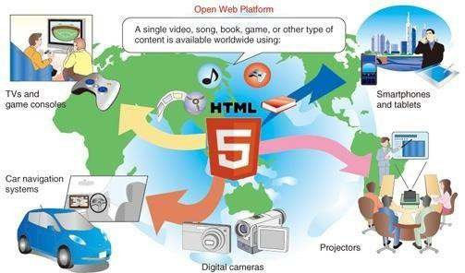

• Cascading Style Sheets (CSS):

Cascading Style Sheets (CSS) is a stylesheet language used to describe the presentation of a document written in HTML or XML (including XML dialects such as SVG, MathML or XHTML). CSS describes how elements should be rendered on screen, on paper, in speech, or on other media.

CSS is among the core languages of the open web and is standardized across Web browsers according to W3C specifications. Previously, the development of various parts of CSS specification was done synchronously, which allowed the versioning of the latest recommendations. You might have heard about CSS1, CSS2.1, or even CSS3. There will never be a CSS3 or a CSS4; rather, everything is now CSS without a version number.

After CSS 2.1, the scope of the specification increased significantly and the progress on different CSS modules started to differ so much, that it became more effective to develop and release recommendations separately per module. Instead of versioning the CSS specification, W3C now periodically takes a snapshot of the latest stable state of the CSS specification and individual modules progress. CSS modules now have version numbers, or levels, such as CSS Color Module Level 5.

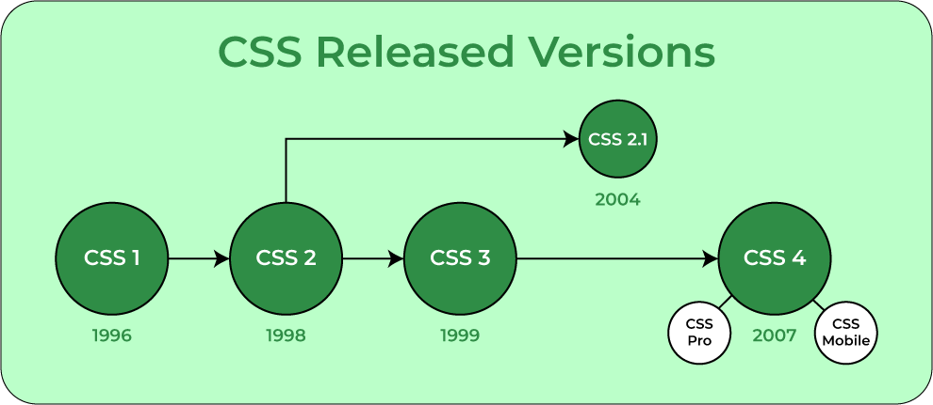

PROJECT WORK

Problem Analysis: Our main problem area focuses on the
1. A high return rate:
According to Forrester Research, the return rate of the fashion category in India is “around 25- 35%, and this number can go up to 40% during sales. Well, it is surprisingly very high, and most of this has to do with the wrong size ordered by the customers. Moreover, customers often complain that the product doesn't match the product description or they simply changed their mind about the purchase.

2. Pressure to provide free and fast shipping:
In today's digital space, 1 out of 3 shoppers will choose one ecommerce brand over the other due to better shipping options. Moreover, customers tend to abandon their carts if the shipping isn't free or fast.

3. Fierce competition:
As more and more brands are entering the fashion industry, it's becoming harder to make a name for yourself. In such a saturated ecommerce space, it's easy to get lost in the crowd without getting any customer attention.
4. Changing attitudes towards fashion:
A significant change in the fashion world is the change in customers' attitudes toward sustainability. It's not enough for online fashion brands to churn out fast fashion items and ignore the actual cost to the planet or the people working on them; now, their customers are demanding some accountability. 81% of the global respondents state that businesses are responsible for the environment.
5. Lack of real-time assistance:
Customers are most likely to have questions about their purchases, especially regarding apparel, footwear, accessories, and more. If they aren't answered right away, they can abandon their carts. However, if a customer is having an issue with your product, it doesn't mean you have to lose a customer. Instead, you can use such situations to assist your customers if they face any difficulty.
6. Frequent stock outs:
It's highly common in the fashion industry that one or more products create a massive buzz among the masses. So on one hand, it increases ecommerce sales but on the other hand, it causes frequent stock outs. Product stock-outs are a significant concern for fashion brands as well as prospective buyers—fashion brands can lose out on sales. At the same time, customers will be unhappy and turn to other fashion brands.
7. Different device screens showing different colors:
Well, “color” plays a vital role in the fashion industry. Most of the time, customers complain that the product they received is different from what they ordered. The major problem with color is that it depends on the screen your customer is looking at it and the background color combination.

Implementation Methodology:
Model View Controller or MVC as it is popularly called, is a software design pattern for developing web applications. A Model View Controller pattern is made up of the following three parts:
- Model - The lowest level of the pattern which is responsible for maintaining data.
- View - This is responsible for displaying all or a portion of the data to the user.
Controller - Software Code that controls the interactions between the Model and View. MVC is popular as it isolates the application logic from the user interface layer and supports separation of concerns. Here the Controller receives all requests for the application and then works with the Model to prepare any data needed by the View. The View then uses the data prepared by the Controller to generate a final presentable response.

FLOW CHART:
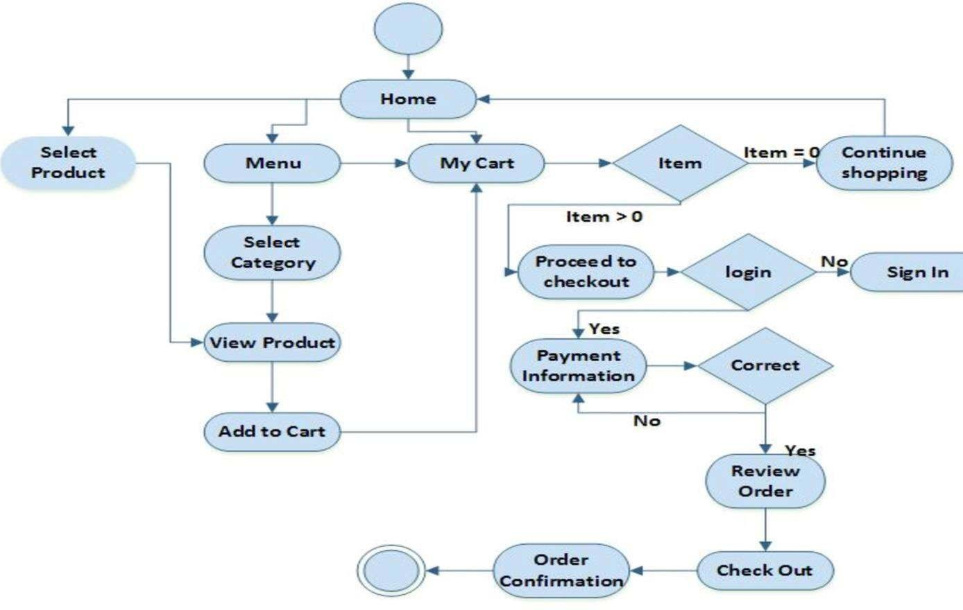

MODULES

• Cloth Management Module: Used for managing the Cloth Item details.
• Confirm Order Module: Used for managing the details of Confirm Order.
• Payment Module: Used for managing the details of Payment.
• Category Management Module: Used for managing the information and details of the category.
• Customer Module: Used for managing the Customer details.
• Order Module: Used to managing the order information.
• Login Module: Used for managing the login details.
• Users Module: Used for managing the users of the system

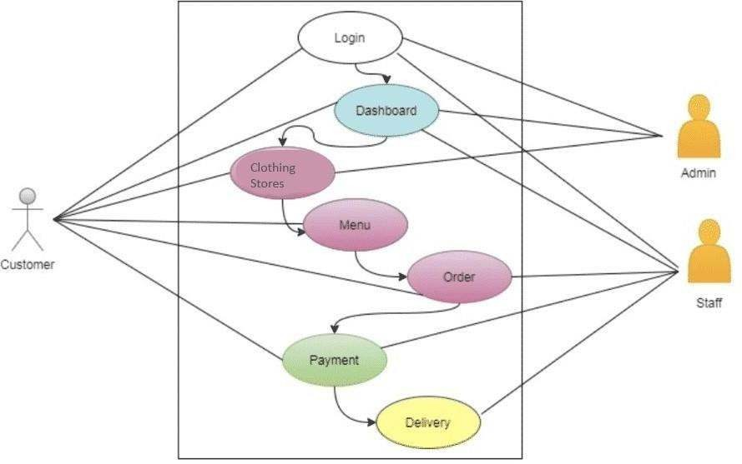

INTERFACE:
• System interfaces:
The SHOPOCK links with a current payment system, which includes a cash register and a software-accessible credit/EFTPOS system, to manage client invoicing quickly and conveniently. The payment system should be able to communicate information about whether or not the payment was successful to the SHOPICK.
• User interfaces:
There are three separate user interfaces in the SHOPICK software, each of which is coupled to a physical hardware component (see Section 2.1.3). The three user interfaces accessible are Surface Computer UI, Tablet UI, and Display UI. User Interface Design is concerned with the interaction between a user and a computer. It covers everything from starting the system to logging in to the final presentation of essential inputs and results. The whole flow of screens and communications is referred to as a dialogue.
The following are some guidelines for designing a user interface:
• The system's user should always be aware of what to do next.
• The screen should be set up so that various types of data, instructions, and messages are always presented in the same general area.
• Messages, instructions, and other information should be given for the system user to read for a sufficient amount of time.
• Don't employ display features excessively.
• User-enterable fields and answers should have default values.
• If a mistake is found, the user should not be allowed to continue

RESULTS AND DISCUSSIONS

INPUT AND OUTPUT DESIGN:
Input Design: Input design is the process of converting user-oriented inputs to a computer- based format, which gets the credentials details from the supplier.

Home Page
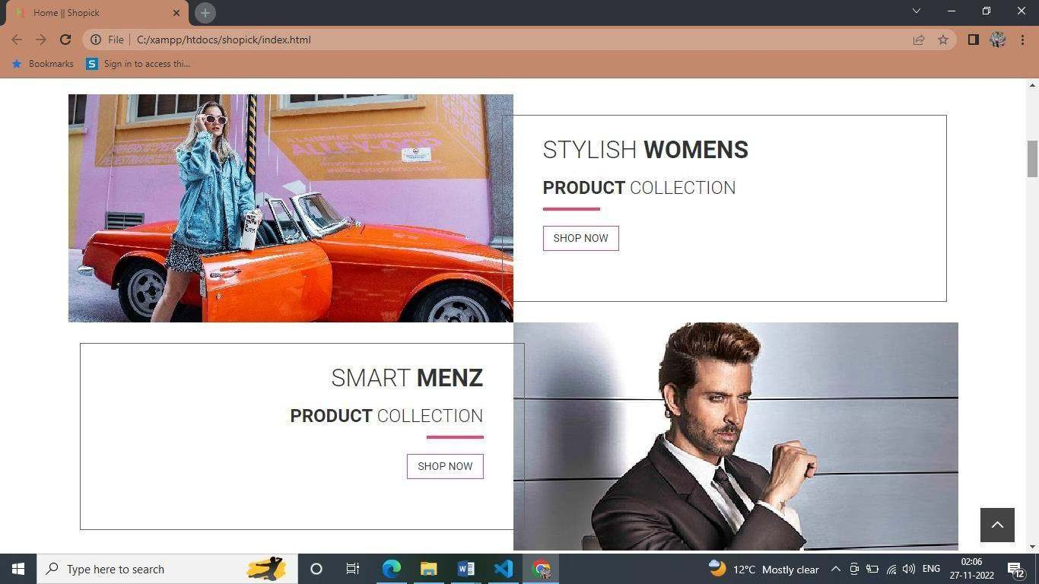

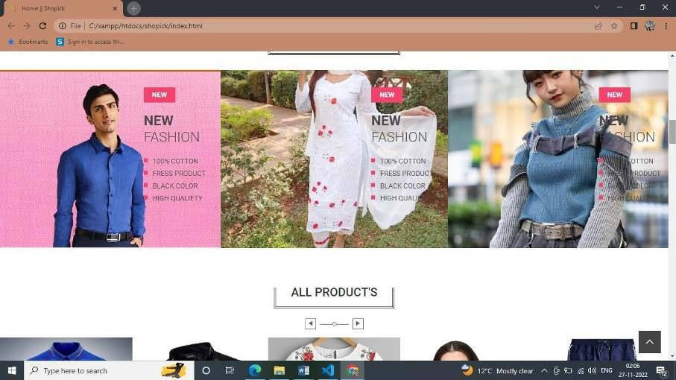

Output Design: Output generally refers to the results and information that are generated by the system. For many end users, outputs are the main reason for developing the system and the basics on which they will evaluate the usefulness of the application.

Users generally merit the system analyst works easily with the user through an interactive process, until the result is considered to be satisfactory. Therefore, an effective interactive design is an important feature of design specification.
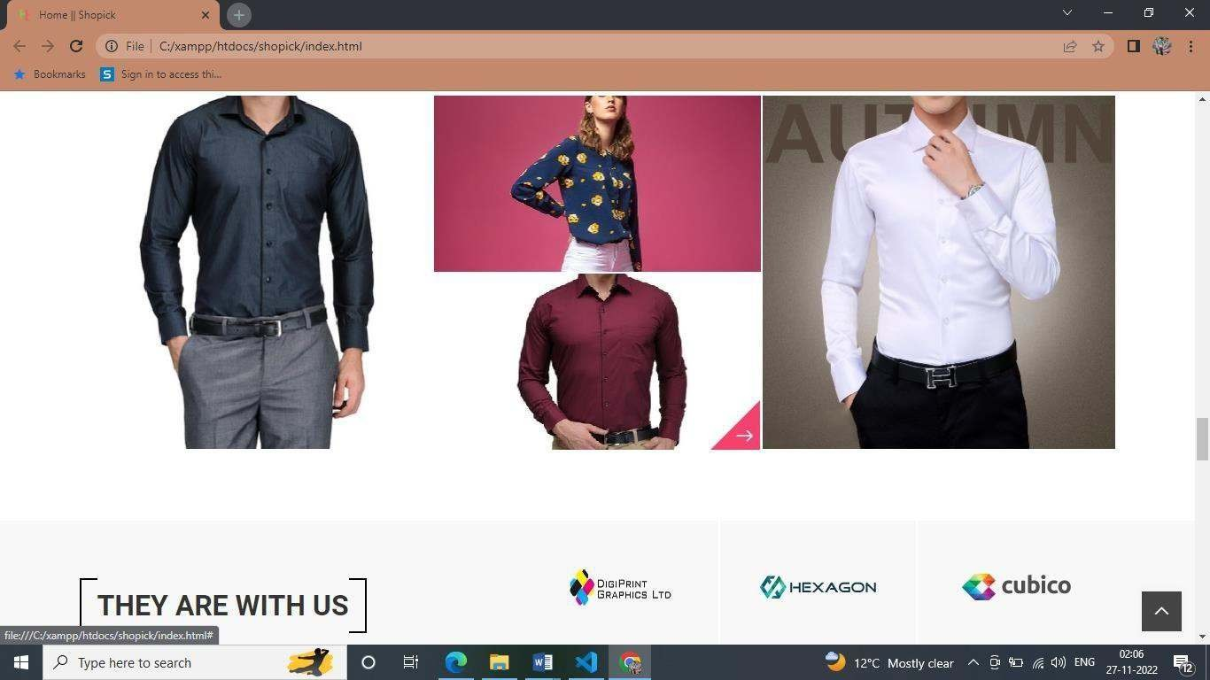
Single-Product Page
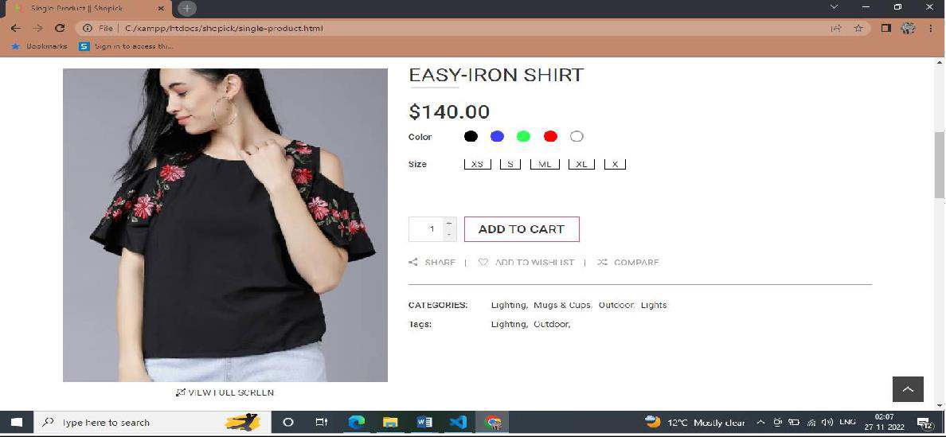

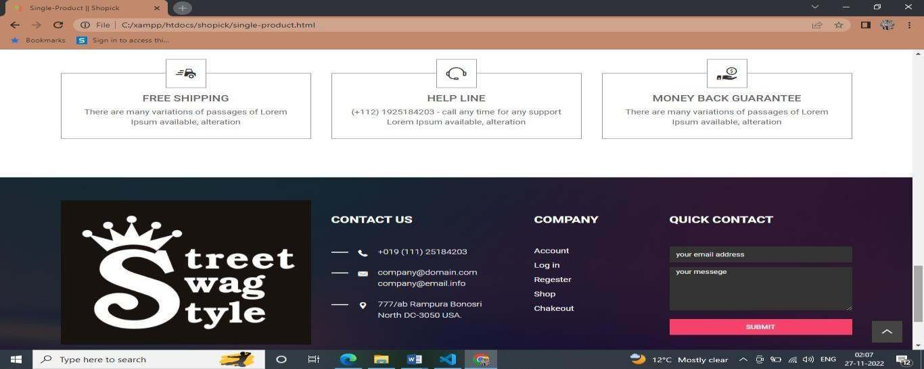

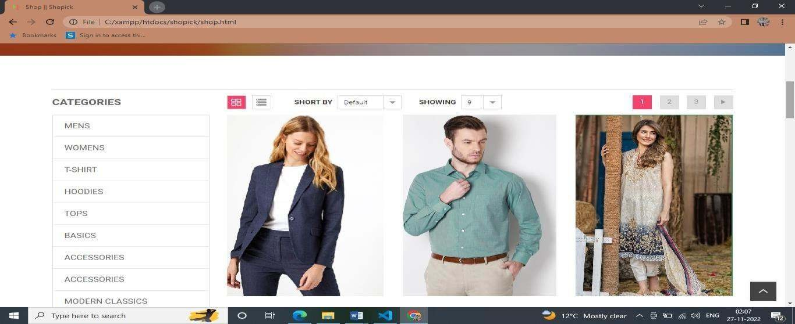
Shop Page
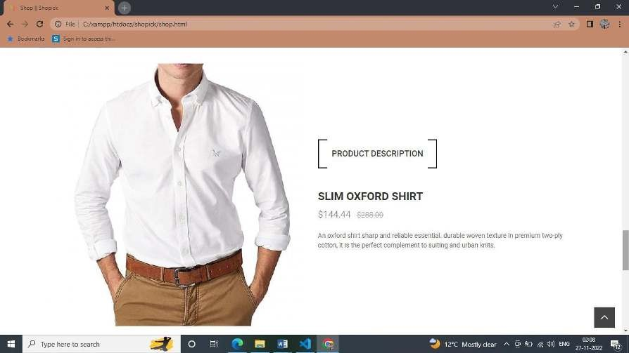

Contact Page
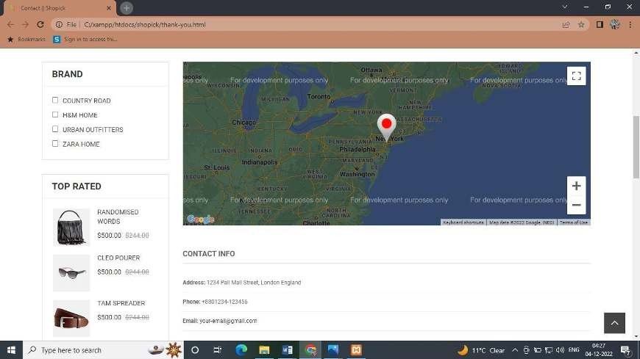

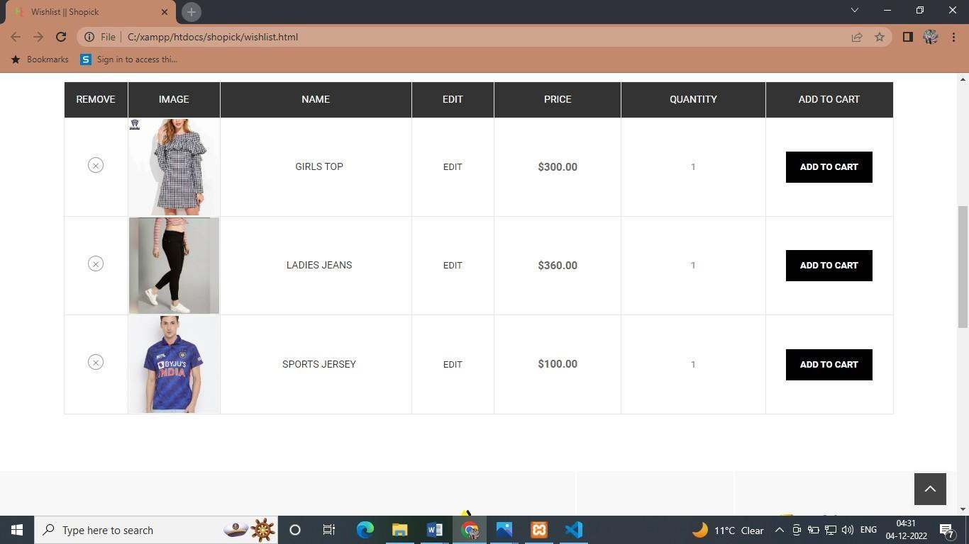
Wishlist Page
Checkout Page
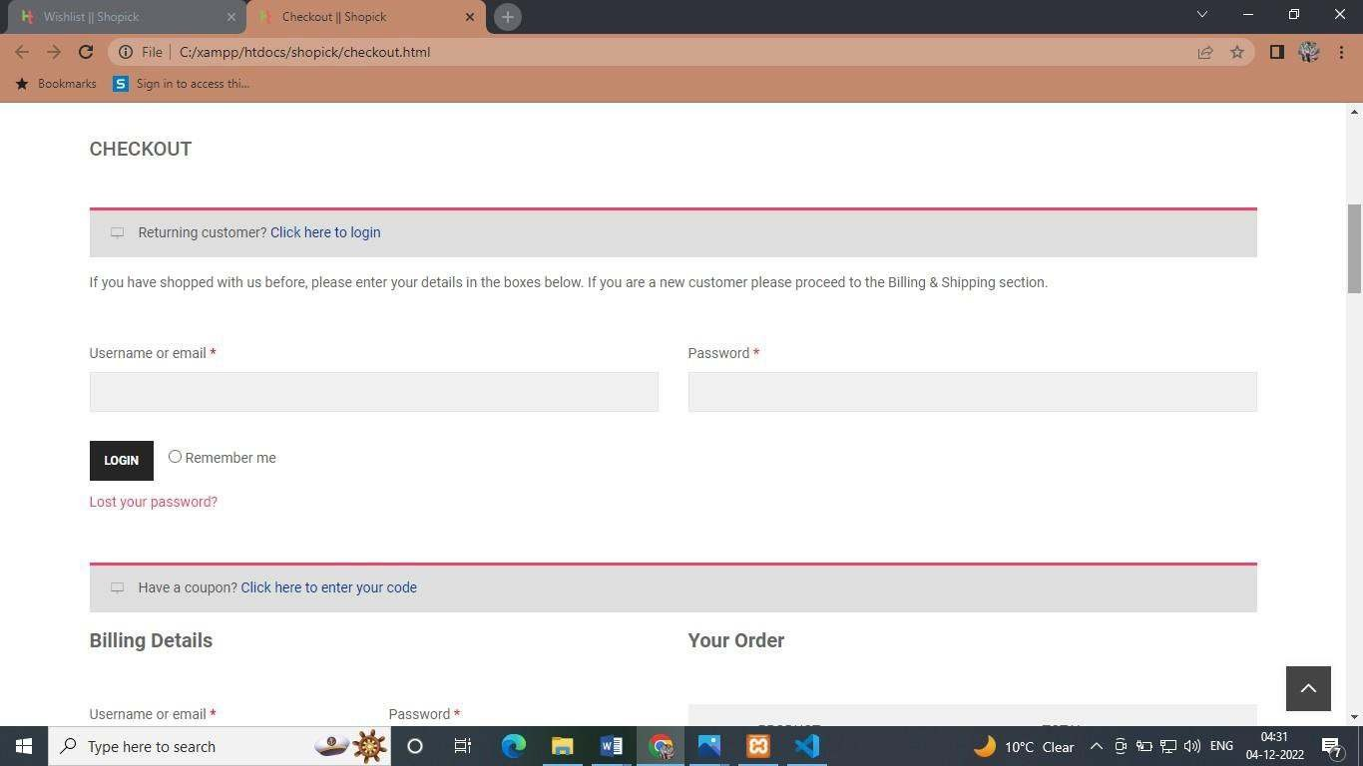

Login Page
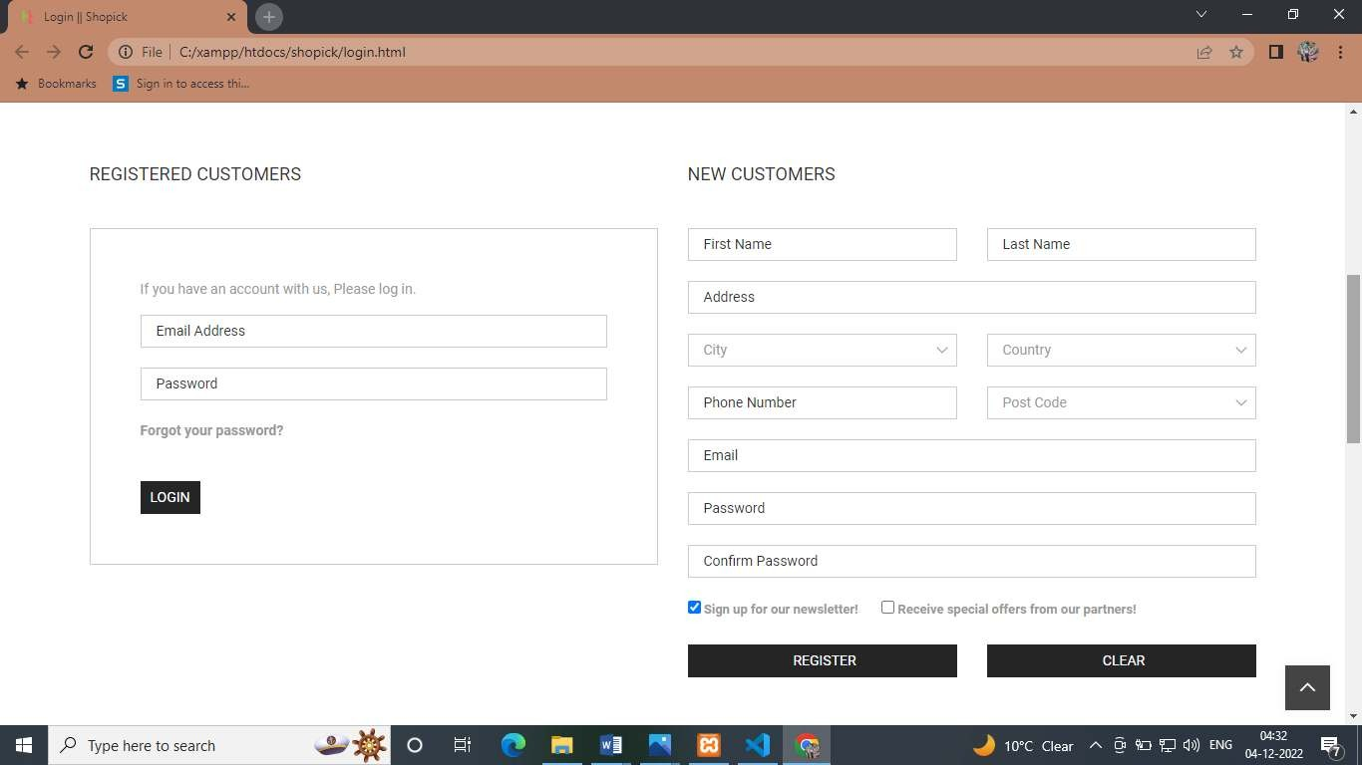

DISCUSSION
Online Shopping System, as described above, can lead to error free, secure, reliable and fast management system. It can assist the user to concentrate on their other activities rather to concentrate on the record keeping. Thus it will help organization in better utilization of resources. The organization can maintain computerized records without redundant entries.
The technology we recommend is an easy-to-use online shopping system for customers. It overcomes the disadvantages of traditional queuing systems. Our system is a convenient way to order clothes and accessories. The procedure of taking a customer's order is made easier with this technology. Customers may place orders fast utilizing the online shopping ordering system, which generates an online menu. Customers can also use a tracker to keep track of their orders. Users can also rate the product using this system's feedback feature. In addition, based on the user's ratings, the proposed system can recommend brands, and our staff will be notified of any quality adjustment.
Conclusions
Finally, for the online ordering system, we created a secure, user-friendly clothes ordering administration system. Whether they are Administrators or Customers, this system can look after them all. This system will let them manage client meals, delivery boy data, and expand without creating any disruption. This system is completely secure because each user is assigned a unique user ID and password, preventing unauthorized access. With online payment, registration, and cancellation, it's a lot easier to use. As a result, using this strategy will help to minimize labor expenses while also giving clients more opportunity to enjoy the services.
Online ordering system that I am proposing here, greatly simplifies the ordering process for both the customer and the website. System presents an interactive and up-to-date menu with all available options in an easy-to-use manner. Customer can choose one or more items to place an order which will land in the Cart. Customer can view all the order details in the cart before checking out. At the end, customer gets order confirmation details. Once the order is placed it is entered in the database and retrieved in pretty much real time. This allows our Employees to quickly go through the orders as they are received and process all orders efficiently and effectively with minimal delays and confusion.
Scope
E-commerce was not popular among many of us until very recently. Most of us were apprehensive about the concept. We could not really put our trust in online shopping websites to provide good quality products and services. Over time, as it gained popularity within the younger generation, e-commerce started blooming.
However, when the coronavirus pandemic hit the world, we were all confined to our houses, it became impossible for us to physically go out and buy the things that we wanted. I think this is when the rest of the world really started trying out e-commerce services. They realized that reputable online shopping websites provided numerous options and remarkable services.
The scope of e-commerce in India bloomed during the pandemic. This success can also be the result of increased internet use among our generation. The soaring popularity of e-commerce websites can be rightly called a ‘positive impact of covid-19 on e-commerce. Some of the most successful e-commerce business 2022 are Amazon, Flipkart, etc. One of the biggest benefits of e-commerce to business is that an e-commerce website makes it easy to sell products to a larger audience, no matter where their physical location is. India has shown rapid growth in the eCommerce sector. It is now brimming with job opportunities and service providers.

