Back Pressure Turbo-Generator (BPTG)

Steam is a major energy user and many industrial processes end up wasting some of it; especially if it is produced at higher pressures than what is needed. The conventional approach is to install pressure-reducing valves (PRVs) at various locations to reduce the steam pressure, exhausting the steam to the atmosphere. However, a non-condensing or backpressure turbine, also called a backpressure turbogenerator, can reduce the pressure while simultaneously converting the exhaust steam into electricity.

The steam is expanded until it reaches a pressure that the facility can use. While the steam expands, part of its thermal energy is converted into mechanical energy to be used by pumps, fans, compressors, and other equipment. The lower pressure steam is exhausted into the process header from the steam turbine, where a nozzle directs jets of high-pressure steam against the turbine's rotor blades. These blades are attached to a shaft, which rotates to produce power for the electrical generator. Because the exhaust steam temperature is lower compared with a PRV, the boiler steam throughput must be increased by 5% to 7%.

A backpressure steam turbine has a power generation efficiency ranging from 15% to 35% and requires steam of 20 to 100 lb/h per kilowatt (kW). The turbine operates with an exhaust equal to or in excess of atmospheric pressure. In general, installed cost ranges from $400/kW to $800/kW. Not all plants are candidates for backpressure turbines, as the following table shows:

|  |  |  |  |
| --- | --- | --- | --- |
| **Required Conditions for a Backpressure Steam Turbine** | | | |
| Parameter | Best for Pressure Reducing Valve | Good for Backpressure Turbine | Best for Backpressure Turbine |
| Steam Flow Rate (lbm/h) | <4,000 | >4,000 | >10,000 |
| Inlet Pressure (psig) | <125 | >125 | >150 |
| Pressure Drop (psi) | <100 | >100 | >150 |
| Cost of Electricity (cents/kWh) | <1.5 | >1.5 | >6.0 |
| Capacity Factor (%) | <25 | >25 | >50 |
| *Source: TurboSteam.  Note: lbm/h=pound mass per hour, psig=pounds per square inch gauge* | | | |

Maintenance is minimal for these turbines, as long as both the steam and oil are of good quality. Changing the oil and checking the bearings should be done periodically. Service life is typically 20 years, with some turbines lasting as long as 50 years, when properly maintained. At one chemical plant, a 450-kW system using 110-psi steam operates 24 hours a day, five days per week, with few problems.

**Reduce Costs and Lower Emissions**

According to the U.S. Department of Energy (DOE), electricity produced by backpressure turbines can cost less than 3 cents/kWh. Payback can be under two years. After a new clinical research center at the National Institutes of Health installed backpressure turbines, the building generated about 5% of its own electricity, saving more than $170,000 annually in electricity costs. When combined with a high-efficiency boiler (80%), effective electrical efficiencies can reach as high as 78%. The following table compares the economics of two different systems:

|  |  |  |
| --- | --- | --- |
| **Economics of Two Backpressure Turbine Systems** | | |
| Parameter | 240-psig Exhaust, 1,371 kW | 150-psig Exhaust, 1,986 kW |
| Annual Generation, kWh/yr | 9,342,349 | 13,965,000 |
| Electrical Energy Produced, $/yr | 355,009 | 530,670 |
| Increase in Natural Gas Usage, $/yr | 209,107 | 312,580 |
| Estimated Annual Operating and Maintenance Costs, $/yr | 16,000 | 16,000 |
| Net Annual Benefits, $/yr | 129,902 | 202,090 |
| Base Equipment Costs | 521,690 | 568,000 |
| Total Installed Cost | 1,258,700 | 1,380,700 |
| *Note: electricity = $0.038/kWh, natural gas = $5.29/MMBtu.  Source: Washington State University* | | |

Although backpressure steam turbines do not generate any emissions, the steam generator or boiler does. Emissions will depend on the type of boiler fuel, and as shown in the following table, natural gas generates the fewest *total*emissions:

|  |  |  |  |  |  |  |
| --- | --- | --- | --- | --- | --- | --- |
| **Comparison of Boiler Emissions, lbs/MMBtu** | | | | | | |
| **Type of Fuel** | **500 kW System** | | | **3 MW or 15 MW System** | | |
| NOx | CO | PM | NOx | CO | PM |
| Coal | NA | NA | NA | 0.20-1.24 | 0.02-0.7 | <0.30 |
| Wood | 0.22-0.49 | 0.6 | 0.33-0.56 | 0.22-0.49 | 0.06 | 0.33-0.56 |
| Fuel Oil | 0.15-0.37 | 0.03 | 0.01-0.08 | 0.07-0.31 | 0.03 | 0.01-0.08 |
| Natural Gas | 0.03-0.1 | 0.08 | -- | 0.1-0.28 | 0.08 | -- |
| *Note: All emissions are without post-combustion treatment. Source: U.S. Environmental Protection Agency* | | | | | | |

Flow Diagram of Steam in BPTG 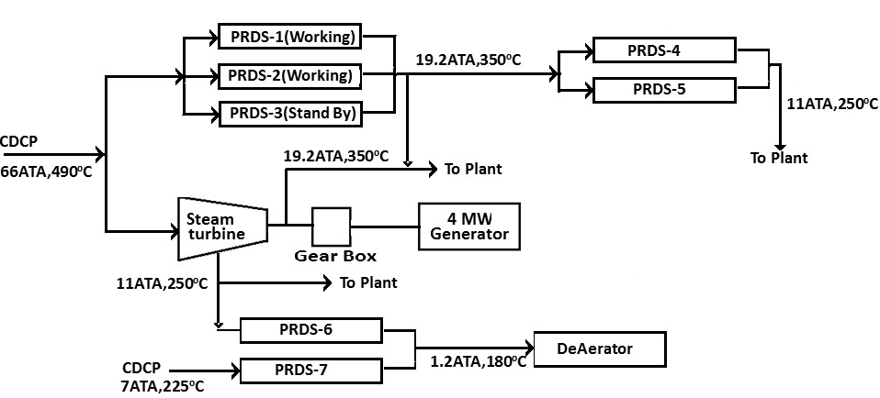

Deaerator in BPTG

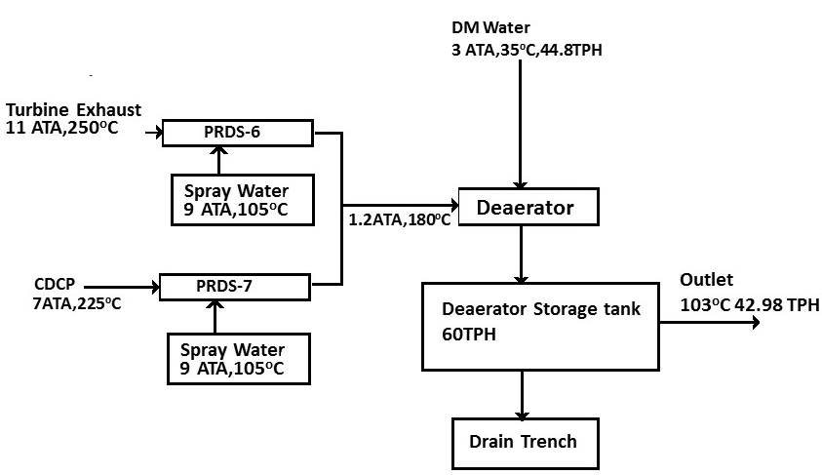

BPTG Load Calculations

