**NEED OF STEAM TURBOBLOWERS IN BSP**

Blast Furnaces can be considered as the heart of a Steel Plant. The blast furnace is the first step in producing steel from iron oxides. The purpose of a blast furnace is to chemically reduce and physically convert iron oxides into liquid iron called "hot metal". The raw materials such as iron ore, coke and limestone are dumped into the top and preheated air known as Hot air blast is blown into the bottom. The raw materials undergo numerous chemical reactions and descend to the bottom to become final product of liquid iron and slag. The hot air blast is produced by passing cold air blast trough a stove where residual blast furnace gases are burned. This cold air blast is provided by Turbo blowers form Power and Blowing Station.

Each blower installed on the new Power and Blowing station will provide on average 1500 Nm3/min of cold air blast. There will be 3 Steam Turbine driven Turbo Blowers (2 working and 1 Standby) each with 50% capacity of maximum air blast requirement.

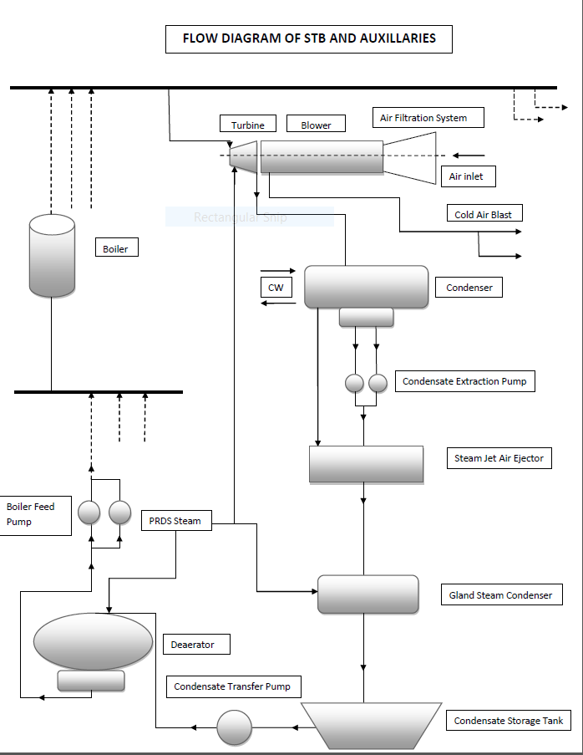

**PROCESS OVERVIEW OF STB AND AUXILIARIES**

The steam used to drive the blowers is produced in 3 **Boilers** at 40 ata, 450 degree Celsius. Waste gases from blast furnace and coke oven mainly BF gas and CO gas are used to fire the burners in boiler to produce steam. The steam so produced is sent to main steam header from where tapings are taken for different stations mainly **Turbo blowers, Turbo generators** and **Pressure Reducing and De superheating Station**.

Steam enters the **Turbine** at around 36 ata, 440 degree Celsius. The steam in turbine passes through different stages where its enthalpy is converted into rotational energy to drive the turbine shaft which in turn drives the **Blower** attached. The blower thus sucks the air passing through air filtration system and delivers the high pressure air to the blower outlet. The steam from turbine outlet goes through **Condenser** where it is condensed by cooling water to liquid condensate which is collected in hotwell.

The liquid condensate from the hotwell is then pumped using **Condensate Extraction Pump**. The condensate is then passed through the **Steam Jet Air Ejector** where the condensate is heated and the air in the condenser is simultaneously ejected using the steam from **PRDS**. The condensate is then passed through the **Gland Steam Condenser** where it is heated using the PRDS steam.

The condensate is then stored in the **Condensate Storage Tank**. The condensate is then transferred to the **Dearator** using the **Condensate Transfer Pump**. The condensate is sprayed form the top in the dearator and PRDS steam is used to heat the condensate and remove the impurities. The feed water so formed is collected and then pumped to the Boiler using the **Boiler Feed Pump**. The feedwater in the boiler is first converted to saturated liquid by economizer and then it goes to the boiler drum where it is evaporated and then passes through superheater before reaching its final state and transferred to main steam header.

**LAYOUT OF STB PBS-2**

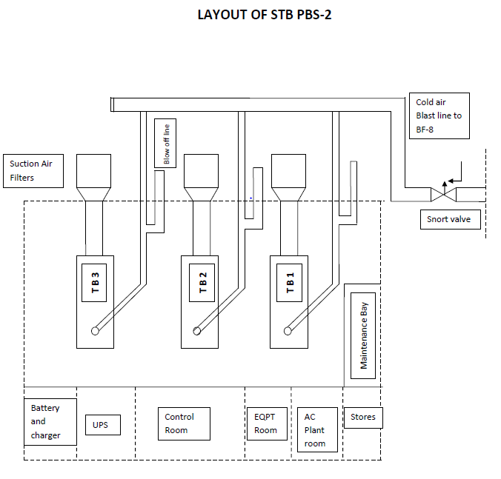

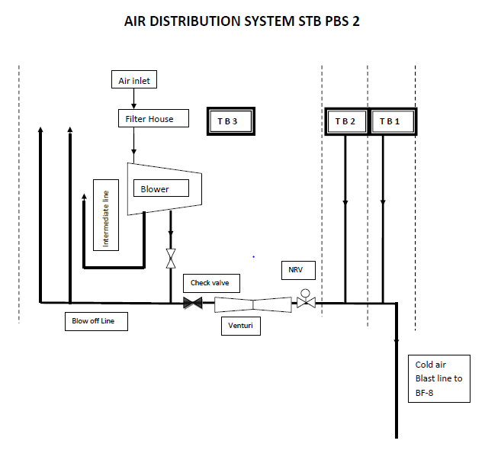

**TURBO-BLOWERS**

Turbo-blower is a combination of two turbo machines - Turbine and Blower. A turbo machine is a device that exchanges energy with a fluid using continuously flowing fluid and rotating blades The turbine is a work producing device which is run using the steam from the boilers. This turbine thus rotates the shaft attached to the blower. Blower is a work consuming device and is used to transfer energy to the fluids. Thus the turbine takes the energy from one fluid (steam) and the blower then transfers this energy to other fluid (air, in our case).

There are 3 ways of classifying turbo machines

1)Type of fluid they work on – Compressible or Incompressible

. 

2) Direction of flow in the machines – Radial, Axial or Centrifugal

3) Whether they deliver or extract power – Turbine or Blower

**TURBINE 219000 Nm3/hr BLOWER AT PBS-2 STB**

A steam turbine is a prime mover which continuously converts high pressure high temperature steam supplied by steam generator into shaft work with low temperature steam exhausted to the condenser. This energy conversion takes place in 2 steps

High pressure high temperature steam

expands in nozzle and comes out at a high

velocity. The high velocity jet of steam coming out

of nozzles impinge on the blades mounted on

the wheel, get deflected by an angle and suffers

a loss of momentum which produces torque.

**TURBINE AT PBS-2 STB**



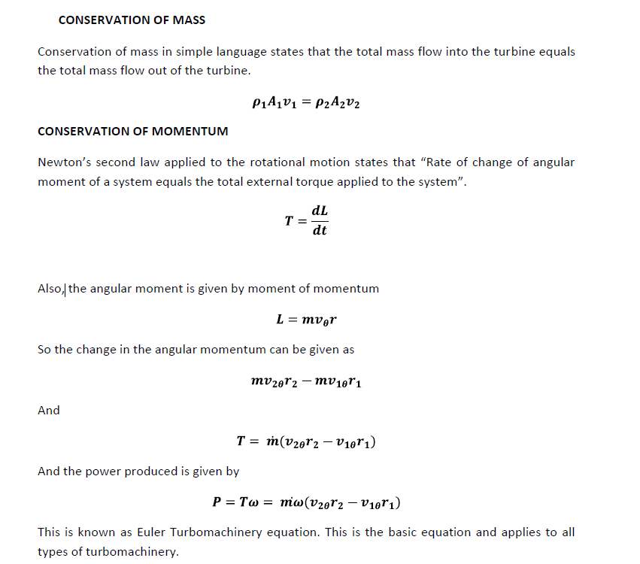

**NOZZLE**

A nozzle is a duct by flowing through which the velocity of a fluid increases at the expense of pressure drop. A duct which decreases the velocity of fluid and causes a corresponding increase in pressure is called a diffuser.

The shape of the nozzle depends on the mach number of a flowing fluid. If the fluid is subsonic, the nozzle will be convergent and if the flow is supersonic, the nozzle will be divergent in shape.

**NOZZLE EFFICIENCY**

Due to friction between the expansion process is irreversible, although still approximately adiabatic. In nozzle design, it is the usual practice to base all calculation on isentropic flow and then to make an allowance for friction using a coefficient or efficiency.

The nozzle efficiency is defined as the ratio of actual enthalpy drop to the ideal enthalpy drop.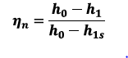

**BLADING**

Depending on the types of blade used and the method of energy transfer from the fluid to the rotor wheel, the turbine may be of two types

Impulse turbine

Reaction turbine

In Impulse turbine, the pressure drop occurs in nozzle and no pressure drop occurs in rotors. The pressure energy is first converted to kinetic energy in nozzles and the kinetic energy is used to turn the rotor blades. These are called impulse turbines as the power is produced using the impulse of the high velocity fluid exiting the nozzles.

Generally, single stage turbines are not used as the enthalpy drop occurs only on one stage and the increase is velocity is very large and this results in higher blade velocity which is not desired. Hence compounding of steam turbines is necessary. The compounding is done in two ways

Pressure compounding or Rateau staging

Velocity compounding or Curtius staging

**Pressure compounding** corresponds to putting a number of simple impulse stages in series. The total enthalpy drop is divided equally among the stages.

**Velocity compounding** or curtis staging, all the pressure drop and hence enthalpy drop occurs on the single row of nozzles and the resultant kinetic energy of the steam is absorbed by the wheel in a number of rows of moving blades with stator in between the two such rows. The purpose of stator or guide blade is to guide the fluid without changing the velocity so that the fluid enters the next stage similar to the previous stage. In curtis satging as the number of rows of moving blades increases, the effectiveness of moving rows decreases.

**REACTION TURBINES**

In these turbines, the pressure drop occurs both in nozzles or fixed row of blades as well as the moving row of blades. Blades rotates both due to both the impulse effects of the jets and the reaction forces from the exiting jets on the blades and this is why they are called as reaction turbines.

The degree of reaction is defined as

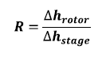

The general arrangement of consist of initial two-row Curtis stage initially which involves large enthalpy drop and then remaining stages can either be of impulse type or reaction type. 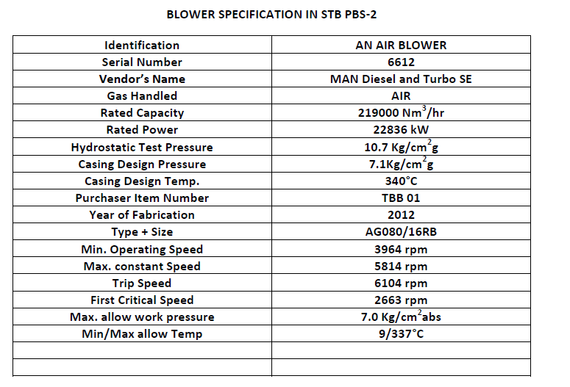

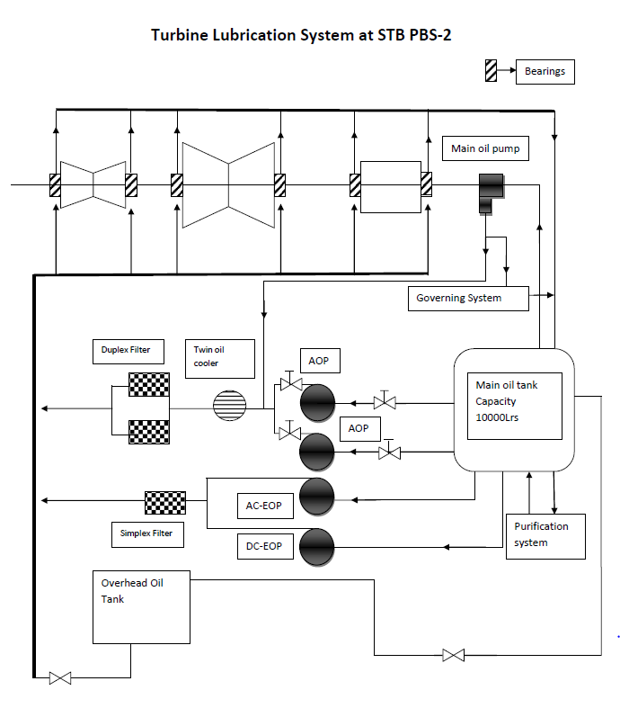

**TURBINE LUBRICATION SYSTEM**

The modern steam turbine and generator are carefully designed pieces of equipment constructed of well selected materials. Its satisfactory performance and useful life in service depend, among other things, on the maintenance of proper lubrication. This is one of the best insurances against turbine outage. The Lubricating oil system performs three basic functions: It reduces friction between rotating and fixed elements, It removes heat from the bearings and In mechanical hydraulic governing systems, it is used as a hydraulic pressure fluid.

Figure shows a typical turbine lubrication system. Majority of oil is stored in a Lube oil tank. Different pumps as described below take suction from pump and discharge oil for bearings.

**Main oil pump**

The main oil pump is the one that delivers all the oil requirements for the turbine-generator at high pressure during normal operation. It is direct-driven from the turbine shaft and may be located at either the turbine or generator end of the shaft. Because the main oil pump is and attached pump, it runs at turbine shaft speed. During startup and shutdown, the main oil pump is not turning fast enough to deliver the required flow so auxiliary pumps are used.

**Auxiliary oil pump**

The auxiliary oil pump has two functions. The first is to operate during the startup and shutdown when the main oil pump is not running and second is to act as a standby during the main oil pump failure.

**Emergency oil pump**

The time required for a turbine to run down from operating speed to a stop is typically from 20 to 45 minutes. If the bearings did not receive lubrication during this period, they would rapidly overheat and be destroyed. The only method of protection is to provide a sufficient number of alternate power supply lube oil pumps to insure all lube oil flow is not lost. The auxiliary lube oil pump is normally backed up with ac and dc emergency lube oil pump. This pump is automatically started from a pressure switch in the lube oil supply header to the bearings.

**Jacking oil pump**

When the heavy turbine-generator shaft is at rest, It will squeeze the oil film from under the shaft at the bearings. If the shaft is then rotated, there will be metal-to-metal rubbing until the oil can work its way underneath. To avoid this situation, the jacking oil pump injects oil at high pressure into the bearing at the bottom of the shaft. This tends to lift or jack the shaft a few hundredths of a millimeter off the bearing so that there will be no metal-to-metal contact.

