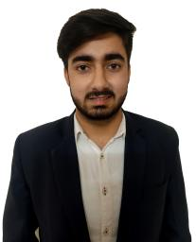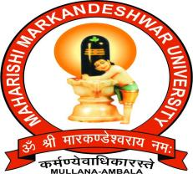

M. M. Engineering College (MMEC)

MAHARISHI MARKANDESHWAR DEEMED TO BE UNIVERSITY

**NAME :** Anshul Soni

**Contact no :** 9736362767

**Email :** [anshul10soni4@gmail.com](mailto:shubh11162538@gmail.com)

<https://www.linkedin.com/in/anshul-soni-b32375196/>

**Career Objective**

Seeking a position in a competitive environment that would challenge me to push my boundaries and expand my knowledge in my field of computer science hence becoming a successful expert person in the field

|  |  |  |  |  |
| --- | --- | --- | --- | --- |
| **Qualification** | | | | |
| **Year** | **Course** | **Institute/College** | **University/Board** | **Marks** |
| 2022 | B-Tech (CSE) | M.M.E.C | M.M.D.U. | 8.4 |
| 2018 | XII | Green Field Sr. Sec. School | C.B.S.E | 84.5 % |
| 2016 | X | Green Field Sr. Sec. School | C.B.S.E | 8.6 |

|  |  |  |  |
| --- | --- | --- | --- |
| **Training/Projects** | | | |
| **Start**  **Month & Year** | **Duration** | **Project Description** | **Company/Institution Name, Location** |
| Aug, 2020 | 6 weeks | MMDU FEE MANAGEMENT SYSTEM  We developed a website to reduce the paperwork and time of college management by easily providing the details of students like fee details. | MMDU, Mullana |
| Jan, 2021 | 6 weeks | NOTES MMDU  We developed a website to provide every note from every subject from any year by uploading the notes and then students can download them anytime, anywhere. | MMDU, Mullana |

**Extra – Curricular Activities**

* Encouraged students to particpate in technical events as Vice President of CODEx.
* Silver Medalist in CricBid in UniversuMM 2018.
* Got a special prize in first year for outperforming in MINITHON.
* Organizer in UniversuMM 2019, UniversuMM 2020.
* Participated in various coding events like CODEARENA, CODE COMMAND.
* Semi Finalist in Badminton tournament in UniversuMM 2018.

Operating System : Windows

**Technical Skills**

Programming Languages : C++

Web Technologies : HTML, CSS, PHP

Backend : Node.js (Basic)

Databases : MySQL, phpmyadmin

Skills : Adobe Photoshop , Video / Photo Editing Skills

Editors and IDE : Visual Studio, Sublime Text.

**Interests/Hobbies**

* Graphic designing.
* Listening to music.
* Making posters and vector images.
* Travelling to new places.
* Playing Cricket.
* Organizing Events.
* Online Multiplayer Gaming.

**Strengths**

* Leadership
* Passionate to deliver results
* Innovative
* Energetic
* Punctual

**Personal Information**

Father’s Name : Mr. Bal Krishan Soni

Date of Birth : 28.06.2001

Nationality : Indian

I hereby declare that the above written particulars are true and correct to the best of my knowledge and belief.

**Date:**

**Place:** Mullana **Signature**