Umbrella Coin: Peer-to-Peer Benefit Payouts

Terry Tata[1], Brandon Sweet[2]

July 2017

**Abstract**

The Umbrella Coin (UMC) team is building a next generation model for providing risk management for individuals and businesses. Our solution will be built on a decentralized, blockchain platform to avoid the fees and management costs associated with traditional insurance companies. We are aiming to have UMC tokens augment standard insurance policies such as life/health (L/H) and property/casualty (P/C). Total net premiums for L/H and P/C insurers was approximately 1.2 trillion in the United States alone in 2015[3]. Juxtapose net premiums with the total profits, approximately 100 billion[4], and there is a clear opportunity for the insured to cut out middle men and stop overpaying for coverage. Furthermore, policyholder’s requirement to pay a deductible and other hidden costs imposes an even greater overhead when attempting to make insurance claims. Our goal is to make UMC viable for standard benefit payouts and later expand to full insurance policies.

Contents

2 Insurance 3

1. Middle-Men 4

2. High Premiums 5

3. Decentralized Centralization 5

4. Mandates 6

5. Deductibles 7

3 UMC 8

Pay UMC for benefits 8

3.1.1 Guarding against fund depletion 9

2. Policy Creation, voting and regulatory compliance 10

3.2.1 Regulating Claims / Voting Process 10

4 Roadmap 11

5 Crowdfund 12

1. Crowdsale Distribution 13

6 Conclusion 14

# Insurance

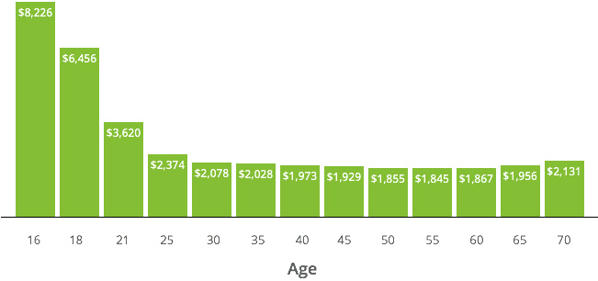

Figure 1. Car Insurance Premiums by age[5]

An insurance policy is a financial contract by which the buyer is protected from financial responsibility in the case of an emergency or unexpected life-event. There is a litany of items that can be insured under a given policy including homes, automobiles, health care, or personal goods. While offering peace of mind and a safeguard against risk for policyholders, insurance is a boon for insurers. Warren Buffett, famous investor and CEO of Berkshire Hathaway, referred to insurance as Berkshire’s “most important sector” in his latest letter to shareholders [6]. Clearly, there are strides to be made for policyholders to retain their value.

This burden is shared worldwide with 10 of the 18 largest insurance companies in the world being headquartered in other countries, including Japan, Germany, China and the UK.[7]

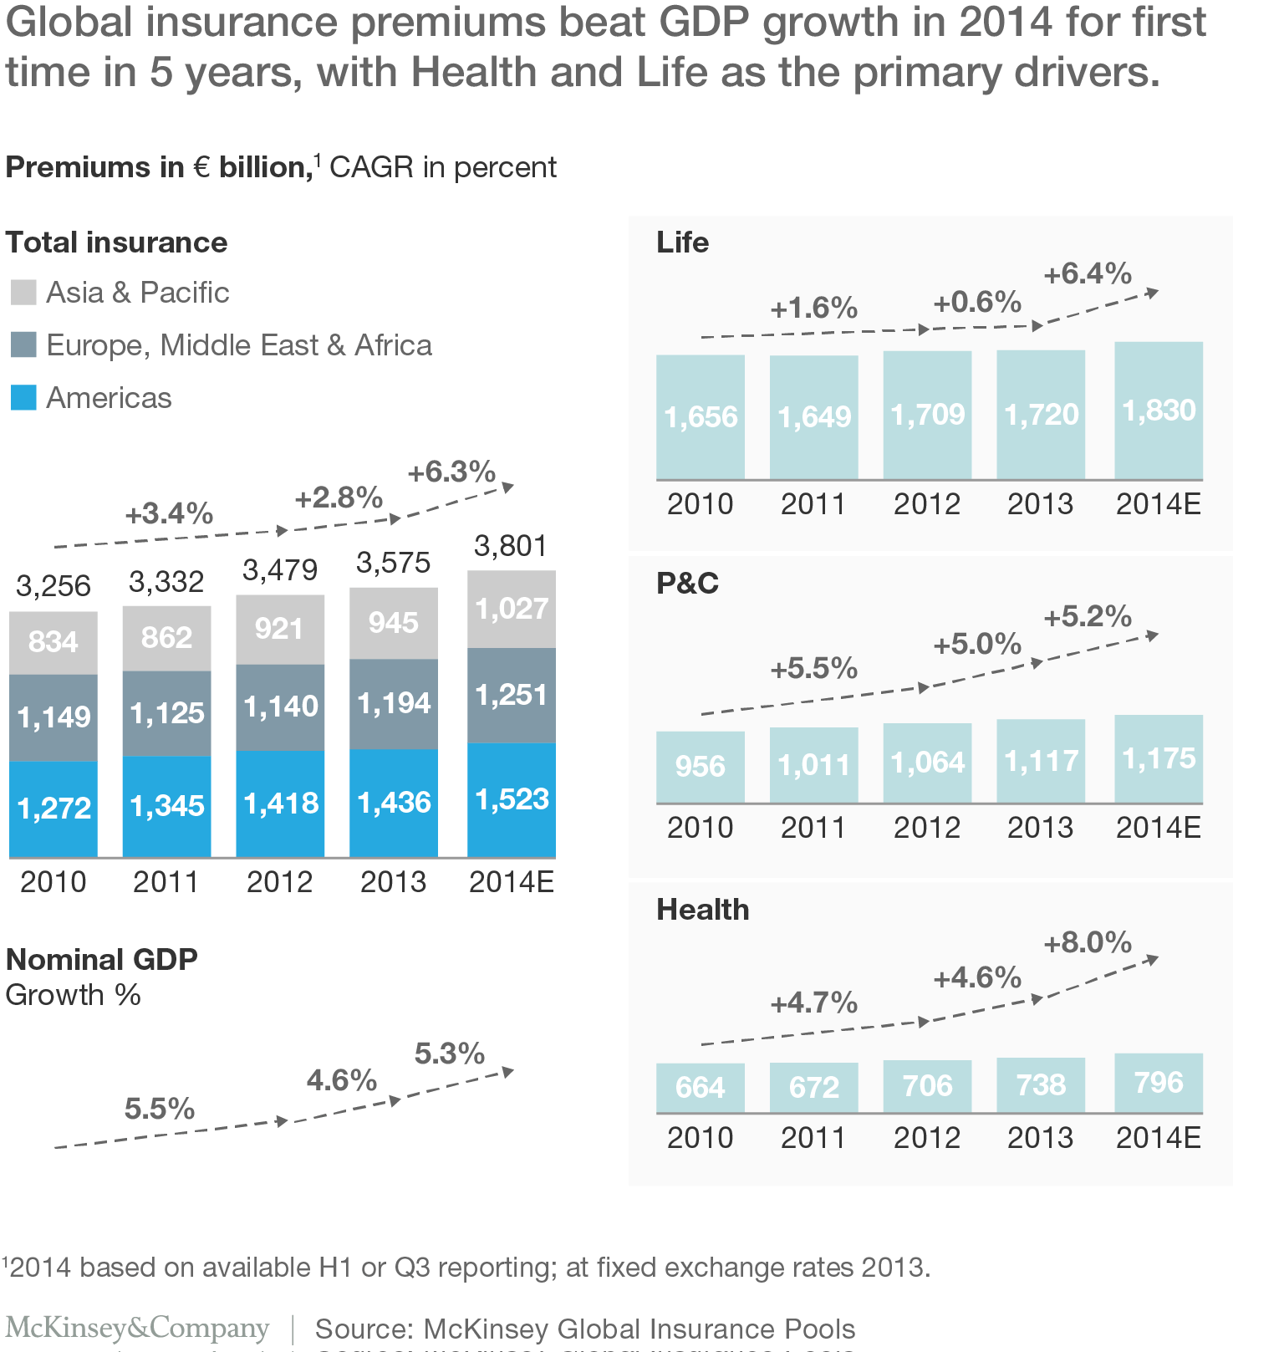

Source: McKinsey[8]

## Middle-Men

Many insurance policies are sold via an agent or broker. These agents are licensed to sell insurance in certain states or territories and make commission on their sale of insurance. The cost of their sale is passed on to the policyholder. While we believe that the profit insurers make off policyholders is absurd, additional parties gaining a profit even further reduces the cost/value ratio of purchasing a policy.

UMC solves this by allowing “policyholders” (or really, coin holders), to bypass the overhead of purchasing through agents and instead purchase from other coin holders.

## High Premiums

As illustrated by figure 1, insurance is sold based on the perceived risk of the policyholder. Actuaries are responsible for assessing the risk factors of a policyholder and determining an acceptable rate for the policyholder. Based on perceived risk, or previous insurance claims, policyholders may be viewed as a greater liability and forced to pay more. Of course, in the event they do not make a claim, their premium is considerable profit for the insurance agency with no monetary gain for the policyholder. As time goes on, rates increase for car insurance and life insurance as you are perceived to be more risk. Furthermore, if a policyholder makes a claim for P/C, their rates will inevitably increase to offset the risk they are perceived to have.

## Decentralized Centralization

Most interestingly about the current insurance model is the funding source and revenue. Insurance companies pool money from policyholder premiums and invest into commodities like stocks, bonds, precious metals, and perhaps even cryptocurrency. Insurance companies therefore collect the growth and interest on policyholder money instead of the policyholder themselves. Couple this with potentially high premiums outlined above and policyholders stand to lose on both their premium costs and what they would have collected in interest. The pooling model from all policyholders essentially causes the insurance industry to crowdfund funds needed to pay claims while simply operating as overhead for the funds. Insurance companies are reduced to glorified money managers, fighting to pay as little as possible in claims to protect their bottom line.

## Mandates

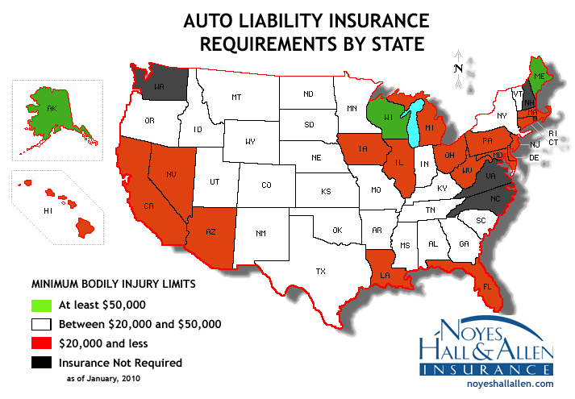

Figure 2. Insurance required by state[9]

While this is gaining much more prominence due to the Affordable Care Act (ACA), the march towards required insurance has been going on for some time. Car insurance has been mandated in some US states as far back as 1925[10], some landlords require renter’s insurance as part of lease agreements, and US employers are required to pay unemployment insurance and disability insurance[11], although the latter varies by state. When mandates are coupled with the already profitable insurance business model, policyholders end up losing even larger percentages of their income with the insurance companies getting richer. An increase in policy count also highlights another problem: most insurance policies cover one liability which causes policyholders to require (and manage) multiple different policies and ensure these are in line with federal and state requirements.

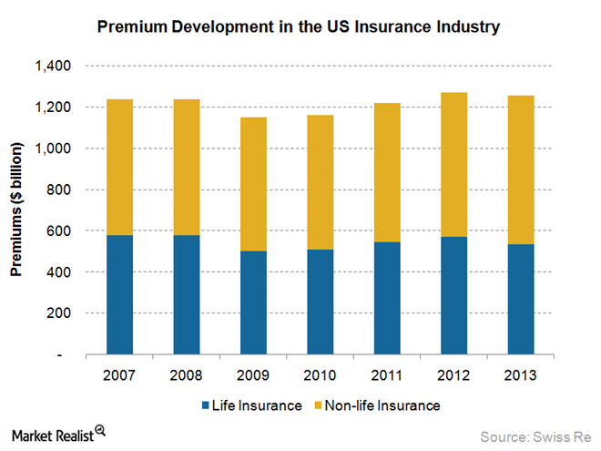

Figure 3. Insurance Premiums by year[12]

UMC will be a one-stop-shop for insurance. It will be sought to be accepted wherever and whenever insurance payouts are necessary, whether that be auto repair, house reconstruction, or medical bills.

## Deductibles

Most policies require holders to pay out of pocket while submitting a claim, before the insurer agrees to cover any of the damages. Many policyholders are unable to pay their deductible, either forcing people into a payment plan or avoiding making a claim due to cost. In 2014, 28% of insured Americans avoided some aspect of medical care due to cost[13]. There is typically a tradeoff between premium and deductible cost, but this is risky proposition for policy holders. Lower premiums mean higher deductibles, which makes it less likely you use your insurance. Higher premiums mean lower deductibles, but that falls into all the pitfalls mentioned in the section above. We believe deductibles, co-pays and co-insurance are the first major area UMC can make an impact while a financial base is established.

# UMC

Initially, UMC will operate with coin holders acting as both policyholders and insurer, essentially combining the role of the traditional format. It is worth noting **we're not trying to replace insurance, but complementing insurance initially as we're not insurance.** UMC is a platform to ensure after the high premiums of insurance, customers aren't left with high out-of-pocket costs. This holds true for all types of insurance- whether it be health, automobile, life, property. We are seeking to disrupt the hidden finances of carrying an existing insurance policy.

## Pay UMC for benefits

In our initial release we will follow a model like Augur.[14] A benefit package can be created by a user by spending UMC on our network. This value is added to our float and immediately invested. Some of the key features are:

1. The maximum benefit a user is entitled to receive from their policy is 5x the UMC spent within their policy period (365 days). So, if you buy 2 ETH worth of UMC during the crowdsale, you're entitled to 10 ETH worth of benefits for the year.
2. At the end of the period, if there were no claims made or the initial invested amount wasn't used, the user gets their unused UMC back. In the previous example, if only 1 ETH worth of valid claim was made the remaining 1 ETH worth of UMC's will be refunded.
3. A user can choose to terminate their policy anytime even prior to the maturity date. However, they might do this at a 70% penalty to avoid fund depletion.  
     
   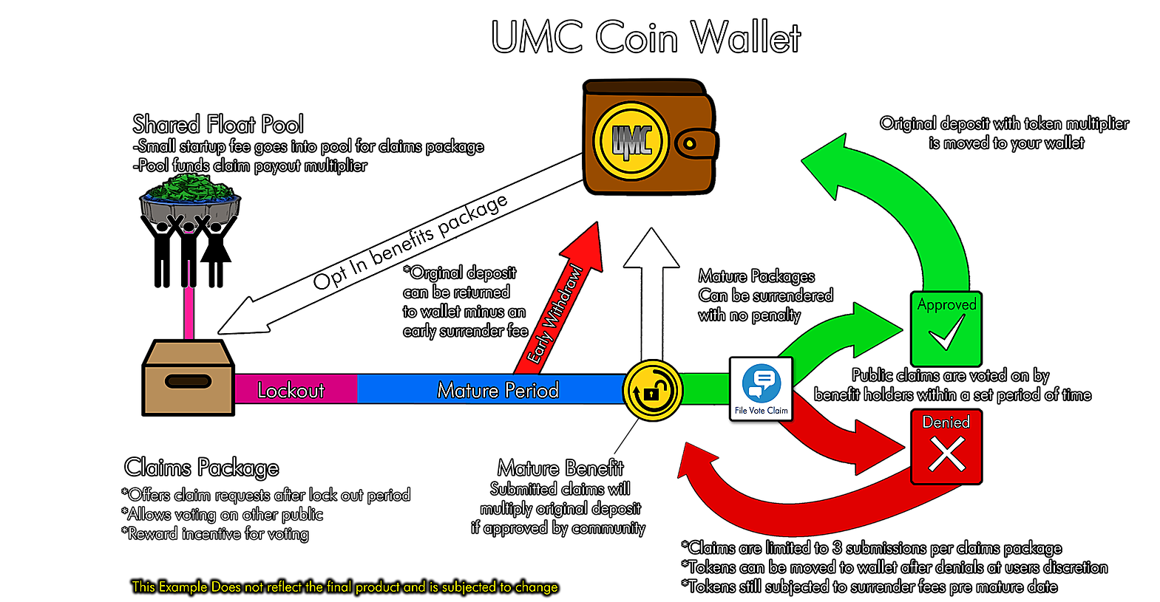Figure 5. Basic UMC Ecosystem

### Guarding against fund depletion

As a new undertaking, our priorities will be to keep the float solvent, and prevent against guard depletion. We'll take a few steps to guard against fund depletion.

#### Early Withdrawal Fees: As explained before, policyholders can terminate anytime but at a penalty of 50% of their investment. This penalty is adjustable to safeguard the float.

1. ***Cap on individual investment***: An individual investor can buy maximum 1% of the net flow at any time, because that entitles them to 5% of the flow's funds. In the initial stages, we'll cap the maximum individual contribution to 500 UMC (entitled to benefits worth 2500 UMC) as well. Any more can cause few claims to deplete the flow instantaneously.
2. ***Cooling period***: Policy-holders can't make claims for 90 days after creating their policies. This is to ensure they don't open policies just in time before an uninsured visit to a doctor, or after some life event has already happened.
3. ***Fraud Claims***: If a community member is discovered to have submitted a fraudulent claim, we propose canceling their policy and keeping the funds in the float.
4. ***Minimum policies:*** To prevent multi-wallet vote stacking, we propose creating a minimum policy amount to discourage users from opening multiple policies with the sole purpose of garnering votes.

## Policy Creation, voting and regulatory compliance

A policy can be created by any coin holder. Their policy will be tied to their wallet address and a claim must be made against a certain policy. You cannot make a claim against a policy not associated with your address. UMC will pay out claims based on a schedule of benefits. The schedule includes auto, home, life, or health costs uncovered by traditional insurance policies. Claims will initially need to be judged by the greater community to be approved or denied. Every claim would need supporting documentation to show it is a legitimate expense on the policy owner's part, and they aren't availing insurance reimbursement for the same. If a claim is approved, the value of the coin holder’s investment portion of their UMC will be credited first, followed by a payment from the greater UMC network drawing from other tokens. However, we recognized a democratic voting process is subject to abuse, and here are some of the methods we've devised to reduce it:

### Regulating Claims / Voting Process

The two opposite concerns we had were either voters not being interested in participating in voting process, or putting "dishonest" votes to deny other policyholders with the expectation of higher returns for themselves. The other concern was vote rigging where some policyholders make a lot of accounts and vote positively on fraudulent claims to obtain all the benefits.  
  
For addressing these concerns, we've devised an anonymous notification-based system to a random sample of voters who have been "chosen to vote" on a particular claim. UMC will assure not to bother them more than once a month. In return, they must participate in the voting process when they're asked to (they can defer if they're busy by clicking a button) within a 24-hour period else face loss of potential payout on their own claims. Therefore, we ensure claim owner's privacy as well as no method to rig individual claims.  
  
On the other hand, there is a problem to incentivize people to vote *truthfully.* Ideally, we want the policyholders to know denying someone else's claim won't increase their own odds of obtaining payouts as we're doing whatever we can towards solvency.Beyond that, we devised a method such that every voter's voting history will be stored and tallied against the final outcome of the voting. If a particular user shows a strong disparity in this metric, they might be warned and would be subject to losing their entitlements as part of the policy. On the other hand, with a high parity with the outcomes and in general, timely participation in the process would entitle the users to lower cooling periods, lower penalties and so on.   
  
A community vote will take place for 24 hours, the choices will be:

1. Yes – specify UMC amount
2. No
3. Need more evidence
4. Fraudulent

We will not publish vote totals until the conclusion of the voting period to not sway votes. We will have a simple majority rules system initially. If the ‘yes’ votes win, the median price of the submitted payouts will be paid to the policyholder. And as stated before there will be added incentives to be on the “winning” side of a claim to encourage fair voting.

**3.2.2 Regulatory Compliance**

As with every business, we can't ignore the regulatory concerns which might crop us as a result of operations. The two categories of compliance issues we might with are to protect investors and customers. As far as SEC is concerned, we will cap the number of US based policyholders to less than 500 to avoid forced public offering. Also, we want to reiterate **we aren't selling securities** with intention of profit. Individuals buy tokens with the intention of using them towards their claims.

The second part of the concern is with licensing issues and the use of blockchain to serve industries. We acknowledge there is significant unpredictability on using blockchain-based solutions and we believe eventually these will be ironed out in favor of cryptocurrencies. As far as licensing issues are concerned, firstly, **we are not insurance.** We however would need to respect customer privacy laws as laid out in HIPAA when we're dealing with medical claims. Our anonymized voting process would allow that. With other licensing issues regarding our democratized model and possible pressure from insurance lobby, we like to remind others we're operating in the same space as Uber and Airbnb when they started out. By the time, the regulators caught up to app market, these firms were big enough and had their fair share of customers who they had pleased. Similarly, we believe rather than worrying too much about licensing issues we will just get out there with blockchain-based solutions, serve the customers and in the end let customer satisfaction speak for an industry which needs monopolies to be loosened.

# Roadmap

Our main product during the crowdfund is to create the infrastructure and client for exchanges, voting, penalties & fees, and claims. Afterwards we will explore marketing this to existing agencies accepting insurance claims directly, expanding policies into different areas, and general algorithmic reviews to ensure proper float throughput.

*June-July 2017* – Whitepaper written, website launched

*August-October 2017* –Client and smart contract development for benefits; float infrastructure implementation

*October 2017 –* Client launched

*September-December 2017 –*policy/claim creation; claim review from community

*November-December 2017-* start partnering with existing benefits companies to offer UMC through their network

*February 2018 –* Client feature complete

*May 2018* – automatic claim review; coin holder policy improvements

*2018* - further partner expansion; algorithmic review

# Crowdfund

**Crowdfund Start Date:** 20 August 2017 12:00 UTC

**Crowdfund End Date:** 20 October 2017 12:00 UTC

**Issuance of UMC Tokens:** 100 000 000 Tokens

**Exchange rate:** 600 UMC = 1 ETH.

**Minimum transaction amount:** 60 UMC (0.1 ETH)

**Maximum transaction amount:** 1 800 000 UMC (3 000 ETH)

**Bonuses:** for the first 5000 ETH raised, a 100% bonus will be given

**Bounty:** 1 200 000 Tokens (1.2% of issuance)

**Total Sale goal:** 100 000 ETH

**Minimal Sale goal:** 5 000 ETH

Token distribution rules:

* 68.8% (68 million tokens) will be available to participants
* 20% (20 million tokens) will be allocated to the UMC trust and will be used to build a preliminary float pool.
* 10% (10 million tokens) will be distributed among team members
* All collected funds shall be received and stored on wallets with multi-signatures.

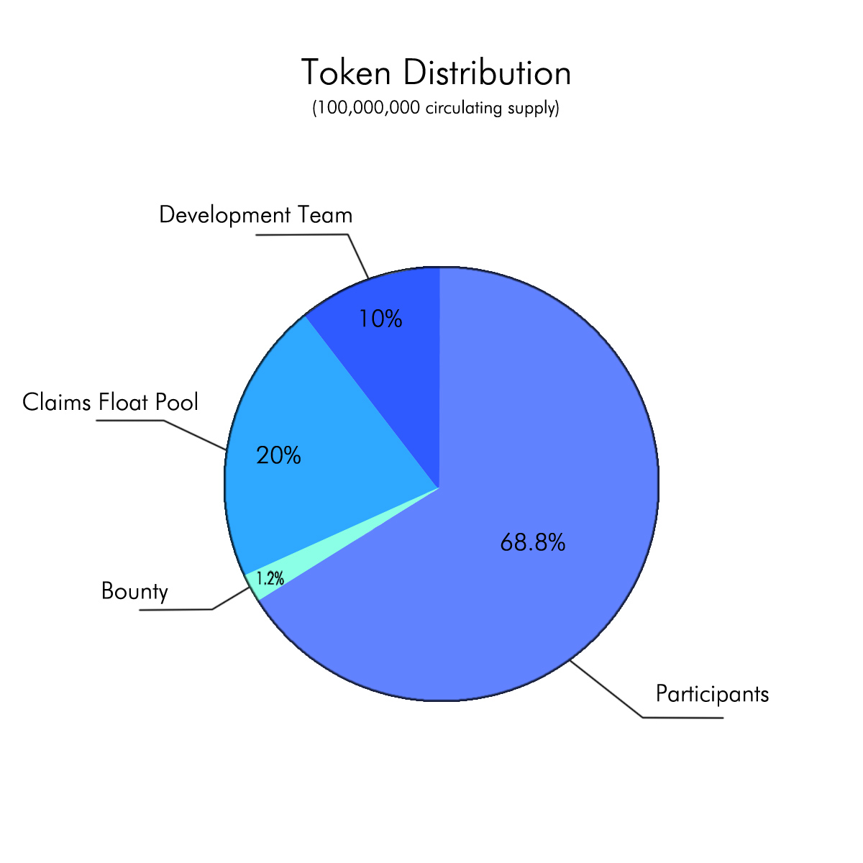

## Crowdsale Distribution

The crowdsale funds will go towards funding future development of the UMC platform and helping us meet our roadmap goals. We are currently a distributed team and plan to maintain this arrangement to keep costs low. Depending on the success of the crowdfund, we see our funding able to sustain the development team for 3-4 years.

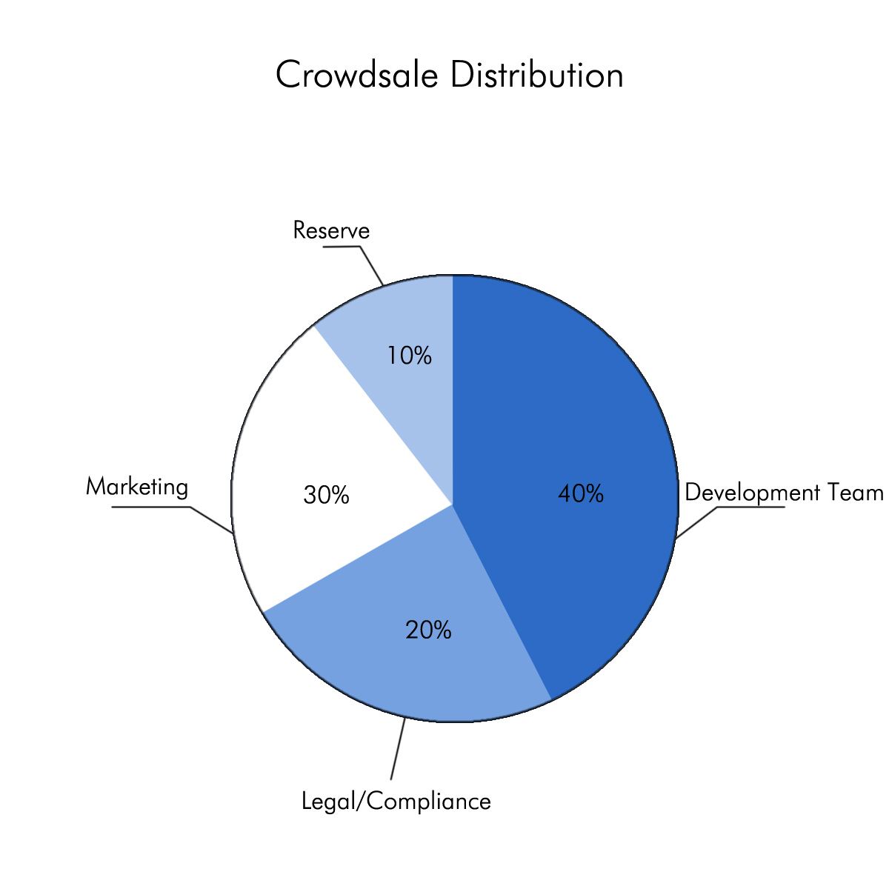

# Conclusion

UMC is being developed to decentralize benefit payouts and put power into the hands of policyholders. We are targeting an aggressive development and launch date for our tokens and client allowing coin holders to submit and make claims. Initially we will target paying limited amount benefit payouts with very strict and very low payouts to ensure solvency. You can learn more about the team and keep up with our progress at:

<https://www.umbrellacoin.org>

<https://bitcointalk.org/index.php?topic=2025943.msg20180128>

<https://www.reddit.com/r/UmbrellaCoin/>

<https://twitter.com/umbrellacoin>

https://www.facebook.com/umbrellacoin/

<https://github.com/umbrellacoin>

<https://discord.gg/85D6jNr>

1. <https://www.linkedin.com/in/terry-tata-a862649a>
2. <https://www.linkedin.com/in/brandon-sweet-32311029>
3. <http://www.iii.org/fact-statistic/industry-overview>
4. <https://www.treasury.gov/initiatives/fio/reports-and-notices/Documents/2016_Annual_Report.pdf>
5. <https://www.valuepenguin.com/average-cost-of-insurance>
6. <http://www.berkshirehathaway.com/letters/2016ltr.pdf>
7. <http://www.propertycasualty360.com/2016/08/24/18-pc-insurance-companies-make-the-2016-fortune-gl?slreturn=1499729987&page=5&page_all=1>
8. <http://www.mckinsey.com/industries/financial-services/our-insights/global-insurance-insights-a-detailed-analysis-of-trends-that-shape-the-industry>
9. <http://rsiclub.tk/gezy/car-insurance-requirements-by-state-2170.php>
10. <https://en.wikipedia.org/wiki/Vehicle_insurance_in_the_United_States>
11. <https://www.sba.gov/managing-business/running-business/insurance/insurance-requirements-employers>
12. <http://marketrealist.com/2015/02/us-insurance-industry-largest-world/>
13. <http://www.commonwealthfund.org/~/media/files/publications/issue-brief/2015/jan/1800_collins_biennial_survey_brief.pdf>
14. <https://augur.net/>