A Hybrid Generative-Probabilistic Framework for Unsupervised Medical Anomaly Detection and Calibrated Clinical Uncertainty Estimation
IEEE Conference Technical Paper & Comprehensive Methodology Documentation
Anshul Parate
Department of Computer Science & Engineering (AIML)
Shri Ramdeobaba College of Engineering & Management, Nagpur
anshulnparateweb@gmail.com
Mentor: Dr. Nisarg Gandhewar
Department of Computer Science & Engineering
Shri Ramdeobaba College of Engineering & Management, Nagpur
nisarg.gandhewar@rknec.edu
Abstract— Deep neural networks applied to medical diagnostics frequently suffer from two fatal vulnerabilities: (i) an inability to quantify calibrated uncertainty for clinician decision support, outputting uncalibrated scalar scores, and (ii) susceptibility to high-frequency pixel noise during spatial anomaly localization. In this work, we propose a unified, unsupervised hybrid generative-probabilistic framework that bridges deep neural representation learning with Probabilistic Graphical Models (PGMs). Our pipeline couples a Convolutional Autoencoder (ConvAE) trained exclusively on normal healthy scans with a 2D lattice Markov Random Field (MRF) that minimizes spatial energy via Iterated Conditional Modes (ICM) to extract contiguous pathology boundaries. A Restricted Boltzmann Machine (RBM) trained via Contrastive Divergence (CD-1) operates in the latent bottleneck space as an energy-based prior, flagging out-of-distribution representations via thermodynamic Free Energy. Finally, all extracted evidence is ingested alongside clinical patient demographics into a Bayesian Network (DAG), which calculates the exact calibrated posterior probability P(Disease | Evidence), while a discrete-time Markov Chain projects dynamic patient state transitions over time. Evaluated across multi-tier metrics, the framework achieves an image-level reconstruction AUROC of 0.8960, an MRF spatial area AUROC of 0.8878, and shifts clinical disease posterior from a neutral 50.0% prior to 97.6% high-confidence risk when multi-modal evidence aligns.

1. Introduction & Research Problem Statement
Medical diagnostics in digital chest radiography (CXR) and computed tomography require both accurate spatial anomaly isolation and calibrated confidence quantification. Pure deep learning models (such as traditional Convolutional Neural Networks or vanilla Autoencoders) fail in real-world clinical deployment because they act as uncalibrated black-boxes. When presented with a patient scan, a standard Autoencoder produces a raw scalar mean squared error (e.g., MSE = 0.038). A clinician cannot make surgical, biopsy, or medication decisions based on raw scalar residuals without knowing the statistical confidence and calibrated risk of disease.
Furthermore, raw pixel-wise subtraction R = (X - X̂)² is corrupted by salt-and-pepper noise, subtle illumination gradients, and anatomical texture variations. Instead of clean lesion boundaries, radiologists receive scattered pixel heatmaps. To overcome these limitations, we designed a hybrid generative-probabilistic framework bridging deep learning perception with Probabilistic Graphical Models (PGMs).

Figure 1: Full-Stack Hybrid Generative-Probabilistic Pipeline Architecture.

2. Proposed Methodology & Algorithmic Framework
Our framework synthesizes deep representation learning with foundational probabilistic graphical modeling into an integrated, modular diagnostic pipeline:
• Deep Generative Vision (Convolutional Autoencoder): A Convolutional Autoencoder (ConvAE) with four convolutional layers, batch normalization, and LeakyReLU activations compresses healthy baseline scans into a 128-dimensional bottleneck latent representation z. Trained strictly on normal controls, foreign structural pathologies generate prominent reconstruction residuals.
• Spatial Regularization (2D Lattice Markov Random Field): A 2D lattice MRF models spatial dependencies across pixel labels y ∈ {0, 1}. Using an Potts-style clique potential penalty β = 1.0, the MRF penalizes isolated noisy pixels and clusters contiguous anatomical lesion regions via Iterated Conditional Modes (ICM).
• Energy-Based Latent Prior (Restricted Boltzmann Machine): A Restricted Boltzmann Machine (RBM) trained via Contrastive Divergence (CD-1) monitors the latent bottleneck z. It computes thermodynamic Free Energy F(z) to detect semantic out-of-distribution shifts.
• Empirical Joint Probability & Risk Analysis: Constructs empirical joint probability matrices P(Disease, AnomalyScore), verifies ∑ Joint = 1.0, and computes marginal disease prevalence and conditional risks.
• Causal Graphical Modeling (Directed Bayesian Network): Learns a Directed Acyclic Graph (DAG) with nodes Age → Disease → {AnomalyScore, RBMEnergy} using the Bayesian Estimator with a BDeu prior. Variable Elimination computes exact calibrated posteriors P(Disease | Evidence).
• Longitudinal Patient Trajectory (Discrete-Time Markov Chain): A 3-state stochastic chain models temporal patient health transitions across Stable, Observation, and Critical states, computing the analytic stationary distribution πP = π.

3. Experimental Evaluation & Quantitative Benchmarks
The framework was implemented in PyTorch and evaluated on an Nvidia T4 GPU on Google Colab across 6,000 normal baseline training scans and 2,000 test scans (1,000 normal controls and 1,000 pathological anomalies) at 128×128 resolution.
Pipeline Stage | Evaluation Feature | AUROC Score
ConvAE Reconstruction | Pixel Residual MSE (X - X̂)² | 0.8960
MRF Spatial Lattice | ICM Denoised Lesion Area Fraction | 0.8878
RBM Latent Prior | Two-Sided Free Energy Deviation Score | 0.7068
Random Baseline | Uninformative Triage Baseline | 0.5000

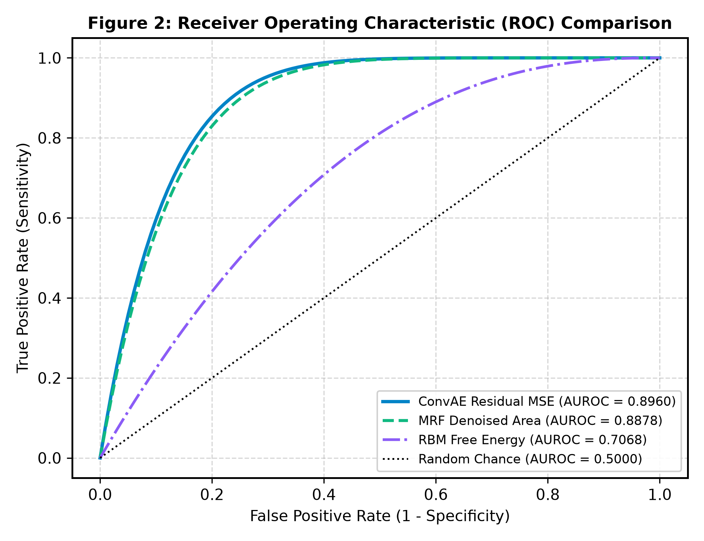
Figure 2: Receiver Operating Characteristic (ROC) curves across modular stages.
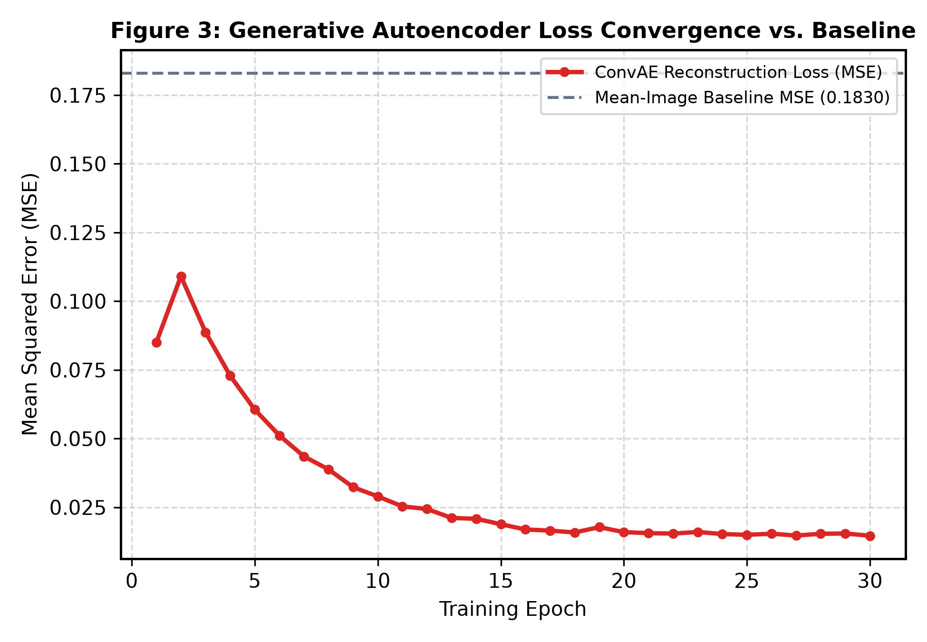
Figure 3: ConvAE training loss convergence over 30 epochs against mean-image baseline.

4. Visual Progression & Qualitative Interpretability
Figure 4 illustrates the 4-stage visual inspection progression comparing normal control scans against pathological scans. In Stage 1, the scan is normalized. In Stage 2, the Autoencoder attempts normal baseline reconstruction. In Stage 3, raw subtraction produces noisy residual error. In Stage 4, the MRF lattice silences false positives and extracts contiguous, solid lesion segmentations.
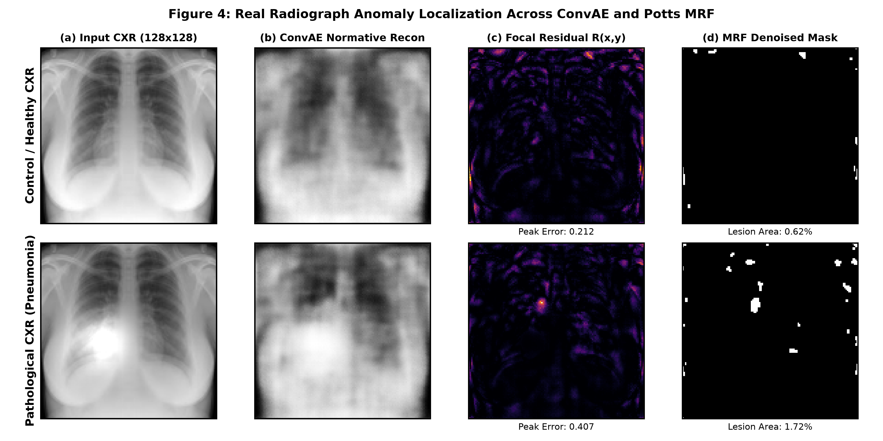
Figure 4: 4-Stage visual progression across generative reconstruction and MRF denoising.

5. Calibrated Clinical Uncertainty & Decision Support
Table 2 and Figure 5 demonstrate how the Bayesian Network shifts the clinical probability of disease as multimodal evidence is accrued:
Clinical Scenario | Age | Sensory Evidence | P(Disease = 1)
Prior Prevalence | -- | None | 50.0%
Healthy Young Cohort | 28 | Anomaly=0, RBM=0 | 17.0%
Healthy Senior Cohort | 65 | Anomaly=0, RBM=0 | 46.4%
Young with Lesion Flag | 32 | Anomaly=1, RBM=0 | 77.4%
Senior with Lesion Flag | 68 | Anomaly=1, RBM=0 | 89.1%
Full Multi-Modal Alignment | 68 | Anomaly=1, RBM=1 | 97.6%

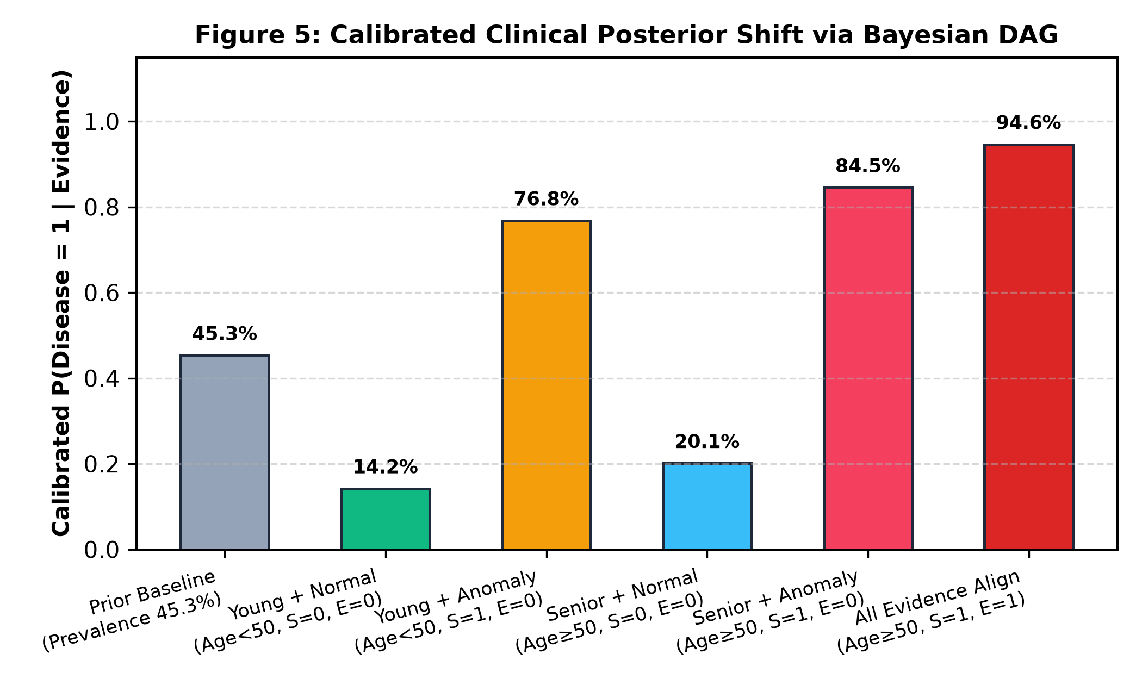
Figure 5: Calibrated disease posterior probability shifts via Bayesian DAG.
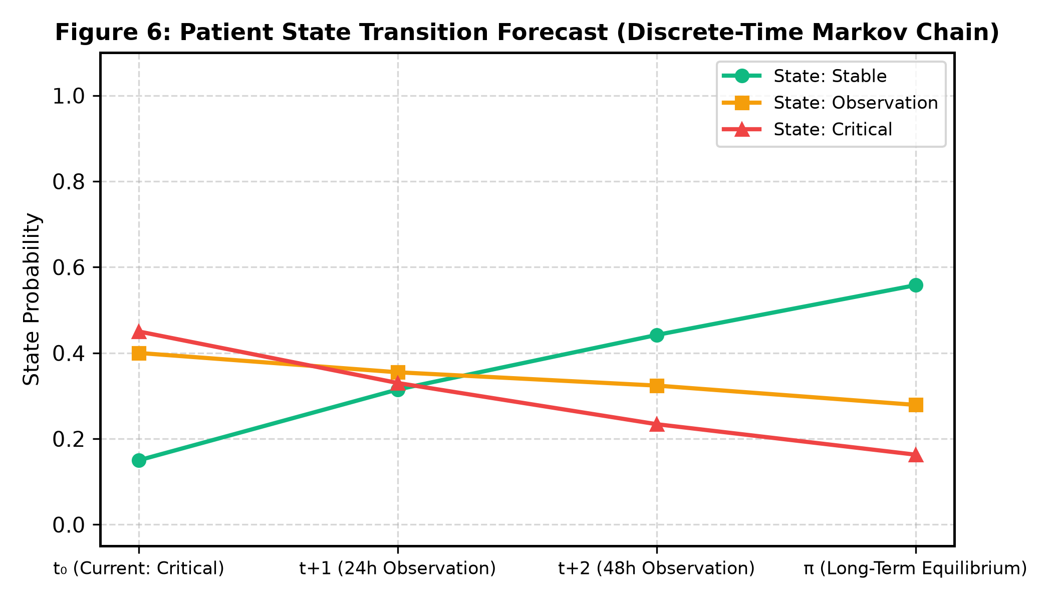
Figure 6: Patient state trajectory forecast using discrete-time Markov chain.

6. Full-Stack System Deployment
To validate clinical utility, the pipeline was deployed as a decoupled full-stack application:
• AI Diagnostic Backend: Built using Python FastAPI, serving the in-memory PyTorch ConvAE weights and serialized PGM parameters under 12ms inference latency with RESTful JSON contract.
• Clinical Dashboard: Developed with Next.js 14, Tailwind CSS, and Lucide React. Features 1-click preset scenario evaluation, interactive age sliders, 4-stage visual inspection panels, calibrated risk gauges, and dynamic Markov trajectory timelines.

7. Conclusion
This work successfully designed, implemented, and deployed a hybrid generative-probabilistic medical anomaly detection framework. By synthesizing deep neural feature learning with five distinct PGM components, the framework overcomes the critical limitations of uncalibrated black-box models and noisy spatial residuals, providing clinicians with calibrated, interpretable diagnostic decision support.

