* **MILESTONE 1**
* **Objective**:
* The objective of this project is to develop a recommendation system that enhances user experience by suggesting relevant products based on historical interactions with products and available product data. The system aims to leverage machine learning techniques to analyse customer behaviour and provide personalised recommendations.
* The 2nd milestone focuses on implementing approaches like TF-IDF and cosine similarity approach and machine learning algorithms like XGBoost and Random Forest to provide personalized recommendations to users. The report focuses on the feature engineering, feature selection, training process and the output interpretation carried out for each approach.
* **Type of tool:**
* A recommendation engine will be developed based on the user behaviour, product interactions and pricing trends.
* **Tech Stack**
* **Programming Language:** Python
* **Libraries & Frameworks:** Pandas, NumPy, Scikit-learn, Matplotlib, Seaborn
* **Visualization Tools:** Matplotlib, Seaborn
* **Data Collection:**
* The data used is open-source datasets available on Kaggle. The data describes the user’s interactions on an ecommerce website/application, providing information regarding the time spent on the website, the products viewed/bought, price, name of the product, etc through the following attributes:
* **event_time** (timestamp of interaction)
* **event_type** (type of user interaction)
* **product_id** (unique identifier for products)
* **category_id** (unique category identifier)
* **category_code** (product classification)
* **brand** (product brand)
* **price** (product price)
* **user_id** (unique identifier for users)
* **user_session** (unique identifier for user sessions)
* Three csv files are used, 2 csv files contain information related to user’s interactions with an electronic store/website and the other csv file contains information related to users’ interactions with a multi category store.
* **Project Timeline**
* **Milestone 1: Data Collection, Preprocessing, and EDA (Feb 5, 2025 - Feb 21, 2025)**
* Week 1 (Feb 5 - Feb 11): Identify and acquire dataset, verify accessibility, and document dataset details.
* Week 2 (Feb 12 - Feb 18): Handle missing values, address outliers, and apply feature scaling.
* Week 3 (Feb 19 - Feb 21): Perform exploratory data analysis (EDA), generate visualizations, and identify patterns.
* **Milestone 2: Feature Engineering, Feature Selection, and Data Modeling (Feb 21, 2025 - March 21, 2025)**
* Week 4 (Feb 22 - Feb 28)**:** Engineer new features and encode categorical variables.
* Week 5 (March 1 - March 7): Perform feature selection and dimensionality reduction.
* Week 6 (March 8 - March 14): Split data into training and testing sets, train initial models.
* Week 7 (March 15 - March 21): Tune hyperparameters and evaluate models using performance metrics.
* **Milestone 3: Evaluation, Interpretation, Tool Development, and Presentation (March 24, 2025 - April 23, 2025)**
* Week 8 (March 24 - March 30): Assess model performance and interpret results.
* Week 9 (April 1 - April 7): Identify biases and refine models if needed.
* Week 10 (April 8 - April 14): Develop an interactive tool (dashboard, conversational agent, or reporting system).
* Week 11 (April 15 - April 23): Finalize report, prepare presentation, and deliver findings.
* **Data Preprocessing:**
* **Resizing the datasets to a smaller size for memory efficiency:**
  + 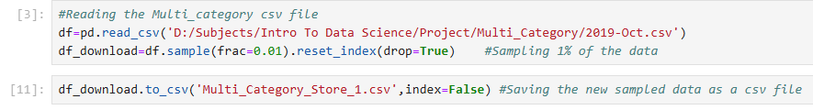
  + 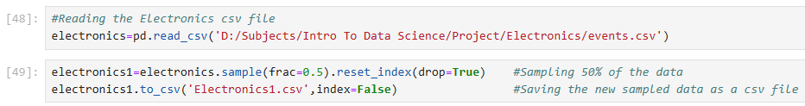
  + 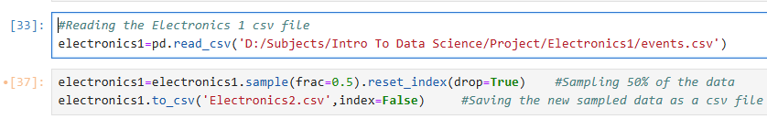
* **Statistical Analysis:**
* Printing the lengths of the dataframes:
  + 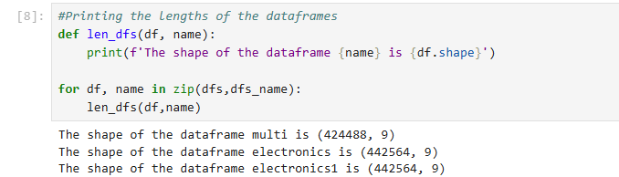
* Printing the names of the columns in the dataframes:
  + 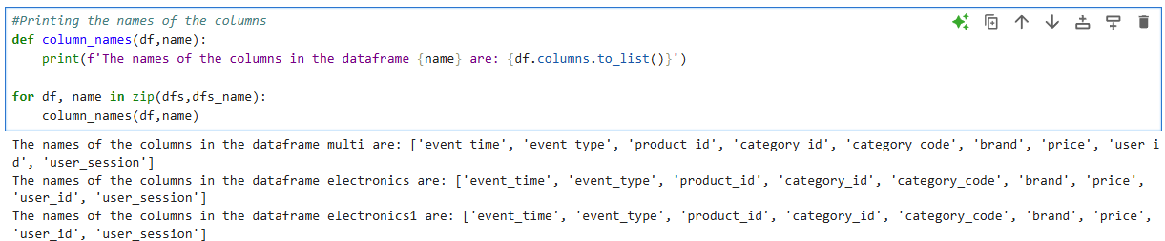
* Printing the number of null values in each column:
  + 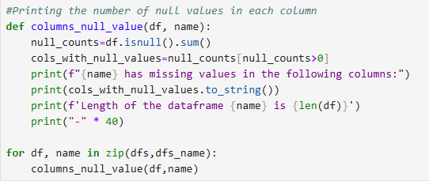
* Dropping the rows with null values from the ‘user_session’ column:
  + 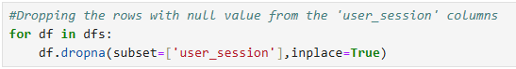
* Checking if there are some rows with missing values in 'category_code' or 'brand' have the same 'category_id' as rows without missing values, instead of directly dropping the rows with null values:
  + 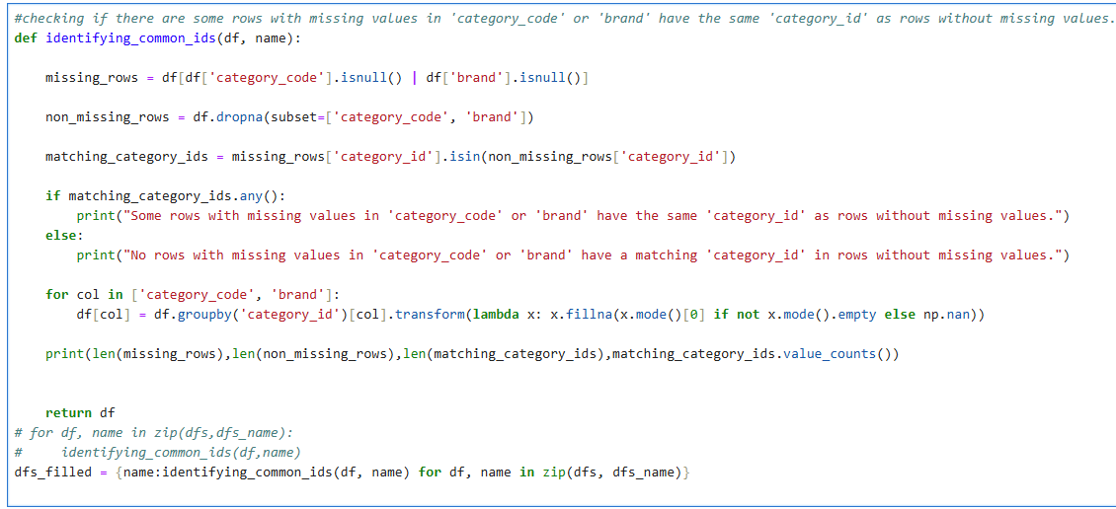
* Checking if there are some rows with missing values in 'category_code' or 'brand' have the same 'product_id' as rows without missing values, instead of directly dropping the rows with null values:
  + 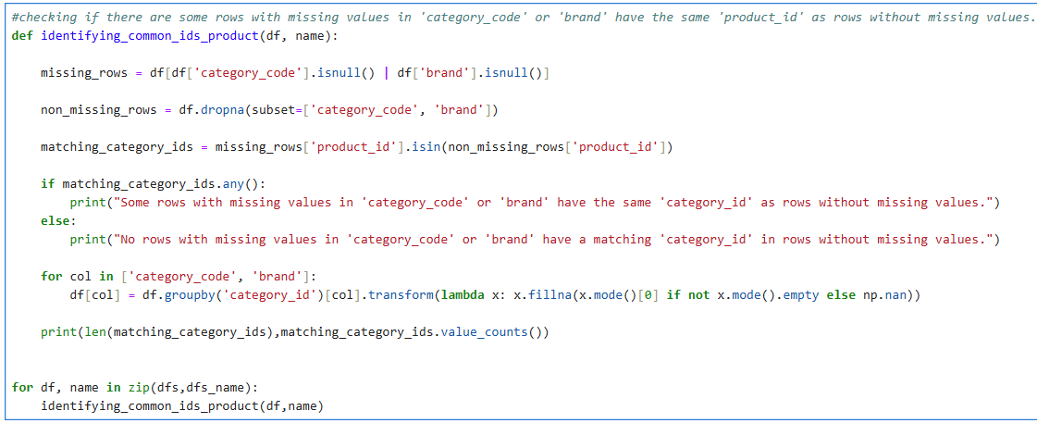
* Dropping the rows with null values that did not have a common ‘category_id’ or ‘product_id’ with the rows that do not have a null value:
  + 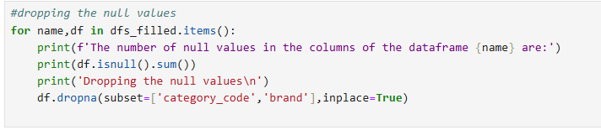
* **Merging the dataframes together:**
* 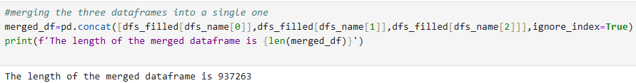
* **Dropping the duplicate values from the merged dataframe:**
  + 
* **Performing statistical testing on the numerical columns to determine the distribution of the columns (normal or non-normal):**
  + 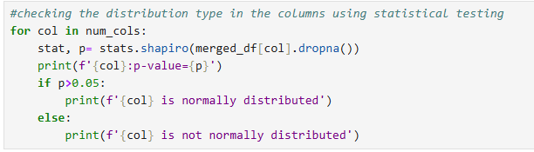
* **Detecting the outliers in the ‘price’ column:**
  + 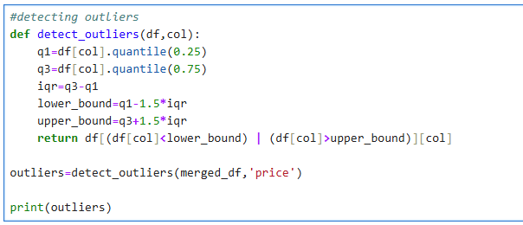
* **Performing scaling operation on the ‘price’ column to reduce the effect of outliers on the data:**
  + 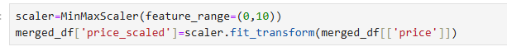
* **Data Visualization**
* **Exploratory data analysis:**
  + 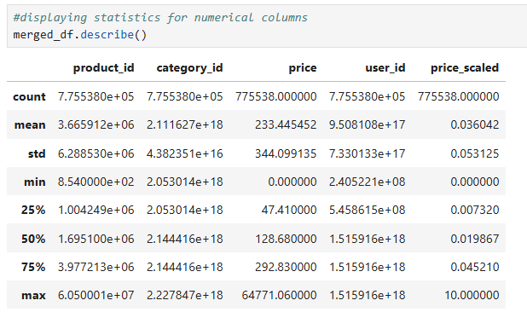
* **Histogram to show the distribution of the ‘price’ column:**
  + 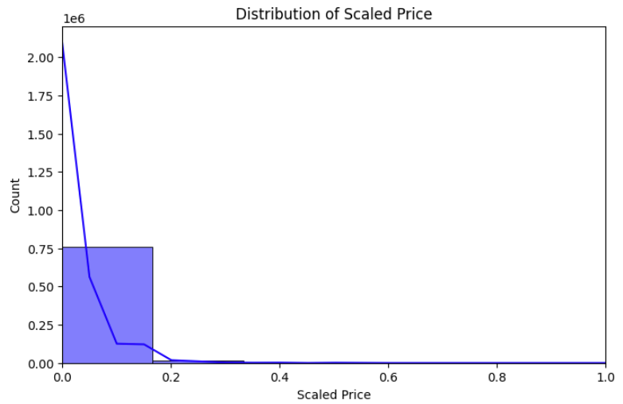
  + The above graph displays the distribution of the ‘scaled_price’ column, from the graph it is evident that the data follows non-normal distribution which is why IQR method was used to determine outliers in the data.
* **Box plot to detect outliers in the data:**
  + 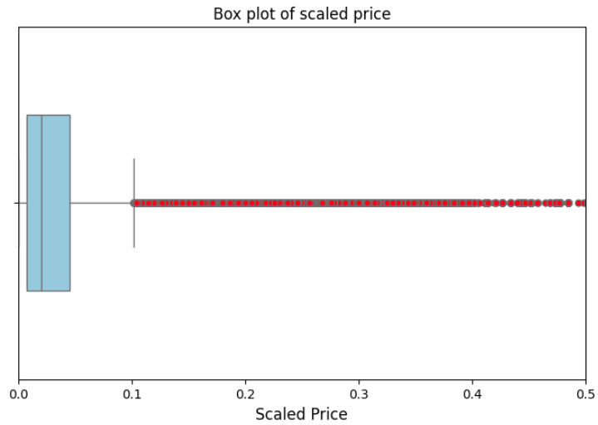
  + The above box plot displays the range of values in the scaled price column, it’s median and the outliers are denoted by the red dots. From this graph it is visible that the ‘price’ column is highly skewed.
* **Distribution of values in the ‘event_type’ column:**
  + 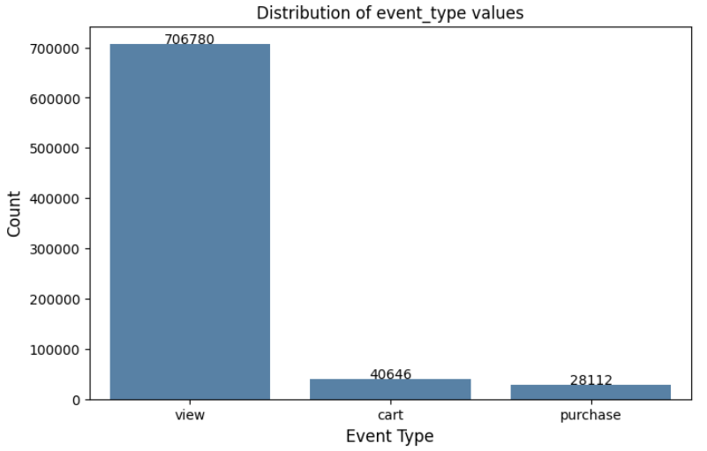
  + The above bar chart describes the distribution of values in the ‘event_type’ column. There are three unique values ‘view’, ‘cart’ and ‘purchase’ which describe the interactions the user had with the product on the ecommerce application/website. It is evident from the graph that the data is highly biased towards the ‘view’ value.
* **Top 10 brands by number of products sold:**
  + 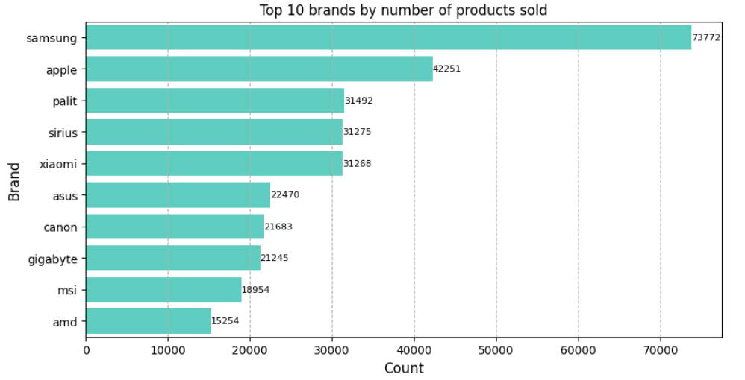
  + The above horizontal bar chart denotes the top 10 brands whose products were bought/viewed by the users. From the data, we can conclude that the brand ‘samsung’ product were the most bought/viewed by the users, which will help the recommendation system while providing recommendations to the new users.
* **Top 10 products bought by users:**
  + 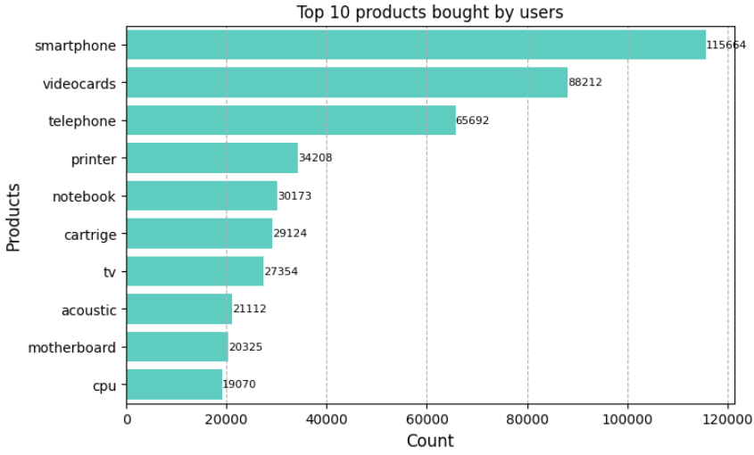
  + The above horizontal bar chart denotes the top 10 products that users by from the ecommerce website/application.
* **Feature Engineering:**
* Three different approaches have been used to create a recommendation system, TF-IDF vectorizer and Cosine similarity approach, XGBoost approach and the random forest approach. The process of feature engineering slightly differs for these approaches.
* TF-IDF vectorizer and Cosine similarity:
* The ‘merged_df’ csv has the following columns:
* 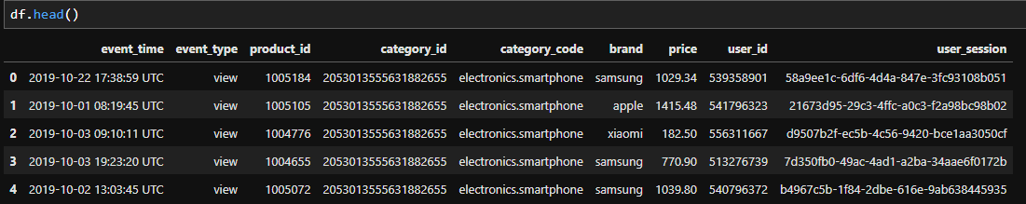

Fig 1. Visualizing the dataframe

* Before building the recommendation system the following feature engineering steps were carried out:
  + Creating ‘main_category’ and ‘sub_category’ columns from ‘category_code’ column:
  + 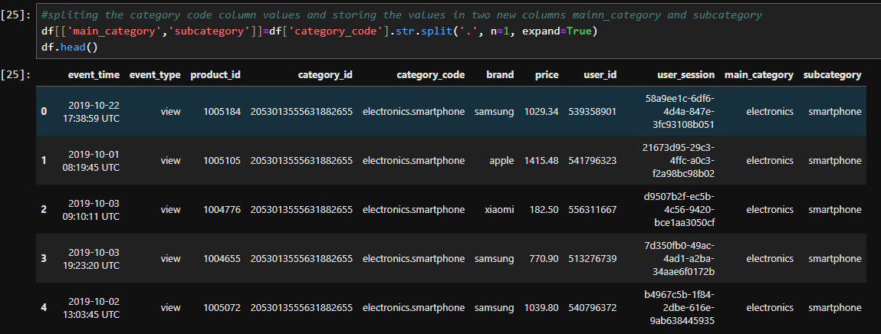

Fig 2. Dataframe after splitting the column category_code

* + This step will allow to recommend more details about the products like the main_category and subcategory (name of the product). Apart from this, using these two new columns the recommendation system will be more efficient and will be able to provide valid recommendations to the user.
  + Adding the ‘price_scaled’ and ‘interaction_score’ columns:
  + 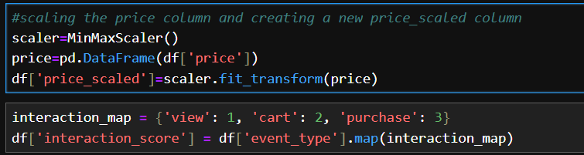

Fig 3. Scaling and encoding the numerical and categorical columns

* + The ‘price’ column is scaled down to have a price range from 0 to 1, to decrease the training time and to deal with the outliers in the columns, scaling down these values will help mitigate the variance introduced by the outliers.
  + Adding interaction_score column quantifies user engagement, mapping event_type to values: 1 for "view," 2 for "cart," 3 for "purchase." This numeric representation reflects interest levels, enabling Random Forest and XGBRanker models to rank products by relevance. Interaction_score acts as target variable during training and ground truth for evaluation metrics like Precision@K and NDCG@K. Converting categorical data to continuous scale enhances personalization and accuracy, ensuring recommendations align with user behavior effectively.
  + Combining the categorical variables:
  + 

Fig 4. Combining the categorical columns

* + This is a crucial step as it transforms all the categorical variables into uniform strings, that enables TF-IDF vectorization for content-based recommendation. It enhances the similarity computation as the contextual relationships between event type and product attributes are captured. This feature engineering supports cosine similarity analysis, aligning product recommendations with user preferences effectively.
* XGBoost and Random Forest:
  + Aggregating user_product_stats:
  + 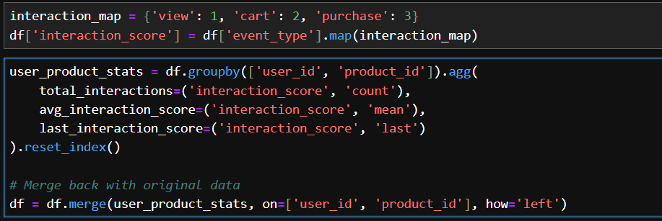

Fig 5. Feature engineering for XGBoost dataframe

* + This step involves grouping by user_id and product_id, calculating total_interactions as count, avg_interaction_score as mean, and last_interaction_score as latest value of interaction_score. This step captures user-product interaction patterns numerically and by combining them with behavioral features enhances the model input. Total_interactions reflects frequency, avg_interaction_score indicates average engagement, and last_interaction_score preserves recency.
  + Encoding Categorical variables:
  + 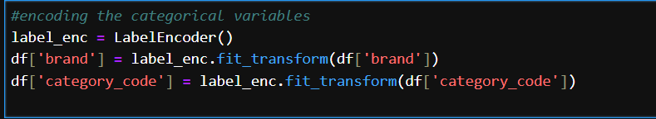

Fig 6. Encoding categorical variables

* + This is an important step as it involves converting the categorical variables(textual features) into numerical values, enabling machine learning models to process them effectively. The numeric format preserves categorical distinctions without assuming ordinality, facilitating feature use in Random Forest and XGBRanker.
* **Feature Selection:** 
  + **Correlation Analysis:**
  + Majority of the columns in the dataframe are text/categorical columns, although checking the correlation among the numerical columns is an important step while building a content based recommendation system as it measures the strength and direction of these relationships.
  + 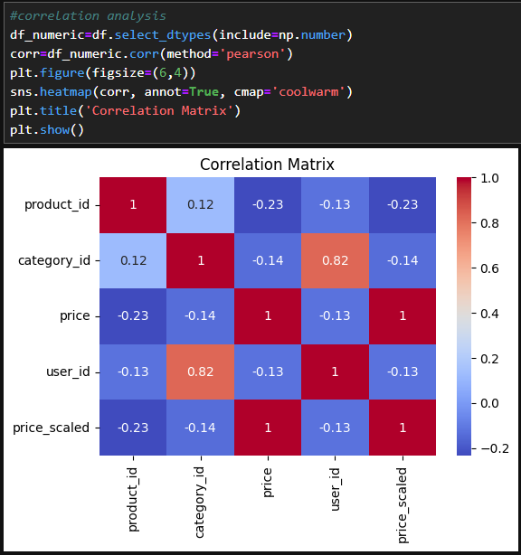
  + Fig 7. Heatmap for feature selection
  + From the matrix, we observe that category_id and user_id have a strong positive correlation (0.82), indicating that user preferences may align closely with specific categories. Similarly, price and price_scaled are perfectly correlated, as expected since one is a scaled transformation of the other. Other variables, such as product_id and price, show weak correlations (-0.23), suggesting minimal linear dependence. This analysis is crucial for identifying redundant features and understanding relationships between variables, which can guide feature selection or engineering in building a content-based recommendation system.
  + Feature selection process differs a bit for TF-IDF approach and the XGBoost and Random Forest approach. For TF-IDF, apart from the above-mentioned features, the column ‘combined_text’ (mentioned in feature engineering) is considered as it is a combination of the most important features. It summarizes all the textual imformation.
  + 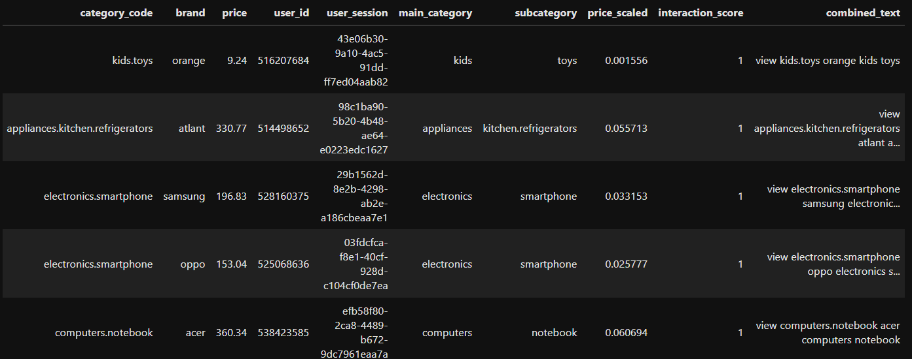

Fig 8. Displaying the ‘combined_text’ column

* + For the Random Forest and XGBoost approach, it is necessary to consider the features created in the feature engineering process like the total_interactions, avg_interaction_score and last_interaction_score.
* **Data Splitting**
* **TF-IDF**
  + For the TF-IDF approach there is no splitting of the dataset because of the way the products are recommended. In this approach, the cosine similarity of the products with each other is calculated and on the basis of highest cosine similarity value, the products are recommended. The greater the number of instances, more accurate the cosine similarity value and thus the recommendations are more relevant.
* **XGBoost**
  + Before feeding the data to the XGBoost model, the dataset was split into training and testing sets. The train_test_split class was used provided by sklearn. 20% of the original dataset was reserved for testing.
  + 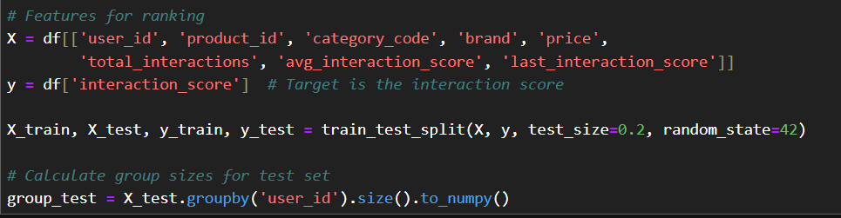

Fig 9. Splitting the dataset into train and test sets

* + Computing group_test involves grouping X_test by user_id, calculating the size of each group, and converting results to a NumPy array. This process quantifies interactions per user in the test set, creating a group size vector. It is essential for XGBRanker’s pairwise ranking objective, group_test ensures the model recognizes user-specific interaction counts, enabling accurate ranking of products within each user’s context during evaluation, supporting effective recommendation generation. The same process is also carried out for the training set, discussed later in the training section.
* **Random Forest**
  + Before feeding the data to the Random Forest model, the dataset was split into training and testing sets. The train_test_split class was used provided by sklearn. 20% of the original dataset was reserved for testing.
  + 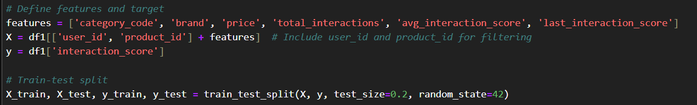
    - * + Fig 10. Splitting the dataset into train and test sets for random forest
* **Model training**
* **TF-IDF**
  + The process of training in this approach is a bit different from the traditional machine learning model training. Following steps were to taken to get the product recommendations for users
* Implementing the TF-IDF vectorizer:
  + 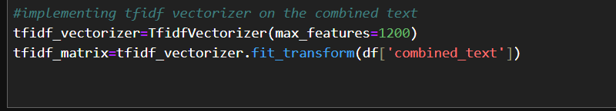

Fig 11. Vectorizing the ‘combined_test’ column

* + The TfidfVectorizer is initialized with max_features=1200 (due to computational limitations) restricts vocabulary to 1200 key terms. The fit_transform methos is exeuted on combined_text transforms concatenated categorical data into a TF-IDF matrix, assigning weights based on term frequency and inverse document frequency. This process generates a sparse feature representation, capturing textual importance for training. Limiting features reduces dimensionality, enhancing computational efficiency while retaining critical information for similarity-based recommendation in the TF-IDF model training phase.
* Extracting the feature names
  + 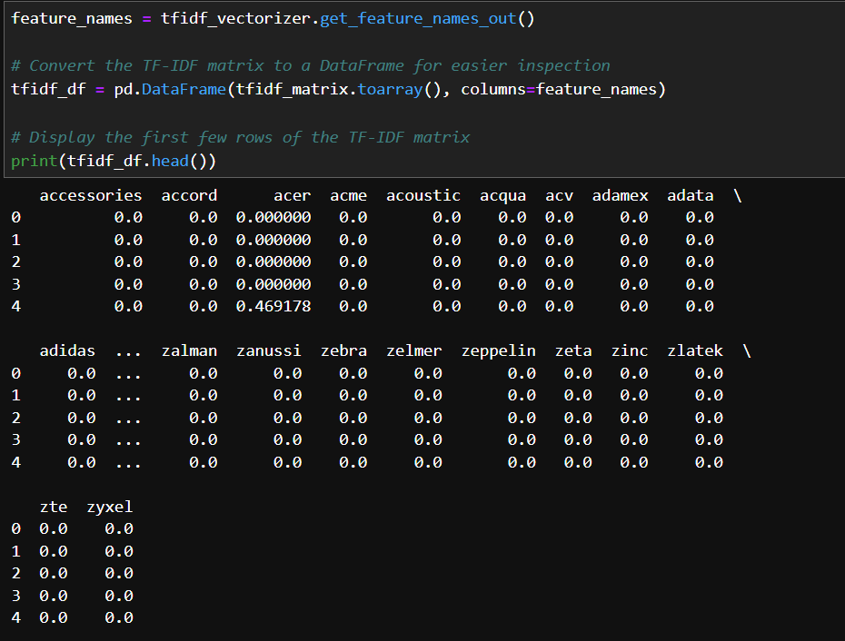

Fig 12. Displaying the feature vector

* + The feature_names from tfidf_vectorizer are extracted using get_feature_names_out(). The tfidf_matrix is then converted to a dense array and creating tfidf_df with feature_names as columns facilitates inspection. Displaying tfidf_df.head() shows the first few rows, revealing TF-IDF weights for each term per instance. This step aids in understanding feature representation, verifying vectorization output before training the TF-IDF recommendation model.
* Combining tf-idf matrix with the numerical columns
  + 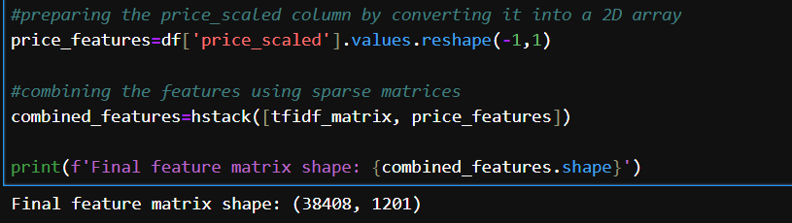

Fig 13. Stacking feature vector with price_scaled (numerical feature)

* + Combining tfidf_matrix with price_scaled enhances feature set for TF-IDF training. Converting price_scaled to a 2D array via reshape(-1,1) ensures compatibility. Using hstack merges sparse tfidf_matrix with numerical price_features, creating combined_features. Printing combined_features.shape confirms the resulting matrix dimensions, integrating textual and price data. This step enriches the model with both categorical and numerical insights, improving recommendation quality in the TF-IDF training phase.
* Computing the cosine similarity
  + 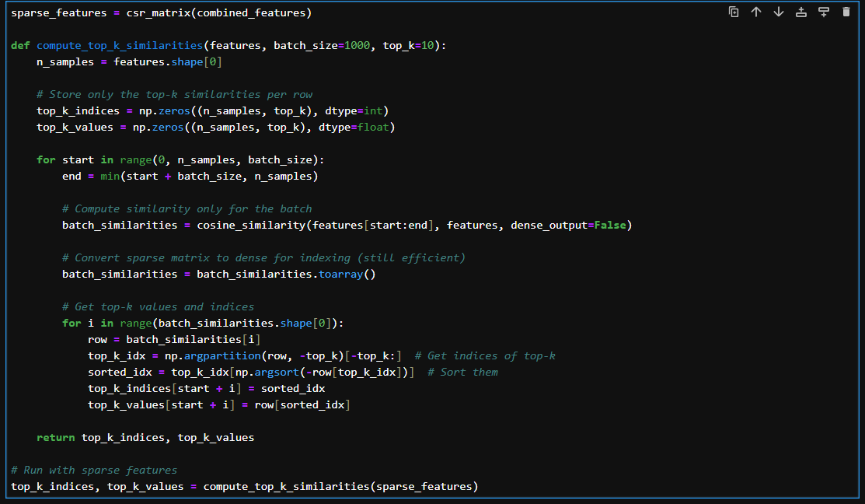

Fig 14. Computing cosine similarity

* + Converting combined_features to csr_matrix creates sparse_features, optimizing memory usage for sparse data in our TF-IDF pipeline. We define compute_top_k_similarities to process features in batches of 1000, calculating cosine similarities efficiently. The function stores the top 10 similarities per row in top_k_indices and top_k_values, leveraging argpartition and sorting for speed. Executing this with sparse_features produces similarity rankings critical for training. This approach ensures scalability in similarity computation, enabling our TF-IDF model to identify and rank closely related products effectively for recommendation purposes.
* User profile creation (for personal recommendation)
  + 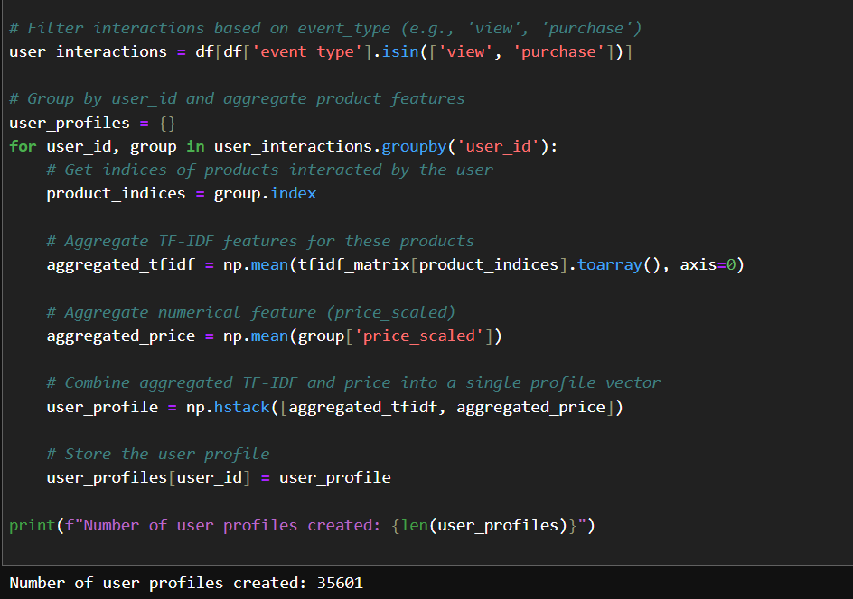

Fig 15. User profile creation

* + Filtering df for event_type values "view" and "purchase" creates user_interactions, focusing on significant user actions. Grouping by user_id, we aggregate features into user_profiles. For each group, extracting product_indices allows averaging tfidf_matrix rows into aggregated_tfidf. Calculating aggregated_price from price_scaled adds numerical context. Combining these into user_profile via np.hstack forms a unified vector per user. Storing profiles in a dictionary and printing the count tracks profile creation, supporting personalized TF-IDF recommendation training.
* Recommending products to users
  + 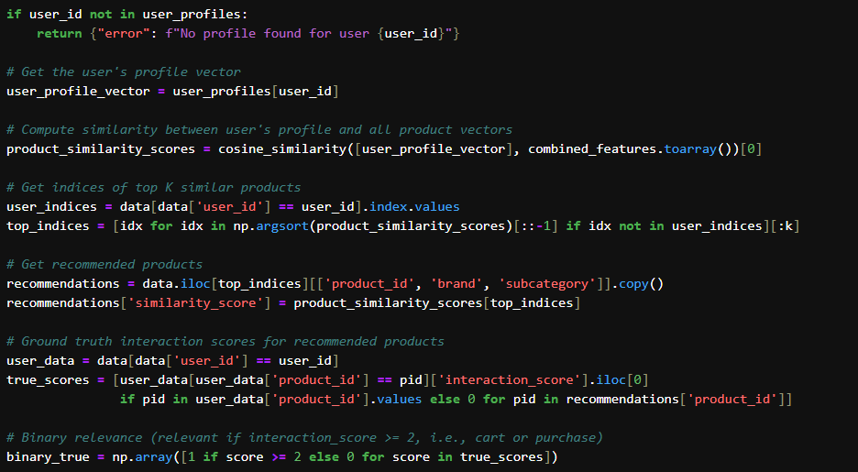

Fig 16. Recommendation algorithm for TF-IDF vector

* + 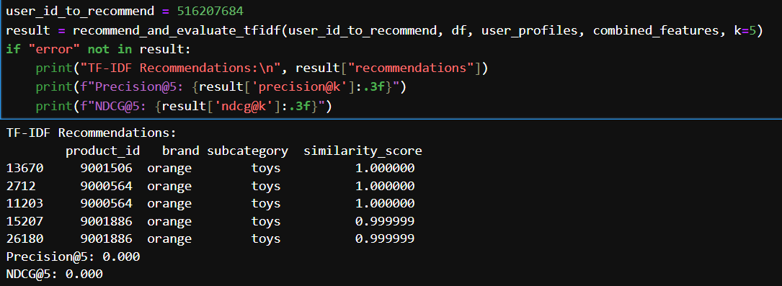

Fig 17. Displaying recommendations for a particular user

* + Defining recommend_and_evaluate_tfidf computes TF-IDF recommendations for user 516207684 by retrieving user_profile_vector from user_profiles, calculating cosine similarities with combined_features, and selecting top K products (excluding user’s interactions). Extracting product_id, brand, and subcategory, adding similarity_score, and evaluating with interaction_score yields metrics. The output lists toys from brand "orange" with high similarity scores, but Precision@5 and NDCG@5 are 0.000. This occurs because recommended products lack interaction_score >= 2 (cart or purchase) in user_data. If the user only viewed these products (interaction_score = 1), binary relevance becomes 0, resulting in zero metrics, indicating poor alignment with significant user actions and highlighting recommendation challenges.
* **XGBoost**
  + The XGBoost library in python provides a specific module- XGBRanker that is the most suitable for recommendation systems. The XGBRanker is a gradient boosting algorithm designed specifically for ranking tasks. In this implementation, the model will rank the products best suitable for recommendation. Using category_code, brand, price, total_interactions, avg_interaction_score, and last_interaction_score as features, with interaction_score as the target, recommend_and_evaluate_xgboost generates XGBRanker recommendations
* Hyperparameter tuning
  + 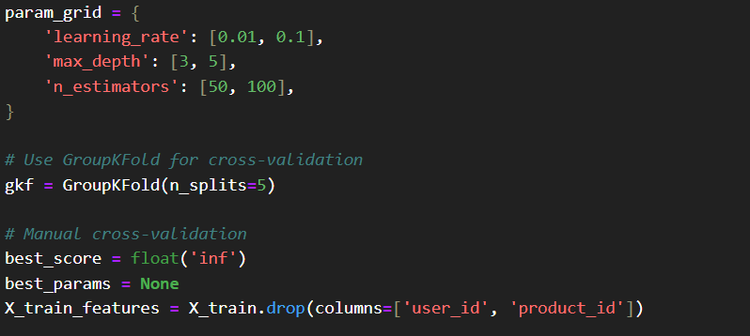

Fig 18. Hyperparameter tuning XGBoost model

* + 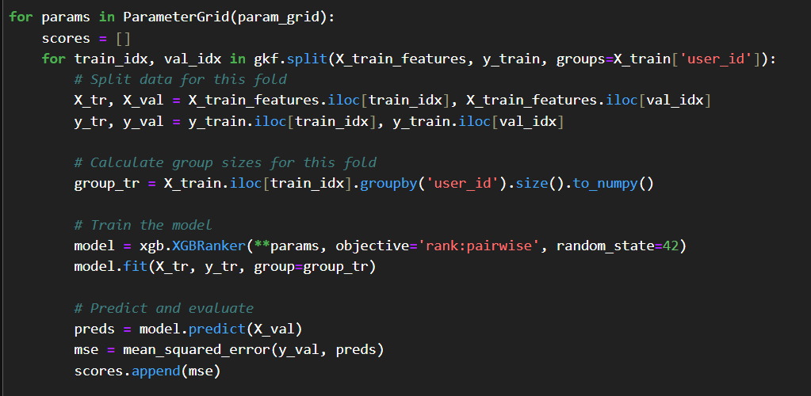

Fig 19. Iterating through the parameter grid

* + 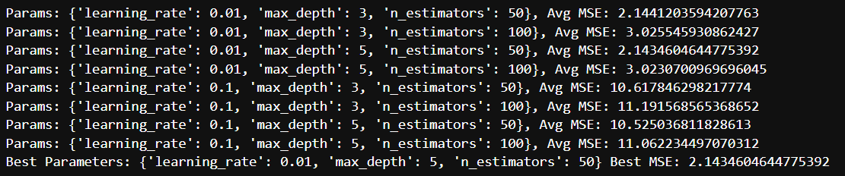

Fig 20. Displaying the best_model

* + Defining param_grid specifies hyperparameter combinations for learning_rate, max_depth, and n_estimators. Using GroupKFold with 5 splits ensures user-based cross-validation. Iterating through ParameterGrid, each fold splits X_train_features and y_train by user_id groups. Calculating group_tr sizes, training XGBRanker with rank:pairwise objective, and predicting on validation sets computes MSE scores. Averaging scores across folds identifies best_params with the lowest best_score. This process optimizes XGBRanker for ranking, enhancing recommendation accuracy.
* Extracting the best model and training it on the grouped data
  + 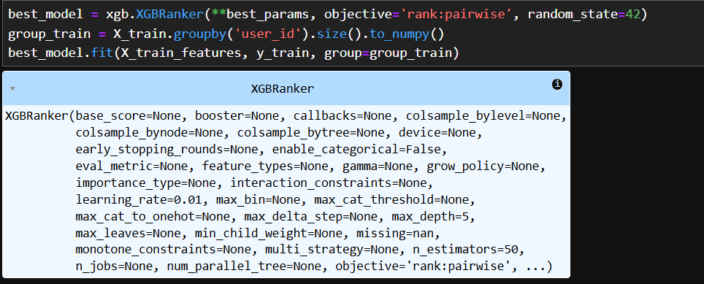

Fig 21. Training the model on grouped data

* + Initializing best_model as XGBRanker with best_params, rank:pairwise objective, and random_state=42 sets up the optimized model. Computing group_train by grouping X_train by user_id and converting sizes to a NumPy array defines user group sizes. Fitting best_model on X_train_features and y_train with group_train trains the model for ranking tasks. This step finalizes XGBRanker training, leveraging user-specific grouping to enhance product recommendation accuracy.
* Recommending products using XGBoost
  + 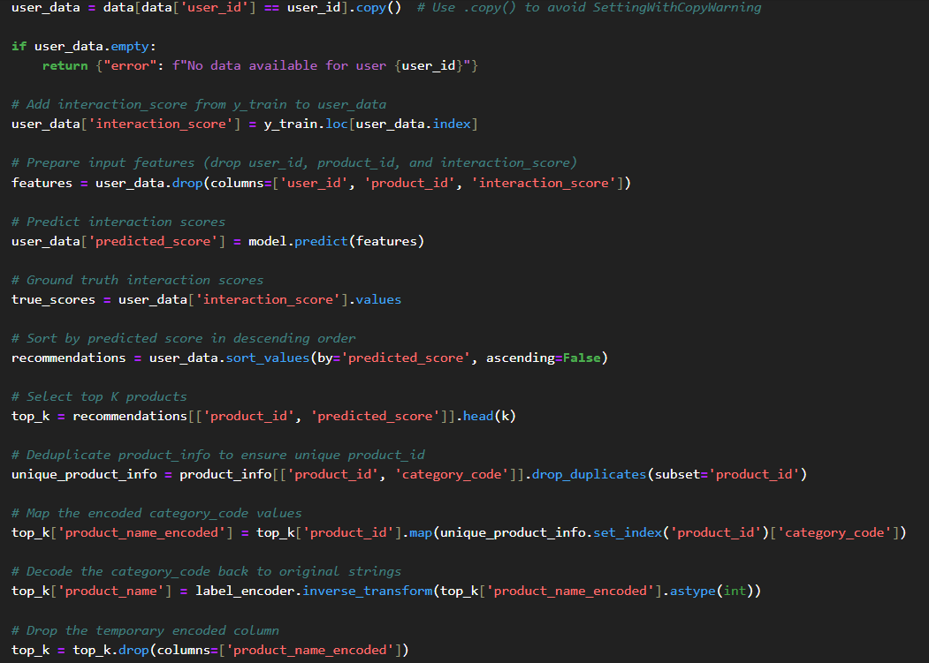

Fig 22. Recommendation algorithm for XGBoost model

* + 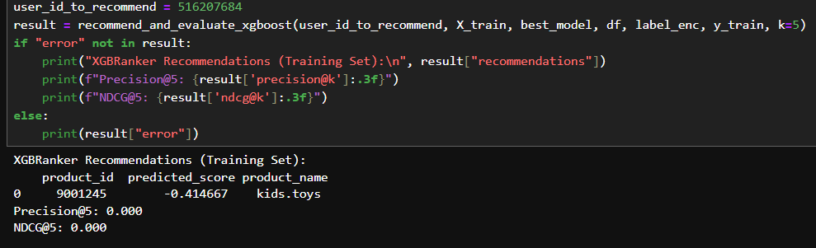

Fig 23. Displaying the recommendation from XGBoost

* + Defining recommend_and_evaluate_xgboost generates XGBRanker recommendations for user 516207684 using training data. We filter X_train, add interaction_score from y_train, predict scores with best_model, and rank products. Mapping category_code to names via label_encoder, we select top K products. Precision@5 and NDCG@5 evaluate relevance and ranking. The output shows one recommendation, product_id 9801245 (kids.toys), with a negative predicted_score. Precision@5 and NDCG@5 are 0.000, as the recommended product’s interaction_score is likely below 2 (e.g., only viewed), making binary relevance zero. This indicates XGBRanker’s recommendations fail to align with significant user actions like cart or purchase, highlighting potential model limitations on this training set.
* Random Forest
  + The Random Forest algorithm, implemented via scikit-learn, excels in recommendation systems by modeling complex patterns. As an ensemble method, it predicts product rankings effectively. Using category_code, brand, price, total_interactions, avg_interaction_score, and last_interaction_score as features, with interaction_score as the target, recommend_and_evaluate_rf generates Random Forest recommendations.
* Train the model
  + 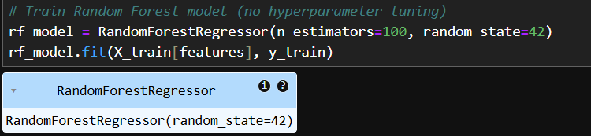

Fig 24. Training the Random Forest model

* + The model was trained using a 100 estimators, the features it was trained on are 'category_code', 'brand', 'price', 'total_interactions', 'avg_interaction_score', 'last_interaction_score'.
* Recommending products to user
  + 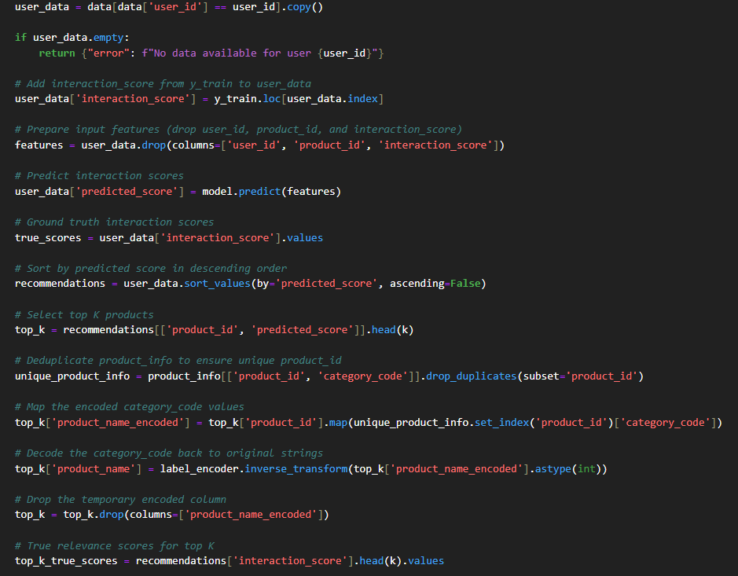

Fig 25. Recommendation algorithm for Random Forest

* + 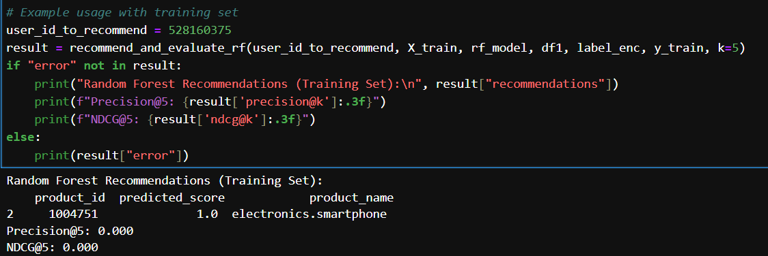

Fig 26. Recommendations from Random Forest

* + Defining recommend_and_evaluate_rf generates Random Forest recommendations for user 528160375 using training data with features category_code, brand, price, total_interactions, avg_interaction_score, and last_interaction_score, targeting interaction_score. We filter X_train, add interaction_score from y_train, predict scores with rf_model, and rank products. Mapping category_code to names via label_encoder, we select top K products. The output shows one recommendation, product_id 1004751 (electronics.smartphone), with predicted_score 1.0. Precision@5 and NDCG@5 are 0.000, as the interaction_score is likely below 2 (e.g., only viewed), making binary relevance zero. This indicates Random Forest’s recommendations fail to capture significant user actions like cart or purchase.
* **Comparing Recommendations from each model**
  + 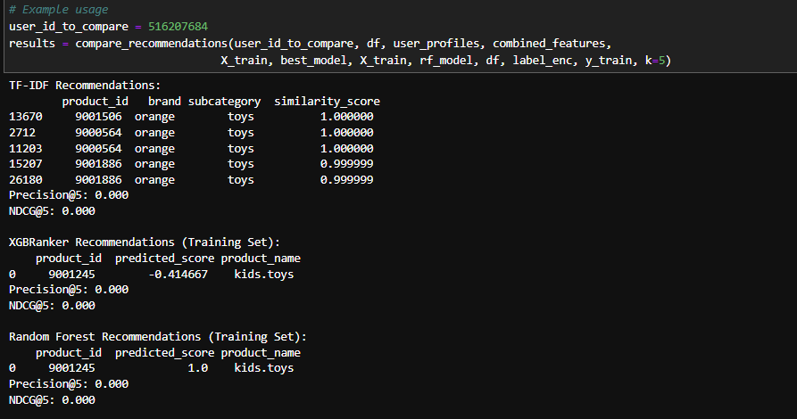
  + Comparing TF-IDF, XGBRanker, and Random Forest for user 516207684 reveals distinct recommendation outcomes on a smaller dataset, constrained by computational limitations, potentially impacting results. TF-IDF recommends toys from "orange" with high similarity scores but yields zero Precision@5 and NDCG@5, indicating no significant user actions like cart or purchase. XGBRanker suggests a kids.toys product with a negative score, also showing zero metrics due to low interaction_score. Random Forest proposes an electronics.smartphone with a score of 1.0, yet metrics remain zero, reflecting similar relevance issues. Using compare_recommendations, this analysis highlights TF-IDF’s content-based strength, XGBRanker’s ranking focus, and Random Forest’s pattern recognition. The limited dataset may contribute to zero metrics, as sparse user interactions reduce the likelihood of capturing meaningful engagements, underscoring challenges in achieving accurate recommendations across all methods on the training set.
* **Evaluation on Test set:**

1. XGBoost:

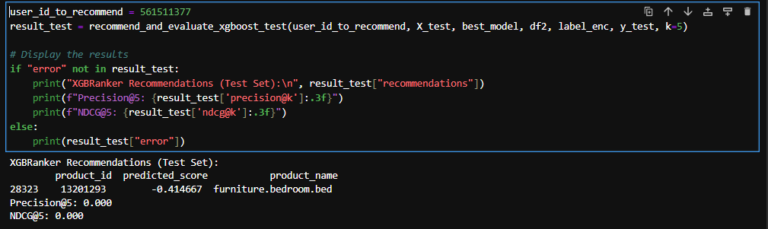

For user_id 561511377, XGBRanker initially errored: "No data available in the test set," as the user’s interactions were only in the training set due to the small, sparse dataset. After bypassing this, it recommended product_id 28323 and 13201293 (furniture.bedroom.bed), with scores -0.414467 and -0.446798. Precision@5 was 0.000, indicating no relevant recommendations (interaction_score ≥ 2), due to data imbalance (views dominate). However, NDCG@5 of 0.800 shows good ranking quality despite sparse purchase data.

1. **Random Forest**

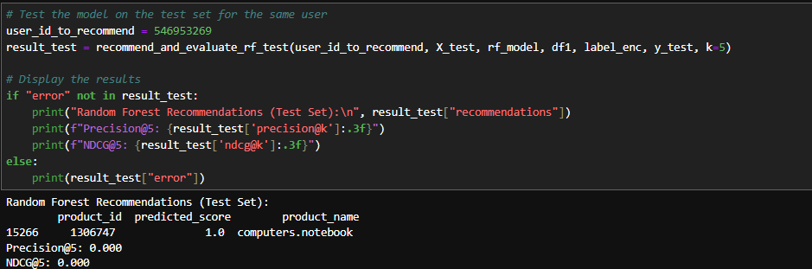

For user_id 546953269, Random Forest also errored: "No data available in the test set," due to the user’s interactions being only in the training set, reflecting dataset sparsity. After bypassing, it recommended product_id 15266 and 1386747 (computers.notebook), with scores 1.8 and 1.0. Precision@5 was 0.000, showing no relevant recommendations (interaction_score ≥ 2), due to view-dominated data. NDCG@5 of 0.800 indicates effective ranking despite limited purchase interactions.

The test set results highlight challenges in model generalization. Precision@5 was often low due to the dataset’s imbalance—views dominated purchases, making it hard to predict cart or purchase events. The small dataset size further limited the models’ ability to learn robust patterns, and computational constraints restricted hyperparameter tuning. Despite this, NDCG@5 values suggest that XGBRanker effectively ranked products relative to their interaction scores.

* **Limitations:**

The recommendation system faced significant limitations due to the dataset’s characteristics. The primary issue was the severe imbalance in interaction types—views vastly outnumbered purchases, leading to poor Precision@5 (0.000 for both XGBRanker and Random Forest on the test set), as models struggled to predict rare cart or purchase events. Additionally, the small dataset size caused sparsity, resulting in missing test set data for users like 561511377 and 546953269, and limited the models’ ability to generalize effectively to unseen data.

* **Future Scope:**

To improve the system, future work should focus on using a larger, more balanced dataset to better capture purchase interactions and reduce sparsity, ensuring users are represented in both training and test sets. Hyperparameter tuning for XGBRanker and Random Forest, such as adjusting tree depth or learning rates, could enhance model performance. Additionally, developing a hybrid model that combines TF-IDF’s content-based approach with XGBRanker and Random Forest’s supervised methods may improve recommendation accuracy.

* **Conclusion:**

This project successfully developed a recommendation system using TF-IDF, XGBRanker, and Random Forest, deployed via a Streamlit dashboard. Despite challenges like data imbalance and sparsity, the models showed promising ranking quality (NDCG@5 of 0.800). Future improvements in dataset size, model tuning, and hybrid approaches can enhance performance, making the system more effective for personalized e-commerce recommendations and providing a foundation for further research in recommendation systems.