Practical no. 2

Aim : Use Network Utility Command like ping, ipconfig, netstat, tracert to observe the network details.

Network Utility command:

**Ping:**

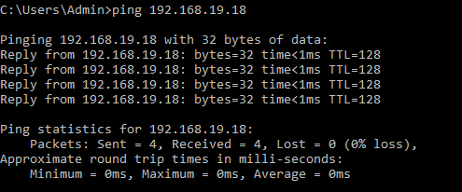

**Ipconfig:**



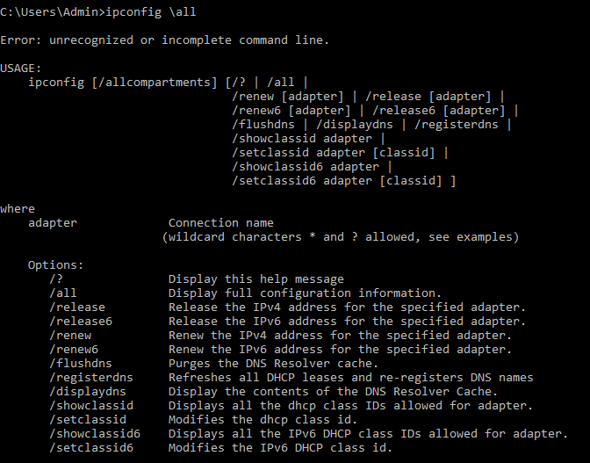

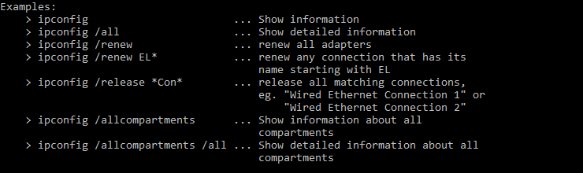

Netstat:

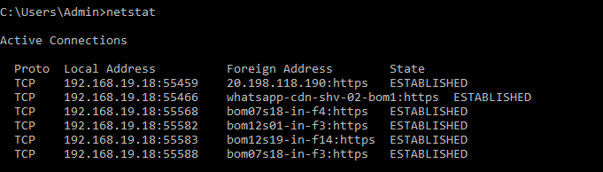

Tracert:

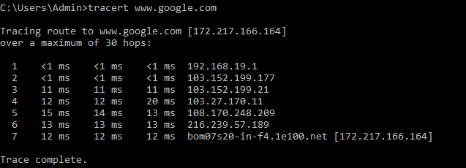

**Conclusion**: Network utility Command has been successfully executed