7 . PR0JECT SNAP SHOTS

In this section, we provide visual snapshots of key aspects of the project, accompanied by detailed descriptions explaining the features and functionalities depicted in each snapshot.

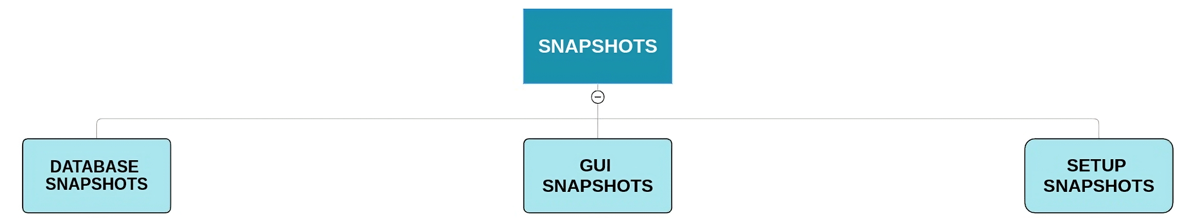

1 )- DATABASE SNAPSHOTS :

The database snapshot provides a glimpse into the underlying data structure and organization within the system. This snapshot showcases the various tables and relationships present in the database schema, highlighting the essential components that facilitate data storage and retrieval.

➤ Structure of Meetings Table:

The Meetings table serves as a crucial component of the database schema, storing essential information about scheduled Zoom meetings. The table structure is designed to accommodate various attributes necessary for meeting management and tracking. Below is the structure of the Meetings table:

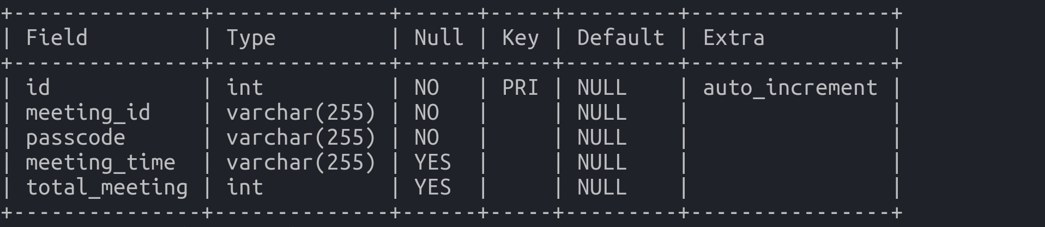

Fig 1.1 – Structure of table “meetings”

➤ Sample Data in Meetings Table:

Below is a sample of data entries in the Meetings table, illustrating various scenarios and use cases within the system:
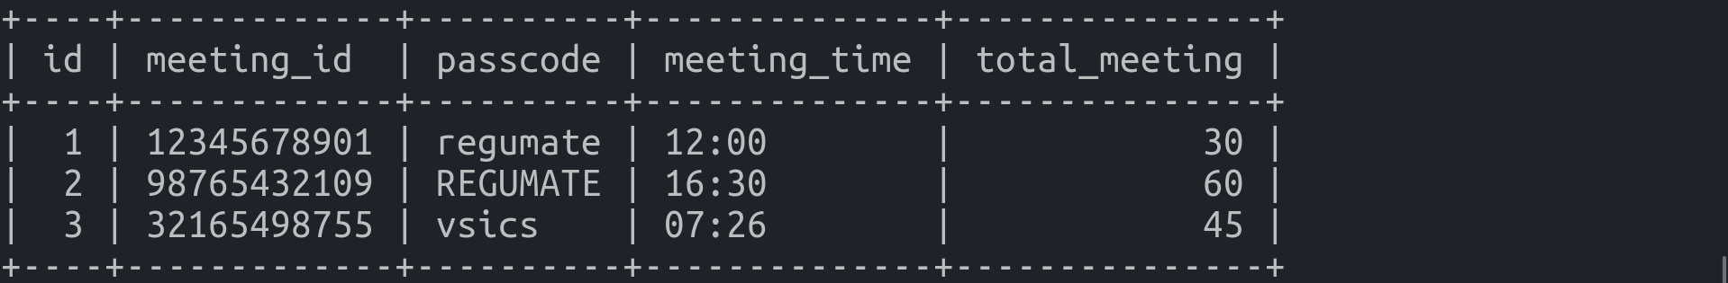

Fig 1.2 – Sample Data in Table “meetings”

Each entry represents a unique Zoom meeting scheduled within the system, with details such as meeting ID, passcode, scheduled time, and total meeting duration. The sample data provides a glimpse into the functionality of the system and demonstrates how meeting information is structured and stored in the database.

➤ In addition to the table structure, the Meetings table may include indexes and constraints to optimize performance and ensure data integrity:
- Primary Key Constraint: The meeting_id field may be designated as the primary key, ensuring unique identification of each meeting entry and facilitating fast retrieval of meeting records.
- Foreign Key Constraints: If the system incorporates relationships with other tables (e.g., Users table), foreign key constraints may be applied to maintain referential integrity and enforce data consistency.
- Indexing: Indexes may be created on frequently queried fields such as meeting_time to improve query performance, especially for large datasets. Indexes help accelerate data retrieval by creating efficient access paths to specific records.

By implementing appropriate indexes and constraints, the database ensures reliability, consistency, and efficiency in managing Zoom meeting data within the system.

1 ) - GUI SNAPSHOTS :

The GUI snapshot offers users a visual representation of the application's user interface, providing a comprehensive overview of the interactive elements and functionalities available within the system. It serves as a window into the user experience, highlighting the intuitive design and user-friendly features that enhance usability and engagement.

By showcasing the graphical elements and layout of the interface, the snapshot offers users insights into how they can interact with the application and navigate its various features seamlessly. From the main interface to specific modules such as meeting scheduling, upcoming meetings, and settings, users can gain a deeper understanding of the application's capabilities and functionalities.

Furthermore, the GUI snapshot goes beyond mere aesthetics, emphasizing the practicality and functionality of the interface. Each element is purposefully designed to streamline user interactions and optimize productivity, ensuring that users can accomplish their tasks efficiently and effectively.

Overall, the GUI snapshot serves as a visual guide for users, enabling them to explore the application's interface and discover its rich array of features and functionalities. It enhances user comprehension and engagement, ultimately contributing to a more satisfying and rewarding user experience.

➤ FULL SCREEN GUI INTERFACE :

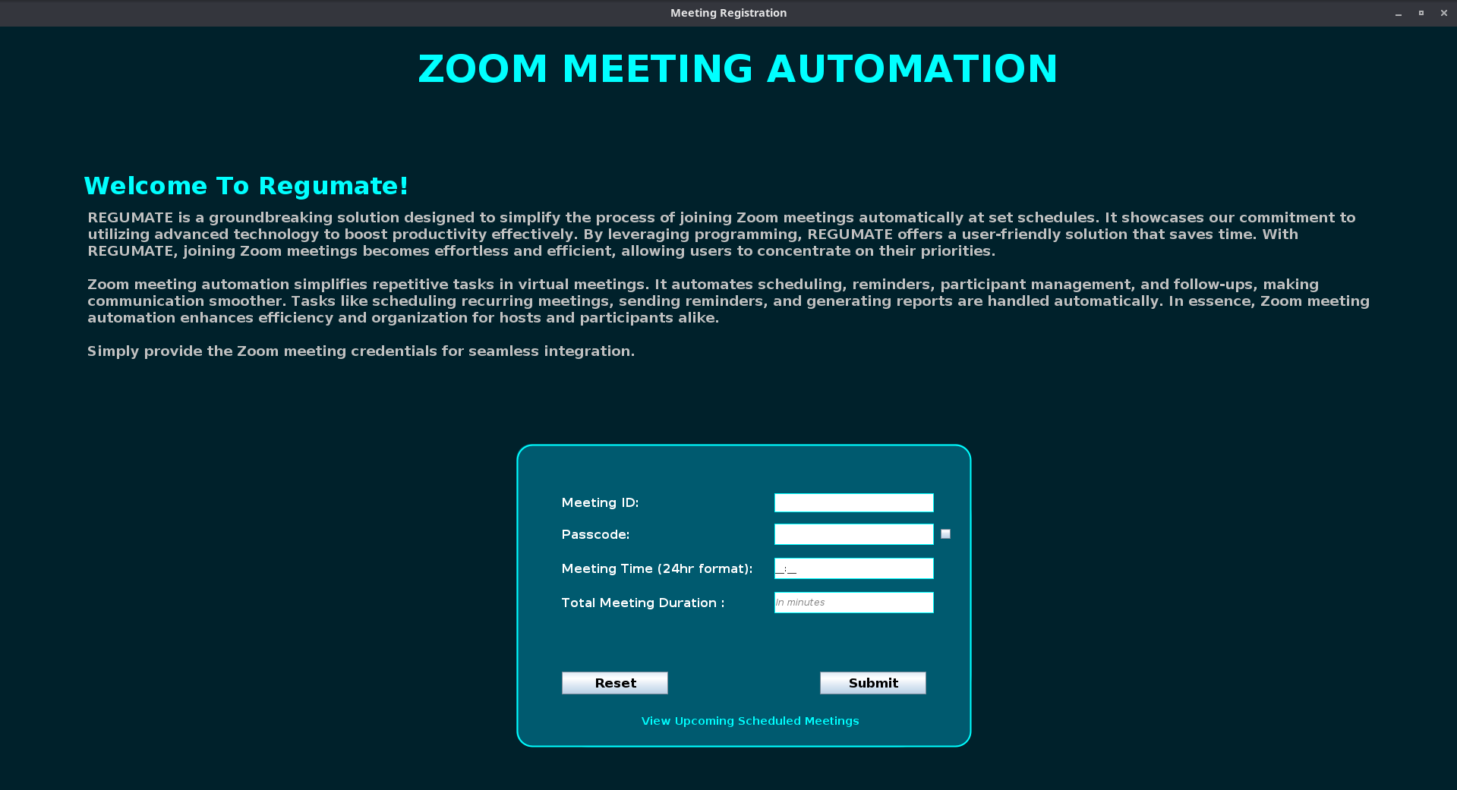
Fig 1.3 – MAIN DASHBOARD SNAPSHOT

• It is our main Dashboard of GUI where user would interact to fill zoom meeting credentials .

➤ PANEL 2 INPUT GUI :

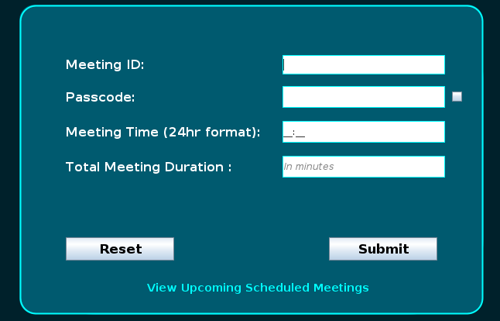

Fig 1.4 – PANEL 2 OF INPUT FIELDS

• It is our panel 2 which would take credential from the user.

➤ Handling Empty Fields in Database Entries :

Handling empty fields in database entries is crucial to ensuring data integrity and system functionality. When certain fields are left empty during data entry or update processes, it can lead to errors, inconsistencies, and incomplete records within the database. Therefore, it's essential for the system to handle these scenarios effectively to maintain data quality and reliability.

In the context of the project, several snapshots depict various scenarios where essential fields, such as Meeting ID, Passcode, Meeting Time, and Total Meeting Duration, are left empty. These snapshots serve as visual representations of potential errors or issues that users may encounter during the scheduling of Zoom meetings. So Now i am adding some snapshots to show how it works ...

● Empty Meeting ID Field:
  - Description: This snapshot illustrates the scenario where the Meeting ID field is left empty during the meeting scheduling process.
  - Importance: The Meeting ID serves as a unique identifier for each scheduled Zoom meeting. Leaving this field empty can lead to errors in meeting identification and tracking.
  - System Response: The system should prompt the user to enter a valid Meeting ID before proceeding with the scheduling process. An error message may be displayed, indicating that the Meeting ID field is required.
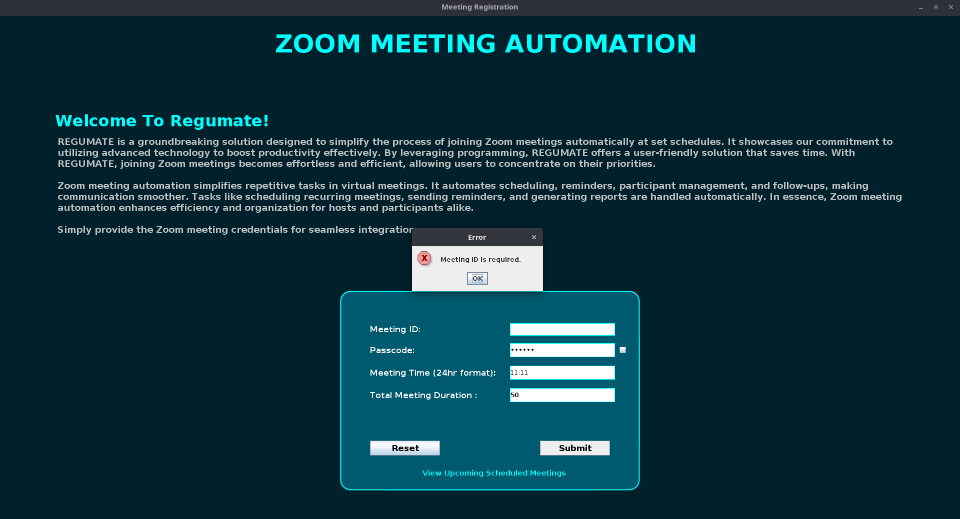

Fig 1.5 – MEETING ID IS REQUIRED ERROR

● Empty Passcode Field:

- Description: This snapshot depicts the situation where the Passcode field is left blank when scheduling a Zoom meeting.
- Importance: The Passcode is essential for securing access to the meeting room. Omitting the passcode can compromise meeting security and expose the meeting to unauthorized access.
- System Response: The system should validate the Passcode field and prompt the user to provide a passcode for the meeting. An error message should be displayed if the field is left empty, indicating that a passcode is required for meeting security.
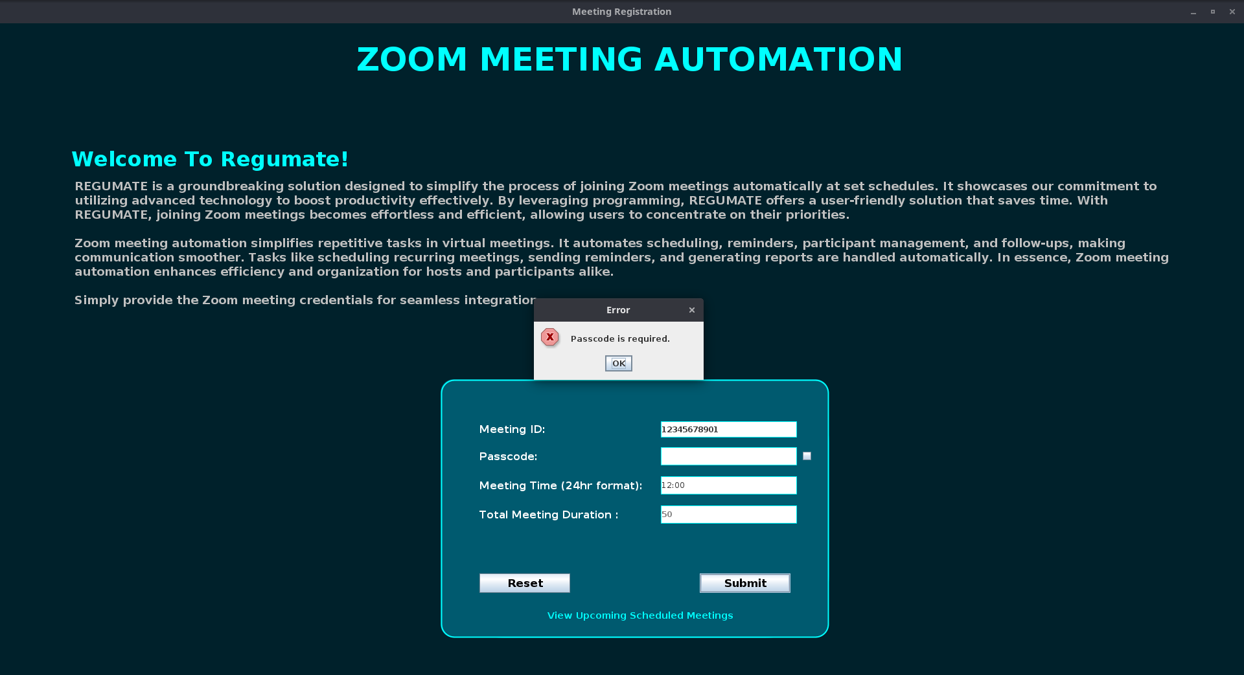

Fig 1.6 – PASSCODE FIELD IS REQUIRED ERROR

● Empty Meeting Time Field:
- Description: This snapshot showcases the scenario where the Meeting Time field is not specified during meeting scheduling.
- Importance: The Meeting Time indicates the scheduled date and time for the Zoom meeting. Without this information, the system cannot accurately schedule and manage meetings.
- System Response: The system should require users to input the meeting time before proceeding. An error message should be displayed if the field is left empty, prompting the user to enter a valid meeting time.

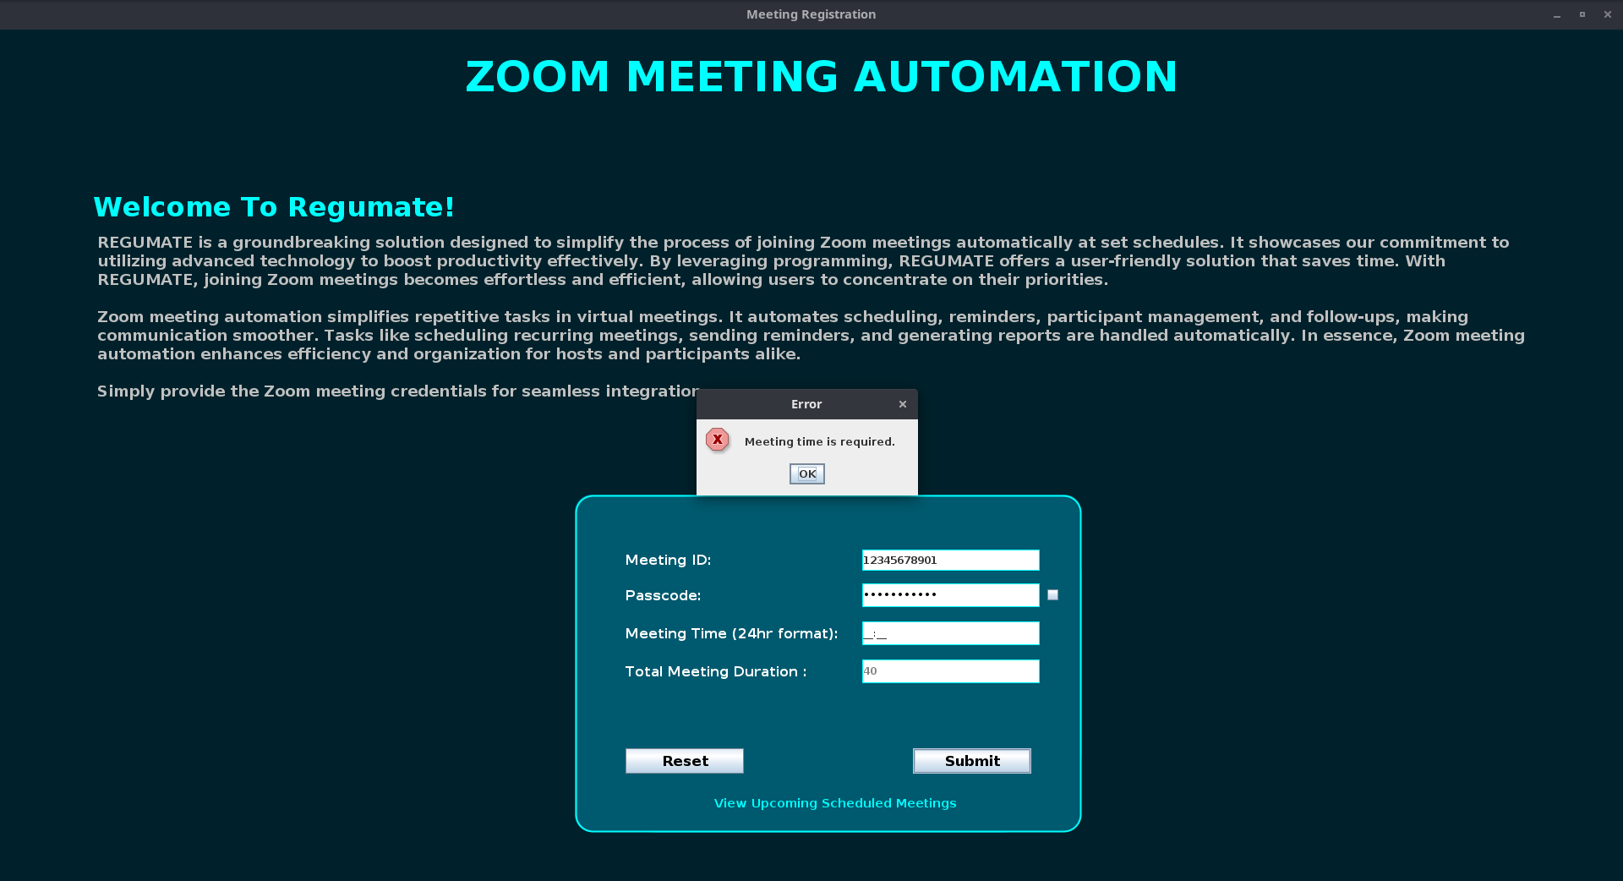
Fig 1.7 – MEETING TIME IS REQUIRED ERROR

● Empty Total Meeting Duration Field:
- Description: This snapshot illustrates the situation where the Total Meeting Duration field is left unspecified.
- Importance: The Total Meeting Duration defines the length of the scheduled Zoom meeting. Without this information, the system cannot accurately determine the meeting's duration and schedule conflicts.
- System Response: The system should validate the Total Meeting Duration field and prompt the user to input the meeting duration. An error message should be displayed if the field is left empty, indicating that the meeting duration is required for scheduling.

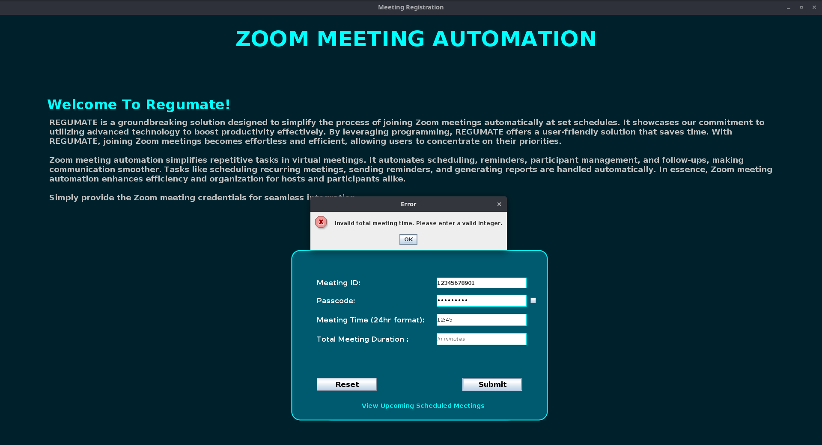

Fig 1.8 – TOTAL MEETING TIME IS REQUIRED ERROR

The snapshots highlighting empty field errors in the database entries underscore the critical importance of data completeness and accuracy in the system. These scenarios serve as reminders of the potential pitfalls and challenges associated with incomplete or erroneous data entry.

In conclusion, effective handling of empty field errors is paramount to maintaining data integrity, system reliability, and user satisfaction. By implementing robust validation mechanisms, error handling procedures, and user-friendly prompts, the system can mitigate the risk of data inconsistencies and ensure seamless operation.

➤ Tooltips for Empty Text Fields on Hovering Feature:

In this section, we offer a detailed overview of the tooltip feature integrated into the Graphical User Interface (GUI) of the application. This feature serves as a helpful aid to users by providing real-time prompts and guidance when required information is missing from input fields. By examining the snapshots provided below, users gain insight into how the tooltip mechanism functions in different scenarios, effectively enhancing the user experience and streamlining the data entry process.

Let's dive deeper into the purpose and functionality of each snapshot:

● On Hovering Meeting ID Text Field:

* Description:
This snapshot illustrates the scenario where the Meeting ID field is left blank. In such instances, hovering over the empty field triggers the display of a tooltip message, prompting the user to input the required meeting ID. This proactive approach helps prevent oversight and ensures that essential information is provided before proceeding with scheduling a meeting.

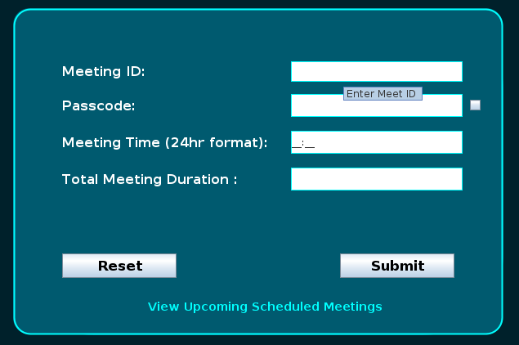

Fig 1.9 – ON HOVERING MEETING ID TEXTFIELD

● On Hovering Passcode Text Field:

*Description:
Here, we observe the tooltip feature in action when the Passcode field is left unfilled. Upon hovering over the empty field, a tooltip message emerges, directing the user to enter the meeting passcode. This prompt serves as a gentle reminder and aids in completing the necessary fields accurately, thereby minimizing errors and enhancing data integrity.

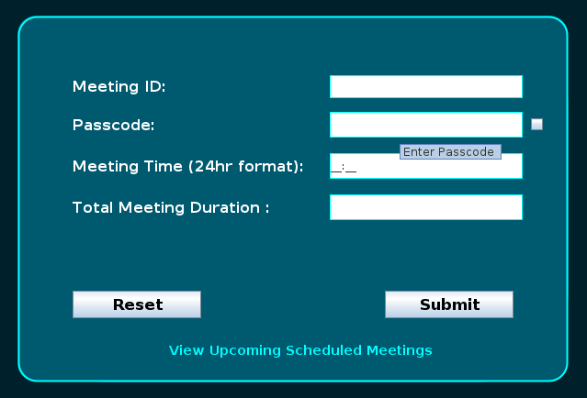

Fig 2.0 – ON HOVERING PASSCODE TEXTFIELD

● On Hovering Meeting Time Text Field:

*Description:

In this snapshot, we encounter a scenario where the Meeting Time field is devoid of input. Upon hovering over the empty field, a tooltip message appears, guiding the user to specify the meeting time. By providing timely reminders, the tooltip feature ensures that all relevant details are included, facilitating efficient meeting scheduling and coordination..
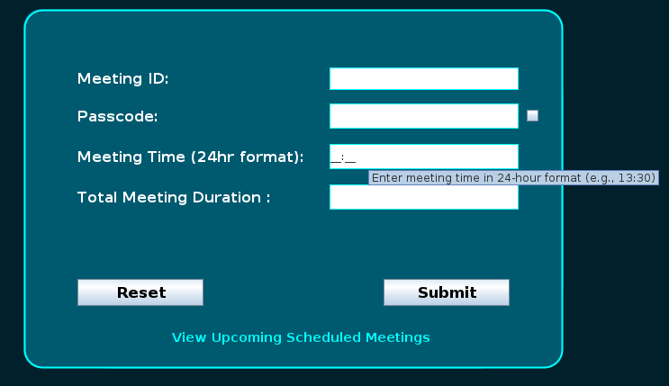

Fig 2.1 – ON HOVERING MEETING TIME TEXTFIELD

● On Hovering Total Meeting Duration Text Field:

*Description:
Lastly, we examine the tooltip functionality when the Total Meeting Duration field is left empty. Hovering over the unfilled field prompts the display of a tooltip message, prompting the user to indicate the duration of the meeting. This proactive assistance aids users in accurately inputting meeting details, thereby enhancing productivity and reducing the likelihood of oversight.
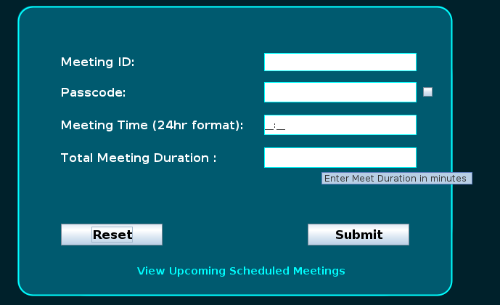

Fig 2.2 – ON HOVERING TOTAL MEETING DURATION TEXTFIELD

➤ Passcode Field with Password Visibility Toggle :

In this section, we explore the integration of a password visibility toggle feature within the Graphical User Interface (GUI) of the application. This feature empowers users with the ability to toggle between displaying the passcode in plain text or concealing it behind asterisks for enhanced privacy and security. By examining the snapshots provided below, users gain insight into how the password visibility toggle operates and its impact on the user experience.

● Passcode Field with Hidden Password (BEFORE):
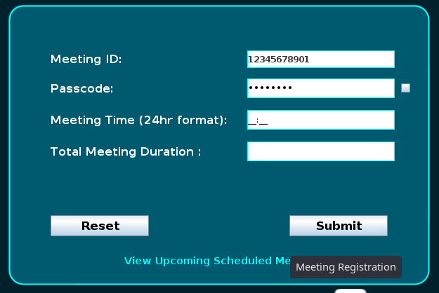

Fig 2.3 – BEFORE ‘ON’ OF CHECKING BOX

* Description:
This snapshot depicts the initial state of the Passcode field, with the password hidden behind asterisks. By default, the passcode is obscured to protect sensitive information and maintain confidentiality. Users have the option to reveal the passcode in plain text by interacting with the password visibility toggle.

● Passcode Field with Visible Password (AFTER):

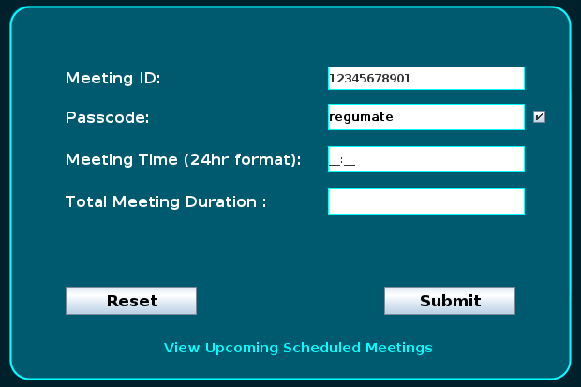

Fig 2.4 – AFTER ‘ON’ OF CHECKING BOX

* Description :
Upon clicking the password visibility toggle checkbox, the passcode is revealed in plain text format, as illustrated in this snapshot. This feature enables users to verify the accuracy of their input and facilitates ease of entry, particularly when entering complex or lengthy passcodes. By providing flexibility in password visibility, the GUI accommodates diverse user preferences and enhances usability.

● Through these snapshots, users gain a comprehensive understanding of how the password visibility toggle feature augments the functionality of the GUI, providing users with control over their passcode visibility while ensuring convenience and security in data entry.

➤ Meeting Time Field Restrictions (Exceeded Duration and Minutes) :

Meeting time inputs are subject to specific constraints to ensure accurate scheduling and prevent unrealistic values. This section highlights two common scenarios where the meeting time field encounters input errors due to exceeded duration and minutes.

● Meeting Time Field with Exceeded Duration:

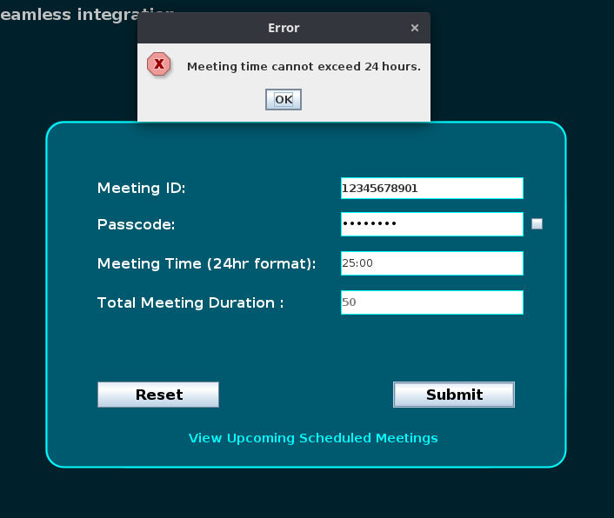

Fig 2.5 – ON INVALID “HOUR” FORMAT OF MEETING TIME

* Description:

This snapshot illustrates a situation where the user attempts to input a meeting duration exceeding the maximum limit of 24 hours. The GUI promptly detects the invalid input during the key event and triggers an error message prompt. This prompt serves as real-time feedback, notifying the user of the time restriction policy. By alerting users to revise their input accordingly, the GUI ensures adherence to system constraints, thereby promoting data integrity and accurate scheduling.

● Meeting Time Field with Exceeded Minutes:
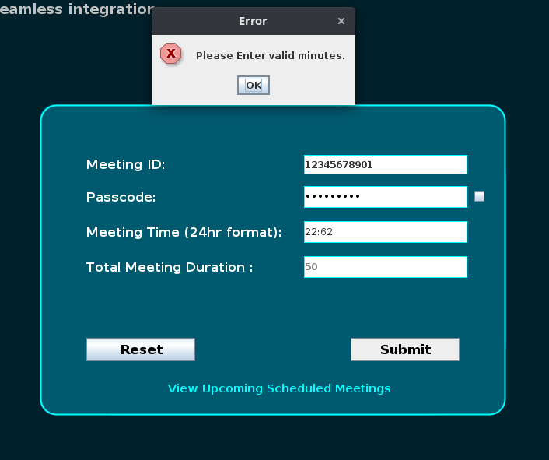

Fig 2.6 – ON INVALID “MINUTES” FORMAT OF MEETING TIME

* Description:

In this snapshot, the user enters minutes exceeding the maximum limit of 60. The GUI promptly detects the invalid input and displays an error message prompt, emphasizing the minute limit policy. By providing immediate feedback, the GUI guides users to correct their input and comply with system requirements. This proactive approach enhances user experience by preventing input errors and ensuring data accuracy in meeting time scheduling.

➤ Successful Data Saving in Database with Dialogue Box

Upon successfully saving data in the database, the system triggers a dialogue box confirmation to notify the user of the successful operation. This snapshot demonstrates the seamless integration of database functionality with user interaction, ensuring transparency and feedback throughout the data-saving process.
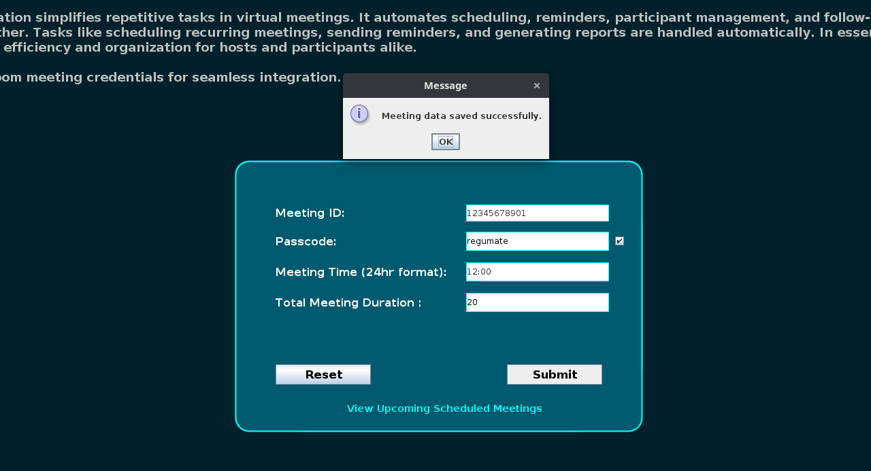

Fig 2.7 – SUCCESSFULLY DATA SAVING IN DATABASE

* Description :
In this snapshot, a dialogue box confirmation appears on the GUI interface, informing the user that the data has been successfully saved in the database. The message "Data Saved Successfully!" serves as a reassuring indicator of the completion of the database operation. By providing immediate feedback, the system enhances user experience and instills confidence in the reliability of the data-saving process.

● In conclusion, the successful data saving in the database with a dialogue box confirmation represents a pivotal aspect of the system's functionality. By seamlessly integrating database operations with user interaction, the system ensures transparency, reliability, and user empowerment. The presence of a dialogue box confirmation serves as a feedback mechanism, providing users with immediate reassurance of their actions' successful outcome. This feedback fosters user trust and confidence in the system's reliability and enhances the overall user experience.

➤ Reset Button Functionality :

The reset button feature enhances the usability and convenience of the graphical user interface (GUI) by providing users with a quick and efficient method to reset all input fields to their default or null values. This functionality is particularly useful in scenarios where users need to clear previously entered data or start afresh without reloading the entire page.

● Before Reset :

Before clicking the reset button, the GUI displays various input fields containing user-entered data, checkboxes with selected options, and other interactive elements reflecting user actions. This snapshot captures the GUI in its current state, showing the data and selections made by the user up to that point.
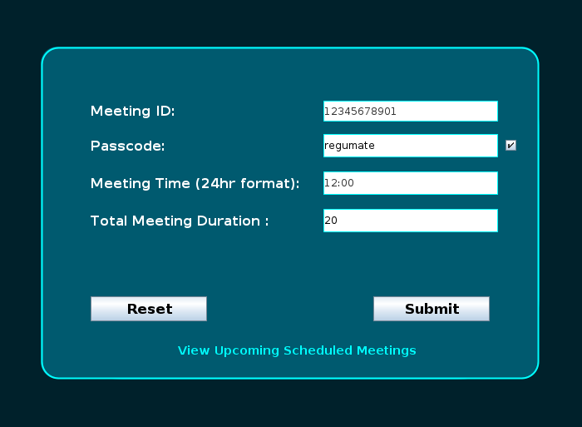

Fig 2.8 – BEFORE CLICKING ON RESET BUTTON

● After Reset :

Upon clicking the reset button, the GUI triggers a reset action that clears the contents of all input fields, including text fields and checkboxes, effectively reverting them to their initial state. After the reset operation, all input fields are empty, checkboxes are unchecked, and any previously selected options or entered data are removed.
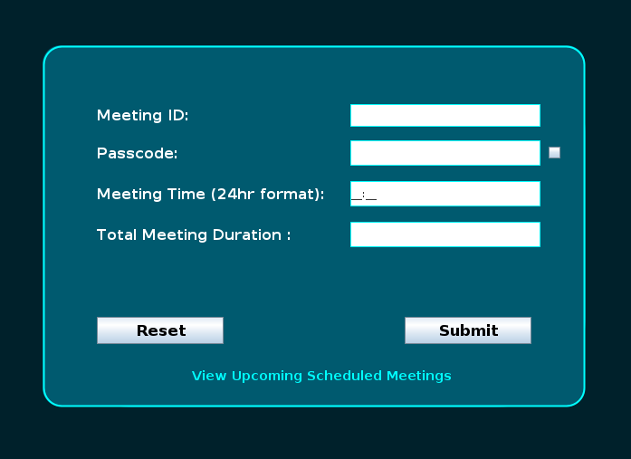

Fig 2.9 – AFTER CLICKING ON RESET BUTTON

● Benefits of the Reset Button Functionality :

• Enhanced User Control : The reset button provides users with a sense of control over their interactions with the GUI, allowing them to easily undo any changes or corrections.

• Improved Data Accuracy : By enabling users to reset input fields to their default values, the functionality helps maintain data accuracy and integrity, reducing the risk of errors or inaccuracies in the system.

• Streamlined User Experience : The availability of the reset button streamlines the data entry process, enabling users to make quick adjustments or start afresh without the need to reload the entire page or navigate back and forth.

• Error Correction : In the event of user errors or accidental data entry, the reset button offers a convenient way to rectify mistakes and ensure that only valid and accurate information is submitted.

• User-Friendly Design : Incorporating the reset button aligns with principles of user-centered design, enhancing the overall usability and accessibility of the GUI and contributing to a positive user experience.

● Conclusion :

Overall, the reset button functionality plays a crucial role in facilitating user interactions with the GUI, empowering users to manage their data input effectively and ensuring a seamless and intuitive user experience.

➤ View Upcoming Scheduled Meetings Hyperlink :

The "View Upcoming Scheduled Meetings" hyperlink serves as a gateway for users to access their scheduled meetings conveniently within the GUI. This section explores the functionality and user experience associated with this interactive feature.

● Before Clicking :

Before clicking on the "View Upcoming Scheduled Meetings" hyperlink, the GUI displays the existing interface with various elements, including input fields, buttons, and other interactive components. The hyperlink appears as highlighted text, indicating its presence and potential functionality to the user.

Fig 3.0 – BEFORE CLICKING ON HYPERLINK

● After Clicking :

Upon clicking on the "View Upcoming Scheduled Meetings" hyperlink, the GUI triggers an event that navigates to a new panel or window dedicated to displaying upcoming scheduled meetings. This new panel provides a comprehensive overview of all scheduled meetings retrieved from the database, presenting relevant details such as meeting ID, date, time, and other pertinent information as shown in this snapshot below.

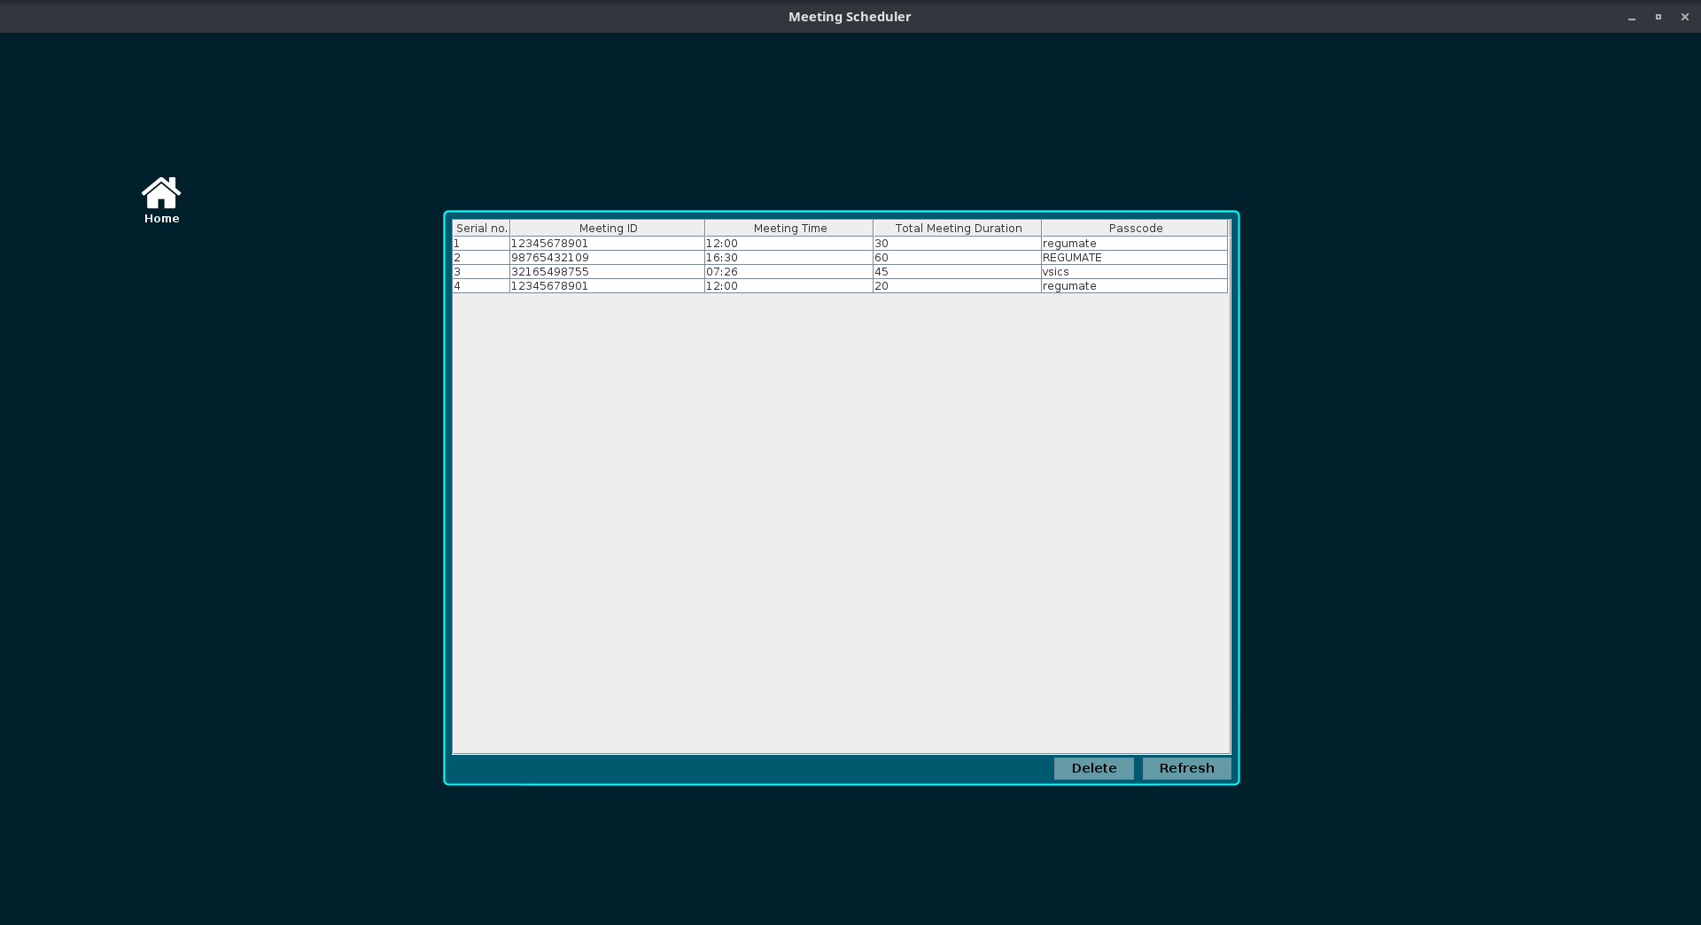

Fig 3.1 – AFTER CLICKING ON HYPERLINK

● Interactive Functionality :

The scheduled meetings panel may include interactive features to enhance user experience and facilitate efficient management of meeting schedules. For example, users may have the option to:

• Click on individual meeting entries to view detailed information or modify settings.

• Sort meetings based on criteria such as date, time, or duration for easier navigation.

• Filter meetings by specific criteria to focus on relevant information, such as meetings scheduled for a particular date or time range.

● Benefits and User Experience :

The inclusion of the "View Upcoming Scheduled Meetings" hyperlink enriches the user experience by providing convenient access to vital meeting information directly within the GUI. Users can quickly review their upcoming schedule without the need to switch to external tools or applications, streamlining their workflow and promoting productivity.

● Conclusion :

The "View Upcoming Scheduled Meetings" hyperlink exemplifies the user-centric design of the GUI, prioritizing accessibility and efficiency in meeting management. By seamlessly integrating this feature, the GUI empowers users to stay organized and informed, ultimately contributing to a more effective and enjoyable user experience.

➤ DELETION OF SCHEDULED MEETING FUNCTIONALITY :

When implementing the deletion functionality for scheduled meetings, several considerations must be taken into account to ensure a seamless user experience and data integrity. Below, we outline the key aspects of this functionality:

• Confirmation Dialog Box : Before proceeding with the deletion of a scheduled meeting, the system presents a confirmation dialog box to the user. This dialog box serves as a safety measure to prevent accidental deletions. It typically includes options for the user to confirm or cancel the deletion action.

• User Confirmation : Upon seeing the confirmation dialog box, the user has the opportunity to confirm or cancel the deletion action. This ensures that the user has full control over the deletion process and can proceed with confidence.

• Feedback Mechanism : After the deletion process is initiated, the system provides immediate feedback to the user to indicate the outcome of the deletion. This feedback may include a success message confirming the successful removal of the meeting from the schedule.

• Error Handling : In the event of any errors or issues during the deletion process, the system should handle them gracefully and provide informative error messages to the user. This helps users understand the nature of the problem and take appropriate actions.

• Data Integrity : Throughout the deletion process, the system must maintain data integrity to ensure that no unintended consequences occur. This involves verifying that the correct meeting entry is being deleted and that any associated data or references are updated accordingly.

By carefully considering these aspects, the deletion functionality can be implemented effectively, providing users with a reliable and intuitive way to manage their scheduled meetings.

● Before Clicking Delete Button :

Before the user clicks the "Delete" button next to a particular meeting entry, the system displays a list of upcoming scheduled meetings in the view panel. Each meeting entry is accompanied by an option to delete it from the schedule.
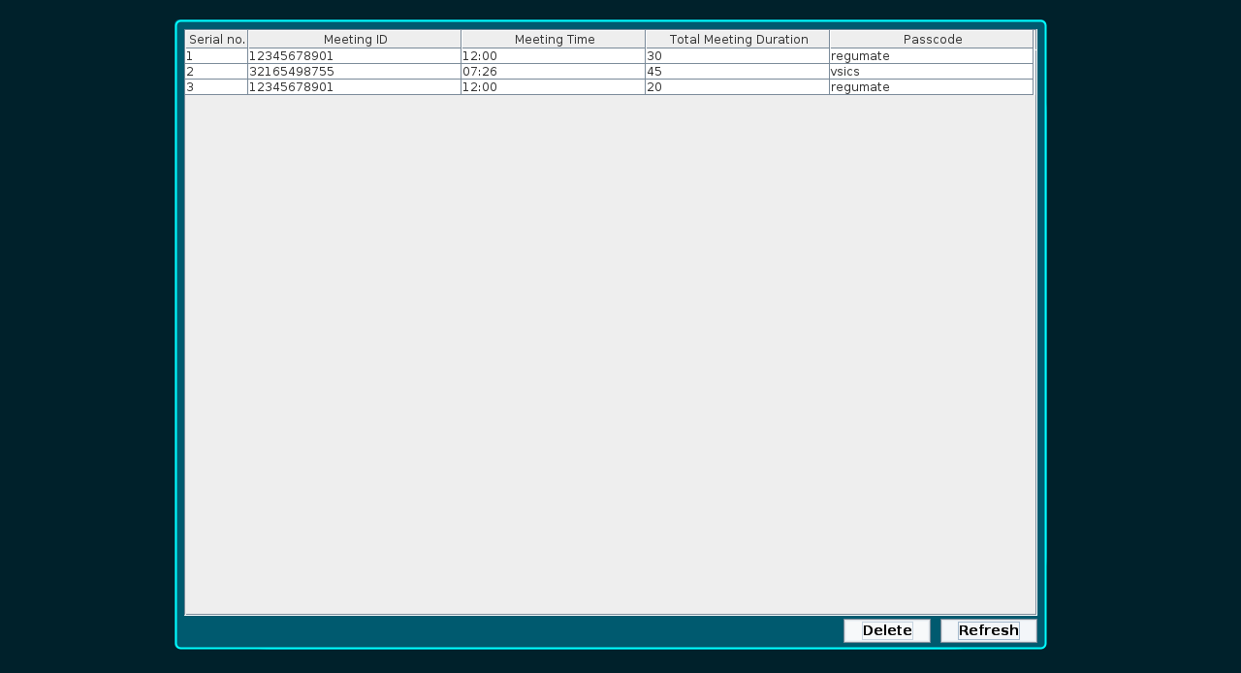

Fig 3.2 – BEFORE CLICKING ON DELETE BUTTON

● Upon Clicking Delete Button :

When the user clicks the "Delete" button next to a specific meeting entry, the system initiates the deletion process for that particular meeting. This action prompts the system to present a confirmation dialogue box to the user, seeking confirmation before proceeding with the deletion.
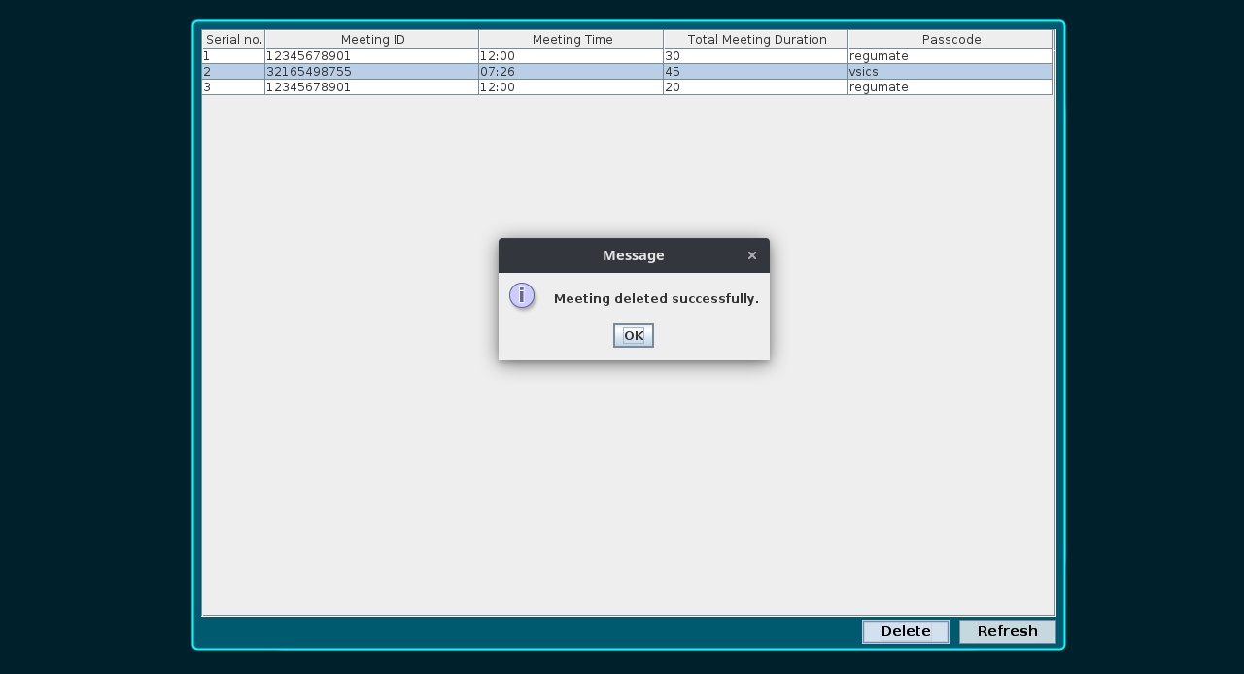

Fig 3.3 – UPON CLICKING ON DELETE BUTTON

● After Deletion :

Once the user confirms the deletion action, the system executes the deletion process, removing the selected meeting entry from the schedule. The user interface updates dynamically to reflect the deletion, with the selected meeting entry no longer appearing in the list of upcoming scheduled meetings. Users receive immediate visual feedback indicating the successful removal of the meeting from the schedule.

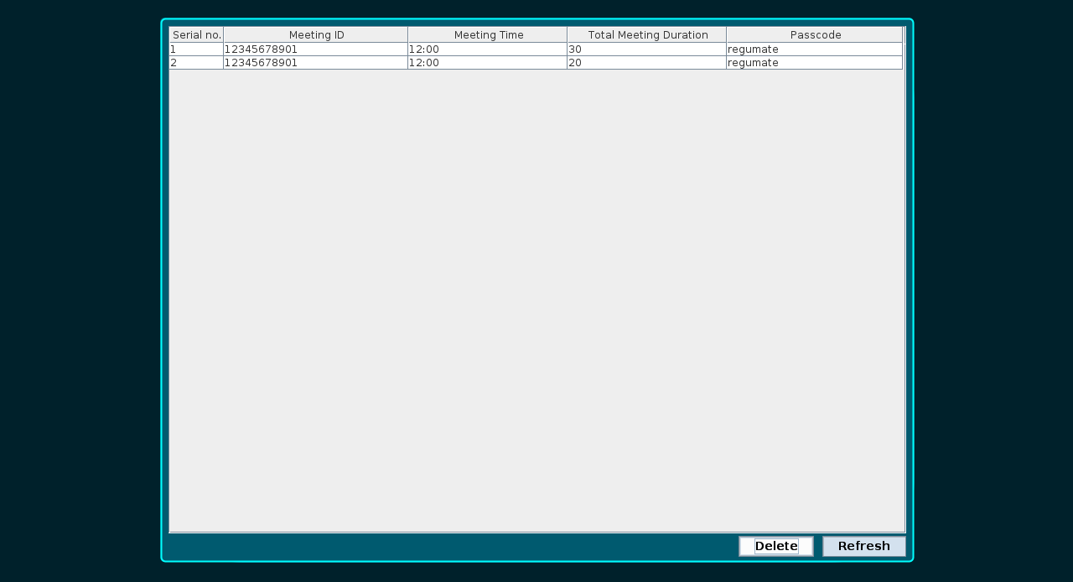

Fig 3.4 – AFTER DELETION OF MEETING SCHEDULED AT 7:26

1 ) - SETUP SNAPSHOTS :

➤ SETUP FILE FUNCTIONALITIES :

The Setup file serves as a crucial component for initializing the necessary dependencies and resources required to use the Regumate software seamlessly. It offers several key functionalities to streamline the setup process, ensuring a smooth user experience. Below are the four main features of the Setup file, each accompanied by a detailed description and corresponding snapshots.

● Setup File GUI :

The Regumate Setup file features a user-friendly Graphical User Interface (GUI) designed to streamline the setup process and facilitate intuitive interaction for users. The GUI provides an intuitive interface for accessing and executing various setup functionalities seamlessly. Below is an overview of the graphical elements and functionalities incorporated within the Regumate Setup GUI:

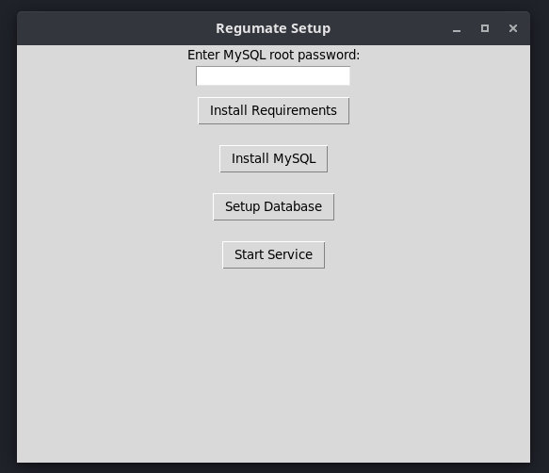

Fig 3.5 – SETUP FILE GUI INTERFACE

● Install Requirements Button :
- Description : A clickable button labeled "Install Requirements" allows users to initiate the installation of all necessary libraries and dependencies essential for running the Regumate software. This feature ensures that the user's system meets all prerequisites for utilizing Regumate effectively.It would take required python libraries from requirements.txt file.

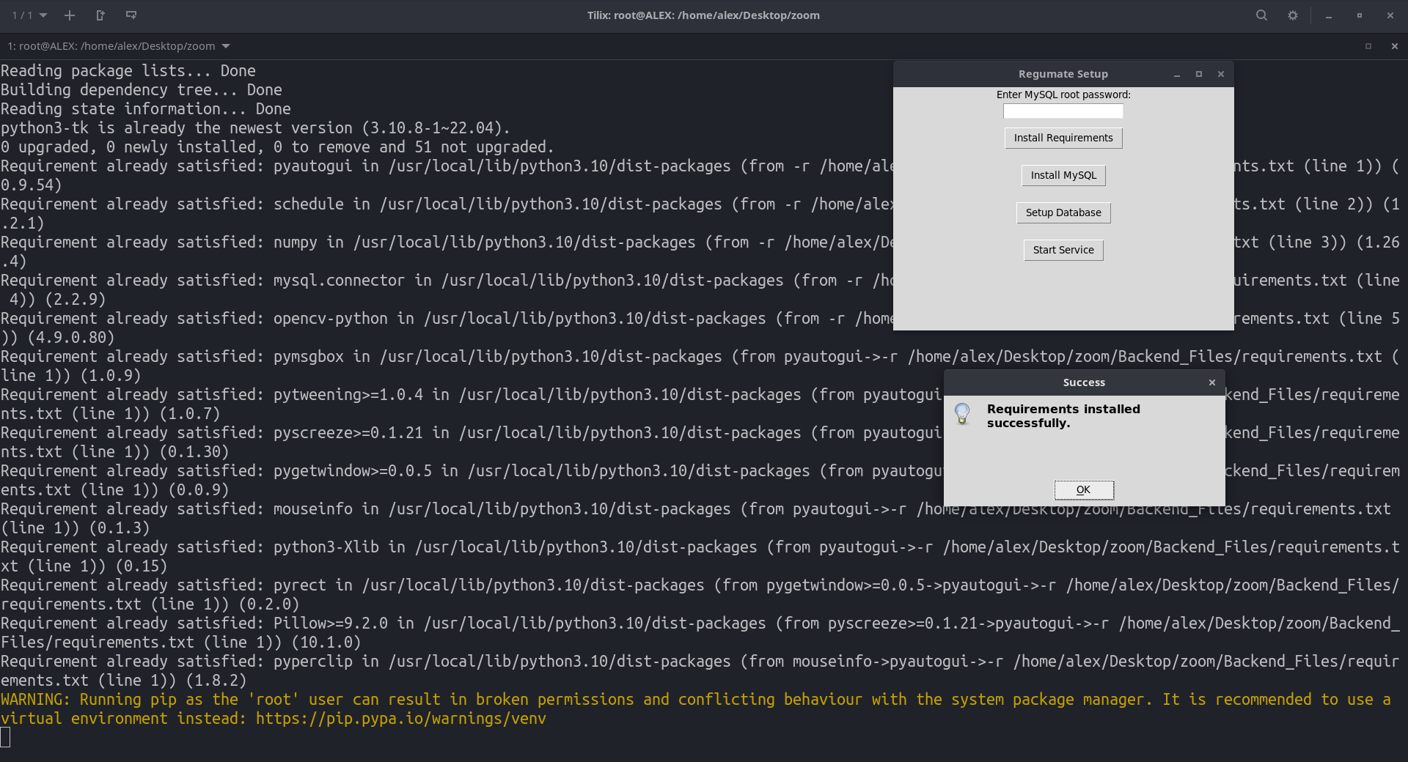

Fig 3.6 – INSTALL REQUIREMENTS BUTTON

● Install MySQL Button :
- Description : The "Install MySQL" button enables users to install MySQL or MariaDB, depending on the operating system requirements. By clicking this button, users can seamlessly set up the database management system required for storing and managing Zoom meeting data within the Regumate software.If the user does not have already installed MySQL in the system then user can download and install it using this button and if Mysql or MariaDB is already installed on the system then it would show message of “MySQL or MariaDB is already installed ” in Terminal.

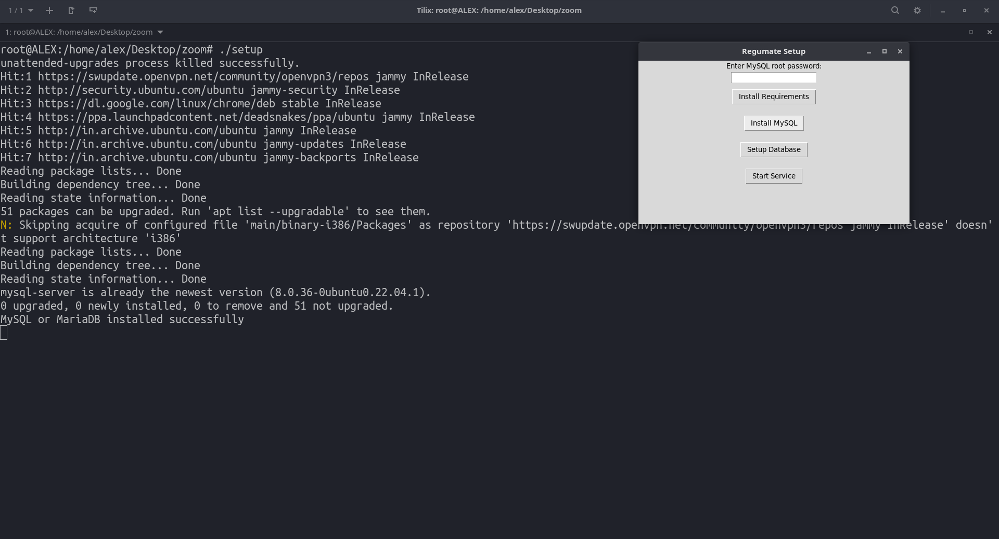
Fig 3.7 – INSTALL MySQL BUTTON

● Setup Database Button :
- Description: With the "Setup Database" button, users can initialize the Regumate database and create the necessary tables for storing meeting information. This functionality streamlines the database setup process, ensuring that users can seamlessly utilize the Regumate software without any manual configuration.on clicking on this button would lead to create a common user in any system named as ‘reguuser’ and password ‘regupass’ of MySQL or MariaDB so that username and password could change dynamically and does not vary across different system.

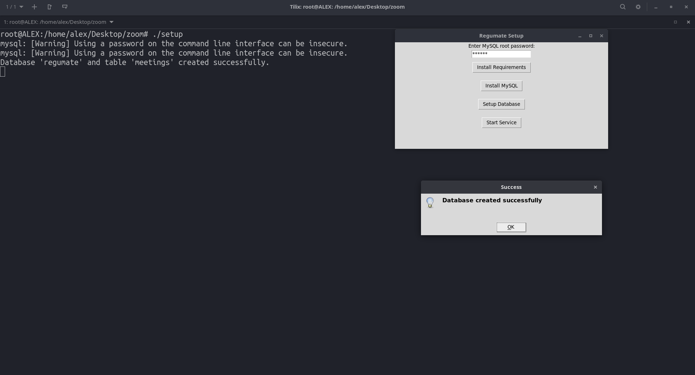
Fig 3.8 – SETUP DATABASE BUTTON

● Start Service Button :
- Description: The "Start Service" button initiates the Regumate.service, enabling the automated execution of background tasks essential for the software's functionality. By clicking this button, users ensure that Regumate operates efficiently, performing tasks such as joining Zoom meetings automatically and monitoring scheduled meetings in real-time.On clicking on this button it would copy the “Regumate.service” in path /etc/systemd/system/ so that it would run regumate.service file which has working of running regumate.py file always on background so that regumate.py can match the meeting time from the database and real time always and at the same time of both it would automatically join zoom meeting successfully.
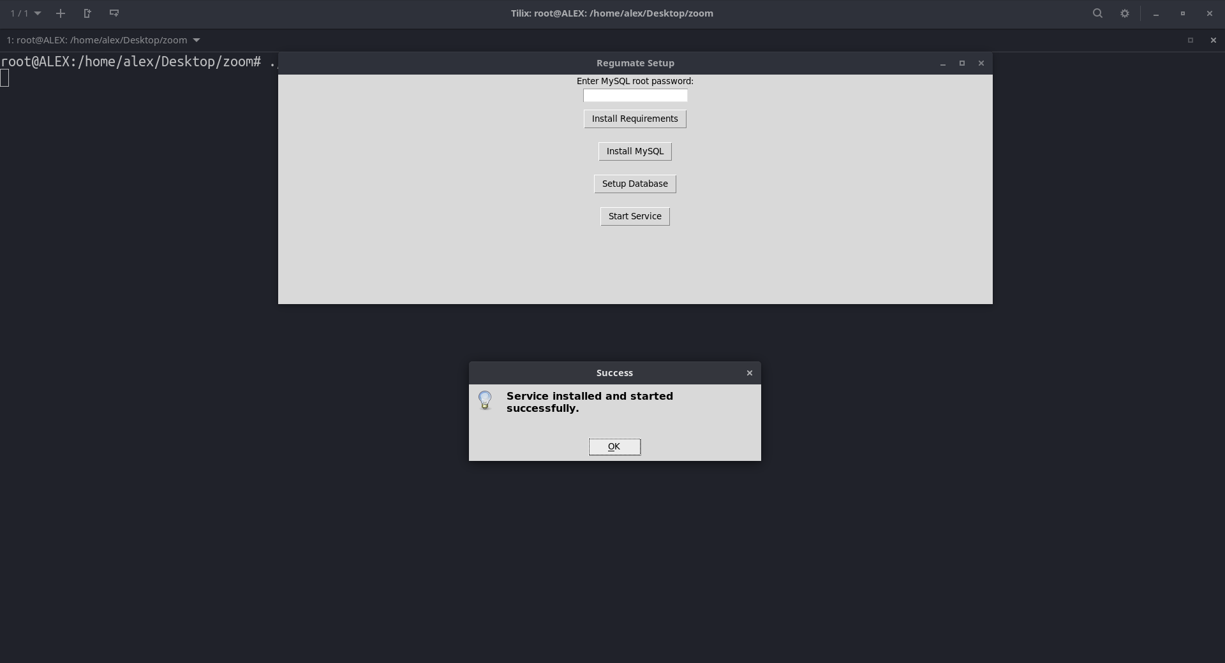

Fig 3.9 – START SERVICE BUTTON

The Setup GUI offers a visually appealing and user-friendly interface, empowering users to configure their system for optimal usage of the Regumate software with ease and convenience. By providing intuitive access to essential setup functionalities, the GUI enhances the overall user experience and simplifies the setup process for users of all levels of expertise.

