**You are working as a Test Engineer in XYZ Corp. Your company has decided to automate a few functionalities for one of the Banking companies. You have been asked to design a functionality to automate testing using Cypress.io framework.**

1. **LOGIN Test Scenario**

it('login', () => {

cy.visit('https://www.hsbc.co.in/')

i) Validate Logo

cy.get('div[class="header-logo lg-2"]').find("img").should('be.visible')

ii) Validate Title

cy.title().should('eq','HSBC India - Credit Cards, NRI Services, Saving and Deposit')

iii) Validate Logon Button Click

cy.contains('Log On').click({force:true})

iv) Validate Continue disability

cy.contains('Continue').should('be.visible').and('be.disabled')

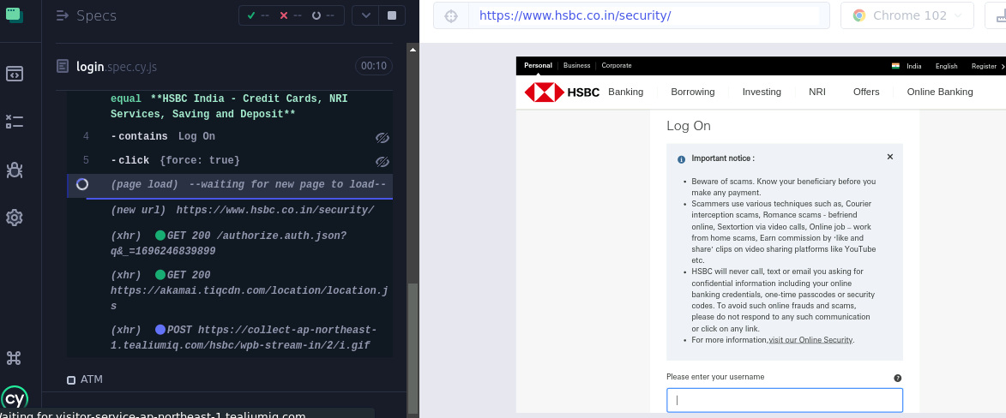

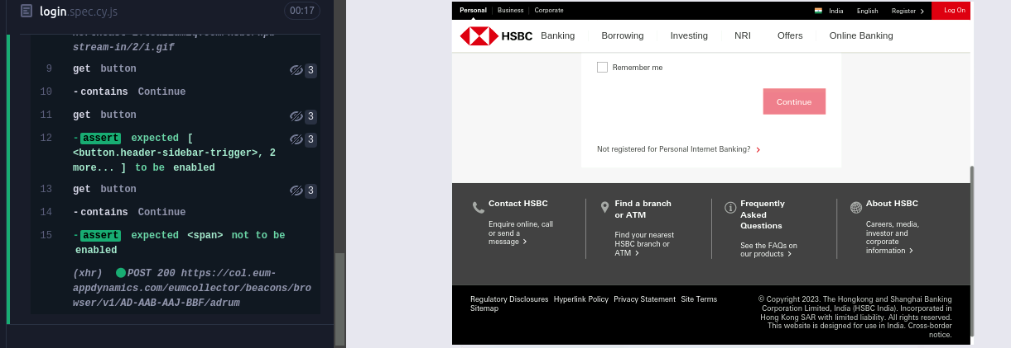

v) Validate Continue ability

vi) Validate Remember me check box

cy.get('#username').type('randomemail@example.com');

cy.contains('Continue').should('be.visible').and('be.enabled');

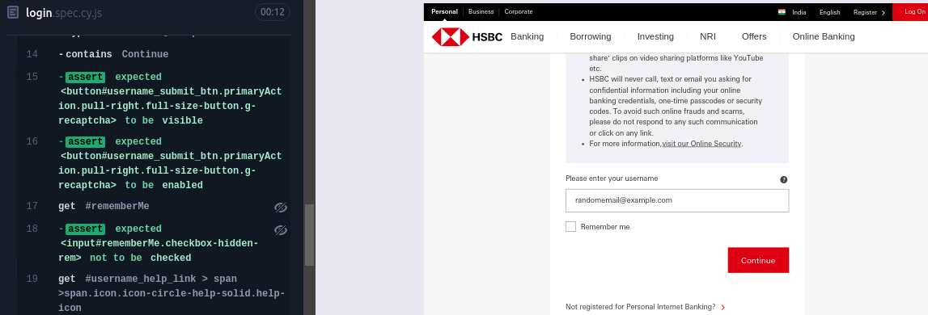

vii) Validate there is a question mark tooltip

cy.get('#rememberMe').should('not.be.checked');

cy.get('#username_help_link>span>span.icon.icon-circle-help-solid.help-icon').should('be.visible').click({force:true});

viii) Validate the username header

cy.contains('Username').should('be.visible');

ix) Validate there is a Close button

cy.get('#username_help_link>span>span.icon.icon-circle-help-solid.help-icon').should('be.visible').click({force:true});

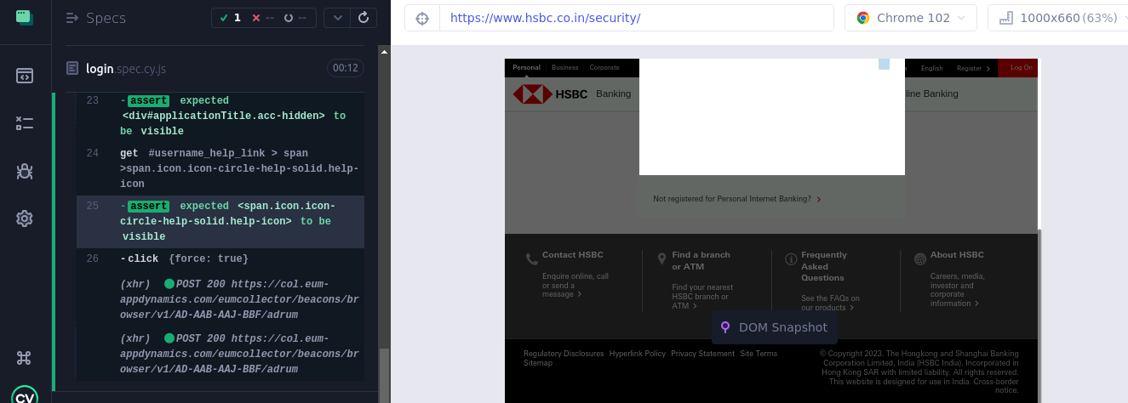

**b) ATM**

1. Validate Header as Branches & ATM

cy.contains('Find your nearest HSBC branch or ATM ').click({force:true})

cy.go('forward')

cy.contains('Branch & ATM locations near you').should('be.visible')

cy.contains('h1', 'Branches & ATM').should('be.visible');

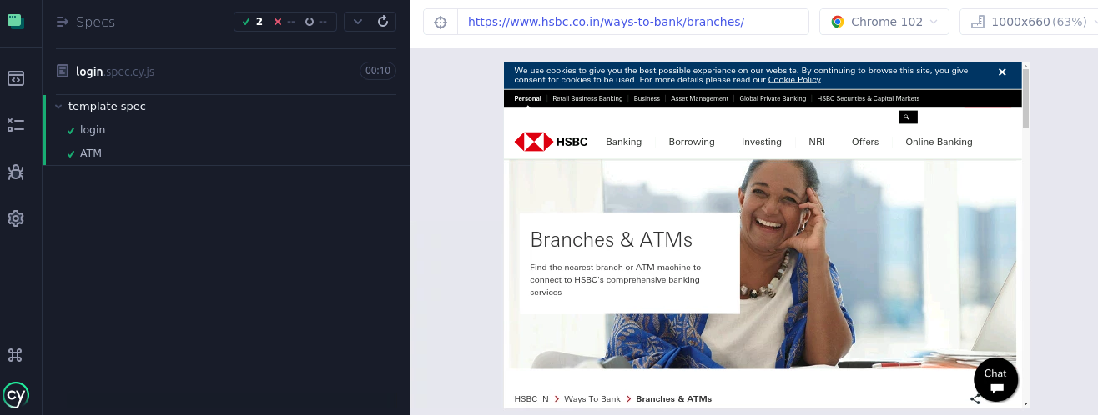

ii) Validate ATM Header name is showing as Rajbhavan Road

cy.get('#content_main_button_1').click({force:true})

cy.get('#searchInput').type('India', { force: true });

cy.contains('India').click();

cy.contains('#_1521gYSzrNIMk9R-rS4Hur', 'Rajbhavan Road').should('be.visible');

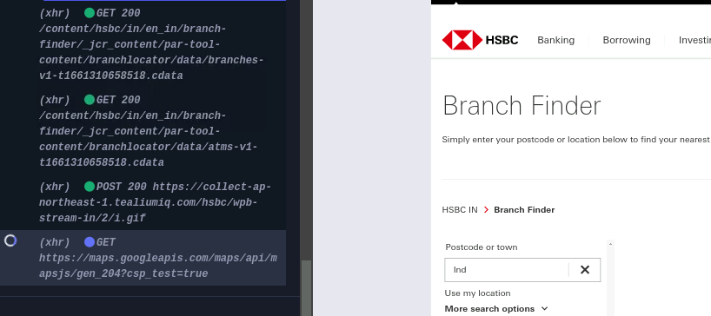

iii) Validate page is navigating to home page

cy.get('div[class="right-column"]').find("img").should('be.visible')

iv) Validate Privacy Statement as Header

cy.scrollTo('bottom');

cy.contains('Privacy Statement ').click({force:true})

//cy.go('forward')

cy.contains('h1', 'Privacy Statement').should('be.visible');

**c) Credit Card**

i) Validate Credit Card as a header text

cy.visit('https://www.hsbc.co.in/')

cy.contains('Banking Cards & Accounts').trigger('mouseover');

cy.contains('Credit Cards').click({force:true});

cy.contains('h1', 'Credit Cards').should('be.visible');

ii) Validate Apply Now

cy.contains('Apply Now').click({force:true});

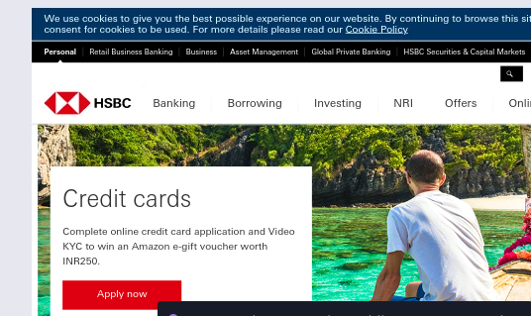

iii) Validate image

cy.get('.grid O-SMARTSPCGENGRID:first').should('have.length', 4);;

cy.get('.A-IMAGE-RW-ALL smart-image-img').find("img").should('be.visible');

cy.get('.A-LNKND38L-RW-ALL text-container text h1').should('have.text', 'HSBC Cashback Credit Card');

iv) Validate Select cards

cy.get('.grid O-SMARTSPCGENGRI:first').within(() => {

cy.contains('Compare cards').should('exist');

cy.contains('Find out more').should('exist');

cy.contains('Apply now').should('exist');

});

v) Validate popups

cy.get('.grid O-SMARTSPCGENGRI:first').contains('Compare cards').click();

cy.get('.modal-dialog').should('exist').contains('.close-button').should('exist');

cy.contains('.A-TYPS2R-RW-DEV h2', 'Select cards to compare').should('exist');

cy.get('.modal-dialog').should('have.length', 4);

cy.get('.modal-checkbox:nth-child(1) input').check();

cy.get('.modal-checkbox:nth-child(2) input').check();

cy.get('.A-BTNP-RW-ALL').click();

cy.get('.selected-cards').should('have.length', 2);

cy.get('.selected-cards .remove-link').should('have.length', 2);

cy.get('.add-card-link').click();

cy.get('.modal-checkbox:nth-child(3) input').check();

cy.get('.selected-cards').should('have.length', 3);

cy.get('.selected-cards .remove-link').should('have.length', 3);

cy.get('.selected-cards .remove-link:first').click();

cy.get('.selected-cards').should('have.length', 2);

cy.get('.add-card-link').click();

cy.get('.modal-dialog .close-button').click();

cy.get('.modal-dialog').should('not.exist');