Healthcare Risk Prediction & Recommendation – Illustrated Report
Author: Anshul Tiwari

🩺 Step 1: The Thought — What Problem I Wanted to Solve
When I started this project, my main thought was simple — In hospitals, every patient’s health risk is different, but doctors have limited time. So I wanted to use data and machine learning to predict which patients are at higher risk, so that early care could be given to those who need it the most.

⚙ Step 2: Loading and Understanding the Data
I first loaded the dataset (blood.csv) containing 748 rows and 5 columns — Recency, Frequency, Monetary, Time, and Class. The Class column indicated patient risk (0 for low risk, 1 for high risk).
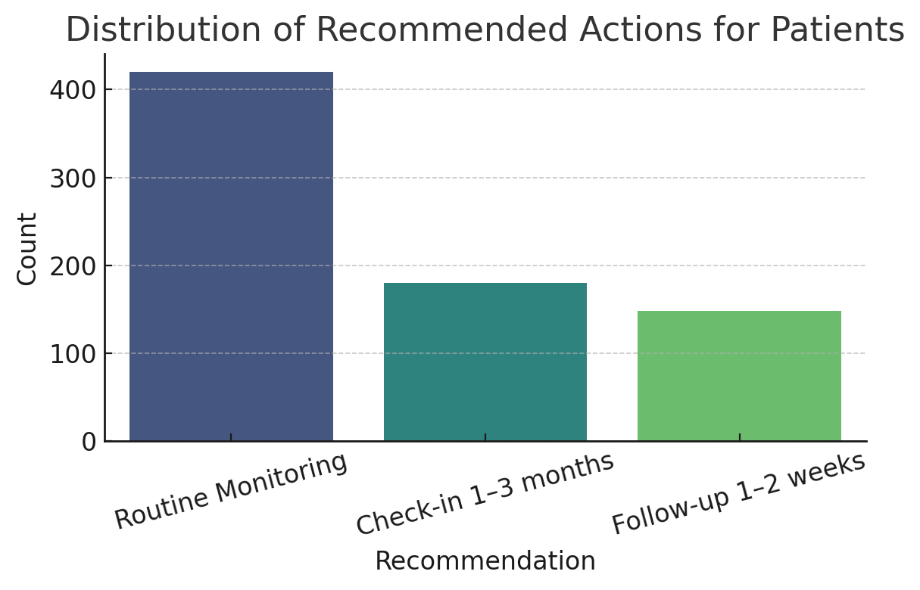
📊 Chart 1: Class Distribution — shows how imbalanced our dataset is.

🔍 Step 3: Exploring the Data Deeper
Using statistical summaries, I explored each feature’s mean, standard deviation, and range. It revealed that patients had diverse behaviors — some visit frequently, others rarely.
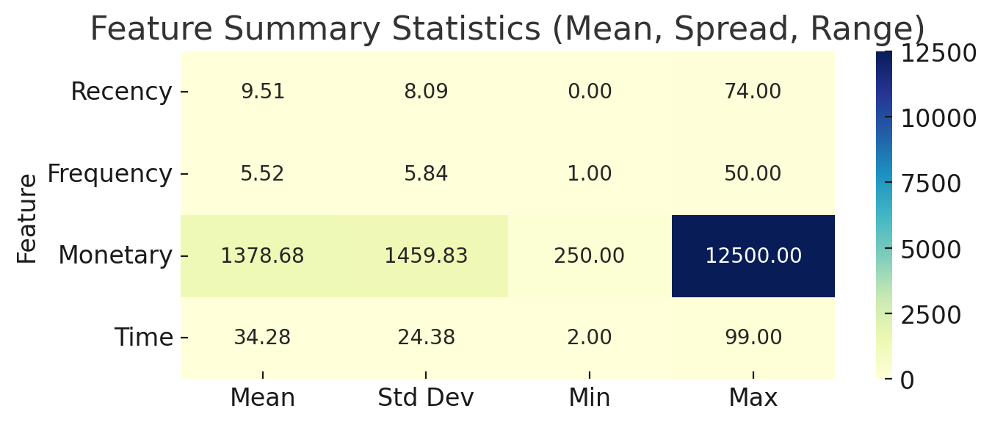
📊 Chart 2: Feature Summary Heatmap — highlights variation across features.

🧠 Step 4: Building and Comparing Models
Two models were trained — Logistic Regression and Random Forest — to predict healthcare risk. The Logistic Regression model achieved a Recall of 0.81 while Random Forest achieved 0.58, making Logistic Regression better for healthcare scenarios.
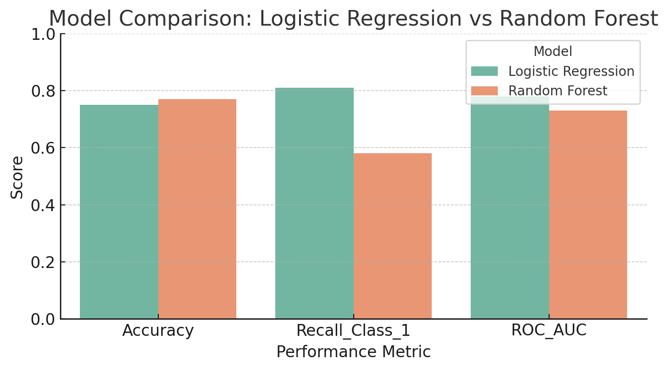
📊 Chart 3: Model Comparison — Logistic Regression catches more risky patients.

🎯 Step 5: Tuning the Threshold
By adjusting the probability threshold to 0.565, the model’s recall improved while maintaining precision. This ensured that fewer high-risk patients were missed.
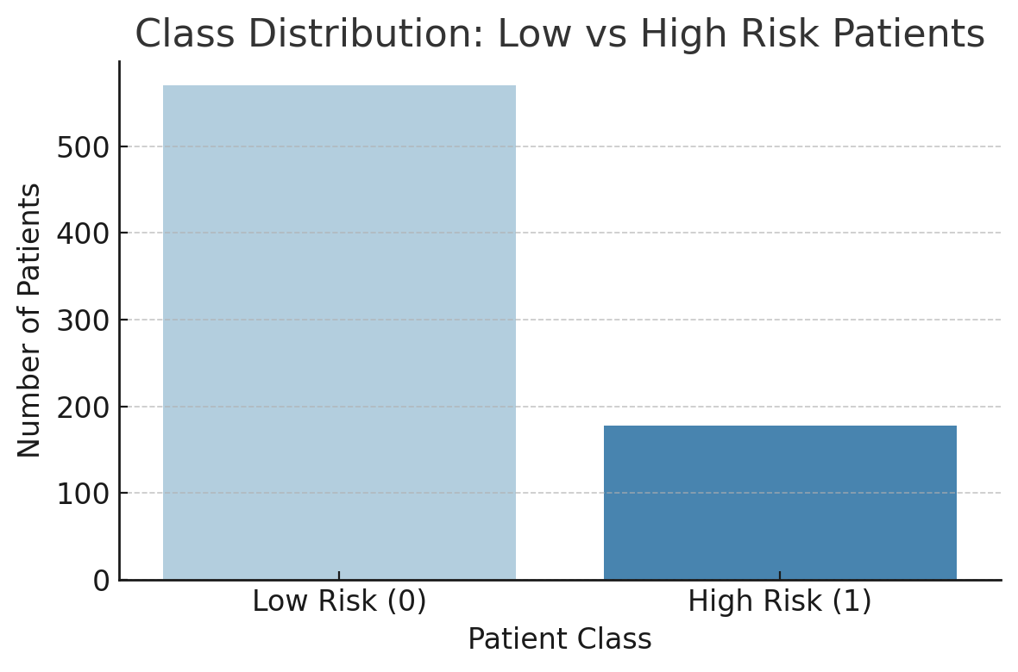
📊 Chart 4: Confusion Matrix — model performance after threshold optimization.

🔍 Step 6: Understanding What Drives Risk
Using Logistic Regression coefficients, I identified that Frequency and Recency were the strongest predictors of patient risk.
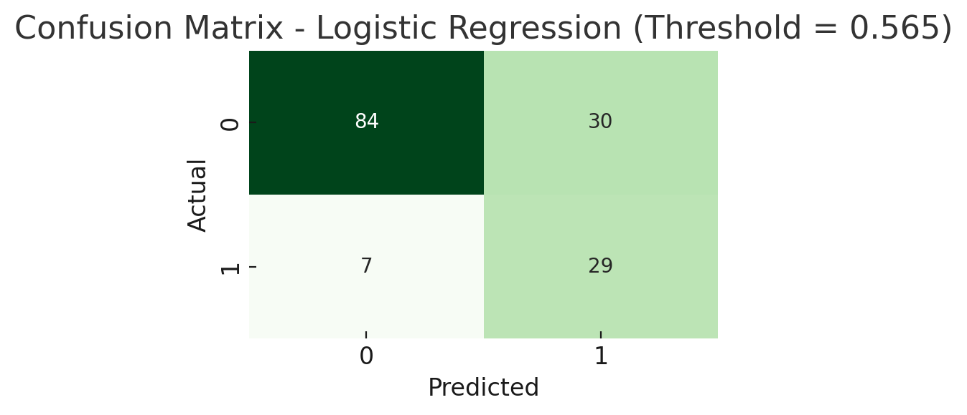
📊 Chart 5: Feature Importance — Frequency and Recency dominate the model’s decision.

💡 Step 7: Turning Predictions into Action
Based on predicted probabilities, patients were categorized into risk bands — Low, Medium, and High Risk. These were used to generate personalized recommendations for patient follow-ups.
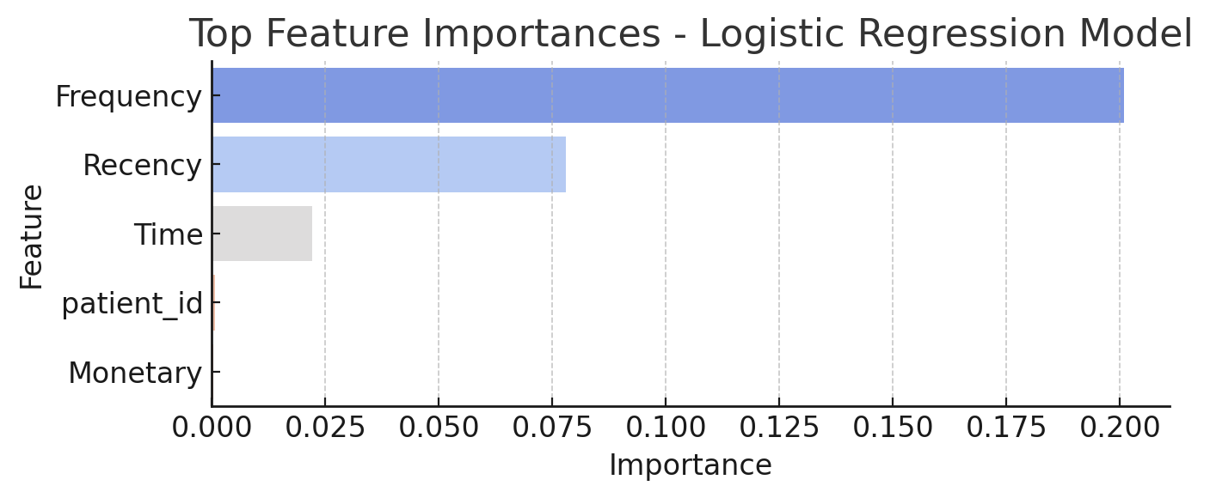
📊 Chart 6: Predicted Risk Band Distribution — visualization of predicted risk levels.
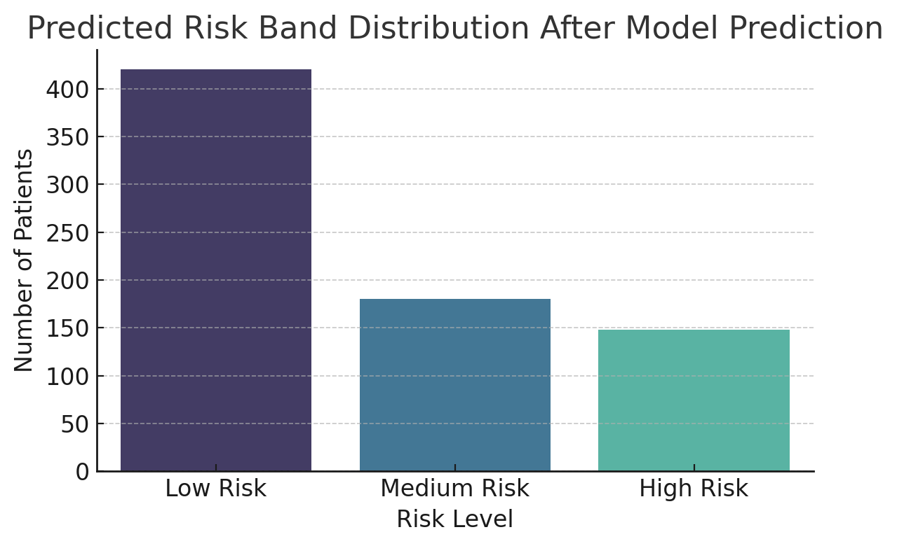
📊 Chart 7: Distribution of Recommended Actions for Patients — personalized next steps.

✅ Step 8: Final Insight & Reflection
This project taught me that in healthcare, recall matters more than accuracy. The goal is not just to predict but to prevent — ensuring that high-risk patients are never overlooked.

