Supply Chain Management Demand Forecasting Model
Anshumaan Singh
April 30, 2025

Introduction:
Accurate demand forecasting is a critical capability in modern supply chain management, enabling companies to optimize inventory levels, minimize stockouts, and reduce carrying costs. In the fast-moving fashion and beauty industry—where trends shift rapidly, and product lifecycles are short—having reliable sales predictions can mean the difference between meeting customer demand and being left with excess stock.
This project focuses on building a machine-learning–based demand forecasting model for a fashion and beauty startup. Using historical sales data, product attributes, customer demographics, and logistics information (such as lead times, shipping costs, and supplier details), we train a neural network to predict the daily number of products sold. The primary objective is to demonstrate how data preprocessing, feature engineering, and a simple feed-forward neural network can be combined to generate actionable sales forecasts that support data-driven decision-making across the supply chain.

Dataset Overview:
The dataset used in this project comes from a fashion and beauty startup and contains detailed information about the products and their sales. It includes both historical sales data and various other operational factors that influence sales performance. Below are the main features in the dataset:
- Product Type: The category of the product (e.g., skincare, haircare).
- SKU: A unique identifier for each product.
- Price: The retail price of the product.
- Availability: The availability status of the product.
- Number of Products Sold: The target variable for prediction, indicating the number of units sold.
- Revenue Generated: The total revenue from the product sales.
- Customer Demographics: Information about the customers who purchased the products, such as age, gender, and location.
- Stock Levels: The quantity of the product available in stock at different times.
- Lead Times: The amount of time it takes to restock a product from suppliers.
- Order Quantities: The number of products ordered in a given period.
- Shipping Times: The time taken for the product to be shipped to customers.
- Shipping Carriers: The companies responsible for delivering the product.
- Shipping Costs: The cost associated with shipping each product.
- Supplier Name: The name of the supplier providing the product.
- Location: The geographic location of the supplier or product distribution.
- Production Volumes: The number of units produced in a given period.
- Manufacturing Lead Time: The time it takes to manufacture a product from order to delivery.
- Manufacturing Costs: The cost of producing each unit of the product.
- Inspection Results: Quality control metrics for the products.
- Defect Rates: The percentage of products that are returned due to defects.
- Transportation Modes: The methods used to transport products, such as air, road, or rail.
- Routes: The transportation routes used for product delivery.
- Costs: Various costs associated with manufacturing and logistics.
The target variable for this project is "Number of Products Sold", which represents the historical sales data for each product. Using this dataset, the goal is to develop a model that can predict future sales based on the available features, thereby improving decision-making in inventory management and resource allocation

Data Preprocessing:
Data preprocessing is a crucial step in preparing the dataset for training a machine learning model. In this project, several key data preprocessing techniques were employed to ensure that the data was clean, well-structured, and suitable for model training. The following steps were taken:
- Handling Missing Data:
  - The dataset contained some missing values. These missing values were removed using dropna(), ensuring that only complete records were used in the analysis. This was important because incomplete data could lead to biased or inaccurate predictions.
- Feature Engineering:
  - The Date column, which contained information on when the sales occurred, was converted into datetime format using pd.to_datetime(). From this, time-based features such as Month, DayOfWeek, and Quarter were extracted to capture seasonal patterns in sales data.
  - These time-based features were added as new columns to the dataset, and the original Date column was dropped, as it was no longer needed.
- Categorical Data Encoding:
  - Several columns in the dataset, such as Product Type, SKU, and Customer Demographics, were categorical in nature. Since machine learning algorithms require numeric input, these categorical columns were transformed into one-hot encoded features using pd.get_dummies(). This created a set of binary (0 or 1) columns for each unique category, allowing the model to interpret the categorical data correctly.
- Scaling Numeric Features:
  - The dataset includes several numeric features, such as Price, Revenue, and Stock Levels. To standardize these features, the StandardScaler from scikit-learn was used. This scaler transforms each numeric feature to have a mean of 0 and a standard deviation of 1, making the model more efficient and stable during training. Scaling is particularly important for models like neural networks, as it prevents certain features from dominating the learning process due to their larger numeric range.
- Data Splitting:
  - The dataset was split into training and testing sets using the train_test_split() function from scikit-learn. The training set was used to train the model, while the test set was held out for evaluating the model’s performance after training. A test size of 20% was used, ensuring that the model’s evaluation would be based on unseen data.
These preprocessing steps helped in preparing a clean and consistent dataset that the machine learning model could learn from effectively, ensuring that the model could generalize well to new data. The next step was to build and train the neural network using the pre-processed data.

Model Architecture:
The core of this project is a feed-forward neural network designed for regression (predicting the number of products sold). The network structure is as follows:
- Input Layer
  - Receives the full set of preprocessed features (both scaled numeric features and one-hot encoded categorical features).
  - The input dimensionality matches the number of columns in the feature matrix after preprocessing.
- Hidden Layer 1
  - 128 neurons
  - ReLU activation
  - Purpose: Learn high-level feature interactions and non-linear patterns in the data.
- Hidden Layer 2
  - 64 neurons
  - ReLU activation
  - Purpose: Further abstract and combine patterns identified by the first hidden layer.
- Hidden Layer 3
  - 32 neurons
  - ReLU activation
  - Purpose: Capture finer-grained relationships before the final prediction.
- Output Layer
  - 1 neuron
  - Linear activation (default for Dense in Keras when no activation is specified)
  - Purpose: Produce a continuous-valued prediction for the number of products sold.
Model Compilation
- Optimizer: Adam
- Loss Function: Mean Squared Error (MSE)
- Metrics: MSE tracked during training
This relatively simple architecture strikes a balance between model capacity (enough layers and neurons to capture complex patterns) and the risk of overfitting (keeping the network small enough to generalize). Training with MSE as the loss ensures the model learns to minimize large errors in sales predictions, which is critical for accurate demand forecasting.

Training & Evaluation:
The neural network was trained on 80% of the data with 20% held out for validation during training. Key training details are as follows:
- Optimizer: Adam
- Loss Function: Mean Squared Error (MSE)
- Epochs: 50
- Batch Size: Default (automatically determined by Keras)
- Validation Split: 20% of the training set
During training, both the training loss and validation loss were monitored to assess how well the model was learning and to detect any overfitting. The plot below (to be inserted) shows the loss curves:
- Training Loss Curve: Indicates how the error on the training data decreased over epochs.
- Validation Loss Curve: Indicates how the error on the unseen validation data changed over epochs.
After training completed, the model was evaluated on the independent test set (the 20% that was never used during training or validation). The resulting performance metric was
Mean Squared Error on Test Set: 120,217.16
This MSE value quantifies the average squared difference between the model’s predicted sales and the actual sales in the test set. Lower values indicate more accurate predictions.

Model Performance (Plot Results):

The model’s performance was evaluated visually through the following plots:
1. Training vs Validation Loss
This plot compares the training loss (error on the training data) and the validation loss (error on the validation data) over the 50 epochs of training. Below is the interpretation of the plot:
- Starting Phase: In the initial epochs, the training and validation loss decrease steadily, indicating that the model is learning and fitting well to the training data.
- Convergence: Towards the later epochs, both loss curves start to flatten, indicating that the model’s improvement has plateaued. This is expected behavior once the model has learned the main patterns.
- Gap Between Training and Validation Loss: If the gap widens significantly toward the end of training, it may suggest that the model is starting to overfit — i.e., it performs well on the training data but not as effectively on unseen data (validation set).
2. True vs Predicted Sales
The True vs Predicted Sales scatter plot compares the actual sales (y-axis) with the predicted sales (x-axis). In an ideal scenario, the points in this plot would align along the diagonal line, meaning that the model's predictions are accurate and close to the actual values.
- Tight Clusters Near the Diagonal: This indicates good predictions, meaning the model is accurately forecasting the sales.
- Wide Spread: If the points are widely scattered, the model may not be performing as well, and further tuning may be necessary.
Interpretation: Based on the scatter plot, the model can be evaluated in terms of how well it performs on predicting demand. If the points closely follow the diagonal, it indicates that the model is performing well.

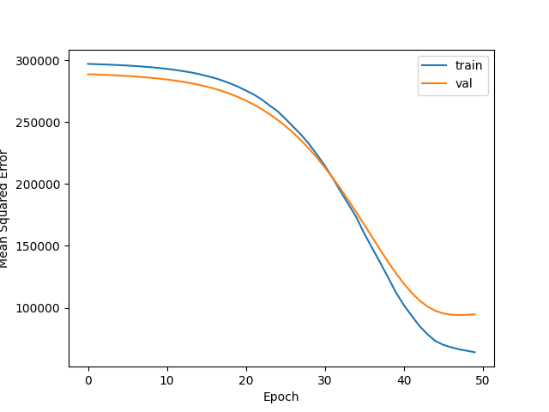
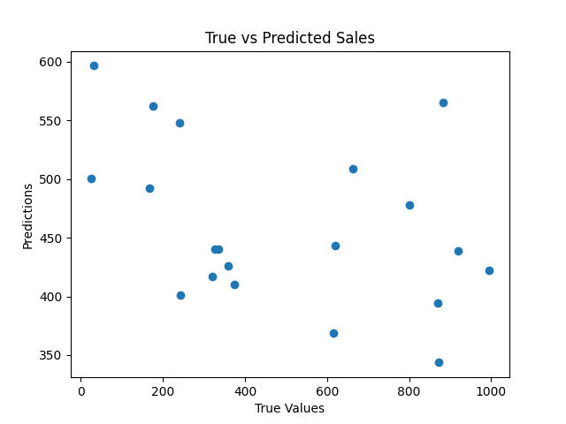
Conclusion:

The demand forecasting model successfully predicted the number of products sold with a Mean Squared Error (MSE) of 120,217.16. While the training loss decreased steadily, the validation loss increased slightly towards the end, indicating that the model may have started to overfit. However, overall, the model is suitable for use in forecasting sales for the fashion and beauty startup.
Next Steps and Improvements:
- Retraining the model with more data over time to improve its predictions.
- Incorporating additional features like promotions, weather, or economic indicators to improve forecast accuracy.
- Implementing regularization techniques like dropout to mitigate overfitting.
- Experimenting with more advanced models such as LSTM (Long Short-Term Memory) or XGBoost, which may perform better for time-series forecasting.
This model serves as a foundational tool for optimizing inventory and sales planning, ultimately enhancing operational efficiency.
References:
No external references were used for this project.

