**Software Requirement Specification(SRS) for**

**Store Management System**

**Document:**Software Requirement Specification

**Title:** SRS for Store Management System

**Team:** Anshumala Jaiswal

Arti Rathore

**Purpose**

The Store Management system will enable a chain of stores to coordinate with their supplier to facilitate on time supply and to maintain updated information about available stocks at each store.

This Stores Management System can be hosted over either an intranet or over the internet. For stores owned by the manufacturer the system can be operated over a company wide network to enable transfer of information.

**Scope**

The online store management System for products Web Applictaion is intended to provide complete solution for shopkeeper as well as supplier through a single Gateway using internet.

The main goal of the application is to maintain the records of purchase,Sales , stock and Supplier details.Store management system is very needy for large whole sale market.This software help them maintain day to day transactions in computer.This system makes the daily activities efficient and provides fast response by storing and retrieving informationabout all the products.

**Definition**

SRS : Software Requirement Specification

SMS : Store Management System

BI : Business Intelligence

Dashboard : Personalized information presented using BI techniques

**Overview**

Administration and management of a store is an essential part of overall working and function of a store management system. Particularly in the case of bigger stores,there wil be several products and number of sections. So good and effective use of resources and effective management is necessary to the success and smooth working.

**Overall Description**

The proposed Store Management System concentrateds on providing smart functioning in the store with userfriendly application.This application requires less paper work. Also human and manual work is reduced.

Store Management system is an advanced system which is designed keeping in view to make the existing system easier and faster.This system provides a better management of products .Store is an important component of material management since it is a place that keeps the materials in a way by which the materials are well accounted for, are maintained safe, and are available at  the time of requirement. Storage is an essential and most vital part of the economic cycle and store management is a specialized function, which can contribute significantly to the overall efficiency and effectiveness of the materials function.

To implement the system we have used Spring Boot, Java for backend. It provides support to all major servers like Apache and databases like MySQL.Further we have used React js,BootStrap 4,CSS,HTML for front-end implementation.React is a JavaScript-based UI development library. Facebook and an open-source developer community run it. Although React is a library rather than a language, it is widely used in web development.

There are mainly 3 roles in our project namely : Admin, Salesman and Supplier.

ADMIN

The super user, admin class represents complete authority over the system. The following activities are performed by Admin:-

i)Login as Admin

ii)Can add,update,delete and view the users i.e. Salesman and Supplier.

SALESMAN

i)Login as Salesman

ii)can view profile

iii)can fill and view his address details

iv)Add Category and respective products

v)view the status of products and request the supplier for delivery of required items.

SUPPLIER

i)Login as Suppplier

ii)can view supplier

iii)can change the status of products to delivered.

**Requirements:**

***Functional Requirements:***

I)Admin Functionality

* Login , Enter Email and Password
* On successful login, Admin will be able to see his/her dashboard.He will be able to see all users list and can add, update or delete users.

II)Salesman Functionality

* Login,Enter Email and Password .
* On Successful login ,Salesman will be able to see his/her dashboard.
* Here Salesman will be able to see his profile and can update if required,Add address of the shop where the delivery is to be done.
* Salesman will be able to see the category and product list and can add,update and delete the category and product accordingly.
* There will be one status bar which shows whether the product is delivered or not.

III)Supplier Functionality

* Login,Enter Email and Password
* On successful login,Supplier can see dashboard .
* Here supplier will be able to see the products which are to be delivered or which are delivered.He will be able to maintain the status the products supplied and can view the address where the product is to be supplied.

***Non-Functional Requirements:***

Following Non-Functional Requirements will be there in the insurance to the internet:

* Secure access to consumer’s confidential data.
* 24X7 availability.
* Better component design to get better performance at peak time.
* Flexible service based architecture will be highly desirable for future extension.Non-Functional Requirements define system properties and constraints.

Various other Non-Functional Requirements are:

* Security : Registered user can maintain their various functionalities.
* Reliability : The system will backup business data on regular basis and recover in short time duration to keep system operational.Continous updates are matained , continous Adminstration is done to keep system operational.During peak hours system will maintain same user experience by managing load balacning .
* Availability : 24*7 Available
* Maintainability : IT operations team will easily monitor and configure System using Adminstrative tools provided by Servers.Separate enviornment will be maintained for system for isolation in production, testing, and development.
* Portability : System will provide portable User Interface ( HTML, CSS, JS) through which users will be able to access store management portal.
* Modularity : System will designed and developed using reusable,independent or dependent business senarios in the form of modules.These modules will be loosely coupled and highly cohesive.
* Performance : Easy tracking of records and updating can be done.

**E-R DIAGRAM**

1. For Admin

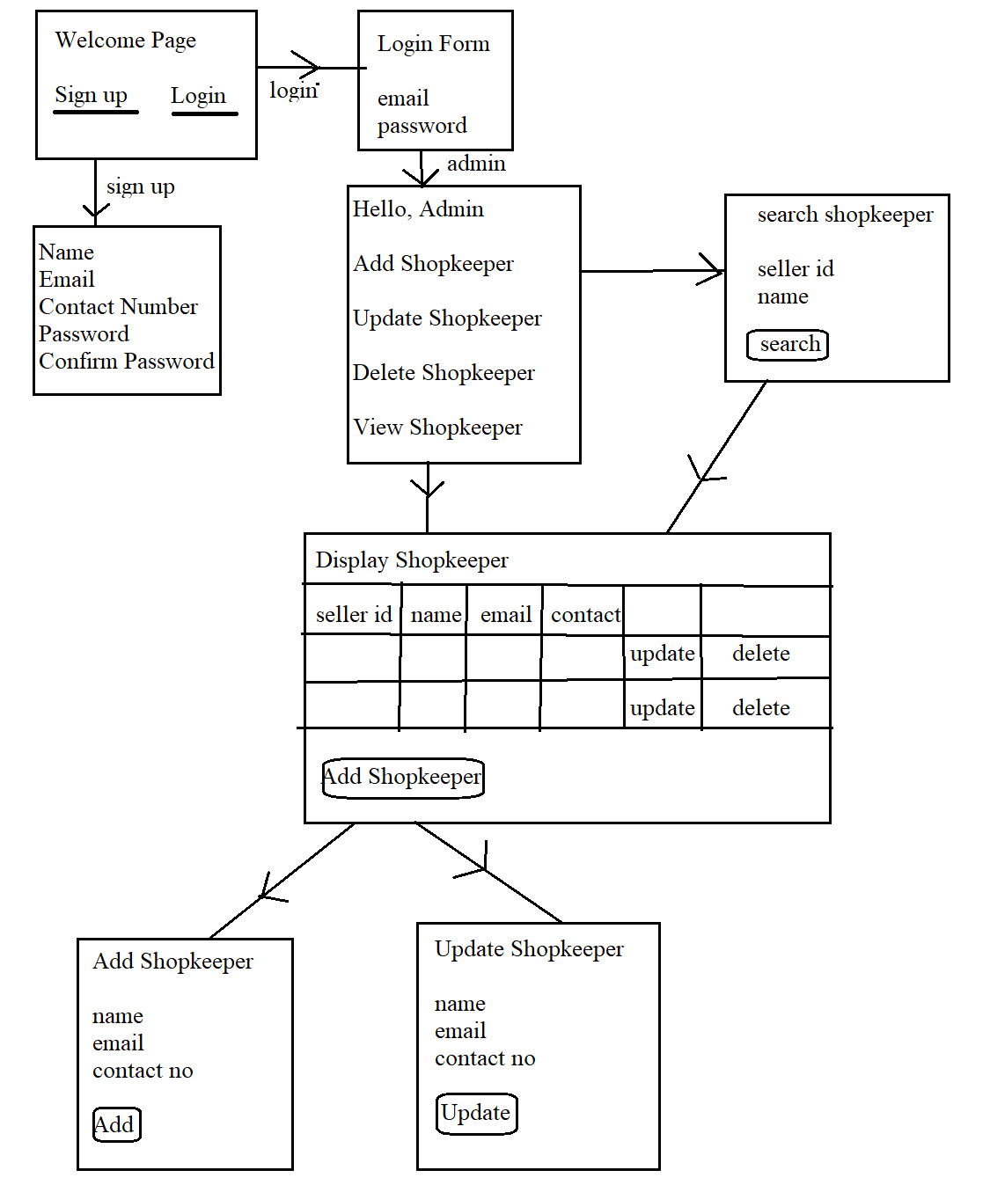

1. For Salesman and Supplier

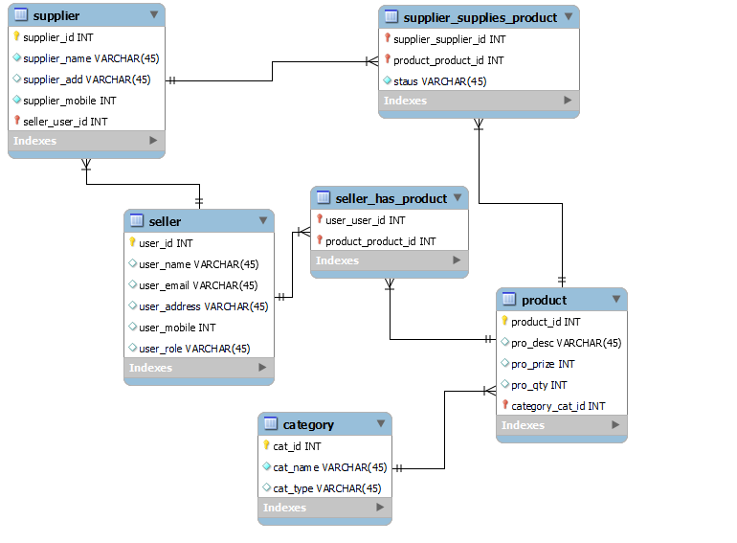

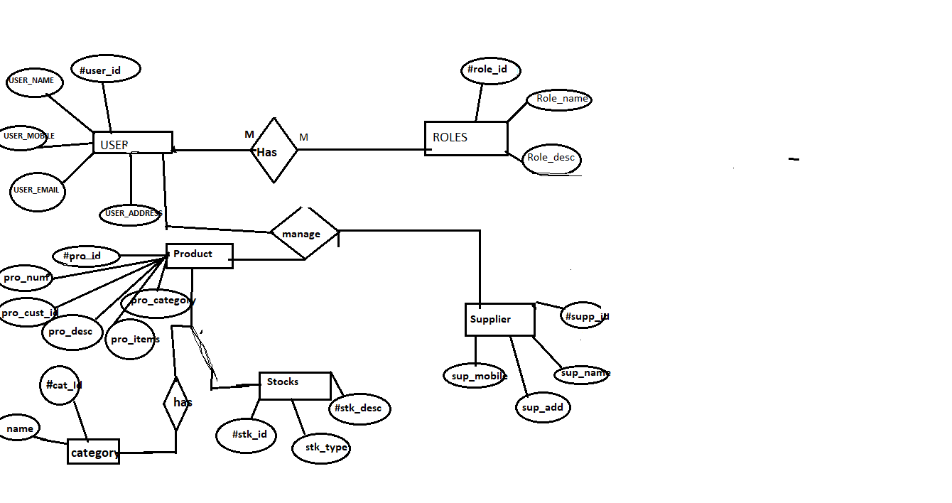

**Database Tables**

Users

|  |  |
| --- | --- |
| Id | Int,primary key,auto_increment |
| Email | Varchar(30),not null,unique |
| First_name | Varchar(20),not null,unique |
| Last_name | Varchar(20),not null |
| Password | Varchar(20),not null |
| Phone | Varchar(20) |
| Role | Varchar(20) |

Category_table

|  |  |
| --- | --- |
| Id | Int,primary key,auto_increment |
| Category_name | Varchar(255) |
| Category_description | Varchar(255) |
| Category_type | Varchar(255) |

Product_table

|  |  |
| --- | --- |
| id | Int,Primary key,auto_increment |
| Discount | Int,not null |
| Final_price | Double,not null |
| Product_desc | Varchar(100) |
| Product_price | Int,not null |
| Product_qty | Int,not null |
| Product_name | Varchar(20) |
| Status | Varchar(20) |
| Category_id | Int,foreign_key(category_table) |
| User_id | Int,foreign_key(user_table) |

Address_table

|  |  |
| --- | --- |
| User_id | Int,primary key |
| City | varchar(255) |
| Country | varchar(255) |
| State | varchar(255) |
| Zip_code | Int |
| Shop_name | varchar(255) |

**Conclusion**

The project titled “Store Management System” was successful.It is designed in such a way that further more modules can be added easily.

The system is developed with much care and free of errors.It is efficient and less time consuming.The purpose of this project was to develop a web application for easy maintenance of all the products in a shop.

This project helps us in gaining practical knowledge and we a got a hands on experience on several topics like designing a web page using React.js,use of responsive templates ,using bootstrap components easily and helps in management of database using Mysql.The entire project helped us in understanding about the various phases of software development and software development life cycle.

This project can help various shopkeepers of big retail shop to easily maintain all the products category-wise.Also they can track whether their ordered product is delivered or not.

There is a scope for further development of this project like we can add a cart and can see the delivered items in one page and not delivered item in other page.Further we can calculate total amount of product to be delivered to the supplier for the ease.