1. Created a file file1.txt using nano file1.txt entered some data in it.
2. Copied the content of file1 to file2 using cp file1.txt to file2.txt and showed the content of file2.txt using cat file2.txt in below screenshot.

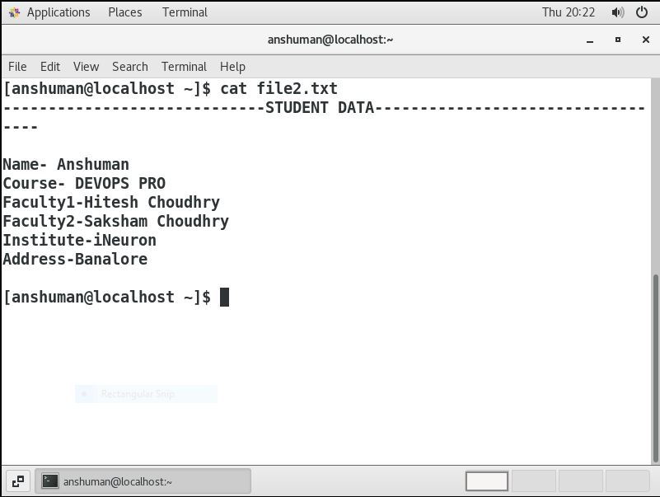

1. Moved the file2.txt to /home directory. Then checked is the file moved to home directory using ls command. The screenshot is attached below.

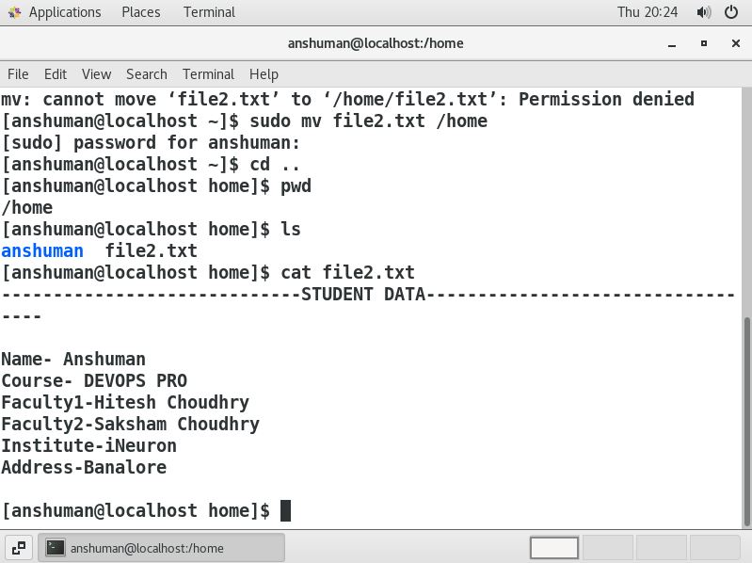

1. Created two files file3.txt and file4.txt in home directory and added some content in the files. We changed the permission of files and added some data in the file3.txt and file4.txt . Now did echo”Hello I am newline”>file3.txt and echo”Hello I am newline”>>file4.txt and observed ‘>’ is the output redirection operator used to overwrite the content of file as in case of file3.txt whereas ‘>>’ is also the output redirectory operator used to append the content of file as in case of file4.txt.

Below attached the screenshot .

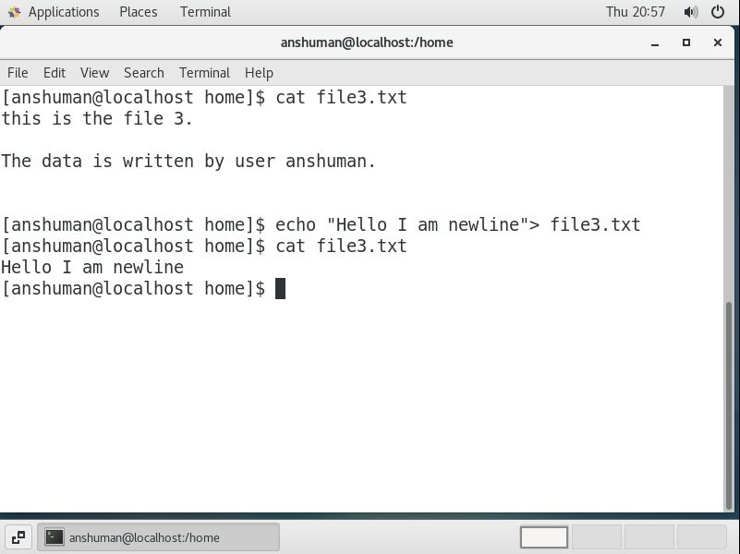

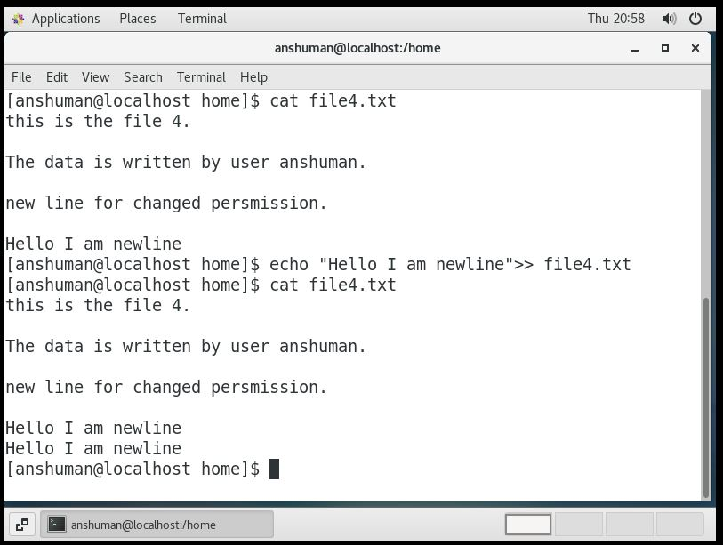

1. Below screenshot shows implementation of rm and rmdir commands to delete file and directory in LINUX.

