1. When we login using a non existing user then it won’t allow us to login.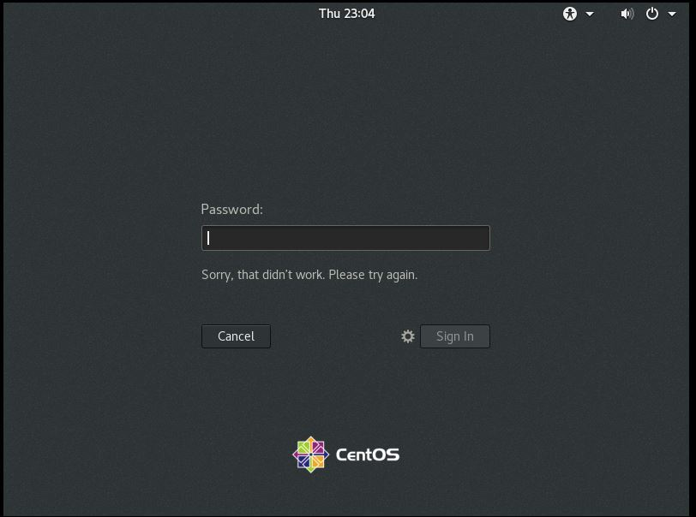

We understood that Linux provides security to its users. It is difficult to login as non existing user.

1. Password changing is done and password changed to IneuROn#42 and hit enter. After hitting enter we could see that it again asks for confirmation of new password. When we provide the password again it updates the password of the user.

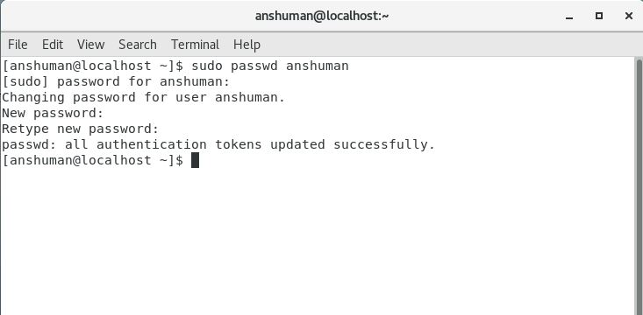

We again tried changing the password using 1234 or abcd. I t prompts that the password is bad password and the length is shorter than 8 characters. However it updates the password.

Below screenshot shows it.

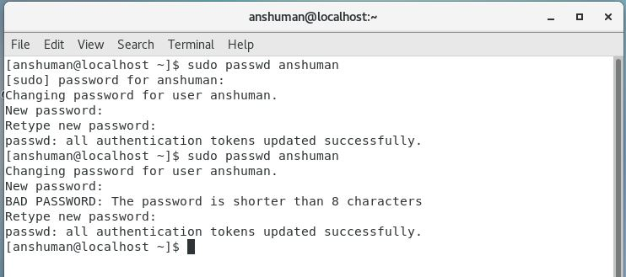

Now again upon changing the password and not putting any password it shows manipulation error and doesn’t allow to change the password. Below is the screenshot for it.

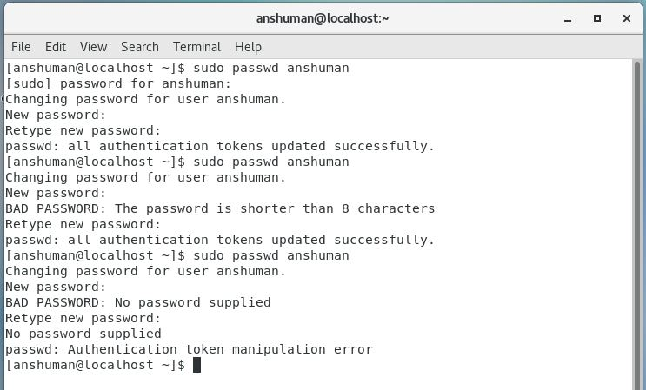

1. Working with directories. When we use cd/ command the directory changes to root. Now ls command lists all the directories and files in the root directory.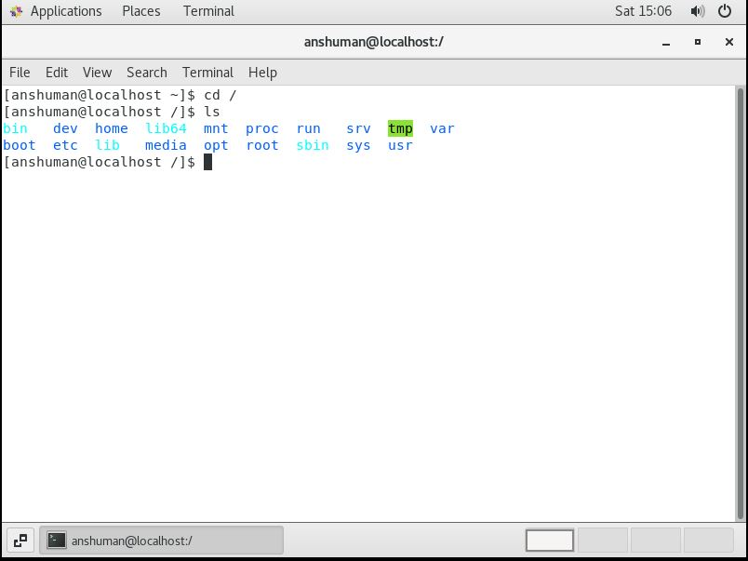

Cd /home command changes the directory to home directory. Now ls command lists all directories and files in home directory.

Below is the screenshot attached.

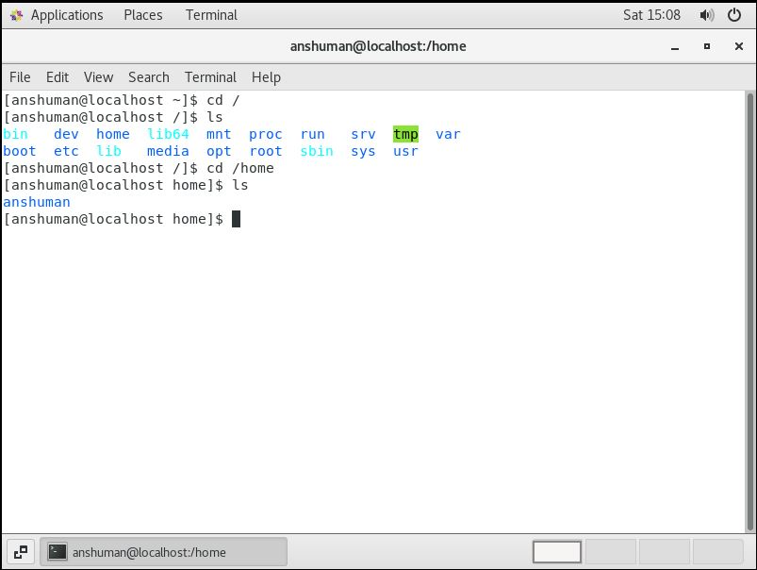

Entering cd .. command takes to the parent directory of present directory which is root directory in our case.

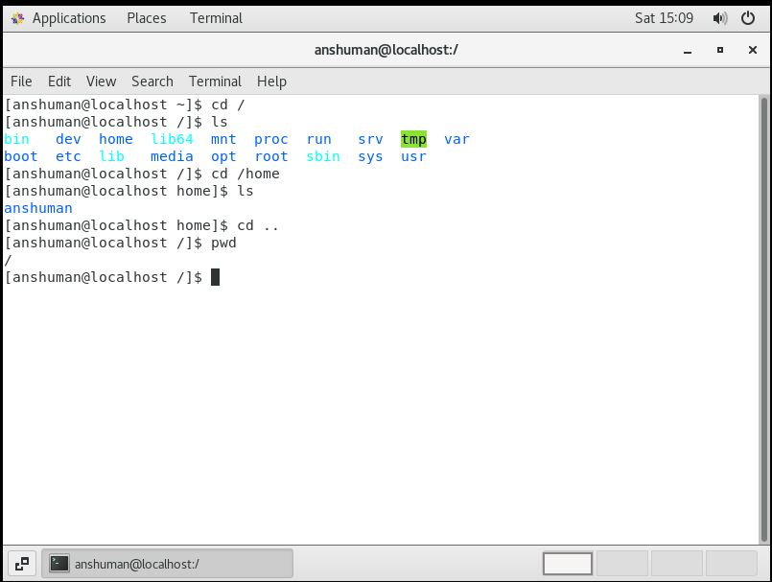

Now entering cd /var/www/html shows no such directory present. Then upon entering cd it goes to home directory. Please find in below screenshot.

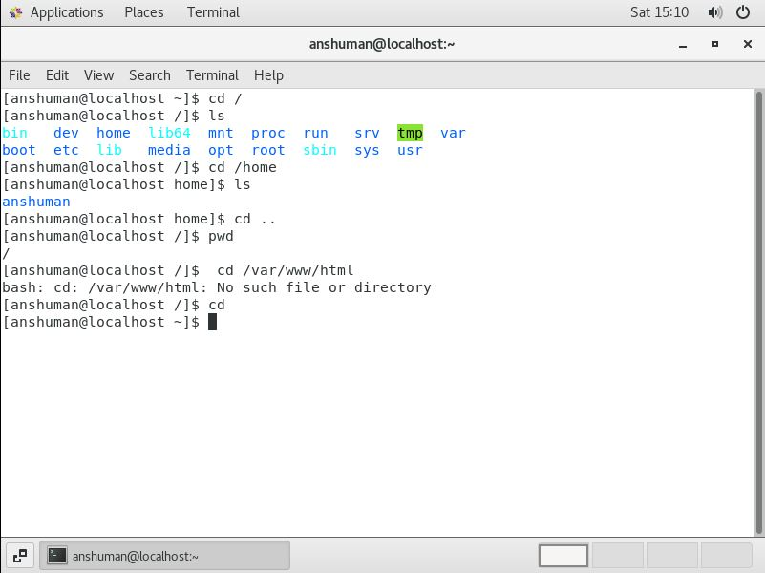

Now entered cd/root and ls. Below screenshot shows the information.

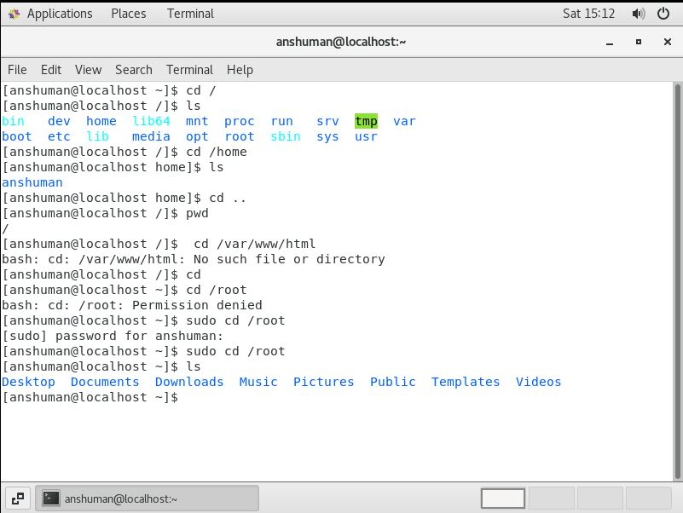

1. Cd /etc and ls shows list of files and directories in etc directory. Which stores configuration files .

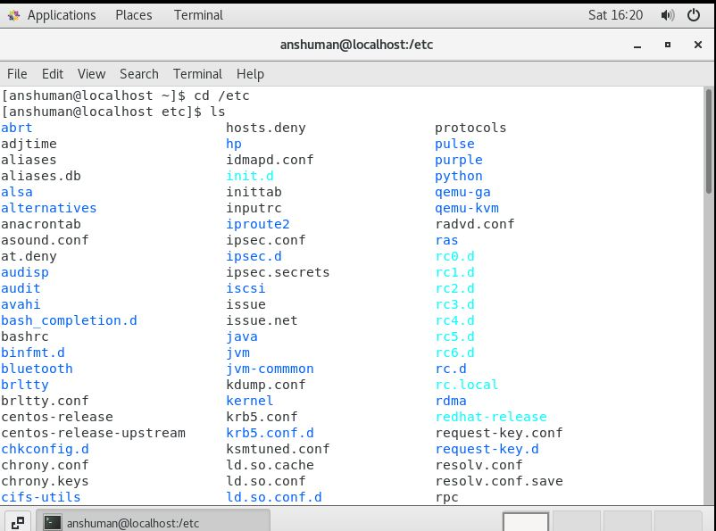

ls -al command is entered and shows list of all files in etc directory both hidden and non hidden in long format.

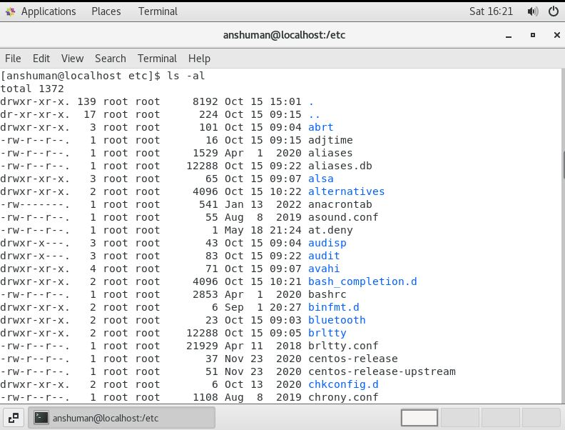

ls-i command lists all files and directories along with its inode number.

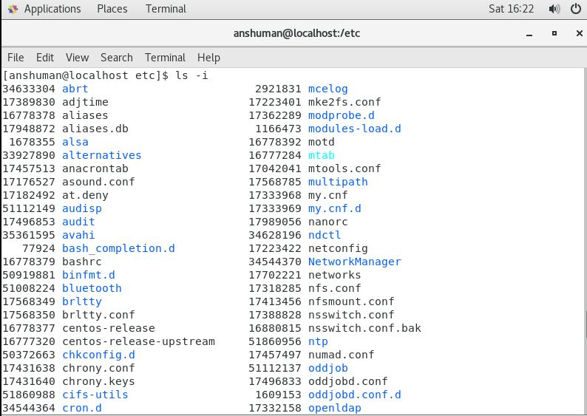

Ls –help command lists all the option that can be used with ls command.

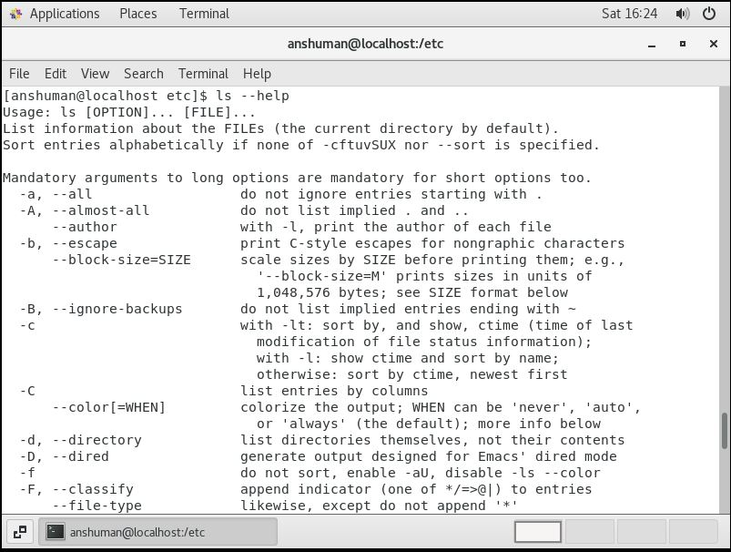

1. Pwd cd/var and ls commands are used and screenshot is given below.