P7 - Crop Type and Cropping Pattern Mapping using Multi-season Satellite Data and Introductory Machine Learning
A Case Study of Karnal District, Haryana (Kharif and Rabi Seasons)
Project Report Submitted in fulfillment of
the Requirements for the Award of the
Internship of Summer Training Program
Space Science Technology
Remote Sensing and GIS with Python
By
Anshuman Tripathi
Bundelkhand University
Institute Roll No.: 221381030012
Enrollment No.(India Space Academy): 688677
Under the Supervision of
Miss. Alisha Sinha
India Space Academy,
Department of Space Education, India Space Week

Table of Contents
1. Title 3
2. Objective 3
3. Study Area 3
4. Data Used 4
5. Methodology 6
6. Results 10
7. Conclusion 25
8. References 26

1. Title
Crop Type and Cropping Pattern Mapping using Multi-season Satellite Data and Introductory Machine Learning – A Case Study of Karnal District, Haryana, covering both the Kharif and Rabi Seasons, using Sentinel-2 Imagery.

2. Objective
The main aim of this project was to look at how crop area and land cover in Karnal district change across the Kharif season by using Sentinel-2 satellite images together with a simple machine learning model. Instead of only depending on one vegetation index, the idea was to combine the six raw spectral bands (Blue, Green, Red, NIR, SWIR-1, SWIR-2) with four derived indices (NDVI, NDWI, SAVI and NDBI) and pass all of them to a Random Forest classifier so that the model can separate agriculture, water and built-up areas on its own instead of relying on fixed threshold values. Along with the classification part, the project also tried to understand which spectral band or index actually helps the model the most, and how accurate the final map really is once it is checked against the labelled ground points.
The second half of the project extends the same workflow to the Rabi (winter) season, so that a proper multi-season comparison could finally be made. A second Sentinel-2 composite was built for the January–March window, the same feature-stacking and Random Forest approach was repeated for the winter crops, and the two seasonal classifications were then compared pixel by pixel to work out how land use actually shifts from Kharif to Rabi. This last step, sometimes called a crop-rotation or cropping-intensity analysis, and it is really the piece that makes the whole exercise useful for something like identifying rice-wheat rotation land or spotting fields that stay fallow through winter.

3. Study Area
Karnal district lies in the state of Haryana, in the northern part of the Indo-Gangetic plain, and is one of the well-known agricultural belts of India. The district is roughly bound between 76.48°E–77.21°E longitude and 29.44°N–29.99°N latitude, with a geographic area of around 2,520 sq. km according to district records. The region is heavily irrigated and mostly flat, and it is well known for its paddy (rice) and wheat rotation, along with sugarcane in some pockets. Karnal is in fact often referred to as the 'Rice Bowl' of Haryana because of the large area under basmati and non-basmati paddy cultivation in the Kharif season, which made it a good choice of study area. Since strong seasonal vegetation change was expected here.
Because the district is dominated by the classic rice-wheat cropping system, it also works well for the Rabi part of the study — most of the land that shows up as flooded paddy or dense crop cover during the monsoon is expected to be sown with wheat (and, in smaller pockets, mustard) once the winter season starts. This made Karnal a natural fit for testing whether a simple pixel-wise comparison between the two seasonal classifications could actually pick up this rotation pattern.
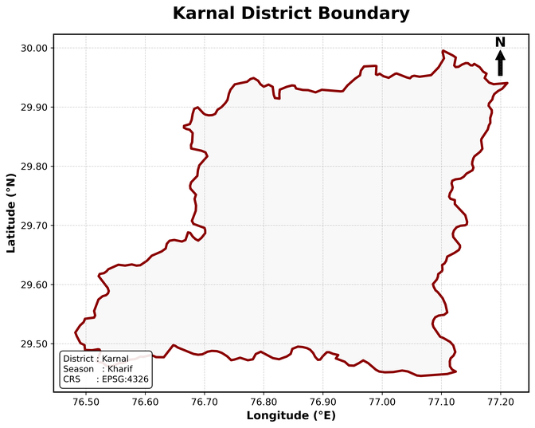
Figure 3.1: Administrative boundary of Karnal district used as the Area of Interest (AOI) for this study.

4. Data Used

4.1 Kharif Season Satellite Data
- Sentinel-2 Level-2A Surface Reflectance (Harmonized) imagery, accessed and processed on the Google Earth Engine (GEE) platform using the COPERNICUS/S2_SR_HARMONIZED collection.
- Kharif season imagery filtered between 15 August 2023 and 30 September 2023, with a cloud cover filter of less than 20% (using the CLOUDY_PIXEL_PERCENTAGE property).
- Images were cloud-masked using the Scene Classification Layer (SCL) band, removing cloud shadow, medium and high probability cloud, thin cirrus and snow pixels, before generating a median seasonal composite.
- The composite was clipped to the Karnal district boundary and exported at 10 m resolution (EPSG:4326) for further processing in Python.

4.2 Bands Used
- Band 2 – Blue
- Band 3 – Green
- Band 4 – Red
- Band 8 – Near Infrared (NIR)
- Band 11 – Short Wave Infrared 1 (SWIR-1)
- Band 12 – Short Wave Infrared 2 (SWIR-2)

4.3 Ancillary Data
- Karnal district administrative boundary, extracted from the FAO GAUL (Global Administrative Unit Layers) 2015 Level-2 dataset on Google Earth Engine and used as the Area of Interest (AOI).
- A labelled training dataset of 2,432 reference points collected across four land cover / vegetation classes, used to train and test the Kharif Random Forest model.

4.4 Data Sources
- Sentinel-2 imagery: Google Earth Engine Data Catalog, COPERNICUS/S2_SR_HARMONIZED
- District boundary: FAO GAUL 2015 Level-2 boundaries, Google Earth Engine Data Catalog (FAO/GAUL/2015/level2)

4.5 Reference / Validation Data
- Google Earth Pro was used for visual cross-checking of the classified output.

4.6 Rabi Season Satellite Data
For the Rabi season, a second Sentinel-2 composite was built on Google Earth Engine, again from the COPERNICUS/S2_SR_HARMONIZED collection, but this time filtered between 1 January 2025 and 31 March 2025 (cloud filter still below 20% CLOUDY_PIXEL_PERCENTAGE), which is roughly the window in which wheat and mustard are actively growing in this part of Haryana. The same cloud/cirrus masking logic used for Kharif was applied, and the median composite was scaled to surface reflectance (0–1 range) directly during export, unlike the Kharif export which kept the raw digital number values. The final Rabi raster, Karnal_Rabi_SelectedBands.tif, has six bands (B2, B3, B4, B8, B11, B12) at 10 m resolution and the same 8,118 × 6,122 pixel grid as the Kharif raster used earlier, which turned out to be useful later since it meant the two classified rasters lined up pixel-for-pixel without needing much extra reprojection work.

4.7 Rabi Season Training Data
The Rabi training points were exported from Google Earth Engine as Karnal_Rabi_Training_Data.csv, giving 1,982 labelled points with the six spectral bands and four derived indices (NDVI, NDWI, NDBI, SAVI) already calculated, plus a numeric class column. The class distribution was fairly imbalanced: class 0 had 1,000 points, class 2 had 500, class 1 had 452, and class 3 had only 30 points.
One thing worth explaining honestly here is how these classes were labelled. The training polygons were originally digitized as generic land-cover categories — Agriculture, Water, Built-up and Bare soil — the same four categories used for the Kharif training set, and the same digitized field locations were simply re-sampled on the new Rabi composite. Since the crop actually growing at a given location changes with the season, these same locations were then re-interpreted for the Rabi season based on what is grown there in winter: the "Agriculture" points became the Wheat class (0), since wheat dominates winter cropping on these fields, the "Water" points became Mustard (1) — mostly low-lying, moisture-retaining plots near ponds and channel edges where mustard is commonly grown — the "Built-up" points stayed as Urban (2), and the "Bare soil" points became Fallow (3), which is a reasonably direct match since bare, unplanted land in winter is exactly what "fallow" means. This relabeling is an approximation rather than a field-verified ground truth, and it is flagged again in the Methodology and Conclusion sections since it does affect how the Rabi accuracy numbers should be read.

4.8 Rabi Data Sources
- Sentinel-2 imagery and training samples: Google Earth Engine, COPERNICUS/S2_SR_HARMONIZED collection, exported via a custom GEE script.
- District boundary: same Karnal_Boundary shapefile used for the Kharif season (FAO GAUL 2015 Level-2, reused for consistency).

5. Methodology
The whole workflow for this project was carried out mainly in Python (using rasterio, geopandas, numpy, scikit-learn and matplotlib) instead of a manual QGIS workflow, since the machine learning part needed more flexibility. Google Earth Engine was used only at the data-collection stage, to export the multi-band Sentinel-2 composite and the training points; everything after that – clipping, index calculation, feature stacking and classification – was done in a Jupyter Notebook. The steps followed are given below.

5.1 Data Preparation
The Karnal district boundary shapefile was read using GeoPandas and reprojected to match the CRS of the Sentinel-2 raster (EPSG:4326). The 6-band Sentinel-2 composite (8,118 × 6,122 pixels, 10 m resolution) was opened with Rasterio, and its extent was cross-checked against the AOI boundary before clipping the raster to the exact shape of the district using rasterio.mask.

5.2 True Colour and False Colour Composites
Once the bands were clipped, a True Colour Composite (Red-Green-Blue) and a False Colour Composite (NIR-Red-Green) were generated to visually check the crop and water areas before doing any calculation. In the False Colour Composite, the healthy paddy fields of the Kharif season appear bright red because of strong near-infrared reflectance, while water bodies appear dark.
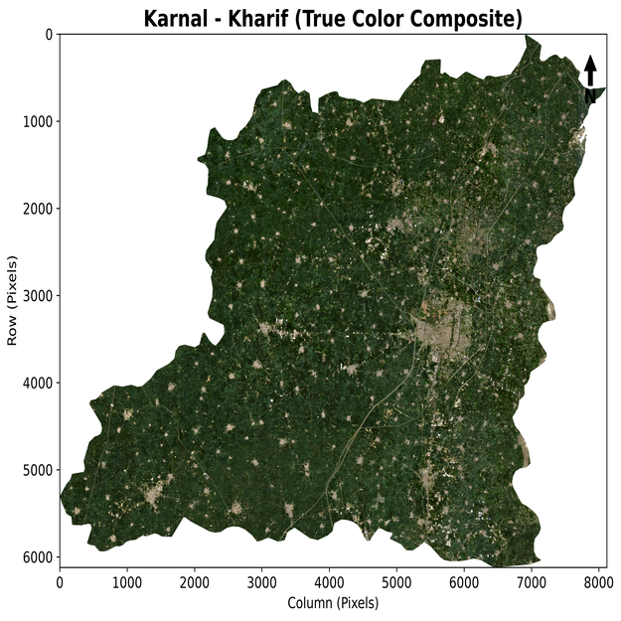
Figure 5.1: True Colour Composite (Red-Green-Blue) of Karnal district, Kharif season.
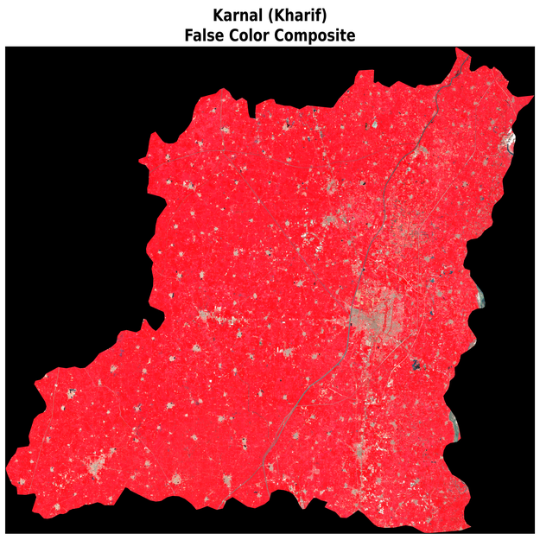
Figure 5.2: False Colour Composite (NIR-Red-Green) of Karnal district, Kharif season, showing dense vegetation in red.

5.3 Spectral Band Statistics
Basic statistics (minimum, maximum, mean, median, standard deviation) were computed for each of the six bands, and their distribution was checked using boxplots and histograms, mainly to confirm there were no obvious data errors such as clipped values or missing pixels before moving to the index calculation stage.
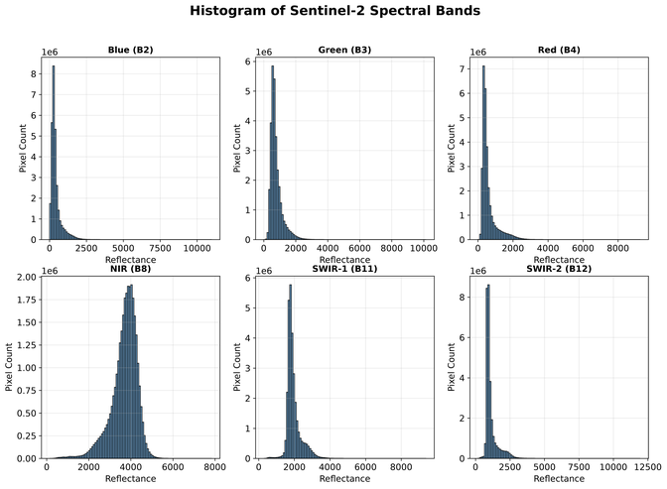
Figure 5.3: Histogram distribution of the six Sentinel-2 spectral bands over Karnal district.

5.4 Vegetation and Land Cover Indices
Four spectral indices were derived from the clipped bands using standard formulas:
- NDVI (Normalized Difference Vegetation Index) = (NIR − Red) / (NIR + Red)
- NDWI (Normalized Difference Water Index, McFeeters 1996) = (Green − NIR) / (Green + NIR)
- SAVI (Soil Adjusted Vegetation Index) = [(NIR − Red) / (NIR + Red + L)] × (1 + L), with L = 0.5
- NDBI (Normalized Difference Built-up Index) = (SWIR1 − NIR) / (SWIR1 + NIR)
Each index was computed over the entire raster and saved separately as a GeoTIFF for later use. The exact same four formulas were reused later for the Rabi season composite, so both seasons are directly comparable.

5.5 NDVI-based Threshold Classification
Along with the machine learning part, a simple threshold-based classification was also carried out directly on the NDVI raster, mainly to get a quick and independent estimate of vegetation cover without depending on the trained model. The NDVI values were grouped into four classes: Water/Built-up (NDVI < 0), Bare Soil (0 ≤ NDVI < 0.2), Moderate Vegetation (0.2 ≤ NDVI < 0.5) and Dense Vegetation (NDVI ≥ 0.5), and the area under each class was then calculated in hectares and sq. km.

5.6 Feature Stack and Correlation Check
All six spectral bands and the four indices were stacked together into a single 10-layer feature array (10 × 6,122 × 8,118), which is what was actually fed into the Random Forest model later. Before training, a Pearson correlation matrix was generated across all ten features to see which bands and indices were redundant and which ones were adding new information.
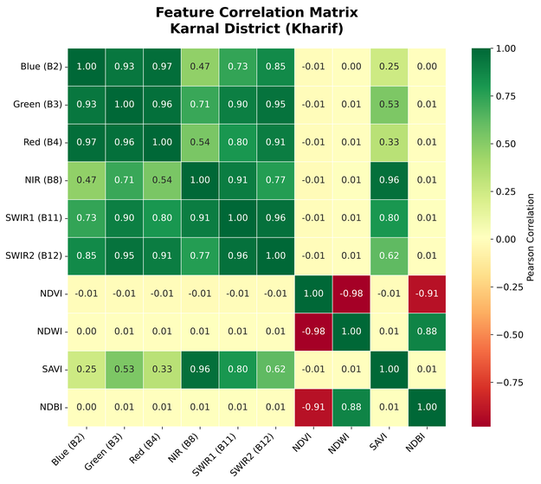
Figure 5.4: Correlation matrix among the six spectral bands and four derived indices.

5.7 Random Forest Classification – Kharif Season
The 2,432 labelled training points (with attributes B2, B3, B4, B8, B11, B12, NDVI, NDWI, SAVI, NDBI and a class label) were split into 70% training and 30% testing using a stratified split (random_state = 42) so that the class proportions stay the same in both sets. A Random Forest Classifier with 300 trees (n_estimators = 300) and a maximum depth of 20 was trained using scikit-learn. After training, the model was used to predict the class of every single pixel in the full 10-band feature stack, and the trained model was saved as a .pkl file so it could be reused without retraining.

5.8 Accuracy Assessment – Kharif Season
The trained model was evaluated on the 30% held-out test data using overall accuracy, a class-wise classification report (precision, recall, f1-score) and a confusion matrix. Feature importance values from the Random Forest were also extracted to check which bands or indices contributed the most to the classification.

5.9 Area Statistics and Final Kharif Map
Once the whole raster was classified, the number of classified pixels was converted into hectares and sq. km (each Sentinel-2 pixel = 10 m × 10 m = 100 sq. m), and a final publication-quality map was prepared showing the classified land cover of Karnal district for the Kharif season.

5.10 Rabi Season Data Preparation
For the Rabi half of the study, the same district boundary shapefile was loaded again with GeoPandas, and the 6-band Rabi composite (Karnal_Rabi_SelectedBands.tif, 8,118 × 6,122 pixels) was opened with Rasterio and its band order confirmed against the descriptions written by GEE (B2, B3, B4, B8, B11, B12), just to make sure nothing had shifted during export.

5.11 Rabi Season Feature Engineering
The Rabi training CSV already came with NDVI, NDWI, NDBI and SAVI pre-computed by the GEE export script, so these were used directly as ten features (B11, B12, B2, B3, B4, B8, NDBI, NDVI, NDWI, SAVI) rather than recalculated in Python. For predicting over the full raster, the same four index formulas from section 5.4 were applied pixel-by-pixel to the six Rabi bands (after dividing by the Sentinel-2 scale factor of 10,000 to bring the raster into the same 0–1 reflectance range as the training CSV), and the ten layers were stacked in the exact column order the model was trained on.

5.12 Random Forest Classification – Rabi Season
The 1,982 Rabi training points were split 75% training / 25% testing using a stratified split (random_state = 42, test_size = 0.25). A Random Forest Classifier with 300 trees was trained, this time with min_samples_leaf = 2 and class_weight = "balanced" added, since the Bare Soil / Fallow class only had 30 points and would otherwise have been almost ignored by the model. Once the held-out accuracy was recorded, a second Random Forest (same settings, plus a LabelEncoder to keep the class codes tidy) was trained on the full 1,982-point dataset so that the final full-raster prediction could make use of every available labelled point rather than just the 75% training split.

5.13 Kharif → Rabi Rotation Analysis
To compare the two seasons pixel by pixel, the earlier Kharif classification raster was reprojected onto the exact grid of the (AOI-clipped) Rabi raster using nearest-neighbour resampling — nearest-neighbour was used deliberately since the classes are categorical labels and any other resampling method would have invented fractional "in-between" classes that don't mean anything. Only pixels that were valid (non-nodata) in both rasters were kept, and a cross-tabulation was built between the four Kharif classes (Agriculture, Water, Built-up, Dense Vegetation, using the same labels as the Phase 1 report) and the four Rabi classes (Wheat, Mustard, Fallow, Urban). Pixel counts were converted to hectares using a latitude-corrected pixel size of roughly 8.68 m × 10.00 m (since the raster is stored in EPSG:4326 geographic coordinates rather than a projected metric CRS, the east-west pixel size in metres changes slightly with latitude and has to be corrected for), giving a pixel area of about 0.008685 ha.

5.14 Final Maps and Summary Panel
Publication-style maps were then prepared for the Rabi classification, the Kharif vs Rabi side-by-side comparison, and the Kharif → Rabi rotation pattern, each with a proper class-colour legend, north arrow and scale bar. A class-wise area comparison chart and a combined four-panel summary figure were generated at the end to bring the two seasons together in one place.

6. Results

6.1 Sentinel-2 Band Statistics (Kharif)
Table 6.1 gives the summary statistics of the six Sentinel-2 bands used in this study, over the full clipped raster of Karnal district.
Band | Minimum | Maximum | Mean | Median | Std. Dev.
Blue (B2) | 0.50 | 11000.00 | 427.64 | 316.00 | 384.68
Green (B3) | 1.00 | 10144.00 | 771.19 | 666.00 | 385.81
Red (B4) | 3.00 | 9272.00 | 601.88 | 439.00 | 459.75
NIR (B8) | 135.00 | 7848.00 | 3693.12 | 3796.00 | 617.20
SWIR-1 (B11) | 282.00 | 9395.00 | 1953.82 | 1841.00 | 406.21
SWIR-2 (B12) | 180.00 | 11952.50 | 1119.40 | 950.50 | 463.99
Table 6.1: Summary statistics of Sentinel-2 bands, Kharif season (raw digital numbers).
The NIR band shows a much higher mean reflectance (3693) than the visible bands, which is expected during the Kharif season since dense, healthy crop canopy reflects strongly in the near-infrared region.

6.2 Spectral Composites
Figure 6.1: Histogram of pixel values across all six Sentinel-2 bands.

6.3 Vegetation and Land Cover Indices (Kharif)
Table 6.2 summarises the statistics of the four indices derived for Karnal district.
Index | Minimum | Maximum | Mean | Median | Std. Dev.
NDVI | -0.50 | 1.00 | 0.72 | 0.79 | 0.20
NDWI | -1.00 | 0.61 | -0.65 | -0.70 | 0.17
SAVI | -0.75 | 1.50 | 0.65 | 0.89 | 0.58
NDBI | -0.73 | 0.72 | -0.30 | -0.35 | 0.13
Table 6.2: Summary statistics of derived spectral indices, Kharif season.
The mean NDVI value of 0.72 across the district points towards good overall crop health during the Kharif season, which matches with what is generally reported for this region since Karnal is a paddy-growing belt.
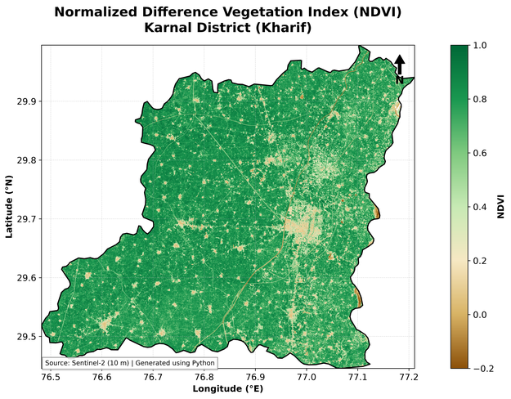
Figure 6.2: NDVI map of Karnal district, Kharif season.
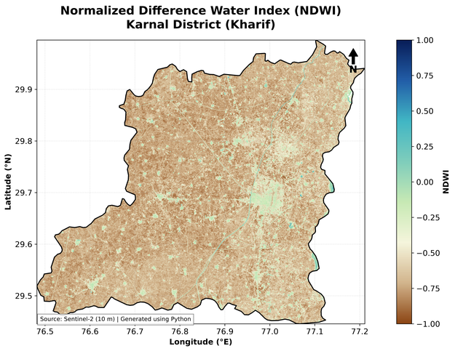
Figure 6.3: NDWI map of Karnal district, showing waterlogged and water-body areas.
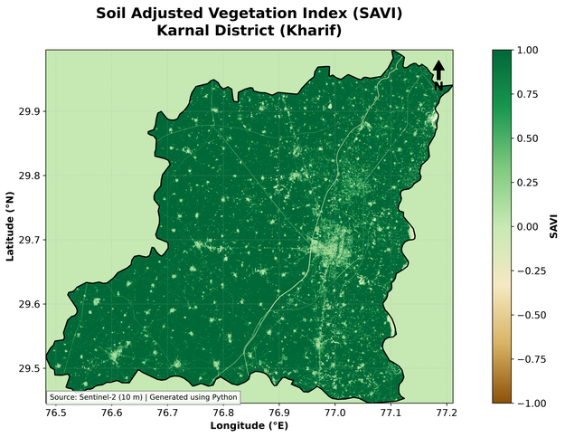
Figure 6.4: SAVI map of Karnal district, showing vegetation cover adjusted for soil background.
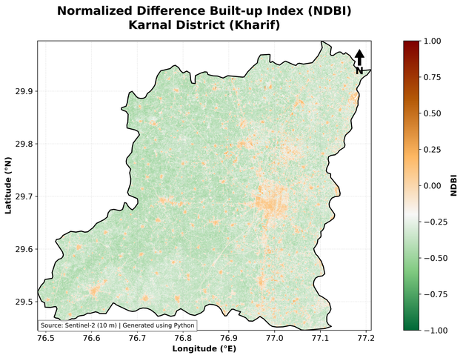
Figure 6.5: NDBI map of Karnal district, showing built-up and non-vegetated surfaces.
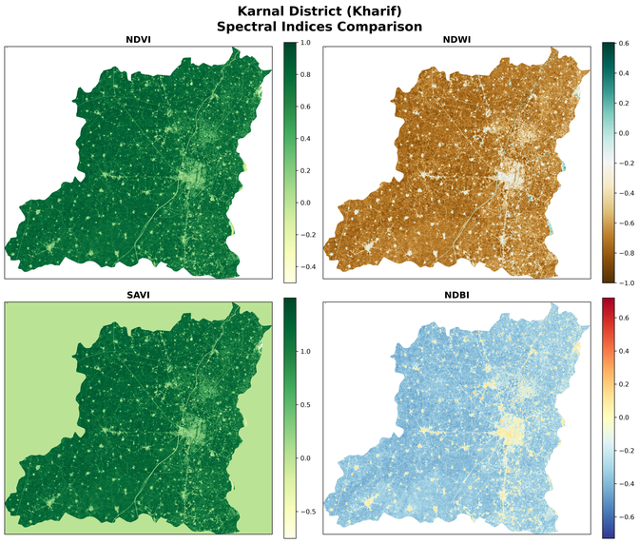
Figure 6.6: Side-by-side comparison of NDVI, NDWI, SAVI and NDBI over Karnal district.

6.4 NDVI-based Threshold Classification (Kharif)
Using the simple NDVI threshold rule described in the methodology, the following area was obtained under each vegetation class (Table 6.3).
Class | Area (ha) | Area (sq. km) | Percentage (%)
Water/Built-up | 1,894.07 | 18.94 | 0.63
Bare Soil | 12,268.68 | 122.69 | 4.11
Moderate Vegetation | 23,571.92 | 235.72 | 7.90
Dense Vegetation | 260,752.03 | 2,607.52 | 87.36
Table 6.3: NDVI threshold class areas, Kharif season.
As can be seen, close to 87% of the district area falls under the Dense Vegetation class during the Kharif season, which lines up well with the fact that Karnal is dominated by paddy cultivation in this season.
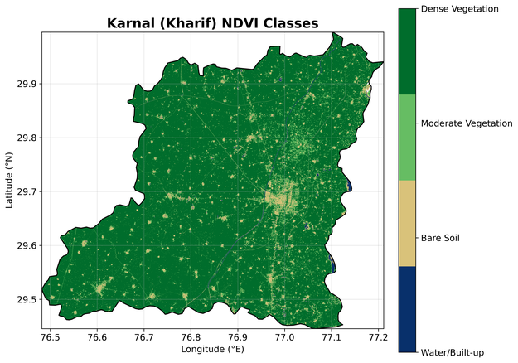
Figure 6.7: NDVI-based classified map of Karnal district.
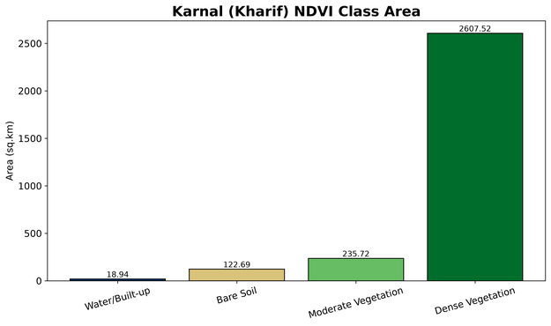
Figure 6.8: Area (sq. km) under each NDVI class.

6.5 Random Forest Model Accuracy (Kharif)
On the 30% held-out test set (730 points out of 2,432), the Random Forest model gave an overall accuracy of 78.36%. The class-wise performance is given in Table 6.4.
Class | Precision | Recall | F1-score | Support
0 – Agriculture | 0.78 | 0.86 | 0.82 | 300
1 – Water | 0.80 | 0.66 | 0.73 | 130
2 – Built-up | 0.59 | 0.53 | 0.56 | 150
3 – Dense Vegetation | 0.95 | 0.99 | 0.97 | 150
Table 6.4: Class-wise classification report, Kharif season.
Class 3 (Dense Vegetation) was picked up almost perfectly by the model, with a recall of 0.99, which was expected since dense paddy fields have a very distinct spectral signature during Kharif. Class 2, on the other hand, had the weakest performance (precision 0.59, recall 0.53), meaning this class gets mixed up with the others quite often — most likely due to the overlapping spectral response between moderately vegetated and bare/fallow patches.
The confusion matrix for the test set is given below (rows = actual class, columns = predicted class):
Actual \ Predicted | 0 | 1 | 2 | 3
0 | 258 | 10 | 28 | 4
1 | 17 | 86 | 27 | 0
2 | 56 | 11 | 79 | 4
3 | 1 | 0 | 0 | 149
Table 6.4 (contd.): Confusion matrix, Kharif season.
The biggest confusion is between class 0 and class 2 (56 points of class 2 were wrongly predicted as class 0, and 28 points of class 0 were wrongly predicted as class 2), which again suggests that these two classes share overlapping spectral characteristics in this dataset.

6.6 Feature Importance (Kharif)
The Random Forest feature importance scores (Table 6.5) show which bands and indices mattered the most for the classification.
Rank | Feature | Importance
1 | Blue (B2) | 0.1427
2 | NDWI | 0.1328
3 | SWIR-1 (B11) | 0.1070
4 | SWIR-2 (B12) | 0.1048
5 | NDVI | 0.0955
6 | NIR (B8) | 0.0890
7 | SAVI | 0.0886
8 | Red (B4) | 0.0826
9 | Green (B3) | 0.0818
10 | NDBI | 0.0752
Table 6.5: Random Forest feature importance ranking, Kharif season.
It was a bit surprising to see that the raw Blue band (B2) and NDWI came out on top instead of NDVI, which is normally treated as the most important feature in crop mapping studies. This probably happened because NDWI and the Blue band helped the model separate water and built-up surfaces very cleanly, while NDVI alone was not able to fully separate the two vegetation-related classes (moderate vs dense), which is also visible in the confusion matrix above.

6.7 Final Classified Land Cover and Area Statistics (Kharif)
After predicting the class of every pixel in the district using the trained Random Forest model, the area under each broad land cover category was calculated (Table 6.6). Since the raster used for prediction covers the full rectangular Sentinel-2 tile extent (before the final polygon clip), the total area shown here is somewhat larger than the official district area of Karnal (~2,520 sq. km).
Class | Land Cover | Pixels | Area (ha) | Area (sq. km)
0 | Agriculture | 21,259,542 | 212,595.42 | 2,125.95
1 | Water | 24,233,050 | 242,330.50 | 2,423.31
2 | Built-up | 4,205,804 | 42,058.04 | 420.58
Table 6.6: Final Random Forest area statistics, Kharif season (full raster tile).
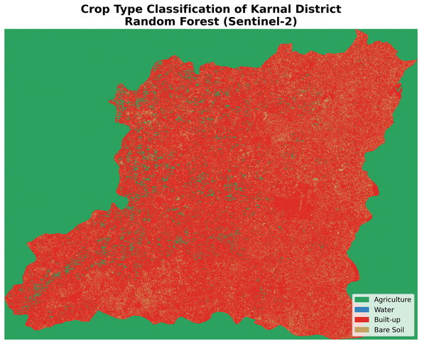
Figure 6.9: Final publication-quality classified map of Karnal district (Kharif season).
This final map and the area table should be read together with the NDVI threshold-based result in section 6.4. The NDVI-based approach, which uses the exact district boundary, shows agriculture-dominated vegetation cover of close to 87%, while this table (based on the full Random Forest prediction over the rectangular raster tile) understandably reports a larger area, since it is not limited to the precise administrative polygon.

6.8 Rabi Season Spectral Statistics
Table 6.7 gives the minimum, maximum and mean values of the ten Rabi season features (six bands plus NDVI, NDWI, NDBI, SAVI), computed over every valid pixel of the classified raster. Unlike the Kharif band table in section 6.1, these values are already scaled to 0–1 surface reflectance rather than raw digital numbers, since the Rabi export divided by the Sentinel-2 scale factor of 10,000 before the composite was built.
Feature | Minimum | Maximum | Mean
Blue (B2) | 0.0042 | 0.6932 | 0.0422
Green (B3) | 0.0111 | 0.7696 | 0.0655
Red (B4) | 0.0051 | 0.8256 | 0.0504
NIR (B8) | 0.0025 | 0.8473 | 0.3609
SWIR-1 (B11) | 0.0090 | 0.7244 | 0.1560
SWIR-2 (B12) | 0.0030 | 0.8923 | 0.0939
NDVI | -0.8245 | 0.9544 | 0.7308
NDWI | -0.8797 | 0.8873 | -0.6674
NDBI | -0.8338 | 0.8388 | -0.3771
SAVI | -0.1835 | 0.7904 | 0.5007
Table 6.7: Summary statistics of Rabi season bands and indices (0–1 reflectance scale).
The mean NDVI for the Rabi season composite (0.73) is very close to the Kharif mean (0.72), which makes sense since both composites were taken while the main crop (paddy in Kharif, wheat in Rabi) was near peak growth. This is actually a useful sanity check — if the Rabi NDVI had come out much lower, it would have suggested the January–March window was catching the fields too early or too late in the wheat growth cycle.

6.9 Rabi Season Classification Map
The trained Random Forest model was applied to every pixel of the Rabi composite, and the resulting map, shown in Figure 6.10, is dominated almost entirely by the Wheat class, with small, scattered patches of Mustard mostly near field edges and water channels, and Fallow and Urban limited to a much smaller share of the district.
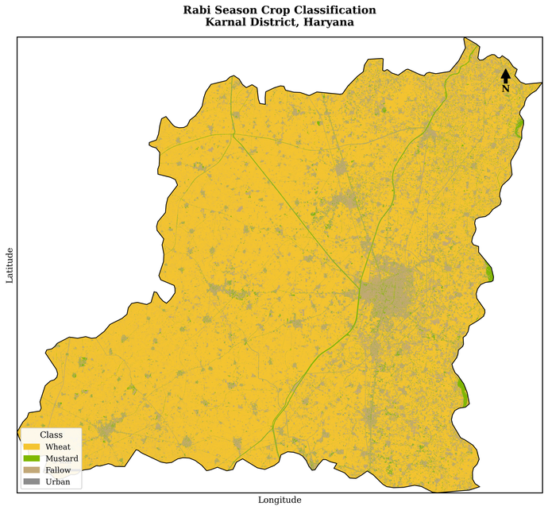
Figure 6.10: Random Forest classified map of Karnal district, Rabi season.

6.10 Random Forest Model Accuracy (Rabi)
On the 25% held-out test set (496 points out of 1,982), the Rabi Random Forest model gave an overall accuracy of 67.54%, noticeably lower than the 78.36% obtained for Kharif. The class-wise performance is given in Table 6.8.
Class | Precision | Recall | F1-score | Support
0 – Wheat | 0.72 | 0.79 | 0.75 | 250
1 – Mustard | 0.72 | 0.60 | 0.66 | 113
2 – Fallow | 0.53 | 0.51 | 0.52 | 125
3 – Urban | 0.75 | 0.75 | 0.75 | 8
Table 6.8: Class-wise classification report, Rabi season.
Just like in the Kharif model, the Fallow class (2) is the weakest performer (precision 0.53, recall 0.51). Wheat (0), the dominant class, is recognised reasonably well (recall 0.79), and Urban (3) actually looks strong on paper (0.75 precision/recall) but that number should be taken with a pinch of salt given it is based on only 8 test points.
The confusion matrix for the test set is given below (rows = actual class, columns = predicted class):
Actual \ Predicted | Wheat | Mustard | Fallow | Urban
Wheat | 197 | 15 | 37 | 1
Mustard | 25 | 68 | 20 | 0
Fallow | 49 | 11 | 64 | 1
Urban | 2 | 0 | 0 | 6
Table 6.8 (contd.): Confusion matrix, Rabi season.
The clearest confusion here is between Wheat and Fallow (37 Wheat points predicted as Fallow, and 49 Fallow points predicted as Wheat). This is a fairly believable mix-up — wheat fields early in the growth cycle, or fields that were only partially sown at the time of the composite, can look spectrally quite close to bare/fallow land, so the model ends up guessing wrong at that boundary fairly often.
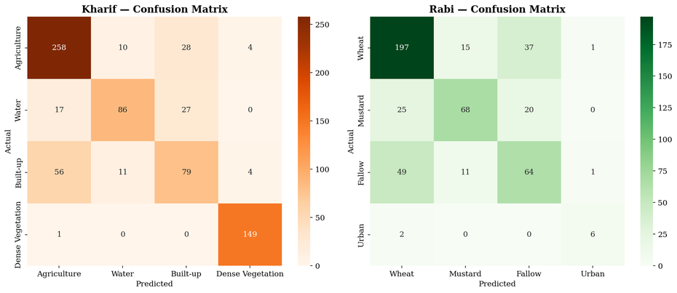
Figure 6.11: Confusion matrices for the Kharif (left) and Rabi (right) Random Forest models, shown side by side for comparison.

6.11 Feature Importance (Rabi)
Table 6.9 gives the Rabi season feature importance ranking from the Random Forest model.
Rank | Feature | Importance
1 | SWIR-1 (B11) | 0.1314
2 | SWIR-2 (B12) | 0.1270
3 | NDBI | 0.1153
4 | SAVI | 0.1069
5 | Blue (B2) | 0.1033
6 | NIR (B8) | 0.0949
7 | NDWI | 0.0942
8 | NDVI | 0.0849
9 | Green (B3) | 0.0784
10 | Red (B4) | 0.0638
Table 6.9: Random Forest feature importance ranking, Rabi season.
The Rabi model leaned much more heavily on the two SWIR bands and NDBI than the Kharif model did, which is an interesting seasonal difference. During winter, the main separation the model has to make is between actively growing wheat, drying fallow soil and built-up land — all of which show up quite differently in the SWIR region because of moisture and surface roughness differences — while in the monsoon season, the dominant separation was more about water versus dense green canopy, which leaned more on NDWI and the Blue band instead. NDVI, again, ends up mid-table rather than at the top in either season.
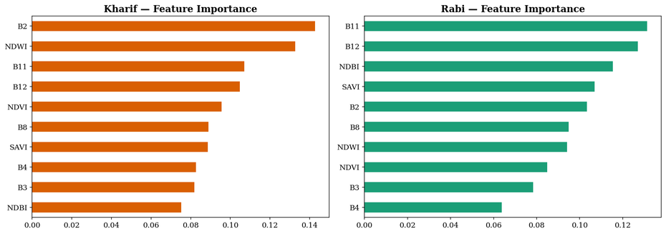
Figure 6.12: Feature importance for the Kharif (left) and Rabi (right) Random Forest models, side by side.

6.12 Seasonal Accuracy Comparison
Figure 6.13 puts the two overall accuracy figures side by side. The roughly 11-point drop from Kharif to Rabi is consistent with what showed up in the confusion matrices and the training data itself: the Rabi training set is smaller (1,982 vs 2,432 points), more imbalanced (only 30 points for the smallest class before relabeling), and the underlying class labels for Rabi are a reinterpretation of the original Kharif training polygons rather than a fresh, field-verified ground truth, so some extra label noise is expected.
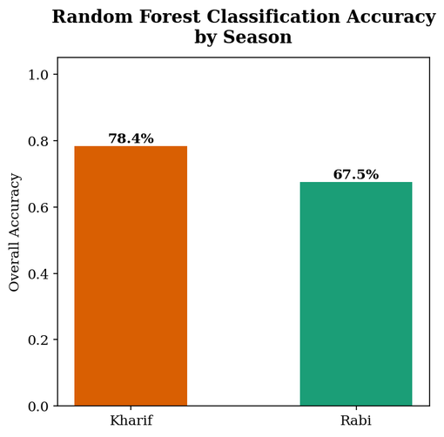
Figure 6.13: Overall Random Forest classification accuracy, Kharif vs Rabi season.

6.13 Kharif vs Rabi Classification Comparison
Figure 6.14 shows both seasonal classifications side by side over the same district outline. The contrast is quite striking visually — the Kharif map is almost entirely blue (Water/paddy-flooded fields), while the Rabi map is almost entirely gold (Wheat), which on its own is a fairly direct illustration of the rice-wheat rotation this district is known for.
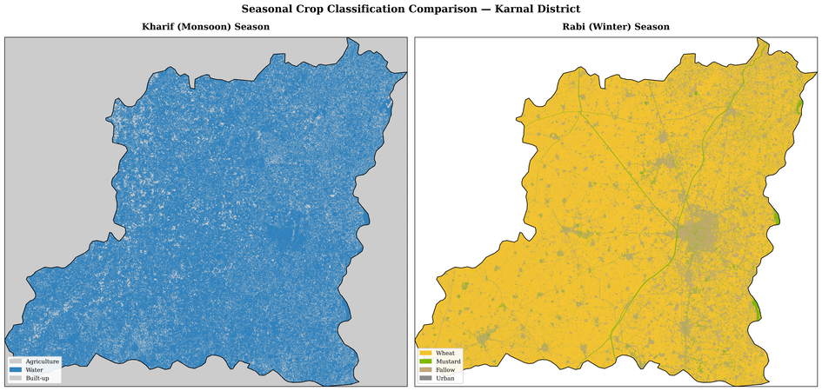
Figure 6.14: Side-by-side seasonal crop classification comparison, Karnal district.

6.14 Class-wise Area Comparison
Table 6.10 and Figure 6.15 compare the area under each class in the two seasons, computed independently over each season's own full raster extent (these are not restricted to the district-overlap region used later in the rotation analysis, so the totals here are a little larger than the true district area).
Class | Kharif (ha) | Rabi (ha)
Agriculture | 184,630.9 | –
Built-up | 36,525.8 | –
Water | 210,454.7 | –
Wheat | – | 196,594.7
Fallow | – | 47,471.1
Mustard | – | 14,502.9
Urban | – | 723.6
Table 6.10: Class-wise area comparison, Kharif vs Rabi season.
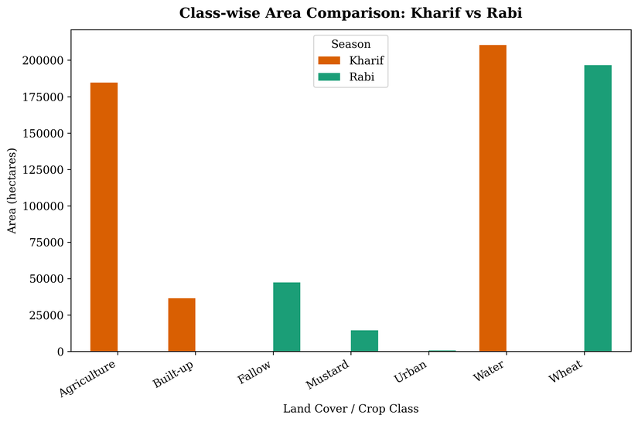
Figure 6.15: Class-wise area comparison chart, Kharif vs Rabi season.

6.15 Kharif → Rabi Crop Rotation Analysis
This is really the central result of the second half of the project. After aligning the two classified rasters onto the same grid and restricting the comparison to pixels that are valid (within the district boundary) in both seasons, the cross-tabulated area works out to about 2,593 sq. km, which lines up well with Karnal's official district area of ~2,520 sq. km — a good sign that the overlap comparison is behaving sensibly, unlike the two independent, unclipped area tables in section 6.14.
Kharif \ Rabi | Fallow (ha) | Mustard (ha) | Urban (ha) | Wheat (ha)
Agriculture | 611.3 | 143.2 | 2.2 | 11,709.3
Built-up | 7,396.3 | 2,271.0 | 139.3 | 26,719.3
Water | 39,463.6 | 12,088.7 | 582.1 | 158,166.2
Table 6.11: Kharif → Rabi crop rotation matrix (hectares).
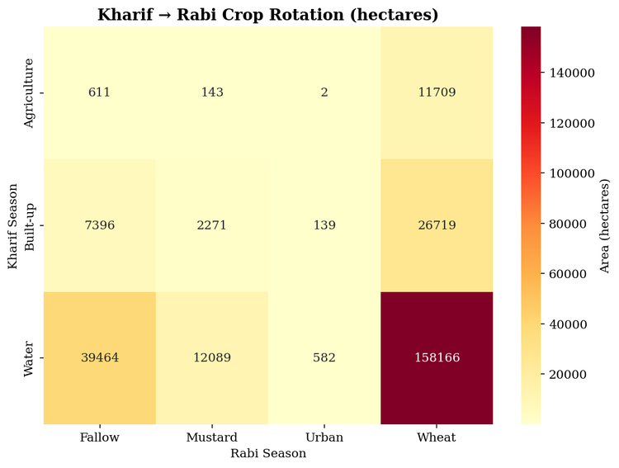
Figure 6.16: Heatmap of the Kharif → Rabi rotation matrix, showing area (hectares) transitioning between each class pair.
The single biggest transition by a wide margin is Water → Wheat, at 158,166.2 ha, which is well over half the entire cross-tabulated area. In this dataset, the "Water" label in Kharif is really standing in for flooded, actively-transplanted paddy fields rather than permanent water bodies, so a Water → Wheat pixel is best read as classic rice-wheat rotation land: flooded for paddy in the monsoon, drained and sown with wheat by winter. The Built-up → Wheat (26,719.3 ha) and Agriculture → Wheat (11,709.3 ha) transitions are smaller but point the same way — land that looked non-paddy or lightly cropped in Kharif is still picked up as wheat by Rabi, which is plausible for fields that were fallow or under a shorter Kharif crop. The Water → Fallow transition (39,463.6 ha) is also sizeable and represents paddy land that was left unplanted through the winter rather than carried into a second crop, i.e. the single-cropped share of the rice belt.
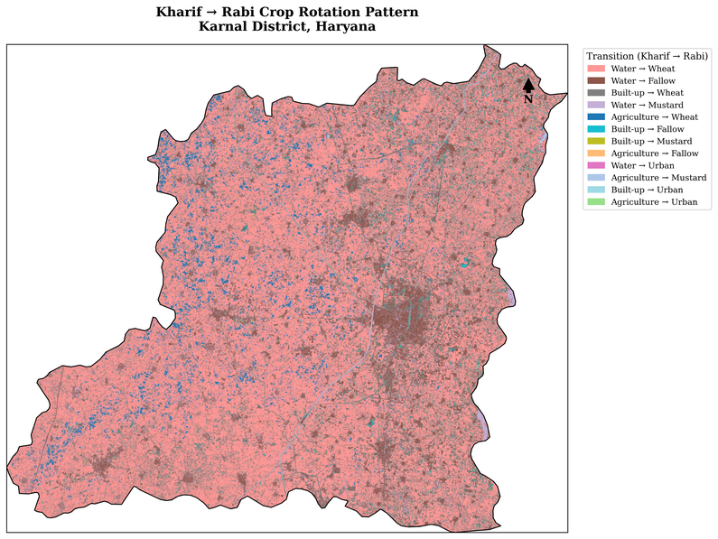
Figure 6.17: Spatial map of the Kharif → Rabi rotation pattern across Karnal district, coloured by transition type.
Read together, Table 6.11 and Figure 6.17 give a rough first-cut answer to the original cropping-intensity question from the project brief: the great majority of the agricultural extent in Karnal behaves as double-cropped (paddy followed by wheat) land, with a meaningful but clearly smaller share sitting fallow over winter, and only small, scattered pockets going to mustard instead of wheat.

6.16 Multi-Season Summary
Figure 6.18 brings the Kharif classification, the Rabi classification, the rotation map and the class-wise area chart together into one summary panel.
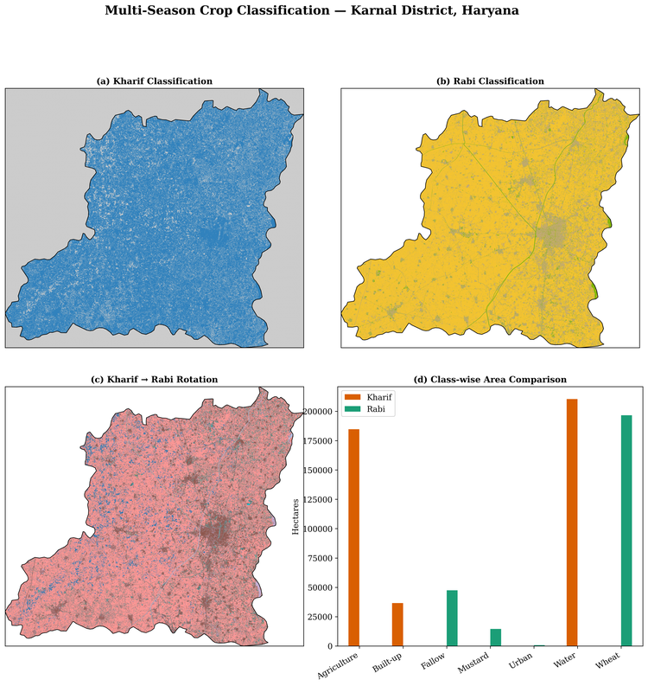
Figure 6.18: Multi-season summary panel — (a) Kharif classification, (b) Rabi classification, (c) Kharif → Rabi rotation, (d) class-wise area comparison.

7. Conclusion
This project set out to classify crop and land cover for Karnal district using Sentinel-2 imagery and a Random Forest classifier, and then to push that further into an actual multi-season, Kharif-to-Rabi comparison — the part that was left incomplete in the first phase of the work. Both goals were achieved. The Kharif model reached 78.36% overall accuracy on its held-out test set, and the Rabi model, trained the same way but on a smaller and more imbalanced set of training points, reached 67.54%. Both numbers are reasonable for a first attempt with introductory machine learning on a four-class problem, and the pattern of errors in both seasons makes agronomic sense: the model is excellent at recognising the dominant, spectrally distinct class in each season (Dense Vegetation/paddy in Kharif at 99% recall, Wheat in Rabi at 79% recall), and weakest at separating the more ambiguous, transitional classes — moderately vegetated versus bare/built-up land in Kharif, and early-stage wheat versus fallow land in Rabi.
The main achievement of the second phase, though, is the rotation analysis in section 6.15. By aligning the two classified rasters and cross-tabulating them pixel by pixel, the workflow was able to show, in actual hectares, that most of Karnal's cropped area follows the classic rice-wheat double-cropping pattern (Water → Wheat, 158,166 ha), with a smaller but still substantial share of paddy land left fallow through winter (Water → Fallow, 39,464 ha) rather than carried into a second crop. This is exactly the kind of single-cropping/double-cropping/fallow-land breakdown that the original project brief asked for, and it would not have been possible from either seasonal classification looked at on its own.
A few limitations are worth being upfront about. The Rabi training labels were built by re-interpreting the original Kharif training polygon locations rather than from fresh, field-verified Rabi ground truth, which almost certainly explains part of the accuracy gap between the two seasons and should be treated as an approximation rather than a certainty, especially for the smaller Mustard and Urban classes. The area figures in section 6.14 also come from each season's own unclipped raster tile and are not directly comparable to one another or to the district's official area — only the overlap-restricted rotation matrix in section 6.15 can really be trusted for absolute hectare figures. Finally, both models still work with only four broad classes each; splitting "Agriculture"/"Wheat" into more specific crop types (basmati vs non-basmati paddy, or wheat vs sugarcane) would make the cropping-pattern output considerably more useful in practice.
Overall, multi-season Sentinel-2 data in Python — building seasonal composites, deriving and interpreting different vegetation, water and built-up indices, training and honestly evaluating a supervised classifier for two separate seasons, and then combining the two classifications into a genuine cropping-pattern and rotation product rather than stopping at a single-season map. These are core skills for agricultural remote sensing, and the same pixel-alignment-and-cross-tabulation approach used here for the rotation analysis can be extended fairly directly to longer multi-year time series for cropping-intensity monitoring, fallow-land tracking and precision agriculture applications.

8. References
- Hegde, A. S., Ranjan, R., & Hegde, S. S. (2024). Crop classification and cropping intensity estimation using geospatial technology in the upper Gangetic plains of Uttarakhand. Heliyon, 10(22).
- Panigrahy, S., Upadhyay, G., & Ray, S. S. (2010). Mapping of cropping system for the Indo-Gangetic Plain using multi-date SPOT NDVI-VGT data. Journal of the Indian Society of Remote Sensing.
- Saad El Imanni, H., El Harti, A., Hssaisoune, M., Velastegui-Montoya, A., Elbouzidi, A., Addi, M., ... & El Hachimi, J. (2022). Rapid and automated approach for early crop mapping using Sentinel-1 and Sentinel-2 on Google Earth Engine.
- Sonia, Ghosh, T., Gacem, A., Alsufyani, T., Alam, M. M., Yadav, K. K., ... & Cabral-Pinto, M. M. (2022). Geospatial evaluation of cropping pattern and cropping intensity using multi temporal harmonized product of Sentinel-2 dataset on Google Earth engine. Applied Sciences, 12(24), 12583.
- Sun, C., Bian, Y., Zhou, T., & Pan, J. (2019). Using of multi-source and multi-temporal remote sensing data improves crop-type mapping in the subtropical agriculture region.
- Yi, Z., Jia, L., & Chen, Q. (2020). Crop classification using multi-temporal Sentinel-2 data in the Shiyang River Basin of China. Remote Sensing, 12(24), 4052.
- Khan, A., Patil, C. H., Vibhute, A. D., & Mali, S. (2026). Crop type classification using Sentinel-2 images and AI-enabled methods for precision agriculture. Applied Geomatics, 18(1), 8.

