- select count(created_date),customer_id from SubscriptionData
group by customer_id having count(created_date) >1 ---customers re-taking subscritpion
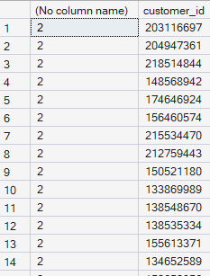
- select count(canceled_date) from SubscriptionData
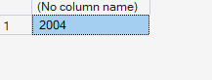
- select min(subscription_cost) from SubscriptionData

select max(subscription_cost) from SubscriptionData
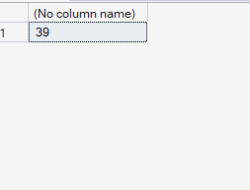

select count(created_date) from SubscriptionData where canceled_date is null
- 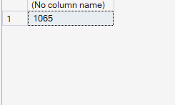[[[the retention no]]]
- select count(created_date) from SubscriptionData where canceled_date is not null
- 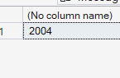 [[the non-retention]]
- with cte as (select count(created_date) as cnt from SubscriptionData)

- select
- cast(round(count(created_date)*100.0/(select cnt from cte),3) as decimal(5,3))as rate
- from SubscriptionData where canceled_date is not null
- 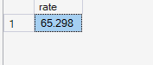[[non-retention rate]]
- with cte as (select count(created_date) as cnt from SubscriptionData)

- select
- cast(round(count(created_date)*100.0/(select cnt from cte),3) as decimal(5,3))as rate
- from SubscriptionData where canceled_date is null
- 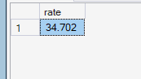[[retention rate]]

- KPI 1: What month has the highest subscriber retention, the lowest retention?
- SELECT
- FORMAT(created_date, 'yyyy-MM') AS signup_month,
- COUNT(*) AS total_signups,
- -- Use NULL for the else condition so COUNT() skips it, and multiply by 100.0
- CAST(COUNT(IIF(canceled_date IS NULL, 1, NULL)) * 100.0 / COUNT(*) AS DECIMAL(6,3)) AS retention_rate
- FROM SubscriptionData
- GROUP BY FORMAT(created_date, 'yyyy-MM')
- ORDER BY retention_rate desc ;
- 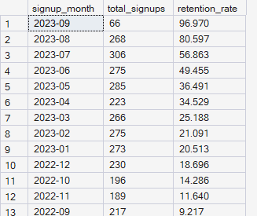

- so 2023-09 has the highest retention rate and 2022-09 has the lowest retention
_______________________________________________________________________________
2>.how the trend went as month went on::

SELECT
FORMAT(created_date, 'yyyy-MM') AS signup_month,
COUNT(*) AS total_signups,
-- Use NULL for the else condition so COUNT() skips it, and multiply by 100.0
CAST(COUNT(IIF(canceled_date IS NULL, 1, NULL)) * 100.0 / COUNT(*) AS DECIMAL(6,3)) AS retention_rate
FROM SubscriptionData
GROUP BY FORMAT(created_date, 'yyyy-MM')
ORDER BY signup_month ;
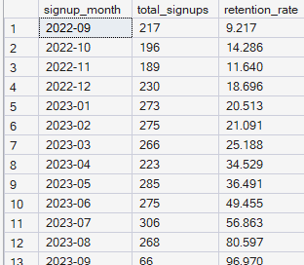 the trend of subscriotion retention increased manifolds and it only increased
__________________________________________________________________________________

3. select count(*) as manifold_subcriber from SubscriptionData

where
datediff(day,created_date,isnull(canceled_date,getdate()))>=150 // find no of subscriber who has taken >=5 months subcription





