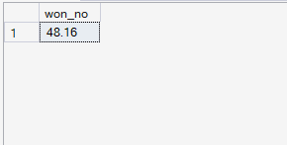
-- deal Won percenatge
select
cast
(count(*)*100.0 /(select count(*) from sales_pipeline)
as decimal(4,2))
as won_no
from sales_pipeline where deal_stage= 'Won'

-- win percentage calculating per product

select product,
count(case when deal_stage='Won' then 1 end)as won_cnt,
count(opportunity_id) as total_cnt,
CAST(
COUNT(CASE WHEN deal_stage = 'Won' THEN 1 END) * 100.0 / COUNT(*)
AS DECIMAL(6,2)
) AS win_rate_percentage
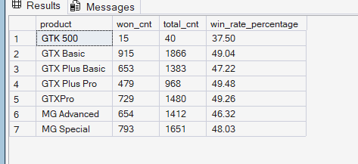
from sales_pipeline
group by product order by product

-- kpi 4>>>not win percentage calculating per product

select product,
count(case when deal_stage not like 'Won' then 1 end)as not_won_cnt,
count(opportunity_id) as total_cnt,
CAST(
COUNT(CASE WHEN deal_stage not like 'Won' THEN 1 END) * 100.0 / COUNT(*)
AS DECIMAL(6,2)
) AS not_win_rate_percentage

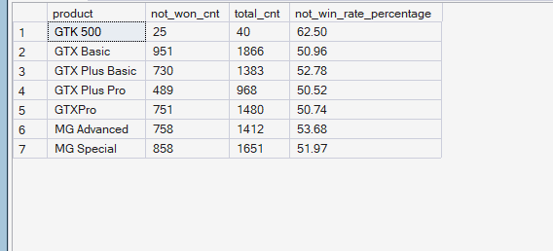
from sales_pipeline
group by product order by product

--kpi2>> win percentage calculatig per sales_agent

select sales_agent,
count(case when deal_stage = 'Won' then 1 end)as won_cnt,
count(opportunity_id) as total_cnt,
CAST(
COUNT(CASE WHEN deal_stage = 'Won' THEN 1 END) * 100.0 / COUNT(*)
AS DECIMAL(6,2)
) AS win_rate_percentage

from sales_pipeline
group by sales_agent order by win_rate_percentage asc
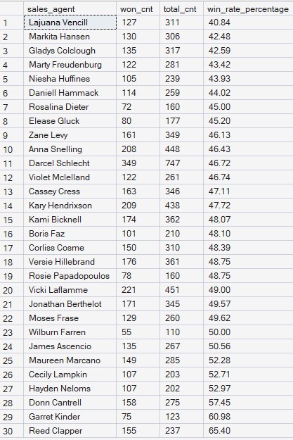

-- trend of winning as we go from 2016-10-20 to 2017-12-27,,day by day
select engage_date,cnt_won from (
select engage_date,
count(*) over(partition by engage_date ) as cnt_won,
dense_rank() over(partition by engage_date order by close_date) as cnt_rnk
from sales_pipeline

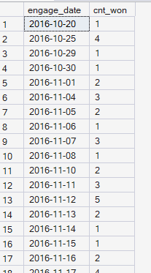
where deal_stage='Won') E

where cnt_rnk=1
order by engage_date

-- trend of winning as we go from 2016-10 to 2017-12 ,, month by month

select engage_date,sum(cnt_won) as WON from (
select FORMAT(engage_date, 'yyyy-MM') as engage_date,
count(*) over(partition by FORMAT(engage_date, 'yyyy-MM') ) as cnt_won,
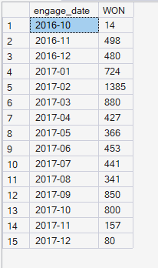
dense_rank() over(partition by FORMAT(engage_date, 'yyyy-MM') order by close_date) as cnt_rnk
from sales_pipeline

where deal_stage='Won')E

where cnt_rnk=1
group by engage_date
order by engage_date

--kp1>> How is each sales team performing compared to the rest?
SELECT
T.manager AS TEAM,
COUNT(CASE WHEN S.deal_stage = 'Won' THEN 1 END) AS won_deals,
COUNT(*) AS total_team_deals,
CAST(
COUNT(CASE WHEN S.deal_stage = 'Won' THEN 1 END) * 100.0 / COUNT(*)
AS DECIMAL(5,2)
) AS win_rate_percentage
FROM sales_pipeline S
JOIN sales_teams T ON S.sales_agent = T.sales_agent
GROUP BY T.manager
ORDER BY win_rate_percentage DESC; 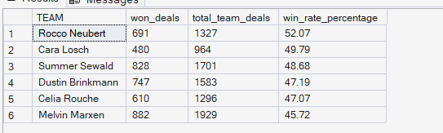

-- kpi3>>,,Are there any quarter-over-quarter trends?

SELECT
CONCAT(YEAR(engage_date), '-Q', DATEPART(QUARTER, engage_date)) AS engage_quarter,
COUNT(*) AS WON
FROM sales_pipeline
WHERE deal_stage = 'Won'
AND engage_date IS NOT NULL
GROUP BY
CONCAT(YEAR(engage_date), '-Q', DATEPART(QUARTER, engage_date)),
YEAR(engage_date),
DATEPART(QUARTER, engage_date)
ORDER BY
YEAR(engage_date),
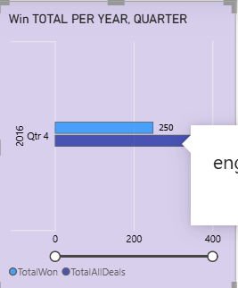
DATEPART(QUARTER, engage_date);

