- What were the most popular baby names of each decade?
-- for 1980 to 2010
with sub as(

select * ,
case WHEN year BETWEEN 1980 AND 1989 THEN '1980-1989'
WHEN year BETWEEN 1990 AND 1999 THEN '1990-1999'
WHEN year BETWEEN 2000 AND 2010 THEN '2000-2010'
end as decade,

dense_rank()over(
partition by
CASE
WHEN year BETWEEN 1980 AND 1989 THEN 1
WHEN year BETWEEN 1990 AND 1999 THEN 2
WHEN year BETWEEN 2000 AND 2010 THEN 3
end
order by births desc
) as rnk
from names
where year between 1980 AND 2010
)
select * from sub where rnk=1

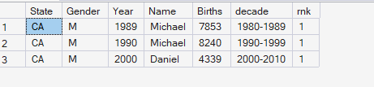

- trend of highest no went on over time,,, (ie, for each year)..highest..
-- for 1980 to 2010
with sub as(

select * ,
case WHEN year BETWEEN 1980 AND 1989 THEN '1980-1989'
WHEN year BETWEEN 1990 AND 1999 THEN '1990-1999'
WHEN year BETWEEN 2000 AND 2010 THEN '2000-2010'
end as decade,

dense_rank()over(
partition by year order by births desc
) as rnk
from names
where year between 1980 AND 2010
)
select * from sub where rnk=1
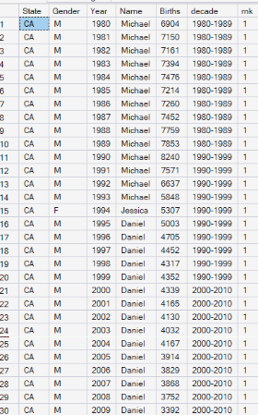

- tWhich baby names had the biggest jumps and drops in popularity?
-- for 1980 to 2010
with sub as(

select * ,
case WHEN year BETWEEN 1980 AND 1989 THEN '1980-1989'
WHEN year BETWEEN 1990 AND 1999 THEN '1990-1999'
WHEN year BETWEEN 2000 AND 2010 THEN '2000-2010'
end as decade,

dense_rank()over(
partition by year order by births desc
) as rnk
from names
where year between 1980 AND 2010
)

select name,year ,sum(births) as tot_births from (select * from sub where rnk<=6 )s
group by name, year order by year asc, tot_births desc
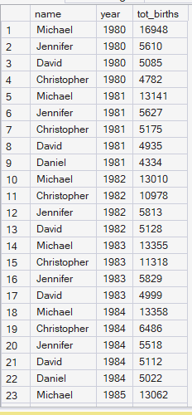

- Are there differences in baby name popularity based on the states in the United States?
-- for 1980 to 2010
with sub as(

select * ,
case WHEN year BETWEEN 1980 AND 1989 THEN '1980-1989'
WHEN year BETWEEN 1990 AND 1999 THEN '1990-1999'
WHEN year BETWEEN 2000 AND 2010 THEN '2000-2010'
end as decade,

dense_rank()over(
partition by year,state order by births desc
) as rnk
from names
where year between 1980 AND 2010
)
select * from sub where rnk=1

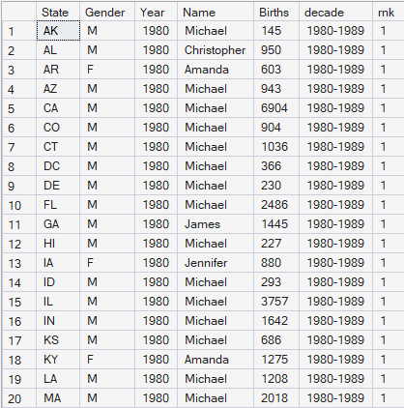

- Are there differences in baby name popularity based on the regions in the United States?
-- for 1980 to 2010
with state_to_region as(

select * ,CASE
WHEN state IN ('CT','ME','MA','NH','RI','VT','NJ','NY','PA') THEN 'Northeast'
WHEN state IN ('IL','IN','MI','OH','WI','IA','KS','MN','MO','NE','ND','SD') THEN 'Midwest'
WHEN state IN ('DE','FL','GA','MD','NC','SC','VA','DC','WV','AL','KY','MS','TN','AR','LA','OK','TX') THEN 'South'
WHEN state IN ('AZ','CO','ID','MT','NV','NM','UT','WY','AK','CA','HI','OR','WA') THEN 'West'
END AS region,
case WHEN year BETWEEN 1980 AND 1989 THEN '1980-1989'
WHEN year BETWEEN 1990 AND 1999 THEN '1990-1999'
WHEN year BETWEEN 2000 AND 2010 THEN '2000-2010'
end as decade
from names WHERE year BETWEEN 1980 AND 2010

),
regional_totals as (
select region, decade, name, sum(births)as total_births from state_to_region
WHERE region IS NOT NULL
group by region,decade, name

)
,
ranked_regional as(
select *,
DENSE_RANK() over(partition by region,decade order by total_births desc) as rnk from
regional_totals

)

select * from ranked_regional where rnk<=6 ORDER BY region, decade, total_births DESC

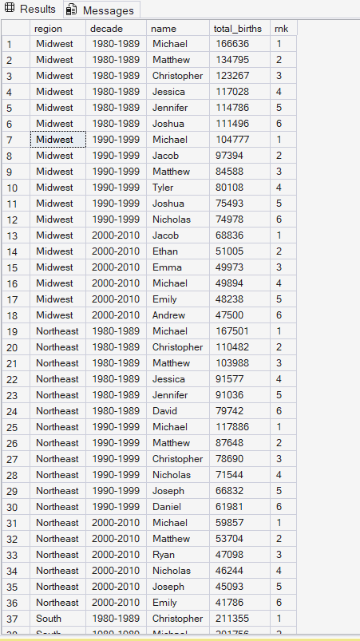

- Are there differences in which names are given to boys vs girls vs both over time?

with sub as(

select * ,
case WHEN year BETWEEN 1980 AND 1989 THEN '1980-1989'
WHEN year BETWEEN 1990 AND 1999 THEN '1990-1999'
WHEN year BETWEEN 2000 AND 2010 THEN '2000-2010'
end as decade from names),
sub2 as(
select * ,
dense_rank()over(
partition by year,gender order by births desc
) as rnk
from sub
where year between 1980 AND 2010
)
select name,gender,year,sum(births) from sub2 where rnk<=2 group by gender, name,year

