AI Coding Agents:
Failure Modes & Reliable Architecture
A practical engineering guide to context, structure, verification and multi-agent workflows
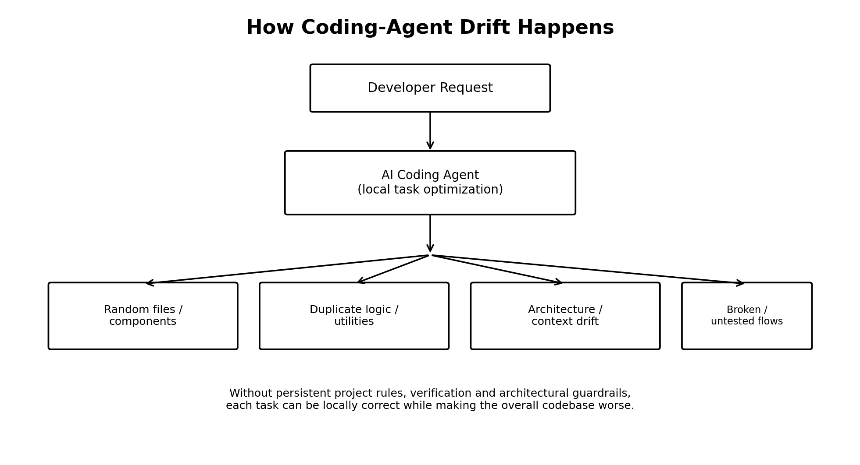
Figure 1 — Local task optimization can create long-term codebase drift.

1. The Core Problem
Modern coding agents can inspect repositories, edit multiple files, run commands, write tests and reason about implementation details. Their main weakness is not usually the ability to generate code; it is maintaining the long-term integrity of a software system across many independent tasks.
A useful mental model is: the agent optimizes the task currently in front of it, while the engineering team must optimize the health of the whole codebase.

2. Major Problems Developers Face

Context loss and context drift
The agent gradually loses earlier architectural decisions, constraints and business rules. Later changes can be locally reasonable but inconsistent with the original system design.

Random component and file creation
The agent creates new components, hooks, utilities or folders instead of discovering and reusing existing abstractions.

Duplicate logic
Similar formatting, validation, API, state or database logic is implemented in multiple places.

Architecture degradation
Business logic migrates into UI components or routes, boundaries become unclear, and layers become tightly coupled.

Overengineering
Simple requirements become large abstraction trees, factories, managers and wrappers that provide little value.

Underengineering
The opposite failure: everything is placed in one route/component/function with little separation of concerns.

Unnecessary refactoring
A small requested change causes unrelated files, styling, configuration or shared components to be rewritten.

Scope creep
The agent adds features or improvements that were not requested, increasing the review surface and regression risk.

Breaking existing functionality
A shared component, API or utility is changed without fully checking all of its consumers.

Dependency sprawl
The agent adds libraries that overlap with existing dependencies or are unnecessary for the task.

Version mismatch
Generated code may target a different version of a framework or library than the repository actually uses.

API contract mismatch
Frontend, backend and external integrations can disagree on names, types, status codes or response shapes.

Database/schema drift
Database models, migrations, backend assumptions and frontend types can fall out of sync.

Security mistakes
Agents can accidentally expose secrets, weaken authorization, create unsafe input handling or introduce insecure configuration.

Environment/configuration breakage
Changes to environment variables, Docker, build configuration or deployment files can break other environments.

False completion
The agent may report success after code generation without running meaningful tests, type checks, builds or integration checks.

Weak tests
Generated tests can verify superficial behavior instead of the important business behavior.

Test manipulation
When a test fails, an agent can sometimes change the test instead of fixing the underlying implementation.

Hallucinated APIs or files
The agent may assume functions, files or APIs exist without verifying them in the repository or installed package version.

Business-logic misunderstanding
Technically valid code can still be wrong when implicit business rules were not captured in the requirements.

Premature implementation
Large tasks may be coded before the repository, dependencies, architecture and risks are properly inspected.

Multi-agent conflicts
Two agents can make incompatible assumptions or edit overlapping files, creating coordination and merge problems.

Large and noisy Git diffs
AI can change hundreds of lines for a small feature, making it difficult to distinguish necessary changes from accidental ones.

Documentation drift
README files, architecture docs and API documentation can become inconsistent with the implementation.

Workarounds instead of root-cause fixes
The agent may hide a problem with a timeout, conditional or workaround instead of correcting the underlying architecture.

3. Six Categories of Failure
Category | Typical failures | Primary control
Context | Drift, forgotten decisions, inconsistent assumptions | Persistent project context + focused documentation
Architecture | Random files, duplication, poor abstractions | Architecture rules + reuse-first policy
Consistency | API/type/schema/dependency mismatches | Contracts, type checking and integration tests
Safety | Secrets, permissions, insecure changes | Least privilege + security checks + human review
Verification | Weak tests, false completion, regressions | Automated checks + definition of done
Coordination | Agent conflicts, huge diffs, unclear ownership | Scoped tasks + Git discipline + review

4. A Reliable Agent Architecture
The answer is not simply a better model. A reliable system surrounds the model with project context, rules, repository state, permissions and automated verification.
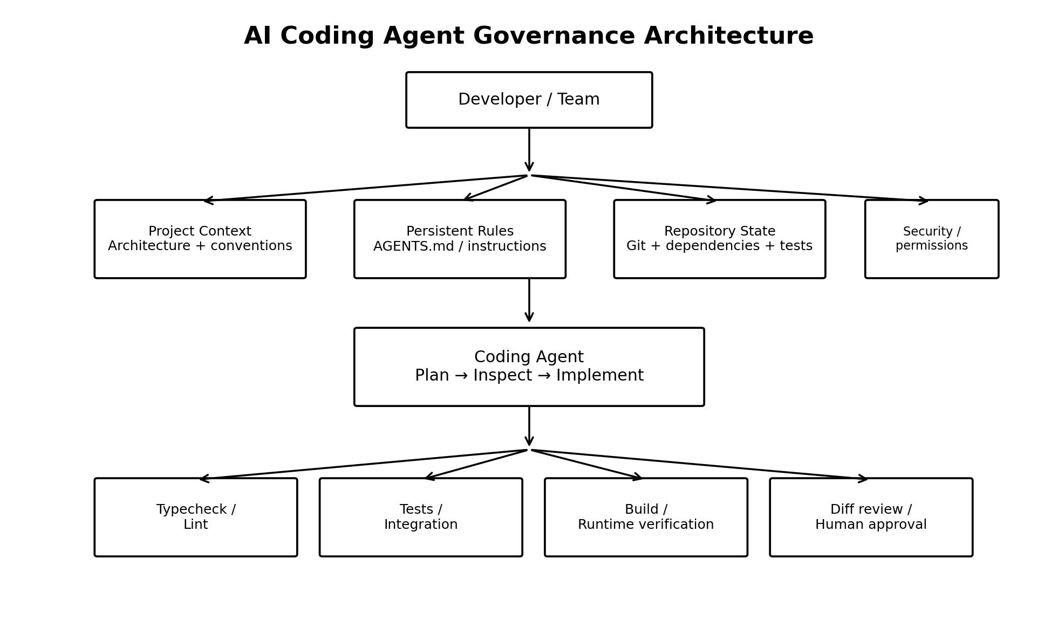
Figure 2 — Governance layers that keep an agent aligned with the codebase.

5. What the Project Should Provide to the Agent
- Project rules: Short, explicit rules covering structure, naming, dependencies, security and what the agent must not change.
- Architecture map: A concise description of major modules, ownership boundaries and data flow.
- Source of truth: Clear instructions for where schemas, API contracts, shared components and configuration live.
- Definition of done: Required type checks, linting, tests, builds and runtime verification.
- Change boundaries: For each task, define what may be changed and prohibit unrelated refactoring.
- Repository feedback: Git diff, test output, build output and compiler errors should be treated as evidence, not assumptions.

6. Ideal Agent Workflow
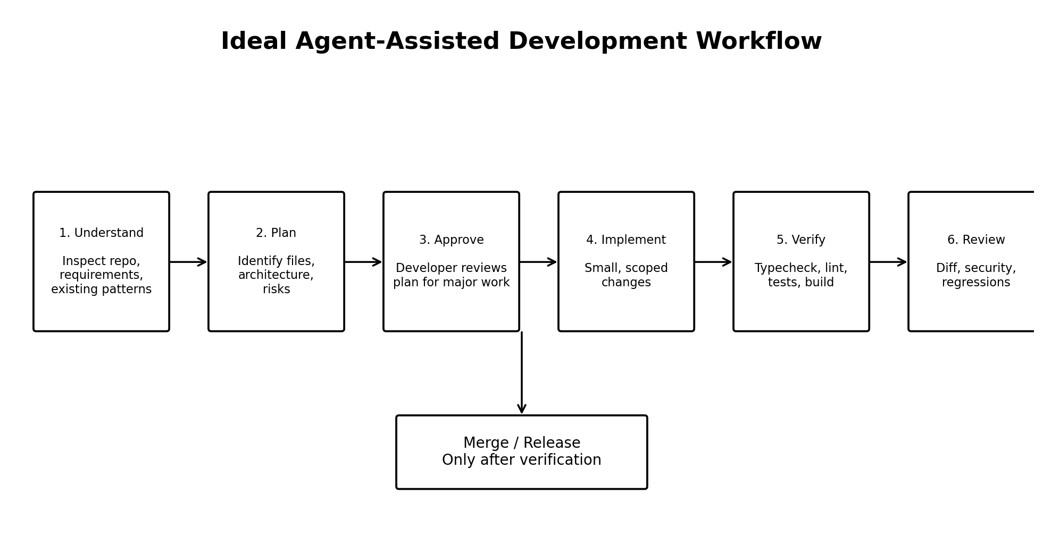
Figure 3 — A controlled workflow for agent-assisted development.

7. Practical Rules for Any Coding Agent
- Inspect before editing. Search the repository and identify existing patterns before creating new code.
- Reuse before creating. If a component, utility, hook, service or type already exists, extend or reuse it.
- Keep changes scoped. Do not refactor unrelated areas unless explicitly requested.
- Plan large changes first. Separate architectural decisions from implementation when the task is substantial.
- Never trust a green-looking UI alone. Run type checks, linting, tests and production builds as appropriate.
- Treat tests as specifications, not obstacles. Fix the implementation when behavior is wrong rather than weakening the test.
- Protect secrets and configuration. Never place private credentials in source code or client bundles.
- Check installed versions. Read package manifests and existing usage before using framework APIs.
- Keep Git diffs reviewable. Small, coherent commits make AI-generated changes safer.
- Use human approval for architectural changes, migrations, security-sensitive changes and broad refactors.
- Use multiple agents carefully. Give each agent a clear role and avoid simultaneous edits to the same files.

8. The Key Principle
A coding agent should not be treated as the architect of the entire project by default.
The model is responsible for reasoning and implementation. The surrounding engineering system is responsible for preserving architecture, enforcing constraints and proving that the resulting software still works.
The strongest setup therefore looks like: Context → Plan → Implement → Verify → Review → Merge. This pattern applies regardless of whether the underlying agent is Cursor, Claude Code, Codex, Gemini CLI, OpenCode, Windsurf, Copilot, Cline, Roo Code, Antigravity or another coding agent.

