**NATIONAL HELPLINE**

Bayer launched a national helpline for farmers. Farmers can place a toll free call on Bayer’s national helpline number 1800-120-4049 or 1800-200-6321 from both landline and mobile phones. The helpline will be operational between 09:00 am – 06:00 pm every Monday to Saturday. Calls will be answered by local agri-experts from 10 call centers located in Andhra Pradesh, Gujarat, Jharkhand, Karnataka, Madhya Pradesh, Odisha, Punjab, Tamil Nadu, Maharashtra and Uttar Pradesh.

**NGOs TO SUPPORT THE FARMERS**

**1. Haritika**

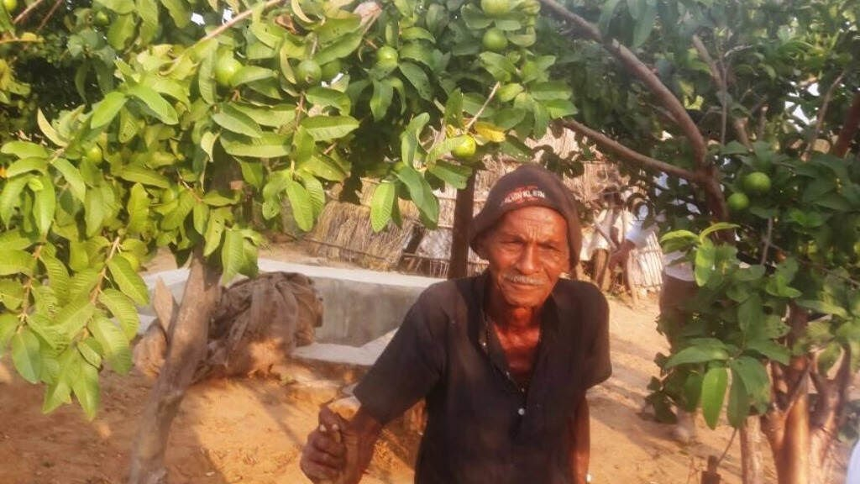

[Haritika](https://www.giveindia.org/nonprofit/haritika?utm_source=Blog&utm_campaign=NGOhomepage&utm_medium=Farmers&utm_term=textlink2&utm_content=Haritika) is an organization started with the aim of working on sustainable projects related to water harvesting and management, crop optimization, soil conservation, and afforestation. Their ‘Horticulture Wadi Development program’ works to help farmers in India struggling with extreme poverty, illiteracy and lack of healthcare. They ensure that farmers can support their families by providing them with seeds, saplings, pesticides, and other supplies. The necessary agricultural products are handed to farmers between March and October. Donate now and [support poor farmers with saplings](https://www.giveindia.org/program/Support-poor-farmers-with-free-saplings?utm_source=Blog&utm_campaign=CTAbutton&utm_medium=Farmers&utm_term=textlink3&utm_content=Haritika)

Link: https://www.giveindia.org/nonprofit/haritika?utm_source=Blog&utm_campaign=NGOhomepage&utm_medium=Farmers&utm_term=textlink2&utm_content=Haritika

**2. Manuvikasa**

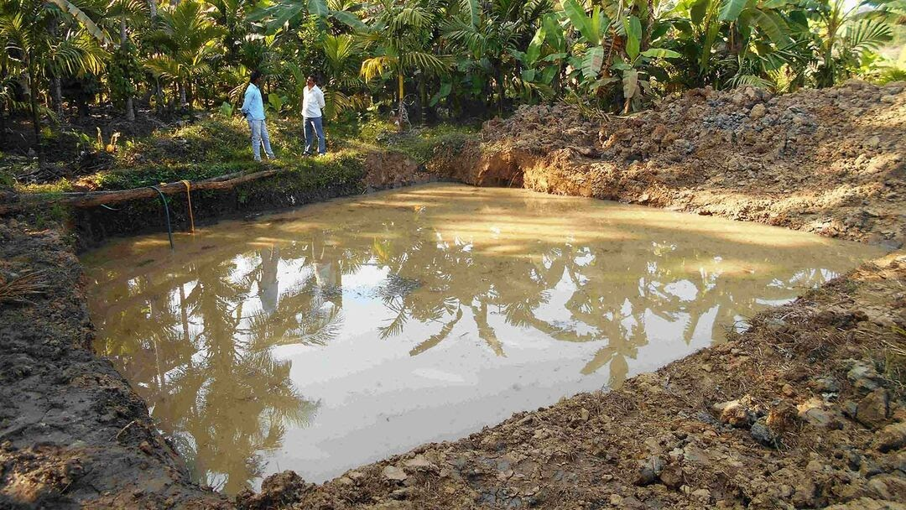

[Manuvikasa](https://www.giveindia.org/nonprofit/manuvikasa?utm_source=Blog&utm_campaign=NGOhomepage&utm_medium=Farmers&utm_term=textlink4&utm_content=Manuvikasa) is working to help farmers in India by building at least four water tanks in every village. The locations of the tanks are decided by the farmers with the assistance of local water experts. The structures are designed to last for at least 10 years with no maintenance. Poor and needy farmers are selected to work on the project with the NGO. They are trying to support farming communities to improve agriculture income through SRI cultivation. Donating to this program will [help villagers get access to a harvesting pond.](https://www.giveindia.org/program/Help-villagers-get-access-to-a-harvesting-pond?utm_source=Blog&utm_campaign=CTAbutton&utm_medium=Farmers&utm_term=textlink5&utm_content=Manuvikasa)

Link: https://www.giveindia.org/nonprofit/manuvikasa?utm_source=Blog&utm_campaign=NGOhomepage&utm_medium=Farmers&utm_term=textlink4&utm_content=Manuvikasa

**ANIMAL HUSBANDRY SUPPORT**

### Toll Free Kissan Call Centre- 1800 180 1551

<http://www.animalhusb.upsdc.gov.in/en>

Rural Banks

### ****Regional Rural Banks in Bihar****

**Local Language –**Bhojpuri

|  |  |  |
| --- | --- | --- |
| **S.No.** | **List of RRBs** | **Head Offices** |
| **6.** | Uttar Bihar Gramin Bank | Muzaffarpur |
| **7.** | Dakshin Bihar Gramin Bank | Patna |

### ****Regional Rural Banks in Haryana****

**Local Language -**Haryanvi

|  |  |  |
| --- | --- | --- |
| **S.No.** | **List of RRBs** | **Head Offices** |
| **11.** | Sarva Haryana Gramin Bank | Rohtak |