|  |  |  |
| --- | --- | --- |
|  | **ELP 725** |  |
|  | **Wireless Communication Lab** |  |
|  |  |  |
|  |  |  |
|  | **Experiment 1** |  |
|  | **Study of Basic Antennas** |  |
|  |  |  |
|  | **iitd** |  |
|  |  |  |
|  | **Indian Institute of Technology,Delhi** |  |
|  |  |  |
|  |  |  |
|  |  |  |
|  | **Submitted By : Group Number 8** |  |
|  | **Anshuman Singh (2018JTM2004)**  **Pardhi Chandan Waman (2018JTM2248)** |  |
|  | **10th January 2019** |  |

**Contents**

|  |  |  |  |  |
| --- | --- | --- | --- | --- |
| **1** | **Objectives** | | | **3** |
| **2** | **Observations** | | | **3** |
|  | 2.1 | Observation Table | | **3** |
|  |  | 2.1.1 | Observations for Dipole Antenna | **3** |
|  |  | 2.1.2 | Observations for Folded Dipole Antenna | **4** |
|  |  | 2.1.3 | Observations for Monopole Antenna | **4** |
|  |  | 2.1.4 | Observations for Yagi Uda Antenna | **5** |
|  | 2.2 | Radiation Pattern Plot | | **5** |
| **3** | **Analysis** | | | **6** |
| **4** | **Conclusions** | | | **6** |
| **5** | **Quiz** | | | **6** |

**List of Tables**

|  |  |  |
| --- | --- | --- |
| **1** | Dipole Antenna Observation Table | **3** |
| **2** | Folded Dipole Antenna Observation Table | **4** |
| **3** | Monopole Antenna Observation Table | **4** |
| **4** | Yagi Uda Antenna Observation Table | **5** |

**List of Figures**

|  |  |  |
| --- | --- | --- |
| **1** | Dipole Antenna | **5** |
| **2** | Folded Dipole Antenna | **5** |
| **3** | Monopole Antenna | **5** |
| **4** | Yagi Uda Antenna | **5** |

1. **OBJECTIVES**
2. To plot the radiation pattern of simple antenna - Dipole, Monopole, Folded, dipole antenna etc, in E and H planes on log and linear scales on polar and cartesian plots.
3. To measure the beam width (-3dB), front to back ratio, side lobe level and its angular position, plane of polarization and directivity and gain.
4. **OBSERVATIONS**

**2.1 Observation Table**

* + 1. **Observations for Dipole Antenna**

|  |  |  |
| --- | --- | --- |
| 1. No. | Phase Difference between Receiver and Transmitter (in degrees) | Received Power (dB) |
| 1 | 0° | 58 |
| 2 | 15° | 58 |
| 3 | 30° | 60 |
| 4 | 45° | 69 |
| 5 | 60° | 63 |
| 6 | 75° | 72 |
| 7 | 90° | 76 |
| 8 | 105° | 68 |
| 9 | 120° | 62 |
| 10 | 135° | 60 |
| 11 | 150° | 59 |
| 12 | 165° | 59 |
| 13 | 180° | 58 |
| 14 | 195° | 60 |
| 15 | 210° | 61 |
| 16 | 225° | 63 |
| 17 | 240° | 64 |
| 18 | 255° | 65 |
| 19 | 270° | 69 |
| 20 | 285° | 67 |
| 21 | 300° | 73 |
| 22 | 315° | 64 |
| 23 | 330° | 62 |
| 24 | 345° | 59 |

* + 1. **Observations for Folded Dipole Antenna**

|  |  |  |
| --- | --- | --- |
| S. No. | Phase Difference between Receiver and Transmitter (in degrees) | Received Power (dB) |
| 1 | 0° | 44 |
| 2 | 30° | 43 |
| 3 | 60° | 39.9 |
| 4 | 90° | 33 |
| 5 | 120° | 34.5 |
| 6 | 150° | 54.5 |
| 7 | 180° | 56 |
| 8 | 210° | 52.5 |
| 9 | 240° | 49.3 |
| 10 | 270° | 45.9 |
| 11 | 300° | 49.1 |
| 12 | 330° | 51.5 |
| 13 | 360° | 54.2 |

* + 1. **Observations for Monopole Antenna**

|  |  |  |
| --- | --- | --- |
| S. No. | Phase Difference between Receiver and Transmitter (in degrees) | Received Power (dB) |
| 1 | 0° | 69 |
| 2 | 15° | 67.4 |
| 3 | 30° | 66 |
| 4 | 45° | 57.9 |
| 5 | 60° | 55.7 |
| 6 | 75° | 45.9 |
| 7 | 90° | 56.4 |
| 8 | 105° | 61.7 |
| 9 | 120° | 59.4 |
| 10 | 135° | 64.7 |
| 11 | 150° | 65.6 |
| 12 | 165° | 63.2 |
| 13 | 180° | 62.6 |
| 14 | 195° | 64.7 |
| 15 | 210° | 63.9 |
| 16 | 225° | 42.9 |
| 17 | 240° | 47 |
| 18 | 255° | 62.2 |
| 19 | 270° | 66.8 |
| 20 | 285° | 69 |
| 21 | 300° | 70 |
| 22 | 315° | 69.9 |
| 23 | 330° | 71.1 |
| 24 | 345° | 70.9 |
| 25 | 360° | 72 |

* + 1. **Observations for Yagi Uda Antenna**

|  |  |  |
| --- | --- | --- |
| S. No. | Phase Difference between Receiver and Transmitter (in degrees) | Received Power (dB) |
| 1 | 0° | 59 |
| 2 | 30° | 58 |
| 3 | 60° | 54.8 |
| 4 | 90° | 55.3 |
| 5 | 120° | 55.8 |
| 6 | 150° | 56.4 |
| 7 | 180° | 55.6 |
| 8 | 210° | 53.1 |
| 9 | 240° | 53.5 |
| 10 | 270° | 54 |
| 11 | 300° | 55.1 |
| 12 | 330° | 58.2 |
| 13 | 360° | 58.8 |

* 1. **Radiation Pattern Plot**

|  |  |
| --- | --- |
| **/home/anshumansingh/Downloads/finalreadings/dipole.jpgdipole** | **/home/anshumansingh/Downloads/finalreadings/folded_dipole.jpgfolded_dipole** |
| **Figure 1 - Dipole Antenna** | **Figure 2 - Folded Dipole Antenna** |
| **/home/anshumansingh/Downloads/finalreadings/mono.jpgmono** | **/home/anshumansingh/Downloads/finalreadings/yagi_uda.jpgyagi_uda** |
| **Figure 3 - Monopole Antenna** | **Figure 4 - Yagi Uda Antenna** |

1. **Analysis**

|  |  |  |  |
| --- | --- | --- | --- |
| 1. | Antenna Test frequency ( f ) | | 600 MHz |
| 2. | Antenna Test Wavelength ( λ ) | | 25 cm |
| 3. | Rayleigh Distance, near field-Far field boundary  (L is the maximum dimension of the antenna in m.) | | 196cm |
| 4. | Distance between the two antennas R | | 1 m |
| 5. | Power fed to the transmitting antenna (Pt) | | 27.35 dBµ |
| 6. | E-plane –3dB bandwidth of the antenna ( θ°HP) | |  |
|  | ● | Dipole Antenna | 85° |
|  | ● | Folded Dipole Antenna | 103° |
|  | ● | Monopole Antenna | 75° |
|  | ● | Yadi Uda | 84.19° |

1. **Conclusions**

The observed readings helped us plot the radiation pattern of Dipole, Monopole, Folded Dipole and Yagi Uda Antenna. The pattern thus obtained approximates the actual radiation pattern of these antennas. This completes the study of basic antennas.

1. **Quiz**
2. **What will happen if a conducting plate is placed behind the dipole?**

**Ans.** The dipole antenna starts behaving as a monopole antenna as the plates reflect back all the radiation coming towards it.

1. **Identify the type of antenna associated with following radiation pattern?**

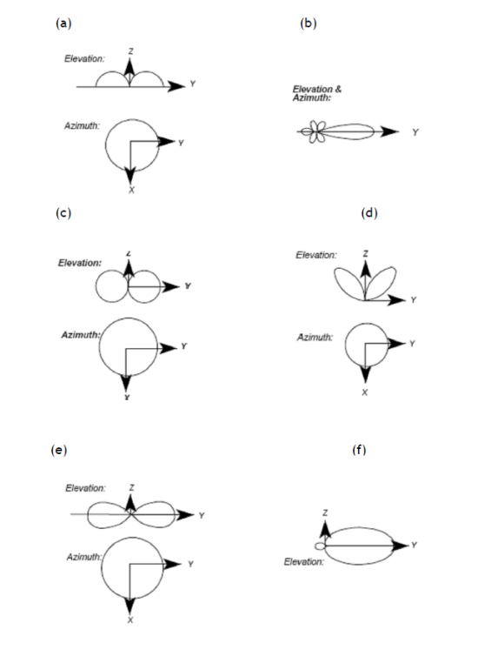

**Ans.** The antenna shown are as following :

* 1. Monopole
  2. Yagi Uda
  3. Half Wave Vertical Dipole
  4. Small Loop Antenna
  5. Quarter Wave Vertical Dipole
  6. Folded Dipole

1. **List the factors on which the shape of overall pattern of an antenna array depends?**

**Ans.** The shape of overall pattern of an antenna array will depend on following factors like, separating distance between elements of antenna array, amplitude, phase shift of feed in each elements, numbers of elements in array.

1. **What will happen if a folded dipole is attached to 5V AC, 50 MHZ signal?**

**Ans.** The antenna will start radiating a strong electromagnetic wave than before.

1. **What will happen if a folded dipole is attached to 230V AC,50 Hz main supply?**

**Ans.** The antenna will start radiating a very weak electromagnetic wave than before.

1. **When a 5V DC is applied across a folded dipole antenna, will it radiate energy? Justify your answer.**

**Ans.** There will be no electromagnetic radiation from the antenna. It can be understood by above equation also. As for DC w=0 Hence no radiation can take palce. Also a time varying current waveform is needed to set up an alternating electromagnetic field. Since DC current sets up a static field, the antenna will not radiate.

1. **“The Dipole antenna is extremely flexible”. Justify the statement?**

**Ans.**

1. Dipole antennas are symmetric about their axis. Hence they are naturally balanced antennas.Due to the symmetric nature this antenna can get signals from a variety of frequency types and minimizes problems relating to unbalanced signals or conflicting signals.
2. Dipole antennas can move, which allows antennas to pick up more signals. Any dipole antenna can move horizontally, vertically and at a slant to pick up a wide variety of radio signals, which provides more options.
3. **A Hertz half wave dipole antenna is aligned along X-axis. Where radiation peak will occur.**

**Ans.** As Hertzian dipole has radiation null towards it aligned position and maxima at orthogonal position hence the peak will occur along the Y-axis.

1. **How does a radiation pattern depend upon the radius on antenna element?**

**Ans.** As gain of any antenna in any direction directly defines the radiation pattern for that antenna and for any antenna gain is given by G = 4πAe=λ2, where Ae is effective area which is further given by Ae = k × A, where k = radiation efficiency and A = πr2. Hence as the radius of any antenna increases its gain increases resulting in giving higher strength radiation pattern.

1. **What will be radiation pattern of dipole antenna, if it will put on ground?**

**Ans.** If dipole antenna will be put on ground,it will be short circuited and as ground works as a perfect reflector. Hence, the antenna radiation will be same as that of a Monopole.