|  |  |  |
| --- | --- | --- |
|  | **ELP 725** |  |
|  | **Wireless Communication Lab** |  |
|  |  |  |
|  |  |  |
|  | **Experiment 3** |  |
|  | **ANTENNA RESONANCE AND GAIN BANDWIDTH**  **MEASUREMENTS** |  |
|  |  |  |
|  | **iitd** |  |
|  |  |  |
|  | **Indian Institute of Technology,Delhi** |  |
|  |  |  |
|  |  |  |
|  |  |  |
|  | **Submitted By :** |  |
|  | **Anshuman Singh (2018JTM2004)** |  |
|  | **Group Number 8** |  |
|  | **17th January 2019** |  |

**Contents**

|  |  |  |  |  |
| --- | --- | --- | --- | --- |
| **1** | **Objectives** | | | **3** |
| **2** | **Observations** | | | **3** |
| **3** | **Equipments Required** | | |  |
|  | 3.1 | Observation Table | | **3** |
|  |  | 3.1.1 | Observations for Dipole Antenna | **3** |
|  |  | 3.1.2 | Observations for Helix LHCP Antenna | **4** |
|  |  | 3.1.3 | Observations for Helix RHCP Antenna | **4** |
| **4** | **Analysis** | | | **6** |
| **5** | **Conclusions** | | | **6** |
| **6** | **Quiz** | | |  |

**List of Figures**

|  |  |  |
| --- | --- | --- |
| **1** | Figure 1: Dipole Antenna | **3** |
| **2** | Figure 2: Monopole Antenna | **4** |
| **3** | Figure 3: Folded Dipole Antenna |  |
| **4** | Figure 4: Biconical Antenna |  |
| **5** | Figure 5: Yagi-Uda Antenna |  |

**List of Tables**

|  |  |  |
| --- | --- | --- |
| **1** | Table 1: Dipole Antenna | **3** |
| **2** | Table 2: Helix LHCP Antenna Table | **4** |
| **3** |  |  |

1. **OBJECTIVES**
2. To identify whether an antenna is resonating or non-resonating type.
3. To measure basic antenna’s Gain Bandwidth using log periodic antenna.

**2 EQUIPMENTS REQUIRED**

1. Antenna Digital RF Transmitter, MADL -2.4.
2. Antenna Digital RF Receiver, MADL – 2.4
3. Antenna Tripods.
4. Dipole, Log periodic, Yagi-Uda, Monopole, Folded Dipole and Biconical antennas.

**3 OBSERVATIONS**

**3.1 Observation Table**

|  |  |  |  |  |  |
| --- | --- | --- | --- | --- | --- |
| **Frequency**  **(MHz)** | **Power Received** | | | | |
| **Dipole** | **Monopole** | **Folded Dipole** | **Biconical** | **Yagi-Uda** |
| **450** | 73.7 | 53.8 | 55 | 53.7 | 37 |
| **460** | 74.4 | 53.6 | 54.6 | 56.9 | 37.6 |
| **470** | 74.5 | 56.3 | 62.4 | 64.3 | 43.2 |
| **480** | 73.7 | 56.6 | 68 | 65.7 | 43.4 |
| **490** | 65.6 | 58.9 | 73.2 | 63.8 | 47.7 |
| **500** | 70 | 53.3 | 67.2 | 67.9 | 45.9 |
| **510** | 75.3 | 44.2 | 57.2 | 70.4 | 57 |
| **520** | 75.9 | 53.2 | 60.4 | 72.5 | 57.9 |
| **530** | 75.9 | 55.6 | 64.7 | 71.5 | 53 |
| **540** | 76 | 53.4 | 69.5 | 69 | 51.1 |
| **550** | 76 | 45 | 72.4 | 65.7 | 53.7 |
| **560** | 76 | 49.5 | 75.4 | 65 | 57.6 |
| **570** | 76 | 44.3 | 75.6 | 65 | 62.3 |
| **580** | 76 | 54.4 | 75 | 67 | 70.7 |
| **590** | 76 | 49 | 73.2 | 65.5 | 77 |
| **600** | 76 | 53.5 | 71.2 | 59.6 | 79.2 |
| **610** | 76 | 52.5 | 68.9 | 56.6 | 75.7 |
| **620** | 75.6 | 51.5 | 65.1 | 55.3 | 73.9 |
| **630** | 75.4 | 49.2 | 61.1 | 50.6 | 70 |
| **640** | 75.8 | 46.5 | 59 | 45.9 | 71.4 |
| **650** | 76 | 52.9 | 62.8 | 53 | 73.2 |
| **660** | 76.1 | 60.7 | 68.5 | 63.8 | 76.7 |
| **670** | 76 | 65.2 | 70.3 | 65.4 | 77.1 |
| **680** | 76.1 | 68.2 | 71 | 66.8 | 72 |
| **690** | 75.9 | 67.2 | 70 | 64.4 | 65 |
| **700** | 76 | 66.2 | 68.7 | 66 | 60.5 |
| **710** | 75.9 | 65.2 | 71.7 | 68.9 | 61 |
| **720** | 76 | 66.2 | 72.7 | 73.1 | 64.9 |
| **730** | 75 | 69.8 | 74.6 | 75.7 | 67 |
| **740** | 74 | 73.1 | 76 | 76.2 | 71.1 |
| **750** | 73 | 73.5 | 76.2 | 76.2 | 67.5 |

1. **PLOTS**
   1. **Dipole Antenna**

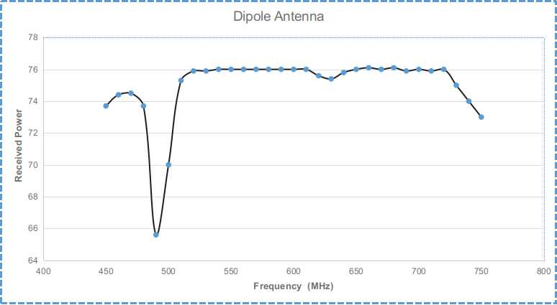

Figure 1: Dipole Antenna

* 1. **Dipole Antenna**

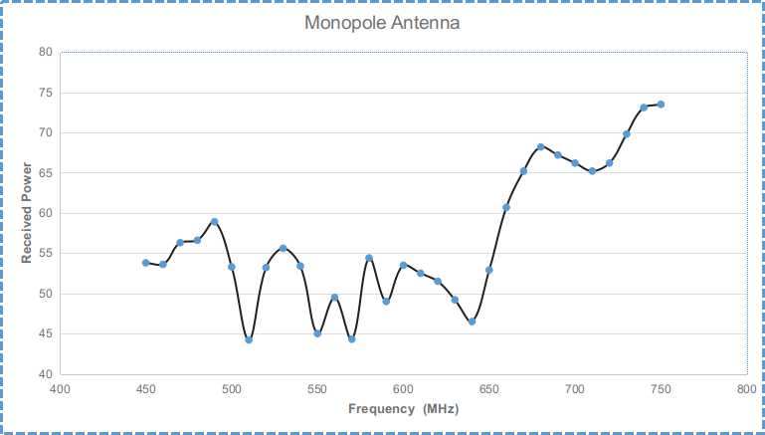

Figure 2: Monopole Antenna

* 1. **Folded Dipole**

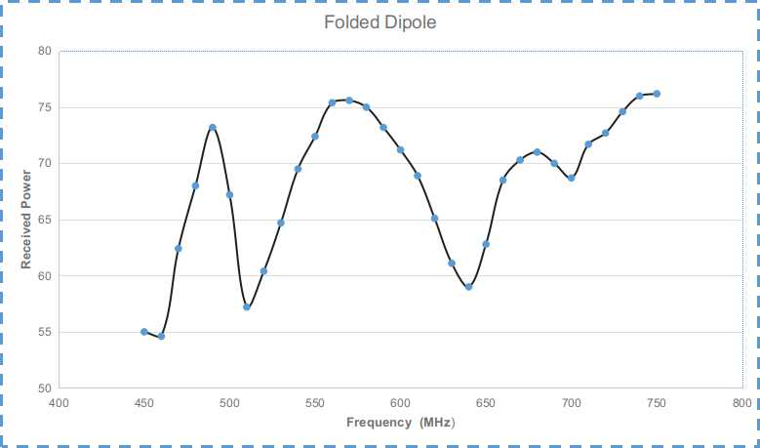

Figure 3: Folded Dipole Antenna

* 1. **Biconical Antenna**

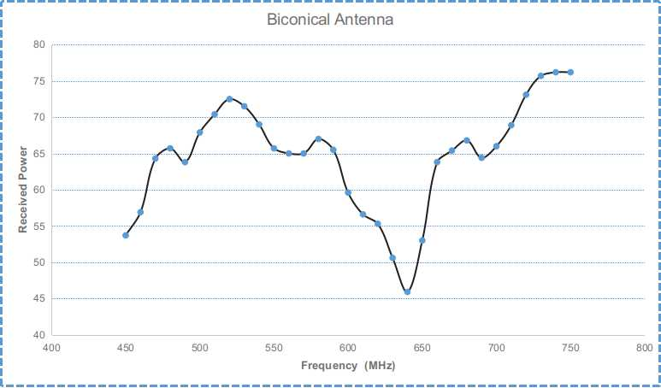

Figure 4: Biconical Antenna

**4.5 Yagi-Uda Antenna**

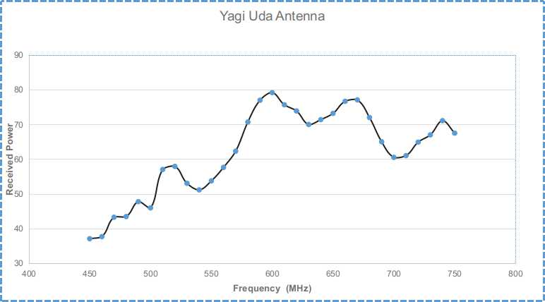

Figure 5: Yagi-Uda Antenna

**4 ANALYSIS**

|  |  |  |
| --- | --- | --- |
| **Type of Antenna** | **Resonance Frequency (MHz)** | **Bandwidth**  **(MHz)** |
| Dipole |  |  |
| Monopole |  |  |
| Folded Dipole |  |  |
| Biconical |  |  |
| Yagi Uda |  |  |

**5 CONCLUSIONS**

1. **QUIZ**