|  |  |  |
| --- | --- | --- |
|  | **ELP 725** |  |
|  | **Wireless Communication Lab** |  |
|  |  |  |
|  | **Experiment 3** |  |
|  | **Characterization of Fading Effects** |  |
|  |  |  |
|  | **iitd** |  |
|  |  |  |
|  | **Indian Institute of Technology, New Delhi** |  |
|  |  |  |
|  |  |  |
|  | **Submitted By :** |  |
|  | **Anshuman Singh (2018JTM2004)** |  |
|  | **Group Number 8** |  |
|  | **31th January 2019** |  |

**Contents**

|  |  |  |  |  |
| --- | --- | --- | --- | --- |
| **1** | **Objectives** | | | **3** |
| **2** | **Equipments Required** | | | **3** |
| **3** | **Observations** | | |  |
|  | 3.1 | Observation Table | | **3** |
| **4** | **Plots** | | |  |
|  |  | 4.1 | At frequency, f = 2.40 GHz | **4** |
|  |  | 4.2 | At frequency, f = 2.42 GHz | **4** |
|  |  | 4.3 | At frequency, f = 2.44 GHz | **5** |
| **5** | **Analysis** | | | **6** |
| **6** | **Conclusions** | | | **6** |
| **7** | **Quiz** | | | **7** |

**List of Figures**

|  |  |  |
| --- | --- | --- |
| **1** | Figure 1: Plot of fades vs distance at frequency f = 2.4 GHz | **4** |
| **2** | Figure 2: Plot of fades vs distance at frequency f = 2.42 GHz | **4** |
| **3** | Figure 3: Plot of fades vs distance at frequency f = 2.44 GHz | **5** |

**List of Tables**

|  |  |  |
| --- | --- | --- |
| **1** | Table 1 : Observations at 2.4, 2.42 and 2.44 GHz | **3** |

1. **OBJECTIVES**
2. To observe and characterize the multi-path fading effects in the lab environment using:
3. CRO
4. Power meter (in-built in the Receiver) and
5. Spectrum analyzer (prefer this to measure the received power)
6. To determine the fade duration at different frequencies.

**2 EQUIPMENTS REQUIRED**

1. Microwave analog digital link transmitter MADL 2.4.
2. Microwave analog digital link receiver MADL 2.4.
3. Scientific Function Generator, HM 5030-4.
4. FS 300 spectrum Analyzer 9KHz 3 GHz.
5. Digital oscilloscope or 100 MHZ analog oscilloscopes, HM 1004-3.
6. Two dipole antennas and antenna tripods.

**3 OBSERVATIONS**

**3.1 Observation Table**

|  |  |  |  |  |  |  |
| --- | --- | --- | --- | --- | --- | --- |
| **Distance**  **(in cm)** | **Received Power (dBm)** | | | | | |
| **at f = 2.40 GHz** | | **at f = 2.42 GHz** | | **at f = 2.44 GHz** | |
| Horizontal  Polarization | Vertical  Polarization | Horizontal  Polarization | Vertical  Polarization | Horizontal  Polarization | Vertical  Polarization |
| 30 | -51.2 | -50 | -67.1 | -53.5 | -70.1 | -50.8 |
| 45 | -53.3 | -52.9 | -69.5 | -53.6 | -69.2 | -50.3 |
| 60 | -54.9 | -53.9 | -70.1 | -52.8 | -69.4 | -49.6 |
| 75 | -55 | -54 | -70.2 | -53.9 | -70.7 | -51.2 |
| 90 | -58.6 | -55.5 | -70.3 | -54.9 | -70.7 | -49.9 |
| 105 | -54.2 | -56.1 | -70.3 | -56.3 | -70.9 | -50.5 |
| 120 | -54.5 | -54.5 | -69.2 | -55 | -69 | -50.7 |
| 135 | -50.8 | -54.3 | -69.5 | -56.5 | -69.6 | -49.2 |
|  |  |  |  |  |  |  |
|  | Table 1 : Observations at 2.4, 2.42 and 2.44 GHz | | | | |  |

1. **PLOTS**
   1. **At frequency, f = 2.40 GHz**

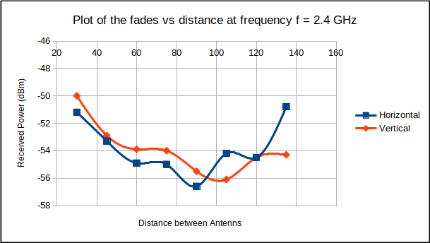

Figure 1: Plot of fades vs distance at frequency f = 2.4 GHz

For Horizontal Polarization , Deep Fade Distance is 90 cm

For Vertical Polarization , Deep Fade Distance is 100 cm

Average Distance between fades for Horizontal polarization is 30 cm.

X 1 = 90-60 = 30 cm.

X 2 = 120-90 = 30 cm.

D A = (X1 + X2)/2 = 30 cm.

Average Distance between fades for Vertical polarization is 40 cm.

X 1 = 100-60 = 40 cm.

X 2 = 140-100 = 40 cm.

D A = (X1 + X2)/2 = 40 cm.

* 1. **At frequency, f = 2.42 GHz**

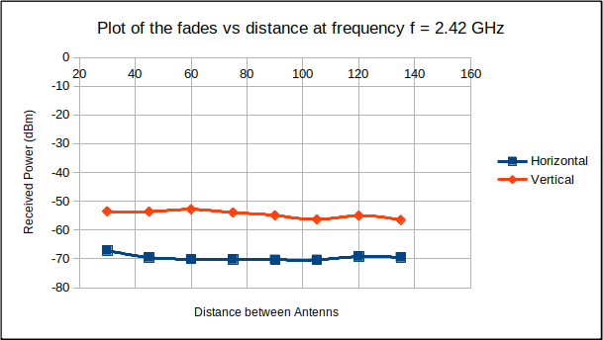

Figure 2: Plot of fades vs distance at frequency f = 2.42 GHz

For Horizontal Polarization , Deep Fade Distance is 105 cm

For Vertical Polarization , Deep Fade Distance is 135 cm

Average Distance between fades for Horizontal polarization is 45 cm.

X 1 = 105-45= 60 cm.

X 2 = 135-105 = 30 cm.

D A = (X1 + X2)/2 = 45 cm.

Average Distance between fades for Vertical polarization is 30 cm.

X 1 = 90-60 = 30 cm.

X 2 = 120-90 = 30 cm.

X 3 = 150-120 = 30 cm.

D A = (X 1 + X 2 +X 3)/3 = 30 cm.

* 1. **At frequency, f = 2.44 GHz**

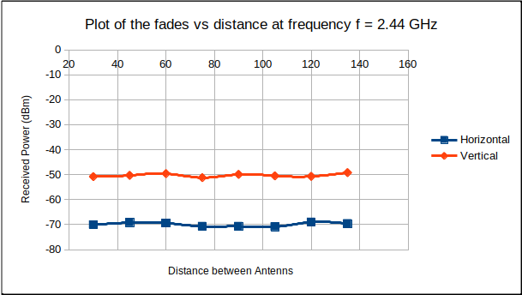

Figure 3: Plot of fades vs distance at frequency f = 2.44 GHz

For Horizontal Polarization , Deep Fade Distance is 105 cm

For Vertical Polarization , Deep Fade Distance is 75 cm

Average Distance between fades for Horizontal polarization is 35 cm.

X 1 = 75-30 = 45 cm.

X 2 = 105-80 = 25 cm.

D A = (X1 + X2)/2 = 35 cm.

Average Distance between fades for Vertical polarization is 45 cm.

X 1 = 75-30 = 45 cm.

X 2 = 120-75 = 45 cm.

D A = (X 1 + X 2)/2 = 45 cm.

**4 ANALYSIS**

* **For 2.4 GHz with Horizontal Polarization :**

**PL (d) = PL(do) + 10nlog(d/do)+ Xσ**

d0 = Reference close in distance = 30 cm (assumed)

d = distance between transmitter and receiver = 90 cm (for a single reading)

Because of lack of information : Xσ=0 σ=0

Let input power = x dBm

PL (d) = (x – (-58.6)) dBm

PL (d0) = (x – (-51.2)) dBm

58.6 = 51.2 + 10nlog (90/30) + 0

n = 1.55

*Path loss exponent (n) = 1.55*

* **For 2.4 GHz with Vertical Polarization :**

**PL (d) = PL(do) + 10nlog(d/do)+ Xσ**

d0 = Reference close in distance = 30 cm (assumed)

d = distance between transmitter and receiver = 90 cm (for a single reading)

Because of lack of information : Xσ=0 σ=0

Let input power = x dBm

PL (d) = (x – (-55.5)) dBm

PL (d0) = (x – (-50)) dBm

-55.5 = 50 + 10nlog (90/30) + 0

n = 1.15

*Path loss exponent (n) = 1.15*

**5 CONCLUSIONS**

1) Loss Exponent for Horizontal Polarization is greater than that for Vertical Polarization.

2) Deep fade distance at 2.4 GHz is 90cm and 100cm for Horizontal & Vertical Polarization respectively.

3) Deep fade distance at 2.42 GHz is 105cm and 135cm for Horizontal & Vertical Polarization respectively.

4) Deep fade distance at 2.44 GHz is 105cm and 75cm for Horizontal & Vertical Polarization respectively.

1. **QUIZ**
2. **Give the values of the IF and RF used in your experiment?**

**Ans.** RF frequency used in this experiment is 2.40 GHz, 2.42 GHz, 2.44 GHz.

1. **What type of modulation the transmitter is using?**

**Ans.** Frequency Modulation

1. **Is n a function of frequency?**

**Ans.** Path loss depend upon the external environments like obstacles occurring(buildings etc) and is not a function of frequency.

1. **What will be the effect on Average Fade Duration if the receiver uses 2**

**antennas with received signals uncorrelated?**

**Ans.** Effective Fade duration will reduce.

1. **If the Coherence Bandwidth is greater than the channel bandwidth, do we need equalizer? Give reason to support your answer?**

**Ans.** No, because only flat fading will occur and thus amplifier will serve the purpose to increase signal strength.

1. **Point out some WLAN channel models and clearly gives the parameters ranges under which these models are suitable?**

**Ans.** This list of WLAN channels is the set of legally allowed wireless local area network channels. currently we use in four distinct frequency ranges:

I) 2.4 GHz : There are 14 channels spaced 5 MHz apart

II) 3.6 GHz : The channels are ranging from 3657.5MHz to 3690MHz

III) 4.9 GHz : The channels are ranging from 4940MHz to 4990MHz

IV) 5 GHz : The channels are ranging from 5150MHz to 5725MHz

1. **Which WLAN channel model may best describe your working environment in lab?**

**Ans.** 2.40 GHz is often used in our lab's Tx and Rx available easily tune into

this frequency.