|  |  |  |
| --- | --- | --- |
|  | **ELP 725** |  |
|  | **Wireless Communication Lab** |  |
|  |  |  |
|  |  |  |
|  | **Experiment 5** |  |
|  | **Delay Spread Measurement**  **and Calculation of Coherence Bandwidth** |  |
|  |  |  |
|  | **iitd** |  |
|  |  |  |
|  | **Indian Institute of Technology,Delhi** |  |
|  |  |  |
|  |  |  |
|  |  |  |
|  | **Submitted By :** |  |
|  | **Anshuman Singh (2018JTM2004)** |  |
|  | **Group Number 8** |  |
|  | **14th February 2019** |  |

**Contents**

|  |  |  |  |  |
| --- | --- | --- | --- | --- |
| **1** | **Objectives** | | | **3** |
| **2** | **Observations** | | | **3** |
| **3** | **Equipments Required** | | |  |
|  | 3.1 | Observation Table | | **3** |
|  |  | 3.1.1 | Signal Voltage ‘δV’ at 10 % Duty Cycle (mV) | **3** |
| **4** | **Waveforms** | | | **4** |
|  | **4.1** | Input & Output Waveform at 2.4 GHz | | **4** |
|  | **4.2** | Input & Output Waveform at 2.42 GHz | | **4** |
| **5** | **Plots** | | |  |
|  | **5.1** | Delay profile for 2.40 GHz | | **5** |
|  | **5.2** | Delay profile for 2.42 GHz | | **5** |
| **5** | **Analysis** | | | **6** |
| **6** | **Conclusions** | | | **6** |
| **7** | **Quiz** | | | **6** |

**List of Figures**

|  |  |  |
| --- | --- | --- |
| **1** | Input & Output Waveform at 2.4 GHz | **4** |
| **2** | Input & Output Waveform at 2.42 GHz | **4** |
| **3** | Delay profile for 2.40 GHz | **5** |
| **4** | Delay profile for 2.42 GHz | **5** |

**List of Tables**

|  |  |  |
| --- | --- | --- |
| **1** | Signal Voltage ‘δV’ at 10 % Duty Cycle (mV) | **4** |
| **2** | Analysis | **6** |

1. **OBJECTIVES**
2. To measure the rms delay spread of the wireless channel.
3. To determine the coherence Bandwidth.

**2 EQUIPMENTS REQUIRED**

1. Microwave Analog Digital Link Transmitter MADL 2.4.
2. Microwave Analog Digital Link Receiver MADL 2.4.
3. Signal generator SML03.
4. Digital phosphorous oscilloscope TDS 5104B or100 MHz Analog Oscilloscope HM 1004-3.
5. Any 2 antennas – dipole or helix.

**3 OBSERVATIONS**

**3.1 Observation Table**

|  |  |  |
| --- | --- | --- |
| **Time ‘δt’**  **(µsec)** | **Signal Voltage ‘δV’ at 10 % Duty Cycle (mV)** | |
| **2.4 Ghz** | **2.42 Ghz** |
| 10 | 100 | 100 |
| 20 | 260 | 260 |
| 30 | 280 | 280 |
| 40 | 240 | 240 |
| 50 | 80 | 100 |
| 60 | 20 | 20 |
| 70 | -100 | -80 |
| 80 | -220 | -200 |
| 90 | -240 | -180 |
| 100 | -180 | -200 |
| 110 | -140 | -160 |
| 120 | -120 | -100 |
| 130 | -80 | -80 |
| 140 | -40 | -60 |
| 150 | -20 | -20 |
| 160 | 0 | -40 |
| 170 | 0 | 0 |
| 180 | 20 | 0 |
| 190 | 20 | 0 |
| 200 | 40 | 0 |
| 210 | 40 | 20 |
| 220 | 40 | 20 |
| 230 | 0 | 20 |
| 240 | 20 | 20 |
| 250 | 0 | 20 |
| 260 | 20 | 0 |
| 270 | 20 | 0 |
| 280 | 20 | 0 |
|  |  |  |
| Table 1 : Signal Voltage ‘δV’ at 10 % Duty Cycle (mV) | | |

1. **WAVEFORMS**
   1. **At frequency 2.4GHz, Duty Cycle 10%**

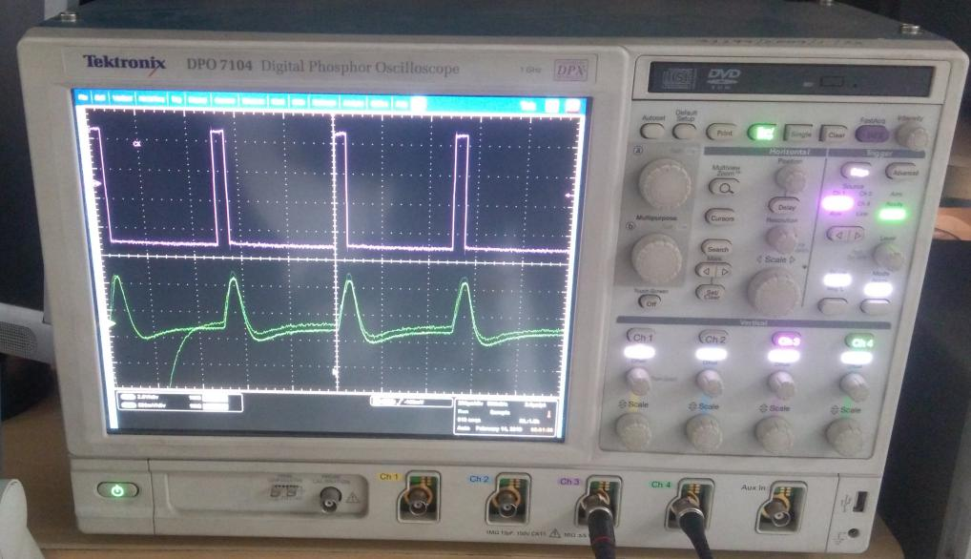

Figure 1 : Input & Output Waveform at 2.4 GHz

* 1. **At frequency 2.42GHz, Duty Cycle 10%**

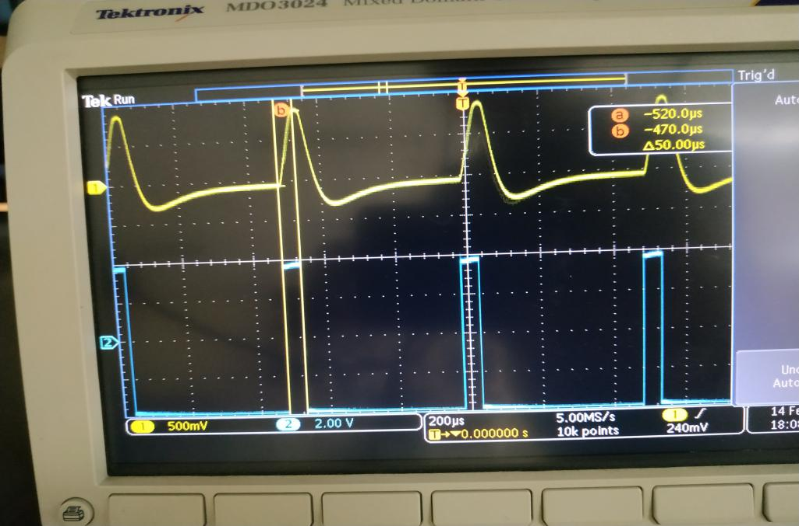

Figure 2 : Input & Output Waveform at 2.42 GHz

1. **PLOTS**
   1. **Delay Profile 2.4 GHz**

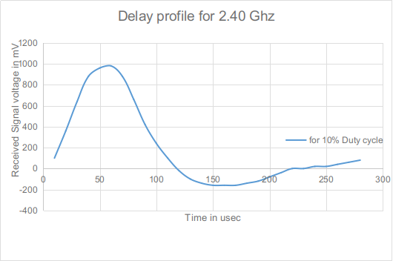

Figure 3: Delay profile for 2.40 GHz

* 1. **Delay Profile 2.42 GHz**

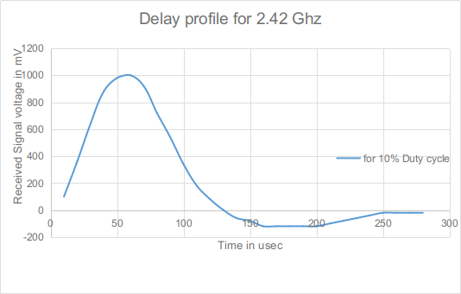

Figure 4 : Delay profile for 2.42 GHz

**4 ANALYSIS**

|  |  |  |
| --- | --- | --- |
|  | **10% duty cycle** | |
| **2.40 GHz** | **2.42 GHz** |
| **Mean excess delay**  **(in µsec)** | 59.96681049 | 60.84615385 |
| **RMS delay spread (µsec)** | 27.80286371 | 26.25597706 |
| **Coherence Bandwidth**  **(in Hz)** | 719.3503594 | 761.7313176 |
|  |  |  |
| Table 2 : Analysis | | |

1. **CONCLUSIONS**

* Large part of fading occurs due to the disturbances in the wireless channels because of multi-path signal receptions at the receiver.
* As far as delay spread is concerned, it can be effectively calculated from the formula.
* But, because the channels are less ideal, there is a need to measure the flatness bandwidth of the channel for taking counter measures and reducing the effects of fading or delay spread.
* This can be achieved by calculating first and second moments and finally able to appreciate the coherence bandwidth value from the above moments.
* This gives and idea about the required measures to be taken in case of any wireless channels surrounded by ’n’ number of disturbances.

1. **QUIZ**

**Ques 1: Explain the sentence “One of the ways to reduce multi-path interference is to use an antenna with a very narrow HPBW”. What is disadvantage of using an antenna with narrow HPBW?**

**Ans 1:** When HPBW is reduced, the beam becomes narrow and more directional. But the disadvantage is that a very narrow, sharp beam will cover very small area, thus a large number of directional antenna elements will be required to cover the same area.

**Ques 2: What are the HPBW of antennas in the base station and in the handset for a typical mobile communication scenario (for GSM and for CDMA2000)?**

**Ans 2:** 60 to 70 degree approx.

**Ques 3: Calculate the Coherence Bandwidth for mobile communication in India (GSM and CDMA 2000). Will your answer change with degree of urbanization?**

**Ans 3:** Coherence Bandwidth is about 500 KHz. In urban areas, due to moremultipath receptions,fading delay spread will increase causing a decrease in coherence bandwidth.

**Ques 4: A signal is said to undergo flat fading if Bs < Bc, where Bs is signal bandwidth and Bc is coherence bandwidth, otherwise signal undergoes frequency selective fading. Is your signal transmission in lab undergoing at fading or frequency selective fading?**

**Ans 4:** The square pulse is produced at 1 KHz with 10% duty cycle. Coherence BW obtained is roughly 1030 Hz so here Bs < Bc so it experiences flat fading.

**Ques 5: For each of the scenario below, decide if the received signal is best described as undergoing fast fading, frequency selective fading, or at fading?**

**(a) A binary modulation has a data rate of 500kbps, and fc=1GHz and a typical urban radio channel is used.**

**(b) A binary modulation has a data rate of 5kbps, and fc=1GHz and a typical urban radio channel is used to provide communication to cars moving on a highway?**

**Ans 5:** Let the modulation to be BPSK or QPSK.

For BPSK Bandwidth = 2 x Bit-rate, and for QPSK Bandwidth = Bit-rate.

a) It will undergo flat fading, since fs < fc.

b) It will undergo flat fading, since fs < fc.

fs : signal frequency

fc: coherence bandwidth

**Ques 6: Which channel has more RMS delay spread between Indoor channel and Outdoor channel and why?**

**Ans 6:** Outdoor channel has more delay (in micro seconds) as there are more multi-path in outdoor environment, whereas indoor channel has less delay because less number of multi-path (in nano seconds).