|  |  |  |
| --- | --- | --- |
|  | **ELP 725** |  |
|  | **Wireless Communication Lab** |  |
|  |  |  |
|  |  |  |
|  | **Experiment 6** |  |
|  | **FADING COUNTER-MEASURES USING ANTENNA DIVERSITY AND FREQUENCY DIVERSITY** |  |
|  |  |  |
|  | **iitd** |  |
|  |  |  |
|  | **Indian Institute of Technology,Delhi** |  |
|  |  |  |
|  |  |  |
|  |  |  |
|  | **Submitted By :** |  |
|  | **Anshuman Singh (2018JTM2004)** |  |
|  | **Group Number 8** |  |
|  | **21th February 2019** |  |

**Contents**

|  |  |  |  |  |
| --- | --- | --- | --- | --- |
| **1** | **Objectives** | | | **3** |
| **2** | **Equipment's Required** | | | **3** |
| **3** | **Observations** | | |  |
|  | 3.1 | Observation Table | | **3** |
|  |  | 3.1.1 | Fading Effect | **3** |
|  |  | 3.1.2 | Transmitter Diversity |  |
|  |  | 3.1.3 | Receiver Diversity |  |
|  |  | 3.1.4 | Frequency Diversity |  |
| **4** | **Plots** | | | **4** |
|  | 4.1 | Fading Effect | | **4** |
|  | 4.2 | Transmitter Diversity | | **4** |
|  | 4.3 | Receiver Diversity | |  |
|  | 4.4 | Frequency Diversity | |  |
| **5** | **Analysis** | | | **6** |
| **6** | **Conclusions** | | | **6** |
| **7** | **Quiz** | | | **6** |

1. **OBJECTIVES**
2. To observe effects of multiple antennas on the received signal strength.
3. To use antenna diversity as fading counter measure.
4. To use frequency diversity as fading counter measure.

**2 EQUIPMENTS REQUIRED**

1. Microwave Analog Digital Link Transmitter MADL 2.4.
2. Microwave Analog Digital Link Receiver MADL 2.4.
3. Function Generator, HM 5030-4.
4. FS 300 spectrum Analyzer 9KHz 3 GHz.
5. Digital oscilloscope Two or 100 MHZ analog oscilloscope, HM 1004-3
6. Three antenna & three antenna tripods.

**3 OBSERVATIONS**

**3.1 Fading Effect**

|  |  |
| --- | --- |
| **Distance(cm)** | **Received Power (dBm) at f = 2.4 GHz** |
| 30 | 55 |
| 45 | 54 |
| 60 | 54 |
| 75 | 25 |
| 90 | 33 |
| 105 | 35 |
| 120 | 28 |
| 135 | 37 |
| 150 | 34 |
|  |  |
| Table 1 : Received Power (dBm) vs Distance (cm) at f =2.4 GHz | |

**3.2 Transmitter Diversity**

|  |  |
| --- | --- |
| **Distance(cm)** | **Received Power (dBm) at f = 2.4 GHz** |
| 30 | 56 |
| 45 | 55 |
| 60 | 54 |
| 75 | 37 |
| 90 | 30 |
| 105 | 36 |
| 120 | 39 |
| 135 | 31 |
| 150 | 47 |
|  |  |
| Table 2 : Received Power (dBm) vs Distance (cm) at f = 2.4 GHz in Transmitter Diversity | |

**3.3 Receiver Diversity**

|  |  |  |
| --- | --- | --- |
| **Distance(cm)** | **Received Power (dBm) at f = 2.4 GHz** | |
| Dipole Antenna 1 | Dipole Antenna 1 |
| 30 | 43 | 41 |
| 45 | 56 | 38 |
| 60 | 53 | 35 |
| 75 | 45 | 33 |
| 90 | 45 | 30 |
| 105 | 38 | 34 |
| 120 | 37 | 29 |
| 135 | 41 | 24 |
| 150 | 43 | 29 |
|  |  | |
| Table 3 : Received Power (dBm) vs Distance (cm) at f = 2.4 GHz in Receiver Diversity | | |

**3.4 Frequency Diversity**

|  |  |  |  |
| --- | --- | --- | --- |
| **Distance(cm)** | **Received Power (dBm)** | | |
| f = 2.4 GHz | f = 2.42 GHz | f = 2.44 GHz |
| 30 | 55 | 55 | 55 |
| 45 | 54 | 45 | 54 |
| 60 | 54 | 43 | 55 |
| 75 | 25 | 23 | 36 |
| 90 | 33 | 25 | 23 |
| 105 | 35 | 31 | 33 |
| 120 | 28 | 21 | 29 |
| 135 | 37 | 35 | 36 |
| 150 | 34 | 33 | 31 |
|  |  | |  |
| Table 4 : Received Power (dBm) vs Distance (cm) at different frequencies | | | |

1. **PLOTS**
   1. **Fading**

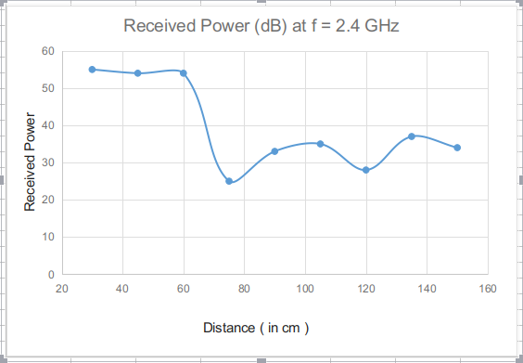

Figure 1 : Received Power (dBm) vs Distance (cm) at f = 2.4 GHz

* 1. **Transmitter Diversity**

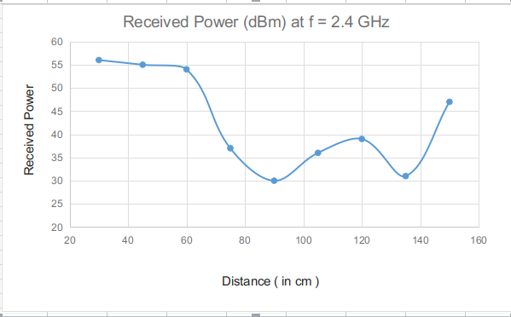

Figure 2 : Received Power (dBm) vs Distance (cm) at f = 2.4 Ghz in Transmitter Diversity

* 1. **Receiver Diversity**

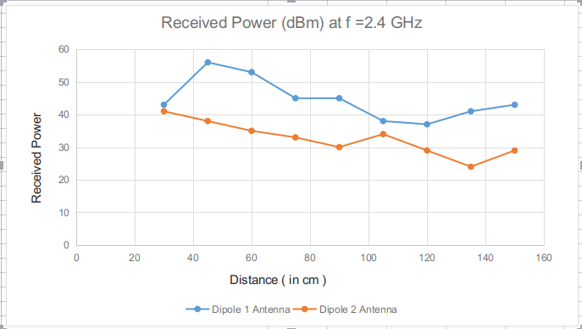

Figure 3 : Received Power (dBm) vs Distance (cm) at f = 2.4 GHz in Receiver Diversity

* 1. **Frequency Diversity**

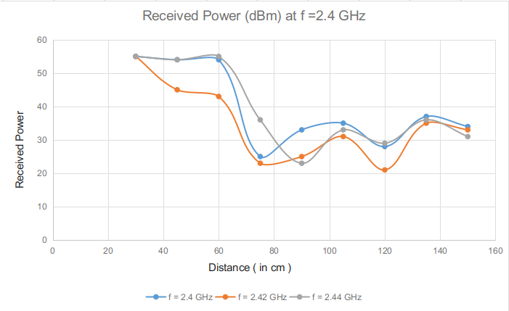

Figure 4 : Received Power (dBm) vs Distance (cm) at different frequencies

**4 ANALYSIS**

* It is observed from the graphs that in case of SISO, there is a deep fade at distances 75cm, 120cm.
* By using antenna diversity, in case of MISO system, it is clear from the graphs that it was possible to come out of fade.We get the deep fade at 90 cm and 135s cm.
* Also, by using SIMO techniques, the system could come out of fade. However, the system went into a deep fade at other distance for SIMO case. This can happen due to multiple reflections in a lab environment.
* It was also observed that when the frequency was increased from 2.4 GHz to 2.44 GHz, the system exhibits a different fading profile for different frequencies. Hence frequency diversity is also a fading counter measure.

1. **CONCLUSIONS**

* In case of Transmitter Diversity, Average Fade distance is found to be 45 cm.
* In case of Receiver Diversity, Average Fade distance is found to be 30 cm.
* In case of Frequency Diversity,

• At f = 2.40 GHz , Average Fade distance is found to be 15 cm.

• At f = 2.42 GHz , Average Fade distance is found to be 20 cm.

• At f = 2.44 GHz , Average Fade distance is found to be 25 cm.

1. **QUIZ**

**1. Give an example where Time Diversity Technique is used?**

**Ans**: Time diversity is used in satellite communications.

1. **What can be the distance between the antennas in Antenna Diversity for signals to be uncorrelated?**

**Ans**: Distance of about λ/2 between the two diversity antennas is required to effectively distinguish between different multi-path channels, hence being uncorrelated.

**3. Which diversity Technique is used in base station design?**

**Ans**: Polarization diversity is used in base station design.

1. **Describe briefly the conditions under which small scale and large scale fading will occur?**

**Ans**: Small scale fading occurs when the distance between the Transmitter and Receiver is changed by small amount. It is called as Rayleigh fading due to the fact that various multi-path at the Rx with random amplitude and delay add up together to render Rayleigh pdf for total signal and large scale fading caused due to shadowing occurs over large distances of the order of then distances between the base stations.

1. **Why space diversity technique is considerably less practical at base station? Which diversity technique will be more suitable at base station?**

**Ans**: Space diversity technique considerably less practical at the base station because of the following reasons:

a) Large spacing required at the base station of the order of 30 times the wavelength

for tall base station.

b) Hardware size could be large depend upon the device technology.

Polarization diversity will be more practical as comparison to antenna diversity because of the following reasons:

a) No space is required in polarization diversity, signals will be uncorrelated by means of phase difference i.e. horizontal and vertical polarized wave.

b) No extra bandwidth is required.

c) Hardware size will not be large.

**6. Which diversity technique is suitable for Line-of-Sight Microwave Links?**

**Ans**: Several remedial measures—like space diversity, frequency diversity, route diversity, increase in antenna height, antenna tilting, etc.—have been tried by many operators to overcome the debilitating effect of multi-path fading in fixed line-of-sight microwave and mobile communication links.

**7. Suggest some other fading counter measures?**

**Ans**: Techniques such as Orthogonal frequency division multiplexing (OFDM), Space time block coding, Efficient error coding like Trellis coded modulation(TCM) can be used to counter fading effects.