|  |  |  |
| --- | --- | --- |
|  | **ELP 725** |  |
|  | **Wireless Communication Lab** |  |
|  |  |  |
|  |  |  |
|  | **Experiment 7** |  |
|  | **Handover Demonstration** |  |
|  |  |  |
|  | **iitd** |  |
|  |  |  |
|  | **Indian Institute of Technology,Delhi** |  |
|  |  |  |
|  |  |  |
|  |  |  |
|  | **Submitted By :** |  |
|  | **Anshuman Singh (2018JTM2004)** |  |
|  | **Group Number 8** |  |
|  | **28th February 2019** |  |

**Contents**

|  |  |  |  |
| --- | --- | --- | --- |
| **1** | **Objectives** | | **3** |
| **2** | **Equipments Required** | | **3** |
| **3** | **Observations** | |  |
|  | 3.1 | Fade Profile of Transmitting Dipole Antenna | **3** |
|  | 3.1 | Fade Profile of Both Transmitting Dipole Antennas connected along with a Receiver Antenna | **4** |
| **4** | **Plots** | | **4** |
| **4** | **Analysis** | | **5** |
| **5** | **Conclusions** | | **5** |
| **6** | **Quiz** | | **6** |

**List of Figures**

|  |  |  |
| --- | --- | --- |
| **1** | Received Power (dB) vs Distance (cm) at different frequencies with  Antenna1 connected at Transmitter and Antenna3 at Receiver | **4** |
| **2** | Received Power (dB) vs Distance (cm) at different frequencies with both  Antenna 1 and Antenna 2 connected | **4** |

1. **OBJECTIVES**
2. To demonstrate the concept of handover in a cellular system
3. To plot the received power at the mobile station with respect to the distance

from the two base stations.

1. To set up two overlapping micro cells within the lab.

**2 EQUIPMENTS REQUIRED**

1. Two Microwave Analog Digital Link Transmitter MADL 2.4
2. One Microwave Analog Digital Link Receiver MADL 2.4.
3. SCIENTIFIC Function Generator, HM 5030-4.
4. FS 300 Spectrum analyzer 9KHz-3GHz.
5. Digital Oscilloscope or 100 MHZ analog oscilloscope, HM 1004-3.
6. Three antennas and three antenna tripod
7. T connectors

**3 OBSERVATIONS**

**3.1 Fade Profile of Transmitting Dipole Antenna**

|  |  |  |  |
| --- | --- | --- | --- |
| **Distance (cm)** | **Received Power (dB)** | | |
| **f = 2.4 GHz** | **f = 2.42 GHz** | **f = 2.44 GHz** |
| **30** | 52 | 54 | 52 |
| **45** | 53 | 59 | 50 |
| **60** | 49 | 61 | 52 |
| **75** | 55 | 56 | 48 |
| **90** | 56 | 60 | 53 |
| **105** | 54 | 68 | 55 |
| **120** | 55 | 70 | 50 |
| **135** | 54 | 54 | 52 |
| **150** | 51 | 56 | 50 |

**3.2 Fade Profile of Both Transmitting Dipole Antennas connected along with a Receiver Antenna**

|  |  |  |  |
| --- | --- | --- | --- |
| **Distance (cm)** | **Received Power (dB)** | | |
| **f = 2.4 GHz** | **f = 2.42 GHz** | **f = 2.44 GHz** |
| **30** | 52 | 54 | 52 |
| **45** | 53 | 59 | 50 |
| **60** | 49 | 61 | 52 |
| **75** | 55 | 56 | 48 |
| **90** | 56 | 60 | 53 |
| **105** | 54 | 68 | 55 |
| **120** | 55 | 70 | 50 |
| **135** | 54 | 54 | 52 |
| **150** | 51 | 56 | 50 |

1. **PLOTS**
   1. **Fade Profile of Transmitting Dipole Antenna**

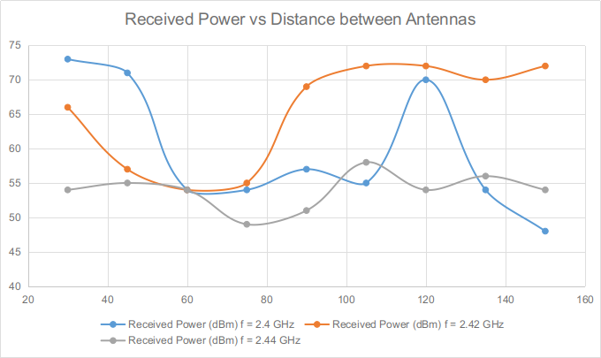

Figure 1 : Received Power (dB) vs Distance (cm) at different frequencies with Antenna1 connected at Transmitter and Antenna3 at Receiver

* 1. **Fade Profile of Both Transmitting Antennas connected along with a Receiver Antenna**

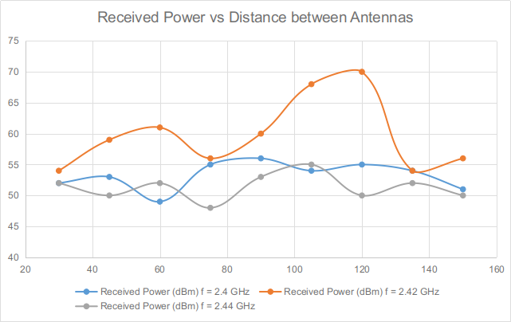

Figure 2 : Received Power (dB) vs Distance (cm) at different frequencies with both Antenna 1 and Antenna 2 connected

**4 ANALYSIS**

1. The fade plot shows variations of Receiver’s Antenna signal strength with distance.
2. When two antennas were simultaneously transmitting we varied a receiver antenna in between the two transmitting antennas from one end to other end and noted down the receiver signal strength to demonstrate Handoff.
3. **CONCLUSIONS**

Handover was demonstrated as the receiving antenna moved from one antenna end to another. Although, exact plots were not obtained due to disturbances in the laboratory, but, if we consider parts of the plot we could observe the process of handover on moving away from one station to another. After a certain distance the signal strength which was deteriorating on going away from one station improved as we moved closer to the other station.

1. **QUIZ**
2. **What is threshold level for power in mobile handset?**

Ans: The PBGT handover threshold ranges from 0 to 127, corresponding to –64 dB to +63 dB. The reference value for suburban areas is 68. The reference value for urban areas is 70 to 72.

1. **Cells are Hexagonal’? Give reason for Hexagonal Cells?**

Ans: Cells are Hexagonal because it covers whole geographical area without overlapping with neighbour cells.

1. **What could be the other cells shape possible? Give three examples and explain the relative merits /demerits.**

Ans: Consider below three possible cell structures.

• Triangular cell: Merit – No overlapping Demerit – Less coverage area

• Square cell: Merit – No overlapping Demerit – Moderate coverage area

• Circular cell: Merit – Maximum coverage area Demerit – Overlapping occurs or Void area remains.

1. **What can be done to increase the capacity of the cell?**

Ans: Frequency re-use.

1. **What is reuse factor? Give the typical cell reuse factor for GSM networks.**

Ans: The key characteristic of a cellular network is the ability to re-use frequencies to increase both coverage and capacity. Adjacent cells must use different frequencies, however there is no problem with two cells sufficiently far apart operating on the same frequency.

The frequency reuse factor is the rate at which the same frequency can be used in the network. It is 1/K, where K is the number of cells which cannot use the same frequencies for transmission. In case of N sector antennas on the same base station site, each with different direction, the base station site can serve N different sectors. N is typically 3. A reuse pattern of N/K denotes a further division in frequency among N sector antennas per site. Example: 3/4 (GSM)

1. **In mobile assisted handoff (MAHO), every mobile station measures the received power from surrounding base station and continually reports the results of the measurements to the saving base station. In this handoff strategy, when handoff will initiate.**

Ans: When power received from the neighbouring base station exceed the power from the current base station by a certain threshold for certain amount of time, at that time handoff is initiated.

1. **What is the range of handoff margin for GSM and value of handoff duration?**

Ans: Handoff margin - 6dB & Handoff duration – 1 to 2 seconds.

1. **What are the practical considerations of handoff?**

Ans: The following points must be taken into considerations.

• Umbrella cell concept: for removal of more number of hand-off for high speed user.

• Cell dragging problem, when handoff is not made for long even if the user is deep inside neighbouring cell. Because average signal strength at main cell is not decayed rapidly.