An Automated Named Entity Recognition System from Text

A project report submitted for the partial fulfillment of the

Bachelor of Technology Degree in

Computer Science & Engineering under
Maulana Abul Kalam Azad University of Technology by

Anshu Kumar

Roll No: 10400117192, Registration Number: 171040110031

Academic Session: 2017-2021

Under the Supervision of

Prof. Anupam Mondal



Department of Computer Science and Engineering Institute of
Engineering & Management

Y-12, Salt Lake, Sector 5, Kolkata, Pin 700091, West Bengal, India

Affiliated To



Maulana Abul Kalam Azad University of Technology

BF 142, BF Block, Sector 1, Kolkata, West Bengal 700064

June 2021



CERTIFICATE

TO WHOM IT MAY CONCERN

This is to certify that the project report titled “An Automated Named Entity Recognition System from Text”, submitted by Anshu Kumar, Roll No: 10400117192, Registration Number: 171040110031 student of Institute of Engineering & Management in partial fulfillment of requirements for the award of the degree of Bachelor of Technology in Computer Science & Engineering, is a bonafide work carried out under the supervision of Prof. Anupam Mondal during the final year of the academic session of 2017-2021. The content of this report has not been submitted to any other university or institute for the award of any other degree.

It is further certified that the work is entirely original and the performance has been found to be satisfactory.

_______________________

________________________

Prof. Anupam Mondal
Assistant Professor
Department of Computer Science and Engineering
Institute of Engineering & Management
Prof.(Dr.) Sourav Saha
H.O.D.
Department of Computer Science and Engineering
Institute of Engineering & Management

_______________________________________
Prof. Indraneel Mukhopadhyay
Principal

Institute of Engineering & Management

INSTITUTE OF ENGINEERING & MANAGEMENT



DECLARATION

FOR NON-COMMITMENT OF PLAGIARISM

I, Anshu Kumar, student of B.Tech in the Department of Computer Science and Engineering, Institute of Engineering & Management have submitted the project report in partial fulfillment of the requirements to obtain the above noted degree. I declare that I have not committed plagiarism in any form or violated copyright while writing the report and have acknowledged the sources and/or the credit of other authors wherever applicable. If subsequently it is found that I have committed plagiarism or violated copyright, then the authority has full right to cancel/reject/revoke our degree.

Name of the Student: Anshu Kumar

Full Signature: Anshu Kumar

Date: 24.06.2021

Contents

- Abstract………………………………………………….. 1

- Acknowledgement……………………………………….. 2

- Keywords…………………………………………………. 3

- Background Work……………………………………………... 4

- Motivations……………………………………………….. 5

- Proposed Methodology…………………………………………….. ..6-7

- Related Work……………………………………………..8-9

- Basic Underlying Concept

8.1 Future Relevance…………………………………… 9-10

8.2 Future Redundancy………………………………… 10-11

- Proposed Approach…………………………………….....11-13

- Algorithm…………………………………………………14-16

- Illustration……………………………………………….. 17-19

- Graph produced by GITAUFS on UCI data sets………20-22

- Experiments and Outcome

13.1 Summary of Outcome……………………………... 23

13.1.1 Comparison of Silhouette width value………… 23-24

13.1.2 Comparison of Feature Reduction…………….. 24-26

13.1.3 Comparison of Execution Time………………... 26-27

13.2 Overall Comparison Performance……………….. 27-28

- Conclusion……………………………………………... 29

- References……………………………………………… 30-31

1. Abstract

Named Entity Recognition (NER) is a subsequence of words in a document that seeks to detect and classify entities into pre-defined categories such as name of the person, organization and location respectively. The impact on NER is high because a lot of Information Extraction (IE) relations are associated using Named Entities (NEs). This paper presents a pioneering method for extraction of NEs for Tamil using Supervised Learning. This hybrid framework makes use of features that are extracted based on the speciality of the Tamil language NEs. The evaluation has been done by using 1028 number of documents which comprises the standard FIRE corpus and an F-measure of 83.54% has been achieved. A performance comparison with one of the state-of-the-art Tamil NE system has been done and the proposed methodology has achieved better accuracy.

1

2. Acknowledgements

I must not forget to acknowledge everyone who has provided constant support to me during our B.Tech course. First and foremost, I would like to express sincere gratitude to our supervisor Prof. Anupam Mondal for his continuous support and motivation in fueling the pursuance of carrying out this project endeavor. Without his guidance and persistent encouragement, this project work would not have been possible. He has been a tremendous mentor for us throughout this academic journey. Many of his academic advises about our career growth have been priceless.

I would like to convey sincere gratitude to Prof. Sourav Saha for providing me constant inspiration to stand firm against several setbacks throughout the course. Additionally, I would like to thank all the technical, non-technical and office staffs of our department for extending facilitating cooperation wherever required. I also express gratitude to all of our friends in the department for providing the friendly environment to work on the project work.

I would also like to thank our Director Prof. Satyajit Chakraborti for providing us an outstanding platform in order to develop our academic career. In addition, I also preserve a very special thankful feeling about our Principal Prof. Indraneel Mukhopadhyay for being a constant source of inspiration.

A special thank is due to our family. Words cannot express how grateful I am to my parents for all the sacrifices that they have made while giving me necessary strength to stand on my own feet.

Finally, I would like to thank everybody who has provided assistance, in whatever little form, towards successful realization of this project but with an apology that I could not mention everybody’s name individually.

2

3. Keywords

Keywords

Descriptions

NER

Named Entity Recognition.

NLP

Natural Language Processing.

EI

Entity Extraction.

FI

Feature Identifiaction.

3

4. Introduction

Over the past decade, contents on various media types such as, e-books, websites, blogs, documentaries, emails, chats have increased significantly. According to researcher [12], massive amount of data has been grown every day. Search engines need to process this massive information and provide precise results from the user query. Natural Language Processing (NLP) is an emerging domain of Computer Science related to the area of Human-Computer Interaction. It is the process of extracting meaningful information by processing the human languages. The major applications of NLP are Automatic Summarization, Sentiment Analysis, Navigation Systems, Information Extraction (IE), Question Answering, Word Sense Disambiguation (WSD) and Information Retrieval (IR). The goal of IE is extracting relevant information from unstructured or semi structured documents. The subdomains of IE are Named Entity Recognition (NER), Relationship extraction, Terminology Extraction and Audio Extraction. This paper presents a novel approach for building NER system for Any Text. NER in English gives an outstanding result due to the adequate of data and standard dataset also available such as MUC- 7[8], CoNLL-2002[14] to evaluate the accuracy.

- Tamil Language Challenges

The task of extracting entities from Tamil language is very challenging due to the following reasons:

Partially free word order: Tamil language has a partially free word order [13]. The meaning of the sentence will remain the same even if the positions of the subject, verb and the object are interchanged. In such cases the Person Name NE and Place NE identification becomes difficult. Sentences without subject, verb or object: In Tamil language, it is possible to construct a sentence without having subject, verb or object. This reduces the number of features that could be extracted to identify the NE.
No capitalization: Capitalization in English first feature that helps in identifying the possible NEs. In Tamil there is no capitalization which induces its own complexity in identifying the NEs.

4

Polysemic nature: Polysemy is the relationship of single word with two or more distinct meanings [5]. Some words are used to refer person name and name of the location. For example, Word Chidambaram refers to name of the person and sometime referred as Location.
Ambiguity: Word refers to different NE’s types based on the meanings. For example, Word Periyar (Noun, person name) can also be used as Periyar Street (Location).
Lack of Resources: No standard corpora, Online gazetteer’s list, Short words are not available for Tamil language to identify the entities.
Regular Expression, POS Tagger and the Contexts are used as the features. The proposed approach attempts to overcome the above said challenges by using these features in a fixed hierarchical manner. This alleviates the complexities involved in identifying the Tamil NEs.
In sum, the contributions of the proposed approach are twofold.
- Design of Unique algorithm to extract features using REGEX (Regular Expression) Feature Extraction, Morphological Feature Extraction, Context Feature Extraction in the specified order.
- Incorporation of word level Naïve Bayes classification to classify the entities.
To the best of our knowledge, this research is the extracting and classifying the NEs in Tamil languages that uses word level Naïve Bayes classification. The rest of the paper is organized as follows:
Section 2 contains Background details about NER, Section 3 discusses Literature Survey, Section 4 demonstrates the proposed approach to identifying and extracting entities from Forum for Information Retrieval (FIRE), Section 5 contains the Results and Discussion obtained and Section 6 describes the Conclusions.

5

5. Background

NER is the process of extracting entities such as person name, organisation name, date, time, money and location. Extracting entities from documents is one of the challenging tasks and it is essential for NLP applications. NER has been done for various languages such as English, Turkish, Spanish, and also for Indian languages. NEs are extracted by using Rule-based approach, Learning-based approach and Hybrid-based approach [16]. Early works on NER mainly focused on Rule based approach. Rule based approach is a methodology consists of hand coded rules to identify the entities with the help of generic resources such as gazetteers or dictionaries. It follows syntactic rules to extract and classify the named entities. It takes a lot of human efforts to generate the hand coded rules. The major drawbacks of rule-based approach are domain specific and time consuming [15,16]. Learning based approaches can be broadly classified as unsupervised, supervised and semi-supervised approaches [4]. Supervised Learning approaches are based on the knowledge of providing labelled training data, annotated by domain experts manually [16]. The labelled data is used to train the model which is further used to identify and classify the named entities to the test data. Semi-supervised approaches use a small amount of labelled training data called seed data. Seed data is mostly used to identify the context features or pattern to each named entity category. The identified pattern is used to extract the entities in the test data. Unsupervised learning approaches are use unlabelled data to classify the named entities. These approaches always rely on statistical techniques, Wordnet, Similarity context between words on a large unannotated corpus [18]. Hybrid Learning approaches that combines Rule-based techniques and Learning based approaches.

6

6. Motivations

Many techniques have been used to obtain the outstanding result in NER due to abundance of data. Researchers are moved towards the supervised approaches such as Support Vector Machine (SVM) [1], Hidden Markov Model (HMM) [3,7,8,10], Conditional Random Field (CRF) [3,6] due to exponential growth on data.
Zhenfei Juet has used a Support Vector Machine (SVM) to recognize the named entity in biomedical abstracts [1]. The author has used a Genia corpus that consists of around 4,60,000 words approximately and obtains a precision of 84.24%. Xia Han et. al. showed that semantic model feature selection combines SVM and K- Nearest Neighbour (KNN) algorithm named as EK-SVM- KNN (Extending K value SVM-KNN) algorithm. It enhanced the quality of NER and made great contribution to the unstructured information process and obtains the F- Measure of 85.6% [9].
Branimir T. Todorovic et. al. has shown the Context HMM is approximately twice faster in both training and classification, and has larger precision (94.88%), recall (93.62%) and F-measure (94.24%) than our implementation of Bikel's HMM [7] named entity recognizer [8]. Branimir used a standard dataset as MUC- 7 text corpus and produced the best result compared to Bikel’s HMM.
Kishorjit Nongmeikapam et. al. built a Conditional Random Field (CRF) model to extract the NER from Manipuri language. It is difficult to extract NER from Manipuri language which is relatively free word order. The author had used a standard corpus to evaluate the CRF model and achieve F-score of 83.33%.
Dilek Kucuk and Adan Yazici proposed a preliminary version of hybrid named entity recognizer or Turkish language [17]. The author has extracted the feature using Rule-based approach and identify the named entities using Rote learning component. Evaluation dataset include the genres of news text, financial news text, child stories historical text and also extract entities from video dataset. This hybrid approach produced a significant result for Turkish texts and news videos. N. Jeyashenbagavalli et. al. recommended a hybrid approach that merge both Rule- based and the machine learning approach to achieve high F-measure score [10]. Initially, classifier is trained using a small number of labelled sentences with all the features. The process continues until all the unlabelled sentences to be included into the training set.

7

. The proposed method can learn features using Rule-based approach and applied to HMM and Expectation-Maximization (EM) model to extract entities from Tamil documents. To the best of our knowledge, Hybrid approach combine Rule based approach with Naïve Bayes (NM) have never been attempted to extract entities in Tamil news documents. There was some research conducted on extracting entities from Tamil documents which includes Hidden Markov Model. Our proposed approach is completely different and tested using Fire corpus and produce an outstanding result

8

7. Proposed Approach

The proposed NER approach mainly includes Feature Extraction and Entity Identification. Fig. 1 shows the architecture of the proposed NER model which describes the sequence of steps involved in the proposed system.

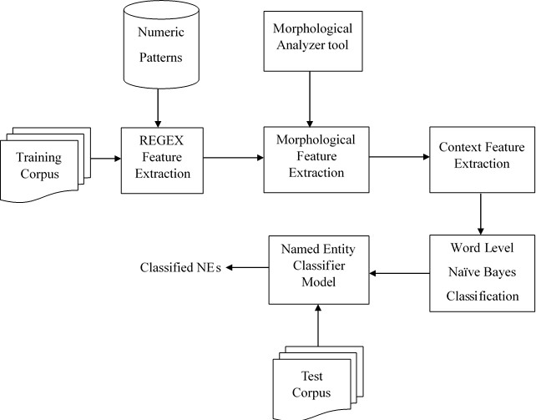

Fig. 1 Architecture of classifier model

Training data of 4111 documents containing 73891 words from news articles in Tamil are taken from the Forum for Information Retrieval Evaluation (FIRE). In 2008, FIRE initiated the new challenges in multilingual information access and a series of FIRE are conducted to evaluate the researches in IE. As the FIRE progressed, the research work on IE has focused on various domains, such as NER, Sentimental Analysis, Question Answering and Information Retrieval [11]. The first step is to extract the features by using Regular Expression (REGEX) feature extraction. Later, Morphological Feature Extraction and Context Feature Extraction are used to identify and extract the features. Once the features are extracted, Naïve Bayes algorithm are used to identify the NEs in the FIRE corpus. The test data which consist of 1028 documents containing 21,316 words approximately.

- Regex Feature Extraction

Extracting features using Regex were introduced by
M. Collins [19]. Regular expression patterns are the one that successfully extract these numerical data effectively.

9

This is the most effective way to extract features of the date and time entities. Since the corpus contains information about news in Tamil which mostly describes date and time entities that are expressed in number. Regex is used to extract features for Date and Time NEs from the corpus which has more than 1,50,000 words. Once the numeric entities are identified, the volume of data gets reduced. It helps to reduce the complexity of the next step. Once the REGEX features are extracted, it should in a separate class. Table 1 describes some of the patterns for numerical entities.

TABLE I FEATURES FOR DATE AND TIME ENTITY
Patterns | Date and Time Entities  Identified
[[0-9] [0-9]-[[A-Z] *] - [2] [0-9] [0-9] [0-9]] | 12-June-2021
[0-9] [0-9] - [0-1] [0-9] – [0-9] [0-9] | 12-06-2021
[0-9] [0-2] [[:] | [.]] [0-5] [0-9] | 11.52

- Morphological Feature Extraction

Morphological analyser is used to identify the Parts- Of-Speech (POS) and the case markers. Morphological analyser is very essential for rich inflectional languages like, Tamil, Malayalam, Telugu etc. Case markers are given by the Morphological Analyser is used as the morphological features to classify the NEs appropriately. For instance, In the Example 1, it clearly describes the morphological features of the word நதுரபயி஬் . Here இ஬் is the Locative Case aids in classifying the Location NE. Similarly, a list of case markers is shown in
the table 2 are used to classify the NEs appropriately. A word need not necessarily have a case marker in it. In most of the time NEs, case markers will not be present. Such cases, the context feature extraction technique is used to classify the NEs which is explained in the next section.

TABLE II CASEMARKERS
Word | Morphological Analyzer | Morphological  Features
நதுரபயி஬் | நதுரப< Entity >  ன்< Sandhi >  இ஬்< Locative Case> | இ஬்  (Location NE)
சு஥த் பதது் க்கு | சு஥த் பந்< Entity >  அதது் < Oblique >  உக்கு< Dative Case > | உக்கு  < Dative Case >

12

- Context Feature Extraction

Context Features are extracted using the words Co- occurring along with the Entities identified by the Morphological Analyser. The Context Features are extracted using a context window of words surrounding the Entities. It forms a pattern which could fall in the following categories. The pattern consists of three-words which can fall into three types of context windows namely, (w_{i-1,} w_{i}) or (w_{i}, w_{i+1}) or (w_{i-1,} w_{i}, w_{i+1}). The NEs are identified using the features extracted from the context window. The bootstrapping approach makes use of the initially identified features and also the NEs identified using these features as the seed set. This initial seed set is augmented in an iterative fashion. The Yarowsky algorithm is the first bootstrapping algorithm to become widely known in Word Sense Disambiguation [2,4].
In above mentioned example1 ஜ஛னகுநாப (jeyakumar) is an entity identified with the help of seed features. By applying Bootstrapping technique, we can identify the new feature தாசி஬்தாப் (Tahsildar) with the existing entity ஜ஛னகுநாப ் (jeyakumar) as shown in in example 2. The process is repeated until no different NES are learnt.

Example 1
திரப஧்஧டஇனக்கு஦பஜ஛னகுநாபஅவபக்
஭்,1959-ஆந்வருடந்அக்டடா஧பநாதந் 2-ஆந்டததிபி஫஥த் ாப.்
 | Wi  -1 | Wi | Wi+1
Meaning: Film director Jayakumar was born on the 2nd of
October 1959

Example 2
சங் கபாபுபந்அருடகநண஬்கடததி் னடிபாக்டரப
தாசி஬்தாபஜ஛னகுநாப஧றிமுத஬்ஜசன் தாப்
 |  |  |  | Wi-  1 | Wi | Wi+1
Meaning: Tasildar Jayakumar confiscated the tractor's
sand tuner near Sankarapuram

13

- Feature Classification algorithm

After identifying all the features, it is possible to group into three different feature sets: features found using Regular Expression, features found from POS, and features based on Context Window. Table 3 describes the various features falling under the three main categories namely, Regex Feature Extraction, Morphology Feature Extraction and Context Feature Extraction.
Feature Extraction algorithm is used to classify the features to identify the different types of entities namely, Person, Organization, Location, Date and Time.

Input: Collection of Sentences (Cs)

Output: Person name (PF) or Organization name (OF) or Location (LF) or Date(D) or Time(T)

Notations: Regex represents Regular Expression Technique

Moa represents Morphological Analyzer
Cw represents Context Window
Technique N represents Noun

F1, F2, F3, F4, F5, F6, F7, F8, F9, F10 areFeatures

Step 1: Read S1, S2, S3 . . . Sn where S represents a sentence

Step 2: For W1, W2, W3 . . . Wn
If W1 follows F1
classify the Features in either D or T
Else if W1 as Noun and follows F2 || F4 || F6 ||F8 (ByApplying Moa)
classify the Features in PF
Else if W1 follows F3||F5||F7||F9||F10(By Applying Cw)
classify the Features in either PF or OF or LF Else W1 is not an entity
Step 3: Continue with Naïve Bayes (For determining Class Probability, Conditional Probability, Predicted class)

Step 4: Exit

14

TABLE III. FEATURE SET
Type | Features | Feature Name
Regular  Expression | F1 | Date, Time
Morphological Analyzer | F2 | Parts of speech of Individual  words
Morphological Analyzer | F3 | Preposition
Context Window | F4 | Prefixed by Salutation  Words (Person name)
Context Window | F5 | Prefixed by Substring (Person, Organization,  Location)
Context Window | F6 | Suffixed by Salutation  Words (Person name)
Context Window | F7 | Suffixed by Substring  (Person, Organization, Location)
Context Window | F8 | Gazetteers (Person)
Context Window | F9 | Previous word of size 3
Context Window | F10 | Next word of size 3

- NE Classification Using Naive Bayes

Naïve Bayes is a supervised machine learning algorithm based on baye’s theorem. Naive Bayes is a probabilistic classifier and assumes that each feature is independent while classifying the NEs. Let the NE classes be represented Ci. The class of an NE(Ci) is identified when a set of features are given, using the posterior probability(ref). This is done by calculating the conditional probability of a particular class Ci signalled by the feature vectors w = (PF, OF, LF, DF, TF).PF represents the person name feature set, where PF= (w1, w2, …., wn) represents independent features belong to person name. Likewise, each entity has a different feature set which mentioned in the above algorithm.

(1)

In NB, calculate the individual probability of a feature are shown in Equation 2.
(2)

P(C_{i}) calculates the prior probability are shown in the Equation 3.
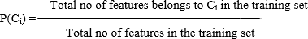 (3)
P(w|C_{i}) computes the conditional probability for the class C_{i}.

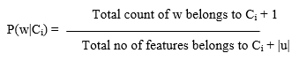
(4)

15

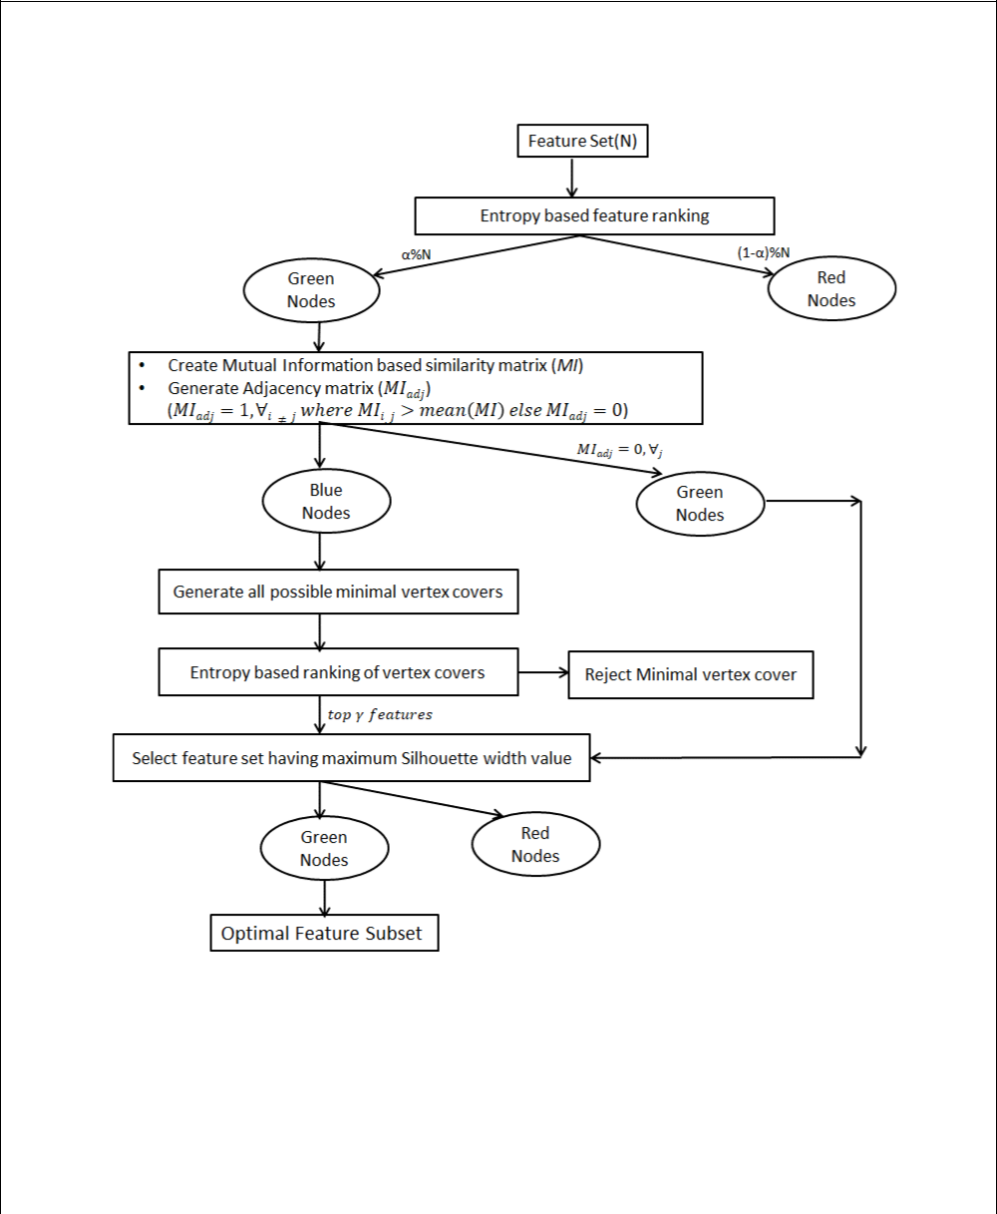

F

16

11. Illustration

In this section, the three stages of GITAUFS approach have been illustrated with the help of generated graphs with color codes representing the selected and rejected vertices after each pruning stage.

Stage•-1: The initial filtering is carried out according to the entropy E of each attribute using Eqn. 2 as described in Section 4. The top α% of attributes are chosen for the next stages (they are colored “green”) and the rest are discarded (colored “red”). In Fig. 3(a), “At2” and “At4” are filtered out from the list of seven attributes.

Stage-2: The mutual information (MI) of each of the “green” attributes is calculated using Eqn. 3 mentioned earlier. The mean ̅̅̅̅ of the resulting similarity matrix is used as threshold to distinguish potentially redundant features from others. An adjacency matrix MI_{ad j} =1, ∀_{i≠j} if MI_{i,j} > ̅̅̅̅ and MI_{ad j}=0, ∀_{i=j}. The features having a higher than average mutual information is grouped into a subset (colored “blue”). “At5” is not a redundant attribute and is selected as a final attribute (colored “green”) for

Stage 3, as shown in Fig 3(b). After this, the attributes having mutual information M_{i,j} > ̅̅̅̅ are connected by edges to form the graph also depicted in the figure.

17

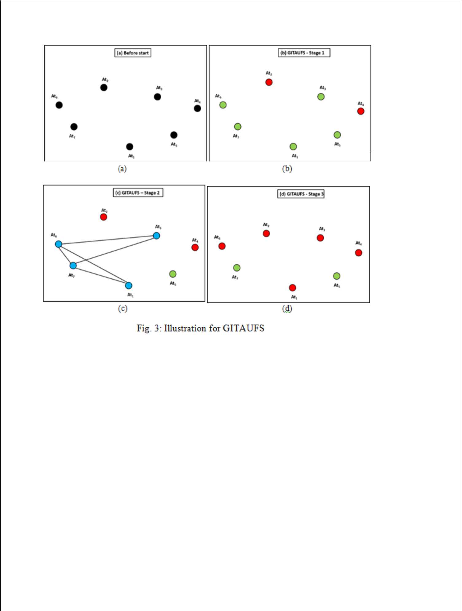

MI | = | A ₁ | A ₁ | A ₃ | A ₅ | A ₆ | A ₇
MI | = | A ₁ | 1.34 | 0.12 | 0.24 | 0.69 | 0.56 | ̅̅̅̅̅ | = 0.46
 |  | A ₃ | 0.12 | 1.37 | 0.15 | 0.54 | 0.58 | ̅̅̅̅̅ | = 0.46
 |  |  |  |  |  |  |  | , | = 0.46
 |  | A ₅ | 0.24 | 0.15 | 1.38 | 0.32 | 0.17
 |  | A ₆ | 0.69 | 0.54 | 0.32 | 1.38 | 0.68
 |  | A ₇ | 0.56 | 0.58 | 0.17 | 0.68 | 1.37
 |  |  | A ₁ | A ₃ | A ₅ | A ₆ | A ₇
MIadj | = | A ₁ | 1.34 | 0.12 | 0.24 | 0.69 | 0.56
 |  | A ₃ | 0.12 | 1.37 | 0.15 | 0.54 | 0.58
 |  | A ₅ | 0.24 | 0.15 | 1.38 | 0.32 | 0.17
 |  | A ₆ | 0.69 | 0.54 | 0.32 | 1.38 | 0.68
 |  | A ₇ | 0.56 | 0.58 | 0.17 | 0.68 | 1.37

Stage•-3: The final selection of vertices is done from the “blue” vertices. The vertices/attributes marked “green” in Stage 2 are directly selected into the final feature subset. Minimal vertex

18

cover (MVC) is run on features marked ‘blue’ in Stage 2. The minimal vertex algorithm returns all possible minimal vertex covers which the top γ minimal vertex covers having high entropy are further evaluated along with features marked ‘green’ in Stage 2 on the basis of silhouette value. The subset having highest silhouette width value is the most final feature subset derived by GITAUFS. These features are marked ‘green’ such as “At7”, is chosen (colored “green”) while the others, such as “At1”, “At3” and “At6” are rejected (colored “red”), as shown in Fig. 3(c).

Data set | # of Features | # of Instances
Apndcts | 7 | 106
Btissue | 9 | 106
Cleave | 13 | 297
Ecoli | 7 | 336
Glass | 9 | 214
ILPD | 10 | 579
Mfeat | 649 | 2000
Pima | 8 | 768
Sonar | 60 | 208
Vehicle | 18 | 846
Wbdc | 30 | 569
Wine | 13 | 178
Wiscon | 9 | 682

Table 1: Description of UCI data sets

19

12. Graphs produced by GITAUFS on UCI data sets

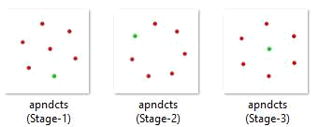

Fig 4: Illustration of ‘apndcts’ dataset

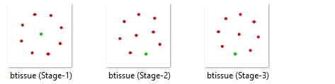

Fig 5: Illustration of ‘btissue’ dataset

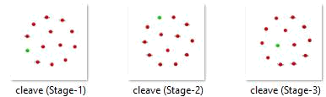

Fig 6: Illustration of ‘cleave’ dataset

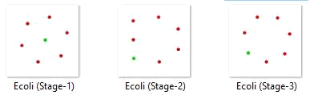

Fig 7: Illustration of ‘Ecoli’ dataset

20

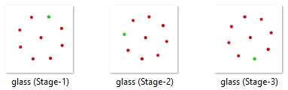

Fig 8: Illustration of ‘glass’ dataset

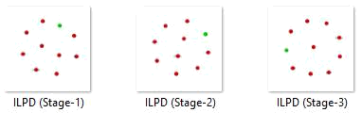

Fig 9: Illustration of ‘ILPD’ dataset

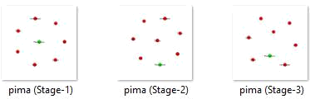

Fig 10: Illustration of ‘pima’ dataset

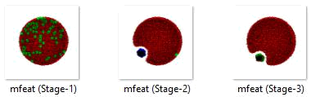

Fig 11: Illustration of ‘mfeat’ dataset

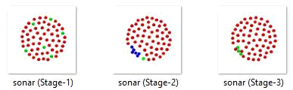

Fig 12: Illustration of ‘sonar’ dataset

21

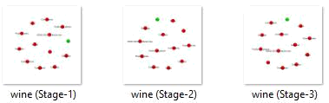

Fig 13: Illustration of ‘wine’ dataset

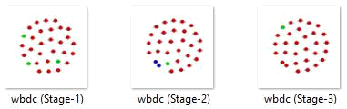

Fig 14: Illustration of ‘wbdc’ dataset

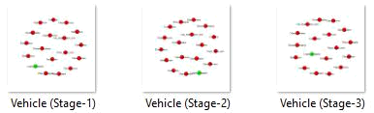

Fig 15: Illustration of ‘Vehicle’ dataset

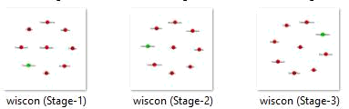

Fig 16: Illustration of ‘wiscon’ dataset

22

13. Experiments and Outcome

Our approach has been benchmarked on data sets obtained from the UCI Machine Learning repository. Our graphs have been generated using the ‘matplotlib’ library in Python. Table 1 depicts the summary of the characteristics of the data sets used for experimenting. The value of α is 10% in this experiment. GITAUFS has been compared with two graph-based feature selection algorithms - DSUB and UFAM and two benchmark feature selection algorithms - Laplacian and Principal Feature Analysis (PFA).

13.1 Summary of Outcome

The proposed algorithm (GITAUFS) has been evaluated for its performance by com- paring it with other competing algorithms based on three main aspects - silhouette width value, percentage of feature reduction and execution time. The following sub-sections describe the comparative results obtained in each of these aspects.

13.1.1 Comparison of Silhouette Width Value

Dataset | GITAUFS | UFAM | ALL | LAPLACIAN | PFA | DSUB
apndcts | 0.66 | 0.6 | 0.46 | 0.44 | 0.48 | 0.43
Btissue | 0.65 | 0.62 | 0.58 | 0.56 | 0.53 | 0.58
Cleave | 0.55 | 0.31 | 0.27 | 0.57 | 0.58 | 0.27
Ecoli | 0.54 | 0.54 | 0.44 | 0.56 | 0.47 | 0.44
Glass | 0.59 | 0.61 | 0.52 | 0.54 | 0.53 | 0.52
ILPD | 0.86 | 0.71 | 0.49 | 0.72 | 0.72 | 0.49
mfeat | 0.20 | 0.2 | 0.24 | 0.18 | 0.14 | 0.19
Pima | 0.56 | 0.27 | 0.51 | 0.27 | 0.27 | 0.24
Sonar | 0.41 | 0.17 | 0.47 | 0.19 | 0.12 | 0.39
Vehicle | 0.62 | 0.52 | 0.32 | 0.43 | 0.38 | 0.47
wbdc | 0.55 | 0.44 | 0.65 | 0.49 | 0.29 | 0.4
Wine | 0.57 | 0.4 | 0.002 | 0.35 | 0.31 | 0.32
wiscon | 0.63 | 0.69 | 0.19 | 0.66 | 0.65 | 0.65
 | Table 2: Performance of silhouette width
 |  |  | 23

The silhouette width values for the proposed algorithm GITAUFS along with other competing algorithms UFAM, LAPLACIAN, PFA, and DSUB have been recorded in Table 2. The column corresponding to ALL contains silhouette width values all features of the dataset.

A graphical comparison of the performance of silhouette width value has been presented in Fig. 4. From Table 2 and Fig. 4 it is evident that GITAUFS has outperformed the benchmark algorithms. GITAUFS has recorded the highest or the near highest silhouette width value for all the data sets used. The summary of the comparison based on silhouette width value is given below.

•
GITAUFS •has the highest silhouette width value for 6 out of 13 data sets used in the experiment. For the other data sets where GITAUFS does not have highest silhouette width value, it is giving value very close to the best value. GITAUFS has outperformed both the benchmark algorithms - Laplacian and PFA with respect to silhouette width value is given below-

GITAUFS• has the highest silhouette width value for 6 out of 13 data sets used in the experiment.

For the• other data sets where GITAUFS does not have highest silhouette width value, it is giving value very close to the best value.
GITAUFS• has outperformed both the benchmark algorithms - Laplacian and PFA with respect to silhouette width value.

13.1.2 Comparison of feature reduction

The percentage of feature reduction for GITAUFS and other competing algorithms has been presented in Table 3. Graphical representation of the comparison has been shown in Fig. 5.

GITAUFS has shown a very high percentage of feature reduction for all the data sets when compared to the benchmark algorithms. An overview of the comparison for feature reduction is given below-

24

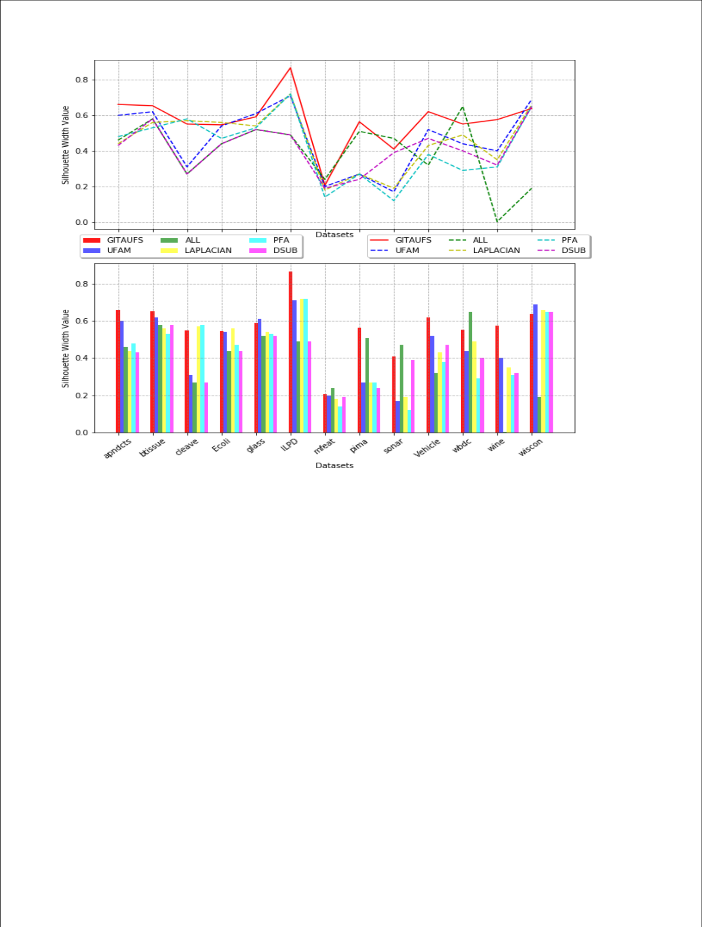

Fig 17: Performance of Silhouette Width

Dataset | GITAUFS | UFAM | PFA | LAPLACIAN | DSUB
Apndcts | 85.71 | 50 | 57.14 | 57.14 | 71.43
Btissue | 88.89 | 62.5 | 55.56 | 55.56 | 66.67
Cleave | 92.31 | 25 | 23.08 | 23.08 | 76.92
Ecoli | 85.71 | 33.33 | 28.57 | 28.57 | 71.43
Glass | 88.89 | 37.5 | 33.33 | 33.33 | 77.78
ILPD | 90 | 44 | 30 | 30 | 70
mfeat | 91.68 | 29.78 | 85.82 | 85.82 | 99.69
Pima | 87.5 | 14.29 | 12.5 | 12.5 | 75
Sonar | 95 | 44.07 | 63.33 | 63.33 | 68.33
Vehicle | 94.44 | 35.29 | 72.22 | 72.22 | 88.89
wbdc | 96.67 | 31.03 | 76.67 | 76.67 | 93.33
wine | 92.31 | 25 | 38.46 | 38.46 | 84.62
wiscon | 88.89 | 37.5 | 33.33 | 33.33 | 77.78

Table 3: Percentage feature reduction

25

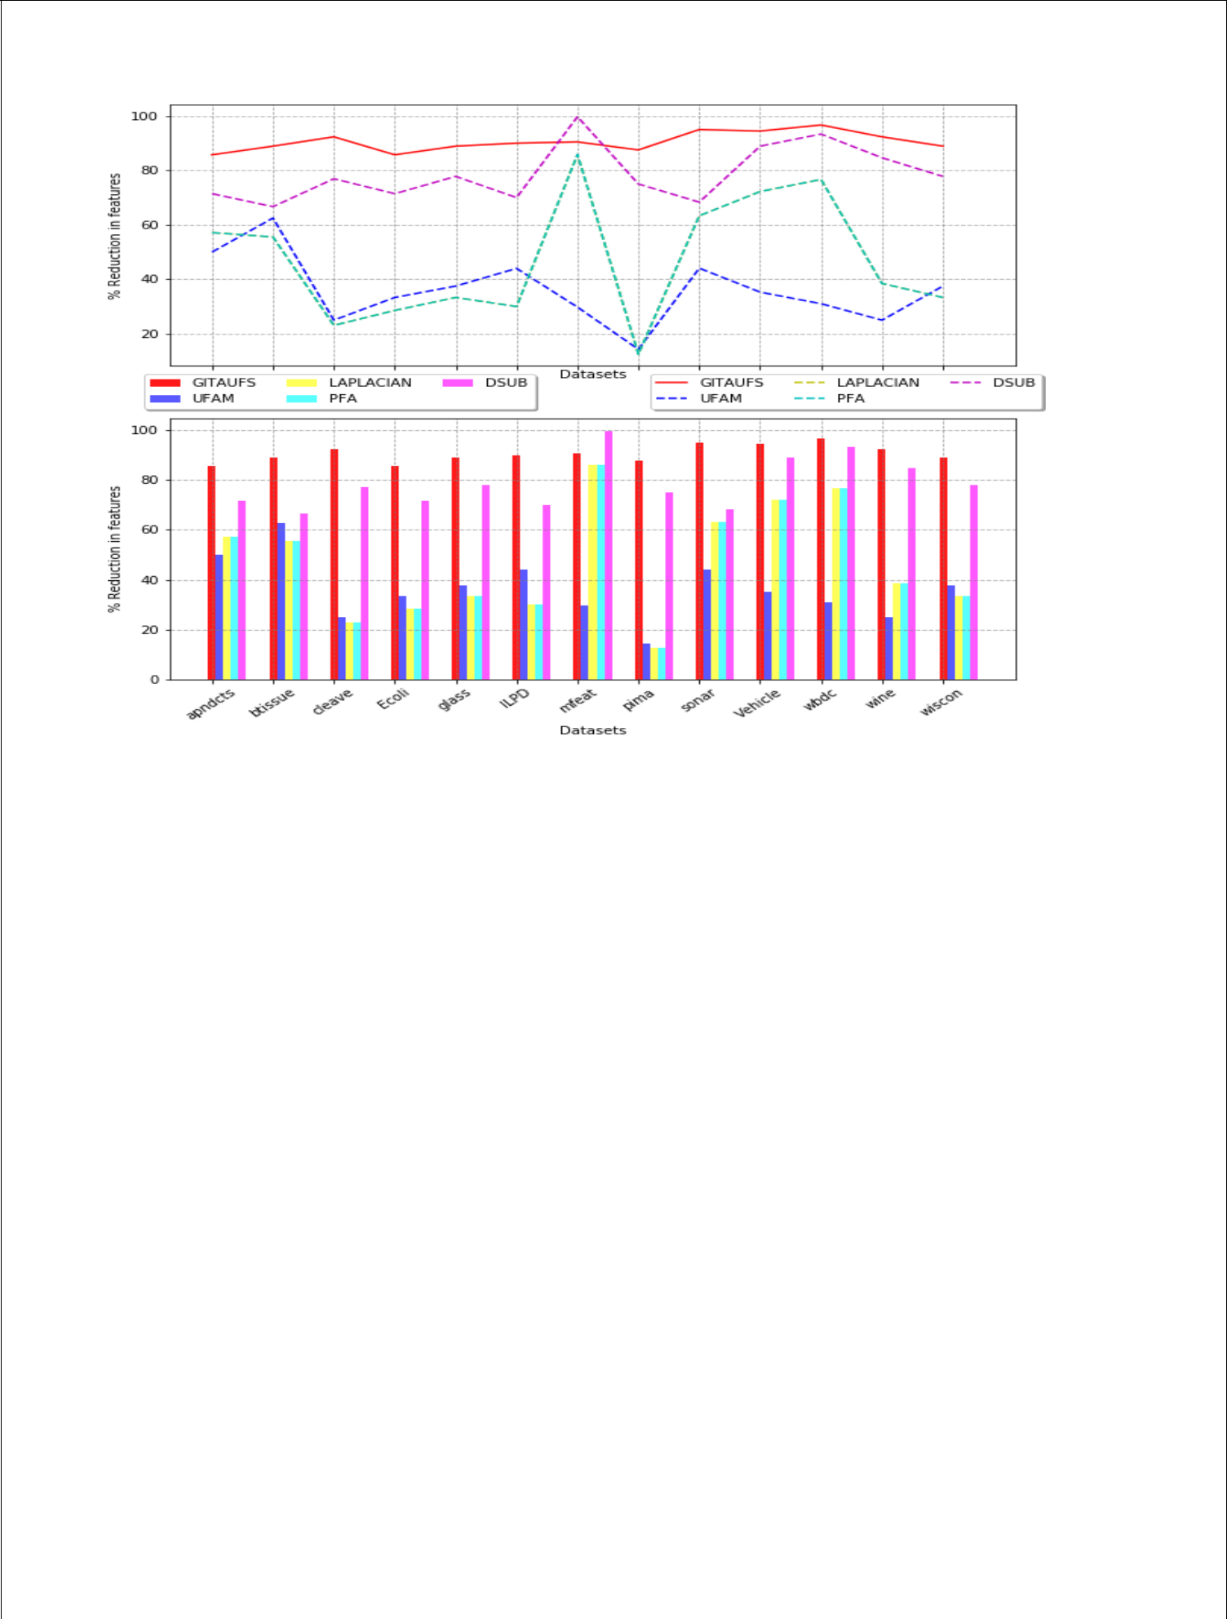

Fig 18: Feature reduction

GITAUFS• has shown the highest reduction in the number of features compared to the competing algorithms for all the data sets except ‘mfeat’ where DSUB has a higher reduction in the number of features. However, GITAUFS has a better silhouette width value than DSUB for ‘mfeat’ justifying its efficiency.

GITAUFS has the highest feature reduction as high as 96.67% and the lowest being 85.71% which is also very high compared to the other competing algorithms.

GITAUFS has performed extremely good for high dimensional data set giving a reduction in features exceeding 91%.

13.1.3 Comparison of execution time

The values representing the execution time for GITAUFS and other

competing algorithm is shown in Table 4. Execution time for

GITAUFS is very close to benchmark algorithms. A summary of the

conclusions drawn on comparing the execution time is given below-

26

Dataset | GITAUFS | UFAM | PFA | LAPLACIAN | DSUB
Apndcts | 0.17 | 0.39 | 0.15 | 0.12 | 0.58
Btissue | 0.25 | 0.4 | 0.18 | 0.15 | 0.09
Cleave | 0.90 | 0.4 | 1.74 | 0.17 | 0.16
Ecoli | 1.37 | 0.41 | 1.27 | 0.1 | 0.09
Glass | 0.61 | 0.41 | 0.46 | 0.12 | 0.11
ILPD | •1.09 | 0.39 | 9.58 | 0.2 | 0.11
mfeat | 854.13 | 2.63 | 41,034.06 | 25.99 | 1,531.69
Pima | 1.17 | 0.39 | 23.9 | 0.14 | 0.1
Sonar | 0.96 | 0.02 | 2.63 | 0.75 | 2.63
Vehicle | 2.74 | 0.47 | 65.5 | 0.14 | 0.3
wbdc | 1.03 | 0.01 | 32.4 | 0.27 | 0.52
Wine | 0.34 | 0.38 | 0.62 | 0.16 | 0.14
wiscon | 0.67 | 0.4 | 17.78 | 0.13 | 0.11

Table 4: Execution time(in seconds)

The execution time for GITAUFS is almost similar to that of

benchmark algorithms.
For high• dimensional data sets like ‘mfeat’, GITAUFS has a fairly acceptable execution time. DSUB has almost double execution time for ‘mfeat’ and the execution time of PFA is almost 48 times higher than GITAUFS

13.2 Overall comparison of performance

An overall comparison of GITAUFS has been done in Table 5 with benchmark algorithms. Summary of the silhouette width performance is given in Table 6. A graphical representation of mean rank for various competing algorithms based on silhouette width value is shown in Fig. 6.

Algorithm | Mean | Mean | Mean Feature
 | Silhouette | Execution | Reduction(%)
 | Width | Time(s)
GITAUFS | 0.57 | 66.58 | 90.62
UFAM | 0.47 | 0.52 | 36.1
LAPLACIAN | 0.46 | 2.19 | 46.92
PFA | 0.42 | 168.48 | 46.92
DSUB | 0.41 | 118.2 | 78.61
Table 5: Comparison of different algorithms

27

Observations made from the Table 5, Table 6 and Fig. 6 are described below-

Algorithm | Mean | Number of
 | Rank | Wins/Ties
HITAUFS | 1.85 | 6
UFAM | 2.77 | 2
ALL | 3.85 | 3
LAPLACIAN | 3.23 | 1
PFA | 4.15 | 1
DSUB | 4.38 | 0

Table 6: Summary of Performance (Silhouette Width)

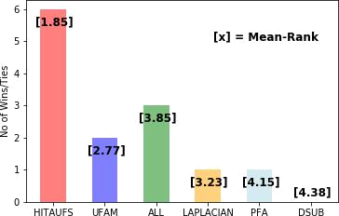

Fig. 19: Wins/Ties for silhouette width value

GITAUFS has higher silhouette width value than all the other competing algorithms. The mean rank for GITAUFS is the lowest which indicates that GITAUFS has the best silhouette value for most of the data sets used. GITAUFS has the highest number of wins based on

its performance of silhouette width.
Feature• reduction is the highest for GITAUFS. GITAUFS has a mean feature reduction of 90.62% which is very high in general and specially high when compared with other competing algorithms.

The •execution time for GITAUFS is similar to other competing algorithms as seen in Table 4. For high dimensional data sets UFAM has best execution time. However GITAUFS also has better than average execution time for high dimensional data sets.

28

14. Conclusion

The proposed approach, GITAUFS, has shown significant feature reduction of 90.62% which is 12% higher than the next best performing algorithm. GITAUFS also gives a high silhouette width value of 57% with the lowest mean rank among other competing algorithms and stands out as the best performer. GITAUFS is an information theoretic approach which captures the general dependency between features. GITAUFS also addresses the challenge of finding the minimal vertex covers being an NP hard problem by evaluating multiple minimum vertex cover. GITAUFS has an added advantage of being a graph-based approach which provides the visualization of all the stages of the algorithm. The graphical representation of features as vertices of a graph gives a visual understanding of the relevance of features and similarity between features. GITAUFS has overall best performance when compared to the benchmark algorithms for the experimental set-up.

29

- References

  - Bache, K., Lichman, M.: Uci machine learning repository [http://archive. ics. uci. edu/ml]. irvine, ca: University of california. School of information and computer science 28 (2013)

  - Bandyopadhyay, S., Bhadra, T., Mitra, P., Maulik, U.: Integration of

dense subgraph finding with feature clustering for unsupervised feature selection. Pattern Recognition Letters 40, 104–112 (2014)

- Battiti, R.: Using mutual information for selecting features in supervised neural net learning.

- Bennasar, M., Hicks, Y., Setchi, R.: Feature selection using joint mutual information maximi- sation. Expert Systems with Applications 42(22), 8520–8532 (2015)

- Brown, G., Pocock, A., Zhao, M.J., Luj a´n, M.: Conditional

- likelihood maximisation: a uni- fying framework for information theoretic feature selection. Journal of machine learning re- search 13(Jan), 27–66 (2012)

- Das, A.K., Goswami, S., Chakrabarti, A., Chakraborty, B.: A new hybrid feature selection approach using feature association map for supervised and unsupervised classification. Expert Systems with Applications 88, 81–94 (2017)

- Das, A.K., Goswami, S., Chakraborty, B., Chakrabarti, A.: A graph-theoretic approach for vi- sualization of data set feature association. In: Advanced Computing and Systems for Security, pp. 109–124. Springer (2017)

- Dey Sarkar, S., Goswami, S., Agarwal, A., Aktar, J.: A novel feature selection technique for text classification using naive bayes. International scholarly research notices 2014 (2014) 9.Ding, C., Peng, H.: Minimum redundancy feature selection from microarray gene
expression
data. Journal of bioinformatics and computational biology 3(02), 185–205 (2005)
- Feng, S., Duarte, M.F.: Graph autoencoder-based unsupervised feature selection with broad and local data structure preservation. Neurocomputing 312, 310–323 (2018)

- Goswami, S., Das, A.K., Guha, P., Tarafdar, A., Chakraborty, S., Chakrabarti, A., Chakraborty, B.: An approach of feature selection using graph-theoretic heuristic and hill climbing. Pattern Analysis and Applications pp. 1–17 (2017)

- Gu, Q., Li, Z., Han, J.: Generalized fisher score for feature selection. arXiv preprint arXiv:1202.3725 (2012)

30

- Hall, M.A.: Correlation-based feature selection for machine learning (1999)
- He, X., Cai, D., Niyogi, P.: Laplacian score for feature selection. In:

Advances in neural information processing systems, pp. 507–514 (2006)

- Hua, J., Tembe, W.D., Dougherty, E.R.: Performance of feature-selection methods in the clas- sification of high-dimension data. Pattern Recognition 42(3), 409–424 (2009)

- Lewis, D.D.: Feature selection and feature extraction for text categorization. In: Proceedings of the workshop on Speech and Natural Language, pp. 212–217. Association for Computa- tional Linguistics (1992)

- Lu, Y., Cohen, I., Zhou, X.S., Tian, Q.: Feature selection using principal feature analysis. In: Proceedings of the 15th ACM international conference on Multimedia, pp. 301–304. ACM (2007)

- Meyer, P.E., Schretter, C., Bontempi, G.: Information-theoretic feature selection in microarray data using variable complementarity. IEEE Journal of Selected Topics in Signal Processing 2(3), 261–274 (2008)

- Moghaddam, B., Pentland, A.: Probabilistic visual learning for object detection. In: Proceed- ings of IEEE international conference on computer vision, pp. 786–793. IEEE (1995)

- Moradi, P., Rostami, M.: A graph theoretic approach for unsupervised feature selection. En- gineering Applications of Artificial Intelligence 44, 33–45 (2015)

- Moradi, P., Rostami, M.: Integration of graph clustering with ant colony optimization for fea- ture selection. Knowledge-Based Systems 84, 144–161 (2015)

- Murphy, K., Torralba, A., Eaton, D., Freeman, W.: Object detection and localization using lo- cal and global features. In: Toward Category-Level Object Recognition, pp. 382–400. Springer (2006)

- Ng, K., Liu, H.: Customer retention via data mining. Artificial Intelligence

- Quinlan, J.R.: C4. 5: programs for machine learning. Elsevier (2014)
- Xing, E.P., Jordan, M.I., Karp, R.M.: Feature selection for high-dimensional

genomic microar- ray data. In: ICML, vol. 1, pp. 601–608. Citeseer (2001)

- Yang, H.H., Moody, J.: Data visualization and feature selection: New algorithms for nongaus- sian data. In: Advances in neural information processing systems, pp. 687–693 (2000) 27.Zhang, Z., Hancock, E.R.: A graph-based approach to feature selection. In: International

Workshop on Graph-Based Representations in Pattern Recognition, pp. 205–

  - Springer (2011)

31

