**My Challan App – Deliverable - 2**

|  |  |  |
| --- | --- | --- |
| **Version** | **Date** | **Description** |
| Inception Draft | Nov 12, 2021 | First Inception Draft, will be refined during elaboration. |
| Elaboration Draft | Dec 19, 2021 | Improved Elaboration Draft |

**Submitted To:**

Mrs. Amna Mirza

**Submitted By:**

Anns Shahbaz      -   BSEF19M007

M.Ahmad Ashfaq  -   BSEF19M039

Abdul Hannan       -   BSEF19M052



**Department of Software Engineering**

# Vision

* **Introduction**

We envision an application that overcomes the manual challan method of our traffic system. We will digitize challan and tickets. The purpose of digitalization is to enable automation, increase data quality and structure, easy and immediate access, and integration. We want to create ease for users as well as for Traffic Administration. Our aim is to provide a perfect solution for the current challenges which the traffic departments are facing with respect to issuance of traffic challans, managing records, paying and tracking them etc.

* **Positioning**

In Pakistan, We see ourselves standing alone in the competition as there exists no such system.

* **Stakeholders**
  + Government
  + Traffic Department
  + Law Enforcement
  + Vendors
  + Banks
  + E-Pay providers

* **High-Level Goals**

|  |  |  |  |
| --- | --- | --- | --- |
| **Goals** | **Priority** | **Problems and Concerns** | **Current Solutions** |
| Ease, Time Saving, Automation, Fast and Accurate Data Processing | High | Difficulty in ticketing and paying, Lack of up to date and accurate information, | Challan on CNIC, pay it through bank or E-Payment. |

* **User-Level Goals**
  + Traffic Warden: Logs in, View Challan details, Issues challan, Vehicle Verification and Document verification.
  + Violator: Pays challan and View challan details.
  + Administrator: Manage Sign ups.

* **Product Overview**

My Challan App will be installed in user’s mobiles as well as in Traffic Controller’s Device. It will provide services to Rule violators and Wardens.

* **Summary of Benefits**
  + Automated and Fast
  + Accurate Data Management
  + Easy Record Management
  + Real time transaction

# Feasibility

* **Financial Feasibility**

Project will cost a high amount, but it will be financially feasible as our main stakeholder is the Government.

* **Technical Feasibility**

Project will be technically feasible as all frontend and backend technologies exist for it.

We’ll work on Java and MySQL.

* **Time Feasibility**

Given our technical expertise the project will be timely feasible.

* **Legal Feasibility**

Project will be legally feasible as our main stakeholder is the Government and Law Enforcement.

# Features List

* Create account
* Log in
* Biometric Verification
* Suspected Vehicle Identification
* Issue Challan
* Wallet services
* E-Pay services
* Cash Pay
* Violators record tracking
* Violators Deposit Tracking
* Real time record management
* Real time Notifications

# Major Requirements

* User (driver/violator) can create an account with his NIC number.
* User can log in to the account using his NIC number and password.
* Traffic Warden can log in to his account using NIC and password, provided by the administrator.
* Traffic violator will put his thumb on a biometric scanner or provide his NIC, the system shall verify the Person.
* Traffic warden select the particular violated rule and issue a challan.
* Traffic violators pay the Challan.
* Traffic warden would be able to view Violator’s details..
* Traffic violators would be able to track his seized document or vehicle.

# Supplementary Specification

* **Introduction**

This area will cover the non-functional requirements of our project.

* **Usability**
  + **Human Factors**
    - **Choice of App’s text language (English + Urdu)**
    - **Two color scheme (Green and Red)**
    - **Touch UI**
    - **Simple system UI**
    - **Customizable font size**
    - **All time accessible menu**
    - **Font text would be visible**
    - **Conservative color palette for color blindness**

* **Help**
  + **24 hour helpline services.**

* **Documentation**
  + **Quick tutorial in app.**

* **Reliability**
  + **Recoverability**

    The system will use Internet services, if there is any interruption in Internet services, we will use the Traffic Controller’s device’s local disk. New data will be stored on the disk temporarily and will be updated to the online database when connection resumes.

* **Performance**

Device’s battery and printer resources backup would be 24 hour.  User authentication would be quick. Challan would be issued on runtime and system database would be updated within minutes. Synchronization of the database would be smooth.

* **Supportability**
  + **Adaptability**

    Different provinces have unique rules and processing, therefore pluggable business rules will be enabled.

* **Purchased Components**

Wallet payment: Already created wallet (credits) system would be purchased.

* **Hardware Interfaces**
  + Biometric scanner
  + Touch screen device
  + Receipt printer

# Domain Rules (Business Rules)

|  |  |  |  |
| --- | --- | --- | --- |
| ID | Rule | Changeability | Source |
| RULE1 | CNIC and License number is required to register an account. | There may come student or other cards/facilities where you can ride even when you are underage. | Law Enforcement |
| RULE2 | No Challaning Officer is authorized to take a fine on the spot without printing a receipt. | -------------------------- | Law Enforcement |
| RULE3 | The violator will have to submit the fine within 10 days and take seized documents. | After paying a double fine, the violator can take the seized documents. | Law Enforcement |
| RULE4 | Challan receipt must be provided to the violator. | ------------------------- | Law Enforcement |

# Risks List

|  |  |  |  |  |
| --- | --- | --- | --- | --- |
| ID | Description | Likelihood of the risk occurring | Impact of the risk | Mitigating action |
| RISK  1 | Project design and deliverable definition is incomplete. | High | High | Understanding the requirements and having face to face discussions |
| RISK 2 | Government response on the application | High | High | Proposing the idea to the authorities |
| RISK 3 | People adapting to the system | High | High | Educating the people |
| RISK 4 | Lack of communication between stakeholders | Medium | Medium | Arranging regular face to face session |
| RISK 5 | Complexity of the project | High | High | Descoping |

# Actors

* **Primary Actors**
  + Traffic Warden
  + Violator
* **Secondary Actors**
  + Database system
  + Administrator
  + Wallet Payment Services system
  + Biometric service system
  + Vehicle authentication system
* **Offstage Actors**
  + Online Payment Service Providers

# Use Cases

# **UC1: Sign Up**

# **UC2: Sign In**

# **UC3: View Challan Details**

* UC4: View Violator Details

# **UC5: Issue Challan**

# **UC6: Pay Challan**

# **UC7: Biometric Identification**

# **UC8: Verify Vehicle**

# **UC9: Verify Documents**

# **UC10: Update Challan status**

**UC4: Issue Challan**

**Scope:** My Challan App

**Level:** User goal

**Primary Actor:** Traffic Warden

**Preconditions:** Warden is identified and authenticated.

                A violation has occurred.

**Success Guarantee (or Post conditions):** Particular violation is selected, challan is issued, system is updated, violator is notified.

**Main Success Scenario (or Basic Flow):**

* Violation has occurred.
* Warden has identified the violator.
* Warden has authenticated the vehicle.
* Warden starts a new challan.
* Warden selects the particular violation(s).
* Warden issues challan.
* System records details of challan and enters it in the system database.
* Notification is sent to the violator.

**Extensions (or Alternative Flows):**

1. **Violator could not be identified:**
   1. Warden asks for hard/physical documents.
   2. Warden identifies the violator.

1. **Violator have pending challan(s):**
   1. Warden checks if the violator has any warning(s) issued.
   2. Warden issues a warning if violator has no warning issued before.
   3. Warden issues challan if violator has warning issues before.

1. **Violator’s vehicle could not be authenticated:**
   1. Warden seizes the vehicle.
   2. Warden will hand over the case to the respective department.

**UC5: Pay Challan**

**Scope:** My Challan App

**Level:** User goal

**Primary Actor:** Violator

**Preconditions:** A challan has been issued.

**Success Guarantee (or Post conditions):** Challan is paid.

**Main Success Scenario (or Basic Flow):**

* The Violator is notified that challan has been issued.
* Violator pays challan using the wallet.
* System updates challan status.
* The Violator is notified that challan has been paid.

**Extensions (or Alternative Flows):**

1. **Paid with E-Pay:**
   1. Violator logs in into his E-Pay account.
   2. The Violator uses an ID number to pay challan through the app.
   3. System confirms the payment.
   4. System updates challan status.
   5. The Violator is notified that challan has been paid.

1. **Paid with cash:**
   1. The Violator pays challan with cash.
   2. Warden confirms the payment.
   3. A receipt is given to the violator.
   4. System updates challan status.
   5. The Violator is notified that challan has been paid.

# Business Level Use Case Diagram

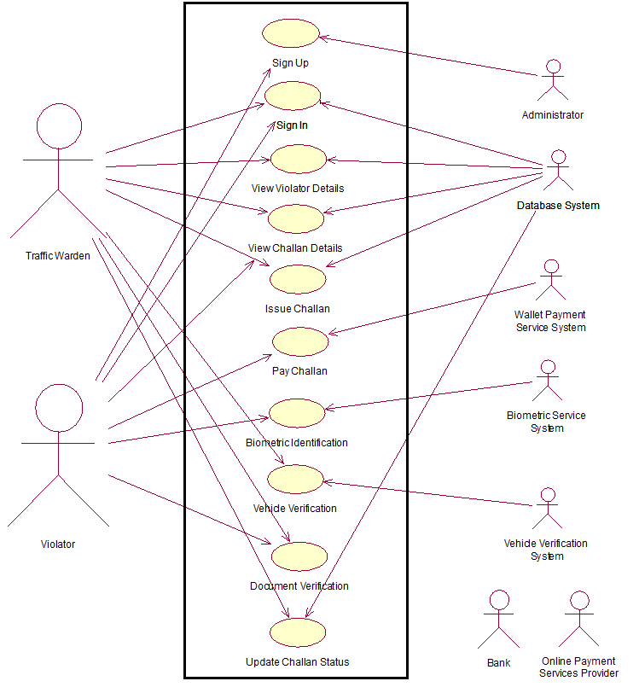

# Analysis Level Use Case Diagram

# https://lh5.googleusercontent.com/YyMWhMejf05H-JL5fCuhEAPTUzAg0IZWGKkMdX5OUuXiPv4MhH3oh13-qAAfvOwyhmdsCE5y3qKzBmZwlrGLEsykUpkP2T7fzd-h5SQdQ_y2UUR_663JMAUgSL3chw9IOqK-g78a

# Package Diagram

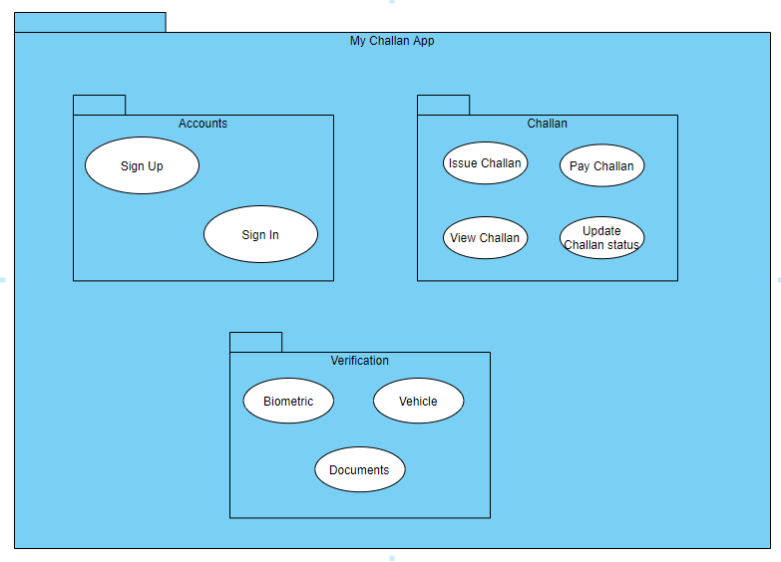

# Activity Diagram

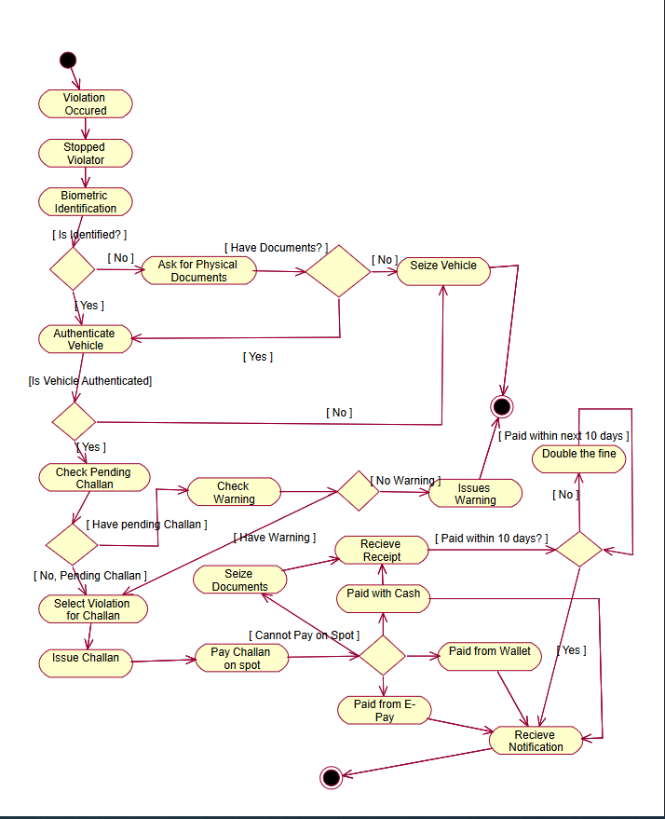

# Activity Diagram with Swim Lane

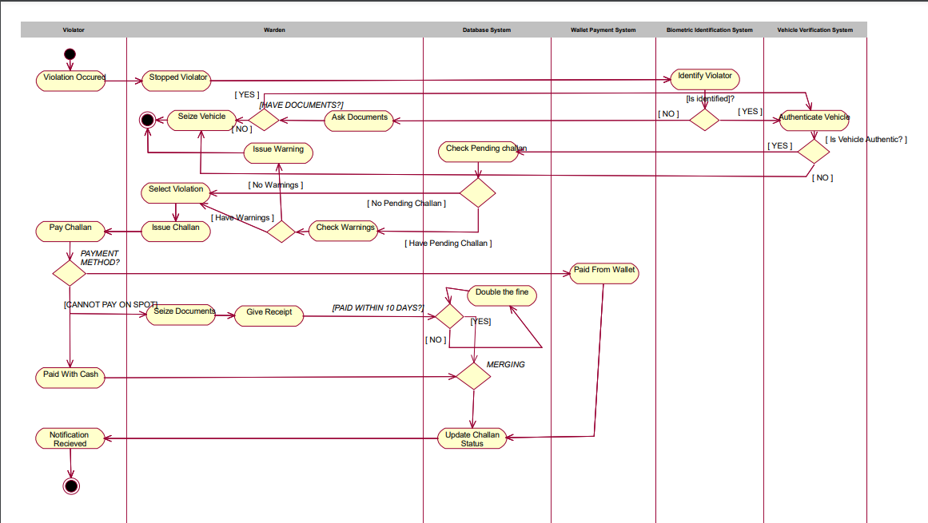

# State Chart Diagram

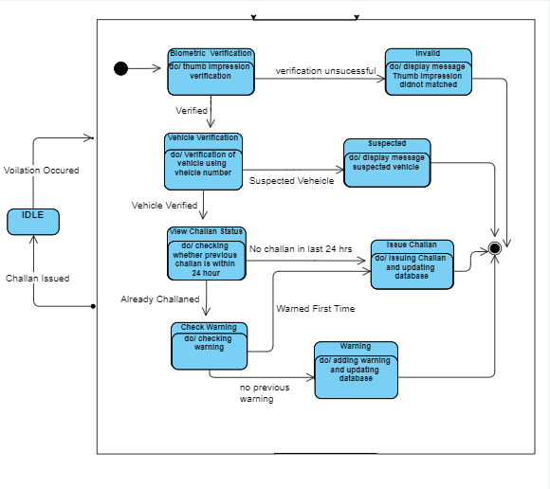

**Warden View**

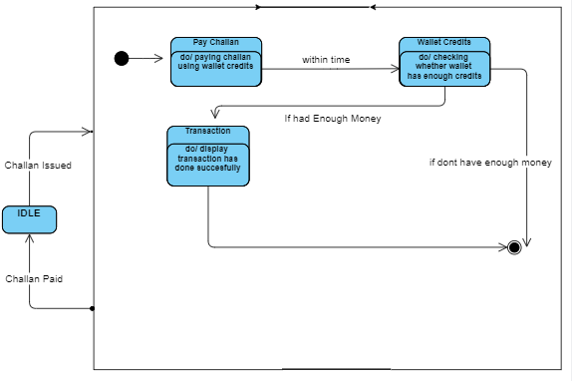

# User View

# Glossary

**Digitalization**

         convert business processes over to use digital technologies

**Automation**

        automation is the creation and application of technologies to produce and deliver goods and services with minimal human intervention

**Integration**

        the act of combining or adding parts to make a unified whole

**Architecture:** MVC

**GitHub – Repository:** [**https://github.com/Ansi007/MyChallanApp-Deliverable-2**](https://github.com/Ansi007/MyChallanApp-Deliverable-2)

**Domain Model**

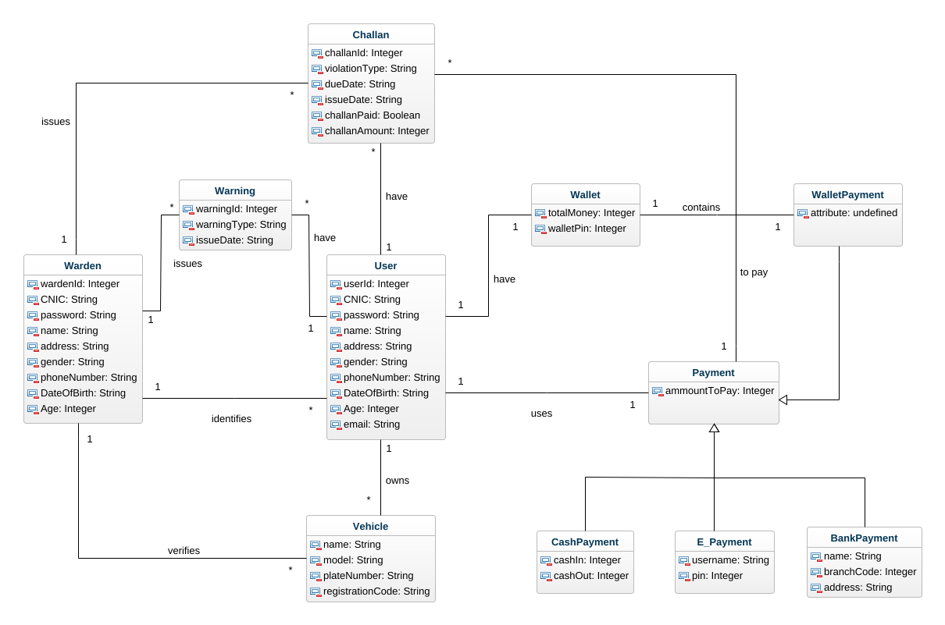

**Design Class Diagram**

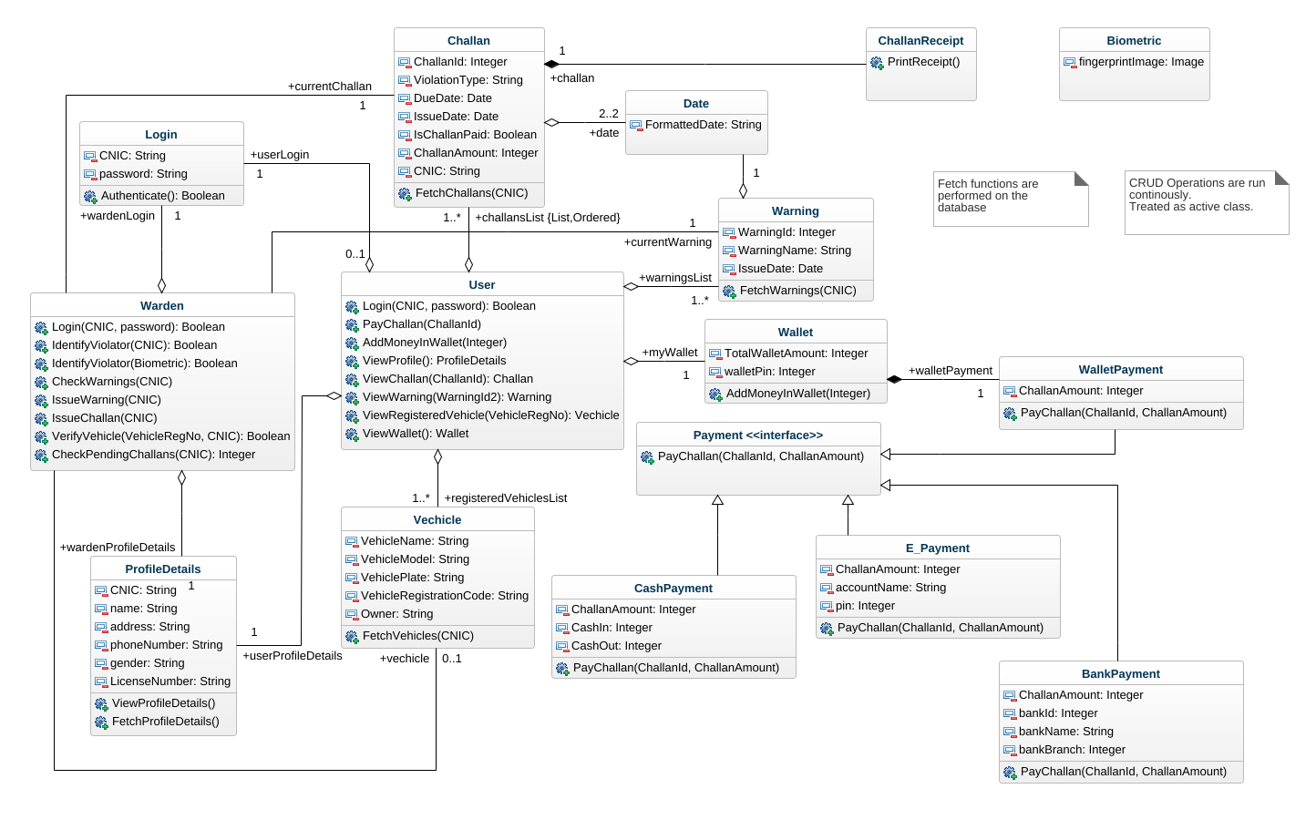

**Login System Sequence Diagram**

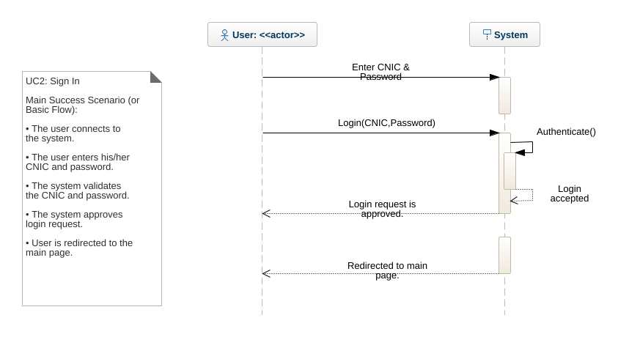

**Issue Challan System Sequence Diagram**

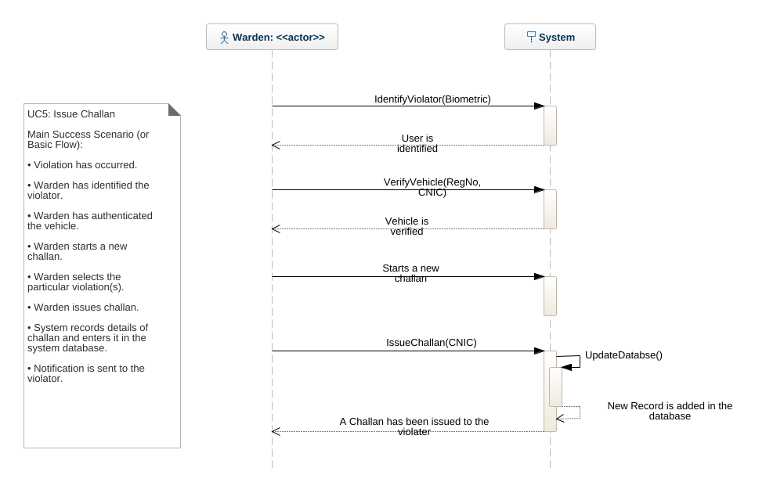

**Pay Challan System Sequence Diagram**

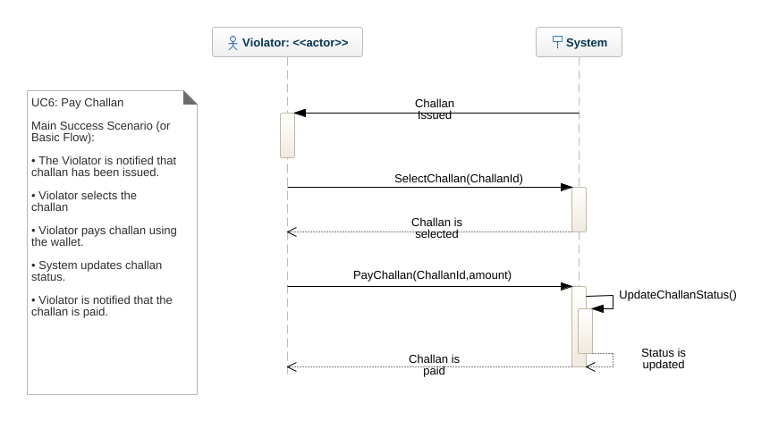

**Sequence Diagram (User View)**

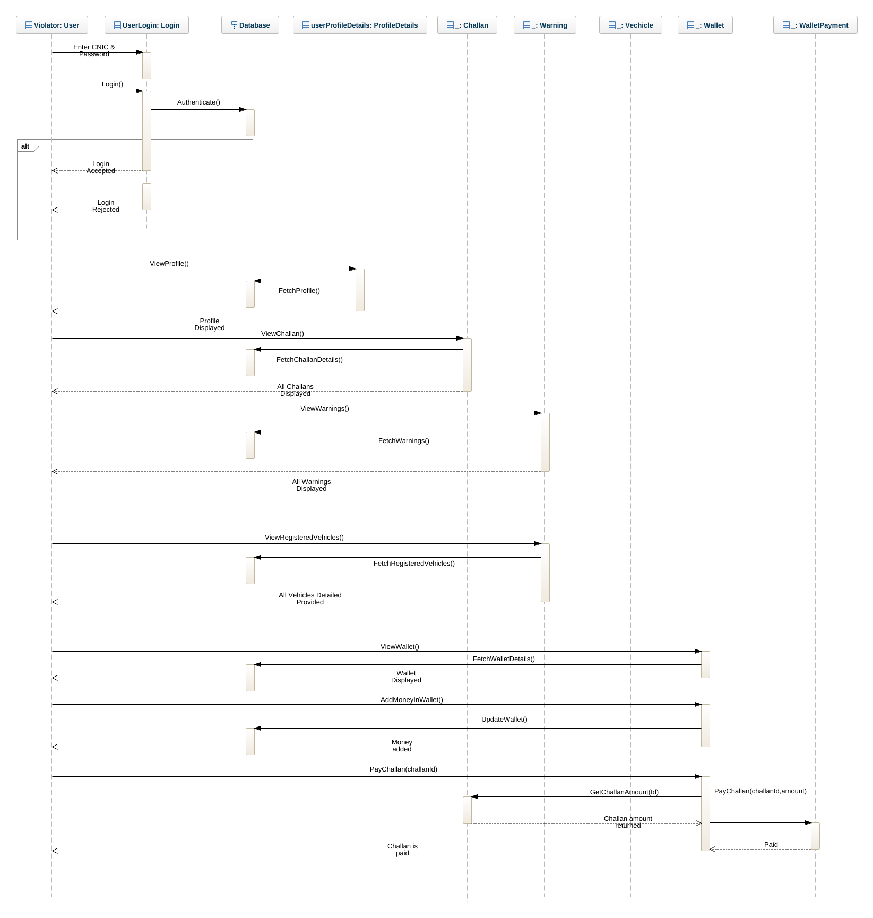

**Sequence Diagram (Warden View)**

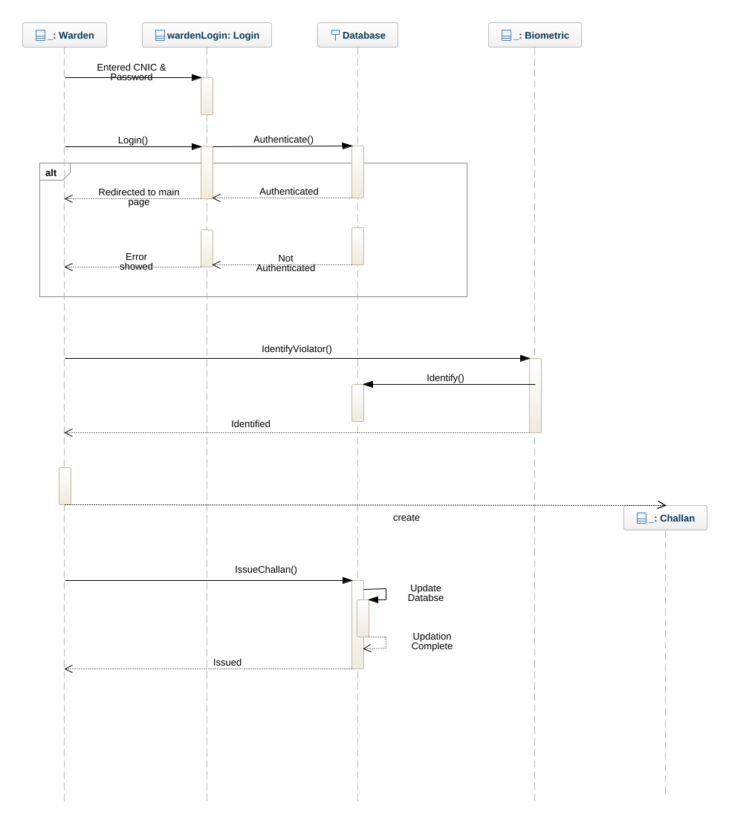

**Collaboration Diagram (User View)**

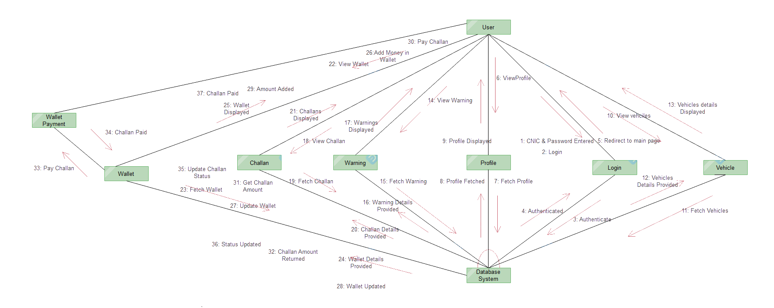

**Collaboration Diagram (Warden View)**

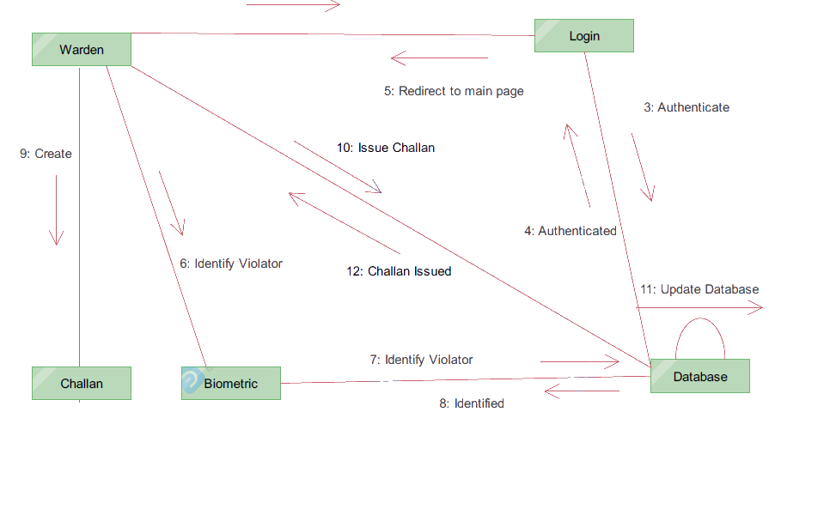

**USE CASE OPERATIONAL CONTRACTS**

**Contract CO1: Login**

**Operation:**

Login(CNIC, password)

**Cross Reference:**

Use Case: Sign in

**Pre-condition:**

CNIC and password are entered.

**Post condition:**

* + userLogin is initialized. (object initialization)
  + userLogin.CNIC became CNIC. (attribute modification)
  + userLogin.password became password. (attribute modification)
  + userLogin.Authenticate() was called.
  + On successful authentication all fields of User were initialized. (attribute modification)
  + The user was authorized to use the app.

**Contract CO2: SelectChallan**

**Operation Name:**

SelectChallan(challanId)

**Cross Reference:**

Use Case: Pay Challan

**Pre-Condition:**

A Challan was issued.

**Post Condition:**

* A Challan instance challan was created. (instance creation)
* challan.challanId became challanId. (attribute modification)
* Challan with challan.challanId was searched in the list.
* All fields of challan were initialized.
* The instance challan was returned.

**Contract CO3: IssueChallan**

**Operation Name:**

IssueChallan(CNIC)

**Cross Reference:**

Use Case: Issue Challan.

**Pre-Condition:**

* A traffic violation occurs.
* The violator's identity and vehicle are verified
* A challan is underway.

**Post-Condition:**

* All field of instance challan were initialized and set. (Attribute modification).
* Instance challan was added in user’s database and list.
* User was notified that the challan has been issued.