**ADS1 Assignment 1: Visualisation**

**ANSIA NIJAS STUDENT ID:22034116**

The provided data, Food Prices for Nutrition and Youth illetrate Population which was complied by World Data Bank provides the comparitive study on the cost, affordability of healthy diets and Youth illetrate Population.

**Link to data:**

**<https://herts365-my.sharepoint.com/personal/an22adx_herts_ac_uk/_layouts/15/onedrive.aspx?id=%2Fpersonal%2Fan22adx%5Fherts%5Fac%5Fuk%2FDocuments%2FADS1%20Assignment%20Data>**

***Or Data available in GitHub***

**GitHub Repository Link:**

<https://github.com/AnsiaNijas/ADS1Assignments.git>

# Line Plot: Evolution of Population who cannot affort a healthy diet

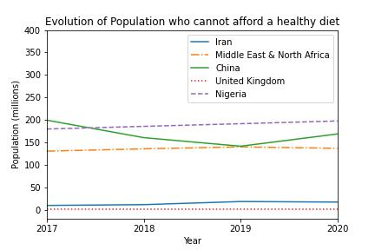

**Figure 1: Line Plot**

The given line plot is used to track the Evolution of Population who cannot affort a healthy diet between 2017 to 2020 and also we can compare the changes within the different countries over same period of time.

According to this graph the affordability of healthy diet of Nigeria continued to rise over the 4 years period. But for China it is fell across 2017 to 2019 and rose again in 2020. The people couldn’t afford a healthy diet for Middle East & North Africa and Iran continues to increase from 2017 to 2019 and falls in 2020 where as the affordability of healthy diet of United Kingdom continues to remains same over 2017 to 2020.

# Pie Plot: Share of Population who cannot affort a healthy diet in 2020 and 2019

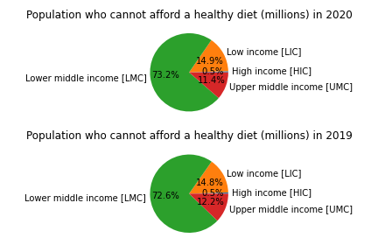

**Figure 2: PiePlot**

# The given Pie plot depicts the Share of population who couldn’t affort a healthy diet in 2020 and 2019.This type of pie plot is a good way of comparing data of various economical statistics of different countries all over the world for 2 years.

# More than 3 billion people, the majority of whom reside in lower-middle-income nations, cannot afford a healthful food. Those who cannot afford a nutritious diet in high income and low income countries respectively in 2020 were 14.9% and 0.5%, which is almost the same percentage as in 2019. The affordability of a healthy diet was most prevalent in lower middle-income nations, where it was 73.2% in 2020 and 72.6% in 2019, while it was lower in upper middle-income countries, where it was 11.4% in 2020 and 12.2% in 2019.

# Stacked Bar Plot: Youth illiterate population of Male and Female

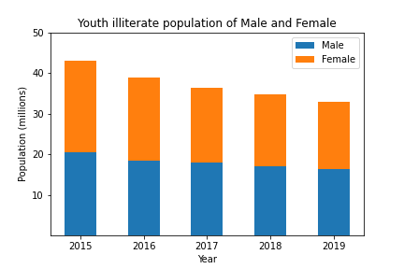

**Figure 3: Stacked Bar Plot**

The given Stacked Bar Plot make it easy to compare Youth illetrate population of Male and Female. Although the illiteracy rates have decreased worldwide for both young men and women between 15 and 24 years, females are on average more illiterate than males. As of 2019, there is a fall of illetrate Males and Females compared to other years.