ML IT Helpdesk System
User Guide

For the helpdesk operators, IT technicians, office managers and system administrator of Manzaneque Limited (ML).
Prepared by Apex Technology Systems (ATS) Limited.
Table 1: Document details
Item | Details
Document | User Guide – part of the User and Technical Documentation (Part 3)
System | ML IT Helpdesk System, pilot version 1.0
Unit | Pearson BTEC Unit 4: Database Design & Development
Author | [Your full name], Junior Database Developer, ATS
Date | 02/11/2026
Audience | ML Helpdesk Operators, IT Technicians, Office Managers and the System Administrator

Contents
1. Introduction
1.1 Conventions used in this guide
2. Getting started
2.1 Opening the system
2.2 Logging in
2.3 Logging out and automatic log-out
2.4 Your password
3. The Main Control Page and menus
3.1 What each role sees
4. Helpdesk Operator tasks
4.1 Logging a new call
4.2 Assigning a technician
4.3 Viewing a problem
4.4 Recording a follow-up call
4.5 The Open Problems List
4.6 Resolving a problem
5. IT Technician tasks
5.1 Your open jobs
5.2 Recording how a problem was resolved
6. Office Manager – management reports
6.1 Running a report
6.2 Reading the action column in R4 and R6
7. System Administrator – registers and user accounts
7.1 Offices
7.2 Employees (personnel register)
7.3 Hardware (equipment register)
7.4 Software & Licences
7.5 Technicians & Skills
7.6 User accounts
8. Database maintenance
8.1 Backing up
8.2 Restoring from a backup (operators)
8.3 Compacting (operators)
8.4 Integrity check (administrator)
9. Messages and what to do
10. Quick reference
10.1 Getting help
Appendix A – Pilot user accounts

Note: If the contents list is empty, right-click it in Word and choose Update Field → Update entire table.

1. Introduction
The ML IT Helpdesk System records every IT problem reported by ML staff, from the first phone call to the fix. It helps helpdesk operators log calls quickly and give each problem to a skilled technician. It also gives managers six reports on how equipment and technicians are performing.
This guide explains, step by step, how to use every screen of the system. Each section is written for one type of user, so you only need to read the sections for your role.
Table 2: Which sections to read
Your role | What you do in the system | Read sections
Helpdesk Operator | Log new and follow-up calls, assign technicians, resolve problems, restore and compact the database | 2, 3, 4, 8, 9, 10
IT Technician | See your own open jobs and record how you fixed them | 2, 3, 5, 9, 10
Office Manager | View, print and save the six management reports | 2, 3, 6, 9, 10
System Administrator | Keep the registers up to date, manage user accounts, run the monthly integrity check | 2, 3, 7, 8, 9, 10

1.1 Conventions used in this guide
- Bold text is a button, menu option or field you can see on the screen, for example Log New Call.
- A red star ***** next to a field name means the field must be filled in.
- Grey boxes are filled in by the system and cannot be changed.
- Coloured badges show a status: green means good (for example Under warranty, Valid, Closed), red means attention is needed (for example Expired, Locked).
- Problem numbers look like P-000128. When searching you can type P-000128, p128 or just 128.

2. Getting started

2.1 Opening the system
The system runs in a web browser (Chrome, Edge or Firefox). Nothing needs to be installed on your computer.
- Open your web browser.
- Type the address given to you by IT, for example https://localhost:8443 for the pilot, and press Enter.
- The Sign in screen opens.

2.2 Logging in
- Type your Username, for example a.khan.
- Type your Password. It is hidden as you type.
- Click Log in. The Main Control Page opens.
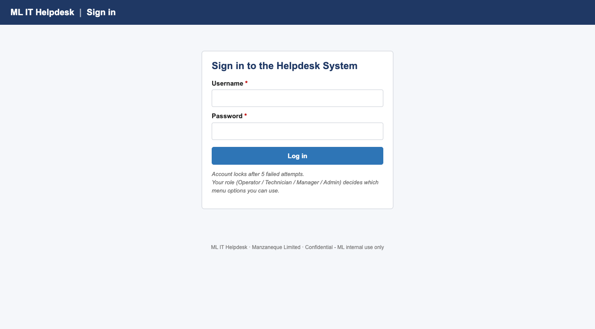
Figure 1: Sign in screen
For the pilot, use one of the accounts below. Every pilot account has the same password: Helpdesk2026 (capital H, no spaces). The full list of 15 accounts is in Appendix A.
Table 3: Pilot log-in accounts (one per role)
Role | Username | Password | Name
Helpdesk Operator | a.khan | Helpdesk2026 | Ayesha Khan
IT Technician | u.tariq | Helpdesk2026 | Usman Tariq
Office Manager | i.shah | Helpdesk2026 | Imran Shah
System Administrator | w.anwar | Helpdesk2026 | Waqas Anwar

Important: These are pilot passwords for testing only. Before the system goes live, the System Administrator must give every user a new, personal password (section 7.6).
If the username or password is wrong, the message Incorrect username or password appears. For security, the system does not say which of the two was wrong.
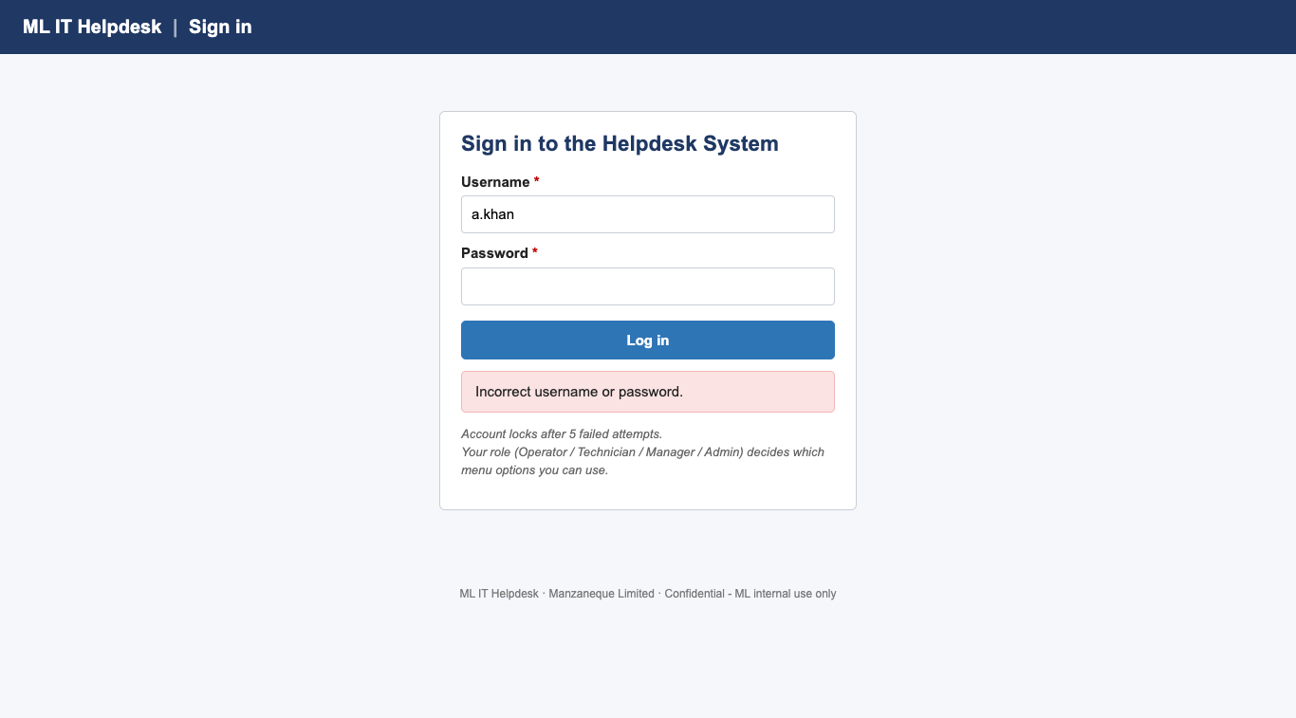
Figure 2: Message after a wrong password
Important: After 5 wrong passwords in a row your account is locked. The message “This account is locked” appears, even if you then type the correct password. Ask the System Administrator to unlock it (section 7.6).

2.3 Logging out and automatic log-out
- Click Log out at the top right of any screen when you finish or leave your desk.
- If you do nothing for 20 minutes, the system logs you out automatically and shows “Your session expired”. Log in again to continue. Anything you had not saved must be typed again.
- Never share your password. Every call, assignment and backup is recorded under your name.

2.4 Your password
A password must be at least 8 characters long and contain at least one letter and one number. To change it, ask the System Administrator (section 7.6). They will ask you to type the new password twice.

3. The Main Control Page and menus
After logging in, every user sees the Main Control Page. It shows three key figures and buttons for the tasks your role is allowed to do. The same menu bar is at the top of every screen, so you can always move to another task or back to the Main Control Page.
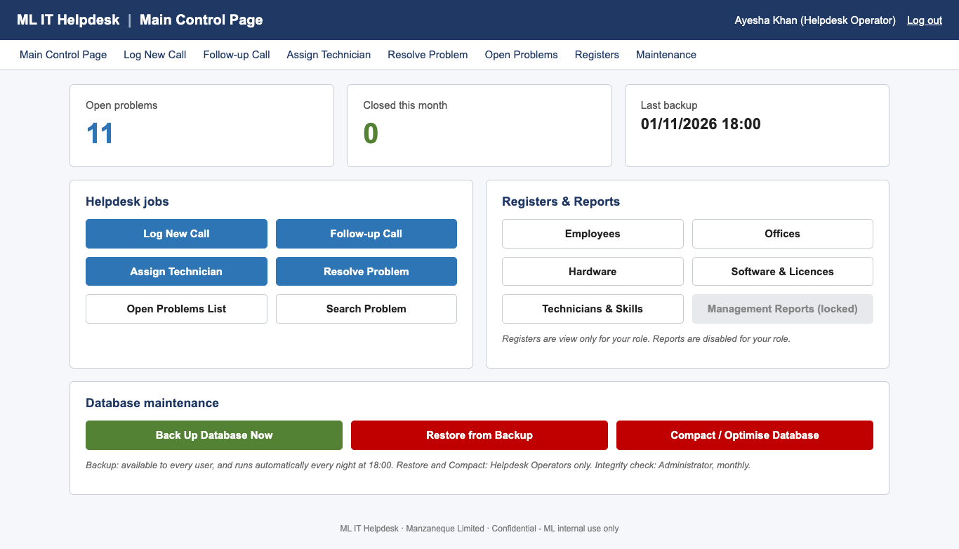
Figure 3: Main Control Page – Helpdesk Operator view
Table 4: Parts of the Main Control Page
Area | What it shows or does
Top bar | System name, screen title, your name and role, and Log out
Menu bar | Links to the screens your role may use
Open problems | Number of problems not yet resolved (technicians see their own open jobs)
Closed this month | Problems resolved since the 1st of this month
Last backup | Date and time of the last successful database backup
Helpdesk jobs | Log New Call, Follow-up Call, Assign Technician, Resolve Problem, Open Problems List, Search Problem
Registers & Reports | Employees, Offices, Hardware, Software & Licences, Technicians & Skills, Management Reports
Database maintenance | Back Up Database Now (everyone); Restore and Compact (operators only)

3.1 What each role sees
The system only shows the options your role may use. If you try to open a page that is not allowed, for example by typing its address, an Access denied page appears (Figure 4).
Table 5: Menu options by role
Function | Operator | Technician | Manager | Admin
Log New Call, Follow-up Call, Assign Technician | Yes | – | – | –
Resolve Problem | Yes | Own jobs | – | –
Open Problems List / Search Problem | All | Own jobs | All | All
Management Reports R1–R6 | – | – | Yes | –
Registers (view) | Yes | Yes | Yes | Yes
Registers (add / edit) | – | – | – | Yes
User Accounts | – | – | – | Yes
Back Up Database Now | Yes | Yes | Yes | Yes
Restore / Compact database | Yes | – | – | –
Integrity Check | – | – | – | Yes

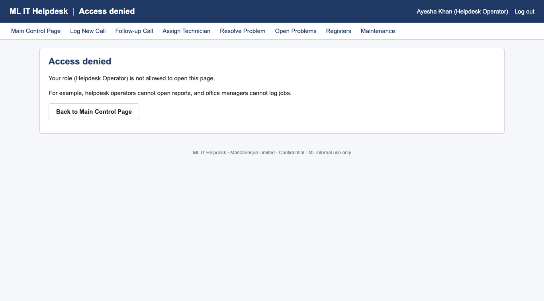
Figure 4: Access denied – an operator trying to open the reports

4. Helpdesk Operator tasks
This section follows a call from the moment the phone rings until a technician has been assigned. A new call takes three clicks from the Main Control Page: Log New Call → fill in the form → Save & Assign.

4.1 Logging a new call
- On the Main Control Page click Log New Call. The system shows the problem number this call will get and the call date and time.
- 1. Caller – choose the caller in Caller name. You can type part of the name to find it. Only current employees are listed. The Job title, Department and Office fill in automatically from the personnel register.
- 2. Equipment & software – type or choose the Computer serial number (it is printed on the label of the computer). The Type / Make, Model and the software installed on the computer fill in automatically. A badge shows Under warranty or Expired.
- Check or choose the Operating system and the Software in use. Each option shows Valid licence or NO valid licence.
- 3. Problem details – choose the Problem type, the Priority (Low, Medium, High, Critical) and the Urgency of caller (Normal, Urgent, Distressed).
- Type the Reason for call (at least 3 characters) and a Description / notes of the problem (at least 10 characters).
- Click Save & Assign. Answer OK when asked “Save this call? Please check the caller and equipment details are correct.”
- A green message shows the problem number, for example Problem P-000065 logged. Read this number to the caller – they quote it when they call again. The Assign Technician screen opens next.
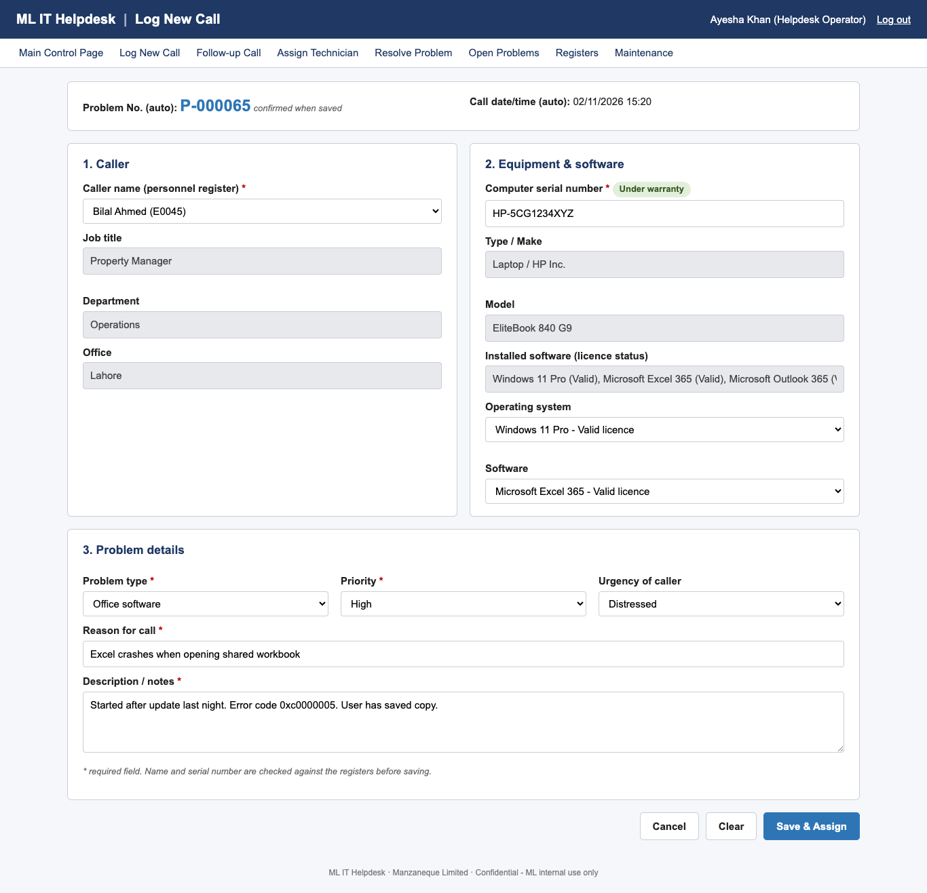
Figure 5: Log New Call with the caller and equipment filled in automatically
Table 6: Log New Call – fields
Field | Required | Notes
Caller name | Yes | Current employees only; ex-employees cannot be callers
Computer serial number | Yes | Must be in the equipment register
Operating system / Software | No | Choose “not relevant” for hardware-only faults
Problem type | Yes | Decides which technicians can be assigned
Priority | Yes | Low, Medium (default), High, Critical
Urgency of caller | No | Normal (default), Urgent, Distressed
Reason for call | Yes | 3–255 characters
Description / notes | Yes | At least 10 characters

Tip: If the serial number shows Not in register, check the label again. If the item is really missing, ask the System Administrator to add it under Registers → Hardware.
Note: The number shown before saving is provisional. If another operator saves a call at the same moment, the number in the green message is the one that counts.

4.2 Assigning a technician
The Assign Technician screen opens automatically after a new call is saved. You can also open it from the menu, which lists all open problems that are still waiting for a technician.
- Check the Problem No., Problem type and Priority at the top.
- The table lists only the technicians skilled in that problem type, with the number of Open jobs each is working on, fewest first.
- The least busy available technician is already selected, highlighted in green and marked recommended. Technicians on leave are shown last as No (on leave).
- Keep the recommendation or select another technician, then click Assign Selected Technician.
- The problem details open with the message Technician assigned.
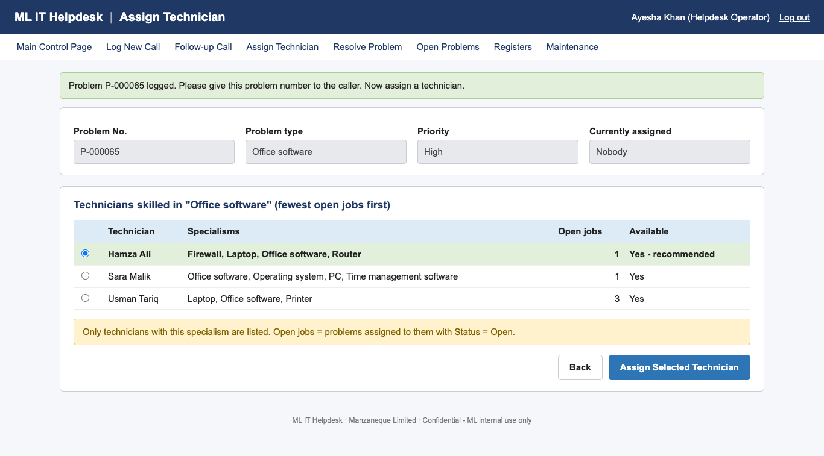
Figure 6: Assign Technician – only skilled technicians, least busy recommended
Note: If you choose a technician without the right skill, the system refuses with “This technician is not skilled in this problem type.” If no technician has the skill, ask the System Administrator to add one under Technicians & Skills.

4.3 Viewing a problem
Click Search Problem (or View in any list) and type the problem number. The page shows the problem, the caller, the office, the equipment and software, the technician and the resolution. Below that is the call history with every call made about the problem. Buttons let you record a follow-up, re-assign the problem or resolve it.
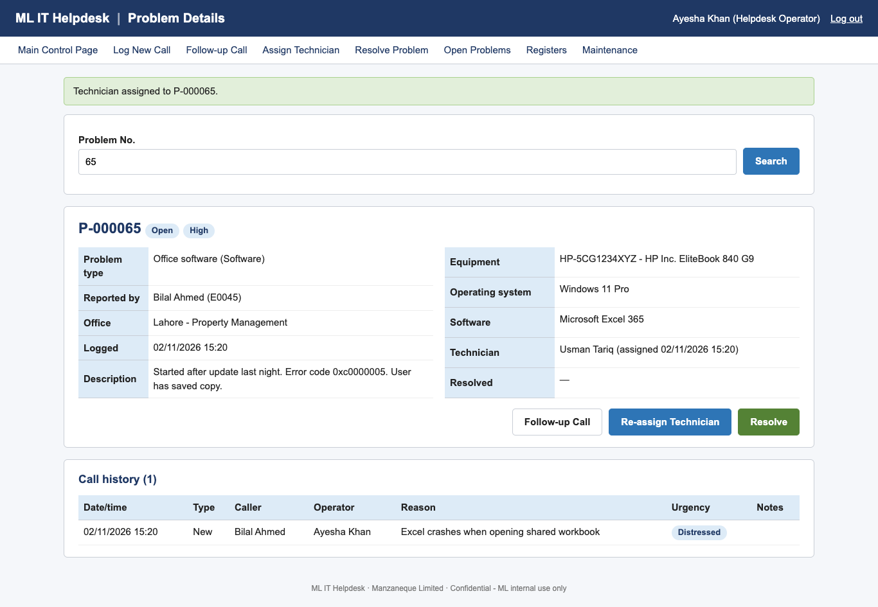
Figure 7: Problem details and call history

4.4 Recording a follow-up call
Use this when a caller rings again about a problem that already has a number.
- Click Follow-up Call.
- Type the problem number the caller quotes and click Find. If the number does not exist, the message “Problem number … does not exist” appears.
- Check the read-only Problem summary and the original reason.
- Choose the Caller name (the original caller is pre-selected) and the Urgency of caller.
- Type the Reason for call. This is always required, even if it only says the caller is chasing progress or is distressed.
- Click Save Follow-up. The call is added to the problem’s call history.
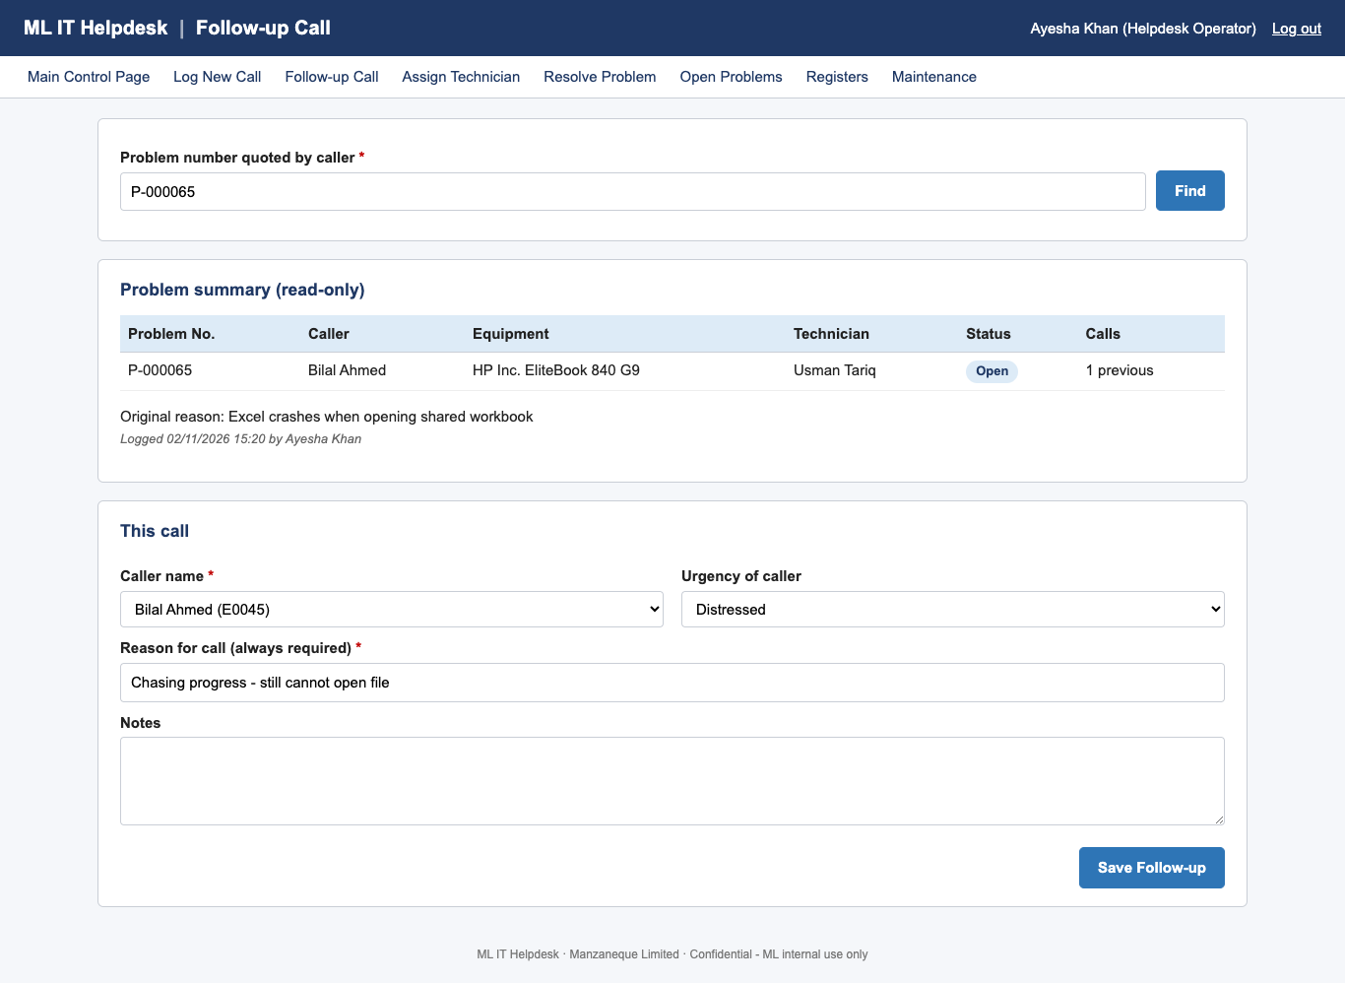
Figure 8: Follow-up Call

4.5 The Open Problems List
Click Open Problems to see every unresolved problem, with the most urgent at the top (Critical first, then oldest first). Filter by Priority or Office and click Filter. Each row has buttons to View, Assign (if no technician yet) or Resolve.
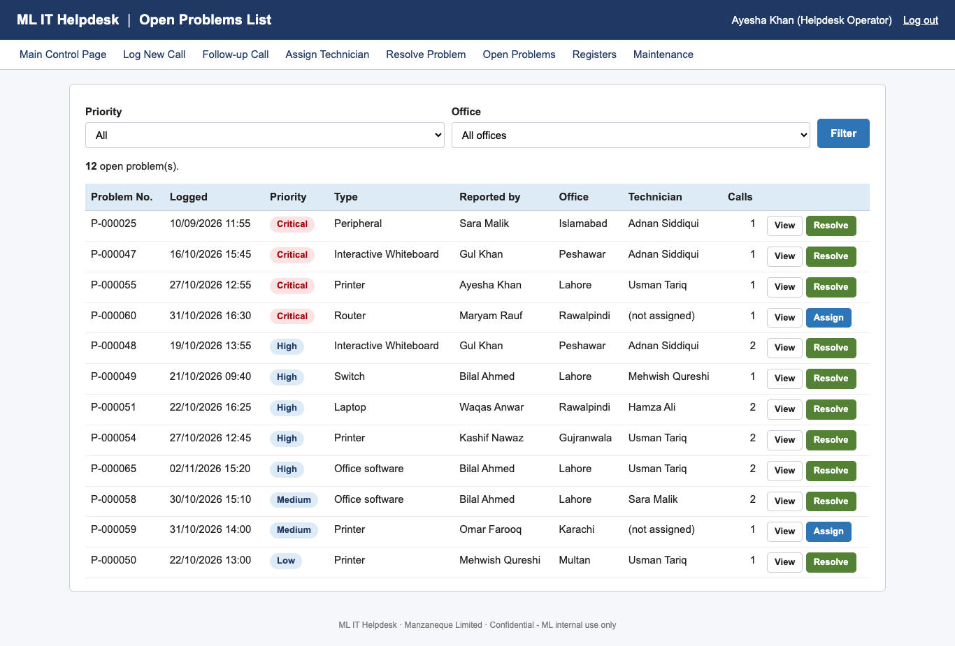
Figure 9: Open Problems List

4.6 Resolving a problem
Operators can close any problem that has a technician. The steps are the same as for technicians – see section 5.2.

5. IT Technician tasks

5.1 Your open jobs
Click Resolve Problem or My Open Jobs on the menu. You see only the problems assigned to you, oldest first, with the type, priority, caller and office.
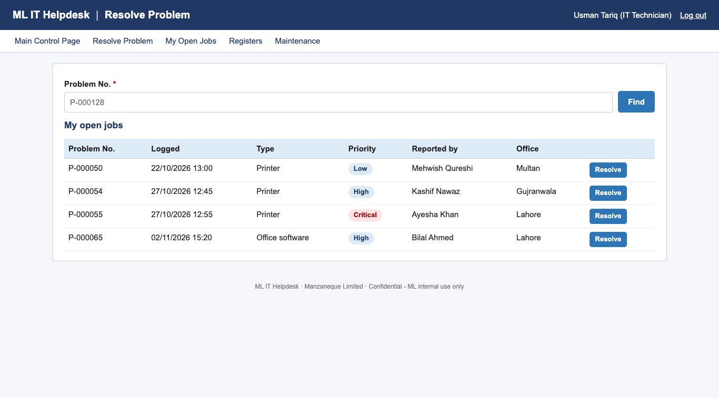
Figure 10: Resolve Problem – My open jobs

5.2 Recording how a problem was resolved
- Click Resolve next to the job, or type the problem number and click Find.
- Check the problem, the assigned technician and the logged date and time.
- Date/time resolved – already set to now. Change it if you fixed the problem earlier. It must be after the logged time and cannot be in the future.
- Time taken (hours) – the hours you spent, between 0.25 and 500. Use decimals: 1.5 = 1 hour 30 minutes, 0.25 = 15 minutes.
- How was the problem resolved? – describe what you did.
- Click Mark as Resolved and answer OK to “Close this problem?”. The status changes to Closed and the job leaves your list.
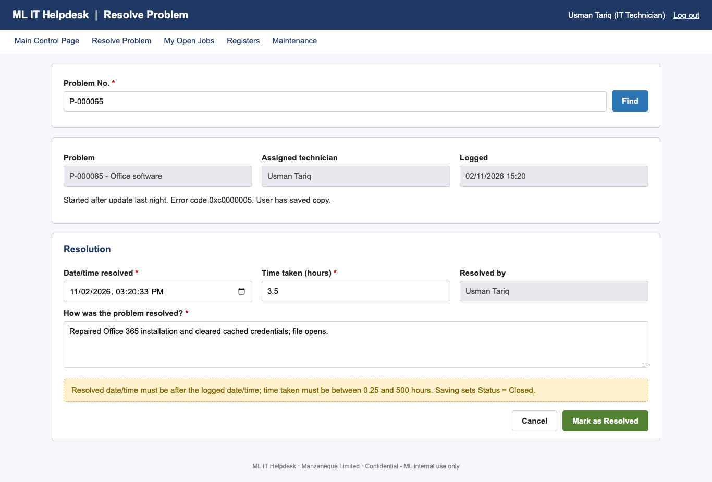
Figure 11: Resolve Problem
Note: Technicians can only resolve their own jobs. If a job belongs to someone else, the message “Technicians can only resolve their own jobs” appears. Ask an operator to re-assign it to you.

6. Office Manager – management reports
Office managers can view all reports but cannot log jobs. The six reports use the data recorded during normal work, so they are always up to date. In all monthly reports, a problem belongs to the month in which it was logged.

6.1 Running a report
- On the Main Control Page click Management Reports.
- Under Report parameters choose the Month. For R5 also choose the Technician; for R6 also choose the Office. For R3 you can tick show all time.
- Click View on screen next to the report you want.
- The report opens with a header (report name, parameters, who ran it and when), one or more tables with totals, and a confidentiality footer.
- Click Print / Save as PDF to print, or choose Save as PDF as the printer to keep a copy. The menus and buttons are left out of the printout automatically.
- Click Back to reports to choose another report.
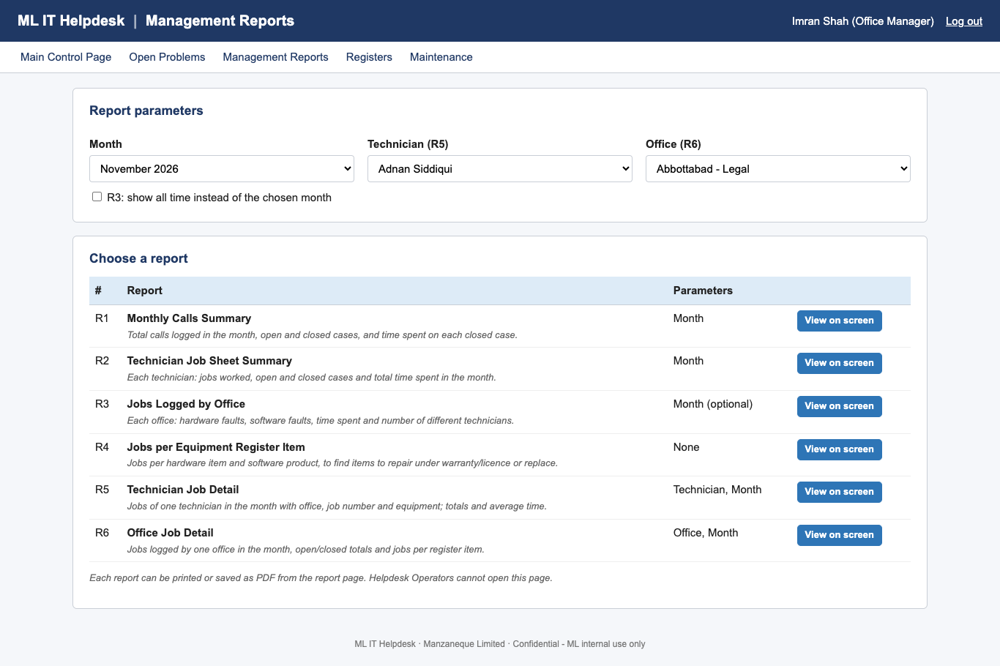
Figure 12: Management Reports menu
Table 7: The six reports
Report | Parameters | What it tells you
R1 Monthly Calls Summary | Month | Total calls (new and follow-up), problems logged, open and closed cases, and the hours spent on each closed case
R2 Technician Job Sheet Summary | Month | For each technician: jobs worked, open and closed jobs, total and average hours – shows who is overloaded
R3 Jobs Logged by Office | Month or all time | For each office: hardware faults, software faults, hours spent and number of different technicians
R4 Jobs per Equipment Register Item | None | Jobs per hardware item and software product, with warranty/licence status and an Action
R5 Technician Job Detail | Technician, month | Every job of one technician with office and equipment, plus open/closed totals and average time per job
R6 Office Job Detail | Office, month | Every job logged by one office, totals, and jobs per register item to spot items that keep failing

6.2 Reading the action column in R4 and R6
Table 8: Actions suggested by the reports
Shown | Meaning | What to do
Warranty claim | 3 or more jobs and the item is still under warranty | Ask the manufacturer to repair or replace it free of charge
Consider replacing | 3 or more jobs and the warranty has expired | Plan to replace the item
Renew licence | No valid licence for this software | Renew or buy a licence
Review with vendor | 3 or more jobs for a licensed software product | Raise the repeated faults with the supplier
Regularly failing – review (R6) | 3 or more jobs for one item in one office this month | Investigate the item

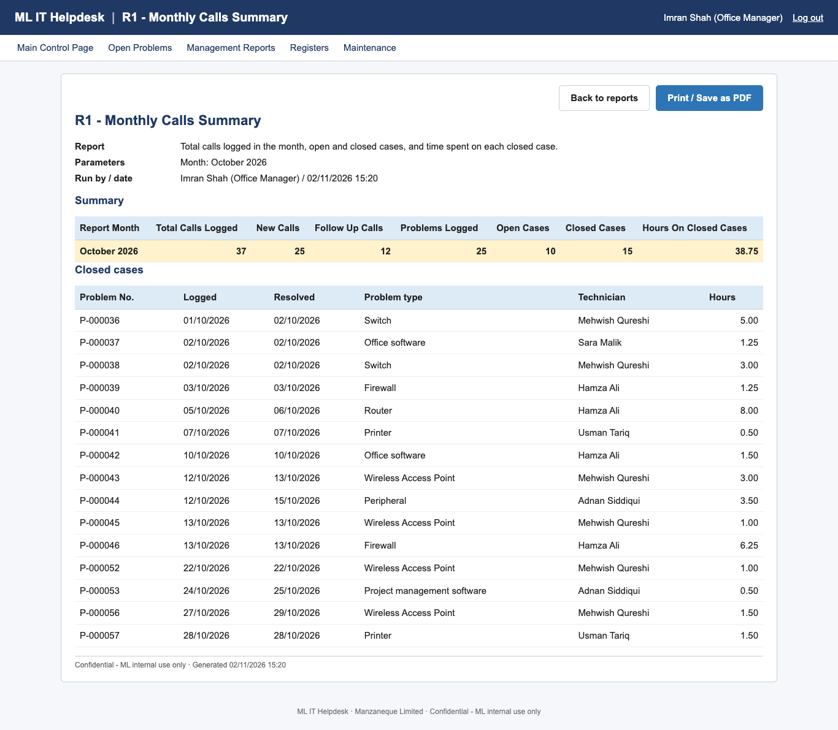
Figure 13: R1 – Monthly Calls Summary
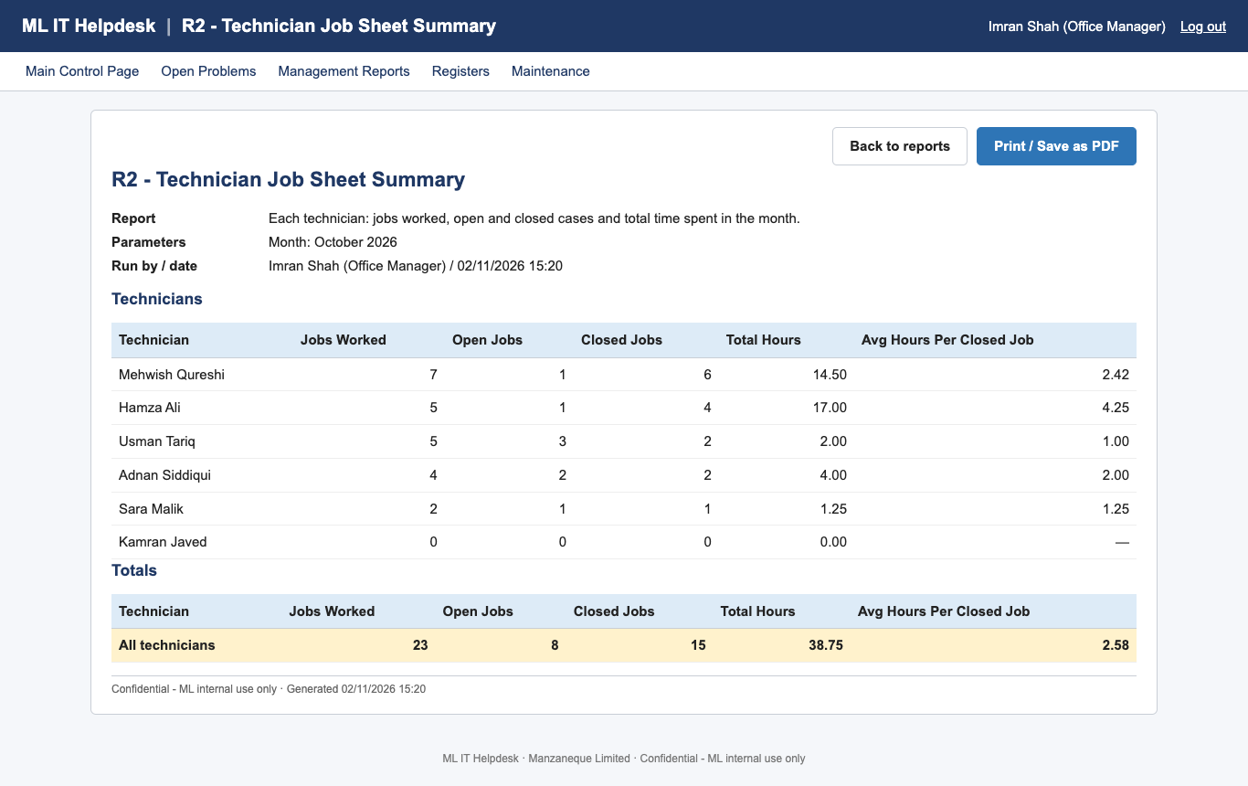
Figure 14: R2 – Technician Job Sheet Summary
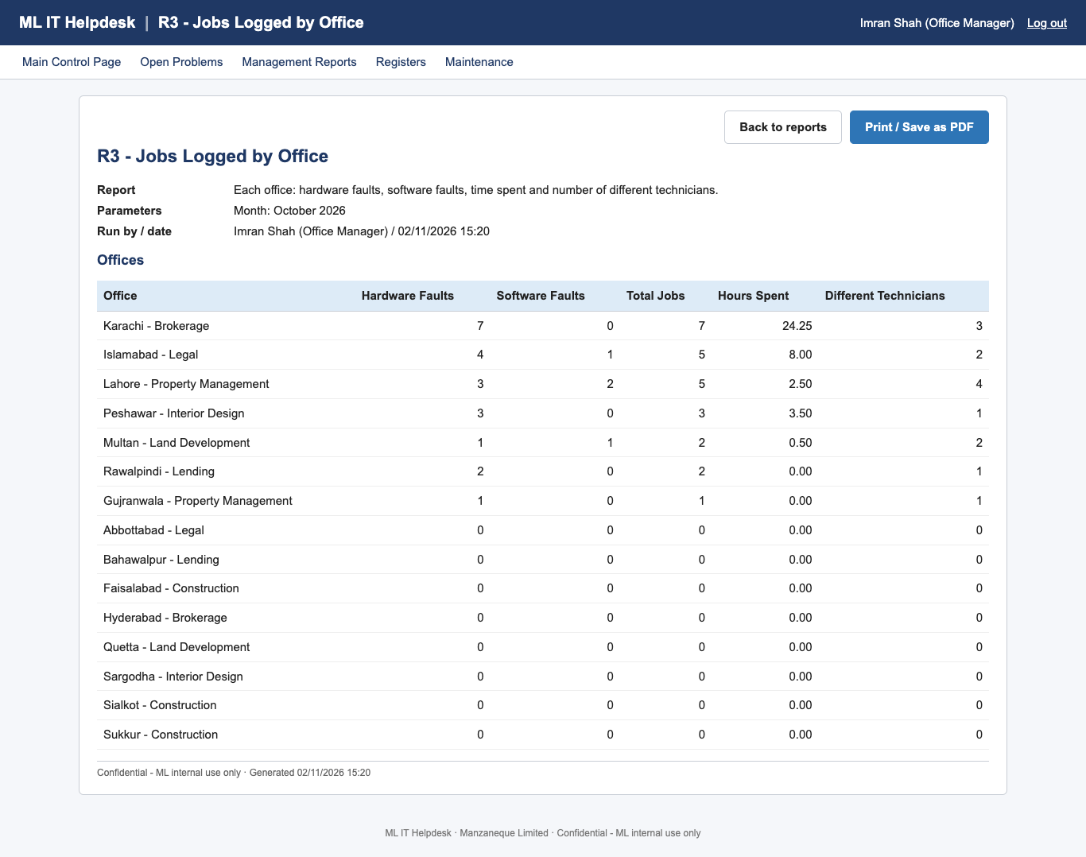
Figure 15: R3 – Jobs Logged by Office
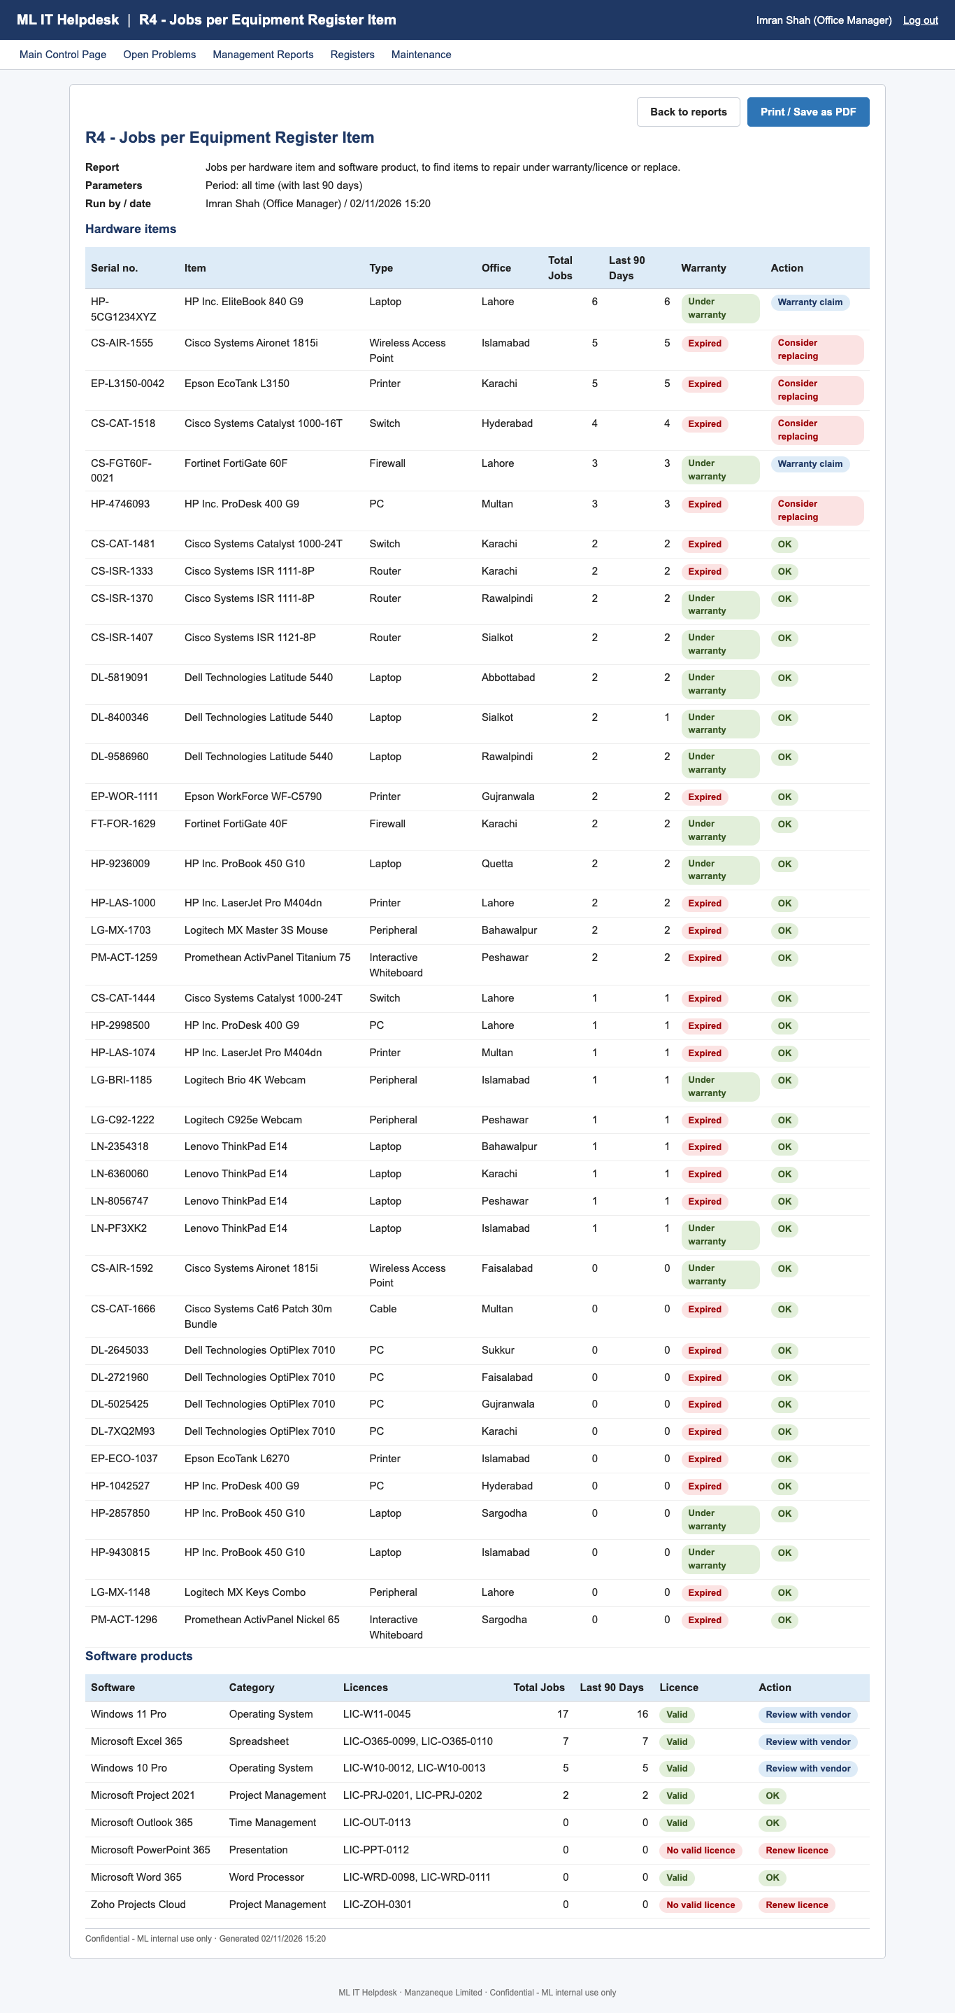
Figure 16: R4 – Jobs per Equipment Register Item
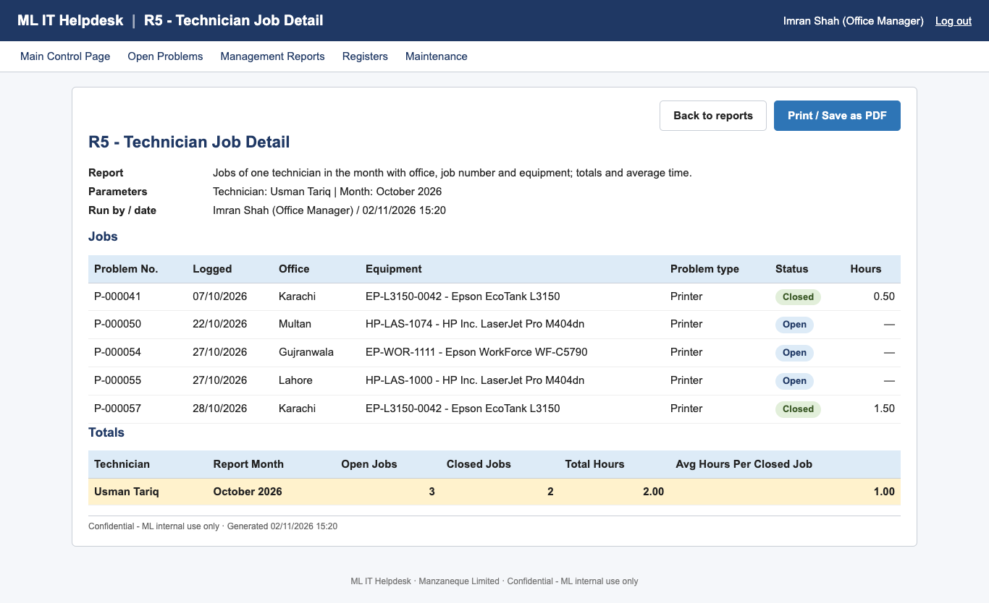
Figure 17: R5 – Technician Job Detail
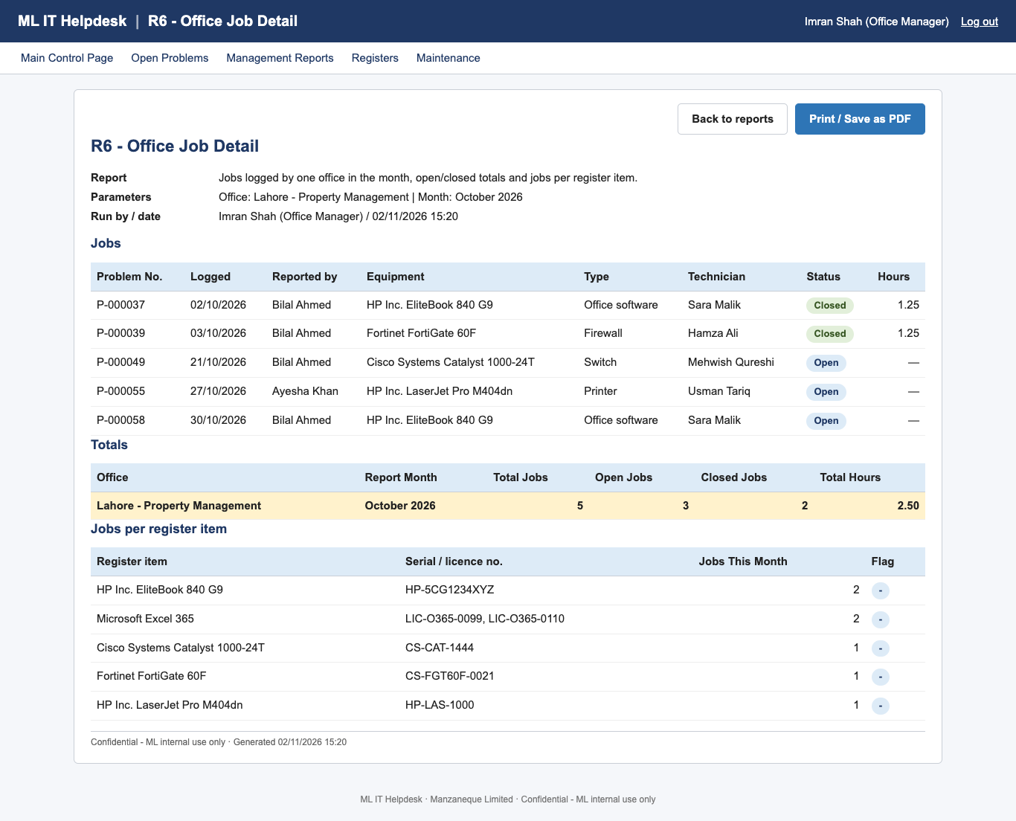
Figure 18: R6 – Office Job Detail
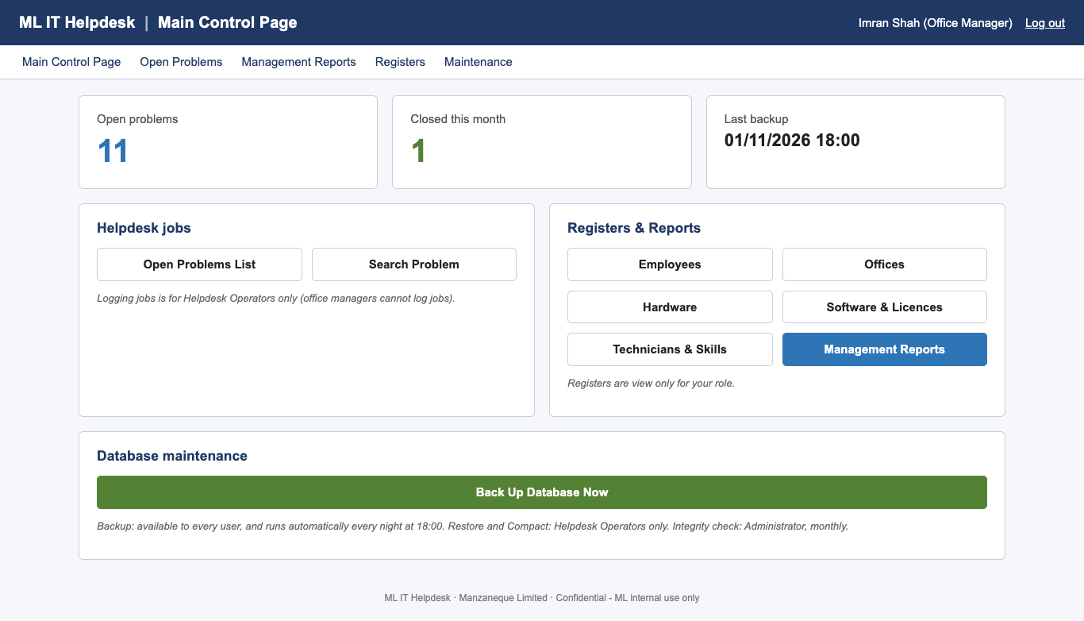
Figure 19: Main Control Page – Office Manager view (no job logging)

7. System Administrator – registers and user accounts
Everybody can view the registers. Only the System Administrator can add or change entries. Open them from Registers on the menu or from the Main Control Page. Every register page has a search or list at the bottom and an Add button. Click Edit on a row to change it, then Save.
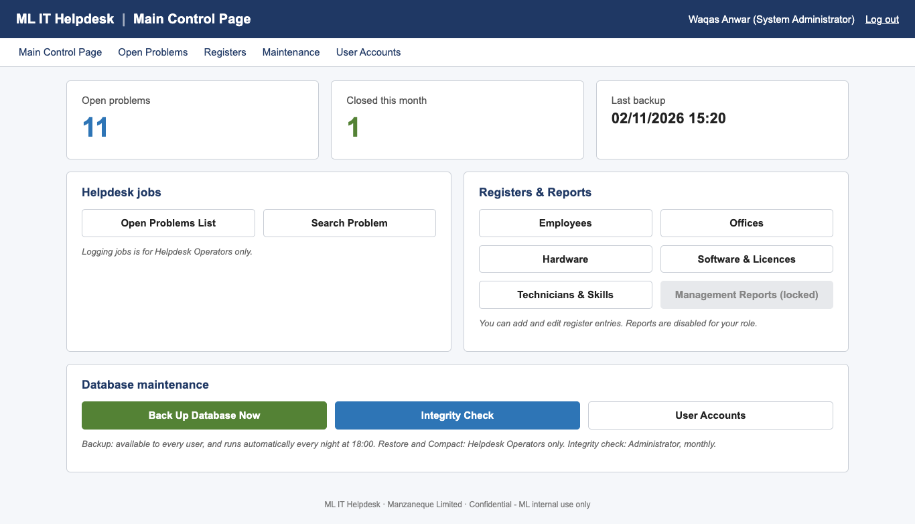
Figure 20: Main Control Page – System Administrator view

7.1 Offices
Each office has a name (unique), address, city, postcode, contact phone and one of seven specialisations. An office that still has employees cannot be deleted.

7.2 Employees (personnel register)
- Click Registers → Employees → Add employee.
- Enter the Employee ID in the format E0045, the first and last name, job title, phone and email. The email must be unique.
- Choose the Office and Department, and enter the Employment start date.
- Click Save.
Important: Employees who leave are never deleted. Click Edit and enter an End date. Their past calls stay in the reports, but they can no longer be chosen as callers or log in. Tick Include ex-employees to see them in the list.
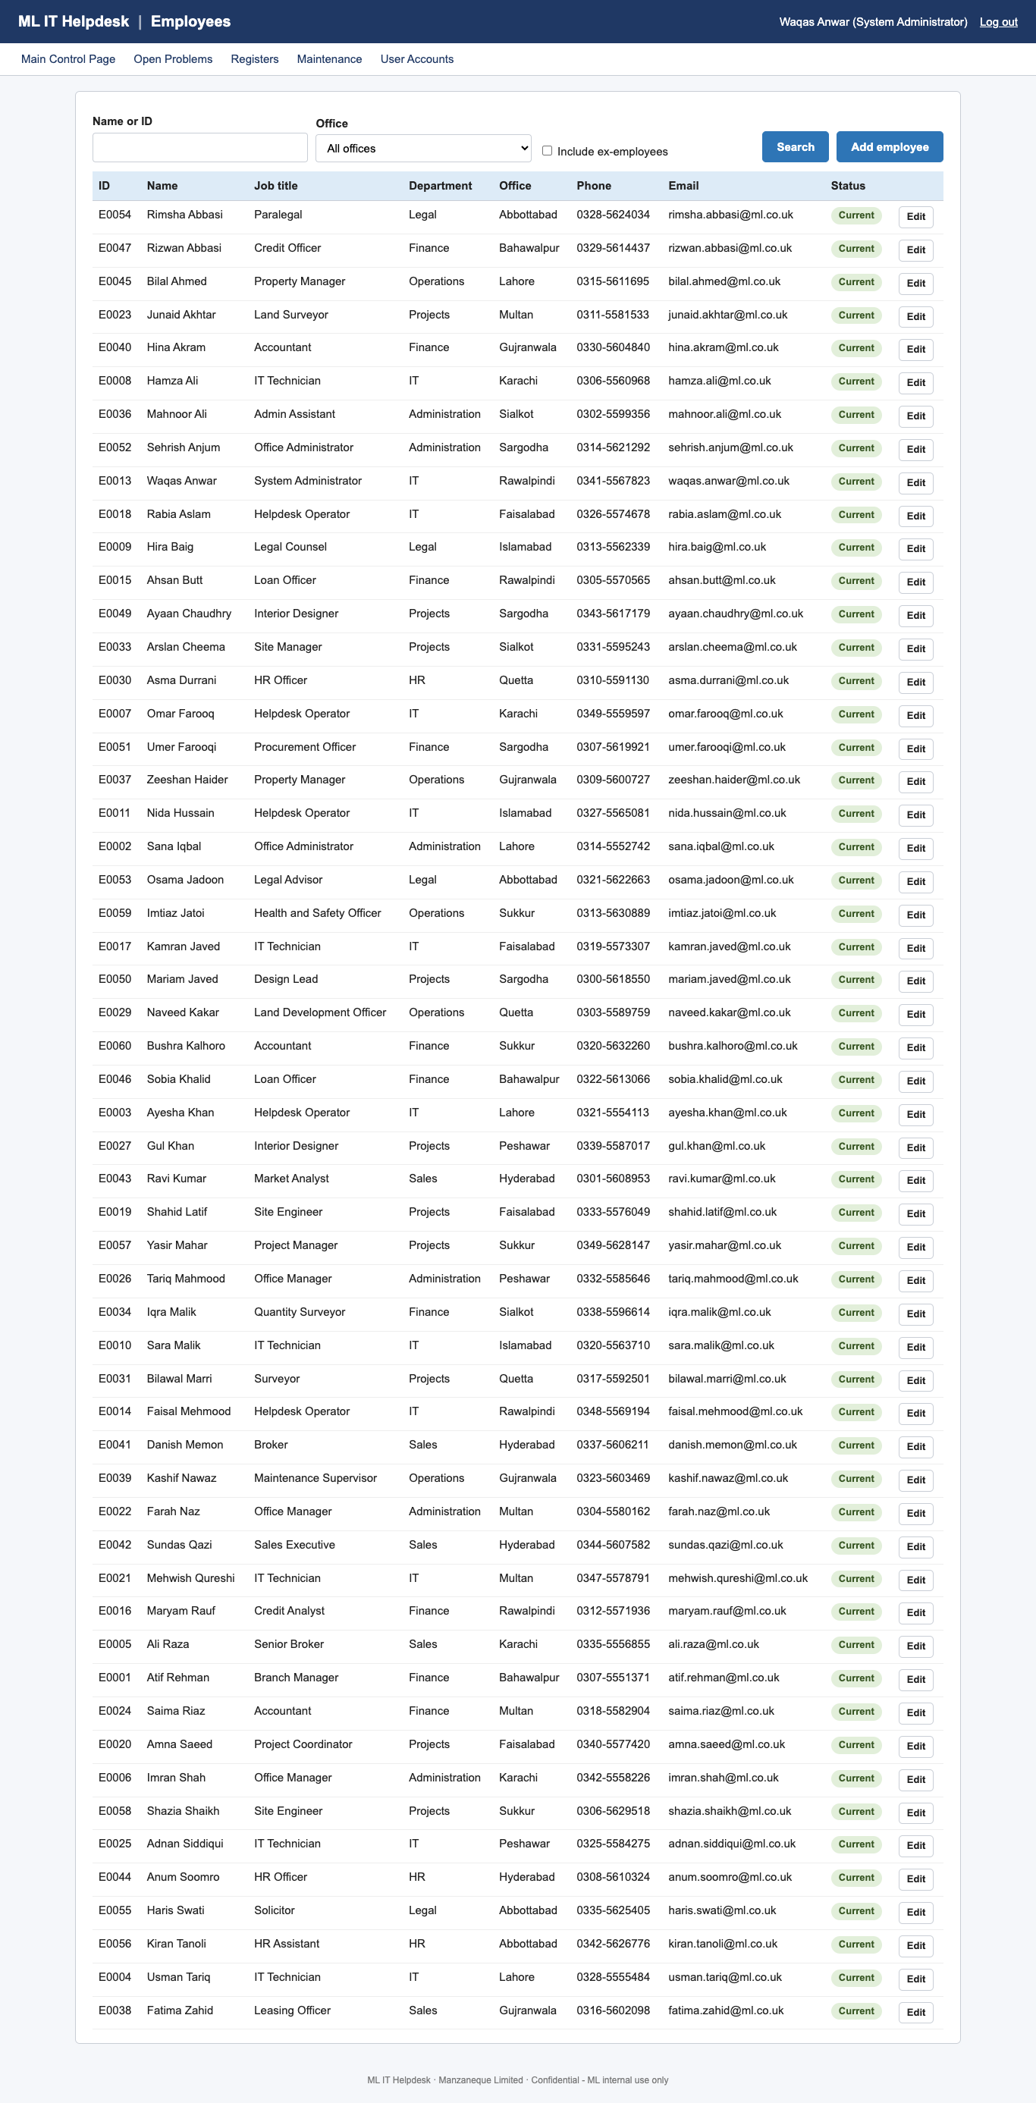
Figure 21: Employees register

7.3 Hardware (equipment register)
Enter the serial number (letters, digits and – only, unique), equipment type, manufacturer, make, model, purchase date, warranty expiry, office and (optionally) the employee who uses it. The warranty status badge updates from the expiry date. For computers, use Install licensed software to record which licences are installed. This is what the operator sees when logging a call.
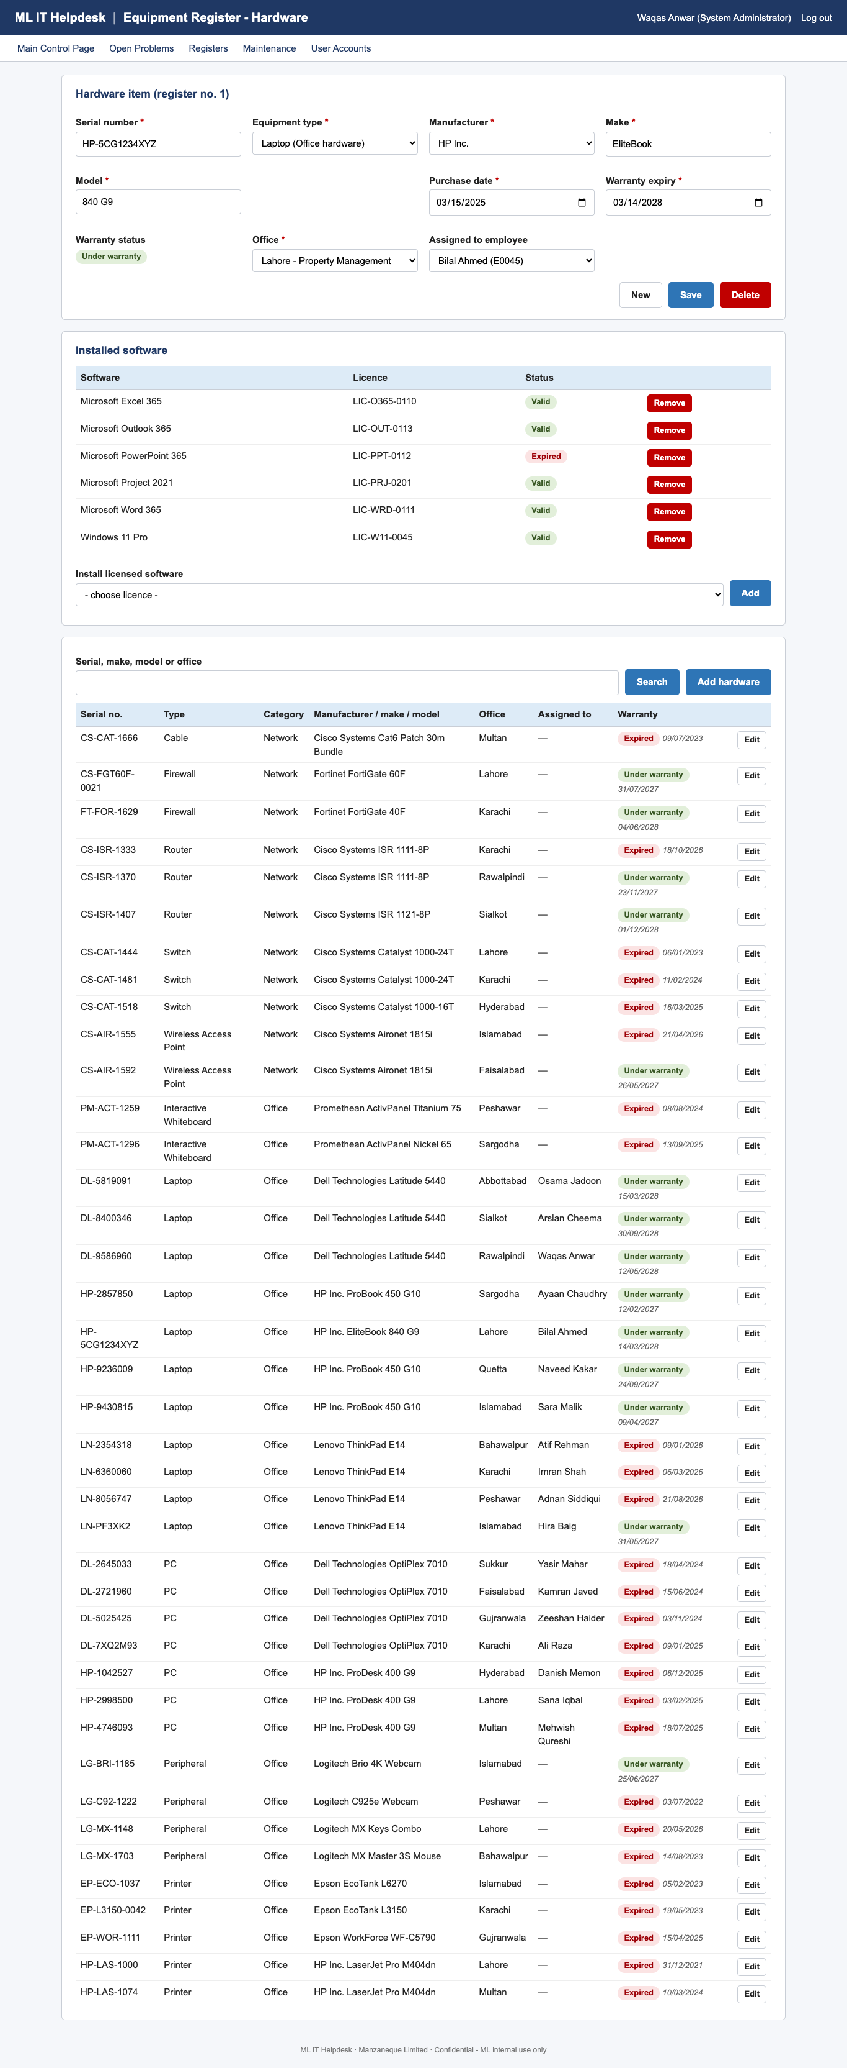
Figure 22: Equipment Register – Hardware

7.4 Software & Licences
Add each software product (name, version, category, publisher), then its licences (licence number, type, number of seats, start date and expiry date). Leave the expiry blank for a perpetual licence. The list shows seats used and whether each licence is Valid or Expired.
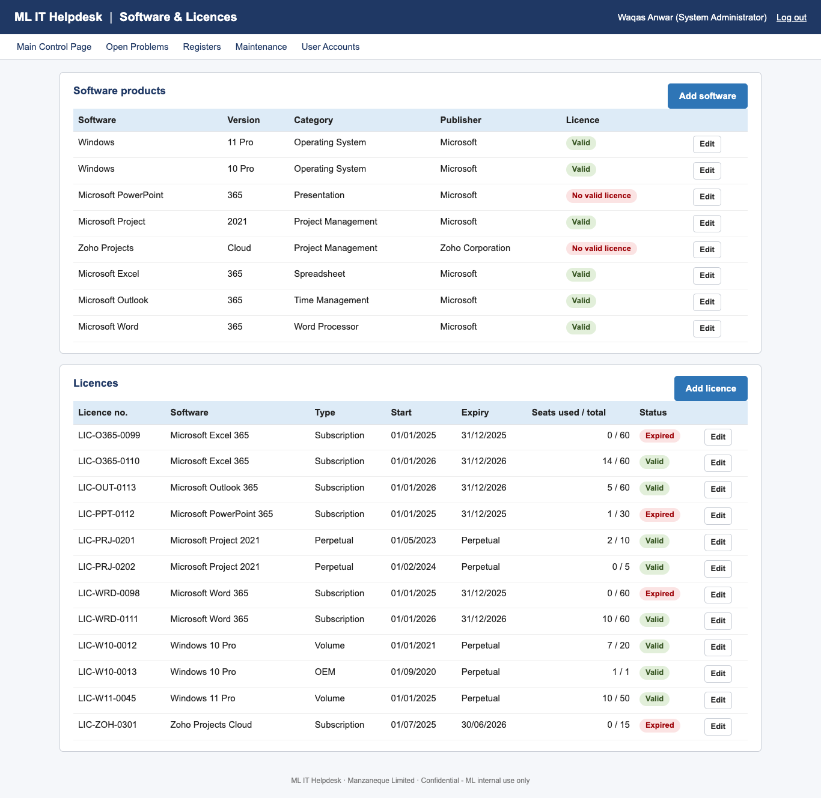
Figure 23: Software & Licences

7.5 Technicians & Skills
Click Add technician, choose the employee and tick at least one specialism. Use Edit to change the specialisms, or untick Available while a technician is on leave. Only technicians with a specialism appear on the Assign Technician screen for that problem type.
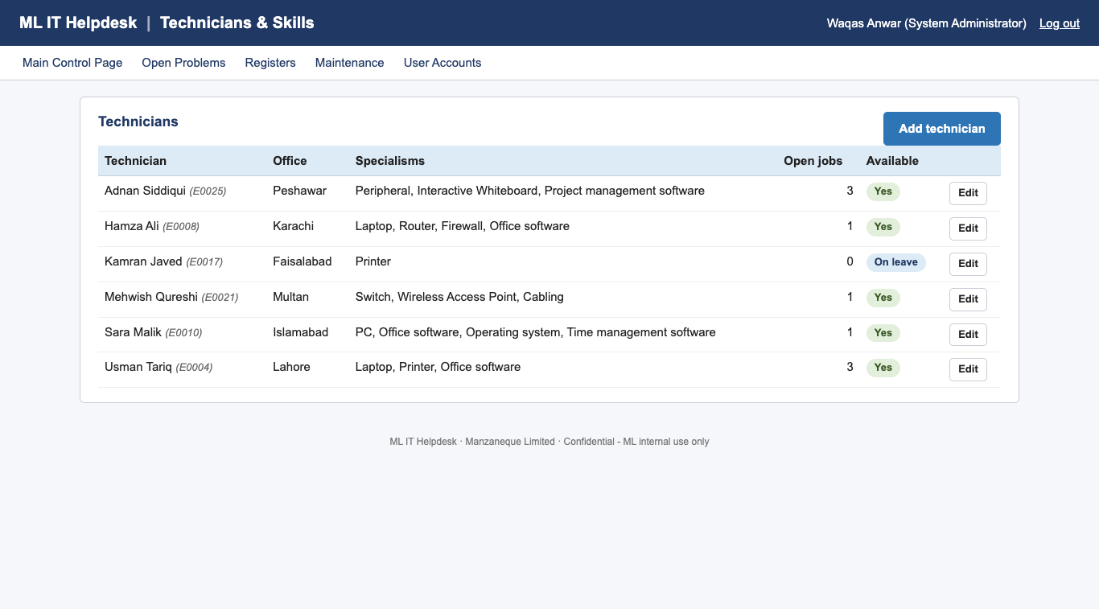
Figure 24: Technicians & Skills

7.6 User accounts
- Create account – choose the employee, a username (4–30 letters, digits, dots or underscores) and a role, and type the password twice.
- Unlock – appears next to a Locked account. It resets the failed log-in counter.
- Edit – change the role, or type a new password twice to reset it.
- Disable – stops an account from logging in, for example when someone changes job.
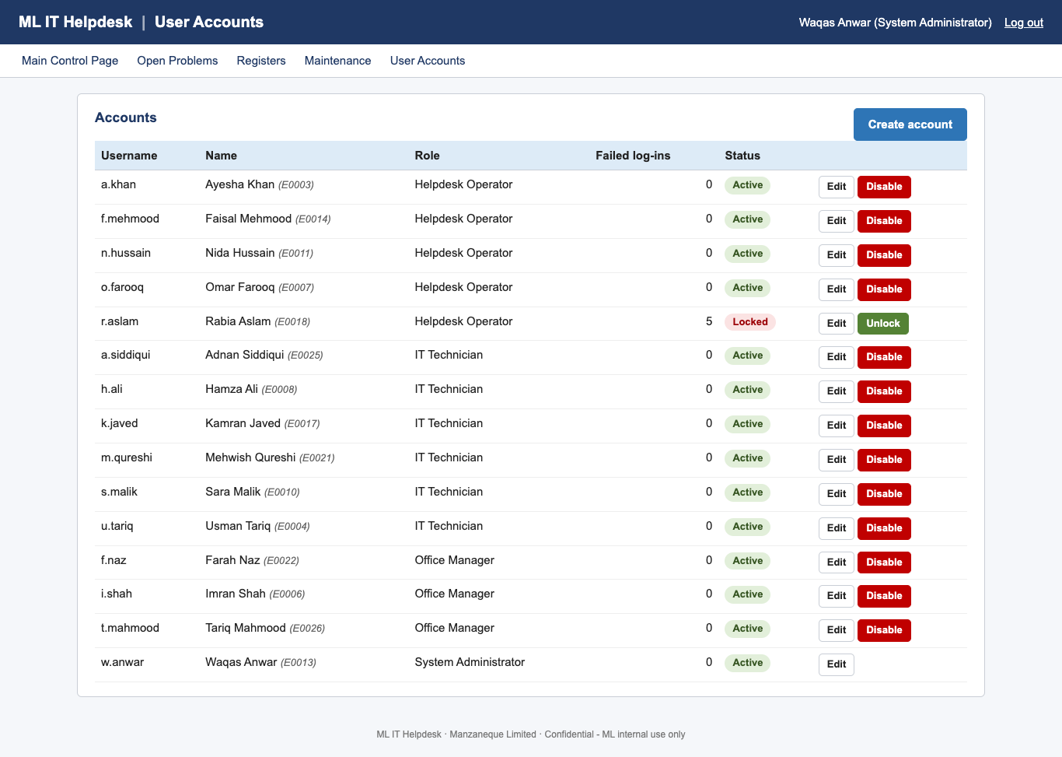
Figure 25: User Accounts

8. Database maintenance
Open Maintenance on the menu. The screen has the backup, restore and compact panels, the integrity check and the maintenance log of every action, with who did it and whether it succeeded.
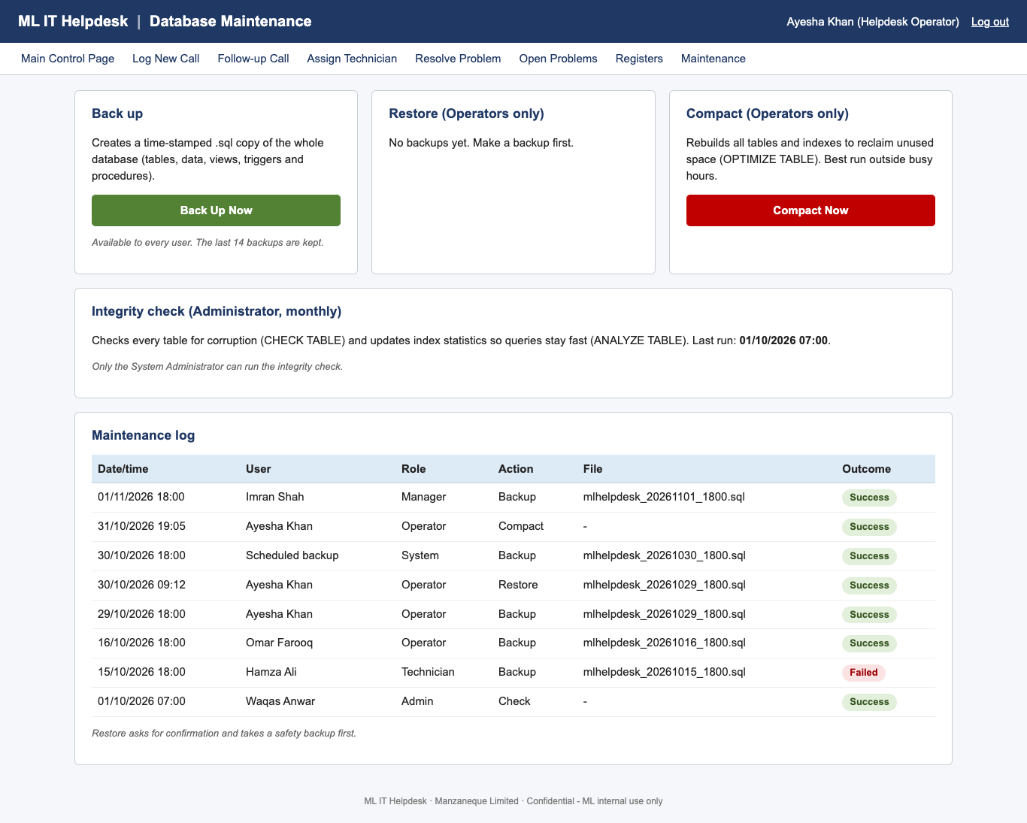
Figure 26: Database Maintenance – operator view
Table 9: Maintenance tasks
Task | Who | When
Back up | Everyone | Automatically every night at 18:00 (Monday–Saturday), and whenever you want an extra copy
Restore | Helpdesk Operators only | Only when data has been lost or damaged
Compact | Helpdesk Operators only | About once a month, outside busy hours
Integrity check | System Administrator only | Once a month

8.1 Backing up
Click Back Up Database Now on the Main Control Page, or Back Up Now on the Maintenance screen. A message shows the file name, for example mlhelpdesk_20261102_1518.sql. The last 14 backups are kept. Backups that run automatically at night appear in the log as Scheduled backup / System.

8.2 Restoring from a backup (operators)
- In the Restore panel choose the Backup file.
- Type the date part of the file name (YYYYMMDD, for example 20261102) in the confirmation box.
- Click Restore and answer OK to the warning.
- The system first saves a safety backup of the current data, then restores the chosen file. If anything goes wrong, it puts the safety copy back automatically.
Important: Restore replaces all current data with the data in the backup. Anything entered after that backup is lost (it is still in the safety backup). Tell other users before restoring.

8.3 Compacting (operators)
Click Compact Now and confirm. All tables and indexes are rebuilt to reclaim unused space. Users may notice a short delay.

8.4 Integrity check (administrator)
Click Run Integrity Check. Every table is checked for damage and its statistics are refreshed so searches stay fast. The result table should show OK for every row. If any row shows Failed, restore the last good backup and contact ATS.
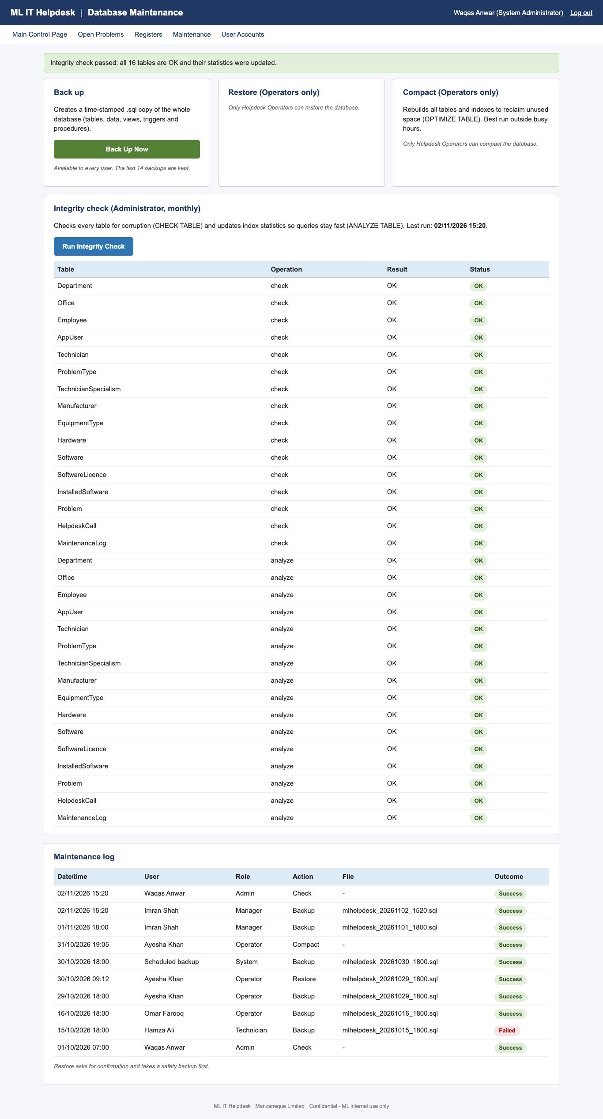
Figure 27: Integrity check results and maintenance log

9. Messages and what to do
When something cannot be saved, the screen stays open, the field is outlined in red and a message under it says what is wrong. Correct the value and save again.
Table 10: Common messages
Message | Why | What to do
Incorrect username or password. | Wrong log-in details | Check Caps Lock and try again; after 5 attempts the account locks
This account is locked. | 5 failed log-ins, or disabled | Ask the System Administrator to unlock it
Your session expired after 20 minutes of inactivity. | No activity for 20 minutes | Log in again
Caller not found or no longer employed. | Ex-employee or unknown caller | Check the name; ex-employees cannot report problems
Serial number not found in equipment register. | Mistyped or unregistered item | Check the label; ask the Administrator to add the item
Please enter the reason for the call. | Reason left empty | Type a reason, even “chasing progress”
Please describe the problem (min. 10 characters). | Description too short | Describe the fault in more detail
Problem number P-… does not exist. | Wrong number quoted | Ask the caller to check the number, or search by Open Problems
This technician is not skilled in this problem type. | Technician lacks the specialism | Choose a technician from the list
Technicians can only resolve their own jobs. | Job assigned to someone else | Ask an operator to re-assign it
Resolved time must be after the logged time. | Date/time resolved too early | Correct the date and time
Time taken must be between 0.25 and 500 hours. | Hours missing or out of range | Enter hours as a number, e.g. 1.5
This email address is already in use. | Duplicate email | Use a different email
This record is still used elsewhere, so it cannot be deleted. | Linked records exist | Edit instead, or end-date the employee
Access denied | Your role may not use this page | Use the menu; ask for the right role if needed
Something went wrong … The error has been logged. | Unexpected system error | Try again; if it repeats, tell the System Administrator

10. Quick reference
Table 11: Quick reference by role
Role | To do this… | …click
Operator | Log a call | Log New Call → fill in → Save & Assign → Assign Selected Technician
Operator | Caller rings again | Follow-up Call → number → Find → reason → Save Follow-up
Operator | See all unresolved problems | Open Problems
Technician | Close a job | Resolve Problem → Resolve → hours + notes → Mark as Resolved
Manager | Monthly report | Management Reports → month → View on screen → Print / Save as PDF
Admin | New employee leaves | Registers → Employees → Edit → End date → Save
Admin | Unlock an account | User Accounts → Unlock
Everyone | Back up | Main Control Page → Back Up Database Now

10.1 Getting help
- Locked out, forgotten password or wrong role: contact the System Administrator.
- System errors, failed backups or failed integrity checks: contact ATS support.
- For how the system is built (database, data flows, flowcharts), see the Technical Documentation.

Appendix A – Pilot user accounts
All 15 accounts created for the pilot. Each one belongs to one ML employee and has exactly one role. Every pilot password is Helpdesk2026.
Table 12: All pilot accounts
Username | Password | Name | Employee ID | Role | Status
a.khan | Helpdesk2026 | Ayesha Khan | E0003 | Helpdesk Operator | Active
o.farooq | Helpdesk2026 | Omar Farooq | E0007 | Helpdesk Operator | Active
n.hussain | Helpdesk2026 | Nida Hussain | E0011 | Helpdesk Operator | Active
f.mehmood | Helpdesk2026 | Faisal Mehmood | E0014 | Helpdesk Operator | Active
r.aslam | Helpdesk2026 | Rabia Aslam | E0018 | Helpdesk Operator | Locked (shows the 5-attempt lock-out)
h.ali | Helpdesk2026 | Hamza Ali | E0008 | IT Technician | Active
s.malik | Helpdesk2026 | Sara Malik | E0010 | IT Technician | Active
u.tariq | Helpdesk2026 | Usman Tariq | E0004 | IT Technician | Active
k.javed | Helpdesk2026 | Kamran Javed | E0017 | IT Technician | Active (on leave as a technician)
m.qureshi | Helpdesk2026 | Mehwish Qureshi | E0021 | IT Technician | Active
a.siddiqui | Helpdesk2026 | Adnan Siddiqui | E0025 | IT Technician | Active
i.shah | Helpdesk2026 | Imran Shah | E0006 | Office Manager | Active
f.naz | Helpdesk2026 | Farah Naz | E0022 | Office Manager | Active
t.mahmood | Helpdesk2026 | Tariq Mahmood | E0026 | Office Manager | Active
w.anwar | Helpdesk2026 | Waqas Anwar | E0013 | System Administrator | Active

To try the lock-out, log in as r.aslam: the message “This account is locked” appears. Log in as w.anwar, open User Accounts and click Unlock, then r.aslam can log in.
Important: Passwords are stored in the database only as encrypted (bcrypt) hashes, never as plain text. This list exists only because these are shared pilot passwords. Remove this appendix and change all passwords before go-live.

