Pearson BTEC Higher National in Computing
Unit 4: Database Design & Development
Relational Database Design Document
IT Helpdesk Information System for Manzaneque Limited (ML)
Prepared by Apex Technology Systems (ATS) Limited for the Boards of ML and ATS
Student Name / ID | [Your full name] / [Your student ID]
Unit Number and Title | Unit 4: Database Design & Development
Assignment Title | Developing A Relational Database System
Part | Part 1 of 3: Relational Database Design Document (LO1: P1, M1, D1)
Academic Year | 2025
Unit Tutor | [Tutor name]
Issue Date | 3 February 2025
Submission Date | 12 May 2025

Document Control
Version | Date | Author | Change
0.1 | [dd/mm/yyyy] | [Your name], Junior Database Developer, ATS | First draft of requirements and ERD
1.0 | [dd/mm/yyyy] | [Your name], Junior Database Developer, ATS | Full design issued to the Boards of ML and ATS

Audience: Boards of Manzaneque Limited (ML) and Apex Technology Systems (ATS), the ML IT Helpdesk Team and the ATS development team.

Contents
Document Control
Contents
1. Introduction
1.1 Purpose of this document
1.2 Background
1.3 Scope of the pilot system
1.4 Chosen database platform
2. Requirements Analysis
2.1 Stakeholders and system users
2.2 User requirements
2.3 System requirements
2.4 Assumptions and constraints
3. Design Methodology, Tools and Techniques
4. Conceptual Data Model
4.1 Entities identified
4.2 Business rules
5. Data Normalisation Design
5.1 Purpose of normalisation
5.2 Un-normalised form (UNF)
5.3 First Normal Form (1NF)
5.4 Second Normal Form (2NF)
5.5 Third Normal Form (3NF)
5.6 Additional relations and normalisation decisions
6. Logical Design: Entity–Relationship Diagram
6.1 Relationships
6.2 Resolving many-to-many relationships
6.3 Key design decisions
7. Physical Design
7.1 Data dictionary
7.2 Example table definition
7.3 Views, triggers and stored procedures
7.4 Indexing and performance
7.5 Pilot data plan
8. Data Validation Design
8.1 Three layers of validation
8.2 Types of validation used
8.3 Validation rules by field
8.4 Verification
9. Interface Design
9.1 Design principles
9.2 Navigation structure
9.3 Screen designs
10. Output (Report) Design
10.1 R1 – Monthly Calls Summary
10.2 R2 – Technician Job Sheet Summary
10.3 R3 – Jobs by Office
10.4 R4 – Jobs per Equipment Register Item
10.5 R5 – Technician Detail (selected technician)
10.6 R6 – Office Detail (selected office)
11. Security Design
11.1 Access control matrix
11.2 Authentication
11.3 Database-level security (MySQL roles)
11.4 Other security measures
12. Database Maintenance Design
13. Evaluation of the Design
13.1 Requirements traceability matrix
13.2 Effectiveness against user requirements
13.3 Effectiveness against system requirements
13.4 Limitations and trade-offs
13.5 Conclusion of the evaluation
14. Conclusion
References

(If the contents list is empty, right-click it in Word and choose Update Field → Update entire table.)

1. Introduction

1.1 Purpose of this document
This document presents the complete design of a relational database system that will log and track IT helpdesk calls for Manzaneque Limited (ML). It is written for the Boards of ML and ATS so that they can review and approve the design before development starts. It covers the user and system requirements, the design tools and techniques used, the conceptual, logical and physical data models, normalisation, data validation, interface (screen) designs, output (report) designs, security, database maintenance and, finally, an evaluation of how well the design meets the requirements.

1.2 Background
ML is a large real-estate company with 15 offices across the country, each specialising in one of: land development, property management, brokerage, lending, legal, interior design or construction. Each office has between 10 and 20 employees. Because of further expansion, ML is establishing a dedicated IT Helpdesk Team. Five helpdesk operators will take calls from staff, log the details of each problem and allocate it to one of several IT technicians, each of whom has one or more specialisms (for example routers, laptops, printers or Office software).
At present there is no central system for recording these jobs. Management therefore cannot see how equipment is performing, which items fail repeatedly, or how efficiently technicians resolve problems. The proposed system replaces informal records with a single, secure, relational database.

1.3 Scope of the pilot system
The brief states that the system "initially does not need to model all of this data but it should contain the basic relational database design to store a core level of pilot data". The design below is therefore complete in structure but will be loaded with a representative pilot data set (see Section 7.5). More data can be added later without changing the structure.
Table 1: Scope of the pilot
In scope | Out of scope (future phases)
Offices, departments, employees and ex-employees | Integration with ML's HR / payroll system
Equipment register: office hardware, network hardware, software and licences | Automatic network discovery of devices
Logging new and follow-up calls with a problem number | E-mail / SMS notifications to callers
Allocating problems to skilled technicians with load balancing | Self-service web portal for staff to raise their own tickets
Recording resolution, time taken and resolution notes | Service-level agreement (SLA) escalation rules
Six management reports (R1–R6) | Charts / dashboards beyond the six reports
Role-based security, backup, restore and compaction | Off-site cloud replication

1.4 Chosen database platform
The system will be built with MySQL Community Server 8.0 (InnoDB storage engine) as the relational database management system (RDBMS), with a browser-based front end written in PHP 8 running on an Apache web server. The reasons are:
- Multi-user, multi-site access: helpdesk operators, technicians and office managers across 15 offices can all use the system through a web browser without installing software.
- Data integrity: InnoDB enforces primary keys, foreign keys, CHECK constraints and ACID transactions, so invalid or orphaned data is rejected by the database itself (Oracle, 2024).
- Built-in security: MySQL user accounts, roles and GRANT privileges support the access rules in the brief (Bertino and Sandhu, 2005).
- Maintenance tools: mysqldump (backup), the mysql client (restore) and OPTIMIZE TABLE (compaction) meet the maintenance requirement directly.
- Cost and skills: it is free, widely documented and well supported by design tools such as MySQL Workbench.
Microsoft Access was also considered. It provides forms, reports and a "Compact and Repair" function out of the box, but it is a single-file desktop database with limited concurrent users and weaker security, which makes it less suitable for 15 offices. MySQL was therefore preferred. (If the college requires Access, the same tables, relationships and validation rules can be implemented in Access without change to the logical design.)

2. Requirements Analysis
Requirements were gathered from the client brief and organised following Sommerville (2016), who separates user requirements (what users need, written in plain language) from system requirements (what the system must do, described precisely enough to build and test). Each requirement has a unique ID so that it can be traced through design, development and testing. Priority uses the MoSCoW method (Must, Should, Could, Won't).

2.1 Stakeholders and system users
Table 2: Stakeholders and users
User / stakeholder | Description | Main needs from the system
Helpdesk Operator (5 users) | Answers calls from ML staff, logs problems and allocates technicians. | Fast call logging; automatic lookup of caller and equipment; list of suitable technicians with workload; restore and compact the database.
IT Technician | Fixes hardware and software problems; has one or more specialisms. | See assigned jobs; record how a problem was resolved and the time taken.
Office Manager / Analyst | Manages an office or analyses helpdesk performance. | View the six management reports; must not be able to log jobs.
System Administrator | Member of ML IT who looks after the system. | Maintain registers (offices, employees, equipment) and user accounts.
ML staff (callers) | Any employee who contacts the helpdesk. | Receive a problem number; have problems fixed quickly.
Boards of ML and ATS | Approve the design and fund the project. | Confidence that the design meets requirements and is secure and maintainable.

2.2 User requirements
Table 3: User requirements
ID | User requirement | User | Priority
UR-01 | When a call comes in, record the caller, the helpdesk operator, the date and time of the call, the serial number of the computer and, if relevant, the operating system and software being used. | Operator | Must
UR-02 | Check the caller's name against the personnel register to retrieve their employee ID, job title and department. | Operator | Must
UR-03 | Check the equipment against the equipment register to show its type and make, and whether it is still under manufacturer warranty. | Operator | Must
UR-04 | Check whether the software being used is under a valid licence. | Operator | Must
UR-05 | Give each new problem a unique problem number that the caller can quote on later calls. | Operator, caller | Must
UR-06 | Record follow-up calls against the existing problem number, always recording a reason for the call (including urgency or distress). | Operator | Must
UR-07 | Record notes and a description of each problem. | Operator | Must
UR-08 | Once the problem type is chosen, show only the technicians with that specialism, together with how many problems each is currently working on, so the least busy one can be chosen. | Operator | Must
UR-09 | When a problem is resolved, record the date and time, how it was resolved and the time taken in hours. | Operator, technician | Must
UR-10 | Keep a register of the 15 offices (name, address, phone, specialisation) and of all employees (ID, name, phone, email, start and end date), including ex-employees. | Administrator | Must
UR-11 | Keep an equipment register of office hardware, network hardware and software, with serial numbers, licence numbers, manufacturer, make and model. | Administrator | Must
UR-12 | Provide the six management reports R1–R6 described in the brief. | Office manager | Must
UR-13 | Helpdesk operators can log jobs but cannot open any reports. | Operator | Must
UR-14 | Office managers cannot log jobs but can view all reports. | Office manager | Must
UR-15 | Any user can back up the database from a command on the main control page. | All users | Must
UR-16 | Only helpdesk operators can restore the database from a backup and compact the database. | Operator | Must
UR-17 | Screens should be simple, consistent and usable with minimal training. | All users | Should
UR-18 | Start with a core set of pilot data and allow more data to be added later. | ML | Should

2.3 System requirements

2.3.1 Functional requirements
Table 4: Functional system requirements
ID | Functional requirement | Meets
FR-01 | Authenticate every user with a username and password and load their role (Operator, Technician, Manager or Admin). | UR-13, UR-14
FR-02 | Show or hide menu options according to the user's role (role-based access control). | UR-13–16
FR-03 | Generate the problem number automatically (AUTO_INCREMENT) and take the call date/time from the server clock. | UR-01, UR-05
FR-04 | Search the Employee table by full or partial name and return EmployeeID, JobTitle, Department and Office; reject ex-employees (EndDate in the past) as callers. | UR-02
FR-05 | Look up Hardware by SerialNumber and return type, manufacturer, make and model; warranty status = "Under warranty" when WarrantyExpiry >= CURRENT_DATE. | UR-03
FR-06 | Licence status = "Valid" when ExpiryDate IS NULL (perpetual) or ExpiryDate >= CURRENT_DATE. | UR-04
FR-07 | Store every call (new or follow-up) as a row in HelpdeskCall linked to one Problem; CallReason is mandatory. | UR-06
FR-08 | List technicians whose TechnicianSpecialism matches the problem type, with a count of their Open problems, sorted lowest first. | UR-08
FR-09 | Refuse to assign a technician who does not have the specialism for the problem type (database trigger). | UR-08
FR-10 | On resolution, set Status = "Closed" and require DateTimeResolved, ResolutionNotes and TimeTakenHours. | UR-09
FR-11 | Produce reports R1–R6 using SQL queries that join and aggregate several tables, filtered by month, technician or office. | UR-12
FR-12 | Enforce entity integrity (primary keys), referential integrity (foreign keys) and domain integrity (data types, CHECK, NOT NULL, UNIQUE). | All
FR-13 | Back up the whole database to a time-stamped .sql file and record the action in MaintenanceLog. | UR-15
FR-14 | Restore the database from a chosen backup file (Operators only) and record the action. | UR-16
FR-15 | Compact the database using OPTIMIZE TABLE (Operators only) and record the action. | UR-16
FR-16 | Keep ex-employees by setting EndDate instead of deleting the row, so history is preserved. | UR-10

2.3.2 Non-functional requirements
Table 5: Non-functional system requirements
ID | Category | Requirement
NFR-01 | Performance | Caller and equipment look-ups return in under 2 seconds; each report runs in under 5 seconds with 50,000 problem records.
NFR-02 | Security | Passwords stored only as bcrypt hashes; account locked after 5 failed log-ins; session times out after 20 minutes idle; database accounts follow least privilege.
NFR-03 | Usability | A new call can be logged in no more than 3 clicks from the main control page; all screens share one layout; error messages say what is wrong and how to fix it.
NFR-04 | Reliability / integrity | All multi-table updates run inside transactions (ACID); a full backup is taken at least daily, so no more than one day of data can be lost.
NFR-05 | Availability | Available during ML business hours, 08:00–18:00, Monday to Saturday.
NFR-06 | Scalability | Supports 15 offices × 20 staff (300 employees) and at least 2,000 equipment items, and can grow without structural change.
NFR-07 | Maintainability | Tables in Third Normal Form; consistent PascalCase naming; full data dictionary; SQL scripts kept under version control.
NFR-08 | Legal / data protection | Employee personal data is handled in line with UK GDPR and the Data Protection Act 2018: only necessary fields are stored and access is restricted (ICO, n.d.).
NFR-09 | Compatibility | Works in current versions of Chrome, Edge and Firefox on Windows and macOS.

2.3.3 Hardware and software requirements
Table 6: Hardware and software requirements
Component | Specification
Database server | MySQL Community Server 8.0, InnoDB engine, utf8mb4 character set
Web / application server | Apache 2.4 with PHP 8.2 (PDO MySQL driver). For the pilot, XAMPP or MAMP on a single machine is sufficient.
Server hardware (production) | 4-core CPU, 8 GB RAM, 100 GB SSD, Windows Server 2022 or Ubuntu 22.04 LTS, on ML's internal network
Client | Any PC or laptop with a modern web browser and access to the ML intranet
Design / development tools | MySQL Workbench 8.0 (ERD and forward engineering), draw.io (wireframes, DFDs, flowcharts), Visual Studio Code
Backup storage | Separate disk or network share with space for at least 14 daily backups

2.4 Assumptions and constraints
- Every caller is a current ML employee and is already in the personnel register.
- Each problem is assigned to one technician at a time. If it is passed to someone else, the TechnicianID is updated (see the evaluation in Section 13 for a possible future change).
- A "job" in the reports means a problem (with its problem number). A problem may have several calls.
- In monthly reports, a problem belongs to the month in which it was logged; its open/closed status is shown as at the time the report is run.
- The office of a problem is the office of the employee who reported it.
- Time taken is entered in hours to two decimal places (for example 1.5 = 1 hour 30 minutes).
- The pilot must be ready by the submission date and must be built by one junior developer, which limits the scope to the items in Table 1.

3. Design Methodology, Tools and Techniques
The design follows the three-stage approach recommended by Connolly and Begg (2015) and Visual Paradigm (n.d.): a conceptual model (what data is needed and how it is related), a logical model (tables, keys and relationships, independent of the DBMS) and a physical model (data types, constraints, indexes and security for MySQL). A top-down approach (entity–relationship modelling) was combined with a bottom-up check (normalisation of the real helpdesk job sheet) so that each confirms the other.
Table 7: Design tools and techniques used
Tool / technique | Purpose in this project | Why it is appropriate
Entity–Relationship Diagram (Crow's Foot notation) | Shows all entities, attributes, keys and relationships (Section 6). | Industry standard, easy for non-technical board members to read (Chen, 1976; Lucidchart, 2022).
MySQL Workbench 8.0 (EER modeller) | Draws the ERD and forward-engineers it into a SQL script. | Keeps the diagram and the database in step; free and designed for MySQL.
Normalisation (UNF → 1NF → 2NF → 3NF) | Removes repeating groups and redundant data (Section 5). | Prevents update, insert and delete anomalies (Codd, 1970; Kumar and Azad, 2017).
Data dictionary | Defines every field's type, size, key, nullability and constraint (Section 7). | Gives developers and testers one precise reference.
Validation rule table | Lists each validation check and its error message (Section 8). | Links validation directly to test cases.
Wireframes and navigation chart (draw.io) | Low-fidelity screen designs (Section 9). | Lets users review screens before any code is written.
Report layout designs | Column layout, grouping and totals of R1–R6 (Section 10). | Confirms management information needs early.
Access control matrix | Maps each role to each function (Section 11). | Makes the security rules in the brief testable.
MoSCoW and requirement IDs / traceability matrix | Prioritises requirements and traces them to design (Sections 2 and 13). | Supports the evaluation against user and system requirements.

4. Conceptual Data Model

4.1 Entities identified
The nouns in the brief were analysed to find the things ML needs to store data about. Sixteen entities were identified. Four of them (Department, Manufacturer, EquipmentType and ProblemType) came out of normalisation as lookup tables. Three link entities resolve many-to-many relationships or support security (TechnicianSpecialism, InstalledSoftware, AppUser), and one supports maintenance (MaintenanceLog).
Table 8: Entities and their source in the brief
Entity | Description | Source in brief
Office | One of ML's 15 offices. | "each office has a name, address, contact phone and specialisation"
Department | Business department an employee works in. | "retrieve the caller's ID number, job title and department"
Employee | Any current or former ML employee (callers, operators, technicians, managers). | "Employee ID, Name, Contact Phone and Email, Employment Start Date and End Date… ex-employees"
AppUser | A log-in account for the system with a role. | "application security measures"
Technician | An employee who works as an IT technician. | "allocate the job to one of several dedicated IT technicians"
ProblemType | A category of fault and skill area, e.g. Printer, Router, Office software. | "Once a problem type has been identified…"
TechnicianSpecialism | Which problem types each technician can solve (M:N link). | "Different IT technicians can have different specialisms"
Manufacturer | Company that makes hardware or publishes software. | "manufacturer, make and model details"
EquipmentType | Type of hardware and whether it is office or network hardware. | "office hardware: PCs, laptops… network hardware: routers, switches…"
Hardware | An individual hardware item identified by serial number. | "register of equipment… serial numbers… warranty"
Software | A software product and version. | "software: spreadsheets, word processors… operating systems"
SoftwareLicence | A licence held for a software product. | "checked to see if it is under a valid licence… licence numbers"
InstalledSoftware | Which licensed software is installed on which hardware (M:N link). | "the operating system and software being used"
Problem | A fault reported to the helpdesk; identified by a problem number. | "each problem is given a problem number"
HelpdeskCall | Each call received (new or follow-up) about a problem. | "Every call is logged… subsequent calls about the same problem"
MaintenanceLog | Audit record of backup, restore and compaction actions. | "database maintenance routine"

4.2 Business rules
Business rules describe the constraints that the data must follow. They are used to decide relationship cardinality and validation.
Table 9: Business rules
ID | Business rule
BR-01 | Each office has one specialisation from a fixed list of seven; each office employs many employees.
BR-02 | Each employee works in exactly one office and one department at a time.
BR-03 | An employee who leaves is not deleted; their EndDate is recorded. EndDate cannot be earlier than StartDate.
BR-04 | Only current employees (no EndDate, or EndDate today or later) can be recorded as callers.
BR-05 | Each technician is one employee; an employee can be at most one technician.
BR-06 | A technician has one or more specialisms; a problem type can be covered by zero or more technicians.
BR-07 | Each hardware item has a unique serial number, one equipment type, one manufacturer and is located at one office. It may be assigned to one employee.
BR-08 | Each software product can have many licences; each licence has a unique licence number. A licence with no expiry date is perpetual.
BR-09 | Each problem is reported by one employee, has one problem type and may relate to one hardware item, one operating system and one application.
BR-10 | Each problem has one or more calls; each call belongs to exactly one problem and is logged by one helpdesk operator. A reason is always recorded.
BR-11 | A problem is assigned to at most one technician, who must have the specialism for its problem type.
BR-12 | A problem is Open until resolved. A closed problem must have a resolved date/time later than the logged date/time, resolution notes and time taken (0.25–500 hours).
BR-13 | Each system user account belongs to one employee and has exactly one role.

5. Data Normalisation Design

5.1 Purpose of normalisation
Normalisation is a formal technique, first defined by Codd (1970), for organising attributes into relations so that each fact is stored once. It removes redundancy and the three types of anomaly (Connolly and Begg, 2015; Beynon-Davies, 2004):
- Update anomaly: a fact stored many times (for example an office phone number on every job) must be changed in every row, or the data becomes inconsistent.
- Insertion anomaly: a fact cannot be stored without an unrelated fact (for example a new technician cannot be recorded until they have a job).
- Deletion anomaly: deleting one fact loses another (for example deleting the only job for a laptop loses the laptop's details).
Two source documents were normalised: (A) the helpdesk job sheet that operators would otherwise fill in on paper, and (B) the technician skills list. The notation used is: RELATION(`PrimaryKey`, Attribute, ForeignKey*), with repeating groups shown in { }.

5.2 Un-normalised form (UNF)

Source A: Helpdesk job sheet
JOB_SHEET( ProblemNumber, ProblemTypeName, FaultCategory, Priority, Status, Description,
DateTimeLogged, SerialNumber, EquipmentTypeName, HardwareCategory, ManufacturerName,
Make, Model, PurchaseDate, WarrantyExpiry, HWOfficeName, OSName, OSVersion,
SoftwareName, SoftwareVersion, LicenceNumber, LicenceExpiry,
ReporterID, ReporterName, ReporterJobTitle, ReporterDepartment, ReporterPhone,
ReporterEmail, OfficeName, OfficeAddress, OfficePhone, OfficeSpecialisation,
TechnicianID, TechnicianName, DateTimeAssigned, DateTimeResolved,
ResolutionNotes, TimeTakenHours,
{ CallNo, CallDateTime, CallType, CallerID, CallerName, OperatorID, OperatorName,
CallReason, UrgencyLevel, CallNotes } )

The group in { } repeats because one problem can have several calls. The sample below shows the redundancy this causes: the details of the problem, the laptop, the reporter and the office are repeated for every call.
Table 10: Sample un-normalised data (selected columns)
Problem No. | Serial No. | Make / Model | Reporter / Office | Office phone | Technician | Call No. | Call date/time | Operator | Call reason
P-000128 | HP-5CG1234XYZ | HP EliteBook 840 G9 | Bilal Ahmed / Lahore | 042-3575 1100 | Usman Tariq | 1 | 02/11/26 10:42 | Ayesha Khan | Excel crashes on shared workbook
 |  |  |  |  |  | 2 | 02/11/26 13:05 | Omar Farooq | Chasing – deadline today (distressed)
P-000129 | CS-FGT60F-0021 | Fortinet FortiGate 60F | Sana Iqbal / Lahore | 042-3575 1100 | Hamza Ali | 1 | 02/11/26 11:15 | Ayesha Khan | No internet in whole office
P-000130 | DL-7XQ2M93 | Dell OptiPlex 7010 | Ali Raza / Karachi | 021-3456 7788 | (not yet) | 1 | 02/11/26 11:30 | Omar Farooq | PC will not start

Source B: Technician skills list
TECHNICIAN_SKILLS( TechnicianID, TechnicianName, TechPhone,
{ ProblemTypeName, FaultCategory } )

5.3 First Normal Form (1NF)
Rule: a relation is in 1NF when every attribute holds a single (atomic) value and there are no repeating groups. Action: the repeating call group is flattened so that there is one row per call, and a primary key is chosen that identifies each row uniquely. For Source A this is the composite key (ProblemNumber, CallNo); for Source B it is (TechnicianID, ProblemTypeName). Reporter and caller names are split into first and last names to make them atomic.
JOB_1NF( ProblemNumber, CallNo, ProblemTypeName, FaultCategory, Priority, Status,
Description, DateTimeLogged, SerialNumber, EquipmentTypeName, HardwareCategory,
ManufacturerName, Make, Model, PurchaseDate, WarrantyExpiry, HWOfficeName, OSName,
OSVersion, SoftwareName, SoftwareVersion, LicenceNumber, LicenceExpiry, ReporterID,
ReporterFirstName, ReporterLastName, ReporterJobTitle, ReporterDepartment, ...,
OfficeName, OfficeAddress, OfficePhone, OfficeSpecialisation, TechnicianID,
TechnicianName, DateTimeAssigned, DateTimeResolved, ResolutionNotes, TimeTakenHours,
CallDateTime, CallType, CallerID, CallerFirstName, CallerLastName, OperatorID,
OperatorName, CallReason, UrgencyLevel, CallNotes )
Primary key = (ProblemNumber, CallNo)

TECH_SKILL_1NF( TechnicianID, ProblemTypeName, TechnicianName, TechPhone, FaultCategory )
Primary key = (TechnicianID, ProblemTypeName)

5.4 Second Normal Form (2NF)
Rule: a relation is in 2NF when it is in 1NF and every non-key attribute depends on the whole primary key, not just part of it (no partial dependencies). Partial dependencies only occur where the key is composite.
- In JOB_1NF, every problem, equipment, reporter, office and technician attribute depends on ProblemNumber alone, not on CallNo. Only the call attributes depend on the full key (ProblemNumber, CallNo).
- In TECH_SKILL_1NF, TechnicianName and TechPhone depend only on TechnicianID, and FaultCategory depends only on ProblemTypeName.
Action: each partial dependency is moved to its own relation, with a copy of the part of the key it depends on.
PROBLEM_2NF( ProblemNumber, ProblemTypeName, FaultCategory, Priority, Status, Description,
DateTimeLogged, SerialNumber, EquipmentTypeName, HardwareCategory, ManufacturerName,
Make, Model, PurchaseDate, WarrantyExpiry, HWOfficeName, OSName, OSVersion,
SoftwareName, SoftwareVersion, LicenceNumber, LicenceExpiry, ReporterID, ReporterFirstName,
ReporterLastName, ReporterJobTitle, ReporterDepartment, OfficeName, OfficeAddress,
OfficePhone, OfficeSpecialisation, TechnicianID, TechnicianName, DateTimeAssigned,
DateTimeResolved, ResolutionNotes, TimeTakenHours )

CALL_2NF( ProblemNumber*, CallNo, CallDateTime, CallType, CallerID, CallerFirstName,
CallerLastName, OperatorID, OperatorName, CallReason, UrgencyLevel, CallNotes )

TECHNICIAN_2NF( TechnicianID, TechnicianName, TechPhone )
PROBLEM_TYPE_2NF( ProblemTypeName, FaultCategory )
TECH_SPECIALISM_2NF( TechnicianID*, ProblemTypeName* )

5.5 Third Normal Form (3NF)
Rule: a relation is in 3NF when it is in 2NF and no non-key attribute depends on another non-key attribute (no transitive dependencies). In other words, every non-key attribute depends on "the key, the whole key and nothing but the key" (Kent, cited in Connolly and Begg, 2015).
Table 11: Transitive dependencies found and how they were removed
Relation | Transitive dependency | New / updated relation
PROBLEM_2NF | SerialNumber → EquipmentTypeName, ManufacturerName, Make, Model, PurchaseDate, WarrantyExpiry, HWOfficeName | Hardware
PROBLEM_2NF | EquipmentTypeName → HardwareCategory | EquipmentType
PROBLEM_2NF | ManufacturerName → (manufacturer details) | Manufacturer
PROBLEM_2NF | SoftwareName + Version → SoftwareCategory, ManufacturerName; LicenceNumber → SoftwareName, LicenceExpiry | Software, SoftwareLicence
PROBLEM_2NF | ReporterID → ReporterFirstName, LastName, JobTitle, Department, OfficeName | Employee
Employee | DepartmentName repeated for many employees | Department
PROBLEM_2NF | OfficeName → OfficeAddress, OfficePhone, OfficeSpecialisation | Office
PROBLEM_2NF | TechnicianID → TechnicianName | Technician (name taken from Employee)
PROBLEM_2NF | ProblemTypeName → FaultCategory | ProblemType
CALL_2NF | CallerID → CallerFirstName, CallerLastName | Employee
CALL_2NF | OperatorID → OperatorName | AppUser → Employee

Surrogate integer keys (for example OfficeID, ProblemTypeID) were then introduced in place of names, because names can change and integers make joins faster. CallNo was replaced with a single surrogate CallID, with ProblemNumber kept as a foreign key. The relations in 3NF are:
Department( DepartmentID, DepartmentName )
Office( OfficeID, OfficeName, AddressLine, City, Postcode, ContactPhone, Specialisation )
Employee( EmployeeID, FirstName, LastName, JobTitle, ContactPhone, Email, StartDate,
EndDate, OfficeID*, DepartmentID* )
Technician( TechnicianID, EmployeeID*, IsAvailable )
ProblemType( ProblemTypeID, TypeName, FaultCategory )
TechnicianSpecialism( TechnicianID*, ProblemTypeID* )
Manufacturer( ManufacturerID, ManufacturerName, SupportPhone, Website )
EquipmentType( EquipmentTypeID, TypeName, HardwareCategory )
Hardware( HardwareID, SerialNumber, EquipmentTypeID*, ManufacturerID*, Make, Model,
PurchaseDate, WarrantyExpiry, OfficeID*, AssignedToEmployeeID* )
Software( SoftwareID, SoftwareName, Version, SoftwareCategory, ManufacturerID* )
SoftwareLicence( LicenceID, LicenceNumber, SoftwareID*, LicenceType, Seats, StartDate,
ExpiryDate )
Problem( ProblemNumber, ReportedByEmployeeID*, ProblemTypeID*, HardwareID*, OSSoftwareID*,
SoftwareID*, Description, Priority, Status, DateTimeLogged, TechnicianID*,
DateTimeAssigned, DateTimeResolved, ResolutionNotes, TimeTakenHours, ResolvedByUserID* )
HelpdeskCall( CallID, ProblemNumber*, CallerEmployeeID*, OperatorUserID*, CallDateTime,
CallType, CallReason, UrgencyLevel, Notes )

5.6 Additional relations and normalisation decisions
Three further relations were added to meet requirements that do not appear on the job sheet. Each is already in 3NF:
- AppUser( `UserID`, Username, PasswordHash, Role, IsActive, FailedLogins, EmployeeID* ): log-in accounts and roles for security (UR-13, UR-14, UR-16).
- InstalledSoftware( **HardwareID*, LicenceID***, InstallDate ): resolves the many-to-many relationship between hardware and software licences, so the operator can see which OS and software are on the caller's computer.
- MaintenanceLog( `LogID`, UserID*, ActionType, ActionDateTime, BackupFile, Outcome ): audit trail of backup, restore and compaction.
Boyce–Codd Normal Form (BCNF) check: in every relation, each determinant is a candidate key (for example, in Hardware both HardwareID and SerialNumber are candidate keys, and SerialNumber is declared UNIQUE). The design therefore also satisfies BCNF.
Controlled redundancy: two deliberate decisions keep the design practical. Status in Problem could be derived from whether DateTimeResolved is filled in, but it is stored because almost every report and the technician workload count filter on it, and a CHECK constraint keeps the two consistent. ReportedByEmployeeID is stored on Problem even though it equals the caller of the first call, because it makes the office-based reports (R3, R6) simpler and faster.

6. Logical Design: Entity–Relationship Diagram
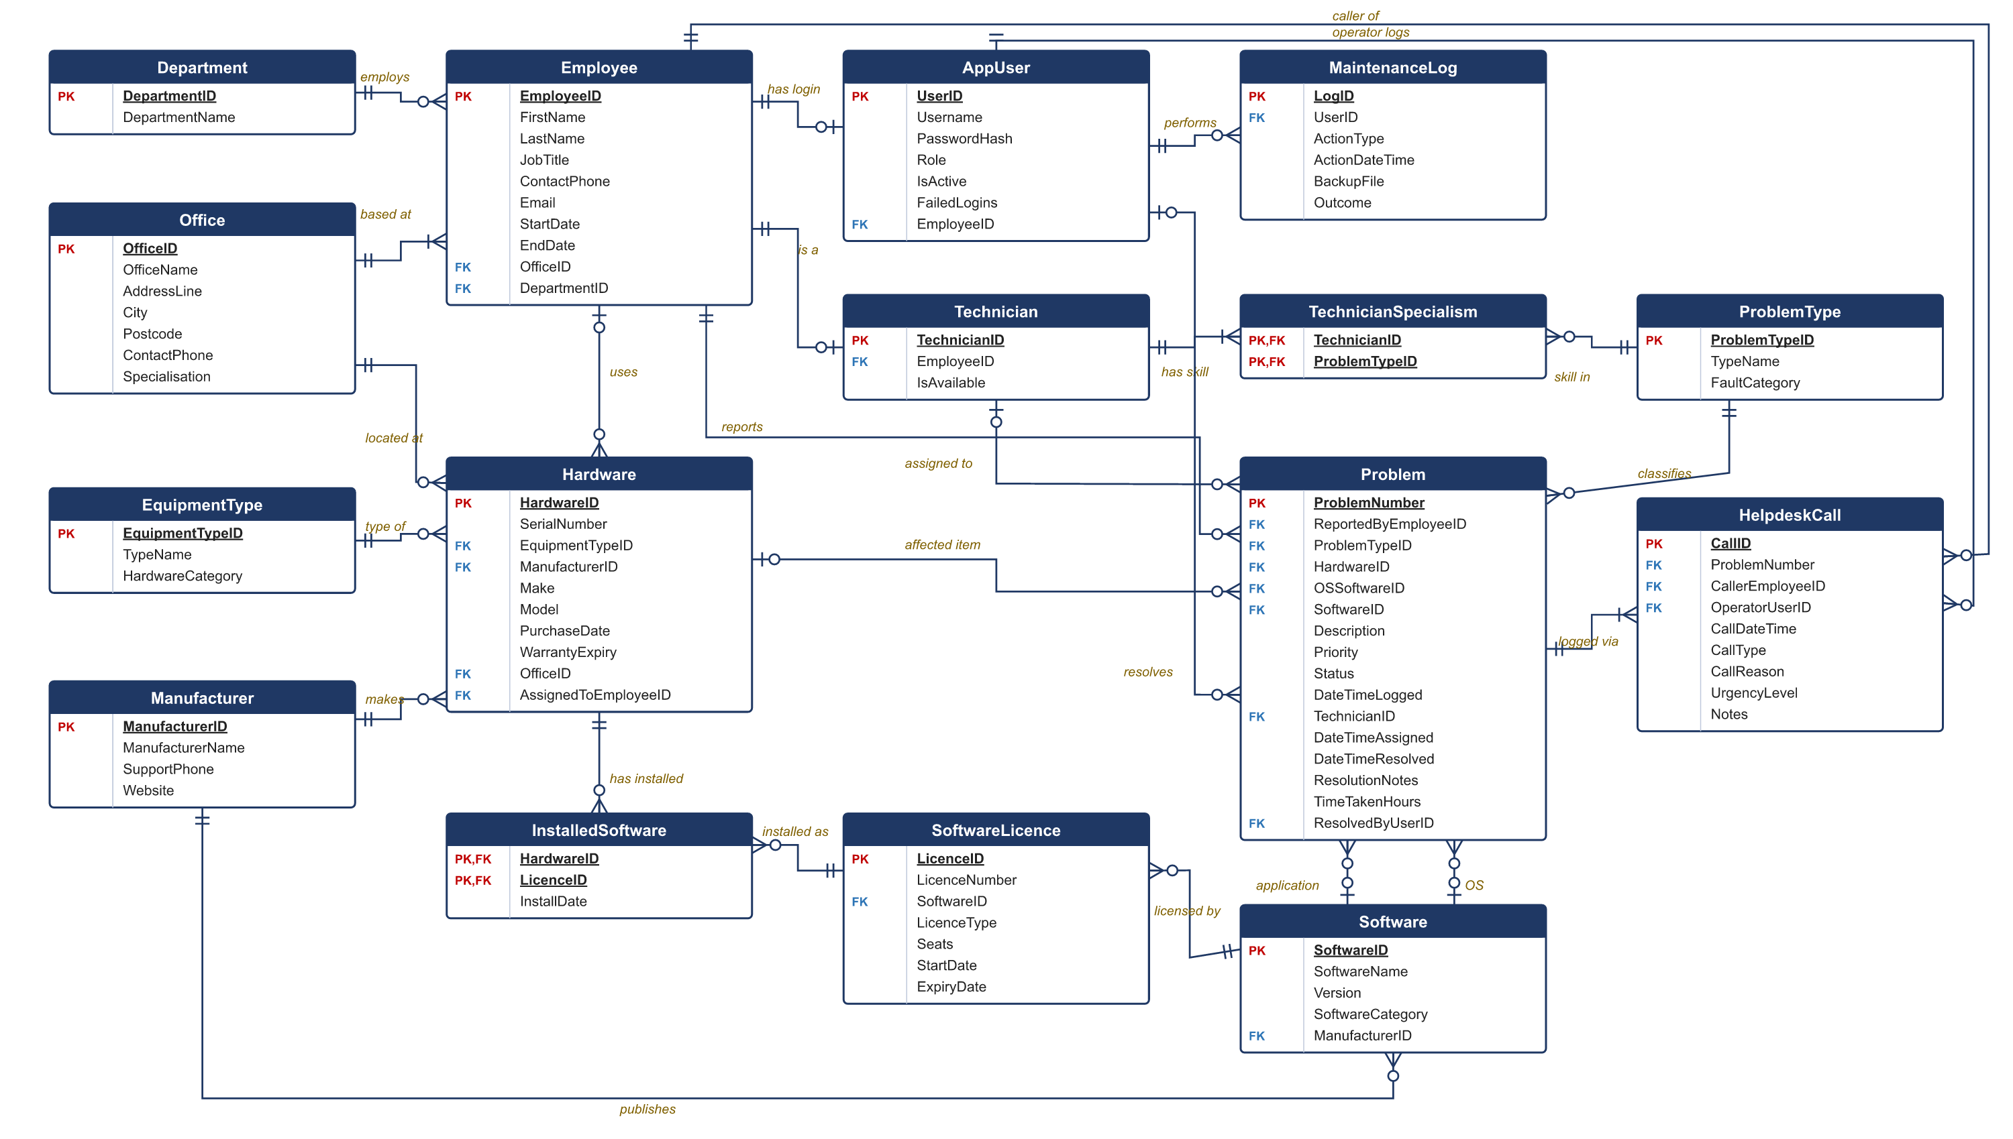
Figure 1: Entity–Relationship Diagram for the ML IT Helpdesk System (Crow's Foot notation). PK = primary key, FK = foreign key.

Figure 2: Crow's Foot cardinality symbols used in the ERD

6.1 Relationships
The ERD in Figure 1 contains 16 interrelated tables (the brief asks for at least four). Each relationship is explained below. "Optional" means a row on the many side may exist without a matching row (the foreign key may be NULL).
Table 12: Relationships in the ERD
Parent (one) | Child (many) | Cardinality | Meaning
Office | Employee | 1 : 1..* | An office employs one or more employees; each employee is based at one office.
Department | Employee | 1 : 0..* | Each employee belongs to one department.
Employee | AppUser | 1 : 0..1 | An employee may have one log-in account.
Employee | Technician | 1 : 0..1 | An employee may be a technician (subtype).
Technician | TechnicianSpecialism | 1 : 1..* | A technician has at least one specialism.
ProblemType | TechnicianSpecialism | 1 : 0..* | A problem type can be covered by many technicians.
Office | Hardware | 1 : 0..* | Each hardware item is located at one office.
Employee | Hardware | 0..1 : 0..* | A hardware item may be assigned to one employee (network kit usually is not).
EquipmentType | Hardware | 1 : 0..* | Each item has one type (PC, Router…).
Manufacturer | Hardware / Software | 1 : 0..* | Each item or product has one manufacturer.
Software | SoftwareLicence | 1 : 0..* | A product can have many licences.
Hardware | InstalledSoftware | 1 : 0..* | A computer can have many licensed products installed.
SoftwareLicence | InstalledSoftware | 1 : 0..* | A licence (with several seats) can be installed on many computers.
Employee | Problem | 1 : 0..* | An employee can report many problems.
ProblemType | Problem | 1 : 0..* | Each problem has one problem type.
Hardware | Problem | 0..1 : 0..* | A problem may concern one hardware item.
Software | Problem (×2) | 0..1 : 0..* | A problem may concern one operating system and one application.
Technician | Problem | 0..1 : 0..* | A problem is assigned to at most one technician.
AppUser | Problem | 0..1 : 0..* | Records the user who closed the problem.
Problem | HelpdeskCall | 1 : 1..* | A problem has one or more calls.
Employee | HelpdeskCall | 1 : 0..* | Each call has one caller.
AppUser | HelpdeskCall | 1 : 0..* | Each call is logged by one helpdesk operator.
AppUser | MaintenanceLog | 1 : 0..* | Each maintenance action is performed by one user.

6.2 Resolving many-to-many relationships
Relational databases cannot store many-to-many (M:N) relationships directly (Harrington, 2016). Two were found and resolved with link (associative) tables:
- Technician ↔ ProblemType ("Technician A specialises in routers, laptops, printers and Office software") → TechnicianSpecialism, with composite primary key (TechnicianID, ProblemTypeID). This table drives the "only show skilled technicians" requirement.
- Hardware ↔ SoftwareLicence (a PC has many programs; a volume licence covers many PCs) → InstalledSoftware, with composite primary key (HardwareID, LicenceID) and the extra attribute InstallDate.

6.3 Key design decisions
- One Employee table for all personnel. Operators, technicians and managers are all ML employees, so they are stored once in Employee. Technician and AppUser are one-to-one extensions, which avoids duplicating names and contact details.
- Ex-employees are kept with an EndDate (BR-03), so their past calls and problems still appear in reports.
- Problem and HelpdeskCall are separate. This allows many calls per problem, so follow-up calls and their reasons are always recorded (UR-06).
- FaultCategory (Hardware/Software) on ProblemType allows Report R3 to count hardware and software faults separately.
- Surrogate keys (INT AUTO_INCREMENT) are used for most tables. EmployeeID uses ML's existing staff number format (for example E0045).

7. Physical Design
The physical design turns the logical model into MySQL 8.0 tables. All tables use the InnoDB engine (needed for foreign keys and transactions) and the utf8mb4 character set. Naming follows PascalCase; primary keys are named <Table>ID, and foreign keys keep the same name as the primary key they reference so that joins are easy to read.

7.1 Data dictionary
Abbreviations: PK = primary key, FK = foreign key, Null = whether the field may be left empty.
Office
Table 13: Data dictionary – Office
Field | Type | Size | Key | Null | Constraint / default | Description
OfficeID | INT | — | PK | No | AUTO_INCREMENT | Unique office number
OfficeName | VARCHAR | 60 |  | No | UNIQUE | e.g. "Lahore"
AddressLine | VARCHAR | 100 |  | No |  | Street address
City | VARCHAR | 40 |  | No |  | City / town
Postcode | VARCHAR | 10 |  | No |  | Postal code
ContactPhone | VARCHAR | 15 |  | No | Digits, spaces, + and - only | Office phone
Specialisation | VARCHAR | 30 |  | No | CHECK IN (Land Development, Property Management, Brokerage, Lending, Legal, Interior Design, Construction) | Office specialisation

Department
Table 14: Data dictionary – Department
Field | Type | Size | Key | Null | Constraint / default | Description
DepartmentID | INT | — | PK | No | AUTO_INCREMENT | Unique department number
DepartmentName | VARCHAR | 50 |  | No | UNIQUE | e.g. "Finance", "Legal"

Employee
Table 15: Data dictionary – Employee
Field | Type | Size | Key | Null | Constraint / default | Description
EmployeeID | CHAR | 5 | PK | No | Format E + 4 digits (E0045) | ML staff number
FirstName | VARCHAR | 40 |  | No | Letters, space, ' and - only | First name
LastName | VARCHAR | 40 |  | No | As above; indexed with FirstName | Last name
JobTitle | VARCHAR | 50 |  | No |  | e.g. "Property Manager"
ContactPhone | VARCHAR | 15 |  | No | Phone format | Work phone
Email | VARCHAR | 100 |  | No | UNIQUE; must contain @ and . | Work email
StartDate | DATE | — |  | No | Not in the future | Employment start date
EndDate | DATE | — |  | Yes | CHECK (EndDate >= StartDate) | Blank = current employee
OfficeID | INT | — | FK | No | REFERENCES Office | Office the employee works at
DepartmentID | INT | — | FK | No | REFERENCES Department | Department

AppUser
Table 16: Data dictionary – AppUser
Field | Type | Size | Key | Null | Constraint / default | Description
UserID | INT | — | PK | No | AUTO_INCREMENT | Account number
Username | VARCHAR | 30 |  | No | UNIQUE; 4–30 letters/digits/._ | Log-in name
PasswordHash | VARCHAR | 255 |  | No | bcrypt hash only | Never stores plain text
Role | VARCHAR | 12 |  | No | CHECK IN (Operator, Technician, Manager, Admin) | Decides permissions
IsActive | BOOLEAN | — |  | No | DEFAULT TRUE | FALSE = locked / disabled
FailedLogins | TINYINT | — |  | No | DEFAULT 0; lock at 5 | Consecutive failed log-ins
EmployeeID | CHAR | 5 | FK | No | UNIQUE; REFERENCES Employee | Owner of the account

Technician
Table 17: Data dictionary – Technician
Field | Type | Size | Key | Null | Constraint / default | Description
TechnicianID | INT | — | PK | No | AUTO_INCREMENT | Technician number
EmployeeID | CHAR | 5 | FK | No | UNIQUE; REFERENCES Employee | The employee who is the technician
IsAvailable | BOOLEAN | — |  | No | DEFAULT TRUE | FALSE when on leave

ProblemType
Table 18: Data dictionary – ProblemType
Field | Type | Size | Key | Null | Constraint / default | Description
ProblemTypeID | INT | — | PK | No | AUTO_INCREMENT | Problem type number
TypeName | VARCHAR | 50 |  | No | UNIQUE | e.g. "Printer", "Office software"
FaultCategory | VARCHAR | 8 |  | No | CHECK IN (Hardware, Software) | Used in Report R3

TechnicianSpecialism
Table 19: Data dictionary – TechnicianSpecialism
Field | Type | Size | Key | Null | Constraint / default | Description
TechnicianID | INT | — | PK, FK | No | REFERENCES Technician ON DELETE CASCADE | Technician
ProblemTypeID | INT | — | PK, FK | No | REFERENCES ProblemType | Skill area

Manufacturer
Table 20: Data dictionary – Manufacturer
Field | Type | Size | Key | Null | Constraint / default | Description
ManufacturerID | INT | — | PK | No | AUTO_INCREMENT | Manufacturer number
ManufacturerName | VARCHAR | 60 |  | No | UNIQUE | e.g. "HP Inc.", "Microsoft"
SupportPhone | VARCHAR | 20 |  | Yes | Phone format | Warranty / support line
Website | VARCHAR | 100 |  | Yes | Must start with http:// or https:// | Support website

EquipmentType
Table 21: Data dictionary – EquipmentType
Field | Type | Size | Key | Null | Constraint / default | Description
EquipmentTypeID | INT | — | PK | No | AUTO_INCREMENT | Equipment type number
TypeName | VARCHAR | 40 |  | No | UNIQUE | PC, Laptop, Printer, Peripheral, Interactive Whiteboard, Router, Switch, Wireless Access Point, Firewall, Cable
HardwareCategory | VARCHAR | 7 |  | No | CHECK IN (Office, Network) | Office or network hardware

Hardware
Table 22: Data dictionary – Hardware
Field | Type | Size | Key | Null | Constraint / default | Description
HardwareID | INT | — | PK | No | AUTO_INCREMENT | Register number
SerialNumber | VARCHAR | 30 |  | No | UNIQUE; letters, digits and - only | Manufacturer serial number
EquipmentTypeID | INT | — | FK | No | REFERENCES EquipmentType | Type of item
ManufacturerID | INT | — | FK | No | REFERENCES Manufacturer | Manufacturer
Make | VARCHAR | 40 |  | No |  | Brand / product line, e.g. "EliteBook"
Model | VARCHAR | 40 |  | No |  | e.g. "840 G9"
PurchaseDate | DATE | — |  | No | Not in the future | Date purchased
WarrantyExpiry | DATE | — |  | No | CHECK (WarrantyExpiry >= PurchaseDate) | Warranty end date
OfficeID | INT | — | FK | No | REFERENCES Office | Where the item is located
AssignedToEmployeeID | CHAR | 5 | FK | Yes | REFERENCES Employee | User of the item (blank for shared/network kit)

Software
Table 23: Data dictionary – Software
Field | Type | Size | Key | Null | Constraint / default | Description
SoftwareID | INT | — | PK | No | AUTO_INCREMENT | Software number
SoftwareName | VARCHAR | 60 |  | No | UNIQUE with Version | e.g. "Microsoft Excel"
Version | VARCHAR | 20 |  | No |  | e.g. "365", "11 Pro"
SoftwareCategory | VARCHAR | 20 |  | No | CHECK IN (Spreadsheet, Word Processor, Presentation, Operating System, Time Management, Project Management) | Category
ManufacturerID | INT | — | FK | No | REFERENCES Manufacturer | Publisher

SoftwareLicence
Table 24: Data dictionary – SoftwareLicence
Field | Type | Size | Key | Null | Constraint / default | Description
LicenceID | INT | — | PK | No | AUTO_INCREMENT | Licence record number
LicenceNumber | VARCHAR | 40 |  | No | UNIQUE | Licence key / agreement number
SoftwareID | INT | — | FK | No | REFERENCES Software | Licensed product
LicenceType | VARCHAR | 12 |  | No | CHECK IN (Perpetual, Subscription, Volume, OEM) | Type of licence
Seats | SMALLINT | — |  | No | CHECK (Seats BETWEEN 1 AND 10000); DEFAULT 1 | Number of installs allowed
StartDate | DATE | — |  | No |  | Licence start
ExpiryDate | DATE | — |  | Yes | CHECK (ExpiryDate >= StartDate) | Blank = perpetual

InstalledSoftware
Table 25: Data dictionary – InstalledSoftware
Field | Type | Size | Key | Null | Constraint / default | Description
HardwareID | INT | — | PK, FK | No | REFERENCES Hardware ON DELETE CASCADE | Computer
LicenceID | INT | — | PK, FK | No | REFERENCES SoftwareLicence | Licence used
InstallDate | DATE | — |  | No | DEFAULT CURRENT_DATE | Date installed

Problem
Table 26: Data dictionary – Problem
Field | Type | Size | Key | Null | Constraint / default | Description
ProblemNumber | INT | — | PK | No | AUTO_INCREMENT; shown as P-000128 | Number given to the caller
ReportedByEmployeeID | CHAR | 5 | FK | No | REFERENCES Employee; must be current | Employee who first reported it
ProblemTypeID | INT | — | FK | No | REFERENCES ProblemType | Type of problem
HardwareID | INT | — | FK | Yes | REFERENCES Hardware | Affected item
OSSoftwareID | INT | — | FK | Yes | REFERENCES Software (category = OS) | Operating system in use
SoftwareID | INT | — | FK | Yes | REFERENCES Software | Application in use
Description | TEXT | — |  | No | Min. 10 characters | Notes / description of the problem
Priority | VARCHAR | 8 |  | No | CHECK IN (Low, Medium, High, Critical); DEFAULT Medium | Business priority
Status | VARCHAR | 6 |  | No | CHECK IN (Open, Closed); DEFAULT Open | Current status
DateTimeLogged | DATETIME | — |  | No | DEFAULT CURRENT_TIMESTAMP | When the problem was first logged
TechnicianID | INT | — | FK | Yes | REFERENCES Technician; must have the specialism | Assigned technician
DateTimeAssigned | DATETIME | — |  | Yes | Set automatically by trigger | When assigned
DateTimeResolved | DATETIME | — |  | Yes | CHECK (> DateTimeLogged); not in the future | When resolved
ResolutionNotes | TEXT | — |  | Yes | Required when Closed | How it was resolved
TimeTakenHours | DECIMAL | 5,2 |  | Yes | CHECK (BETWEEN 0.25 AND 500); required when Closed | Hours spent
ResolvedByUserID | INT | — | FK | Yes | REFERENCES AppUser | Who closed it

HelpdeskCall
Table 27: Data dictionary – HelpdeskCall
Field | Type | Size | Key | Null | Constraint / default | Description
CallID | INT | — | PK | No | AUTO_INCREMENT | Call number
ProblemNumber | INT | — | FK | No | REFERENCES Problem | Problem the call is about
CallerEmployeeID | CHAR | 5 | FK | No | REFERENCES Employee | Who called
OperatorUserID | INT | — | FK | No | REFERENCES AppUser (Role = Operator) | Operator who logged the call
CallDateTime | DATETIME | — |  | No | DEFAULT CURRENT_TIMESTAMP | Date and time of call
CallType | VARCHAR | 9 |  | No | CHECK IN (New, Follow-up) | First call or follow-up
CallReason | VARCHAR | 255 |  | No | CHECK (CHAR_LENGTH(TRIM(CallReason)) >= 3) | Reason – always required
UrgencyLevel | VARCHAR | 10 |  | No | CHECK IN (Normal, Urgent, Distressed); DEFAULT Normal | Caller's urgency/distress
Notes | TEXT | — |  | Yes |  | Extra notes

MaintenanceLog
Table 28: Data dictionary – MaintenanceLog
Field | Type | Size | Key | Null | Constraint / default | Description
LogID | INT | — | PK | No | AUTO_INCREMENT | Log entry number
UserID | INT | — | FK | No | REFERENCES AppUser | Who performed the action
ActionType | VARCHAR | 8 |  | No | CHECK IN (Backup, Restore, Compact) | Maintenance action
ActionDateTime | DATETIME | — |  | No | DEFAULT CURRENT_TIMESTAMP | When it happened
BackupFile | VARCHAR | 255 |  | Yes |  | File created or restored from
Outcome | VARCHAR | 7 |  | No | CHECK IN (Success, Failed) | Result

7.2 Example table definition
The SQL below shows how the design is implemented for the Problem table. All other tables follow the same pattern and will be listed in full in the Development Document.
CREATE TABLE Problem (
ProblemNumber INT AUTO_INCREMENT PRIMARY KEY,
ReportedByEmployeeID CHAR(5) NOT NULL,
ProblemTypeID INT NOT NULL,
HardwareID INT NULL,
OSSoftwareID INT NULL,
SoftwareID INT NULL,
Description TEXT NOT NULL,
Priority VARCHAR(8) NOT NULL DEFAULT 'Medium',
Status VARCHAR(6) NOT NULL DEFAULT 'Open',
DateTimeLogged DATETIME NOT NULL DEFAULT CURRENT_TIMESTAMP,
TechnicianID INT NULL,
DateTimeAssigned DATETIME NULL,
DateTimeResolved DATETIME NULL,
ResolutionNotes TEXT NULL,
TimeTakenHours DECIMAL(5,2) NULL,
ResolvedByUserID INT NULL,
CONSTRAINT chk_priority CHECK (Priority IN ('Low','Medium','High','Critical')),
CONSTRAINT chk_status CHECK (Status IN ('Open','Closed')),
CONSTRAINT chk_hours CHECK (TimeTakenHours BETWEEN 0.25 AND 500),
CONSTRAINT chk_resolved CHECK (DateTimeResolved IS NULL OR DateTimeResolved > DateTimeLogged),
CONSTRAINT chk_closed CHECK (Status = 'Open' OR (DateTimeResolved IS NOT NULL
AND ResolutionNotes IS NOT NULL AND TimeTakenHours IS NOT NULL)),
FOREIGN KEY (ReportedByEmployeeID) REFERENCES Employee(EmployeeID),
FOREIGN KEY (ProblemTypeID) REFERENCES ProblemType(ProblemTypeID),
FOREIGN KEY (HardwareID) REFERENCES Hardware(HardwareID),
FOREIGN KEY (OSSoftwareID) REFERENCES Software(SoftwareID),
FOREIGN KEY (SoftwareID) REFERENCES Software(SoftwareID),
FOREIGN KEY (TechnicianID) REFERENCES Technician(TechnicianID),
FOREIGN KEY (ResolvedByUserID) REFERENCES AppUser(UserID)
) ENGINE=InnoDB DEFAULT CHARSET=utf8mb4;

7.3 Views, triggers and stored procedures
Table 29: Planned database objects
Object | Type | Purpose
vw_TechnicianWorkload | View | Each technician with their specialisms and count of Open problems; used by the Assign Technician screen (UR-08).
vw_HardwareStatus | View | Hardware with type, manufacturer, office and a calculated WarrantyStatus ("Under warranty"/"Expired").
vw_LicenceStatus | View | Licences with a calculated LicenceStatus ("Valid"/"Expired") and seats used vs. seats available.
vw_ProblemDetail | View | Problem joined to type, reporter, office, hardware, software and technician; base for reports R1–R6.
trg_Problem_BeforeInsert | Trigger | Rejects a problem whose reporter has left (EndDate in the past) (BR-04).
trg_Problem_BeforeUpdate | Trigger | Rejects a technician without the right specialism (FR-09); sets DateTimeAssigned when a technician is first assigned.
sp_LogNewProblem | Stored procedure | In one transaction, inserts the Problem and its first HelpdeskCall, then returns the new ProblemNumber.
sp_ResolveProblem | Stored procedure | Validates and records the resolution and sets Status = Closed.
sp_Report_R1 … sp_Report_R6 | Stored procedures | Parameterised report queries (month, technician, office).

7.4 Indexing and performance
Indexes speed up searches and joins but slow down inserts slightly, so they are only added where the requirements need fast look-ups (NFR-01):
- InnoDB automatically indexes every primary key and foreign key, which supports all the joins used in the reports.
- UNIQUE indexes on Hardware.SerialNumber, SoftwareLicence.LicenceNumber, Employee.Email and AppUser.Username give fast, exact look-ups and prevent duplicates.
- INDEX idx_emp_name (LastName, FirstName) supports the caller name search.
- INDEX idx_problem_status (Status, TechnicianID) supports the technician workload count.
- INDEX idx_problem_logged (DateTimeLogged) and INDEX idx_call_datetime (CallDateTime) support the monthly reports.
- The smallest suitable data types are used (for example TINYINT for FailedLogins, DECIMAL(5,2) for hours) to keep rows small.

7.5 Pilot data plan
The brief asks for a core level of pilot data. The table below shows the volume planned for the pilot; it is large enough to test every report and validation rule but small enough to check results by hand.
Table 30: Pilot data volumes
Table | Pilot rows | Notes
Office | 15 | All 15 offices, covering all seven specialisations
Department | 8 | e.g. Finance, Legal, Sales, Operations, HR, IT, Projects, Administration
Employee | 60 | 4 per office, including 5 ex-employees, 5 operators, 6 technicians and 3 managers
AppUser | 15 | One for each operator, technician, manager and one administrator
Technician / TechnicianSpecialism | 6 / 18 | Overlapping skills so load balancing can be tested
ProblemType | 14 | 10 hardware types and 4 software types
Manufacturer / EquipmentType | 10 / 10 | HP, Dell, Lenovo, Cisco, Fortinet, Microsoft, Epson, Promethean…
Hardware | 40 | Mix of office and network kit; some with expired warranties
Software / SoftwareLicence / InstalledSoftware | 8 / 12 / 50 | Some expired licences to test the licence check
Problem / HelpdeskCall | 60 / 90 | Spread over three months, open and closed, with follow-up calls

8. Data Validation Design
Validation checks that data is reasonable and allowed before it is stored; it cannot prove that data is correct. Verification checks that data has been entered accurately, for example by asking the user to confirm (Connolly and Begg, 2015). Both are used.

8.1 Three layers of validation
Validation is applied in three layers ("defence in depth"), so that a mistake missed by one layer is caught by the next:
- Interface (browser): HTML5 attributes such as required, maxlength, pattern, type="date" and drop-down lists give instant feedback and prevent most typing errors.
- Application (PHP): every value is checked again on the server, because browser checks can be bypassed. All SQL uses prepared statements to prevent SQL injection.
- Database (MySQL): data types, NOT NULL, UNIQUE, CHECK, foreign keys and triggers guarantee that invalid data can never be stored, whichever program writes it.

8.2 Types of validation used
Table 31: Validation types
Type | What it checks | Example in this system
Presence check | A required field is not left empty. | CallReason, Description, SerialNumber
Type check | The value is the correct data type. | TimeTakenHours must be a number; dates must be valid dates
Length check | The number of characters is within limits. | Username 4–30 characters; OfficeName ≤ 60
Range check | A number or date is between limits. | TimeTakenHours 0.25–500; Seats 1–10,000
Format (pattern) check | The value matches a pattern. | EmployeeID = E + 4 digits; email contains @
Lookup / list check | The value is one of a set of allowed values. | Priority, Status, Role, Specialisation (drop-downs + CHECK)
Uniqueness check | The value does not already exist. | SerialNumber, LicenceNumber, Email, Username
Referential integrity | A foreign key matches an existing primary key. | A call must belong to an existing problem
Cross-field (consistency) check | Two or more fields agree with each other. | EndDate ≥ StartDate; DateTimeResolved > DateTimeLogged
Business-rule check | A rule from the business is obeyed. | Technician must have the specialism; caller must be a current employee

8.3 Validation rules by field
Table 32: Field validation rules, error messages and test data
Field | Rule | Type | Error message | Valid | Invalid
Caller name | Must match a current employee in the register | Lookup, business rule | "Caller not found or no longer employed." | Bilal Ahmed | Zara Noor (left 2025)
SerialNumber | Required; exists in Hardware | Presence, lookup | "Serial number not found in equipment register." | HP-5CG1234XYZ | ABC-000
CallReason | Required; at least 3 characters | Presence, length | "Please enter the reason for the call." | Printer jammed | (blank)
Description | Required; at least 10 characters | Presence, length | "Please describe the problem (min. 10 characters)." | Screen flickers after update | Broken
ProblemType | Must be chosen from list | Lookup | "Please choose a problem type." | Printer | (none)
Priority | Low / Medium / High / Critical | List | "Invalid priority." | High | Very high
Problem number (follow-up) | Must exist in Problem | Referential | "Problem number P-… does not exist." | P-000128 | P-999999
TechnicianID | Technician must have the specialism | Business rule | "This technician is not skilled in <type>." | Usman (Office software) | Hamza for Printer
DateTimeResolved | After DateTimeLogged and not in the future | Cross-field, range | "Resolved time must be after the logged time." | 02/11/26 15:10 | 01/11/26 09:00
TimeTakenHours | Number 0.25 to 500, max 2 d.p. | Type, range | "Time taken must be between 0.25 and 500 hours." | 3.5 | 0 / -2 / abc
ResolutionNotes | Required when closing | Presence | "Please describe how the problem was resolved." | Replaced toner | (blank)
EmployeeID | E followed by 4 digits; unique | Format, uniqueness | "Employee ID must look like E0045." | E0045 | 45 / E45A
Email | Contains one @ and a dot after it; unique | Format, uniqueness | "Enter a valid, unused email address." | b.ahmed@ml.co.uk | b.ahmed@ml
ContactPhone | Digits, spaces, + and - only; 7–15 characters | Format, length | "Enter a valid phone number." | 042-3575 1100 | 042-ABC
EndDate | Empty or ≥ StartDate | Cross-field | "End date cannot be before start date." | 30/06/2026 | 01/01/2019 (start 2020)
WarrantyExpiry | ≥ PurchaseDate | Cross-field | "Warranty cannot end before purchase." | 14/03/2028 | 01/01/2024
Seats | Whole number 1–10,000 | Type, range | "Seats must be 1 to 10,000." | 25 | 0
Username / Password | Username 4–30 chars; password ≥ 8 chars with a letter and a number | Length, format | "Incorrect username or password." | a.khan / Helpdesk2026 | ak / 1234

8.4 Verification
- Before saving a new call, the operator sees a summary of the caller and equipment that were looked up and confirms they are correct.
- Restore and Compact ask "Are you sure?" and, for Restore, the operator must type the backup file date to confirm.
- When a user's password is set or changed, it must be typed twice and both entries must match.

9. Interface Design

9.1 Design principles
The screens follow Nielsen's usability heuristics (Nielsen, 1994), so that operators can work quickly while on the phone:
- Consistency: every screen has the same header (system name, screen title, logged-in user and role) and buttons in the same place (main action on the right, Cancel next to it).
- Recognition rather than recall: drop-down lists and search boxes are used instead of typing codes; looked-up details appear automatically in grey read-only boxes.
- Error prevention: required fields are marked with *; invalid values are blocked before saving; dangerous actions (Restore, Compact) are red and need confirmation.
- Visibility of system status: coloured badges show warranty and licence status; the problem number is shown immediately so the operator can read it to the caller.
- Role-based menus: users only see the options they are allowed to use, which also supports the security design (Section 11).

9.2 Navigation structure
Figure 3 shows how users move through the system. After logging in, every user arrives at the Main Control Page, which shows only the menu groups allowed for their role.
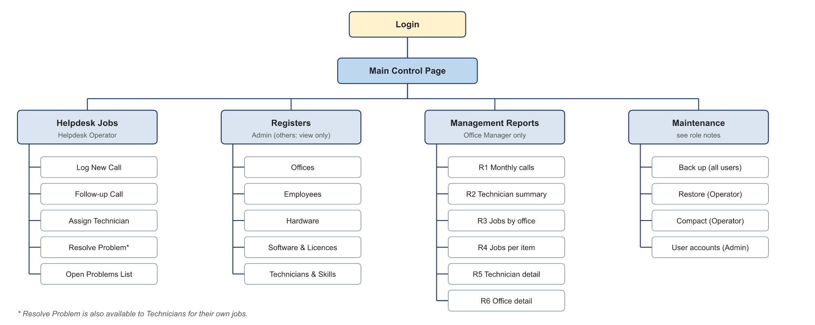
Figure 3: Navigation (menu) structure chart

9.3 Screen designs
The following low-fidelity wireframes show the layout, fields and controls of each main screen. Sample values are shown in the fields to make the purpose of each clear.

Login screen
Users enter a username and password. After 5 failed attempts the account is locked (IsActive = FALSE) and must be unlocked by the administrator. The error message does not say which field was wrong, which makes it harder to guess usernames.
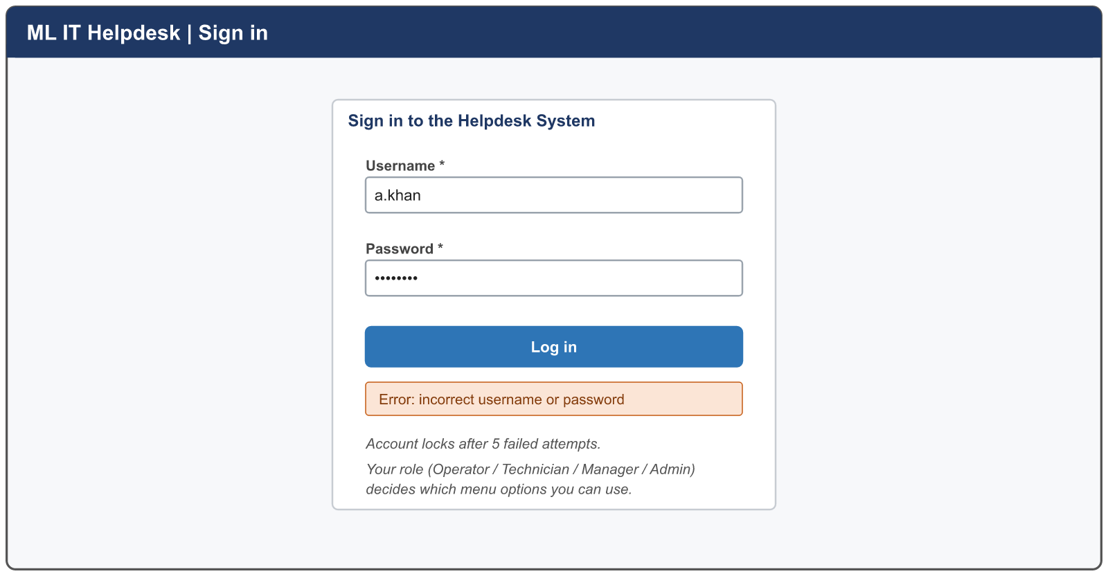
Figure 4: Login screen

Main Control Page
The main control page shows key figures (open problems, problems closed this month and the date of the last backup) and the menu groups. The example is for a Helpdesk Operator: the Management Reports button is locked. For an Office Manager the Helpdesk Jobs group is hidden and Reports is active. The Back Up Database Now command is on this page for every user, as the brief requires; Restore and Compact are shown only to Helpdesk Operators.
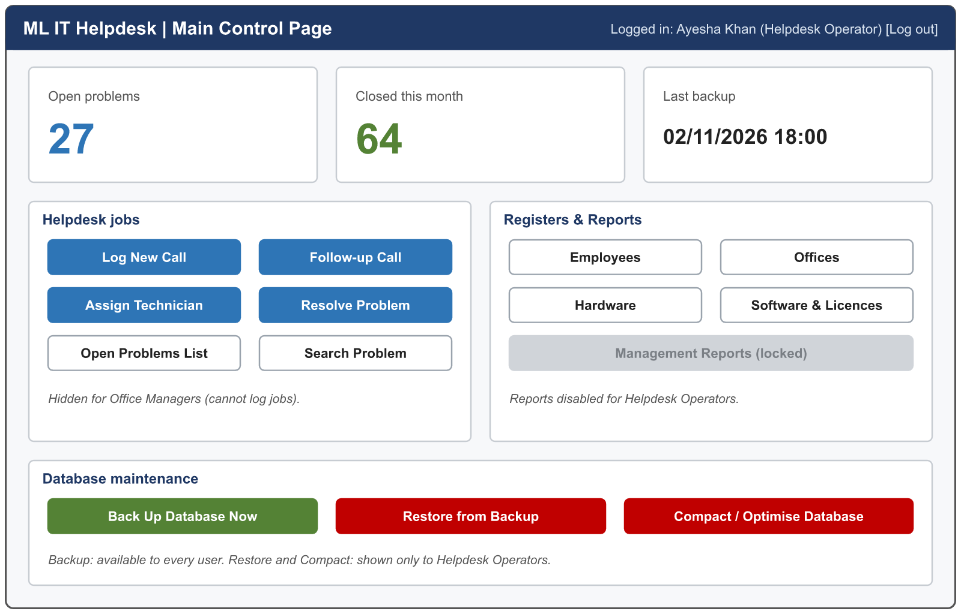
Figure 5: Main Control Page (Helpdesk Operator view)

Log New Call
This is the most-used screen. The problem number and call date/time are generated automatically. When the operator selects the caller's name, the employee ID, job title, department and office are filled in from the personnel register (UR-02). When the serial number is entered, the equipment type, make and model are filled in and a badge shows warranty status (UR-03); the software drop-down shows licence status (UR-04). Save & Assign saves the problem and its first call in one transaction and opens the Assign Technician screen.
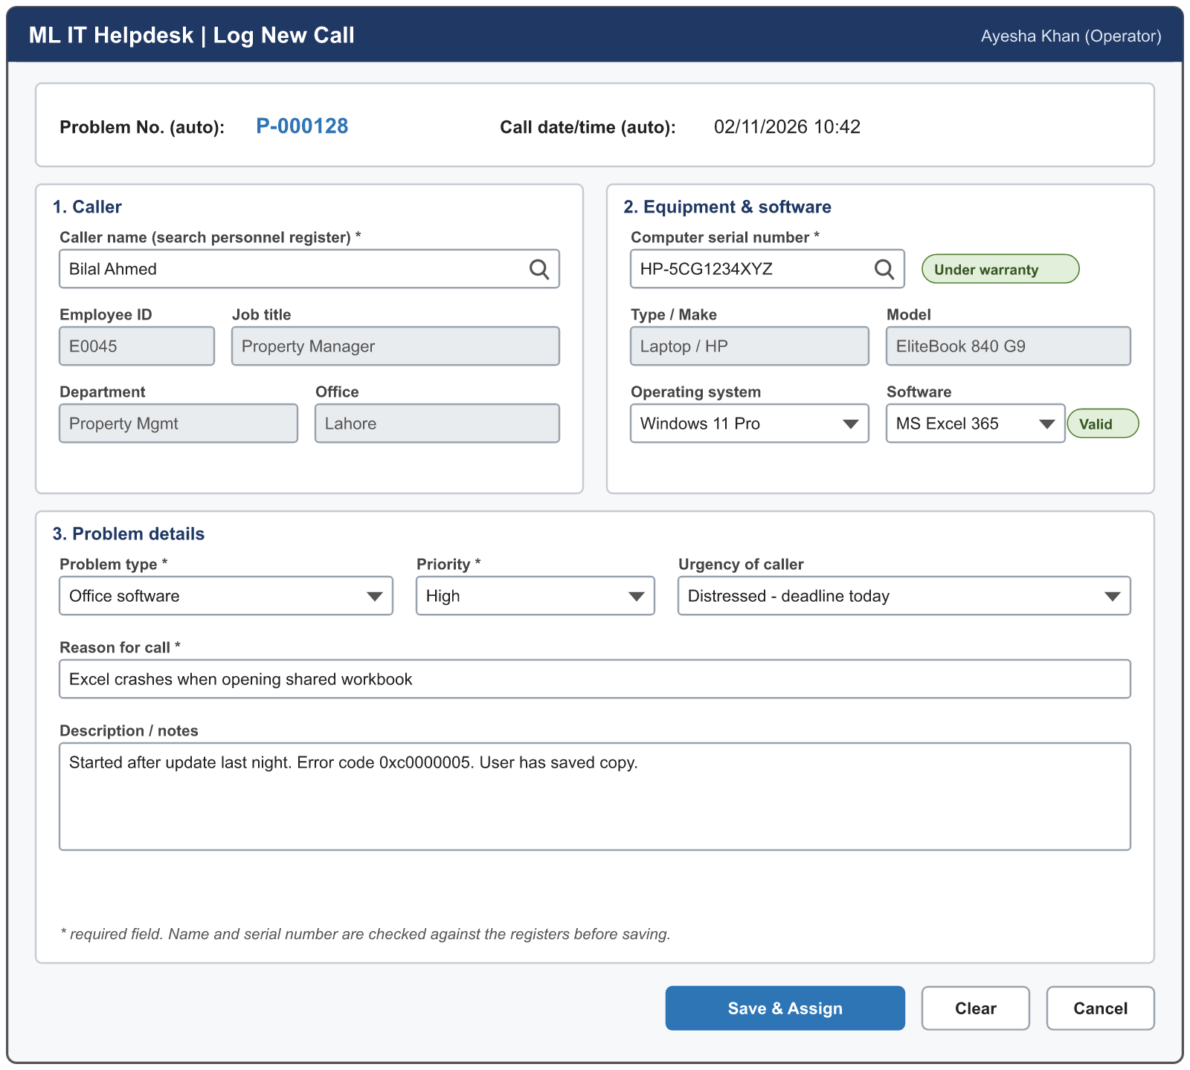
Figure 6: Log New Call screen

Follow-up Call
The operator enters the problem number quoted by the caller. A read-only summary of the problem is shown, and a new call is recorded with its reason and urgency (UR-06).
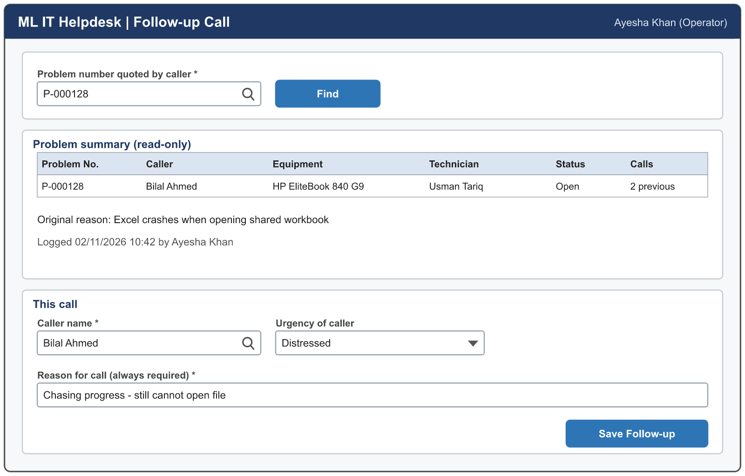
Figure 7: Follow-up Call screen

Assign Technician
Only technicians whose specialisms include the problem type are listed, together with the number of Open problems each is working on, sorted lowest first. The least busy available technician is pre-selected and marked "recommended", which provides load balancing (UR-08).
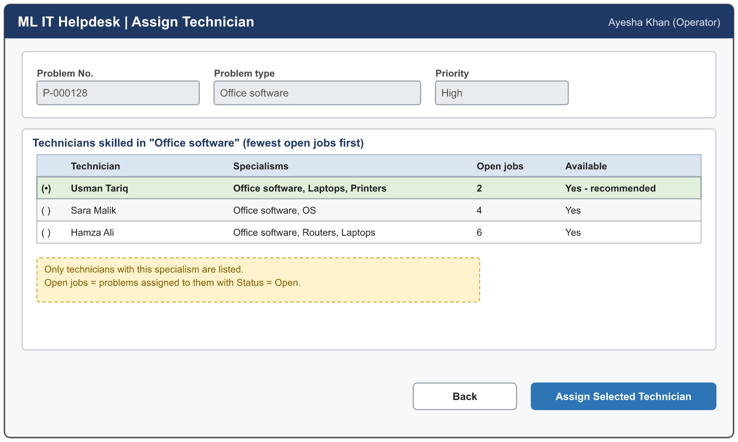
Figure 8: Assign Technician screen with load balancing

Resolve Problem
Used by the operator or technician to close a problem. The resolved date/time, time taken in hours and resolution notes are required (UR-09). Saving sets Status = Closed.
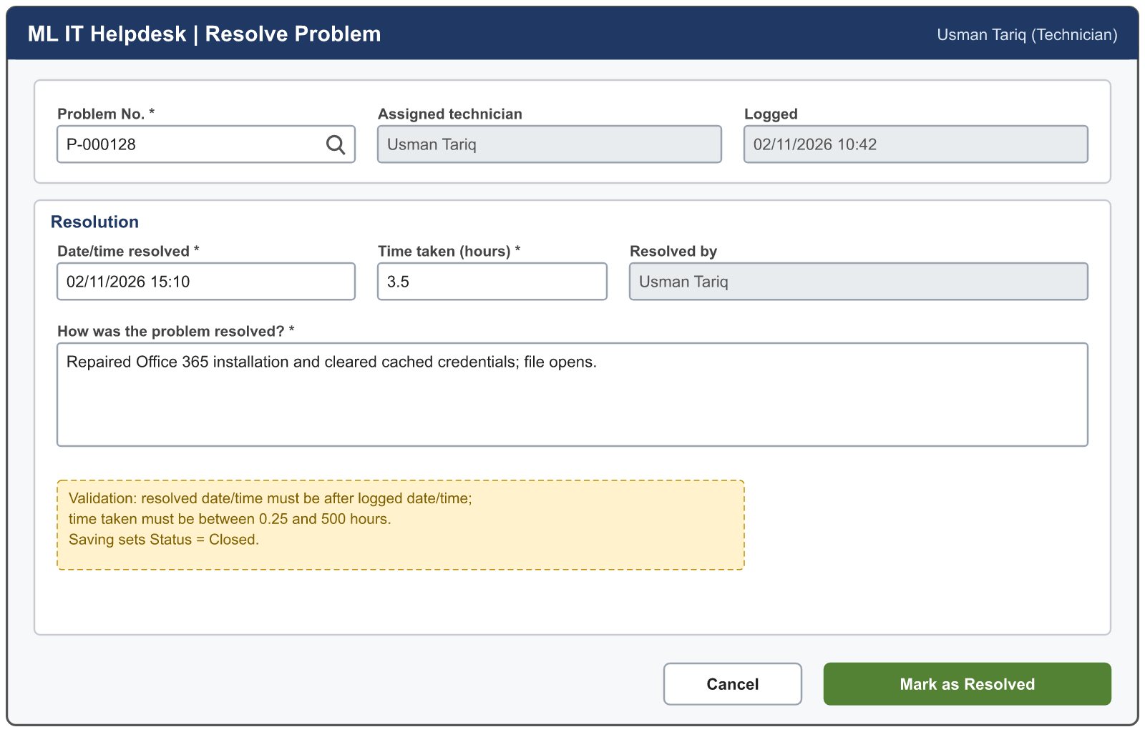
Figure 9: Resolve Problem screen

Management Reports menu
Available to Office Managers only. The manager chooses the month (and technician or office where needed), selects a report and views, prints or exports it.
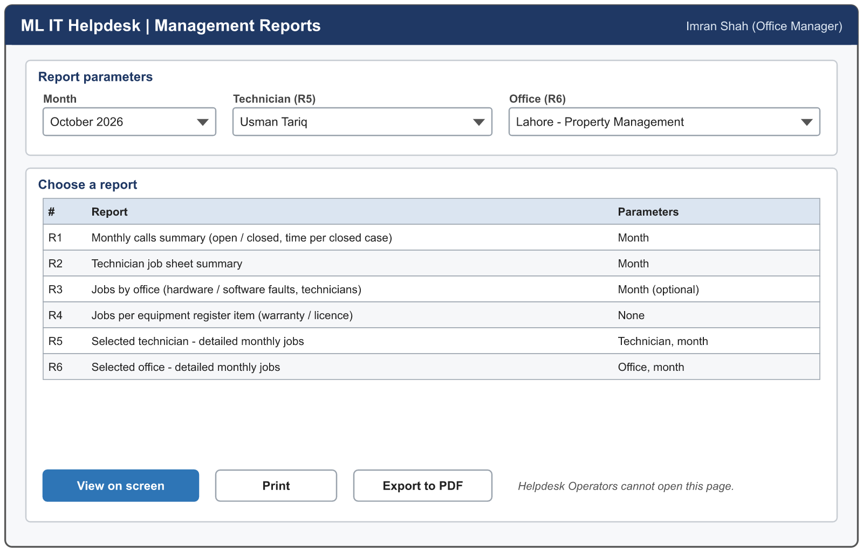
Figure 10: Management Reports menu

Equipment Register (Hardware)
Used by the administrator to add and update hardware. Similar forms are used for Offices, Employees, Software and Licences, and Technicians and Skills.
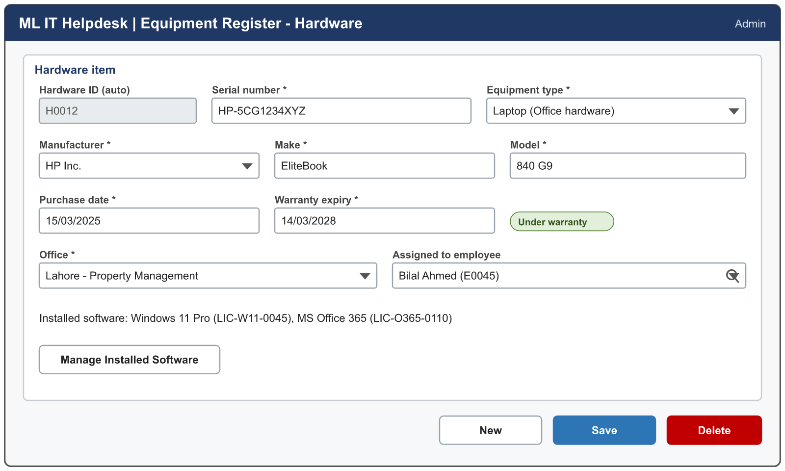
Figure 11: Equipment Register – Hardware form

Database Maintenance
Gives access to backup (all users), restore and compact (Helpdesk Operators only), and shows the maintenance log.
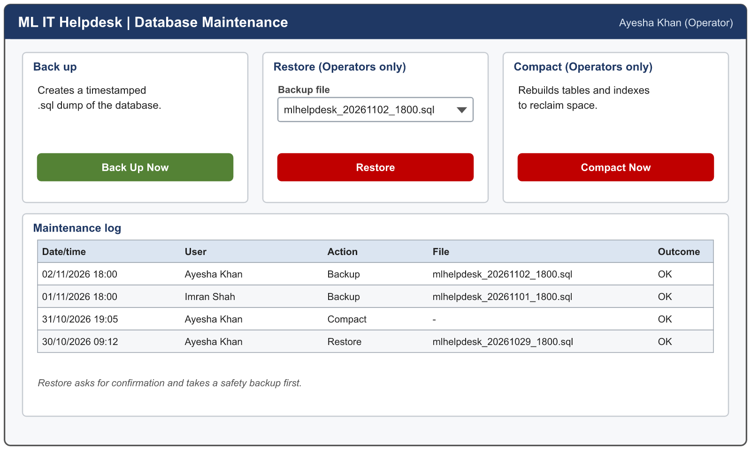
Figure 12: Database Maintenance screen

10. Output (Report) Design
The brief requires six management reports. Every report uses the same layout so that managers can read them easily:
- Header: report name, the parameters chosen (month, technician or office), the user who ran it and the date and time.
- Body: a detail or summary table with clear column headings, sorted in a logical order.
- Totals: summary figures (counts, total and average hours) in a highlighted row.
- Footer: page numbers and a confidentiality note.
All reports are produced by SQL SELECT queries that join several tables and use aggregate functions (COUNT, SUM, AVG) with GROUP BY. The sample figures below are illustrative pilot data.

10.1 R1 – Monthly Calls Summary
Purpose: shows helpdesk workload for one month. Parameter: month. Tables: HelpdeskCall, Problem, ProblemType, Technician, Employee. Logic: count all calls with CallDateTime in the month; count problems logged in the month by Status; list closed problems with TimeTakenHours and a total.
Report | R1 – Monthly Calls Summary
Month | October 2026
Run by / date | Imran Shah (Office Manager) / 02/11/2026 09:15
Footer | Page x of y | Confidential – ML internal use only

Total calls logged | New problems | Follow-up calls | Open cases | Closed cases | Hours on closed cases
112 | 78 | 34 | 14 | 64 | 186.50

Table 33: R1 layout – closed cases
Problem No. | Logged | Resolved | Problem type | Technician | Hours
P-000071 | 01/10/2026 | 01/10/2026 | Printer | Hamza Ali | 1.50
P-000072 | 01/10/2026 | 03/10/2026 | Router | Hamza Ali | 6.00
P-000075 | 02/10/2026 | 02/10/2026 | Office software | Usman Tariq | 0.75
… | … | … | … | … | …
Total (64 closed cases) |  |  |  |  | 186.50

10.2 R2 – Technician Job Sheet Summary
Purpose: compares technicians' workload for one month. Parameter: month. Tables: Technician, Employee, Problem. Logic: for problems logged in the month, GROUP BY technician, counting jobs, open and closed jobs and summing hours.
Report | R2 – Technician Job Sheet Summary
Month | October 2026
Run by / date | Imran Shah (Office Manager) / 02/11/2026 09:15
Footer | Page x of y | Confidential – ML internal use only

Table 34: R2 layout
Technician | Jobs worked | Open | Closed | Total hours | Avg hours / closed job
Hamza Ali | 18 | 3 | 15 | 52.25 | 3.48
Sara Malik | 14 | 2 | 12 | 30.00 | 2.50
Usman Tariq | 16 | 4 | 12 | 28.75 | 2.40
… | … | … | … | … | …
All technicians | 78 | 14 | 64 | 186.50 | 2.91

10.3 R3 – Jobs by Office
Purpose: shows which offices generate most work and of what kind. Parameter: month (optional; all-time if blank). Tables: Office, Employee, Problem, ProblemType. Logic: GROUP BY office; hardware and software faults counted with SUM(CASE WHEN FaultCategory = 'Hardware' THEN 1 ELSE 0 END); different technicians with COUNT(DISTINCT TechnicianID).
Report | R3 – Jobs Logged by Office
Month | October 2026
Run by / date | Imran Shah (Office Manager) / 02/11/2026 09:15
Footer | Page x of y | Confidential – ML internal use only

Table 35: R3 layout
Office | Hardware faults | Software faults | Total jobs | Hours spent | Different technicians
Islamabad – Legal | 3 | 5 | 8 | 17.50 | 3
Karachi – Brokerage | 6 | 2 | 8 | 22.00 | 4
Lahore – Property Management | 7 | 4 | 11 | 31.25 | 4
… | … | … | … | … | …
All offices | 46 | 32 | 78 | 186.50 | 6

10.4 R4 – Jobs per Equipment Register Item
Purpose: identifies items that keep failing and whether they should be repaired under warranty/licence or replaced. Parameter: none (all time; last-90-days column for recent trend). Tables: Hardware, EquipmentType, Manufacturer, Office, Problem (plus Software/SoftwareLicence for software items). Logic: LEFT JOIN so that items with no jobs show 0; warranty/licence status calculated against today's date; Action = "Warranty claim" if 3+ jobs and under warranty, "Consider replacing" if 3+ jobs and out of warranty, otherwise "OK".
Report | R4 – Jobs per Equipment Register Item
Period | All time (with last 90 days)
Run by / date | Imran Shah (Office Manager) / 02/11/2026 09:15
Footer | Page x of y | Confidential – ML internal use only

Table 36: R4 layout
Serial / licence no. | Item | Type | Office | Total jobs | Last 90 days | Warranty / licence | Action
EP-L3150-0042 | Epson L3150 | Printer | Karachi | 7 | 4 | Expired | Consider replacing
HP-5CG1234XYZ | HP EliteBook 840 G9 | Laptop | Lahore | 4 | 3 | Under warranty | Warranty claim
CS-FGT60F-0021 | Fortinet FortiGate 60F | Firewall | Lahore | 2 | 2 | Under warranty | OK
LIC-O365-0110 | Microsoft Office 365 | Software | — | 9 | 5 | Valid | Review with vendor

10.5 R5 – Technician Detail (selected technician)
Purpose: detailed job sheet for one technician for a month. Parameters: technician, month. Tables: Problem, Employee, Office, Hardware, EquipmentType, Manufacturer, ProblemType. Logic: list each job with office and equipment; totals with COUNT, SUM(TimeTakenHours) and AVG(TimeTakenHours) for closed jobs.
Report | R5 – Technician Job Detail
Technician | Usman Tariq (T03)
Month | October 2026
Run by / date | Imran Shah (Office Manager) / 02/11/2026 09:15
Footer | Page x of y | Confidential – ML internal use only

Table 37: R5 layout
Problem No. | Logged | Office | Equipment (serial – make/model) | Problem type | Status | Hours
P-000075 | 02/10/2026 | Lahore | HP-5CG1234XYZ – HP EliteBook 840 G9 | Office software | Closed | 0.75
P-000081 | 04/10/2026 | Islamabad | LN-PF3XK2 – Lenovo ThinkPad E14 | Laptop | Closed | 3.00
P-000117 | 28/10/2026 | Karachi | EP-L3150-0042 – Epson L3150 | Printer | Open | —
… | … | … | … | … | … | …

Open jobs | Closed jobs | Total hours | Average hours per closed job
4 | 12 | 28.75 | 2.40

10.6 R6 – Office Detail (selected office)
Purpose: detailed list of jobs logged by one office in a month, with counts per equipment item to show items that regularly fail. Parameters: office, month. Tables: Office, Employee, Problem, Hardware, Software, Technician. Logic: detail list, totals of open and closed jobs, and a second grouped table counting jobs per register item.
Report | R6 – Office Job Detail
Office | Lahore – Property Management
Month | October 2026
Run by / date | Imran Shah (Office Manager) / 02/11/2026 09:15
Footer | Page x of y | Confidential – ML internal use only

Table 38: R6 layout – jobs
Problem No. | Logged | Reported by | Equipment | Type | Technician | Status | Hours
P-000075 | 02/10/2026 | Bilal Ahmed | HP EliteBook 840 G9 | Office software | Usman Tariq | Closed | 0.75
P-000079 | 03/10/2026 | Sana Iqbal | Fortinet FortiGate 60F | Firewall | Hamza Ali | Closed | 4.50
P-000121 | 30/10/2026 | Bilal Ahmed | HP EliteBook 840 G9 | Laptop | Sara Malik | Open | —
… | … | … | … | … | … | … | …

Total jobs | Open | Closed | Total hours
11 | 2 | 9 | 31.25

Table 39: R6 layout – jobs per register item
Register item | Serial / licence no. | Jobs this month | Flag
HP EliteBook 840 G9 | HP-5CG1234XYZ | 3 | Regularly failing – review
Fortinet FortiGate 60F | CS-FGT60F-0021 | 2 | —
Microsoft Office 365 | LIC-O365-0110 | 2 | —

11. Security Design
Database security aims to protect confidentiality, integrity and availability of data (Bertino and Sandhu, 2005). The brief requires that helpdesk operators can log jobs but cannot open reports, and that office managers can view all reports but cannot log jobs. These rules are enforced in two layers: the application hides and blocks functions by role, and the database itself refuses actions that a role's MySQL account is not granted.

11.1 Access control matrix
Table 40: Role-based access control matrix
Function | Helpdesk Operator | Technician | Office Manager | Admin
Log new call / problem | Yes | No | No | No
Record follow-up call | Yes | No | No | No
Assign technician | Yes | No | No | No
Resolve problem | Yes | Own jobs only | No | No
View open problems list | Yes | Own jobs only | Yes | Yes
View management reports R1–R6 | No | No | Yes | No
Maintain registers (offices, employees, equipment, software) | View only | View only | View only | Yes
Manage user accounts and unlock accounts | No | No | No | Yes
Back up database | Yes | Yes | Yes | Yes
Restore database from backup | Yes | No | No | No
Compact database | Yes | No | No | No

11.2 Authentication
- Each user has their own account (no shared log-ins), so every call and maintenance action can be traced to a person.
- Passwords are hashed with bcrypt (PHP password_hash()), which is salted and slow to crack, as recommended by OWASP (2021). Plain-text passwords are never stored.
- After 5 consecutive failed attempts the account is locked; the counter resets after a successful log-in.
- Sessions expire after 20 minutes of inactivity and every page checks the session role before it loads.

11.3 Database-level security (MySQL roles)
The PHP application connects with a different MySQL account for each role, so the principle of least privilege applies even if the application is bypassed:
CREATE ROLE 'r_operator', 'r_technician', 'r_manager', 'r_admin';

-- Operators: read registers, log and update jobs; no access to report views
GRANT SELECT ON mlhelpdesk.* TO 'r_operator';
GRANT INSERT, UPDATE ON mlhelpdesk.Problem TO 'r_operator';
GRANT INSERT ON mlhelpdesk.HelpdeskCall TO 'r_operator';
GRANT EXECUTE ON PROCEDURE mlhelpdesk.sp_LogNewProblem TO 'r_operator';

-- Office managers: read-only access to report procedures and views; cannot INSERT jobs
GRANT SELECT ON mlhelpdesk.vw_ProblemDetail TO 'r_manager';
GRANT EXECUTE ON PROCEDURE mlhelpdesk.sp_Report_R1 TO 'r_manager'; -- ... to R6

-- Technicians: read jobs, resolve their own via the stored procedure
GRANT SELECT ON mlhelpdesk.vw_ProblemDetail TO 'r_technician';
GRANT EXECUTE ON PROCEDURE mlhelpdesk.sp_ResolveProblem TO 'r_technician';

Report access for operators is blocked in the application: the Reports menu is disabled and every report page checks that the session role is Manager. Because the manager account has no INSERT privilege on Problem or HelpdeskCall, a manager cannot log a job even by calling the database directly.

11.4 Other security measures
- SQL injection: all queries use PDO prepared statements with bound parameters.
- Audit trail: OperatorUserID on every call, ResolvedByUserID on every closed problem and MaintenanceLog for maintenance actions.
- Data protection: only work contact details are stored; the system runs on ML's internal network; backups are stored in a restricted folder (ICO, n.d.).
- Integrity: foreign keys and CHECK constraints stop invalid data; transactions stop half-saved jobs.

12. Database Maintenance Design
Regular maintenance protects against data loss and keeps the database fast (Walters and Fritchey, 2012). The brief requires backup, restore and compaction. Backup runs from a command on the main control page and is available to everyone; restore and compaction are restricted to helpdesk operators.
Table 41: Maintenance routines
Routine | Who | How it works (MySQL) | Safeguards
Back up | All users (button on Main Control Page); also scheduled nightly at 18:00 | mysqldump --single-transaction --routines --triggers mlhelpdesk > mlhelpdesk_YYYYMMDD_HHMM.sql | Consistent snapshot without locking users out; time-stamped file name; last 14 daily backups kept; action logged in MaintenanceLog.
Restore | Helpdesk Operators only | mysql mlhelpdesk < chosen_backup.sql | Confirmation required; a safety backup of the current data is taken first; users are warned; action logged.
Compact | Helpdesk Operators only | OPTIMIZE TABLE on every table (InnoDB rebuilds the table and indexes, reclaiming unused space) | Run outside busy hours; confirmation required; action logged.
Integrity check (extra) | Admin | CHECK TABLE and ANALYZE TABLE monthly | Detects corruption early and updates index statistics so queries stay fast.

The process flow for the backup command is: user clicks Back Up Database Now → application checks the user is logged in → runs mysqldump to the backup folder → checks the file exists and is not empty → inserts a MaintenanceLog row (Success/Failed) → shows a message with the file name. Flowcharts for all three routines will be included in the Technical Documentation.

13. Evaluation of the Design
This section evaluates how effectively the design meets the user and system requirements in Section 2, using a traceability matrix, and then discusses strengths, limitations and trade-offs.

13.1 Requirements traceability matrix
Table 42: Traceability of user requirements to design
Req. | Design elements that satisfy it | Met?
UR-01 | HelpdeskCall (CallDateTime, CallerEmployeeID, OperatorUserID); Problem (HardwareID, OSSoftwareID, SoftwareID); Log New Call screen | Fully
UR-02 | Employee–Department–Office relationships; name search with read-only auto-fill; FR-04 | Fully
UR-03 | Hardware, EquipmentType, Manufacturer; vw_HardwareStatus warranty badge | Fully
UR-04 | Software, SoftwareLicence, InstalledSoftware; vw_LicenceStatus badge | Fully
UR-05 | Problem.ProblemNumber AUTO_INCREMENT, shown on screen as P-000128 | Fully
UR-06 | Problem 1:M HelpdeskCall; CallReason NOT NULL + CHECK; Follow-up Call screen | Fully
UR-07 | Problem.Description; HelpdeskCall.Notes | Fully
UR-08 | TechnicianSpecialism; vw_TechnicianWorkload; Assign Technician screen; trigger FR-09 | Fully
UR-09 | Problem resolution fields; chk_closed constraint; Resolve Problem screen | Fully
UR-10 | Office, Employee with EndDate; register forms | Fully
UR-11 | Hardware, EquipmentType (Office/Network), Software, SoftwareLicence, Manufacturer | Fully
UR-12 | Report designs R1–R6 and stored procedures | Fully (at design stage)
UR-13 / UR-14 | Access control matrix; role-based menus; MySQL roles and GRANTs | Fully
UR-15 / UR-16 | Maintenance design; buttons on Main Control Page; role checks; MaintenanceLog | Fully
UR-17 | Consistent wireframes, auto-fill, drop-downs, clear error messages | Partly – to be confirmed by user testing
UR-18 | Pilot data plan; normalised structure allows new data without redesign | Fully

13.2 Effectiveness against user requirements
Every "Must" user requirement is traced to at least one table, constraint and screen, so the design is complete for the pilot. The design is especially strong for the operator's main task: one screen collects all call details and the system looks up caller and equipment information, which saves time and reduces typing errors while the operator is on the phone. Separating Problem from HelpdeskCall means follow-up calls are recorded without re-entering problem details and the problem number stays the same, exactly as the brief describes. The Assign Technician screen meets the load-balancing requirement directly by filtering on specialism and sorting by open jobs.
For managers, the six report designs map one-to-one to the brief and use data that is captured during normal work, so no extra input is needed. R4 and R6 add a simple action flag, which turns raw counts into a clear decision ("warranty claim" or "consider replacing"), making the information more useful to non-technical managers.
Usability (UR-17) can only be partly judged at this stage. The wireframes follow recognised heuristics, but they have not yet been tested with real operators. This will be checked during user acceptance testing in the Development Document.

13.3 Effectiveness against system requirements
- Integrity (FR-12, NFR-04): the 3NF/BCNF structure removes redundancy, and constraints at the database level mean invalid data cannot be stored whichever program writes it. This is stronger than relying on form validation alone.
- Security (FR-01, FR-02, NFR-02): two layers of control (application and MySQL privileges), hashed passwords and audit fields meet the brief and follow good practice. A weakness is that operators technically have SELECT on all tables, so report data could be read outside the application; this is acceptable for an internal pilot but should be tightened later.
- Performance (NFR-01): indexes on search and date columns and the small data volumes of the pilot should easily meet the 2-second and 5-second targets. This will be measured in testing.
- Scalability and maintainability (NFR-06, NFR-07): new offices, equipment types, problem types or skills are added as rows, not new columns, so the structure does not need to change as ML grows.

13.4 Limitations and trade-offs
Table 43: Design limitations and possible improvements
Limitation / trade-off | Impact | Possible improvement
A problem stores only one technician at a time. | If a job is passed between technicians, the history of who worked on it and their hours is lost; R2/R5 credit all hours to the last technician. | Add a ProblemAssignment table (ProblemNumber, TechnicianID, From, To, Hours).
Office of a job is taken from the reporter's current office. | If an employee moves office, their old jobs would appear under the new office in R3/R6. | Store OfficeID on Problem at the time of logging (deliberate, controlled redundancy).
Status is stored as well as DateTimeResolved. | Small risk of inconsistency. | Already controlled by chk_closed; could be replaced by a generated column.
Workload counts open jobs only. | A technician with two Critical jobs may look less busy than one with three Low jobs. | Weight the workload by Priority in vw_TechnicianWorkload.
Peripherals are not linked to the PC they are attached to. | Cannot see, e.g., which monitor belongs to which PC. | Add an optional ParentHardwareID self-relationship.
Web interface needs a server. | Slightly more set-up than a desktop database. | Accepted, because it allows access from all 15 offices.

13.5 Conclusion of the evaluation
Overall the design is effective. It meets all mandatory user requirements and all functional and non-functional system requirements at the design stage, with 16 interrelated tables in Third Normal Form, complete validation rules, screen and report designs, and a two-layer security model. The main trade-off is that it keeps a single technician per problem to stay simple for the pilot. The improvements listed in Section 13.4 are recommended for a later phase and do not prevent development from starting.

14. Conclusion
This document has presented a complete relational database design for the ML IT Helpdesk System. Requirements were captured and given IDs; the data was modelled with an ERD and checked through normalisation to Third Normal Form; and a physical design for MySQL 8.0 was produced with a full data dictionary. Validation, interface, output, security and maintenance designs show how the system will work for each type of user. The evaluation shows that the design meets the requirements in the brief and identifies sensible improvements for the future. The Boards of ML and ATS are asked to approve this design so that development of the pilot system can begin.

References
Bertino, E. and Sandhu, R. (2005) 'Database security – concepts, approaches, and challenges', IEEE Transactions on Dependable and Secure Computing, 2(1), pp. 2–19. Available at: https://ieeexplore.ieee.org/abstract/document/1416861 (Accessed: 2 November 2026).
Beynon-Davies, P. (2004) 'Normalisation', in Database Systems. 3rd edn. Basingstoke: Palgrave Macmillan, pp. 269–291.
Chen, P.P. (1976) 'The entity-relationship model – toward a unified view of data', ACM Transactions on Database Systems, 1(1), pp. 9–36.
Codd, E.F. (1970) 'A relational model of data for large shared data banks', Communications of the ACM, 13(6), pp. 377–387.
Connolly, T. and Begg, C. (2015) Database Systems: A Practical Approach to Design, Implementation, and Management. 6th edn. Harlow: Pearson.
Harrington, J.L. (2016) Relational Database Design and Implementation. 4th edn. Cambridge, MA: Morgan Kaufmann.
Hernandez, M.J. (2013) Database Design for Mere Mortals. 3rd edn. Upper Saddle River, NJ: Addison-Wesley.
ICO (n.d.) UK GDPR guidance and resources. Information Commissioner's Office. Available at: https://ico.org.uk/for-organisations/uk-gdpr-guidance-and-resources/ (Accessed: 2 November 2026).
Kumar, K. and Azad, S.K. (2017) 'Database normalization design pattern', 4th IEEE Uttar Pradesh Section International Conference on Electrical, Computer and Electronics (UPCON). Mathura, India, pp. 318–322.
Lucidchart (2022) Database structure and design tutorial. Available at: https://www.lucidchart.com/pages/database-diagram/database-design (Accessed: 2 November 2026).
Microsoft (2022) Database design basics. Available at: https://support.microsoft.com/en-us/office/database-design-basics-eb2159cf-1e30-401a-8084-bd4f9c9ca1f5 (Accessed: 2 November 2026).
Nielsen, J. (1994) 10 usability heuristics for user interface design. Nielsen Norman Group. Available at: https://www.nngroup.com/articles/ten-usability-heuristics/ (Accessed: 2 November 2026).
Oracle (2024) MySQL 8.0 Reference Manual. Available at: https://dev.mysql.com/doc/refman/8.0/en/ (Accessed: 2 November 2026).
OWASP (2021) Password storage cheat sheet. Available at: https://cheatsheetseries.owasp.org/cheatsheets/Password_Storage_Cheat_Sheet.html (Accessed: 2 November 2026).
Sommerville, I. (2016) Software Engineering. 10th edn. Harlow: Pearson.
Visual Paradigm (n.d.) Data modeling: conceptual vs logical vs physical data model. Available at: https://online.visual-paradigm.com/knowledge/visual-modeling/conceptual-vs-logical-vs-physical-data-model (Accessed: 2 November 2026).
Walters, R. and Fritchey, G. (2012) 'Common database maintenance tasks', in Beginning SQL Server 2012 Administration. Berkeley, CA: Apress. Available at: https://doi.org/10.1007/978-1-4302-3982-6_10 (Accessed: 2 November 2026).

