YOUTH INVESTMENT SOCIETY
Stock Pitch Report
C3.ai, Inc. (NYSE: AI)
INVESTMENT RECOMMENDATION
SELL
Target Price: $7.60 | Current: $10.30 | Downside: 26.2%

Full Name | DUXIHENG
Team Number | 039
Email | duxiheng_hz@163.com
Date | June 22, 2026

Current Price | Target Price | Implied Downside | Recommendation
$10.30 | $7.60 | 26.2% | SELL

1. Company Overview
1.1 Basic Profile & Business Model
Founded in 2009 by tech entrepreneur Tom Siebel (founder of Siebel Systems, acquired by Oracle), C3.ai is headquartered in Redwood City, California. The company specializes in enterprise-grade artificial intelligence software, delivering model-driven AI platforms targeted at industrial, energy, manufacturing, defense and financial industry clients.
Attribute | Detail
Founded | 2009
Founder | Tom Siebel
HQ | Redwood City, California
Exchange / Ticker | NYSE: AI
Sector | Enterprise AI Software
Employees | ~600 (post 35% layoff)

The company’s revenue structure is highly concentrated in subscription business, paired with low-margin customized service business:
Subscription Software (91% of FY2026 Revenue): Annual authorized access to the company’s low-code AI development platform, serving as the core recurring revenue source.
Engineering Service Business: Customized on-site deployment, AI model construction and post-sale client maintenance. This segment requires massive labor input, severely suppresses overall gross margins and scalability.
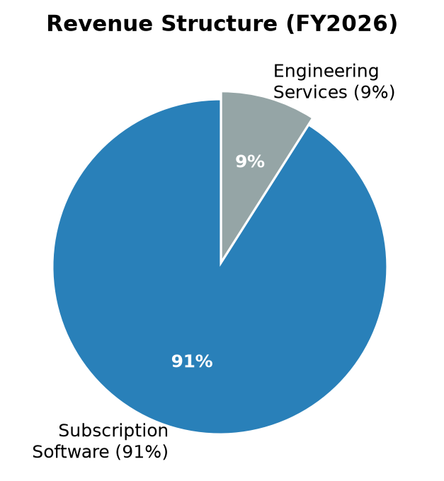
1.2 Core Product Portfolio
Product | Description
C3 Agentic AI Platform | Unified underlying platform for enterprises to independently build customized predictive AI business applications
C3 Generative AI Suite | Integrated tools for enterprise internal data retrieval, business intelligent automation and industrial large model docking
Vertical Industry Apps | Ready-to-use modules covering oil & gas asset management, intelligent manufacturing optimization, military equipment maintenance and financial risk control

1.3 Customer Structure & Geographic Distribution
Customer Concentration Risk: Energy giant Baker Hughes once contributed over 30% of annual revenue; the top 10 clients account for 38% of total revenue. Loss of key partners will cause significant revenue pressure.
Geographic Layout: 100% of revenue comes from U.S. domestic enterprises and federal government agencies, with zero overseas revenue and extremely single market layout.
Core Client Group: Large-cap energy enterprises, heavy manufacturing companies, U.S. military contractors and traditional financial institutions.
1.4 Competitive Landscape
Competitor Category | Key Players | Threat Level
Cloud Giant AI Platforms | Azure AI, AWS AI, Google Vertex AI | EXTREME
Vertical Industrial Software | Palantir (PLTR), GE Digital, Snowflake | HIGH
Niche AI Startups | BigBear.ai and others | MEDIUM

1.5 Management Team
The company is chaired by founder Tom Siebel. Stephen Ehikian was appointed CEO in Q1 FY2026, tasked with improving inefficient sales execution. Notably, the management team has continuously missed profitability guidance for five consecutive fiscal years, with poor long-term performance execution.
⚠ KEY CONCERN: Management has missed profitability guidance for 5 consecutive fiscal years, indicating significant execution risk.

2. Company Operating & Financial Performance
2.1 Historical Revenue & Net Profit Trend
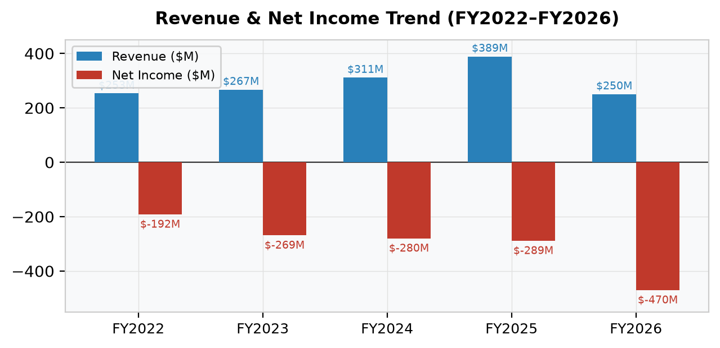
Fiscal Year | Total Revenue | YoY Growth | Net Income (Loss) | Key Observation
FY2022 | $253M | — | ($192M) | Base year
FY2023 | $267M | +5.5% | ($269M) | Losses widen
FY2024 | $311M | +16.5% | ($280M) | Revenue growth, losses persist
FY2025 | $389M | +25.1% | ($289M) | Historical revenue peak
FY2026 | $250.3M | −35.7% | ($470.4M) | Cliff-like revenue decline

⚠ KEY CONCLUSION: Revenue peaked in FY2025 and experienced a cliff-like decline in FY2026. Net losses have continued to expand year by year — the company has NEVER achieved annual profitability since its IPO.

2.2 Profit Margin & Cash Flow Performance
In Q4 FY2026, the company’s GAAP gross margin dropped to 22%, and non-GAAP gross margin was only 37%, a sharp decline from the 50%+ gross margin level two years ago. The labor-intensive customized engineering service business continuously erodes profitability and forms structural margin pressure.
In terms of cash flow, operating cash flow has been negative for consecutive fiscal cycles. The company’s operation completely relies on remaining IPO cash reserves, with no self-hematopoiesis capability.
Metric | FY2024 | FY2025 | FY2026 Q4 | Trend
GAAP Gross Margin | ~52% | ~45% | 22% | ▼ Sharp Decline
Non-GAAP Gross Margin | ~58% | ~50% | 37% | ▼ Declining
Operating Cash Flow | Negative | Negative | Negative | ▼ Persistent Drain
Cash Reserves | — | — | $575M | Finite Runway

2.3 Core Financial Indicators (FY2026 Year-End)
Current Ratio  5.0x | Debt/Equity  0.25 | Cash & Securities  $575M

Current Ratio: 5.0 — Current assets $816M, current liabilities $163M. The company holds $575M in cash and marketable securities, with safe short-term liquidity and no imminent debt default risk.
Debt-to-Equity Ratio: 0.25 — Long-term debt scale is extremely low, with low balance sheet risk. However, continuous large losses will rapidly consume existing liquidity buffers.
2.4 Industry Competition Analysis (Porter’s Five Forces)
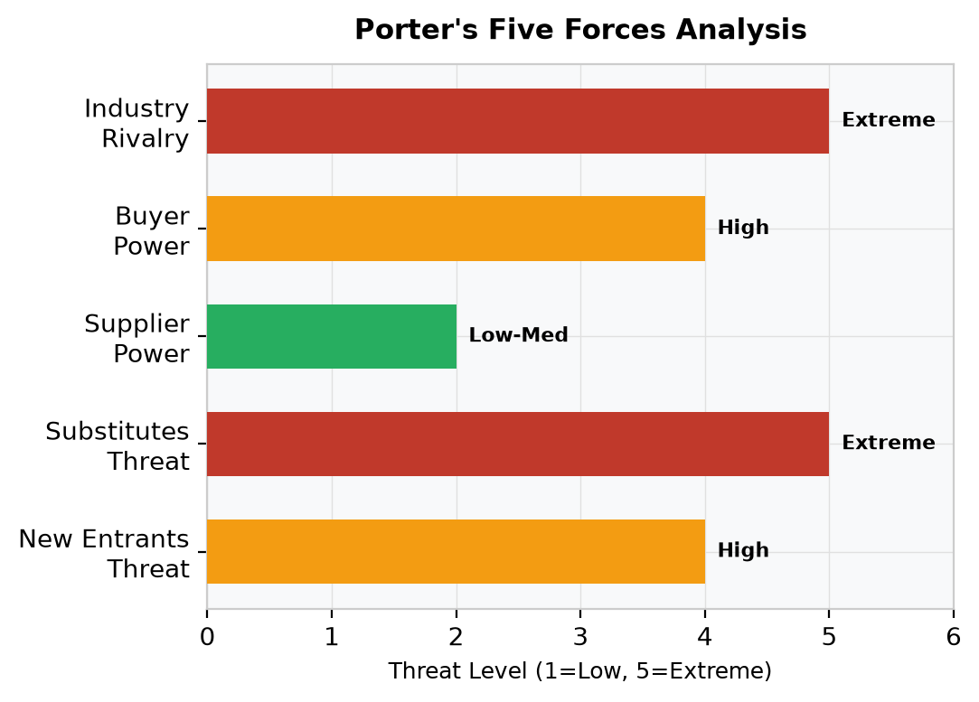
Force | Rating | Analysis
New Entrants Threat | HIGH | Cloud vendors can quickly replicate low-code AI tools with low technical barriers
Substitutes Threat | VERY HIGH | Microsoft, AWS, Google embed AI in existing cloud services at near-zero incremental cost
Supplier Power | LOW | GPU/large model resources outsourced to cloud giants, no pricing bargaining power
Buyer Power | HIGH | Large energy/defense clients have strong discount negotiation leverage
Industry Rivalry | EXTREME | Cloud giants suppress prices; Palantir monopolizes high-margin government orders

2.5 Current Stock Market Metrics
Metric | Value
Current Share Price | $10.30
Market Capitalization | $1.496B
Forward P/S Ratio | 5.98x
Industry Avg P/S | 17x
52-Week Low | $7.68 (Mar 2026)
Decline from IPO Peak | >91%

Although the company’s valuation is far lower than the industry average of 17x for enterprise AI software, the valuation discount fully prices in its structural revenue decline and persistent loss dilemma.

3. Valuation Analysis & Target Price
3.1 Five-Year Stock Price Trend
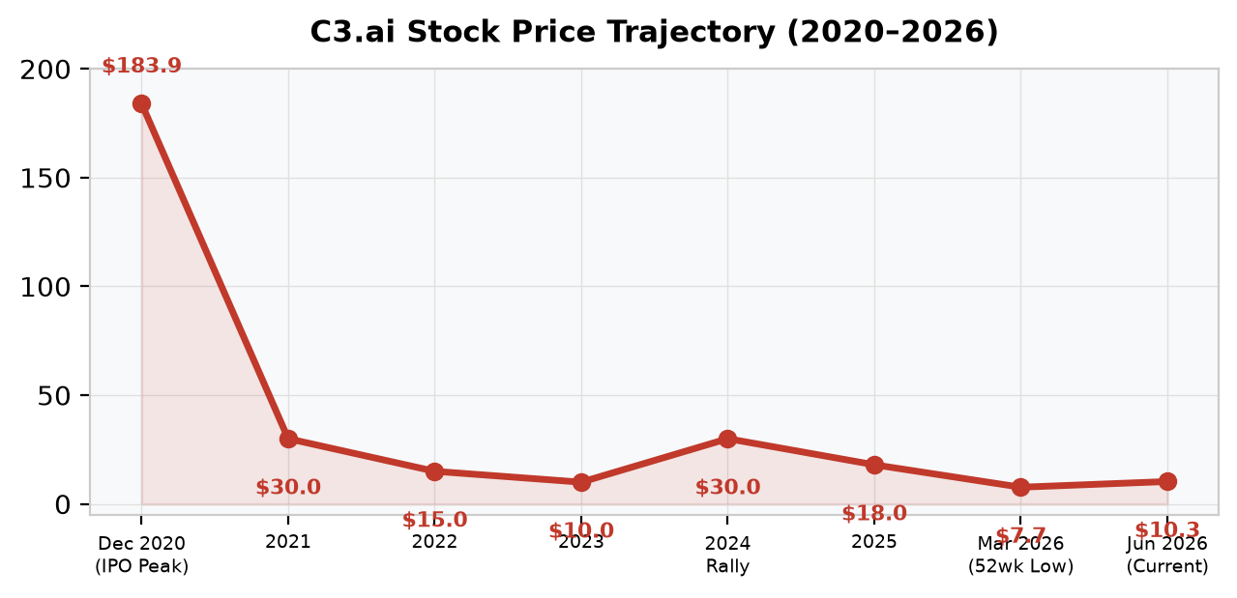
Period | Stock Price | P/S Ratio | Key Event
Dec 2020 (IPO Peak) | $183.90 | >100x | AI ticker speculation peak
2021–2023 | $8–$12 | ~5-8x | AI bubble burst, stabilized
2024–2025 | $30+ | ~10x | GenAI rally, then full retracement
Mar 2026 | $7.68 | ~4x | 52-week low
Jun 2026 (Current) | $10.30 | 5.98x | −91% from peak, −62% in 12 months

3.2 FY2026 Revenue Verification
The full-year revenue of FY2026 was only $250.3M, significantly lower than the original guidance of $289.5M–$309.5M, with a year-on-year decline of 35.7%, confirming the sustained downward trend of the company’s top-line performance.
3.3 FY2027 Revenue Forecast
The company’s official FY2027 revenue guidance is $210M–$240M, with a midpoint of $225M, corresponding to a further 10% year-on-year revenue decline. The company’s 35% workforce reduction in 2026 can only slightly narrow losses and cannot achieve fundamental profitability improvement.
3.4 2027 Target Price Calculation
CORE VALUATION ASSUMPTIONS:
• FY2027 expected revenue midpoint: $225M
• Market-compressed P/S multiple: 4.2x (reflecting continued revenue decline & losses)
• Fully diluted share count: 124M shares

Step | Calculation | Result
Fair Market Cap | $225M × 4.2x | $945M
Target Share Price | $945M ÷ 124M shares | $7.60
Downside vs Current | ($7.60 − $10.30) / $10.30 | −26.2%

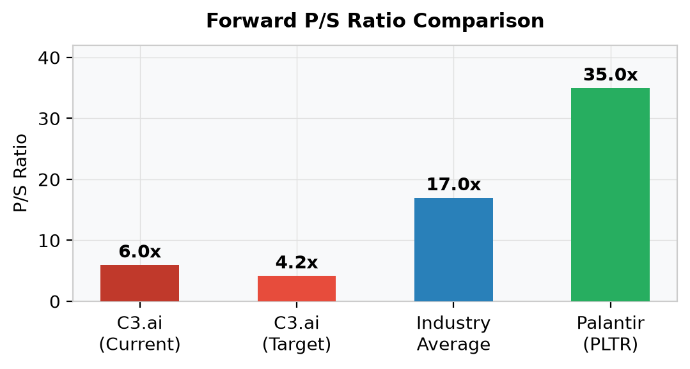
✖ VALUATION CONCLUSION: Target price of $7.60 implies 26.2% downside from current $10.30, fully supporting the SELL investment recommendation.

4. Core Investment Risks
RISK 1: Crushing Competition from Hyper-scale Cloud Giants

Risk Impact
Microsoft, AWS and Google have embedded industrial generative AI functions in their mainstream cloud service packages, providing zero-incremental-cost AI tools for enterprise clients. A large number of trial customers of C3.ai have switched to integrated cloud-native AI solutions, directly leading to the sharp revenue contraction in FY2026, which forms a long-term irreversible competitive disadvantage.
Potential Catalysts & Success Probability
Strive for exclusive long-term joint R&D and co-branding cooperation with top cloud vendors to lock in customer resources.
Success Probability | 20% — Very Low

Cloud giants prioritize their self-developed AI business layout and are unwilling to carry out in-depth exclusive cooperation with independent third-party middleware vendors.

RISK 2: High Customer Concentration + Cyclical Industrial CapEx Downturn

Risk Impact
The company’s revenue is highly dependent on energy and manufacturing industrial clients. Under macroeconomic pressure, industrial enterprises will cut IT digital transformation budgets, delay AI platform deployment and suspend multi-year subscription contracts. The single customer structure leads to extremely unstable revenue and strong cyclical downside pressure.
Potential Catalysts & Success Probability
Quickly expand small and medium-sized enterprise customers, and win large-scale long-term federal defense AI orders to realize revenue diversification.
Success Probability | 25% — Low

The company’s sales team has been greatly reduced after restructuring, resulting in insufficient new customer expansion capacity. Meanwhile, Palantir has absolute leading advantages in government compliance and military order acquisition.

This report is prepared for the Youth Investment Society (YIS) stock pitch competition.
All data sourced from public filings and market data as of June 22, 2026.
This document does not constitute investment advice.

