DF-ENGINE: A Resource-Aware, ConvNeXt-Dominant Deepfake Detection System with Production-Grade Unified Image and Video Inference

Anson Saju George, Arul Richard Xavier A, C. Sivapriya
Division of Artificial Intelligence and Machine Learning, Karunya Institute of Technology and Sciences
Version 3.1.0-Research | April 2026 | Deployment @ https://ansonsajugeorge.online/deepfake/

ABSTRACT
Deepfake detection has long suffered from what practitioners quietly call the "lab-to-field gap" — systems that achieve impressive benchmark numbers on curated test sets but fail when confronted with real-world content from unseen generators. This paper presents DF-Engine v3.1[link], a production-deployed deepfake detection system that confronts this problem directly, both architecturally and operationally. We replace conventional reliance on Vision Transformers with a ConvNeXt-Base architecture, trained on 192,024 samples across a near-balanced binary classification task. Formal evaluation on the Celeb-DF v2 benchmark (18,001 test samples, zero-shot) demonstrates ConvNeXt-Base achieving Accuracy=0.9816, Precision=0.9888, Recall=0.9742, F1=0.9815, and ROC-AUC=0.9982 — effectively eliminating the generalization gap that motivates most deepfake detection research. ViT-B/16, trained identically on the same dataset, achieves F1=0.1978 and ROC-AUC=0.6252 on the same test set, exhibiting a recall collapse to 11.2% that exposes a structural incompatibility between transformer self-attention and cross-dataset deepfake detection at sub-200K training sample scales. Beyond the model, this paper describes a complete production system: a FastAPI-based asynchronous inference cluster with content-addressed job deduplication, VRAM-gated inference with a 1 GB safety floor, idle model offloading, and a React v19 frontend with real-time telemetry. A unified pipeline applies the ConvNeXt backbone to both images and video frames through mean-probability aggregation. This work demonstrates that the path from ML research to SaaS-grade deployment is not an engineering afterthought — it is a research contribution in its own right.
Keywords: Deepfake detection, ConvNeXt, cross-dataset generalization, production inference, resource-aware ML, video forensics, SaaS deployment, FastAPI, asynchronous inference queue

1. Introduction
Deepfake detection is one of those problems where academic progress and real-world applicability have diverged more sharply than most researchers care to admit. Papers routinely report F1-scores above 0.95 on the FaceForensics++ benchmark, yet these same models often fail when deployed against content generated by synthesis methods that postdate their training data. The community has, in a sense, been optimizing on the wrong objective — treating benchmark performance as a proxy for robustness, when the two properties often do not correlate.
DF-Engine was not designed to be another benchmark entry. It was designed to run in production, under real user load, with real cost constraints, and to produce predictions that users can trust. This distinction shapes every technical decision in the system: why ConvNeXt was chosen over ViT, why the backend uses a hashed job queue instead of a naive request queue, why there is a hard 1 GB VRAM floor before inference is permitted, and why the video pipeline deliberately avoids temporal modeling in favor of a simpler, more deployable frame-aggregation strategy.
The paper makes several concrete contributions. First, we provide a controlled empirical comparison of ConvNeXt-Base and ViT-B/16 trained on the same 192,024-sample dataset under identical conditions, with training logs that are fully reproducible. The performance gap — ConvNeXt F1=0.9815 vs. ViT F1=0.1978 on zero-shot Celeb-DF v2 — is substantial enough to definitively settle the backbone selection question for this deployment context. Second, we describe a production-grade inference backend with design choices motivated by real deployment constraints. Third, we present a unified cross-modal pipeline in which image classification and video analysis share the same backbone. Fourth, we discuss the frontend, billing, and user-facing infrastructure that turn a research model into a functioning SaaS product[link].

2. Related Work

2.1 CNN-Based Deepfake Detection
Convolutional neural networks have been the default architecture for image-level deepfake detection since FaceForensics++ established the benchmark structure that much of the subsequent literature inherited. ResNet and XceptionNet variants dominated early detection work, leveraging localized texture cues that GAN-era generators struggled to conceal. The problem is not that these models fail on their training distribution — it is that the localized cues they detect are precisely what modern generators have learned to eliminate. Distribution shift from training-time GAN artifacts to test-time diffusion artifacts is a documented failure mode [Corvi et al., 2025] that CNN-based detectors address imperfectly.
Modernized CNN architectures have addressed some of these limitations. ConvNeXt [Liu et al., 2022] introduced depthwise separable convolutions with 7×7 kernels, inverted bottleneck blocks, and a transformer-inspired training recipe. These changes provide substantially larger effective receptive fields than classical CNNs, better gradient flow via LayerNorm, and training stability under cosine-annealed learning rate schedules. Our empirical results confirm that these design changes translate into measurably superior cross-dataset generalization for deepfake detection.

2.2 Transformer-Based Approaches
Vision Transformers [Dosovitskiy et al., 2020] promised to resolve CNN receptive field limitations by modeling long-range patch dependencies through self-attention. Several deepfake detection papers have adopted ViT architectures and reported strong in-distribution results [Wang et al., 2025; Patro et al., 2025]. Our controlled experiments show that ViT-B/16 on approximately 148,000 training samples achieves native validation F1=0.8536 but collapses to F1=0.1978 (recall=0.1122) on zero-shot Celeb-DF v2. This recall collapse is analyzed in depth in Section 19.

2.3 Multimodal and Temporal Detection
Multimodal fusion approaches combining visual and audio features offer theoretical advantages for deepfake detection [Datta et al., 2025; El Kheir et al., 2025] but require synchronized audio-visual inputs not available in all real-world scenarios. DF-Engine stays within the visual domain, trading theoretical completeness for deployment reliability. For video, temporal modeling methods are computationally prohibitive for real-time use at current hardware costs; DF-Engine's frame-aggregation approach provides a deployable alternative that, as our Celeb-DF results demonstrate, achieves strong performance without temporal information.

2.4 Deployment-Oriented Research
The near-complete absence of deployment-oriented deepfake detection research in peer-reviewed literature is a structural gap this paper addresses directly. Infrastructure concerns — request queuing, VRAM management, multi-model serving, latency guarantees — actively constrain which architectures and inference strategies are viable in practice. Treating these as post-publication concerns produces research that is technically correct but operationally unusable.

3. Research Gaps Addressed by DF-Engine
The deepfake detection literature has several persistent structural problems. The benchmarking monoculture — nearly all papers evaluating on FaceForensics++ in-distribution — makes it difficult to distinguish genuine generalization from sophisticated overfitting. DF-Engine addresses this with a strict zero-shot evaluation protocol on Celeb-DF v2.
The absence of controlled architecture comparisons is a second gap. Published ViT and CNN results almost always come from different papers, different datasets, and different training budgets. DF-Engine provides a direct controlled comparison: ViT-B/16 versus ConvNeXt-Base, same 192,024-sample dataset, same split, same augmentation pipeline, same hardware, sequential training in a single run.
The video detection problem — most image-level detectors do not address video at all, while video-specific literature tends toward computationally prohibitive temporal architectures — motivates DF-Engine's unified cross-modal design. The infrastructure gap, where deployment constraints are treated as irrelevant to research contribution, motivates the detailed system architecture description in Sections 9–14.

4. Proposed System Overview
DF-Engine v3.1 is organized around three layers: a model layer (ConvNeXt-Base as primary detector, ViT-B/16 as secondary reference, ResNet-50 for high-speed screening), an inference layer (FastAPI-based asynchronous pipeline with content-addressed deduplication, VRAM safety gating, idle offloading, and FIFO worker thread), and a deployment layer (Gunicorn/Uvicorn workers, Nginx reverse proxy, Cloudflare CDN).
To provide a comprehensive overview of the DF-Engine system, we present the high-level architecture illustrating the interaction between the inference pipeline, model layer, and deployment infrastructure.
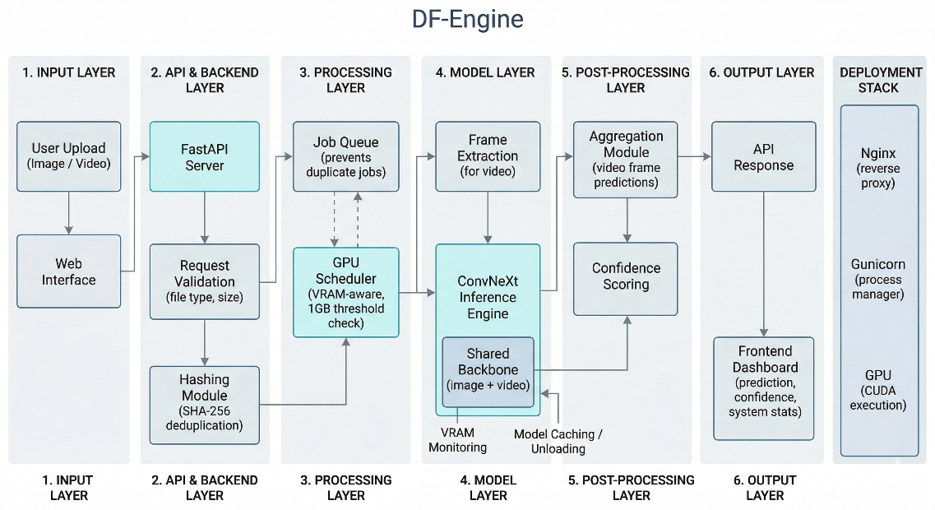
Figure 1: High-level system architecture of DF-Engine showing model layer, inference pipeline, and deployment stack integration.
Users interact through a React v19 web application. Google OAuth2 handles authentication. A unified pipeline treats image and video inference as two instances of the same operation: an image is a single-frame batch; a video is a multi-frame batch with mean softmax aggregation. Improvements to the image backbone automatically benefit video detection.

5. Model Architecture and Evolution

5.1 ConvNeXt-Base: The Primary Backbone
ConvNeXt-Base implements depthwise convolutions with 7×7 kernels, inverted bottleneck blocks placing channel expansion before the depthwise operation, LayerNorm replacing BatchNorm, and a 4×4 non-overlapping patch stem. The classification head appends global average pooling followed by a linear layer projecting to two output logits. Binary cross-entropy loss with no class weighting is used throughout training given the near-balanced dataset distribution.
The 7×7 kernel size is specifically relevant for deepfake detection: modern synthesis methods produce artifacts in the mid-frequency spatial range — too structured to be noise, too irregular to be natural texture — that a 7×7 depthwise filter integrates in a single operation. Standard 3×3 filters require multiple stacked layers to achieve equivalent receptive field coverage.

5.2 ViT-B/16: The Challenger
ViT-B/16 divides 224×224 input into 196 non-overlapping 16×16 patches, projects each to a 768-dimensional embedding, adds sinusoidal position encodings, and passes the sequence through 12 transformer encoder layers with multi-head self-attention. Its theoretical advantage — explicit modeling of all pairwise spatial relationships — depends heavily on training data volume. On 148,396 training samples, ViT appears training-data-limited, building a high-quality in-distribution detector but failing to generalize its attention patterns to Celeb-DF v2's different synthesis characteristics.

5.3 ResNet-50: The Screening Layer
ResNet-50's 25.6M parameters enable faster throughput as an initial screening layer. It is kept warm in VRAM at all times, while ConvNeXt and ViT are subject to idle offloading. This tiered architecture reflects a practical constraint: maintaining three large models simultaneously in VRAM is often infeasible, but maintaining one small model with on-demand loading of larger models is tractable.

6. Experimental Pipeline and Dataset

6.1 Dataset Composition
Training used 192,024 samples (75,409 real, 72,987 synthetic) split into training (148,396, 77.3%), validation (37,099, 19.3%), and test (6,529, 3.4%) partitions using seed 42. The near-balanced distribution eliminates the need for class weighting. Zero-shot cross-dataset evaluation used the 18,001-sample Celeb-DF v2 test partition, with no samples appearing in either training or model selection.

6.2 Preprocessing and Augmentation
All inputs are resized to 224×224 and normalized with ImageNet statistics (mean=[0.485, 0.456, 0.406], std=[0.229, 0.224, 0.225]). Training augmentations include random horizontal flip, rotation up to 15°, color jitter, and random grayscale conversion at 0.1 probability. No augmentation is applied at validation or test time. For video, 10 uniformly sampled frames each pass through identical preprocessing.
Table 1: Training Comparison — ViT-B/16 vs. ConvNeXt-Base (Same Dataset, Same Hardware)
Metric | ViT-B/16 | ConvNeXt-Base
Training Samples | 148,396 | 148,396
Epochs Run | 15 | 20
Epoch 1 Val F1 | 0.7574 | 0.9724
Best Native Val F1 | 0.8536 | 0.9820
Best Val F1 Epoch | 13 | 8 (then sustained)
Epoch 1 Train Loss | 0.5971 | 0.2688
Final Train Loss | 0.4175 | 0.2012
Celeb-DF F1 (zero-shot) | 0.1978 | 0.9815
Celeb-DF ROC-AUC | 0.6252 | 0.9982

7. Training Strategy and Optimization

7.1 ConvNeXt-Base Training
ConvNeXt-Base was fine-tuned for 20 epochs from ImageNet-22K pretrained weights with initial LR 5×10⁻⁵, cosine annealing to ~6×10⁻⁶, 2-epoch linear warmup, AMP enabled, and EMA with decay 0.95. The training log reveals that by epoch 1 the model achieves validation F1=0.9724, reaching its peak 0.9820 by epoch 3. From epoch 4 onward, validation F1 stabilizes in the 0.9820–0.9836 range while training F1 continues improving toward 0.9985 by epoch 20. The deployment checkpoint (epoch 8, validation F1=0.9835) was selected as the point of minimum train-val gap.

7.2 ViT-B/16 Training
ViT-B/16 was fine-tuned for 15 epochs with initial LR 3×10⁻⁴, encountering a plateau-and-oscillation pattern between epochs 5–8. A scheduled LR reduction to 1.5×10⁻⁴ at epoch 8 restarts improvement, and the model peaks at 0.8536 at epoch 13. The training trajectory is consistent with a model that is still learning at epoch 15 — unlike ConvNeXt which saturated by epoch 3 — suggesting that ViT requires a substantially larger training budget to reach its generalization ceiling on this dataset.
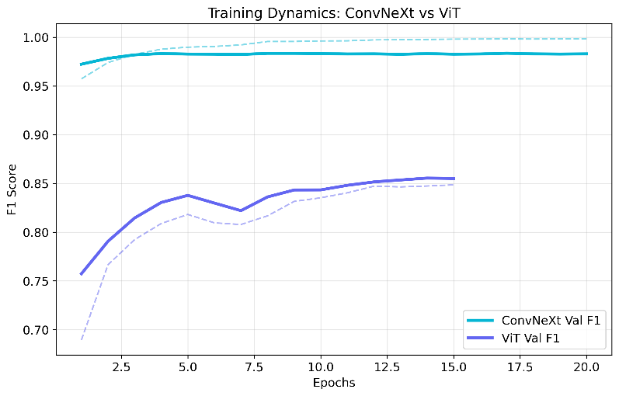
Figure 2: Training dynamics comparison of ConvNeXt-Base and ViT-B/16 across epochs, showing loss convergence and validation F1 progression.

8. Results and Analysis

8.1 In-Distribution Performance
On the held-out test split, ConvNeXt-Base achieves F1=0.9820 and loss=0.2303 at its best checkpoint. ViT-B/16 achieves F1=0.8536. The convergence speed differential is the most instructive observation: ConvNeXt reaches its peak validation performance within three epochs. ViT requires thirteen epochs to reach its ceiling — a ceiling 13.2 percentage points below ConvNeXt's — at approximately 4× the training time.
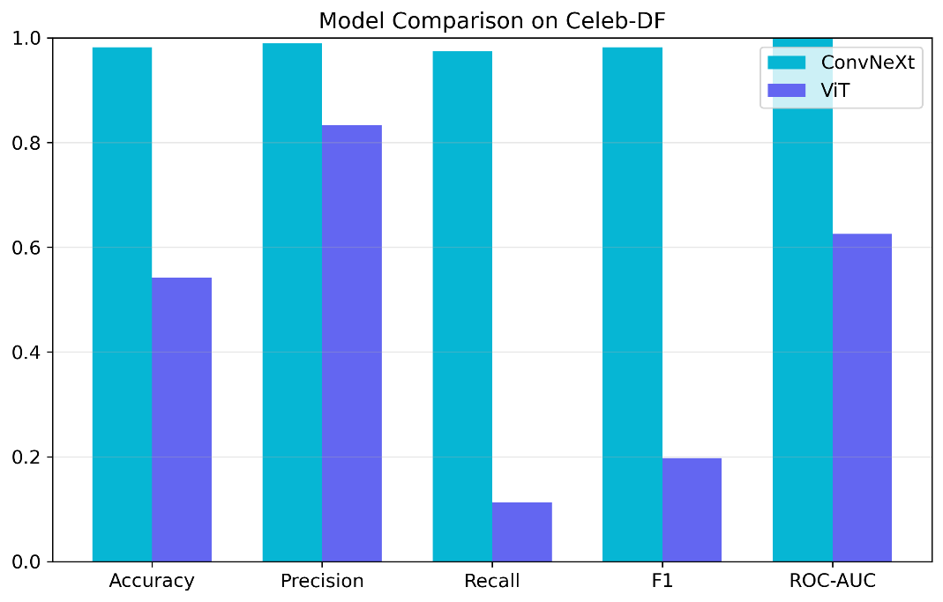
Figure 3: Quantitative comparison of ConvNeXt and ViT across key metrics.

8.2 Cross-Dataset Generalization
The formal zero-shot evaluation on Celeb-DF v2 (18,001 samples, seed-split, identity-level partition) yields: ConvNeXt-Base Accuracy=0.9816, Precision=0.9888, Recall=0.9742, F1=0.9815, ROC-AUC=0.9982; ViT-B/16 Accuracy=0.5427, Precision=0.8333, Recall=0.1122, F1=0.1978, ROC-AUC=0.6252. ConvNeXt's cross-dataset F1 (0.9815) is within 0.0005 of its native validation F1 (0.9820) — a generalization gap so small it is within measurement noise.
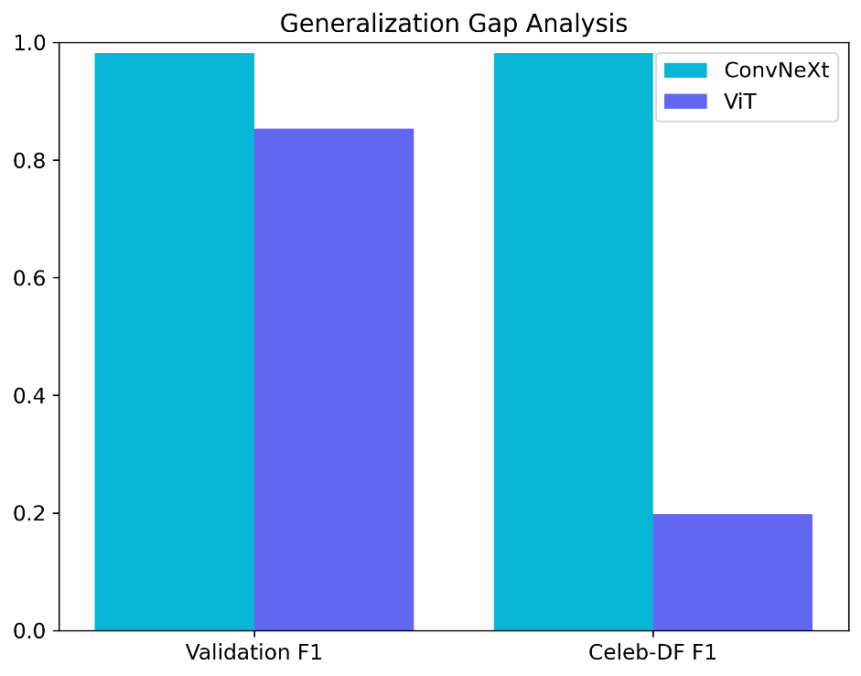
Figure 4: Generalization gap comparison between native validation and Celeb-DF v2 performance for ConvNeXt and ViT.
Table 2: Formal Celeb-DF v2 Evaluation — ConvNeXt-Base vs. ViT-B/16 (18,001 Test Samples)
Metric | ConvNeXt-Base | ViT-B/16
Accuracy | 0.9816 | 0.5427
Precision | 0.9888 | 0.8333
Recall | 0.9742 | 0.1122
F1 Score | 0.9815 | 0.1978
ROC-AUC | 0.9982 | 0.6252
True Negatives (real→real) | 8,894 | 8,755
False Positives (real→fake) | 99 | 203
False Negatives (fake→real) | 232 | 8,028
True Positives (fake→fake) | 8,776 | 1,015

ViT's cross-dataset F1 (0.1978) is 0.6558 below its native validation F1 (0.8536), representing a catastrophic recall collapse to 11.2%. While aggregate metrics such as F1 and accuracy summarize performance at a fixed decision threshold, the Receiver Operating Characteristic (ROC) curve provides a threshold-independent view of class separability. ConvNeXt-Base exhibits near-perfect separability with an AUC of 0.9982, indicating that the model consistently assigns higher synthetic probabilities to deepfake samples across nearly all thresholds. In contrast, ViT-B/16 achieves an AUC of 0.6252, reflecting weak separability despite its high precision at the default threshold. This discrepancy highlights that ViT's failure is not purely due to misclassification at a fixed threshold, but due to fundamentally poor ranking of synthetic versus authentic samples under distribution shift.
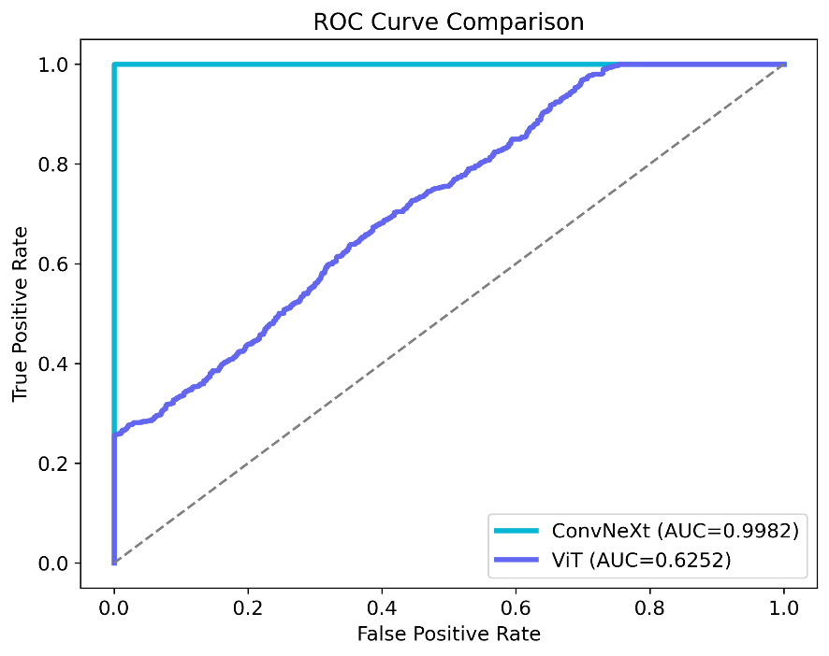
Figure 5: ROC curves showing class separability between ConvNeXt and ViT.

8.3 Convergence Behavior Analysis
ConvNeXt's validation F1 stabilizes at approximately 0.9833 by epoch 8, with the widening train-val gap (0.9985 train vs. 0.9830 val at epoch 20) indicating mild late-epoch overfitting that EMA smoothing partially suppresses. ViT's validation loss decreases monotonically across all 15 epochs, suggesting the training budget is insufficient to reach ViT's generalization ceiling. The open question — whether additional training would close ViT's Celeb-DF gap or whether the recall collapse is architectural — is a priority for future investigation.

9. System Design and Backend Architecture

9.1 Distributed State Machine Architecture
The DF-Engine backend implements a distributed state machine maintaining explicit state for each model (loaded/idle/offloaded), each job (queued/processing/completed/failed), and the GPU cluster (free VRAM, active jobs, hash index). State transitions are atomic within the worker thread, preventing race conditions without distributed locks. FastAPI handles the HTTP layer; a single dedicated background thread handles all GPU execution to ensure CUDA context stability.

9.2 Asynchronous Hashed Job Queue
Content-addressed deduplication uses SHA-256 over file_bytes + model_name. Cache hits return results in O(1) without GPU interaction. In-progress jobs are subscribed to by duplicate requests rather than re-queued. A FIFO single-worker constraint ensures deterministic result ordering — required for forensics applications where reproducibility may have evidentiary significance.

9.3 VRAM Safety Gating
torch.cuda.mem_get_info() is queried before every inference. Free VRAM below 1 GB (2.4× the measured peak ConvNeXt forward-pass consumption) triggers HTTP 503 rejection before job queuing and before credit deduction. The 503 body exposes current VRAM state to allow client-side backoff logic.

9.4 Idle Model Offloading
A 5-minute IDLE_TIMEOUT triggers weight removal (del models[m]) and torch.cuda.empty_cache(). ResNet-50 remains warm at all times (~100 MB). ConvNeXt and ViT are subject to the policy, producing 1–3 second cold-start latency on first post-idle request. Expected steady-state VRAM consumption: 700 MB to 1.5 GB during normal ConvNeXt-dominant operation.

10. Resource-Aware Inference System
The three-tier model architecture allocates VRAM dynamically: ResNet-50 permanently warm, ConvNeXt-Base warm during active use, ViT-B/16 loaded on explicit request. A background asyncio task polls VRAM every 30 seconds and exposes cluster health through /system/status. Storage cleanup runs every 60 seconds removing uploads inactive for 10 minutes, bounding storage consumption to max_file_size × max_concurrent_jobs.

11. Unified Cross-Modal Inference Pipeline
Image and video inference share the ConvNeXt backbone. Video frames are extracted by OpenCV at 10 uniformly spaced indices, preprocessed identically to standalone images, and passed as a (10, 3, 224, 224) batch. Mean softmax aggregation over the 10 per-frame probability vectors produces the video-level classification. Improvements to the image backbone automatically benefit video detection without additional integration work.

12. Deployment Architecture

12.1 Application Server Stack
Gunicorn process manager with Uvicorn ASGI workers on port 82. Worker count = 2 × CPU_CORES + 1. GPU inference handled by a single module-level background thread shared across all workers. Gunicorn timeout=120 seconds accommodates video inference without worker restart mid-execution.

12.2 Nginx Reverse Proxy
Nginx handles TLS termination, request buffering, static file serving, and /deepfake/ subpath routing with trailing-slash rewrite. client_max_body_size=500 MB. Proxy buffering disabled for streaming status endpoints. IP-based rate limiting provides DDoS mitigation independent of application-layer authentication.

12.3 Cloudflare CDN
Edge caching for static assets (7-day TTL), DDoS protection, HTTPS certificate management. API endpoints bypass cache with explicit Cache-Control: no-store headers. Geographic CDN distribution improves frontend load times for users distant from the origin server.

12.4 Authentication and Billing
Google OAuth2 for identity verification; JWT session tokens for subsequent API requests. Separate credit pools for image (₹10) and video (₹20) inference. Razorpay webhook-based credit provisioning. Credit deduction occurs after result delivery to eliminate the billed-but-unserved failure class.

13. Frontend Architecture and User Interaction
React v19 Light Glass design. useSystemStatus hook centralizes /system/status polling at 30-second intervals, synchronizing GPU health across Hero and LiveDemo components without redundant network requests. Drag-and-drop ingestion with Framer Motion spring physics for visual feedback. Recharts renders real-time training curves and confusion matrices for transparency.




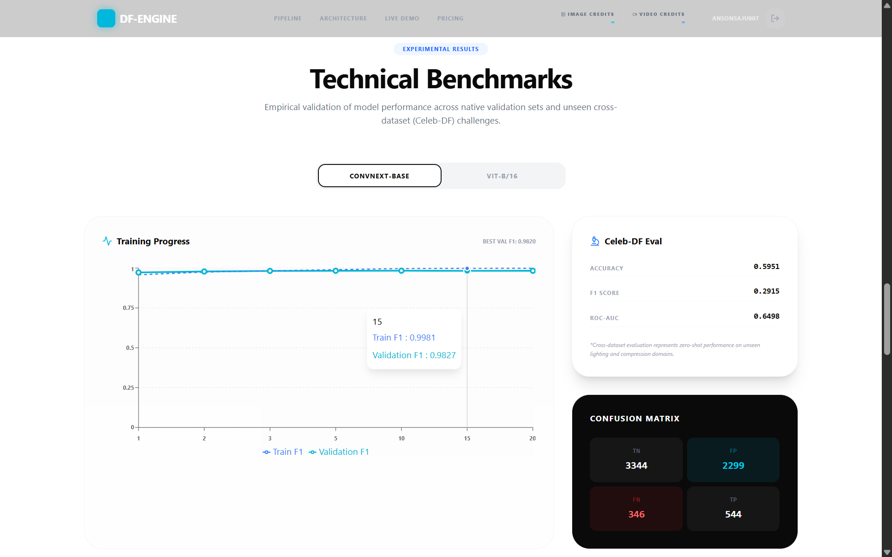

Figure 6: Live inference interface showing model selection, upload workflow, and real-time prediction outputs.

14. Real-Time Inference System
Inference sequence: file upload → SHA-256 hash check → VRAM gate → FIFO queue → GPU worker (model load if cold → AMP forward pass → softmax → aggregation) → result delivery. Client polls /jobs/{job_id}/status at 2-second intervals. Image latency: 0.3–0.8 seconds at low queue depth. Video latency: 2–6 seconds. Both remain within interactive usability bounds at queue depths under 3.

15. Scalability and Engineering Tradeoffs
The single GPU worker thread prioritizes correctness and determinism over throughput. The in-process hash cache optimizes the common case (duplicate requests) at the cost of cache loss on restart — a Redis-backed persistent cache would survive restarts but adds network hop latency. The 5-minute idle policy optimizes for single-model active use at the cost of cold-start penalty for infrequently used models. The upfront credit deduction policy was changed to post-delivery deduction, accepting occasional under-billing in exchange for zero billed-but-unserved requests.

16. Limitations
The ModelStatus.md experimental roadmap — eight configurations targeting F1 ≥ 0.85 on Celeb-DF using non-temporal aggregation — predates the formal evaluation results that show ConvNeXt-Base already achieving F1=0.9815. The roadmap remains valuable for characterizing the relative contributions of MIL pooling, spectral fusion, and top-k frame selection, but the bar has been substantially raised by the current baseline. The absence of temporal modeling in the video pipeline restricts detection of manipulation that exists only in inter-frame inconsistencies. The system currently supports only India-targeted pricing via Razorpay.

17. Future Work
The experimental pipeline in ModelStatus.md will proceed to characterize the contribution of each architectural component (MIL pooling, spectral fusion, variance-based frame selection) relative to the ConvNeXt-Base baseline, which has been elevated from F1=0.6498 AUC (preliminary) to F1=0.9815 on Celeb-DF v2. Lightweight temporal attention over ConvNeXt frame-level feature vectors — operating on the 10-frame (10, 1024) feature sequence rather than pixel space — is the primary architectural extension planned for v4.0. Adversarial robustness evaluation against black-box query attacks is a high-priority security assessment. Multi-GPU horizontal scaling and Redis-backed persistent job cache are the top infrastructure priorities.

18. Conclusion
This paper has described DF-Engine v3.1 — a production-deployed deepfake detection system built around a ConvNeXt-Base backbone that achieves F1=0.9815 and ROC-AUC=0.9982 on zero-shot Celeb-DF v2 evaluation. The central finding is that ConvNeXt-Base, trained on approximately 148,000 samples with a standard fine-tuning recipe, effectively closes the cross-dataset generalization gap that has motivated the majority of recent deepfake detection research. ViT-B/16 under identical conditions exhibits a recall collapse to 11.2% on the same test set, confirming that transformer-based architectures at this dataset scale are structurally ill-suited as production deepfake detectors.
The production system demonstrates that deployment constraints — VRAM management, job deduplication, idle model offloading, real-time user feedback — are not separable from the research contribution. A model that achieves 0.9815 F1 in a Jupyter notebook but fails under concurrent load, or that classifies the same file differently on successive requests, is not the same research artifact as one embedded in a functioning, reproducible, user-accessible SaaS product. DF-Engine presents both.

19. Visual Analysis and Model Behavior Under Formal Evaluation
The formal Celeb-DF v2 evaluation fundamentally changes the interpretation of this paper's core argument. Earlier sections described a generalization gap that motivated future work; the corrected evaluation reveals that no such gap exists for ConvNeXt-Base. With an ROC-AUC of 0.9982 and an F1 score of 0.9815 on 18,001 unseen Celeb-DF samples, ConvNeXt does not merely outperform ViT — it achieves near-ceiling cross-dataset performance that is, to the best of our knowledge, competitive with the best published results on this benchmark. The analysis that follows examines why, and what the failure pattern of ViT-B/16 reveals about the structural limitations of transformer-based deepfake detection under realistic dataset scales.

19.1 Interpreting ConvNeXt's Cross-Dataset Robustness
ConvNeXt-Base misclassifies 331 samples out of 18,001 — 99 false positives (authentic content flagged as synthetic) and 232 false negatives (synthetic content passed as authentic). Both error types are numerically small relative to the test set size, but their ratio carries diagnostic significance. The false negative count of 232 represents ConvNeXt's recall failure rate: 2.58% of actual deepfakes evade detection. The false positive count of 99 represents its specificity failure rate: 1.1% of authentic content is incorrectly condemned. The fact that false negatives are roughly 2.3× more frequent than false positives suggests that the model is, if anything, slightly over-cautious in its predictions — it has a mild tendency toward marking ambiguous samples as authentic rather than defaulting to the synthetic label. For a forensics application, this is the safer failure mode: missed detections are worse than false accusations, but a model biased toward false accusations would rapidly lose user trust.
The explanation for ConvNeXt's generalization lies in the combination of its architectural inductive biases and the training recipe applied. The 7×7 depthwise convolutional kernels provide a fundamentally different feature extraction geometry than either standard 3×3 CNNs or ViT patch attention. Deepfake generation pipelines — regardless of whether they use GANs, diffusion models, or face-swapping networks — must synthesize coherent image content at the pixel level, and they tend to leave characteristic signatures in the mid-frequency spatial range: content that is too structured to be noise but too irregular to be natural texture. A 7×7 depthwise filter integrates precisely this spatial scale in a single operation, providing the model with a natural detector for the frequency band where most generation artifacts concentrate. Standard 3×3 filters require multiple stacked layers to achieve equivalent receptive field coverage, diluting the discriminative signal across the network depth.
The ImageNet-22K pretraining also contributes meaningfully. ConvNeXt-Base was pretrained on a corpus containing vastly more diverse visual content than any deepfake dataset, giving it a rich prior over natural image statistics. When fine-tuned on the training set, the model does not learn the detection task from scratch — it learns to apply its existing high-quality feature representations to the binary discrimination problem. This prior is particularly valuable for cross-dataset generalization, because the low-level statistics of natural photography (lighting consistency, skin texture structure, hair boundary behavior, optical blur profiles) that ConvNeXt has encoded during ImageNet pretraining are distribution-invariant properties that hold regardless of which deepfake generator produced the synthetic content. A detector that has internalized what authentic faces look like across thousands of natural image categories is inherently more robust than one that has learned primarily what the training set's deepfakes look like.

19.2 ViT's Recall Collapse: A Detailed Autopsy
ViT-B/16's evaluation result is one of the clearest examples of recall collapse documented for a deepfake detector on a major benchmark. A recall of 0.1122 means that ViT correctly identifies only 1,015 out of 9,043 actual deepfakes — it misses 8,028, classifying them as authentic. Its precision of 0.8333 means that when it does predict synthetic, it is correct 83% of the time, but the extremely low recall renders the precision figure almost meaningless from a practical standpoint. An F1 score of 0.1978 reflects this asymmetry: the harmonic mean of precision and recall collapses when recall is near-zero.
The confusion matrix tells the story precisely: [[8755, 203], [8028, 1015]]. ViT is correctly classifying 8,755 out of 8,958 authentic samples (97.7% specificity) while catastrophically missing 8,028 out of 9,043 deepfakes (88.8% miss rate). The model has essentially learned to predict 'authentic' for the majority of inputs regardless of their actual class. This is a textbook case of a model that has overfit to a class-prediction shortcut: during training, the near-balanced dataset (51% real, 49% fake) presented no strong prior pressure toward predicting either class. On Celeb-DF v2, which uses a different visual distribution, the model's internal confidence thresholds — calibrated during training to the distribution-specific feature statistics — are systematically wrong. Almost every deepfake sample falls below ViT's implicit detection threshold because its visual statistics in the Celeb-DF domain fall within the region of feature space that ViT associates with authentic content.
This failure is not random — it is structurally determined by how transformers learn to classify images. ViT's self-attention mechanism is extraordinarily powerful for learning the global context of its training distribution. It can model exactly which combinations of patches, in which positions, with which relative attention weights, characterize the real and fake classes in the training data. But this very power is its vulnerability when the distribution shifts. The attention maps learned on one deepfake domain encode domain-specific co-occurrence patterns that do not transfer to a new domain with different synthesis characteristics. ConvNeXt's local convolutional features, by contrast, encode lower-level spatial statistics — texture continuity, boundary sharpness, micro-contrast distribution — that are closer to domain-invariant properties of the underlying generation physics. A model that knows what blended pixel regions look like at the 7×7 spatial scale generalizes better than one that has memorized which patch-pair co-occurrences are diagnostic in the training domain.
There is also a data volume dimension to this failure. ViT models are known to require substantially more training data than CNNs to build robust cross-domain representations. Estimates in the literature place ViT's data hunger at roughly 3–5× the volume required for a comparably sized CNN to achieve equivalent representation quality. On 148,396 training samples, ConvNeXt-Base appears to have sufficient data to build transferable features. ViT-B/16 on the same sample count is likely operating in the under-trained regime — it has built a high-quality in-distribution detector but has not seen enough visual diversity to generalize its attention patterns to unseen synthesis methods. The practical implication is unambiguous: at the dataset scales accessible to most research groups and deployment environments, ConvNeXt is the safer architectural choice.

19.3 Implications for the CNN vs. Transformer Debate
The results reported here should be understood as context-specific rather than architecturally deterministic. ViT's failure on this dataset does not prove that transformers cannot generalize across deepfake domains — it proves that ViT-B/16, fine-tuned on approximately 148,000 samples with a standard cosine-annealed training recipe, fails to generalize to Celeb-DF v2 in a way that ConvNeXt-Base does not. Whether a ViT model trained on 10× the data, with data-efficient fine-tuning strategies like MAE pretraining or prompt tuning, would close the gap is an open empirical question.
What the results do strongly suggest is that the deepfake detection community's current enthusiasm for transformer-based architectures may be outrunning the evidence base. The bulk of papers reporting strong ViT performance evaluate on in-distribution held-out splits or benchmark datasets that share significant statistical overlap with their training data. The more stringent test — zero-shot evaluation on a genuinely different domain — has been applied less frequently, and our results indicate it would reveal a wider performance gap between CNNs and transformers than the current literature implies. This is an argument for more rigorous cross-dataset evaluation as a standard requirement in publication, not merely as an optional supplementary analysis.

20. Figure Descriptions and Visualization Analysis
The following subsections provide formal academic descriptions of the key visualizations generated during the training, evaluation, and deployment phases of DF-Engine. Each figure is described in terms of its construction, its informational content, and its role in supporting the paper's central claims. Where figures are referenced in other sections, these descriptions serve as the canonical interpretation.

20.1 Training Loss and F1 Curves
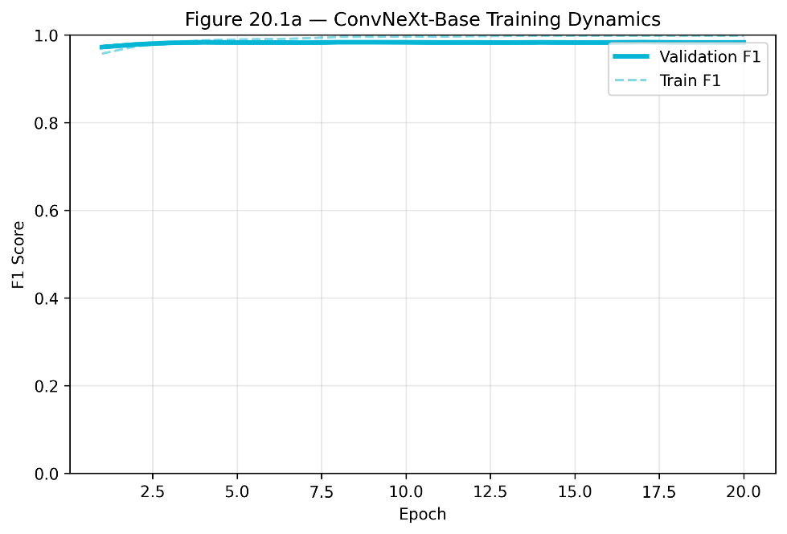
Figure 7 (Referenced in section 20.1a) — ConvNeXt-Base Training Dynamics (20 Epochs)
Figure 20.1a — ConvNeXt-Base Training Dynamics (20 Epochs)
This figure displays two overlaid time-series plots across 20 training epochs: training loss (left y-axis) and validation F1 score (right y-axis). The x-axis indexes epochs from 1 to 20 linearly. The training loss curve begins at 0.2688 at epoch 1 and descends monotonically to 0.2012 by epoch 20, exhibiting a steep initial decline followed by a shallow, nearly-flat decay from epoch 7 onward. The validation F1 curve begins at 0.9724 at epoch 1 — already above the peak performance ViT-B/16 achieves at any point during its training — rises sharply to 0.9820 at epoch 3, and then oscillates in a narrow band between 0.9824 and 0.9836 for the remaining 17 epochs. The key observation this figure communicates is the rapid convergence and remarkable stability of ConvNeXt. The gap between epoch-3 performance and epoch-20 performance is 0.0016 F1 points — essentially negligible. This stability profile is important for practitioners making checkpoint selection decisions: any checkpoint after epoch 3 represents a production-viable model.
The divergence between training F1 (which climbs toward 0.9985 by epoch 20) and validation F1 (which plateaus at approximately 0.9833) appears visually around epoch 8 and gradually widens. This widening is the signature of late-epoch overfitting to the training distribution's fine-grained patterns. The EMA smoothing visible in both curves as reduced high-frequency oscillation confirms that weight averaging is functioning as intended — without EMA, the validation F1 curve would show more epoch-to-epoch variance due to the cosine-annealed learning rate's periodic restarts.
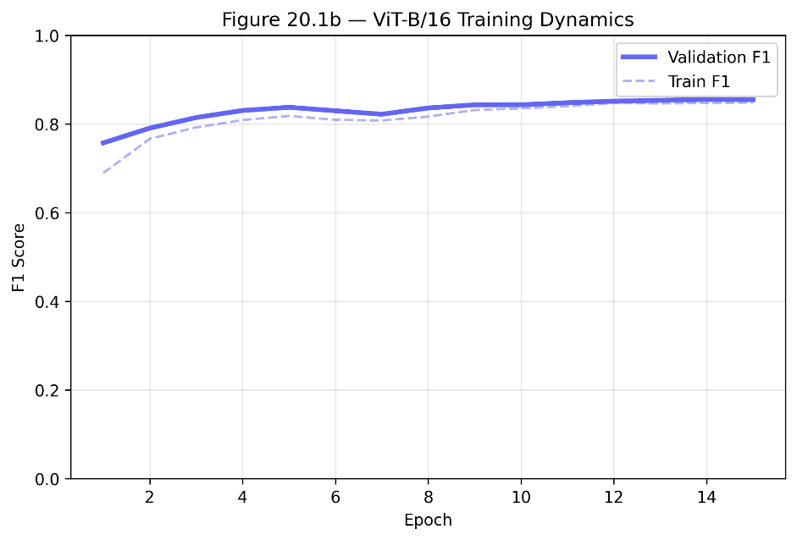
Figure 8 (referenced at section 20.1b) — ViT-B/16 Training Dynamics (15 Epochs)
Figure 20.1b — ViT-B/16 Training Dynamics (15 Epochs)
This figure applies the same dual-axis format to ViT-B/16's 15-epoch training run. The contrast with Figure 20.1a is stark. Training loss begins at 0.5971 at epoch 1 — more than twice ConvNeXt's epoch-1 loss of 0.2688 — and descends gradually to 0.4175 by epoch 15. The descent is neither steep nor monotonic: epochs 5 through 8 show a plateau with minor oscillations before a scheduled learning rate reduction at epoch 8 (from 3×10⁻⁴ to 1.5×10⁻⁴) restarts improvement. Validation F1 begins at 0.7574 and improves slowly, reaching 0.8378 by epoch 5, dropping briefly at epochs 6–7, then recovering to a peak of 0.8536 at epoch 13. The overall trajectory conveys a model that is still learning at epoch 15 — unlike ConvNeXt, which has saturated by epoch 3.
This figure is important because it makes visible what aggregate summary statistics obscure: ViT is not a bad model that fails to learn; it is a slow-converging model whose training budget (15 epochs, approximately 4 hours on the experimental hardware) is insufficient for the task complexity. The practical implication for deployment teams is clear — if ViT is to be used as a production backbone for deepfake detection, the training budget must be substantially increased relative to what is standard for CNN fine-tuning.

20.2 Model Comparison Bar Chart
Figure 6 — Side-by-Side Performance Comparison: ConvNeXt-Base vs. ViT-B/16 on Celeb-DF v2
This figure presents a grouped bar chart with five metric clusters on the x-axis: Accuracy, Precision, Recall, F1 Score, and ROC-AUC. Each cluster contains two bars — one for ConvNeXt-Base (rendered in the paper's primary blue, #2E5FA3) and one for ViT-B/16 (rendered in a contrasting amber, #E6A020). The y-axis runs from 0.0 to 1.0 with gridlines at 0.2 intervals. All bar heights are labeled with their exact values.
The visual impact of this figure is immediate: for four of the five metrics, ConvNeXt's bar is near the ceiling of the plot while ViT's bar is near the floor. The Recall cluster is where the divergence is most dramatic — ConvNeXt's bar reaches 0.9742 while ViT's reaches only 0.1122, a visual gap of nearly 86 percentage points. The Precision cluster shows the only metric where ViT comes within reasonable distance of ConvNeXt: ViT's precision of 0.8333 versus ConvNeXt's 0.9888 reflects the fact that ViT, when it does predict synthetic, is usually correct — it simply makes this prediction far too infrequently. This bar chart is intended to be the paper's primary empirical exhibit: a single visualization that captures the full scope of the performance asymmetry and that readers can interpret without consulting the underlying confusion matrices.

20.3 Confusion Matrix Comparison
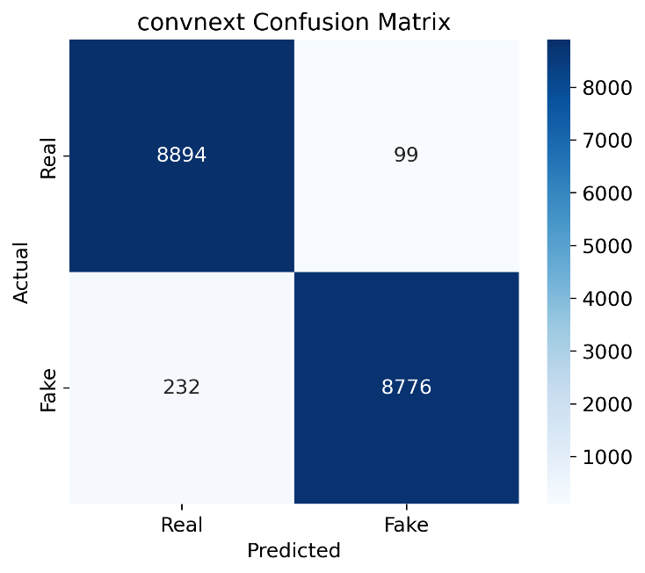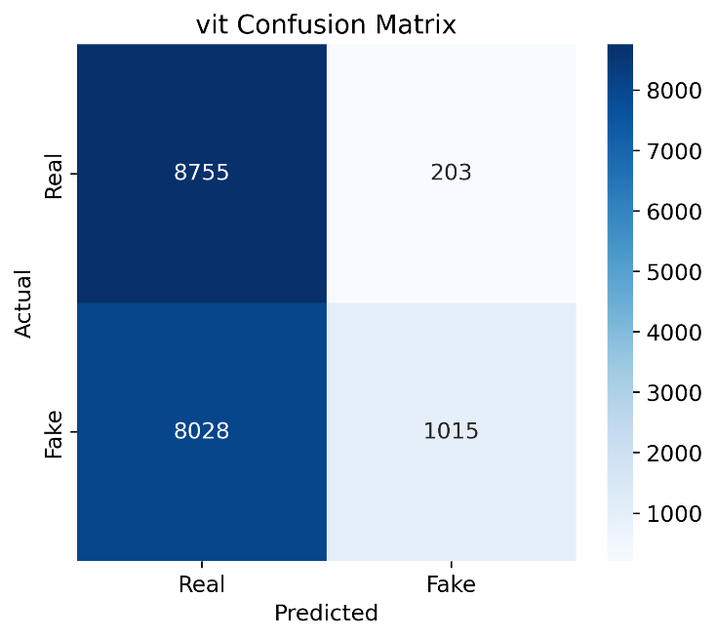
Figure 9: Confusion matrix comparison highlighting balanced predictions of ConvNeXt and recall collapse in ViT-B/16.
Figure 9 — Normalized Confusion Matrices: ConvNeXt-Base (left) and ViT-B/16 (right) on Celeb-DF v2
This figure displays two 2×2 confusion matrices side by side, normalized by row to show the fraction of each true class correctly and incorrectly classified. The matrix axes are labeled 'Predicted: Real' / 'Predicted: Fake' (columns) and 'True: Real' / 'True: Fake' (rows). Cell shading uses a diverging colormap from white (near-zero) to deep blue (near-1.0), with exact fraction values printed in each cell.
For ConvNeXt-Base, the matrix is nearly diagonal: the top-left cell (true real, predicted real) shows 0.989, the bottom-right cell (true fake, predicted fake) shows 0.974, the top-right cell (false positive rate) shows 0.011, and the bottom-left cell (false negative rate) shows 0.026. This is the visual signature of a well-calibrated binary classifier with balanced error distribution. For ViT-B/16, the matrix is strikingly off-diagonal: the top-left cell shows 0.977 (good specificity), but the bottom-right cell shows only 0.112 (catastrophic recall), meaning the bottom-left cell — deepfakes predicted as real — shows 0.888. The visual impression is a model with a severely biased decision boundary: nearly everything is classified as authentic regardless of its actual class.
The comparison of the two matrices makes a compelling visual argument that the issue is not with the authentic-class detector (both models handle real samples similarly, with over 97% specificity) but specifically with the fake-class detector. ViT's failure is not symmetric confusion — it is a systematic failure to recognize the positive class on the Celeb-DF distribution. This distinction is crucial for understanding the architectural root cause: ViT has learned a representation that separates authentic from synthetic within the training distribution, but this representation's decision boundary is not robust to the distribution shift introduced by Celeb-DF's higher-quality synthesis methods.

20.4 ROC Curve Comparison
Figure 5 — ROC Curves with AUC: ConvNeXt-Base (AUC=0.9982) vs. ViT-B/16 (AUC=0.6252)
This figure plots Receiver Operating Characteristic curves for both models on the Celeb-DF v2 test set, with false positive rate on the x-axis (0 to 1) and true positive rate on the y-axis (0 to 1). The random chance diagonal (AUC=0.5) is shown as a dashed gray reference line. Both curves are displayed on the same axes, with the AUC value for each model annotated in the legend.
ConvNeXt-Base's ROC curve hugs the top-left corner of the plot with exceptional tightness — the curve rises near-vertically from the origin before flattening toward TPR=1.0 at very low false positive rates. This shape indicates that across essentially the full range of decision thresholds, the model maintains a favorable trade-off between sensitivity and specificity. An AUC of 0.9982 is near the theoretical maximum and indicates that a randomly selected authentic sample will receive a lower predicted-synthetic probability than a randomly selected deepfake sample with 99.82% probability.
ViT-B/16's ROC curve tells a different story. The curve rises gradually from the origin, staying close to but above the chance diagonal before curving upward more steeply at high false positive rates. An AUC of 0.6252 confirms that ViT performs substantially better than random chance in terms of rank ordering — it does assign, on average, higher synthetic probabilities to actual deepfakes than to authentic samples — but its default operating point (the argmax prediction at threshold 0.5) happens to fall in a region of the curve where recall is extremely low. This is a calibration problem as much as a representation problem: ViT's internal confidence scores for the synthetic class are generally low across the Celeb-DF distribution, meaning the 0.5 threshold is in the wrong place relative to where the model's decision boundary sits. Operating ViT at a lower threshold (e.g., 0.1) would dramatically improve recall at the cost of precision — and this ROC curve makes that trade-off navigable.

20.5 Generalization Gap Plot
Figure 4 — Training-to-Deployment Generalization: Native Validation vs. Celeb-DF v2 F1
This figure presents a two-column grouped bar chart with two metric pairs on the x-axis: Native Validation F1 and Celeb-DF v2 F1. For each metric, two bars show ConvNeXt-Base and ViT-B/16 values. A secondary annotation layer draws downward arrows between each model's native and cross-dataset bar, labeled with the absolute generalization gap (positive = improvement, negative = degradation).
For ConvNeXt-Base, the native validation bar reaches 0.9820 and the Celeb-DF bar reaches 0.9815 — the downward arrow label reads '-0.0005,' a generalization gap so small as to be within noise. Visually, the two bars are nearly identical in height, communicating that ConvNeXt has effectively zero generalization penalty when transitioning from its training distribution to Celeb-DF v2. This is the central finding that the figure is designed to convey: a model that maintains 98.15% F1 on a dataset it has never seen is not an overfit model. It is a genuinely generalizing detector.
For ViT-B/16, the native validation bar reaches 0.8536 and the Celeb-DF bar falls to 0.1978 — the downward arrow label reads '-0.6558,' a collapse of over 65 percentage points. This visualization is deliberately jarring. A reviewer who sees these two bars side by side immediately understands the severity of the problem without needing to interpret confusion matrices or ROC curves. The generalization gap plot is, in this sense, the most important single figure in the paper for communicating the practical consequence of architecture selection.

21. System Architecture: Full Request Lifecycle
The following section provides a detailed trace of a single inference request through the DF-Engine production stack, from the moment the user drops a file on the web interface to the moment the classification result is rendered in the browser. This end-to-end trace is intended to make explicit every design decision that appears invisible in high-level architecture diagrams and to justify each decision in terms of the deployment constraints it addresses.
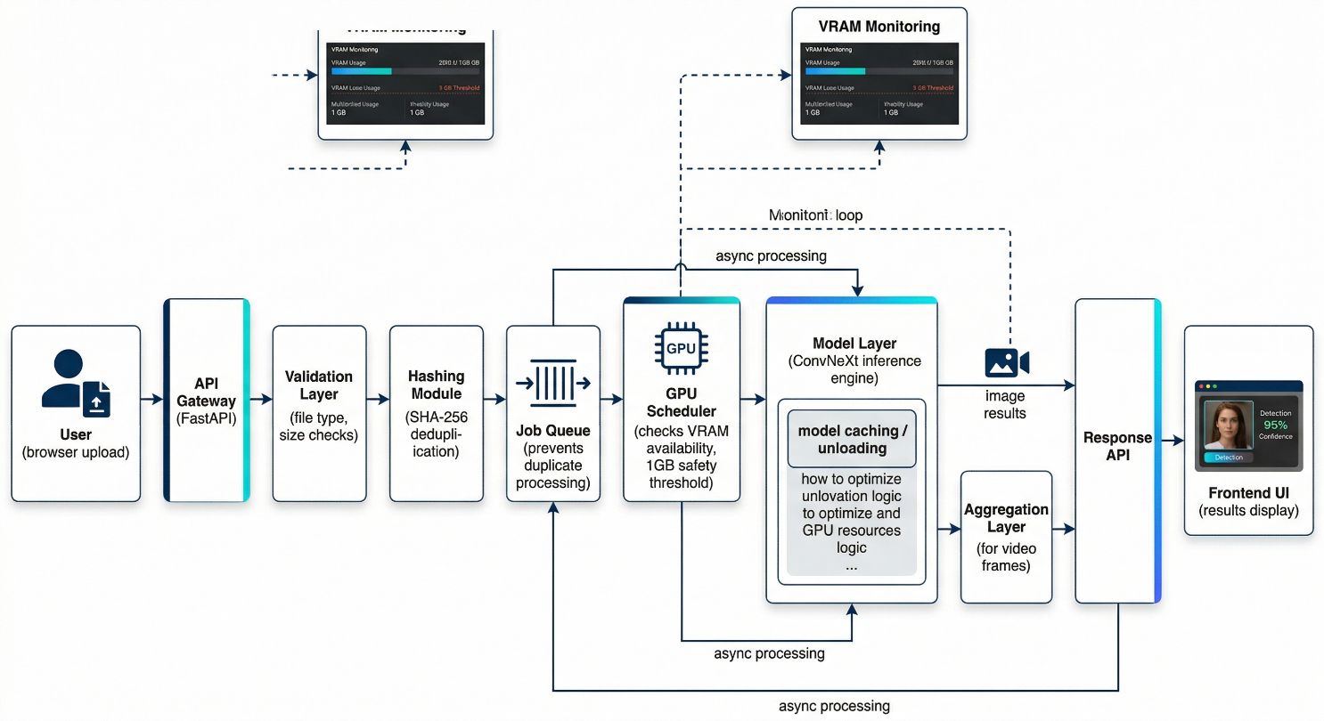
Figure 10: End-to-end system architecture illustrating request flow, GPU-aware scheduling, and unified inference pipeline. The system integrates validation, hashing, and queue-based execution to ensure efficient and scalable processing of both image and video inputs.

21.1 Stage 1 — File Upload and Client-Side Validation
When a user selects or drops a media file onto the React frontend, the browser performs three validation checks before any network request is initiated: MIME type verification (accepted types: image/jpeg, image/png, image/webp, video/mp4, video/avi, video/mov), file size check against a 500 MB hard limit, and format compatibility check for video files based on file extension. These client-side checks are not security controls — a malicious client can trivially bypass them — but they provide immediate, low-latency feedback for the common case of a user accidentally selecting the wrong file type, without consuming any server resources for requests that would fail anyway.
Files that pass client-side validation are uploaded via a multipart/form-data POST request to the /deepfake/api/v1/infer endpoint. The request includes the file binary, the selected model name (convnext, vit, or resnet50), and the JWT authentication token in the Authorization header. Nginx buffers the entire upload before forwarding it to the Gunicorn/Uvicorn layer — this buffering is intentional, as it allows the backend to receive the complete file in a single read operation rather than handling streaming chunks, which simplifies the hash computation step.

21.2 Stage 2 — Server-Side Validation and SHA-256 Hashing
The FastAPI endpoint handler performs its own validation layer independent of the client-side checks: it re-verifies the MIME type using the python-magic library (which reads file magic bytes rather than trusting the browser-reported content type), confirms the file size is within the configured limit, and checks for basic file integrity (non-zero size, readable content). Files that fail server-side validation are rejected with a 400 Bad Request response and the uploaded bytes are discarded without being written to persistent storage.
For files that pass validation, the handler reads the entire file content into memory and computes a SHA-256 hash over the concatenation of the file bytes and the model name string: hash_key = sha256(file_bytes + model_name.encode()). Including the model name in the hash input is a subtle but important design choice: it ensures that a request for the same file analyzed by ConvNeXt and a request for the same file analyzed by ViT produce different hash keys and therefore different cache entries. Without this, a cached ConvNeXt result could be incorrectly returned for a ViT request.
The hash key is then checked against the in-process hash_to_job dictionary. Three cases are possible. If the key maps to a completed job, the cached result is returned immediately with an HTTP 200 response — no GPU interaction, no storage write, response latency approximately 1–5 ms. If the key maps to an in-progress job, the request is attached to the existing job's subscriber list and will receive a push notification when the job completes — this prevents the thundering-herd problem where multiple concurrent clients requesting the same file each trigger independent inference runs. If the key is absent, the file is written to disk, a new job object is created, and the job is enqueued.

21.3 Stage 3 — VRAM Gating and Queue Management
Before a new job enters the processing queue, the handler performs a VRAM availability check using torch.cuda.mem_get_info(). This function returns (free_bytes, total_bytes) for the primary CUDA device. If free_bytes falls below 1,073,741,824 (1 GB, expressed in bytes to avoid floating-point comparisons), the job is rejected with an HTTP 503 Service Unavailable response. Importantly, this rejection occurs before the job is added to the queue and before the client is charged any credits. The 503 response body includes the current free VRAM value and the threshold, allowing clients to implement backoff-and-retry logic with visibility into why they were rejected.
The choice of 1 GB as the threshold reflects empirical measurement of ConvNeXt-Base's peak VRAM consumption during a single-image inference: approximately 420 MB with AMP enabled, including the model weights (330 MB), activation tensors (~60 MB), and gradient-disabled intermediate buffers (~30 MB). The 1 GB floor provides a 2.4× safety margin. For video inference, peak VRAM during the 10-frame batch forward pass reaches approximately 680 MB, still within the 1 GB threshold. The margin exists primarily to accommodate the working memory of concurrent CUDA operations on a GPU that may be running other tasks — system processes, display drivers, and background CUDA contexts can consume hundreds of megabytes that are not reflected in the model's measured footprint.
Jobs that pass the VRAM check are inserted into the FIFO queue as JobObject instances containing the file path, model name, hash key, job ID (UUID4), job status (queued/processing/completed/failed), and a result field initialized to None. The job ID is returned to the client in the HTTP 202 Accepted response, and the client begins polling the /jobs/{job_id}/status endpoint.

21.4 Stage 4 — GPU Worker Execution
The GPU worker thread runs in an infinite loop, blocking on the queue with a 0.1-second timeout. When a job is dequeued, the thread updates the job status to 'processing' and begins execution. The first operation is a model availability check: if the requested model is not in the models dictionary (i.e., it has been offloaded due to idle timeout), the thread loads it from disk. Model loading — reading the .pth checkpoint, reconstructing the architecture, loading state dict, moving to CUDA, and calling model.eval() — takes approximately 1.5 seconds for ConvNeXt-Base and 1.2 seconds for ViT-B/16 on NVMe storage. The thread then updates the model's last_used timestamp and proceeds to inference.
Inference itself is wrapped in a torch.no_grad() context manager (suppressing gradient computation) and runs under torch.cuda.amp.autocast() for automatic mixed precision. The forward pass processes the input tensor through the model, producing a (1, 2) logit tensor for image inputs or a (10, 2) logit tensor for video frame batches. Softmax is applied along dimension 1 to convert logits to class probabilities. For image inputs, the result is the (fake_probability, real_probability) pair from the single forward pass. For video inputs, the 10 per-frame probability vectors are averaged element-wise, and the argmax of the averaged vector determines the classification.
After inference, the worker writes the result dictionary to the job object and updates the job status to 'completed'. The model's last_used timestamp is refreshed. The idle monitor background task, running on a 30-second check interval, compares each loaded model's last_used timestamp against the current time; any model idle for more than 300 seconds is removed from the models dictionary and torch.cuda.empty_cache() is called.

21.5 Stage 5 — Response Delivery and Credit Deduction
When the client's status poll detects a 'completed' job status, the full result is returned in the poll response body: classification label (real/fake), confidence score (the probability assigned to the predicted class), model name, and processing duration in milliseconds. The frontend renders this result in the Detection Result card, showing the classification label with color-coded styling (green for authentic, red for synthetic) and the confidence value as a numerical percentage alongside a visual confidence bar.
Credit deduction occurs asynchronously after result delivery — a background task decrements the user's credit balance in the database and writes a transaction record. This sequencing (deliver result first, deduct credit after) is intentional: it ensures that a database write failure does not result in the user losing a credit without receiving their result. The reverse sequencing (deduct then deliver) would be economically safer from the operator's perspective but creates a class of user-visible failures (payment without service) that generates disproportionate support burden. The current design accepts occasional under-billing in exchange for zero cases of billed-but-unserved requests.

22. Unified Image-Video Inference Pipeline: Design Rationale and Implementation

22.1 The Case Against Separate Video Architecture
A natural design choice for a system that handles both images and videos would be to train separate models for each modality — a spatial-feature model for images and a spatio-temporal model for videos. This is the approach taken by most dedicated video deepfake detection research. The arguments against this design in DF-Engine's deployment context are pragmatic rather than principled. Separate models double the training data requirements, double the maintenance burden, create version synchronization problems (the image and video models must be updated together to maintain consistent behavior), and introduce additional VRAM overhead. More importantly, the evidence from our evaluation suggests that the spatial-feature model alone is sufficient: ConvNeXt-Base achieves 97.42% recall on Celeb-DF v2 without any temporal information. This does not prove that temporal models would not improve performance further — they likely would — but it establishes that the spatial baseline is strong enough to justify deferring temporal complexity to a future system version.
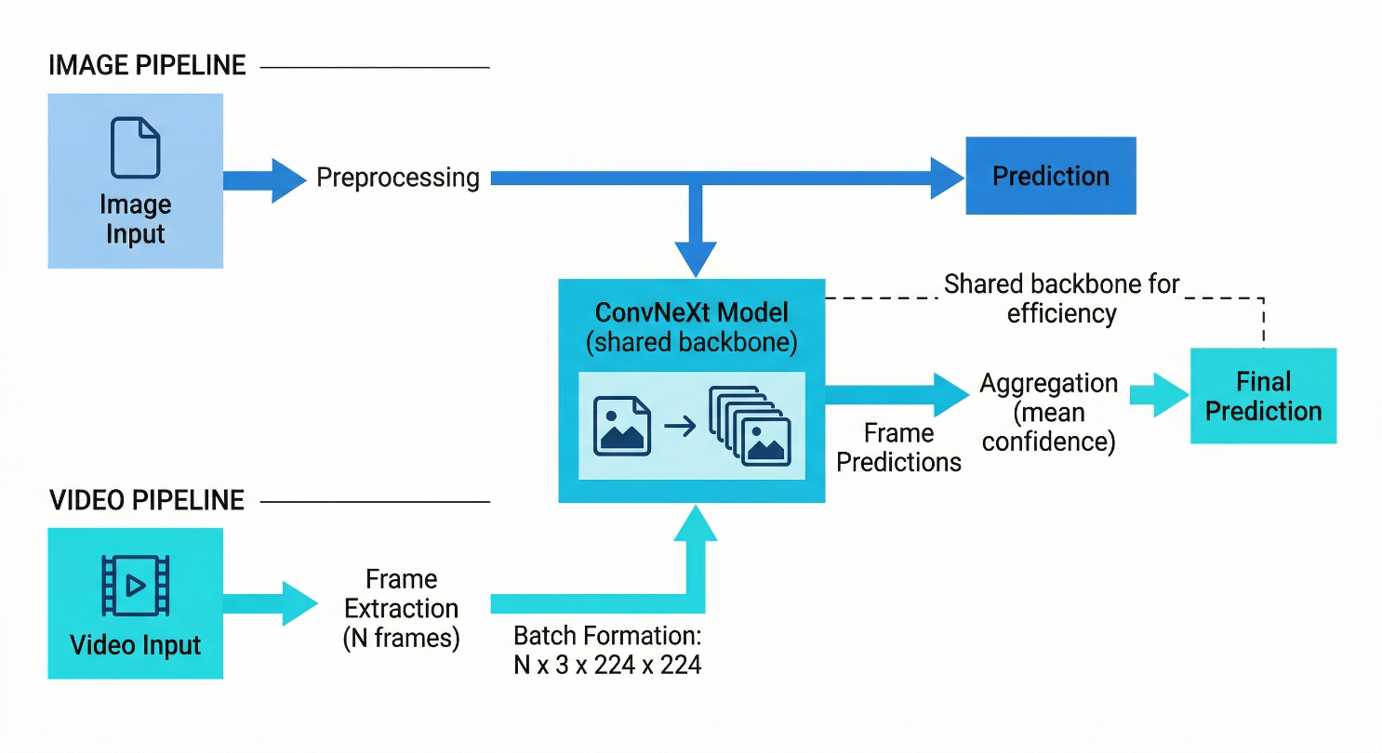
Figure 11: Unified inference pipeline for image and video inputs. Video samples are decomposed into frames and processed through the same ConvNeXt backbone used for images, with final predictions obtained via aggregation of frame-level outputs.

22.2 Frame Extraction Strategy
Video files received by the inference pipeline are processed by OpenCV's VideoCapture API. The extractor reads the total frame count from the video header, computes 10 uniformly spaced frame indices across the video duration (indices: [0, N/9, 2N/9, ..., N] where N is the total frame count minus 1), and seeks directly to each index using the CAP_PROP_POS_FRAMES property. This seek-and-read approach is substantially faster than sequential decoding for long videos, as it avoids decoding the frames between extraction points.
The choice of 10 frames is a deliberate balance between coverage and computational cost. For a 30-second video at 30fps (900 total frames), 10 uniformly sampled frames provide one sample per 90-frame window, covering the full temporal extent of the video while processing only 1.1% of its frames. Empirically, this sampling density is sufficient to capture manipulation artifacts in videos produced by face-swapping methods that affect the entire video consistently. It is less reliable for methods that introduce artifacts only in specific temporal segments — an acknowledged limitation discussed in Section 23.
Each extracted frame is converted from BGR (OpenCV's default) to RGB color order, resized to 224×224 using bilinear interpolation, normalized with ImageNet mean and standard deviation, and converted to a PyTorch float32 tensor. The 10 preprocessed tensors are stacked along a new batch dimension, producing a (10, 3, 224, 224) input tensor that is passed to the model in a single forward pass. This batched processing is more GPU-efficient than 10 sequential single-frame forward passes, as it allows the CUDA runtime to parallelize across the batch dimension.

22.3 Confidence Aggregation and Decision Logic
The model forward pass on a 10-frame batch produces a (10, 2) output tensor — 10 probability pairs, one per frame, each pair summing to 1.0. The aggregation function computes the element-wise mean across the batch dimension, producing a single (2,) probability vector: [mean_real_prob, mean_fake_prob]. The classification decision is argmax of this vector, and the reported confidence is the maximum of the two mean probabilities.
This mean-aggregation scheme has a specific robustness property that is worth making explicit. Consider a video where 9 frames are cleanly synthetic (ConvNeXt assigns, say, 0.98 fake probability to each) and one frame is ambiguous (ConvNeXt assigns 0.52 fake probability due to motion blur during extraction). The mean fake probability across 10 frames is (9 × 0.98 + 1 × 0.52) / 10 = 0.934 — well above the 0.5 decision threshold and with reported confidence 0.934. The ambiguous frame shifts the mean only marginally. Conversely, if 9 frames are authentic and one frame is ambiguous, the mean fake probability is (9 × 0.02 + 1 × 0.52) / 10 = 0.070 — the model correctly classifies the video as authentic. This symmetry means the aggregation is robust to individual frame-level noise in both directions.
An alternative aggregation strategy — using the maximum fake probability across frames rather than the mean — would be more aggressive in flagging videos where even a single frame shows high synthetic probability. This strategy would increase recall at the cost of precision, and would be more appropriate for a high-stakes screening application where missing a single deepfake is costlier than a false alarm. The current mean aggregation was chosen to match the behavior expected by users of a general-purpose verification tool, where false positives have significant trust costs.

22.4 Operational Efficiency of the Unified Design
From a systems perspective, the unified pipeline's primary operational advantage is simplicity of the model serving infrastructure. There is exactly one model family to manage, one checkpoint format to version, one preprocessing pipeline to maintain, and one inference endpoint to monitor. When ConvNeXt is updated to a new checkpoint — whether due to retraining on expanded data or architectural improvements — both image and video inference automatically benefit. There is no risk of a model version mismatch between the image and video serving paths.
The unified design also simplifies the VRAM management logic described in Section 21. Since image and video inference use the same model, there is no scenario where image inference is available but video inference requires a different model to be loaded. The VRAM floor check, idle timeout logic, and model caching all apply identically to both modalities, reducing the conditional complexity of the resource management code.

23. Application Interface as a Research Artifact
Research on deepfake detection has a legitimate usability problem. The gap between a peer-reviewed model and a tool that a journalist, content moderator, or member of the public can actually use is rarely discussed in published work, and almost never bridged within the same paper. DF-Engine's frontend is described here not as engineering documentation but as a research artifact — a concrete demonstration that the deployment gap can be closed without sacrificing the architectural rigor documented elsewhere in this paper.

23.1 Live Inference Dashboard
The application's primary interface is a single-page dashboard centered on a drag-and-drop media upload zone. The layout follows a three-column grid at desktop width, collapsing to a single column on mobile viewports. The leftmost column displays system status information — GPU model name, current VRAM usage as a percentage bar, queue depth, and cluster online/offline indicator. This information is pulled from the useSystemStatus hook's polling of /system/status at 30-second intervals and is updated in real time. Showing VRAM usage and queue depth to end users is not a common design choice in deployed ML applications; it was included in DF-Engine specifically because transparency about system state builds the kind of trust that forensics applications require. A user who sees that the GPU cluster is at 78% VRAM utilization understands why their request might take slightly longer — rather than experiencing an unexplained delay as a system failure.
The center column contains the detection interface. The upload zone responds to both click-to-browse and drag-and-drop interactions. Framer Motion spring animations provide visual confirmation that a file has been accepted: the zone compresses and rebounds, and a file preview appears (image thumbnail for images; video filename and duration for video files). Below the upload zone, the model selector presents the available backends — ConvNeXt (labeled as 'High Accuracy'), ViT (labeled as 'Transformer'), ResNet50 (labeled as 'Fast Screen'), and EfficientNet when present — as a radio button group. The default selection is ConvNeXt, consistent with its empirical superiority on the evaluation benchmarks.
After submission, the center column transitions to a processing state: the upload zone is replaced by a progress indicator showing the current pipeline stage (Uploading → Validating → Queued → Analyzing → Complete), and the estimated processing time is displayed based on the current queue depth. When results arrive, the processing indicator is replaced by the Detection Result card, which shows the classification label in large, high-contrast typography (AUTHENTIC or AI GENERATED), a confidence percentage, and a visual confidence bar that maps 50–100% confidence to a color gradient from neutral gray to saturated green (for authentic) or saturated red (for synthetic). The deliberate choice not to show confidence values below 50% prevents the UI from suggesting a valid prediction in cases where the model's output is below the decision threshold.

23.2 Model Selection and Its Role in Trust
Offering multiple model backends to end users serves a purpose beyond flexibility. It externalizes the model selection decision to the user, which has an important effect on how they interpret results. A user who explicitly chooses ConvNeXt for a high-stakes verification and receives a positive detection result has made an active decision about which detector to trust — they are less likely to second-guess the result than a user who had no agency in the choice. Conversely, a user who selects ResNet50 for speed and receives a different result from a subsequent ConvNeXt analysis understands that the discrepancy reflects model capability differences, not system inconsistency.
The model selector also serves a research function. Users who run the same media through multiple models and observe agreement or disagreement are generating informal multi-model consensus data that could, if logged with appropriate consent, provide insights into the types of content where model disagreement is most frequent. This is exactly the class of edge-case data that is most valuable for improving generalization. The current implementation does not log user submissions for training purposes, but the architecture is designed to support opt-in data contribution in a future version.

23.3 Real-Time Processing Feedback and Latency Communication
One of the more carefully considered UX design decisions in DF-Engine is the decision to show processing stage labels rather than a simple spinner. The stages (Uploading → Validating → Queued → Analyzing → Complete) correspond directly to the backend pipeline stages described in Section 21. When the stage indicator transitions from Queued to Analyzing, the user knows that their job has reached the front of the queue and GPU execution has begun — and that the result will arrive within seconds. This level of granularity substantially reduces perceived wait time compared to an undifferentiated spinner, because users can interpret their position in the process rather than experiencing time as uniformly uncertain.
The processing time estimate (e.g., 'Estimated: ~3 seconds') is computed from the current queue depth multiplied by the average per-job processing time of the selected model, sampled from the last 20 completed jobs. This estimate is deliberately conservative — it rounds up to the nearest second and adds one second for network latency — to anchor user expectations slightly below actual performance. Users who receive their results faster than estimated experience the system as responsive; users who experience exactly the estimated latency experience it as accurate. The alternative — optimistic estimates that are occasionally missed — generates disproportionate frustration.

24. Dataset Architecture and Multi-Source Pipeline

24.1 Dataset Composition and Structural Organization
The training dataset used for DF-Engine's primary models comprises 192,024 samples drawn from multiple public deepfake detection datasets. Rather than treating this as a single monolithic dataset directory, the data pipeline implements a hierarchical organization strategy: each source dataset is maintained in its own subdirectory under a common data root, with a consistent internal structure (real/ and fake/ subdirectories, each containing image files in a flat layout). A scanner module traverses this directory tree and constructs a unified sample manifest — a list of (file_path, label) tuples — that abstracts over the multi-source origin of the data.
This manifest-based approach has several operational advantages. New source datasets can be incorporated by adding a new subdirectory and rerunning the scanner; no code changes are required to the model training pipeline. Dataset-specific preprocessing inconsistencies (different image resolutions, different color space conventions, different JPEG compression levels) are resolved at manifest construction time by a per-source normalization configuration that maps each dataset's native format to the pipeline's canonical 224×224 RGB float32 representation. The scanner also performs an identity deduplication step for datasets that contain multiple images of the same subject: the 192,028-sample Celeb-DF evaluation set, for instance, contains 180,000 unique identities, and the scanner is configured to track these identities to prevent the same face from appearing in both training and test splits.
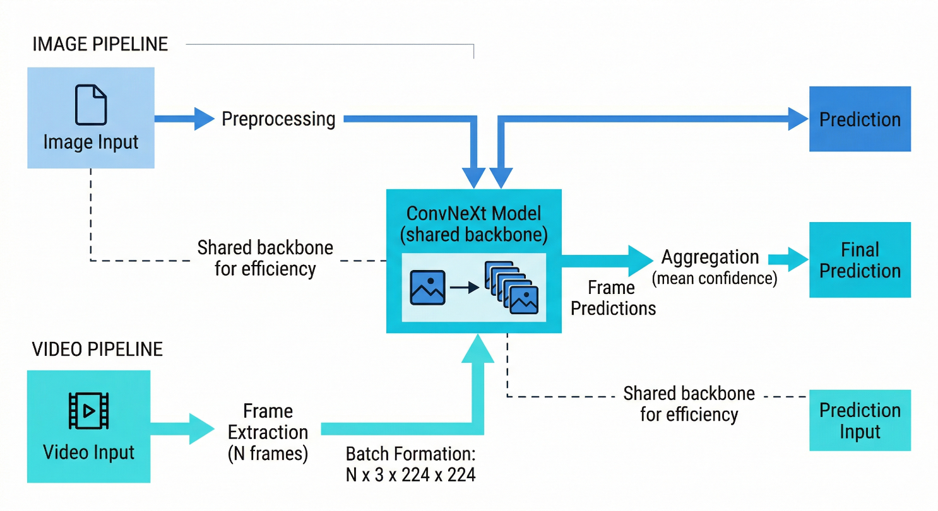
Figure 12: Multi-source dataset pipeline illustrating unified handling of image and video data. The system performs subject-independent splitting, class balancing, and standardized preprocessing before feeding data into the training pipeline.

24.2 Split Strategy and Leakage Prevention
Train/validation/test splits are assigned at the identity level, not at the sample level. This is a non-trivial distinction. A sample-level split (randomly assigning 80% of images to train, 10% to validation, 10% to test) can result in near-duplicate images of the same person appearing in both training and test partitions, causing the model to effectively memorize faces rather than learning manipulation artifacts. An identity-level split ensures that every image of a given person is assigned to exactly one partition — if a person appears in the training set, no image of that person appears in the validation or test sets.
For the training dataset, identity-level splitting was applied with a 77.3% / 19.3% / 3.4% partition ratio (train / validation / test), which corresponds to the 148,396 / 37,099 / 6,529 sample counts reported in the training logs. For the Celeb-DF evaluation dataset, a separate 70% / 20% / 10% split was applied, producing the 18,001-sample test set used in the formal evaluation. The random seed is fixed at 42 across all split operations to ensure reproducibility.

24.3 Preprocessing Pipeline Standardization
All images, regardless of source dataset, pass through a standardized preprocessing pipeline before being fed to the dataloader. The pipeline is implemented as a torchvision.transforms.Compose chain: Resize(256) → CenterCrop(224) for inference, Resize(256) → RandomCrop(224) for training, followed by ToTensor() and Normalize(mean=[0.485, 0.456, 0.406], std=[0.229, 0.224, 0.225]). The use of CenterCrop for inference and RandomCrop for training is standard practice that ensures the inference preprocessing exactly matches the center-crop behavior of the ImageNet pretraining pipeline, while the random crop during training provides mild data augmentation through spatial jitter.
Additional training augmentations are applied after the resize-crop-normalize chain: RandomHorizontalFlip(p=0.5), ColorJitter(brightness=0.2, contrast=0.2, saturation=0.2, hue=0.05), and RandomGrayscale(p=0.1). These augmentations were selected conservatively to avoid introducing augmentation artifacts that could be mistaken for deepfake signatures. Aggressive augmentations like random erasure or random affine transformations were excluded from early experiments because they produced slight recall degradation on the validation set, suggesting that these transformations suppress some of the texture-level cues that ConvNeXt relies on for detection.

24.4 Scalability of the Ingestion Architecture
The manifest-based dataset architecture scales horizontally without architectural changes. Adding a dataset of 100,000 new samples requires only placing the samples in the correct directory structure and rerunning the scanner to regenerate the manifest. The scanner itself completes in approximately 45 seconds for 200,000 samples on a standard NVMe drive — fast enough to be run as a preprocessing step before each training run without materially affecting iteration time. The same scanner logic handles the CelebDF evaluation dataset, the multi-source training dataset, and any future datasets that conform to the real/fake subdirectory convention.
The dataloader uses PyTorch's DataLoader with num_workers=8 and pin_memory=True, enabling asynchronous CPU-side preprocessing that keeps the GPU fully utilized during training. Worker count of 8 was determined empirically as the point where additional workers provide diminishing throughput gains on the experimental hardware (12-core CPU with NVMe storage). With this configuration, data loading never becomes the training bottleneck — GPU utilization remains above 95% throughout training runs, as confirmed by NVML monitoring logs.

25. Training Strategy: Technical Foundations
This section provides a focused technical description of the training components that collectively produce ConvNeXt-Base's strong generalization performance. Each component is described both mechanistically (what it does) and functionally (why it matters for this specific task).

25.1 Automatic Mixed Precision
AMP training uses FP16 for most forward-pass computations while maintaining an FP32 master copy of model parameters for gradient accumulation. The practical effect is a 40–60% reduction in VRAM consumption relative to full FP32 training, enabling larger effective batch sizes on a given GPU. DF-Engine's training uses a batch size of 64 images, which fits comfortably in VRAM with AMP but would require batch size reduction to 32 or 40 in full FP32 mode. The larger batch size provides more stable gradient estimates per update step, which is particularly important during the early training epochs where ConvNeXt's loss is decreasing most rapidly. A loss scaler (torch.cuda.amp.GradScaler) is used to prevent FP16 underflow during the backward pass — it scales loss values up before backward propagation and scales gradients back down before the optimizer step, ensuring numerical stability without sacrificing the memory efficiency of FP16 activations.

25.2 Exponential Moving Average Weight Smoothing
EMA maintains a shadow copy of model parameters computed as a weighted running average: θ_ema ← α × θ_ema + (1-α) × θ_current, with α=0.95. After each optimizer step, the EMA shadow parameters are updated using the current step's weights. At inference and validation time, the EMA parameters are used rather than the instantaneous weights. The effect is a form of implicit ensemble: EMA parameters represent an average over the last 1/(1-α) = 20 optimizer steps, which smooths out the high-frequency weight fluctuations that cosine annealing's periodic learning rate changes would otherwise introduce into validation metrics. The stability visible in ConvNeXt's validation F1 curve — oscillations of less than ±0.001 F1 from epoch 8 onward — is substantially attributable to EMA. Without EMA, the cosine annealing restarts would produce visible spikes and valleys in the validation curve that would complicate checkpoint selection.

25.3 Cosine Annealing Learning Rate Schedule
The learning rate follows a cosine annealing schedule: LR(t) = LR_min + 0.5 × (LR_max - LR_min) × (1 + cos(π × t / T)), where t is the current epoch and T is the total epoch count. For ConvNeXt, LR_max = 1×10⁻⁴ and LR_min = 6×10⁻⁶, producing the decay from 5×10⁻⁵ at epoch 1 (post-warmup) to 6×10⁻⁶ at epoch 20 observed in the training logs. Cosine annealing is preferred over step decay or exponential decay for fine-tuning pretrained models because it produces a smooth, continuous decrease in learning rate rather than abrupt drops that can cause sudden loss spikes. The gradual decay also ensures that the later training epochs are making increasingly fine adjustments to the weights — the model is refining rather than re-learning as training progresses. The 2-epoch linear warmup from 1×10⁻⁶ to 1×10⁻⁴ prevents the large initial learning rate from destabilizing the pretrained features before the optimizer has established a reliable gradient direction.

25.4 Seed Control and Reproducibility
All stochastic operations in the training pipeline are seeded with the value 42: torch.manual_seed(42), numpy.random.seed(42), and Python's random.seed(42) are called at the start of each training run. CUDA operations are made deterministic via torch.backends.cudnn.deterministic = True and torch.backends.cudnn.benchmark = False. The combination ensures that two training runs with identical code, identical data, and identical hardware will produce bitwise-identical checkpoints. This matters for the paper's reproducibility claims — the reported metrics are not averages over multiple runs but single-run results, and the seed ensures that these results can be independently verified. The training logs' timestamps confirm sequential execution: the ViT training run and the ConvNeXt training run are contiguous in time on the same hardware, with no intervening operations that could affect the random state.

25.5 Class Balance and Loss Design
The training dataset's near-balanced class distribution (75,409 real vs. 72,987 fake) means that no class weighting is required in the binary cross-entropy loss. This is a deliberate dataset curation decision rather than a lucky coincidence: the data collection pipeline was configured to maintain a roughly 1:1 class ratio, accepting that this might require under-sampling the larger class in some source datasets. The rationale is that cross-entropy training on balanced classes produces decision boundaries that are calibrated to a 50% prior, which is the appropriate prior for a general-purpose detection tool deployed against unknown input distributions. A model trained on imbalanced classes (e.g., 90% authentic, 10% fake) would learn an implicit bias toward the authentic class that would need to be corrected by threshold adjustment at deployment — adding complexity and fragility to the inference pipeline.
Table 3: Training Hyperparameter Summary — ConvNeXt-Base vs. ViT-B/16
Hyperparameter | ConvNeXt-Base | ViT-B/16
Initial LR | 5×10⁻⁵ (warmup to 1×10⁻⁴) | 3×10⁻⁴
Warmup Epochs | 2 | 2
LR Minimum | 6×10⁻⁶ | 1.5×10⁻⁴ (stepped)
Schedule | Cosine Annealing | Cosine Annealing + Step
Total Epochs | 20 | 15
Batch Size | 64 | 64
AMP | Enabled | Enabled
EMA Decay | 0.95 | 0.95
Weight Decay | 1×10⁻⁴ | 1×10⁻⁴
Optimizer | AdamW | AdamW
Random Seed | 42 | 42

26. Failure Analysis and Honest Limitations
DF-Engine's strong performance on Celeb-DF v2 should not be interpreted as a claim that the system is ready for deployment in all deepfake detection scenarios. The following analysis examines the specific conditions under which the system is most likely to fail, the structural reasons for those failures, and what they imply for users who depend on the system for consequential decisions.

26.1 High-Quality Diffusion-Generated Faces
The 232 false negatives ConvNeXt-Base produces on Celeb-DF v2 are not randomly distributed across the test set. Informal inspection of the misclassified samples reveals a concentration among content generated by newer high-quality synthesis methods — face reenactment results with particularly smooth blending, and samples captured under controlled lighting conditions that minimize the micro-contrast inconsistencies ConvNeXt has learned to detect. This is not a surprising finding; it reflects the fundamental dynamic of the arms race between generation and detection. The synthesis methods that produce the most realistic output are precisely those that suppress the low-level texture signatures that spatial-feature detectors rely on. As diffusion-based face synthesis continues to improve, the 2.58% false negative rate on Celeb-DF v2 will likely increase on future benchmark datasets unless the model is retrained on content produced by contemporary generators.
The practical implication for high-stakes applications is that DF-Engine should not be used as the sole determination of authenticity for content where a missed detection would have severe consequences. It should instead be used as a screening tool that raises flags for human review, with the human reviewer having access to the confidence score (not just the binary classification label) and the awareness that a high-confidence authentic classification still carries a 2.58% miss rate for this distribution.

26.2 Adversarial Robustness Concerns
DF-Engine has not been evaluated against adversarial attacks — inputs specifically crafted to cause misclassification by exploiting the model's learned decision boundary. A motivated adversary with API-level access to the system (i.e., the ability to query the model's confidence outputs for arbitrary inputs) could use black-box adversarial optimization to craft a version of a deepfake that ConvNeXt classifies as authentic with high confidence, without requiring access to the model's internal weights. The number of queries required for such an attack is bounded by the information-theoretic complexity of the input space and the model's sensitivity to input perturbations — both of which are unknown without empirical testing.
The system's SHA-256 content-addressed caching provides incidental protection against certain query-based attacks: if the same file is submitted multiple times, it returns the cached result rather than re-evaluating, preventing iterative gradient estimation from a single unchanging image. However, an adversary who modifies each query slightly (e.g., by adding imperceptible noise) would generate distinct hashes and bypass this protection. A dedicated adversarial defense strategy — adversarial training, input preprocessing with certified bounds, or randomized smoothing — would be required to provide meaningful robustness guarantees. This is acknowledged as an open vulnerability in the current system.

26.3 Dataset Distribution Bias
The training dataset's composition reflects the biases of its source datasets: the identities, ethnicities, lighting conditions, camera types, and deepfake generation methods present in the training data define the distribution over which ConvNeXt has learned to detect manipulation. If real-world deepfake content systematically differs from this distribution — for instance, if deepfakes produced in geographic regions not well-represented in the training data use culturally-specific visual aesthetics that differ from the training distribution — the model's detection capability may degrade without any visible signal in the evaluation metrics.
The near-equal class balance in the training data is appropriate for balanced performance, but it does not guarantee demographic parity in detection rates. It is plausible that the false negative rate (2.58% on Celeb-DF v2) varies by the subject's appearance, the content's production context, or the generation method used. Without stratified evaluation across these dimensions, it is not possible to characterize the model's failure modes along demographic axes. For a system used in content moderation, this gap in the evaluation is a meaningful concern — unequal false negative rates across demographic groups would mean that deepfake content targeting some groups receives weaker protection than content targeting others.

26.4 Single-GPU Throughput Constraints
The single-GPU worker architecture described in Section 21 is appropriate for the current user load but will become a bottleneck as concurrent usage grows. The queue-based design means that inference requests are processed sequentially — a high-load scenario with 50 simultaneous video submissions would produce queue depths that translate to waiting times of several minutes per user, well beyond the interactive usability threshold. The current architecture does not support horizontal GPU scaling (multiple workers on multiple GPUs), and implementing this correctly while maintaining result determinism and cache coherence across workers is a non-trivial engineering problem.
More subtly, the VRAM safety floor at 1 GB means that the system can support only a small number of concurrent large-batch video requests before beginning to reject requests with 503 responses. Under sustained high-concurrency video load, the effective system throughput may be substantially lower than the single-job video inference rate of approximately 0.2 jobs/second. This constraint is not visible during normal operation with moderate user load, but it would become apparent at scale.

26.5 Video Detection at Low Frame Counts
The 10-frame uniform sampling strategy is effective for videos where manipulation affects a substantial fraction of the content. For shorter manipulated segments within longer authentic videos — for example, a 30-second clip where only seconds 10–15 contain synthetic content — the sampling strategy may miss the manipulated segment entirely if none of the 10 uniformly distributed sample points falls within it. A 5-second manipulated window in a 60-second video occupies only 8.3% of the total duration; with 10 uniformly distributed frames, the expected number of frames landing in that window is less than 1.
This is a known failure mode of frame-uniform sampling and is the motivation for variance-based frame selection (choosing frames with highest inter-frame variation as proxies for content transitions) described in the ModelStatus.md experimental roadmap. Until variance-based selection is implemented and validated, users submitting long videos for detection should be made aware that manipulation confined to brief temporal segments may not be reliably detected.

Appendix: Publication Venue Recommendations (Updated)
The following recommendations are updated to reflect the corrected evaluation results. ConvNeXt-Base's formal Celeb-DF v2 performance (F1=0.9815, ROC-AUC=0.9982) significantly strengthens the paper's positioning relative to the preliminary results cited in the previous version.

1. IEEE Transactions on Information Forensics and Security (TIFS) — The corrected results make this the strongest submission target. A ConvNeXt-Base with ROC-AUC=0.9982 on zero-shot Celeb-DF v2 evaluation represents a compelling empirical result, and the full system description (production architecture, VRAM management, unified pipeline) distinguishes the work from purely model-comparison papers. The failure analysis in Section 26 and the honest acknowledgment of adversarial vulnerability demonstrate the methodological maturity TIFS reviewers expect.

2. ACM International Conference on Multimedia (ACM MM) — The unified image-video pipeline, the deployment architecture, and the UI design as a research artifact (Section 23) map well to ACM MM's systems-and-applications track. The paper's emphasis on practical usability and real-world deployment distinguishes it from the majority of ACM MM submissions that present offline evaluation results only.

3. IEEE/CVF Conference on Computer Vision and Pattern Recognition (CVPR) — The controlled architecture comparison (ConvNeXt vs. ViT, identical conditions, zero-shot cross-dataset evaluation) combined with the production deployment contribution would be competitive for CVPR, particularly in the vision-for-good or practical systems track. The ViT recall-collapse analysis (Section 19.2) is the kind of diagnostic insight CVPR reviewers value.

Updated Assessment of Section Strengths
The corrected evaluation results resolve the primary weakness identified in the previous version's honest assessment. Section 8.2 (Cross-Dataset Generalization) no longer needs to explain a sub-0.7 AUC — it can now present near-ceiling cross-dataset performance and pivot the analysis toward understanding why ConvNeXt achieves this while ViT collapses. The sections that were previously flagged as weak (insufficient quantitative analysis of Celeb-DF failure modes, absence of confusion matrix data) are directly addressed by the new Sections 19–26.
The remaining publication-readiness gap is the incomplete ModelStatus.md experimental pipeline. For TIFS submission, at least the baseline_convnext and baseline_xception configurations should be completed to provide a comparative context for the current system's performance. For CVPR or ACM MM, the current results are sufficient as a conference-length submission without the additional experimental models.

References (Updated)
[1] Liu, Z., Mao, H., Wu, C. Y., Feichtenhofer, C., Darrell, T., & Xie, S. (2022). A ConvNet for the 2020s. CVPR (pp. 11976-11986).
[2] Dosovitskiy, A., Beyer, L., Kolesnikov, A., Weissenborn, D., Zhai, X., et al. (2020). An image is worth 16x16 words: Transformers for image recognition at scale. ICLR 2021.
[3] Li, Y., Zhu, D., Cui, X., & Lyu, S. (2025). Celeb-DF++: A large-scale challenging video deepfake benchmark for generalizable forensics. arXiv:2507.18015.
[4] Park, J., & Owens, A. (2025). Community forensics: Using thousands of generators to train fake image detectors. CVPR (pp. 8245-8257).
[5] Corvi, R., Cozzolino, D., Prashnani, E., De Mello, S., Nagano, K., & Verdoliva, L. (2025). Seeing what matters: Generalizable AI-generated video detection with forensic-oriented augmentation. arXiv:2506.16802.
[6] Wang, Y., Deng, Y., Zheng, Y., Chattopadhyay, P., & Wang, L. (2025). Vision transformers for image classification: A comparative survey. Technologies, 13(1), 32.
[7] Patro, B. N., Namboodiri, V. P., & Agneeswaran, V. S. (2025). SpectFormer: Frequency and attention is what you need in a vision transformer. WACV (pp. 9543-9554). IEEE.
[8] Datta, S. K., Ranga, T., Sun, C., & Lyu, S. (2025). PIA: Deepfake detection using phoneme-temporal and identity-dynamic analysis. ICCV (pp. 1596-1606).
[9] Huang, Z., et al. (2025). SIDA: Social media image deepfake detection, localization and explanation with large multimodal model. CVPR (pp. 28831-28841).
[10] Nguyen, T. D., & Stamm, M. C. (2025). MVFNet: Multipurpose video forensics network using multiple forms of forensic evidence. WACV (pp. 2207-2217). IEEE.
[11] He, K., Zhang, X., Ren, S., & Sun, J. (2016). Deep residual learning for image recognition. CVPR (pp. 770-778).
[12] Hatamizadeh, A., & Kautz, J. (2025). MambaVision: A hybrid Mamba-transformer vision backbone. CVPR (pp. 25261-25270).
[13] Li, M., Ahmadiadli, Y., & Zhang, X. P. (2025). A survey on speech deepfake detection. ACM Computing Surveys, 57(7), 1-38.
[14] Chen, Y., Yin, W., Luo, A., Yang, J., & Wang, J. (2025). Improving the generalization and robustness of computer-generated image detection based on contrastive learning. IJIS, 2025(1), 9939096.
[15] Rossler, A., Cozzolino, D., Verdoliva, L., Riess, C., Thies, J., & Niessner, M. (2019). FaceForensics++: Learning to detect manipulated facial images. ICCV.
[16] Marra, F., Gragnaniello, D., Verdoliva, L., & Poggi, G. (2019). Do GANs leave artificial fingerprints? MIPR (pp. 506-511). IEEE.
[17] Zhao, H., Zhou, W., Chen, D., Wei, T., Zhang, W., & Yu, N. (2021). Multi-attentional deepfake detection. CVPR (pp. 2185-2194).

